

Master Table Microservice
API Sequence Diagram

Copyright © 2026, Torry Harris Business Solutions Private Limited. All Rights Reserved.

No part of this document may be reproduced in any form or by any electronic or mechanical means, including information storage and retrieval devices or systems, without prior written permission from Torry Harris Business Solutions Private Limited
.

Amendment History

Sl. No | Author | Reviewer | Version | Date | Description
1 | Anusha_ramesh | To be filled | 1.0 | 05-Aug-2026 | Initial version of the Master Table Microservice API Sequence Diagram Documentation, covering all 164 APIs exposed by the Master Table Postman collection.

Distribution List
This document is distributed to the following stakeholders for review, implementation reference, and client handover.
Sl. No | Name and Designation | Version | Date Issued | Remarks
1 | Sentheel Kumaran C, BU Head | 1.0 | 30-07-2025
2 | Kamal Anand, Technical Lead | 1.0 | 30-07-2025
3 | Mahalakshmee Pitta | 1.0 | 30-07-2025
4 | Saptarshi Das | 1.0 | 30-07-2025
5 | Krishna Gopal Sharma, Support Engineer | 1.0 | 30-07-2025

Table of Contents
Amendment History 2
Distribution List 3
1. Introduction 10
1.1 Purpose 10
1.2 Scope 10
1.3 Objectives 11
1.4 Target Audience 11
1.5 Document Overview 11
2. Master Table Microservice Overview 12
2.1 What is the Master Table Microservice 12
2.2 Business Purpose 12
2.3 Architecture Overview 12
2.4 Technologies Used 13
3. API Documentation 14
3.1 Approval Workflow APIs (approval-workflow-controller) 14
3.1.1 Retrieve All Approval Workflow 14
3.1.2 Create Approval Workflow 19
3.1.3 Search / List Approval Workflow 24
3.1.4 Retrieve Approval Workflow by ID 29
3.1.5 Update Approval Workflow 33
3.1.6 Delete Approval Workflow 37
3.2 Business Role APIs (business_role) 41
3.2.1 Retrieve All Business Role 41
3.2.2 Retrieve Business Role by ID 45
3.2.3 Create Business Role 49
3.2.4 Update Business Role 53
3.3 Department APIs (Department) 58
3.3.1 Retrieve All Department --- department 58
3.3.2 Retrieve Department by ID 63
3.3.3 Retrieve All Department --- getcsrdepartment 68
3.3.4 Search / List Department 72
3.3.5 Create Department 76
3.3.6 Update Department 80
3.4 Eligibility Criteria APIs (Eligibility-criteria) 85
3.4.1 Retrieve Eligibility Criteria (Filtered) 85
3.5 Event & Notification APIs (Event APIs) 90
3.5.1 Retrieve All Event & Notification --- Fetch All Events 90
3.5.2 Retrieve All Event & Notification --- Active Recipients 94
3.5.3 Retrieve All Event & Notification --- Non-Role Recipients 98
3.5.4 Retrieve All Event & Notification --- Default Settings 103
3.5.5 Create Event & Notification --- create event reciepients 108
3.5.6 Search / List Event & Notification --- Get Event Recipients 113
3.5.7 Create Event & Notification --- Create Event 117
3.5.8 Search / List Event & Notification --- Get Event By ID 122
3.5.9 Enable / Disable Event & Notification --- Enable/Disable Event 126
3.5.10 Update Event & Notification --- Update Event/id 129
3.5.11 Update Event & Notification --- Update Event Recipient 134
3.5.12 Create Event & Notification --- eventbyrole 139
3.5.13 Update Event & Notification --- Event Role Mandatory Mapping (Default Settings) 144
3.5.14 Search / List Event & Notification --- Get Default Settings By Recipient 149
3.5.15 Search / List Event & Notification --- Get Events According to Recipient 154
3.5.16 Enable / Disable Event & Notification --- enabledisablenottification 158
3.5.17 Search / List Event & Notification --- getallnotificationconfiguration 163
3.5.18 Enable / Disable Event & Notification --- enabledsiableDefaultsettings 167
3.5.19 Update Event & Notification --- Update Event Recipients (Notification Config) 172
3.5.20 Update Event & Notification --- Update Notification Configuration for CSR Manager 177
3.5.21 Search / List Event & Notification --- Get Notification Configuration for CSR Manager 182
3.5.22 Create Event & Notification --- create notifications 186
3.6 General / File Settings APIs (General Settings) 191
3.6.1 Retrieve All General / File Settings 191
3.6.2 Update General / File Settings 195
3.6.3 Search / List General / File Settings 200
3.7 General Status APIs (General-Status APIs) 205
3.7.1 Retrieve All General Status 205
3.7.2 Create General Status 210
3.7.3 Update General Status 214
3.7.4 Enable / Disable General Status 219
3.8 Group & Auto-Assignment APIs (Group APIs) 224
3.8.1 Create Group & Auto-Assignment --- create/group 224
3.8.2 Retrieve All Group & Auto-Assignment --- approve/group 229
3.8.3 Retrieve All Group & Auto-Assignment --- automatedactions/all 234
3.8.4 Update Group & Auto-Assignment 238
3.8.5 Search / List Group & Auto-Assignment --- getAllGrop 242
3.8.6 Create Group & Auto-Assignment --- autoassign 247
3.8.7 Search / List Group & Auto-Assignment --- autoassin/all 252
3.8.8 Search / List Group & Auto-Assignment --- group/autoassign 257
3.8.9 Enable / Disable Group & Auto-Assignment 262
3.8.10 Create Group & Auto-Assignment --- categoryorsubcategory/autoassign 266
3.8.11 Create Group & Auto-Assignment --- group/id 271
3.9 Location APIs (Location APIs) 275
3.9.1 Retrieve Location by ID 275
3.9.2 Retrieve All Location --- locations 280
3.9.3 Retrieve All Location --- location/all 284
3.9.4 Update Location 288
3.9.5 Create Location 293
3.10 Master Table / Lookup Configuration APIs (Look Up) 297
3.10.1 Create Master Table / Lookup Configuration --- create/mastertable 297
3.10.2 Update Master Table / Lookup Configuration --- urgency/urgency{id} 302
3.10.3 Update Master Table / Lookup Configuration --- updatelookuprule/id 307
3.10.4 Update Master Table / Lookup Configuration --- update/mastertable 312
3.10.5 Update Master Table / Lookup Configuration --- operator/id 317
3.10.6 Update Master Table / Lookup Configuration --- lookupfiled/id 322
3.10.7 Update Master Table / Lookup Configuration --- impact/id 326
3.10.8 Create Master Table / Lookup Configuration --- value 331
3.10.9 Create Master Table / Lookup Configuration --- urgency 336
3.10.10 Create Master Table / Lookup Configuration --- priority Values 341
3.10.11 Create Master Table / Lookup Configuration --- operators 346
3.10.12 Create Master Table / Lookup Configuration --- lookupfiled 350
3.10.13 Create Master Table / Lookup Configuration --- impacts 355
3.10.14 Search / List Master Table / Lookup Configuration --- getmastertables 360
3.10.15 Search / List Master Table / Lookup Configuration --- getlookuprulefordepttype 365
3.10.16 Search / List Master Table / Lookup Configuration --- getlookupfileld (1) 370
3.10.17 Search / List Master Table / Lookup Configuration --- getlookupfileld (2) 375
3.10.18 Search / List Master Table / Lookup Configuration --- getlookupcondition 379
3.10.19 Create Master Table / Lookup Configuration --- createlookuprule 384
3.10.20 Create Master Table / Lookup Configuration --- columns 389
3.10.21 Enable / Disable Master Table / Lookup Configuration 394
3.10.22 Retrieve All Master Table / Lookup Configuration --- tables 399
3.10.23 Retrieve All Master Table / Lookup Configuration --- getlookuprule 403
3.10.24 Retrieve Master Table / Lookup Configuration by ID 406
3.11 Nominate Approver (Delegation) APIs (Nominate-Approver) 411
3.11.1 Retrieve Nominate Approver (Delegation) (Filtered) 411
3.11.2 Create Nominate Approver (Delegation) 416
3.11.3 Search / List Nominate Approver (Delegation) 421
3.11.4 Enable / Disable Nominate Approver (Delegation) 426
3.11.5 Update Nominate Approver (Delegation) 430
3.12 Participant Purpose APIs (Participant Purpose Controlle) 434
3.12.1 Retrieve All Participant Purpose --- participantpurposes 434
3.12.2 Create Participant Purpose 439
3.12.3 Update Participant Purpose 444
3.12.4 Retrieve Participant Purpose by ID 448
3.12.5 Retrieve All Participant Purpose --- participantpurposes/evict 453
3.12.6 Retrieve All Participant Purpose --- participantpurposes/all 458
3.13 Permission APIs (Permission) 462
3.13.1 Retrieve Permission by ID --- permissions/{permissionid} 462
3.13.2 Retrieve Permission by ID --- permissions/role/{roleid} 467
3.13.3 Create Permission 472
3.13.4 Update Permission 477
3.13.5 Search / List Permission 481
3.13.6 Enable / Disable Permission 485
3.14 Priority Type APIs (Priority APIs) 489
3.14.1 Retrieve All Priority Type --- prioritytypes/all 489
3.14.2 Retrieve All Priority Type --- prioritytypes 492
3.14.3 Create Priority Type 497
3.14.4 Retrieve Priority Type by ID 501
3.14.5 Update Priority Type 506
3.15 Reason APIs (Reason APIs) 511
3.15.1 Retrieve All Reason 511
3.15.2 Retrieve Reason (Filtered) 515
3.16 Role APIs (Roles) 518
3.16.1 Retrieve All Role --- roles (1) 518
3.16.2 Retrieve All Role --- roles (2) 522
3.16.3 Create Role --- roles 526
3.16.4 Search / List Role 531
3.16.5 Create Role --- rolebyid 535
3.16.6 Update Role 539
3.16.7 Retrieve All Role --- roles/evit 544
3.16.8 Create Role --- report 547
3.16.9 Retrieve All Role --- getgenieroles 552
3.16.10 Retrieve Role by ID 556
3.16.11 Retrieve All Role --- getalladminroles 561
3.16.12 Retrieve All Role --- businessunit 566
3.16.13 Retrieve All Role --- businessrole 570
3.17 SLA Type & Timezone APIs (SLA Types) 574
3.17.1 Update SLA Type & Timezone --- slatype 574
3.17.2 Update SLA Type & Timezone --- update/slatimezone 577
3.17.3 Update SLA Type & Timezone --- slatarget 581
3.17.4 Update SLA Type & Timezone --- slaschedule 585
3.17.5 Enable / Disable SLA Type & Timezone 589
3.17.6 Update SLA Type & Timezone --- update/sladefinition 594
3.17.7 Search / List SLA Type & Timezone --- slatype/all 599
3.17.8 Search / List SLA Type & Timezone --- get/slatarget 602
3.17.9 Search / List SLA Type & Timezone --- getsladefinition/all 607
3.17.10 Search / List SLA Type & Timezone --- get/slaschedual 611
3.17.11 Search / List SLA Type & Timezone --- slatarget 616
3.17.12 Create SLA Type & Timezone --- slatimezone 620
3.17.13 Create SLA Type & Timezone --- create/slatype 624
3.17.14 Create SLA Type & Timezone --- create/slatimezone 629
3.17.15 Create SLA Type & Timezone --- create/sladefinition 633
3.17.16 Create SLA Type & Timezone --- slaschedule 638
3.17.17 Retrieve SLA Type & Timezone by ID 643
3.17.18 Retrieve All SLA Type & Timezone 648
3.18 Status Flow APIs (Status Flow APIs) 653
3.18.1 Delete Status Flow 653
3.18.2 Update Status Flow 658
3.18.3 Create Status Flow 662
3.18.4 Search / List Status Flow --- statusflow/getallstatusflowdetails 667
3.18.5 Search / List Status Flow --- getstatusflowdetails/{statusflowid} 672
3.18.6 Retrieve All Status Flow --- statusflow (1) 677
3.18.7 Retrieve All Status Flow --- statusflow (2) 681
3.18.8 Retrieve All Status Flow --- statusflow (3) 685
3.19 Ticket Category APIs (Ticket category APIs) 688
3.19.1 Retrieve Ticket Category by ID --- categories/1 688
3.19.2 Retrieve Ticket Category by ID --- categories/dept/id 693
3.19.3 Update Ticket Category 698
3.19.4 Retrieve Ticket Category by ID --- categories/dept/all/id 703
3.19.5 Retrieve Ticket Category by ID --- getcsrcategory/{deptid} 707
3.19.6 Create Ticket Category 712
3.20 Ticket Sub Category APIs (Ticket Sub Categories) 716
3.20.1 Retrieve Ticket Sub Category by ID --- subcategory/subcategoryid 716
3.20.2 Retrieve Ticket Sub Category by ID --- subcategories/bycategory/{categoryid} 721
3.20.3 Retrieve Ticket Sub Category by ID --- subcategories/bycategory/all/{categoryid} 726
3.21 Ticket Type APIs (Ticket Type) 731
3.21.1 Retrieve All Ticket Type --- tickettypes 731
3.21.2 Retrieve Ticket Type by ID 735
3.21.3 Retrieve All Ticket Type --- Tickettypes/all 740
3.21.4 Create Ticket Type 743
3.21.5 Update Ticket Type 748
3.21.6 Retrieve Ticket Type (Filtered) 752

1. Introduction
This document describes the Master Table Microservice — the master-data / reference-data configuration service of the platform — and provides a detailed, API-by-API sequence diagram and process specification for every endpoint exposed by the service, as captured in the "Master Table" Postman collection.

1.1 Purpose
The purpose of this document is to provide a single, authoritative technical reference that explains what each Master Table Microservice API does, who uses it, how a request flows through the Controller, Service, and Repository layers down to the database, and what success and error responses a consuming application should expect. It is intended to support development, testing, integration, and knowledge transfer for the Master Table Microservice.

1.2 Scope
- Covers all 164 API endpoints present in the Master Table Postman collection, organized into 21 functional controllers/modules (Approval Workflow, Business Role, Department, Eligibility Criteria, Event & Notification, General Settings, General Status, Group, Location, Look Up / Master Table, Nominate Approver, Participant Purpose, Permission, Priority, Reason, Roles, SLA Types, Status Flow, Ticket Category, Ticket Sub Category, and Ticket Type).
- Provides a PlantUML-based sequence diagram for every API illustrating the Client, Controller, Service, Repository, and Database interaction.
- Documents the HTTP method, URL, headers, query parameters, path variables, and request/response payloads captured in the source collection.
- Documents the expected detailed process flow (request initiation, user validation, business logic, database interaction, and success response) for each API.
- Documents controller, service, repository, and database-level analysis, validation rules, exception handling, authentication and authorization, performance, and security considerations that apply across the microservice.
- Does not cover microservices other than Master Table (e.g., Timesheet, HRMS) except where they are referenced as external dependencies.
- Where information (such as exact database schema, source code, or captured sample responses) is not present in the provided Postman collection, this document explicitly states that the information is not available rather than assuming or inventing behavior.

1.3 Objectives
- Provide a clear, visual, and textual understanding of every API request flow within the Master Table Microservice.
- Enable developers to implement, debug, and extend the microservice consistently.
- Enable QA teams to design accurate test cases covering success and error scenarios.
- Enable architects and client stakeholders to understand the microservice's architecture, dependencies, and business value.
- Serve as a durable reference artifact for onboarding, audits, and future enhancements.

1.4 Target Audience
- Developers — for implementation, debugging, and optimization of the Master Table Microservice and its consumers.
- Testers / QA Engineers — for designing functional, negative, and regression test cases.
- Technical Architects — for architectural review, integration planning, and impact analysis.
- Project Stakeholders / Client Reviewers — for business and functional sign-off.
- Support / Operations Teams — for production troubleshooting and incident triage.

1.5 Document Overview
Section 2 introduces the Master Table Microservice and its architecture and technology stack. Section 3 provides the complete API-by-API documentation — one chapter per API — including sequence diagrams, endpoint details, and detailed process flow. Sections 4 through 15 provide cross-cutting analysis covering the Controller, Service, Repository, and Database layers, validation rules, exception handling, authentication and authorization, the generic API request flow, performance considerations, security considerations, best practices, and a closing summary.

2. Master Table Microservice Overview

2.1 What is the Master Table Microservice
The Master Table Microservice is the centralized configuration and reference-data service (exposed under the base path /srv2/genie/...) that manages the master/lookup data consumed across the platform's ticketing and workflow ecosystem. It owns the lifecycle (create, read, update, enable/disable, and in limited cases delete) of reference entities such as Departments, Roles, Business Role Types, Locations, Priorities, Ticket Categories and Sub-Categories, Ticket Types, General Statuses, Status Flows, SLA Types, Permissions, Groups, Approval Workflows, Eligibility Criteria, Nominated Approvers, Participant Purposes, Reasons, and Events/Notifications, along with a generic metadata-driven "Look Up" engine for dynamically defined master tables and lookup rules.

2.2 Business Purpose
Rather than hard-coding classification and configuration values inside individual modules, the platform centralizes them in the Master Table Microservice. This gives business/process owners and system administrators a single, governed place to add, rename, reclassify, or retire reference values (for example, adding a new Ticket Category, changing an SLA Type's timezone, or configuring which roles participate in an Approval Workflow) without requiring code changes to the modules that consume this data. This directly supports configurability, auditability, and faster time-to-change for the platform's ticketing/service-management capabilities.

2.3 Architecture Overview
The Master Table Microservice follows a layered Spring Boot microservice architecture:
- Controller Layer — exposes REST endpoints (annotated with @RestController / @RequestMapping) under the /srv2/genie base path, receives HTTP requests, performs request binding/validation, and delegates to the Service layer.
- Service Layer — implements business rules, orchestrates validations, and coordinates calls to one or more repositories; this is where domain logic such as duplicate checks, referential-integrity checks, and status transitions is expected to live.
- Repository Layer — implemented with Spring Data JPA, translates method calls into SQL against the underlying relational database that stores the master tables.
- Database Layer — a relational database (schema/table names not present in the Postman collection; Information not available in the provided API collection.) that persists master-data entities and their relationships.
- Cross-cutting concerns — a userId header is present on virtually every request in the collection, indicating an upstream authentication/identity mechanism (e.g., API Gateway or shared security filter) that resolves and forwards the calling user's identity to this microservice.
The specific class names, package structure, and source code of the Controller/Service/Repository layers are not included in the provided artifacts; the class and method names used throughout this document (e.g., DepartmentController, DepartmentService) are illustrative names that follow standard Spring Boot naming conventions and are provided to aid understanding of the architecture. Information not available in the provided API collection.

2.4 Technologies Used

Technology | Role in the Microservice
Spring Boot | Application framework used to expose REST APIs, manage dependency injection, and bootstrap the microservice. Inferred from the REST/JSON API conventions observed in the collection.
REST APIs | All 164 endpoints are exposed as synchronous JSON-over-HTTP REST APIs using standard HTTP verbs (GET, POST, PUT, DELETE).
JPA (Jakarta/Java Persistence API) | Expected ORM specification used by the Repository layer to map Java entities to relational database tables.
Hibernate | Expected JPA provider used under Spring Data JPA for entity persistence.
Relational Database | Backing data store for all master tables. Specific vendor (MySQL/PostgreSQL/Oracle/SQL Server) is not available in the provided API collection.
Authentication | A userId header is present on nearly all requests; the underlying authentication scheme (JWT, session, or gateway-level SSO) is not available in the provided API collection.
JSON | Request and response payload format for all APIs.
HTTP | Transport protocol; the collection targets host localhost:7002 (and an internal IP in a small number of requests) with base path /srv2/genie.
Microservice Architecture | The Master Table service is one of several independently deployable microservices (alongside, e.g., Timesheet and HRMS) that together form the platform.

3. API Documentation
This chapter documents all 164 APIs exposed by the Master Table Microservice, grouped by functional controller as organized in the source Postman collection. Each API is documented with its overview, a PlantUML sequence diagram, endpoint details, and a detailed process flow covering request initiation, user validation, business logic, database interaction, success response, and a conclusion.

3.1 Approval Workflow APIs (approval-workflow-controller)
Defines the multi-level approval sequence (roles, order of approval) that is later attached to tickets, requests, or change records so that they can be routed for approval before they are actioned.

3.1.1 Retrieve All Approval Workflow

3.1.1.1 Overview
Purpose: To retrieve the complete list of Approval Workflow master records configured in the Master Table Microservice, so that consuming screens and downstream services can populate dropdowns, grids, and configuration views.
Business Requirement: Every screen and workflow that references Approval Workflow data (creation forms, filters, reports) needs an authoritative, always-current list of active Approval Workflow values sourced from a single master table rather than being hard-coded.
Who Uses the API: Approver / Workflow Administrator, and any internal microservice/UI module that needs to render Approval Workflow options.
Business Flow: Client sends a GET request → Controller delegates to the Service layer → Service layer calls the Repository → Repository queries the Approval Workflow table → the result set is mapped to response DTOs and returned to the Client.

3.1.1.2 Sequence Diagram
The diagram below illustrates the end-to-end interaction for "Retrieve All Approval Workflow" across the Client, Controller, Service, Repository, and Database layers.
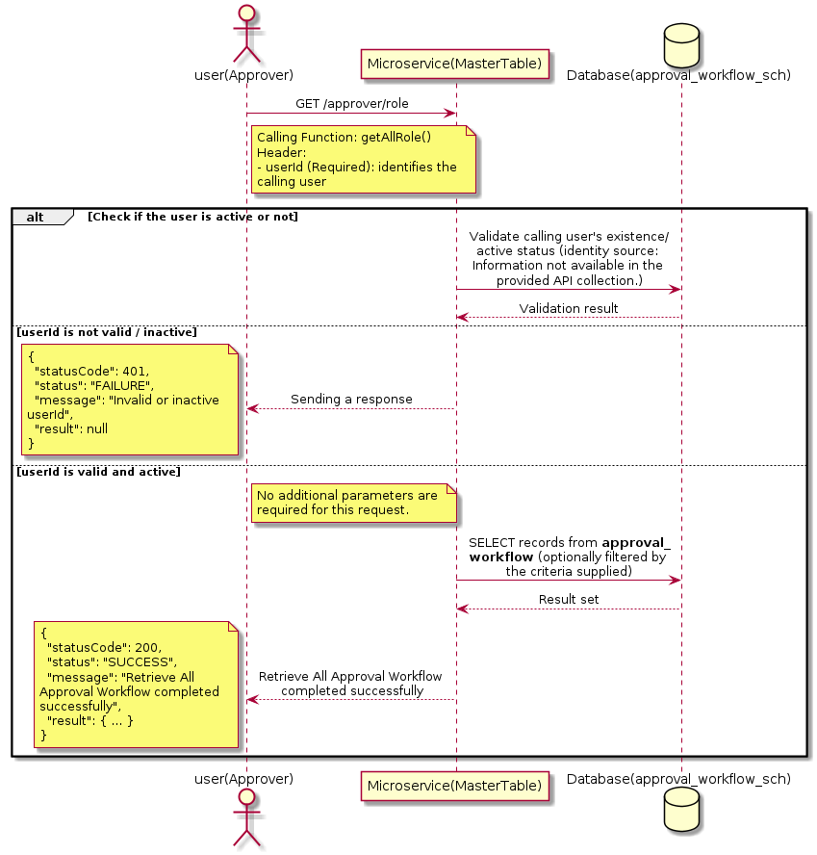

3.1.1.3 API Endpoint
Method | GET
URL | http://localhost:7002/srv2/genie/approver/role
Headers | userId: 67
Authorization | Not present in the captured request. Information not available in the provided API collection.
Content-Type | application/json (assumed)
Query Parameters | None
Path Variables | None
Request Body:
Not applicable — this operation does not accept a request body.
Response Body (illustrative — see 3.x.4.5 Success Response for details):
The source Postman collection does not include a captured sample response for this request (the response array is empty). Information not available in the provided API collection. Section 3.1.1.4.5 below presents the response envelope inferred from the standard response wrapper used consistently by this platform's services.

3.1.1.4 Detailed Process Flow

3.1.1.4.1 Request Initiation
The flow begins when Approver (or a calling microservice on their behalf) invokes the GET endpoint http://localhost:7002/srv2/genie/approver/role. The request must include the mandatory `userId` header used by the Master Table Microservice to identify the calling user for auditing purposes. At the Controller layer, Spring Boot's request-mapping infrastructure routes the call to the appropriate handler method (`getAllRole`), and Bean Validation annotations (if configured on the DTO) perform structural validation before the request reaches the Service layer. Information not available in the provided API collection. regarding the exact validation annotations used in the source code.

3.1.1.4.2 User Validation
The Master Table Microservice relies on the `userId` header to identify the calling user. Based on the pattern observed consistently across this API collection, the platform's authentication/authorization is expected to be enforced upstream (e.g., by an API Gateway or a shared security filter) using this identifier; the Postman collection does not include an `Authorization` / `Bearer` token header on this request, so the exact authentication mechanism (JWT validation, session lookup, or gateway-level SSO) is Information not available in the provided API collection. Role-based authorization — i.e., confirming that the user identified by `userId` holds a role/permission entitled to perform this operation — is expected to be enforced by the Service layer (see Section 8 – Controller Analysis and Section 14 – Authentication & Authorization), but the specific role/permission checks are Information not available in the provided API collection.

3.1.1.4.3 Business Logic
The Service layer contains no conditional business branching for this operation beyond invoking the Repository to fetch all Approval Workflow records. Depending on the record volume, the Service layer may apply default sorting (e.g., by name or creation order) before returning the list.

3.1.1.4.4 Database Interaction
The Repository layer (Spring Data JPA) interacts with the underlying relational database that backs the Approval Workflow master table. The primary operation issued is a **SELECT** against the table associated with Approval Workflow. No write operations occur; the query returns all rows that satisfy the entity's default scope (typically active records). The exact table name, column names, primary/foreign key definitions, and JPA repository method signatures are not included in the Postman collection; therefore, precise schema details are information not available in the provided api collection.

3.1.1.4.5 Success Response
Status Code: 200 OK. Sample response envelope (illustrative — the source collection did not capture a sample response for this API):
{
"statusCode": 200,
"status": "SUCCESS",
"message": "Retrieve All Approval Workflow completed successfully",
"result": [
{
"id": 1,
"name": "Sample Approval Workflow",
"isActive": 1
}
],
"error": null,
"corelationId": "c6f2a1e4-2b3d-4a9e-9f1a-1234567890ab",
"url": null
}

3.1.1.4.6 Conclusion
This API provides a well-defined, single-purpose capability within the Master Table Microservice for retrieve all approval workflow. The Controller → Service → Repository → Database layering keeps request validation, business rules, and persistence concerns separated, which allows the Approval Workflow master data to be maintained consistently and safely by authorized administrators while remaining available for consumption by every other module that depends on this reference data.

3.1.2 Create Approval Workflow

3.1.2.1 Overview
Purpose: To create a new Approval Workflow master record in the system, allowing administrators to extend the master-data catalogue that other modules (ticketing, workflow, notifications) depend on.
Business Requirement: Business/process owners need a controlled way to add new Approval Workflow values so that the platform's classification, routing, and reporting capabilities can evolve as the organization changes.
Who Uses the API: Approver / Workflow Administrator responsible for master-data configuration.
Business Flow: Client sends a POST request with the new Approval Workflow payload → Controller validates the payload (mandatory fields, formats) → Service layer applies business rules (e.g., duplicate-name check) → Repository persists the new record → the created record (with generated identifier) is returned to the Client.

3.1.2.2 Sequence Diagram
The diagram below illustrates the end-to-end interaction for "Create Approval Workflow" across the Client, Controller, Service, Repository, and Database layers.
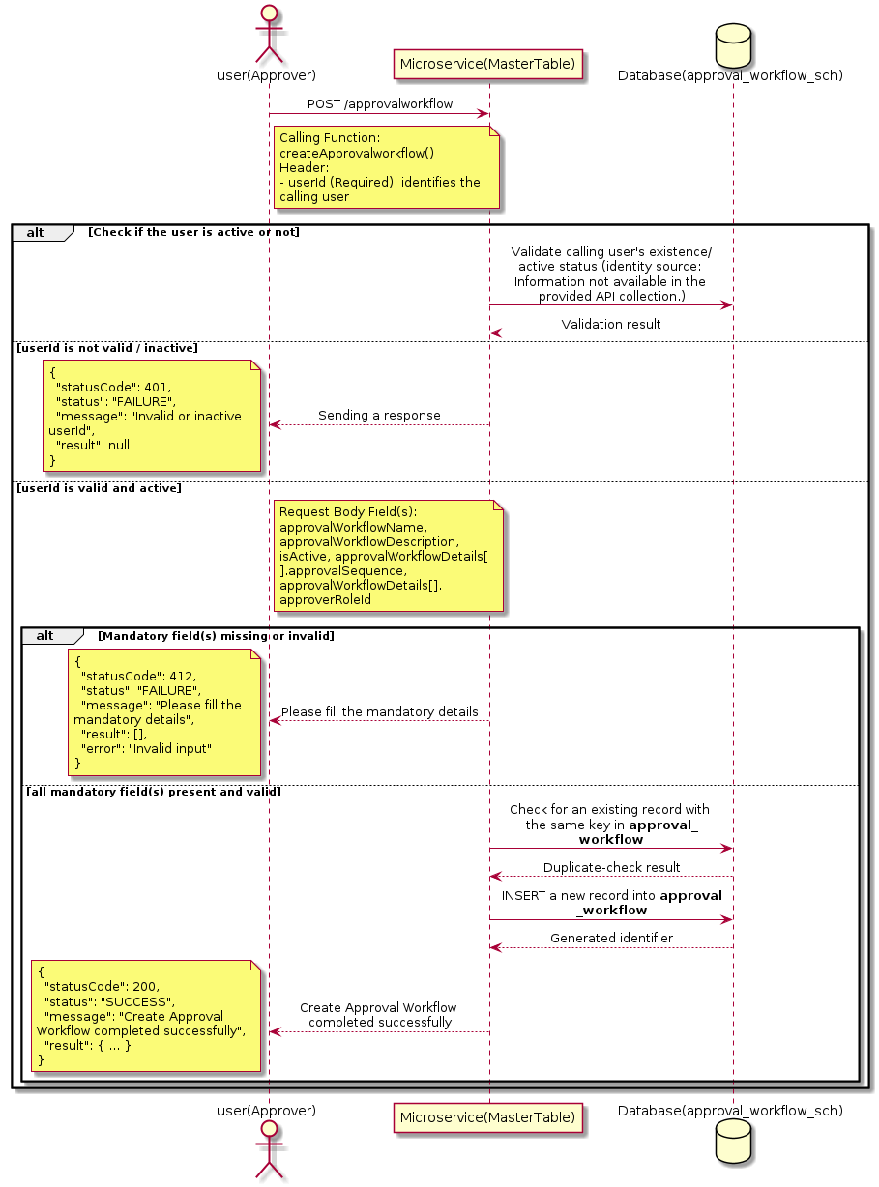

3.1.2.3 API Endpoint
Method | POST
URL | http://localhost:7002/srv2/genie/approvalworkflow
Headers | userId: 67 Content-Type: application/json
Authorization | Not present in the captured request. Information not available in the provided API collection.
Content-Type | Content-Type: application/json
Query Parameters | None
Path Variables | None
Request Body:
{
"approvalWorkflowName": "Test Workflow2",
"approvalWorkflowDescription": "Test approval workflow",
"isActive": "1",
"approvalWorkflowDetails": [
{
"approvalSequence": 1,
"approverRoleId": 1
},
{
"approvalSequence": 2,
"approverRoleId": 2
}
]
}
Response Body (illustrative — see 3.x.4.5 Success Response for details):
The source Postman collection does not include a captured sample response for this request (the response array is empty). Information not available in the provided API collection. Section 3.1.2.4.5 below presents the response envelope inferred from the standard response wrapper used consistently by this platform's services.

3.1.2.4 Detailed Process Flow

3.1.2.4.1 Request Initiation
The flow begins when Approver (or a calling microservice on their behalf) invokes the POST endpoint http://localhost:7002/srv2/genie/approvalworkflow. The request must include the mandatory `userId` header used by the Master Table Microservice to identify the calling user for auditing purposes. The request carries a JSON payload in the request body which the Controller binds to its Data Transfer Object (DTO) before any processing begins. At the Controller layer, Spring Boot's request-mapping infrastructure routes the call to the appropriate handler method (`createApprovalworkflow`), and Bean Validation annotations (if configured on the DTO) perform structural validation before the request reaches the Service layer. Information not available in the provided API collection. regarding the exact validation annotations used in the source code.

3.1.2.4.2 User Validation
The Master Table Microservice relies on the `userId` header to identify the calling user. Based on the pattern observed consistently across this API collection, the platform's authentication/authorization is expected to be enforced upstream (e.g., by an API Gateway or a shared security filter) using this identifier; the Postman collection does not include an `Authorization` / `Bearer` token header on this request, so the exact authentication mechanism (JWT validation, session lookup, or gateway-level SSO) is Information not available in the provided API collection. Role-based authorization — i.e., confirming that the user identified by `userId` holds a role/permission entitled to perform this operation — is expected to be enforced by the Service layer (see Section 8 – Controller Analysis and Section 14 – Authentication & Authorization), but the specific role/permission checks are Information not available in the provided API collection.

3.1.2.4.3 Business Logic
The Service layer performs the following: (1) validates that mandatory fields are present and correctly formatted, (2) checks for duplicates (e.g., an existing Approval Workflow with the same name/code), (3) sets system-managed fields (e.g., `isActive = 1`, `createdBy`, timestamps) where applicable, and (4) persists the new record via the Repository. If any validation fails, the Service layer returns a business error rather than proceeding to persistence. The key fields exchanged for this operation, as observed in the sample payload, are: `approvalWorkflowName`, `approvalWorkflowDescription`, `isActive`, `approvalWorkflowDetails[].approvalSequence`, `approvalWorkflowDetails[].approverRoleId`.

3.1.2.4.4 Database Interaction
The Repository layer (Spring Data JPA) interacts with the underlying relational database that backs the Approval Workflow master table. The primary operation issued is a **INSERT** against the table associated with Approval Workflow. A new row is inserted into the master table; if the entity has related child records (as seen in nested request payload arrays), corresponding child-table inserts are performed within the same transaction. The exact table name, column names, primary/foreign key definitions, and JPA repository method signatures are not included in the Postman collection; therefore, precise schema details are information not available in the provided api collection.

3.1.2.4.5 Success Response
Status Code: 200 OK. Sample response envelope (illustrative — the source collection did not capture a sample response for this API):
{
"statusCode": 200,
"status": "SUCCESS",
"message": "Create Approval Workflow completed successfully",
"result": {
"id": 101,
"approvalWorkflowName": "Test Workflow2",
"approvalWorkflowDescription": "Test approval workflow",
"isActive": "1",
"approvalWorkflowDetails[].approvalSequence": 1,
"approvalWorkflowDetails[].approverRoleId": 1
},
"error": null,
"corelationId": "c6f2a1e4-2b3d-4a9e-9f1a-1234567890ab",
"url": null
}

3.1.2.4.6 Conclusion
This API provides a well-defined, single-purpose capability within the Master Table Microservice for create approval workflow. The Controller → Service → Repository → Database layering keeps request validation, business rules, and persistence concerns separated, which allows the Approval Workflow master data to be maintained consistently and safely by authorized administrators while remaining available for consumption by every other module that depends on this reference data.

3.1.3 Search / List Approval Workflow

3.1.3.1 Overview
Purpose: To search and list Approval Workflow records based on a search payload (e.g., free-text search or structured criteria), supporting list/grid screens that need paginated or filtered master data.
Business Requirement: List/search screens for Approval Workflow configuration need server-side search so that administrators can locate specific records in large master tables without scanning the full data set.
Who Uses the API: Approver / Workflow Administrator operating the Approval Workflow configuration/list screen.
Business Flow: Client sends a POST request with a search payload → Controller validates the payload → Service layer constructs the search/query logic → Repository executes the search against the Approval Workflow table → matching records are returned to the Client.

3.1.3.2 Sequence Diagram
The diagram below illustrates the end-to-end interaction for "Search / List Approval Workflow" across the Client, Controller, Service, Repository, and Database layers.
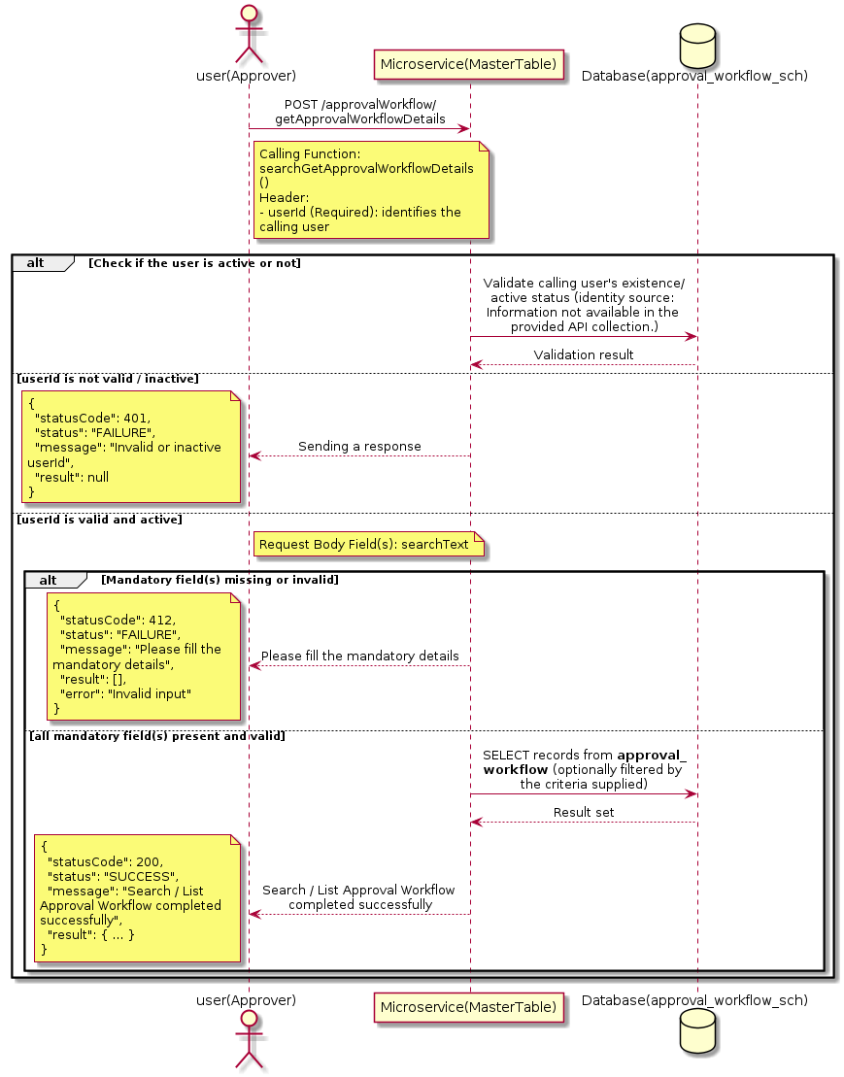

3.1.3.3 API Endpoint
Method | POST
URL | http://localhost:7002/srv2/genie/approvalWorkflow/getApprovalWorkflowDetails
Headers | userId: 67 Content-Type: application/json
Authorization | Not present in the captured request. Information not available in the provided API collection.
Content-Type | Content-Type: application/json
Query Parameters | None
Path Variables | None
Request Body:
{
"searchText": ""
}
Response Body (illustrative — see 3.x.4.5 Success Response for details):
The source Postman collection does not include a captured sample response for this request (the response array is empty). Information not available in the provided API collection. Section 3.1.3.4.5 below presents the response envelope inferred from the standard response wrapper used consistently by this platform's services.

3.1.3.4 Detailed Process Flow

3.1.3.4.1 Request Initiation
The flow begins when Approver (or a calling microservice on their behalf) invokes the POST endpoint http://localhost:7002/srv2/genie/approvalWorkflow/getApprovalWorkflowDetails. The request must include the mandatory `userId` header used by the Master Table Microservice to identify the calling user for auditing purposes. The request carries a JSON payload in the request body which the Controller binds to its Data Transfer Object (DTO) before any processing begins. At the Controller layer, Spring Boot's request-mapping infrastructure routes the call to the appropriate handler method (`searchGetApprovalWorkflowDetails`), and Bean Validation annotations (if configured on the DTO) perform structural validation before the request reaches the Service layer. Information not available in the provided API collection. regarding the exact validation annotations used in the source code.

3.1.3.4.2 User Validation
The Master Table Microservice relies on the `userId` header to identify the calling user. Based on the pattern observed consistently across this API collection, the platform's authentication/authorization is expected to be enforced upstream (e.g., by an API Gateway or a shared security filter) using this identifier; the Postman collection does not include an `Authorization` / `Bearer` token header on this request, so the exact authentication mechanism (JWT validation, session lookup, or gateway-level SSO) is Information not available in the provided API collection. Role-based authorization — i.e., confirming that the user identified by `userId` holds a role/permission entitled to perform this operation — is expected to be enforced by the Service layer (see Section 8 – Controller Analysis and Section 14 – Authentication & Authorization), but the specific role/permission checks are Information not available in the provided API collection.

3.1.3.4.3 Business Logic
The Service layer evaluates the search payload; if the search text/criteria is empty, the operation typically behaves like a full list (all Approval Workflow records); if populated, it is used to build a case-insensitive `LIKE`/contains predicate against the relevant column(s). The key fields exchanged for this operation, as observed in the sample payload, are: `searchText`.

3.1.3.4.4 Database Interaction
The Repository layer (Spring Data JPA) interacts with the underlying relational database that backs the Approval Workflow master table. The primary operation issued is a **SELECT** against the table associated with Approval Workflow. No write operations occur; the search is typically implemented using a JPA derived query method or a native/JPQL query with `LIKE` predicates. The exact table name, column names, primary/foreign key definitions, and JPA repository method signatures are not included in the Postman collection; therefore, precise schema details are information not available in the provided api collection.

3.1.3.4.5 Success Response
Status Code: 200 OK. Sample response envelope (illustrative — the source collection did not capture a sample response for this API):
{
"statusCode": 200,
"status": "SUCCESS",
"message": "Search / List Approval Workflow completed successfully",
"result": [
{
"id": 1,
"name": "Sample Approval Workflow",
"isActive": 1
}
],
"error": null,
"corelationId": "c6f2a1e4-2b3d-4a9e-9f1a-1234567890ab",
"url": null
}

3.1.3.4.6 Conclusion
This API provides a well-defined, single-purpose capability within the Master Table Microservice for search / list approval workflow. The Controller → Service → Repository → Database layering keeps request validation, business rules, and persistence concerns separated, which allows the Approval Workflow master data to be maintained consistently and safely by authorized administrators while remaining available for consumption by every other module that depends on this reference data.

3.1.4 Retrieve Approval Workflow by ID

3.1.4.1 Overview
Purpose: To retrieve a single Approval Workflow record identified by its unique identifier, typically used to pre-populate an edit screen or to validate a reference before use.
Business Requirement: Edit screens, validation routines, and cross-service lookups need to resolve a single Approval Workflow record by its identifier reliably and quickly.
Who Uses the API: Approver / Workflow Administrator, and internal services validating a Approval Workflow reference (e.g., ticket creation, workflow configuration).
Business Flow: Client sends a GET request with the identifier in the URL path → Controller extracts the path variable → Service layer requests the Repository to fetch the record → if found, the record is mapped and returned; if not found, a 404 is returned.

3.1.4.2 Sequence Diagram
The diagram below illustrates the end-to-end interaction for "Retrieve Approval Workflow by ID" across the Client, Controller, Service, Repository, and Database layers.
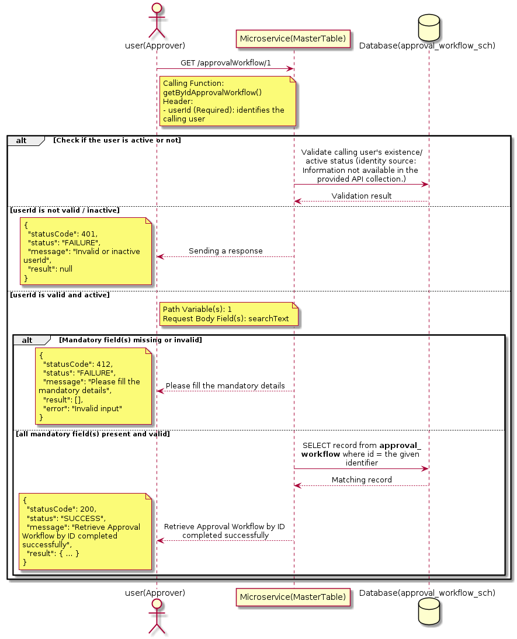

3.1.4.3 API Endpoint
Method | GET
URL | http://localhost:7002/srv2/genie/approvalWorkflow/1
Headers | userId: 67 Content-Type: application/json
Authorization | Not present in the captured request. Information not available in the provided API collection.
Content-Type | Content-Type: application/json
Query Parameters | None
Path Variables | 1
Request Body:
{
"searchText": ""
}
Response Body (illustrative — see 3.x.4.5 Success Response for details):
The source Postman collection does not include a captured sample response for this request (the response array is empty). Information not available in the provided API collection. Section 3.1.4.4.5 below presents the response envelope inferred from the standard response wrapper used consistently by this platform's services.

3.1.4.4 Detailed Process Flow

3.1.4.4.1 Request Initiation
The flow begins when Approver (or a calling microservice on their behalf) invokes the GET endpoint http://localhost:7002/srv2/genie/approvalWorkflow/1. The request must include the mandatory `userId` header used by the Master Table Microservice to identify the calling user for auditing purposes. The request carries a JSON payload in the request body which the Controller binds to its Data Transfer Object (DTO) before any processing begins. At the Controller layer, Spring Boot's request-mapping infrastructure routes the call to the appropriate handler method (`getByIdApprovalWorkflow`), and Bean Validation annotations (if configured on the DTO) perform structural validation before the request reaches the Service layer. Information not available in the provided API collection. regarding the exact validation annotations used in the source code.

3.1.4.4.2 User Validation
The Master Table Microservice relies on the `userId` header to identify the calling user. Based on the pattern observed consistently across this API collection, the platform's authentication/authorization is expected to be enforced upstream (e.g., by an API Gateway or a shared security filter) using this identifier; the Postman collection does not include an `Authorization` / `Bearer` token header on this request, so the exact authentication mechanism (JWT validation, session lookup, or gateway-level SSO) is Information not available in the provided API collection. Role-based authorization — i.e., confirming that the user identified by `userId` holds a role/permission entitled to perform this operation — is expected to be enforced by the Service layer (see Section 8 – Controller Analysis and Section 14 – Authentication & Authorization), but the specific role/permission checks are Information not available in the provided API collection.

3.1.4.4.3 Business Logic
The Service layer forwards the identifier to the Repository. If no record is found for the given identifier, the Service layer raises a not-found condition that the Controller/global exception handler converts into an HTTP 404 response. The key fields exchanged for this operation, as observed in the sample payload, are: `searchText`.

3.1.4.4.4 Database Interaction
The Repository layer (Spring Data JPA) interacts with the underlying relational database that backs the Approval Workflow master table. The primary operation issued is a **SELECT** against the table associated with Approval Workflow. No write operations occur; a single-row lookup is performed using the primary key. The exact table name, column names, primary/foreign key definitions, and JPA repository method signatures are not included in the Postman collection; therefore, precise schema details are information not available in the provided api collection.

3.1.4.4.5 Success Response
Status Code: 200 OK. Sample response envelope (illustrative — the source collection did not capture a sample response for this API):
{
"statusCode": 200,
"status": "SUCCESS",
"message": "Retrieve Approval Workflow by ID completed successfully",
"result": {
"id": 1,
"name": "Sample Approval Workflow",
"isActive": 1
},
"error": null,
"corelationId": "c6f2a1e4-2b3d-4a9e-9f1a-1234567890ab",
"url": null
}

3.1.4.4.6 Conclusion
This API provides a well-defined, single-purpose capability within the Master Table Microservice for retrieve approval workflow by id. The Controller → Service → Repository → Database layering keeps request validation, business rules, and persistence concerns separated, which allows the Approval Workflow master data to be maintained consistently and safely by authorized administrators while remaining available for consumption by every other module that depends on this reference data.

3.1.5 Update Approval Workflow

3.1.5.1 Overview
Purpose: To update an existing Approval Workflow master record, allowing administrators to correct or evolve master-data attributes without impacting the record's identity/history.
Business Requirement: Master data changes over time (renames, corrections, re-classification); the platform must allow controlled updates while preserving referential integrity for records that already reference this Approval Workflow.
Who Uses the API: Approver / Workflow Administrator responsible for maintaining master-data accuracy.
Business Flow: Client sends a PUT/PATCH request with the updated Approval Workflow payload → Controller validates the payload → Service layer fetches the existing record, applies the changes, and re-validates business rules → Repository persists the updated record → the updated record is returned to the Client.

3.1.5.2 Sequence Diagram
The diagram below illustrates the end-to-end interaction for "Update Approval Workflow" across the Client, Controller, Service, Repository, and Database layers.
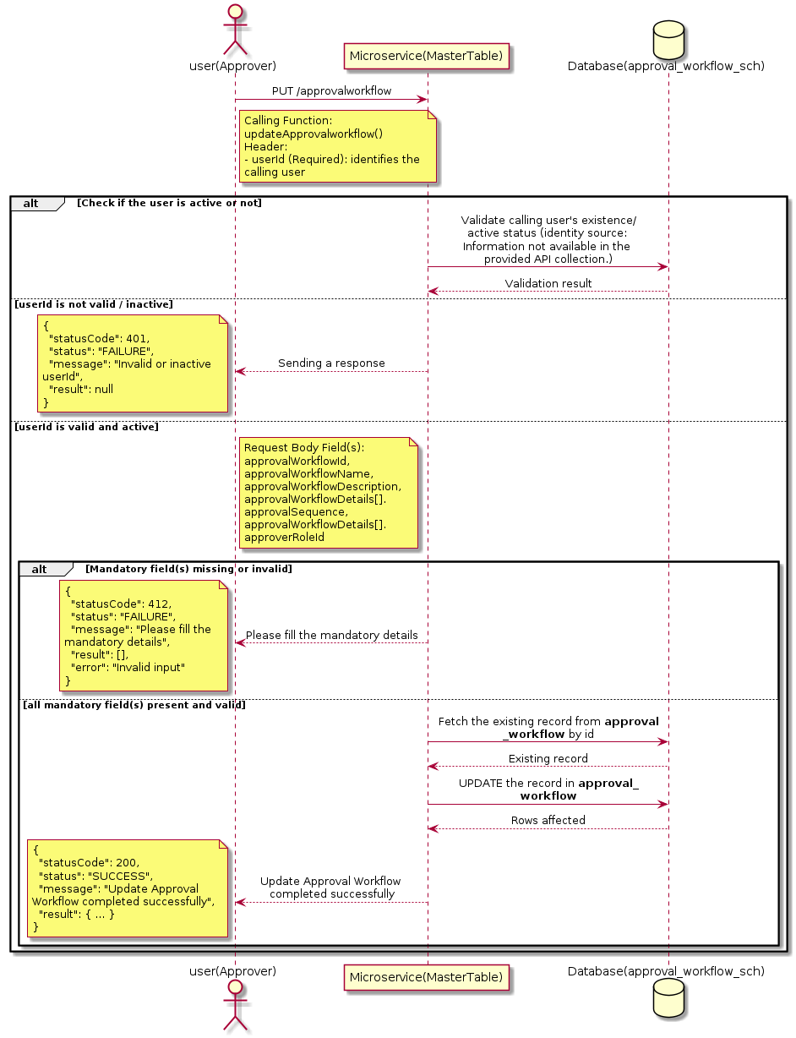

3.1.5.3 API Endpoint
Method | PUT
URL | http://localhost:7002/srv2/genie/approvalworkflow
Headers | userId: 67 Content-Type: application/json
Authorization | Not present in the captured request. Information not available in the provided API collection.
Content-Type | Content-Type: application/json
Query Parameters | None
Path Variables | None
Request Body:
{
"approvalWorkflowId": 3,
"approvalWorkflowName": "Reporting Manager Updated",
"approvalWorkflowDescription": "Updated description",
"approvalWorkflowDetails": [
{
"approvalSequence": 1,
"approverRoleId": 7
}
]
}
Response Body (illustrative — see 3.x.4.5 Success Response for details):
The source Postman collection does not include a captured sample response for this request (the response array is empty). Information not available in the provided API collection. Section 3.1.5.4.5 below presents the response envelope inferred from the standard response wrapper used consistently by this platform's services.

3.1.5.4 Detailed Process Flow

3.1.5.4.1 Request Initiation
The flow begins when Approver (or a calling microservice on their behalf) invokes the PUT endpoint http://localhost:7002/srv2/genie/approvalworkflow. The request must include the mandatory `userId` header used by the Master Table Microservice to identify the calling user for auditing purposes. The request carries a JSON payload in the request body which the Controller binds to its Data Transfer Object (DTO) before any processing begins. At the Controller layer, Spring Boot's request-mapping infrastructure routes the call to the appropriate handler method (`updateApprovalworkflow`), and Bean Validation annotations (if configured on the DTO) perform structural validation before the request reaches the Service layer. Information not available in the provided API collection. regarding the exact validation annotations used in the source code.

3.1.5.4.2 User Validation
The Master Table Microservice relies on the `userId` header to identify the calling user. Based on the pattern observed consistently across this API collection, the platform's authentication/authorization is expected to be enforced upstream (e.g., by an API Gateway or a shared security filter) using this identifier; the Postman collection does not include an `Authorization` / `Bearer` token header on this request, so the exact authentication mechanism (JWT validation, session lookup, or gateway-level SSO) is Information not available in the provided API collection. Role-based authorization — i.e., confirming that the user identified by `userId` holds a role/permission entitled to perform this operation — is expected to be enforced by the Service layer (see Section 8 – Controller Analysis and Section 14 – Authentication & Authorization), but the specific role/permission checks are Information not available in the provided API collection.

3.1.5.4.3 Business Logic
The Service layer fetches the existing Approval Workflow record by its identifier, verifies it exists, applies the incoming changes field by field, re-validates business rules (e.g., uniqueness of a renamed field), and persists the updated entity via the Repository. If the record does not exist, the operation is rejected with a not-found error. The key fields exchanged for this operation, as observed in the sample payload, are: `approvalWorkflowId`, `approvalWorkflowName`, `approvalWorkflowDescription`, `approvalWorkflowDetails[].approvalSequence`, `approvalWorkflowDetails[].approverRoleId`.

3.1.5.4.4 Database Interaction
The Repository layer (Spring Data JPA) interacts with the underlying relational database that backs the Approval Workflow master table. The primary operation issued is a **UPDATE** against the table associated with Approval Workflow. The existing row is located by primary key and updated; if the entity has related child records, the existing child rows are typically replaced/updated within the same transaction. The exact table name, column names, primary/foreign key definitions, and JPA repository method signatures are not included in the Postman collection; therefore, precise schema details are information not available in the provided api collection.

3.1.5.4.5 Success Response
Status Code: 200 OK. Sample response envelope (illustrative — the source collection did not capture a sample response for this API):
{
"statusCode": 200,
"status": "SUCCESS",
"message": "Update Approval Workflow completed successfully",
"result": {
"id": 1,
"isActive": 1
},
"error": null,
"corelationId": "c6f2a1e4-2b3d-4a9e-9f1a-1234567890ab",
"url": null
}

3.1.5.4.6 Conclusion
This API provides a well-defined, single-purpose capability within the Master Table Microservice for update approval workflow. The Controller → Service → Repository → Database layering keeps request validation, business rules, and persistence concerns separated, which allows the Approval Workflow master data to be maintained consistently and safely by authorized administrators while remaining available for consumption by every other module that depends on this reference data.
3.1.6 Delete Approval Workflow

3.1.6.1 Overview
Purpose: To permanently remove a Approval Workflow master record from the system.
Business Requirement: Obsolete or erroneously created Approval Workflow records must be removable so the master table does not accumulate invalid configuration.
Who Uses the API: Approver / Workflow Administrator with delete/configuration privileges.
Business Flow: Client sends a DELETE request identifying the Approval Workflow record → Controller validates the request → Service layer verifies the record exists and is not otherwise referenced → Repository removes the record → a confirmation response is returned to the Client.

3.1.6.2 Sequence Diagram
The diagram below illustrates the end-to-end interaction for "Delete Approval Workflow" across the Client, Controller, Service, Repository, and Database layers.
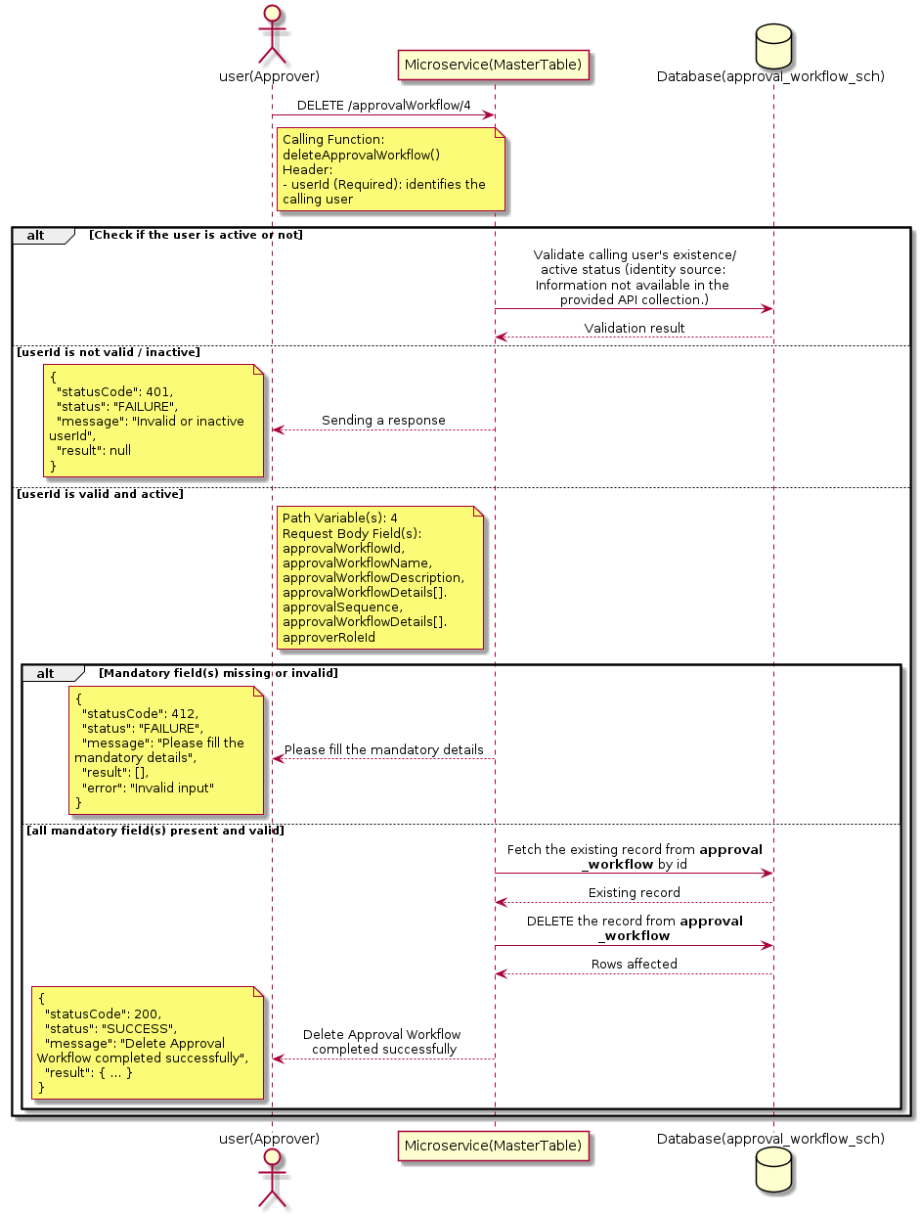

3.1.6.3 API Endpoint
Method | DELETE
URL | http://localhost:7002/srv2/genie/approvalWorkflow/4
Headers | userId: 67 Content-Type: application/json
Authorization | Not present in the captured request. Information not available in the provided API collection.
Content-Type | Content-Type: application/json
Query Parameters | None
Path Variables | 4
Request Body:
{
"approvalWorkflowId": 3,
"approvalWorkflowName": "Reporting Manager Updated",
"approvalWorkflowDescription": "Updated description",
"approvalWorkflowDetails": [
{
"approvalSequence": 1,
"approverRoleId": 7
}
]
}
Response Body (illustrative — see 3.x.4.5 Success Response for details):
The source Postman collection does not include a captured sample response for this request (the response array is empty). Information not available in the provided API collection. Section 3.1.6.4.5 below presents the response envelope inferred from the standard response wrapper used consistently by this platform's services.

3.1.6.4 Detailed Process Flow

3.1.6.4.1 Request Initiation
The flow begins when Approver (or a calling microservice on their behalf) invokes the DELETE endpoint http://localhost:7002/srv2/genie/approvalWorkflow/4. The request must include the mandatory `userId` header used by the Master Table Microservice to identify the calling user for auditing purposes. The request carries a JSON payload in the request body which the Controller binds to its Data Transfer Object (DTO) before any processing begins. At the Controller layer, Spring Boot's request-mapping infrastructure routes the call to the appropriate handler method (`deleteApprovalWorkflow`), and Bean Validation annotations (if configured on the DTO) perform structural validation before the request reaches the Service layer. Information not available in the provided API collection. regarding the exact validation annotations used in the source code.

3.1.6.4.2 User Validation
The Master Table Microservice relies on the `userId` header to identify the calling user. Based on the pattern observed consistently across this API collection, the platform's authentication/authorization is expected to be enforced upstream (e.g., by an API Gateway or a shared security filter) using this identifier; the Postman collection does not include an `Authorization` / `Bearer` token header on this request, so the exact authentication mechanism (JWT validation, session lookup, or gateway-level SSO) is Information not available in the provided API collection. Role-based authorization — i.e., confirming that the user identified by `userId` holds a role/permission entitled to perform this operation — is expected to be enforced by the Service layer (see Section 8 – Controller Analysis and Section 14 – Authentication & Authorization), but the specific role/permission checks are Information not available in the provided API collection.

3.1.6.4.3 Business Logic
The Service layer fetches the existing Approval Workflow record, checks whether it is referenced by dependent records elsewhere in the platform (referential-integrity check), and only proceeds with deletion if no blocking dependency is found. If dependencies exist, the operation is expected to be rejected. Information not available in the provided API collection. regarding the exact dependency checks implemented. The key fields exchanged for this operation, as observed in the sample payload, are: `approvalWorkflowId`, `approvalWorkflowName`, `approvalWorkflowDescription`, `approvalWorkflowDetails[].approvalSequence`, `approvalWorkflowDetails[].approverRoleId`.

3.1.6.4.4 Database Interaction
The Repository layer (Spring Data JPA) interacts with the underlying relational database that backs the Approval Workflow master table. The primary operation issued is a **DELETE** against the table associated with Approval Workflow. The row is removed from the master table by primary key, subject to the referential-integrity checks described in Section 7.3. The exact table name, column names, primary/foreign key definitions, and JPA repository method signatures are not included in the Postman collection; therefore, precise schema details are information not available in the provided api collection.

3.1.6.4.5 Success Response
Status Code: 200 OK. Sample response envelope (illustrative — the source collection did not capture a sample response for this API):
{
"statusCode": 200,
"status": "SUCCESS",
"message": "Delete Approval Workflow completed successfully",
"result": null,
"error": null,
"corelationId": "c6f2a1e4-2b3d-4a9e-9f1a-1234567890ab",
"url": null
}

3.1.6.4.6 Conclusion
This API provides a well-defined, single-purpose capability within the Master Table Microservice for delete approval workflow. The Controller → Service → Repository → Database layering keeps request validation, business rules, and persistence concerns separated, which allows the Approval Workflow master data to be maintained consistently and safely by authorized administrators while remaining available for consumption by every other module that depends on this reference data.
3.2 Business Role APIs (business_role)
Maintains the catalogue of business role types that classify employees/participants for eligibility, notification and approval-routing decisions elsewhere in the platform.

3.2.1 Retrieve All Business Role

3.2.1.1 Overview
Purpose: To retrieve the complete list of Business Role master records configured in the Master Table Microservice, so that consuming screens and downstream services can populate dropdowns, grids, and configuration views.
Business Requirement: Every screen and workflow that references Business Role data (creation forms, filters, reports) needs an authoritative, always-current list of active Business Role values sourced from a single master table rather than being hard-coded.
Who Uses the API: System Administrator / HR Administrator, and any internal microservice/UI module that needs to render Business Role options.
Business Flow: Client sends a GET request → Controller delegates to the Service layer → Service layer calls the Repository → Repository queries the Business Role table → the result set is mapped to response DTOs and returned to the Client.

3.2.1.2 Sequence Diagram
The diagram below illustrates the end-to-end interaction for "Retrieve All Business Role" across the Client, Controller, Service, Repository, and Database layers.
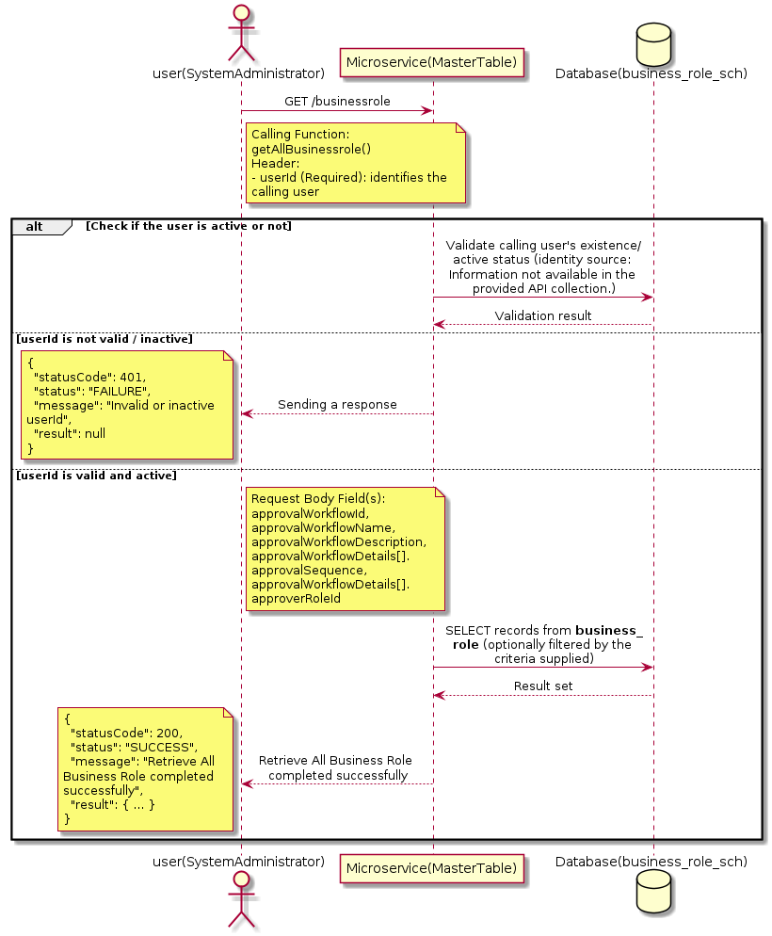

3.2.1.3 API Endpoint
Method | GET
URL | http://localhost:7002/srv2/genie/businessrole
Headers | userId: 67 Content-Type: application/json
Authorization | Not present in the captured request. Information not available in the provided API collection.
Content-Type | Content-Type: application/json
Query Parameters | None
Path Variables | None
Request Body:
{
"approvalWorkflowId": 1,
"approvalWorkflowName": "Reporting Manager Updated",
"approvalWorkflowDescription": "Updated description",
"approvalWorkflowDetails": [
{
"approvalSequence": 1,
"approverRoleId": 7
}
]
}
Response Body (illustrative — see 3.x.4.5 Success Response for details):
The source Postman collection does not include a captured sample response for this request (the response array is empty). Information not available in the provided API collection. Section 3.2.1.4.5 below presents the response envelope inferred from the standard response wrapper used consistently by this platform's services.

3.2.1.4 Detailed Process Flow

3.2.1.4.1 Request Initiation
The flow begins when System Administrator (or a calling microservice on their behalf) invokes the GET endpoint http://localhost:7002/srv2/genie/businessrole. The request must include the mandatory `userId` header used by the Master Table Microservice to identify the calling user for auditing purposes. The request carries a JSON payload in the request body which the Controller binds to its Data Transfer Object (DTO) before any processing begins. At the Controller layer, Spring Boot's request-mapping infrastructure routes the call to the appropriate handler method (`getAllBusinessrole`), and Bean Validation annotations (if configured on the DTO) perform structural validation before the request reaches the Service layer. Information not available in the provided API collection. regarding the exact validation annotations used in the source code.

3.2.1.4.2 User Validation
The Master Table Microservice relies on the `userId` header to identify the calling user. Based on the pattern observed consistently across this API collection, the platform's authentication/authorization is expected to be enforced upstream (e.g., by an API Gateway or a shared security filter) using this identifier; the Postman collection does not include an `Authorization` / `Bearer` token header on this request, so the exact authentication mechanism (JWT validation, session lookup, or gateway-level SSO) is Information not available in the provided API collection. Role-based authorization — i.e., confirming that the user identified by `userId` holds a role/permission entitled to perform this operation — is expected to be enforced by the Service layer (see Section 8 – Controller Analysis and Section 14 – Authentication & Authorization), but the specific role/permission checks are Information not available in the provided API collection.

3.2.1.4.3 Business Logic
The Service layer contains no conditional business branching for this operation beyond invoking the Repository to fetch all Business Role records. Depending on the record volume, the Service layer may apply default sorting (e.g., by name or creation order) before returning the list. The key fields exchanged for this operation, as observed in the sample payload, are: `approvalWorkflowId`, `approvalWorkflowName`, `approvalWorkflowDescription`, `approvalWorkflowDetails[].approvalSequence`, `approvalWorkflowDetails[].approverRoleId`.

3.2.1.4.4 Database Interaction
The Repository layer (Spring Data JPA) interacts with the underlying relational database that backs the Business Role master table. The primary operation issued is a **SELECT** against the table associated with Business Role. No write operations occur; the query returns all rows that satisfy the entity's default scope (typically active records). The exact table name, column names, primary/foreign key definitions, and JPA repository method signatures are not included in the Postman collection; therefore, precise schema details are information not available in the provided api collection.

3.2.1.4.5 Success Response
Status Code: 200 OK. Sample response envelope (illustrative — the source collection did not capture a sample response for this API):
{
"statusCode": 200,
"status": "SUCCESS",
"message": "Retrieve All Business Role completed successfully",
"result": [
{
"id": 1,
"name": "Sample Business Role",
"isActive": 1
}
],
"error": null,
"corelationId": "c6f2a1e4-2b3d-4a9e-9f1a-1234567890ab",
"url": null
}

3.2.1.4.6 Conclusion
This API provides a well-defined, single-purpose capability within the Master Table Microservice for retrieve all business role. The Controller → Service → Repository → Database layering keeps request validation, business rules, and persistence concerns separated, which allows the Business Role master data to be maintained consistently and safely by authorized administrators while remaining available for consumption by every other module that depends on this reference data.

3.2.2 Retrieve Business Role by ID

3.2.2.1 Overview
Purpose: To retrieve a single Business Role record identified by its unique identifier, typically used to pre-populate an edit screen or to validate a reference before use.
Business Requirement: Edit screens, validation routines, and cross-service lookups need to resolve a single Business Role record by its identifier reliably and quickly.
Who Uses the API: System Administrator / HR Administrator, and internal services validating a Business Role reference (e.g., ticket creation, workflow configuration).
Business Flow: Client sends a GET request with the identifier in the URL path → Controller extracts the path variable → Service layer requests the Repository to fetch the record → if found, the record is mapped and returned; if not found, a 404 is returned.

3.2.2.2 Sequence Diagram
The diagram below illustrates the end-to-end interaction for "Retrieve Business Role by ID" across the Client, Controller, Service, Repository, and Database layers.
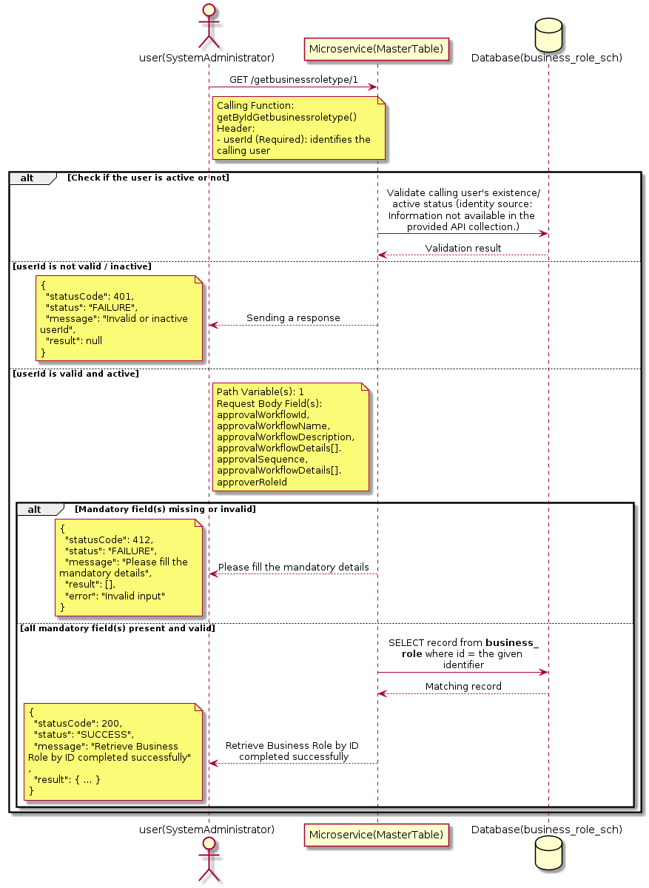

3.2.2.3 API Endpoint
Method | GET
URL | http://localhost:7002/srv2/genie/getbusinessroletype/1
Headers | userId: 67 Content-Type: application/json
Authorization | Not present in the captured request. Information not available in the provided API collection.
Content-Type | Content-Type: application/json
Query Parameters | None
Path Variables | 1
Request Body:
{
"approvalWorkflowId": 1,
"approvalWorkflowName": "Reporting Manager Updated",
"approvalWorkflowDescription": "Updated description",
"approvalWorkflowDetails": [
{
"approvalSequence": 1,
"approverRoleId": 7
}
]
}
Response Body (illustrative — see 3.x.4.5 Success Response for details):
The source Postman collection does not include a captured sample response for this request (the response array is empty). Information not available in the provided API collection. Section 3.2.2.4.5 below presents the response envelope inferred from the standard response wrapper used consistently by this platform's services.

3.2.2.4 Detailed Process Flow

3.2.2.4.1 Request Initiation
The flow begins when System Administrator (or a calling microservice on their behalf) invokes the GET endpoint http://localhost:7002/srv2/genie/getbusinessroletype/1. The request must include the mandatory `userId` header used by the Master Table Microservice to identify the calling user for auditing purposes. The request carries a JSON payload in the request body which the Controller binds to its Data Transfer Object (DTO) before any processing begins. At the Controller layer, Spring Boot's request-mapping infrastructure routes the call to the appropriate handler method (`getByIdGetbusinessroletype`), and Bean Validation annotations (if configured on the DTO) perform structural validation before the request reaches the Service layer. Information not available in the provided API collection. regarding the exact validation annotations used in the source code.

3.2.2.4.2 User Validation
The Master Table Microservice relies on the `userId` header to identify the calling user. Based on the pattern observed consistently across this API collection, the platform's authentication/authorization is expected to be enforced upstream (e.g., by an API Gateway or a shared security filter) using this identifier; the Postman collection does not include an `Authorization` / `Bearer` token header on this request, so the exact authentication mechanism (JWT validation, session lookup, or gateway-level SSO) is Information not available in the provided API collection. Role-based authorization — i.e., confirming that the user identified by `userId` holds a role/permission entitled to perform this operation — is expected to be enforced by the Service layer (see Section 8 – Controller Analysis and Section 14 – Authentication & Authorization), but the specific role/permission checks are Information not available in the provided API collection.

3.2.2.4.3 Business Logic
The Service layer forwards the identifier to the Repository. If no record is found for the given identifier, the Service layer raises a not-found condition that the Controller/global exception handler converts into an HTTP 404 response. The key fields exchanged for this operation, as observed in the sample payload, are: `approvalWorkflowId`, `approvalWorkflowName`, `approvalWorkflowDescription`, `approvalWorkflowDetails[].approvalSequence`, `approvalWorkflowDetails[].approverRoleId`.

3.2.2.4.4 Database Interaction
The Repository layer (Spring Data JPA) interacts with the underlying relational database that backs the Business Role master table. The primary operation issued is a **SELECT** against the table associated with Business Role. No write operations occur; a single-row lookup is performed using the primary key. The exact table name, column names, primary/foreign key definitions, and JPA repository method signatures are not included in the Postman collection; therefore, precise schema details are information not available in the provided api collection.

3.2.2.4.5 Success Response
Status Code: 200 OK. Sample response envelope (illustrative — the source collection did not capture a sample response for this API):
{
"statusCode": 200,
"status": "SUCCESS",
"message": "Retrieve Business Role by ID completed successfully",
"result": {
"id": 1,
"name": "Sample Business Role",
"isActive": 1
},
"error": null,
"corelationId": "c6f2a1e4-2b3d-4a9e-9f1a-1234567890ab",
"url": null
}

3.2.2.4.6 Conclusion
This API provides a well-defined, single-purpose capability within the Master Table Microservice for retrieve business role by id. The Controller → Service → Repository → Database layering keeps request validation, business rules, and persistence concerns separated, which allows the Business Role master data to be maintained consistently and safely by authorized administrators while remaining available for consumption by every other module that depends on this reference data.
3.2.3 Create Business Role

3.2.3.1 Overview
Purpose: To create a new Business Role master record in the system, allowing administrators to extend the master-data catalogue that other modules (ticketing, workflow, notifications) depend on.
Business Requirement: Business/process owners need a controlled way to add new Business Role values so that the platform's classification, routing, and reporting capabilities can evolve as the organization changes.
Who Uses the API: System Administrator / HR Administrator responsible for master-data configuration.
Business Flow: Client sends a POST request with the new Business Role payload → Controller validates the payload (mandatory fields, formats) → Service layer applies business rules (e.g., duplicate-name check) → Repository persists the new record → the created record (with generated identifier) is returned to the Client.

3.2.3.2 Sequence Diagram
The diagram below illustrates the end-to-end interaction for "Create Business Role" across the Client, Controller, Service, Repository, and Database layers.
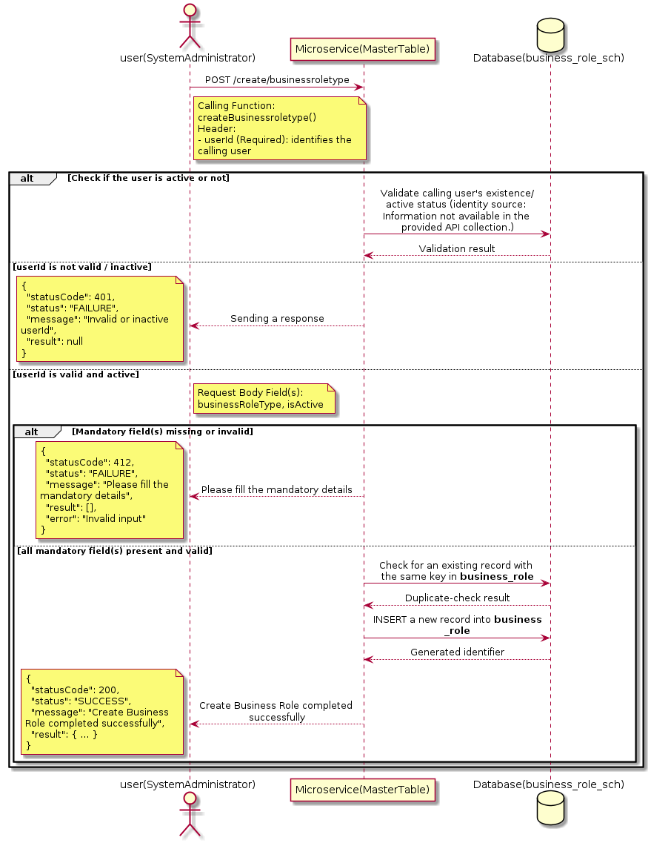

3.2.3.3 API Endpoint
Method | POST
URL | http://localhost:7002/srv2/genie/create/businessroletype
Headers | userId: 67 Content-Type: application/json
Authorization | Not present in the captured request. Information not available in the provided API collection.
Content-Type | Content-Type: application/json
Query Parameters | None
Path Variables | None
Request Body:
{
"businessRoleType": "New Business Role",
"isActive": "1"
}
Response Body (illustrative — see 3.x.4.5 Success Response for details):
The source Postman collection does not include a captured sample response for this request (the response array is empty). Information not available in the provided API collection. Section 3.2.3.4.5 below presents the response envelope inferred from the standard response wrapper used consistently by this platform's services.

3.2.3.4 Detailed Process Flow

3.2.3.4.1 Request Initiation
The flow begins when System Administrator (or a calling microservice on their behalf) invokes the POST endpoint http://localhost:7002/srv2/genie/create/businessroletype. The request must include the mandatory `userId` header used by the Master Table Microservice to identify the calling user for auditing purposes. The request carries a JSON payload in the request body which the Controller binds to its Data Transfer Object (DTO) before any processing begins. At the Controller layer, Spring Boot's request-mapping infrastructure routes the call to the appropriate handler method (`createBusinessroletype`), and Bean Validation annotations (if configured on the DTO) perform structural validation before the request reaches the Service layer. Information not available in the provided API collection. regarding the exact validation annotations used in the source code.

3.2.3.4.2 User Validation
The Master Table Microservice relies on the `userId` header to identify the calling user. Based on the pattern observed consistently across this API collection, the platform's authentication/authorization is expected to be enforced upstream (e.g., by an API Gateway or a shared security filter) using this identifier; the Postman collection does not include an `Authorization` / `Bearer` token header on this request, so the exact authentication mechanism (JWT validation, session lookup, or gateway-level SSO) is Information not available in the provided API collection. Role-based authorization — i.e., confirming that the user identified by `userId` holds a role/permission entitled to perform this operation — is expected to be enforced by the Service layer (see Section 8 – Controller Analysis and Section 14 – Authentication & Authorization), but the specific role/permission checks are Information not available in the provided API collection.

3.2.3.4.3 Business Logic
The Service layer performs the following: (1) validates that mandatory fields are present and correctly formatted, (2) checks for duplicates (e.g., an existing Business Role with the same name/code), (3) sets system-managed fields (e.g., `isActive = 1`, `createdBy`, timestamps) where applicable, and (4) persists the new record via the Repository. If any validation fails, the Service layer returns a business error rather than proceeding to persistence. The key fields exchanged for this operation, as observed in the sample payload, are: `businessRoleType`, `isActive`.

3.2.3.4.4 Database Interaction
The Repository layer (Spring Data JPA) interacts with the underlying relational database that backs the Business Role master table. The primary operation issued is a **INSERT** against the table associated with Business Role. A new row is inserted into the master table; if the entity has related child records (as seen in nested request payload arrays), corresponding child-table inserts are performed within the same transaction. The exact table name, column names, primary/foreign key definitions, and JPA repository method signatures are not included in the Postman collection; therefore, precise schema details are information not available in the provided api collection.

3.2.3.4.5 Success Response
Status Code: 200 OK. Sample response envelope (illustrative — the source collection did not capture a sample response for this API):
{
"statusCode": 200,
"status": "SUCCESS",
"message": "Create Business Role completed successfully",
"result": {
"id": 101,
"businessRoleType": "New Business Role",
"isActive": "1"
},
"error": null,
"corelationId": "c6f2a1e4-2b3d-4a9e-9f1a-1234567890ab",
"url": null
}

3.2.3.4.6 Conclusion
This API provides a well-defined, single-purpose capability within the Master Table Microservice for create business role. The Controller → Service → Repository → Database layering keeps request validation, business rules, and persistence concerns separated, which allows the Business Role master data to be maintained consistently and safely by authorized administrators while remaining available for consumption by every other module that depends on this reference data.
3.2.4 Update Business Role

3.2.4.1 Overview
Purpose: To update an existing Business Role master record, allowing administrators to correct or evolve master-data attributes without impacting the record's identity/history.
Business Requirement: Master data changes over time (renames, corrections, re-classification); the platform must allow controlled updates while preserving referential integrity for records that already reference this Business Role.
Who Uses the API: System Administrator / HR Administrator responsible for maintaining master-data accuracy.
Business Flow: Client sends a PUT/PATCH request with the updated Business Role payload → Controller validates the payload → Service layer fetches the existing record, applies the changes, and re-validates business rules → Repository persists the updated record → the updated record is returned to the Client.

3.2.4.2 Sequence Diagram
The diagram below illustrates the end-to-end interaction for "Update Business Role" across the Client, Controller, Service, Repository, and Database layers.
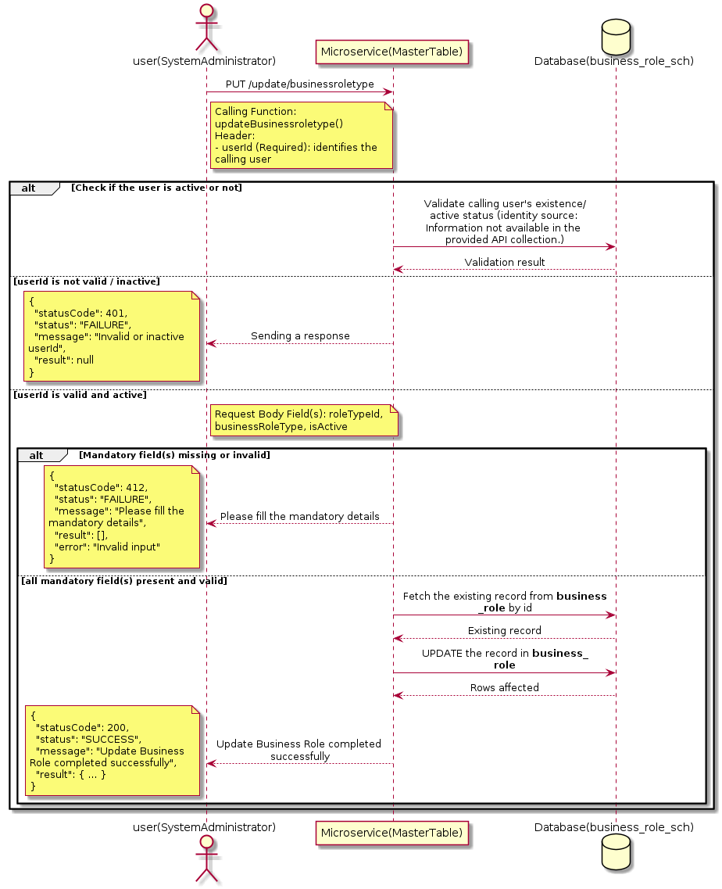

3.2.4.3 API Endpoint
Method | PUT
URL | http://localhost:7002/srv2/genie/update/businessroletype
Headers | userId: 67 Content-Type: application/json
Authorization | Not present in the captured request. Information not available in the provided API collection.
Content-Type | Content-Type: application/json
Query Parameters | None
Path Variables | None
Request Body:
{
"roleTypeId": 1,
"businessRoleType": "Updated Name",
"isActive": "1"
}
Response Body (illustrative — see 3.x.4.5 Success Response for details):
The source Postman collection does not include a captured sample response for this request (the response array is empty). Information not available in the provided API collection. Section 3.2.4.4.5 below presents the response envelope inferred from the standard response wrapper used consistently by this platform's services.

3.2.4.4 Detailed Process Flow

3.2.4.4.1 Request Initiation
The flow begins when System Administrator (or a calling microservice on their behalf) invokes the PUT endpoint http://localhost:7002/srv2/genie/update/businessroletype. The request must include the mandatory `userId` header used by the Master Table Microservice to identify the calling user for auditing purposes. The request carries a JSON payload in the request body which the Controller binds to its Data Transfer Object (DTO) before any processing begins. At the Controller layer, Spring Boot's request-mapping infrastructure routes the call to the appropriate handler method (`updateBusinessroletype`), and Bean Validation annotations (if configured on the DTO) perform structural validation before the request reaches the Service layer. Information not available in the provided API collection. regarding the exact validation annotations used in the source code.

3.2.4.4.2 User Validation
The Master Table Microservice relies on the `userId` header to identify the calling user. Based on the pattern observed consistently across this API collection, the platform's authentication/authorization is expected to be enforced upstream (e.g., by an API Gateway or a shared security filter) using this identifier; the Postman collection does not include an `Authorization` / `Bearer` token header on this request, so the exact authentication mechanism (JWT validation, session lookup, or gateway-level SSO) is Information not available in the provided API collection. Role-based authorization — i.e., confirming that the user identified by `userId` holds a role/permission entitled to perform this operation — is expected to be enforced by the Service layer (see Section 8 – Controller Analysis and Section 14 – Authentication & Authorization), but the specific role/permission checks are Information not available in the provided API collection.

3.2.4.4.3 Business Logic
The Service layer fetches the existing Business Role record by its identifier, verifies it exists, applies the incoming changes field by field, re-validates business rules (e.g., uniqueness of a renamed field), and persists the updated entity via the Repository. If the record does not exist, the operation is rejected with a not-found error. The key fields exchanged for this operation, as observed in the sample payload, are: `roleTypeId`, `businessRoleType`, `isActive`.

3.2.4.4.4 Database Interaction
The Repository layer (Spring Data JPA) interacts with the underlying relational database that backs the Business Role master table. The primary operation issued is a **UPDATE** against the table associated with Business Role. The existing row is located by primary key and updated; if the entity has related child records, the existing child rows are typically replaced/updated within the same transaction. The exact table name, column names, primary/foreign key definitions, and JPA repository method signatures are not included in the Postman collection; therefore, precise schema details are information not available in the provided api collection.

3.2.4.4.5 Success Response
Status Code: 200 OK. Sample response envelope (illustrative — the source collection did not capture a sample response for this API):
{
"statusCode": 200,
"status": "SUCCESS",
"message": "Update Business Role completed successfully",
"result": {
"id": 1,
"isActive": 1
},
"error": null,
"corelationId": "c6f2a1e4-2b3d-4a9e-9f1a-1234567890ab",
"url": null
}

3.2.4.4.6 Conclusion
This API provides a well-defined, single-purpose capability within the Master Table Microservice for update business role. The Controller → Service → Repository → Database layering keeps request validation, business rules, and persistence concerns separated, which allows the Business Role master data to be maintained consistently and safely by authorized administrators while remaining available for consumption by every other module that depends on this reference data.

3.3 Department APIs (Department)
Maintains the organizational department master used to tag tickets, employees, groups and notification rules to a department for ownership, routing and reporting.

3.3.1 Retrieve All Department — department

3.3.1.1 Overview
Purpose: To retrieve the complete list of Department master records configured in the Master Table Microservice, so that consuming screens and downstream services can populate dropdowns, grids, and configuration views.
Business Requirement: Every screen and workflow that references Department data (creation forms, filters, reports) needs an authoritative, always-current list of active Department values sourced from a single master table rather than being hard-coded.
Who Uses the API: System Administrator / HR Administrator, and any internal microservice/UI module that needs to render Department options.
Business Flow: Client sends a GET request → Controller delegates to the Service layer → Service layer calls the Repository → Repository queries the Department table → the result set is mapped to response DTOs and returned to the Client.

3.3.1.2 Sequence Diagram
The diagram below illustrates the end-to-end interaction for "Retrieve All Department — department" across the Client, Controller, Service, Repository, and Database layers.
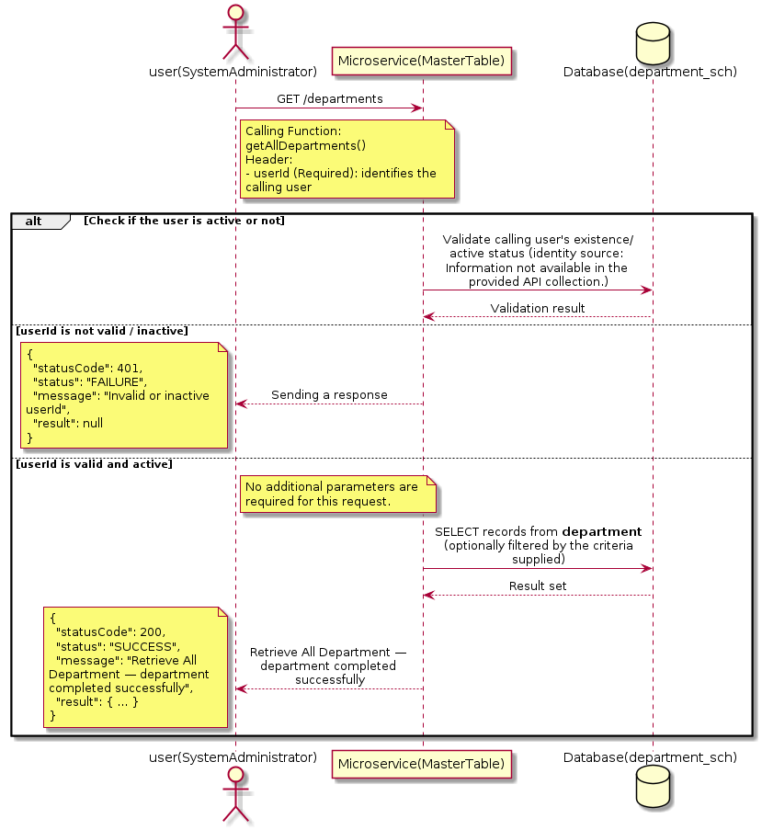

3.3.1.3 API Endpoint
Method | GET
URL | http://localhost:7002/srv2/genie/departments
Headers | userId: 67
Authorization | Not present in the captured request. Information not available in the provided API collection.
Content-Type | application/json (assumed)
Query Parameters | None
Path Variables | None
Request Body:
Not applicable — this operation does not accept a request body.
Response Body (illustrative — see 3.x.4.5 Success Response for details):
The source Postman collection does not include a captured sample response for this request (the response array is empty). Information not available in the provided API collection. Section 3.3.1.4.5 below presents the response envelope inferred from the standard response wrapper used consistently by this platform's services.

3.3.1.4 Detailed Process Flow

3.3.1.4.1 Request Initiation
The flow begins when System Administrator (or a calling microservice on their behalf) invokes the GET endpoint http://localhost:7002/srv2/genie/departments. The request must include the mandatory `userId` header used by the Master Table Microservice to identify the calling user for auditing purposes. At the Controller layer, Spring Boot's request-mapping infrastructure routes the call to the appropriate handler method (`getAllDepartments`), and Bean Validation annotations (if configured on the DTO) perform structural validation before the request reaches the Service layer. Information not available in the provided API collection. regarding the exact validation annotations used in the source code.

3.3.1.4.2 User Validation
The Master Table Microservice relies on the `userId` header to identify the calling user. Based on the pattern observed consistently across this API collection, the platform's authentication/authorization is expected to be enforced upstream (e.g., by an API Gateway or a shared security filter) using this identifier; the Postman collection does not include an `Authorization` / `Bearer` token header on this request, so the exact authentication mechanism (JWT validation, session lookup, or gateway-level SSO) is Information not available in the provided API collection. Role-based authorization — i.e., confirming that the user identified by `userId` holds a role/permission entitled to perform this operation — is expected to be enforced by the Service layer (see Section 8 – Controller Analysis and Section 14 – Authentication & Authorization), but the specific role/permission checks are Information not available in the provided API collection.

3.3.1.4.3 Business Logic
The Service layer contains no conditional business branching for this operation beyond invoking the Repository to fetch all Department records. Depending on the record volume, the Service layer may apply default sorting (e.g., by name or creation order) before returning the list.

3.3.1.4.4 Database Interaction
The Repository layer (Spring Data JPA) interacts with the underlying relational database that backs the Department master table. The primary operation issued is a **SELECT** against the table associated with Department. No write operations occur; the query returns all rows that satisfy the entity's default scope (typically active records). The exact table name, column names, primary/foreign key definitions, and JPA repository method signatures are not included in the Postman collection; therefore, precise schema details are information not available in the provided api collection.

3.3.1.4.5 Success Response
Status Code: 200 OK. Sample response envelope (illustrative — the source collection did not capture a sample response for this API):
{
"statusCode": 200,
"status": "SUCCESS",
"message": "Retrieve All Department — department completed successfully",
"result": [
{
"id": 1,
"name": "Sample Department",
"isActive": 1
}
],
"error": null,
"corelationId": "c6f2a1e4-2b3d-4a9e-9f1a-1234567890ab",
"url": null
}

3.3.1.4.6 Conclusion
This API provides a well-defined, single-purpose capability within the Master Table Microservice for retrieve all department — department. The Controller → Service → Repository → Database layering keeps request validation, business rules, and persistence concerns separated, which allows the Department master data to be maintained consistently and safely by authorized administrators while remaining available for consumption by every other module that depends on this reference data.

3.3.2 Retrieve Department by ID

3.3.2.1 Overview
Purpose: To retrieve a single Department record identified by its unique identifier, typically used to pre-populate an edit screen or to validate a reference before use.
Business Requirement: Edit screens, validation routines, and cross-service lookups need to resolve a single Department record by its identifier reliably and quickly.
Who Uses the API: System Administrator / HR Administrator, and internal services validating a Department reference (e.g., ticket creation, workflow configuration).
Business Flow: Client sends a GET request with the identifier in the URL path → Controller extracts the path variable → Service layer requests the Repository to fetch the record → if found, the record is mapped and returned; if not found, a 404 is returned.

3.3.2.2 Sequence Diagram
The diagram below illustrates the end-to-end interaction for "Retrieve Department by ID" across the Client, Controller, Service, Repository, and Database layers.
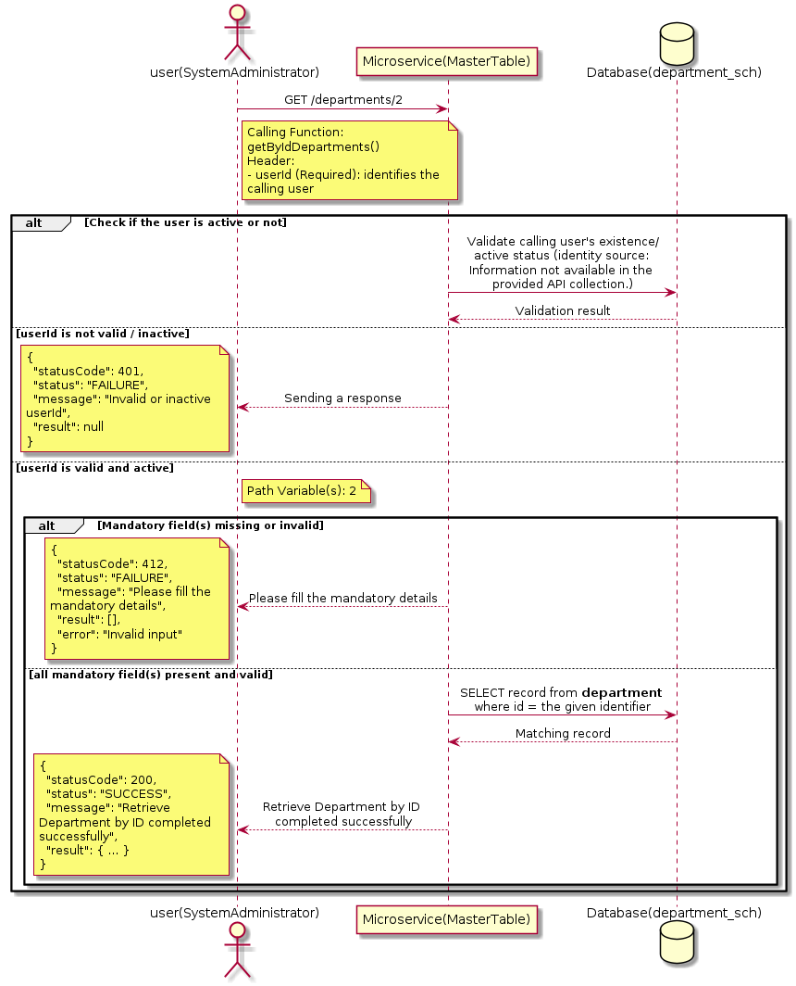

3.3.2.3 API Endpoint
Method | GET
URL | http://localhost:7002/srv2/genie/departments/2
Headers | userId: 67
Authorization | Not present in the captured request. Information not available in the provided API collection.
Content-Type | application/json (assumed)
Query Parameters | None
Path Variables | 2
Request Body:
Not applicable — this operation does not accept a request body.
Response Body (illustrative — see 3.x.4.5 Success Response for details):
The source Postman collection does not include a captured sample response for this request (the response array is empty). Information not available in the provided API collection. Section 3.3.2.4.5 below presents the response envelope inferred from the standard response wrapper used consistently by this platform's services.

3.3.2.4 Detailed Process Flow

3.3.2.4.1 Request Initiation
The flow begins when System Administrator (or a calling microservice on their behalf) invokes the GET endpoint http://localhost:7002/srv2/genie/departments/2. The request must include the mandatory `userId` header used by the Master Table Microservice to identify the calling user for auditing purposes. At the Controller layer, Spring Boot's request-mapping infrastructure routes the call to the appropriate handler method (`getByIdDepartments`), and Bean Validation annotations (if configured on the DTO) perform structural validation before the request reaches the Service layer. Information not available in the provided API collection. regarding the exact validation annotations used in the source code.

3.3.2.4.2 User Validation
The Master Table Microservice relies on the `userId` header to identify the calling user. Based on the pattern observed consistently across this API collection, the platform's authentication/authorization is expected to be enforced upstream (e.g., by an API Gateway or a shared security filter) using this identifier; the Postman collection does not include an `Authorization` / `Bearer` token header on this request, so the exact authentication mechanism (JWT validation, session lookup, or gateway-level SSO) is Information not available in the provided API collection. Role-based authorization — i.e., confirming that the user identified by `userId` holds a role/permission entitled to perform this operation — is expected to be enforced by the Service layer (see Section 8 – Controller Analysis and Section 14 – Authentication & Authorization), but the specific role/permission checks are Information not available in the provided API collection.

3.3.2.4.3 Business Logic
The Service layer forwards the identifier to the Repository. If no record is found for the given identifier, the Service layer raises a not-found condition that the Controller/global exception handler converts into an HTTP 404 response.

3.3.2.4.4 Database Interaction
The Repository layer (Spring Data JPA) interacts with the underlying relational database that backs the Department master table. The primary operation issued is a **SELECT** against the table associated with Department. No write operations occur; a single-row lookup is performed using the primary key. The exact table name, column names, primary/foreign key definitions, and JPA repository method signatures are not included in the Postman collection; therefore, precise schema details are information not available in the provided api collection.

3.3.2.4.5 Success Response
Status Code: 200 OK. Sample response envelope (illustrative — the source collection did not capture a sample response for this API):
{
"statusCode": 200,
"status": "SUCCESS",
"message": "Retrieve Department by ID completed successfully",
"result": {
"id": 1,
"name": "Sample Department",
"isActive": 1
},
"error": null,
"corelationId": "c6f2a1e4-2b3d-4a9e-9f1a-1234567890ab",
"url": null
}

3.3.2.4.6 Conclusion
This API provides a well-defined, single-purpose capability within the Master Table Microservice for retrieve department by id. The Controller → Service → Repository → Database layering keeps request validation, business rules, and persistence concerns separated, which allows the Department master data to be maintained consistently and safely by authorized administrators while remaining available for consumption by every other module that depends on this reference data.

3.3.3 Retrieve All Department — getcsrdepartment

3.3.3.1 Overview
Purpose: To retrieve the complete list of Department master records configured in the Master Table Microservice, so that consuming screens and downstream services can populate dropdowns, grids, and configuration views.
Business Requirement: Every screen and workflow that references Department data (creation forms, filters, reports) needs an authoritative, always-current list of active Department values sourced from a single master table rather than being hard-coded.
Who Uses the API: System Administrator / HR Administrator, and any internal microservice/UI module that needs to render Department options.
Business Flow: Client sends a GET request → Controller delegates to the Service layer → Service layer calls the Repository → Repository queries the Department table → the result set is mapped to response DTOs and returned to the Client.

3.3.3.2 Sequence Diagram
The diagram below illustrates the end-to-end interaction for "Retrieve All Department — getcsrdepartment" across the Client, Controller, Service, Repository, and Database layers.
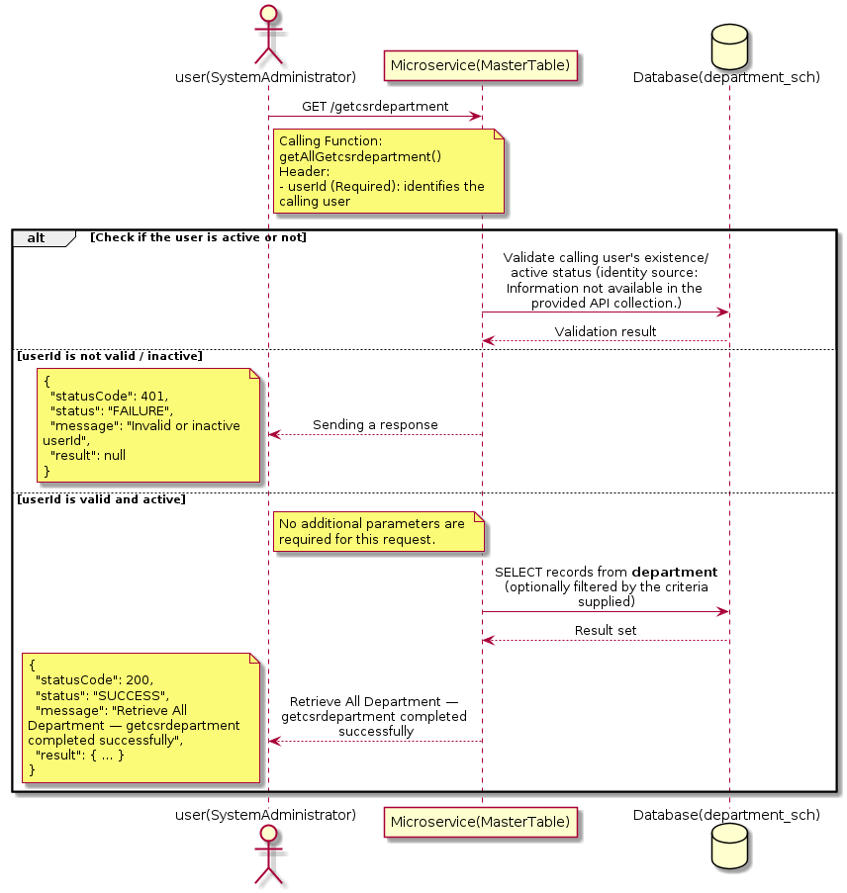

3.3.3.3 API Endpoint
Method | GET
URL | http://localhost:7002/srv2/genie/getcsrdepartment
Headers | userId: 67
Authorization | Not present in the captured request. Information not available in the provided API collection.
Content-Type | application/json (assumed)
Query Parameters | None
Path Variables | None
Request Body:
Not applicable — this operation does not accept a request body.
Response Body (illustrative — see 3.x.4.5 Success Response for details):
The source Postman collection does not include a captured sample response for this request (the response array is empty). Information not available in the provided API collection. Section 3.3.3.4.5 below presents the response envelope inferred from the standard response wrapper used consistently by this platform's services.

3.3.3.4 Detailed Process Flow

3.3.3.4.1 Request Initiation
The flow begins when System Administrator (or a calling microservice on their behalf) invokes the GET endpoint http://localhost:7002/srv2/genie/getcsrdepartment. The request must include the mandatory `userId` header used by the Master Table Microservice to identify the calling user for auditing purposes. At the Controller layer, Spring Boot's request-mapping infrastructure routes the call to the appropriate handler method (`getAllGetcsrdepartment`), and Bean Validation annotations (if configured on the DTO) perform structural validation before the request reaches the Service layer. Information not available in the provided API collection. regarding the exact validation annotations used in the source code.

3.3.3.4.2 User Validation
The Master Table Microservice relies on the `userId` header to identify the calling user. Based on the pattern observed consistently across this API collection, the platform's authentication/authorization is expected to be enforced upstream (e.g., by an API Gateway or a shared security filter) using this identifier; the Postman collection does not include an `Authorization` / `Bearer` token header on this request, so the exact authentication mechanism (JWT validation, session lookup, or gateway-level SSO) is Information not available in the provided API collection. Role-based authorization — i.e., confirming that the user identified by `userId` holds a role/permission entitled to perform this operation — is expected to be enforced by the Service layer (see Section 8 – Controller Analysis and Section 14 – Authentication & Authorization), but the specific role/permission checks are Information not available in the provided API collection.

3.3.3.4.3 Business Logic
The Service layer contains no conditional business branching for this operation beyond invoking the Repository to fetch all Department records. Depending on the record volume, the Service layer may apply default sorting (e.g., by name or creation order) before returning the list.

3.3.3.4.4 Database Interaction
The Repository layer (Spring Data JPA) interacts with the underlying relational database that backs the Department master table. The primary operation issued is a **SELECT** against the table associated with Department. No write operations occur; the query returns all rows that satisfy the entity's default scope (typically active records). The exact table name, column names, primary/foreign key definitions, and JPA repository method signatures are not included in the Postman collection; therefore, precise schema details are information not available in the provided api collection.

3.3.3.4.5 Success Response
Status Code: 200 OK. Sample response envelope (illustrative — the source collection did not capture a sample response for this API):
{
"statusCode": 200,
"status": "SUCCESS",
"message": "Retrieve All Department — getcsrdepartment completed successfully",
"result": [
{
"id": 1,
"name": "Sample Department",
"isActive": 1
}
],
"error": null,
"corelationId": "c6f2a1e4-2b3d-4a9e-9f1a-1234567890ab",
"url": null
}

3.3.3.4.6 Conclusion
This API provides a well-defined, single-purpose capability within the Master Table Microservice for retrieve all department — getcsrdepartment. The Controller → Service → Repository → Database layering keeps request validation, business rules, and persistence concerns separated, which allows the Department master data to be maintained consistently and safely by authorized administrators while remaining available for consumption by every other module that depends on this reference data.

3.3.4 Search / List Department

3.3.4.1 Overview
Purpose: To search and list Department records based on a search payload (e.g., free-text search or structured criteria), supporting list/grid screens that need paginated or filtered master data.
Business Requirement: List/search screens for Department configuration need server-side search so that administrators can locate specific records in large master tables without scanning the full data set.
Who Uses the API: System Administrator / HR Administrator operating the Department configuration/list screen.
Business Flow: Client sends a POST request with a search payload → Controller validates the payload → Service layer constructs the search/query logic → Repository executes the search against the Department table → matching records are returned to the Client.

3.3.4.2 Sequence Diagram
The diagram below illustrates the end-to-end interaction for "Search / List Department" across the Client, Controller, Service, Repository, and Database layers.
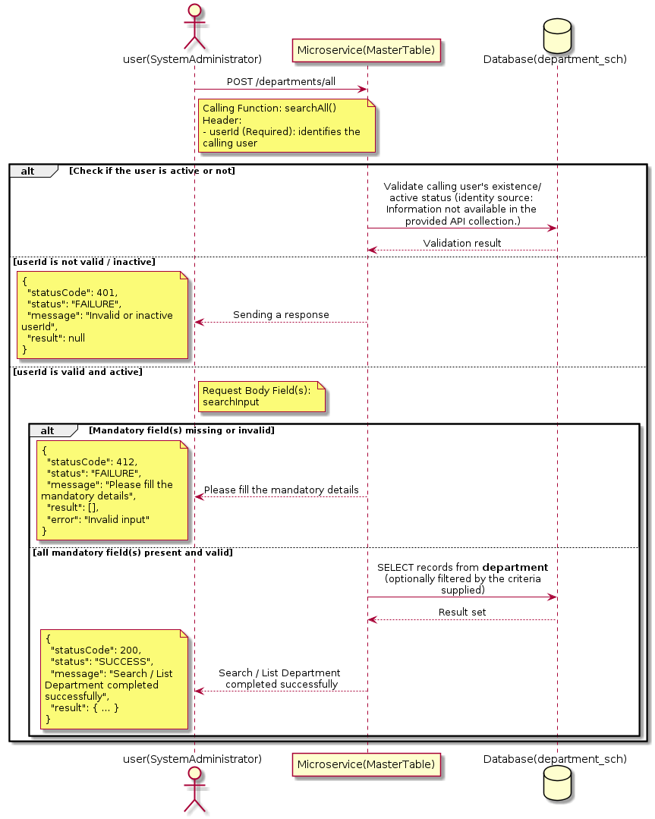

3.3.4.3 API Endpoint
Method | POST
URL | http://172.30.72.35:7002/srv2/genie/departments/all
Headers | userId: 4588 Content-Type: application/json (assumed based on JSON request payload; Information not available in the provided API collection.)
Authorization | Not present in the captured request. Information not available in the provided API collection.
Content-Type | Content-Type: application/json (assumed based on JSON request payload; Information not available in the provided API collection.)
Query Parameters | None
Path Variables | None
Request Body:
{
"searchInput": ""
}
Response Body (illustrative — see 3.x.4.5 Success Response for details):
The source Postman collection does not include a captured sample response for this request (the response array is empty). Information not available in the provided API collection. Section 3.3.4.4.5 below presents the response envelope inferred from the standard response wrapper used consistently by this platform's services.

3.3.4.4 Detailed Process Flow

3.3.4.4.1 Request Initiation
The flow begins when System Administrator (or a calling microservice on their behalf) invokes the POST endpoint http://172.30.72.35:7002/srv2/genie/departments/all. The request must include the mandatory `userId` header used by the Master Table Microservice to identify the calling user for auditing purposes. The request carries a JSON payload in the request body which the Controller binds to its Data Transfer Object (DTO) before any processing begins. At the Controller layer, Spring Boot's request-mapping infrastructure routes the call to the appropriate handler method (`searchAll`), and Bean Validation annotations (if configured on the DTO) perform structural validation before the request reaches the Service layer. Information not available in the provided API collection. regarding the exact validation annotations used in the source code.

3.3.4.4.2 User Validation
The Master Table Microservice relies on the `userId` header to identify the calling user. Based on the pattern observed consistently across this API collection, the platform's authentication/authorization is expected to be enforced upstream (e.g., by an API Gateway or a shared security filter) using this identifier; the Postman collection does not include an `Authorization` / `Bearer` token header on this request, so the exact authentication mechanism (JWT validation, session lookup, or gateway-level SSO) is Information not available in the provided API collection. Role-based authorization — i.e., confirming that the user identified by `userId` holds a role/permission entitled to perform this operation — is expected to be enforced by the Service layer (see Section 8 – Controller Analysis and Section 14 – Authentication & Authorization), but the specific role/permission checks are Information not available in the provided API collection.

3.3.4.4.3 Business Logic
The Service layer evaluates the search payload; if the search text/criteria is empty, the operation typically behaves like a full list (all Department records); if populated, it is used to build a case-insensitive `LIKE`/contains predicate against the relevant column(s). The key fields exchanged for this operation, as observed in the sample payload, are: `searchInput`.

3.3.4.4.4 Database Interaction
The Repository layer (Spring Data JPA) interacts with the underlying relational database that backs the Department master table. The primary operation issued is a **SELECT** against the table associated with Department. No write operations occur; the search is typically implemented using a JPA derived query method or a native/JPQL query with `LIKE` predicates. The exact table name, column names, primary/foreign key definitions, and JPA repository method signatures are not included in the Postman collection; therefore, precise schema details are information not available in the provided api collection.

3.3.4.4.5 Success Response
Status Code: 200 OK. Sample response envelope (illustrative — the source collection did not capture a sample response for this API):
{
"statusCode": 200,
"status": "SUCCESS",
"message": "Search / List Department completed successfully",
"result": [
{
"id": 1,
"name": "Sample Department",
"isActive": 1
}
],
"error": null,
"corelationId": "c6f2a1e4-2b3d-4a9e-9f1a-1234567890ab",
"url": null
}

3.3.4.4.6 Conclusion
This API provides a well-defined, single-purpose capability within the Master Table Microservice for search / list department. The Controller → Service → Repository → Database layering keeps request validation, business rules, and persistence concerns separated, which allows the Department master data to be maintained consistently and safely by authorized administrators while remaining available for consumption by every other module that depends on this reference data.
3.3.5 Create Department

3.3.5.1 Overview
Purpose: To create a new Department master record in the system, allowing administrators to extend the master-data catalogue that other modules (ticketing, workflow, notifications) depend on.
Business Requirement: Business/process owners need a controlled way to add new Department values so that the platform's classification, routing, and reporting capabilities can evolve as the organization changes.
Who Uses the API: System Administrator / HR Administrator responsible for master-data configuration.
Business Flow: Client sends a POST request with the new Department payload → Controller validates the payload (mandatory fields, formats) → Service layer applies business rules (e.g., duplicate-name check) → Repository persists the new record → the created record (with generated identifier) is returned to the Client.

3.3.5.2 Sequence Diagram
The diagram below illustrates the end-to-end interaction for "Create Department" across the Client, Controller, Service, Repository, and Database layers.
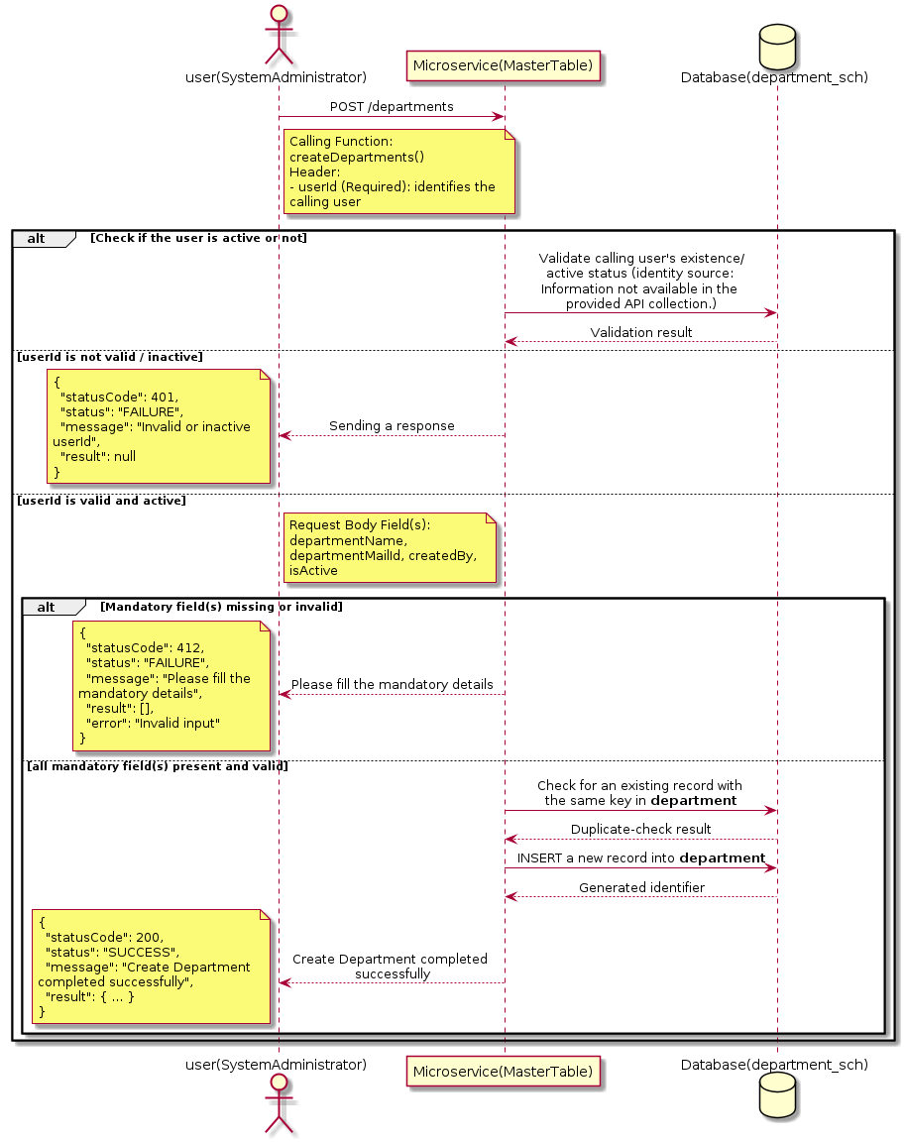

3.3.5.3 API Endpoint
Method | POST
URL | http://localhost:7002/srv2/genie/departments
Headers | userId: 67 Accept: application/json Content-Type: application/json (assumed based on JSON request payload; Information not available in the provided API collection.)
Authorization | Not present in the captured request. Information not available in the provided API collection.
Content-Type | Content-Type: application/json (assumed based on JSON request payload; Information not available in the provided API collection.)
Query Parameters | None
Path Variables | None
Request Body:
{
"departmentName": " Assurance",
"departmentMailId": "qa@thbs.com",
"createdBy": 67,
"isActive": "1"
}
Response Body (illustrative — see 3.x.4.5 Success Response for details):
The source Postman collection does not include a captured sample response for this request (the response array is empty). Information not available in the provided API collection. Section 3.3.5.4.5 below presents the response envelope inferred from the standard response wrapper used consistently by this platform's services.

3.3.5.4 Detailed Process Flow

3.3.5.4.1 Request Initiation
The flow begins when System Administrator (or a calling microservice on their behalf) invokes the POST endpoint http://localhost:7002/srv2/genie/departments. The request must include the mandatory `userId` header used by the Master Table Microservice to identify the calling user for auditing purposes. The request carries a JSON payload in the request body which the Controller binds to its Data Transfer Object (DTO) before any processing begins. At the Controller layer, Spring Boot's request-mapping infrastructure routes the call to the appropriate handler method (`createDepartments`), and Bean Validation annotations (if configured on the DTO) perform structural validation before the request reaches the Service layer. Information not available in the provided API collection. regarding the exact validation annotations used in the source code.

3.3.5.4.2 User Validation
The Master Table Microservice relies on the `userId` header to identify the calling user. Based on the pattern observed consistently across this API collection, the platform's authentication/authorization is expected to be enforced upstream (e.g., by an API Gateway or a shared security filter) using this identifier; the Postman collection does not include an `Authorization` / `Bearer` token header on this request, so the exact authentication mechanism (JWT validation, session lookup, or gateway-level SSO) is Information not available in the provided API collection. Role-based authorization — i.e., confirming that the user identified by `userId` holds a role/permission entitled to perform this operation — is expected to be enforced by the Service layer (see Section 8 – Controller Analysis and Section 14 – Authentication & Authorization), but the specific role/permission checks are Information not available in the provided API collection.

3.3.5.4.3 Business Logic
The Service layer performs the following: (1) validates that mandatory fields are present and correctly formatted, (2) checks for duplicates (e.g., an existing Department with the same name/code), (3) sets system-managed fields (e.g., `isActive = 1`, `createdBy`, timestamps) where applicable, and (4) persists the new record via the Repository. If any validation fails, the Service layer returns a business error rather than proceeding to persistence. The key fields exchanged for this operation, as observed in the sample payload, are: `departmentName`, `departmentMailId`, `createdBy`, `isActive`.

3.3.5.4.4 Database Interaction
The Repository layer (Spring Data JPA) interacts with the underlying relational database that backs the Department master table. The primary operation issued is a **INSERT** against the table associated with Department. A new row is inserted into the master table; if the entity has related child records (as seen in nested request payload arrays), corresponding child-table inserts are performed within the same transaction. The exact table name, column names, primary/foreign key definitions, and JPA repository method signatures are not included in the Postman collection; therefore, precise schema details are information not available in the provided api collection.

3.3.5.4.5 Success Response
Status Code: 200 OK. Sample response envelope (illustrative — the source collection did not capture a sample response for this API):
{
"statusCode": 200,
"status": "SUCCESS",
"message": "Create Department completed successfully",
"result": {
"id": 101,
"departmentName": " Assurance",
"departmentMailId": "qa@thbs.com",
"createdBy": 67,
"isActive": "1"
},
"error": null,
"corelationId": "c6f2a1e4-2b3d-4a9e-9f1a-1234567890ab",
"url": null
}

3.3.5.4.6 Conclusion
This API provides a well-defined, single-purpose capability within the Master Table Microservice for create department. The Controller → Service → Repository → Database layering keeps request validation, business rules, and persistence concerns separated, which allows the Department master data to be maintained consistently and safely by authorized administrators while remaining available for consumption by every other module that depends on this reference data.
3.3.6 Update Department

3.3.6.1 Overview
Purpose: To update an existing Department master record, allowing administrators to correct or evolve master-data attributes without impacting the record's identity/history.
Business Requirement: Master data changes over time (renames, corrections, re-classification); the platform must allow controlled updates while preserving referential integrity for records that already reference this Department.
Who Uses the API: System Administrator / HR Administrator responsible for maintaining master-data accuracy.
Business Flow: Client sends a PUT/PATCH request with the updated Department payload → Controller validates the payload → Service layer fetches the existing record, applies the changes, and re-validates business rules → Repository persists the updated record → the updated record is returned to the Client.

3.3.6.2 Sequence Diagram
The diagram below illustrates the end-to-end interaction for "Update Department" across the Client, Controller, Service, Repository, and Database layers.
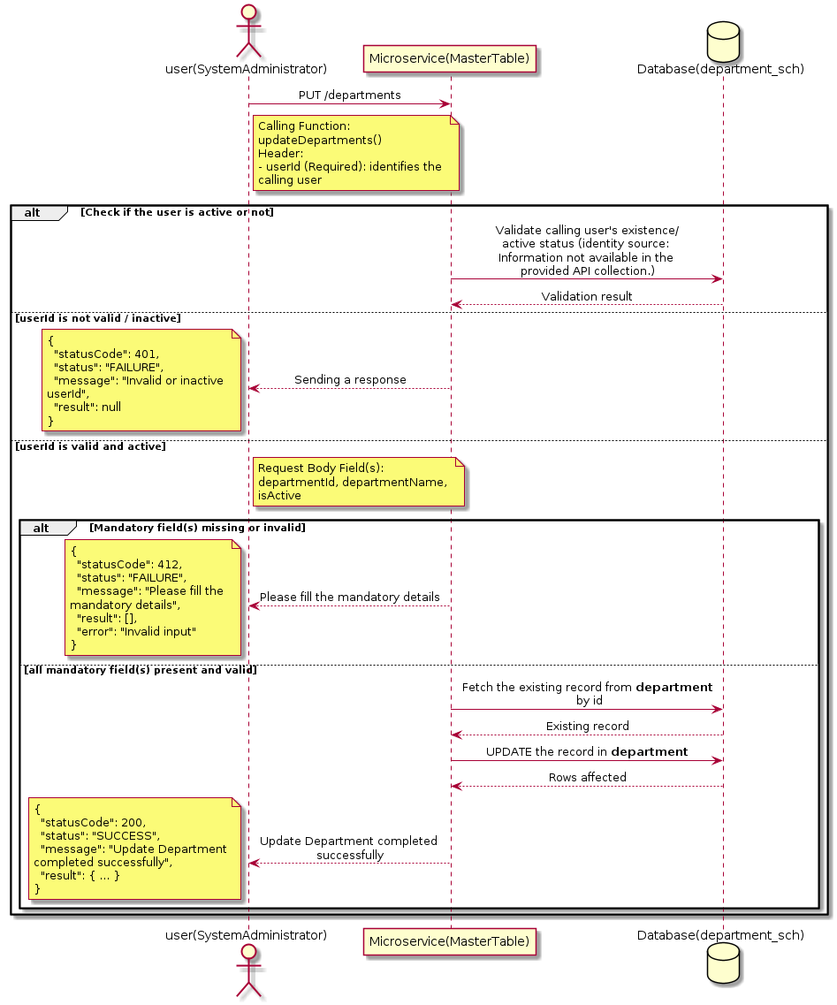

3.3.6.3 API Endpoint
Method | PUT
URL | http://localhost:7002/srv2/genie/departments
Headers | userId: 67 Content-Type: application/json (assumed based on JSON request payload; Information not available in the provided API collection.)
Authorization | Not present in the captured request. Information not available in the provided API collection.
Content-Type | Content-Type: application/json (assumed based on JSON request payload; Information not available in the provided API collection.)
Query Parameters | None
Path Variables | None
Request Body:
{
"departmentId": 1,
"departmentName": "IT",
"isActive": "1"
}
Response Body (illustrative — see 3.x.4.5 Success Response for details):
The source Postman collection does not include a captured sample response for this request (the response array is empty). Information not available in the provided API collection. Section 3.3.6.4.5 below presents the response envelope inferred from the standard response wrapper used consistently by this platform's services.

3.3.6.4 Detailed Process Flow

3.3.6.4.1 Request Initiation
The flow begins when System Administrator (or a calling microservice on their behalf) invokes the PUT endpoint http://localhost:7002/srv2/genie/departments. The request must include the mandatory `userId` header used by the Master Table Microservice to identify the calling user for auditing purposes. The request carries a JSON payload in the request body which the Controller binds to its Data Transfer Object (DTO) before any processing begins. At the Controller layer, Spring Boot's request-mapping infrastructure routes the call to the appropriate handler method (`updateDepartments`), and Bean Validation annotations (if configured on the DTO) perform structural validation before the request reaches the Service layer. Information not available in the provided API collection. regarding the exact validation annotations used in the source code.

3.3.6.4.2 User Validation
The Master Table Microservice relies on the `userId` header to identify the calling user. Based on the pattern observed consistently across this API collection, the platform's authentication/authorization is expected to be enforced upstream (e.g., by an API Gateway or a shared security filter) using this identifier; the Postman collection does not include an `Authorization` / `Bearer` token header on this request, so the exact authentication mechanism (JWT validation, session lookup, or gateway-level SSO) is Information not available in the provided API collection. Role-based authorization — i.e., confirming that the user identified by `userId` holds a role/permission entitled to perform this operation — is expected to be enforced by the Service layer (see Section 8 – Controller Analysis and Section 14 – Authentication & Authorization), but the specific role/permission checks are Information not available in the provided API collection.

3.3.6.4.3 Business Logic
The Service layer fetches the existing Department record by its identifier, verifies it exists, applies the incoming changes field by field, re-validates business rules (e.g., uniqueness of a renamed field), and persists the updated entity via the Repository. If the record does not exist, the operation is rejected with a not-found error. The key fields exchanged for this operation, as observed in the sample payload, are: `departmentId`, `departmentName`, `isActive`.

3.3.6.4.4 Database Interaction
The Repository layer (Spring Data JPA) interacts with the underlying relational database that backs the Department master table. The primary operation issued is a **UPDATE** against the table associated with Department. The existing row is located by primary key and updated; if the entity has related child records, the existing child rows are typically replaced/updated within the same transaction. The exact table name, column names, primary/foreign key definitions, and JPA repository method signatures are not included in the Postman collection; therefore, precise schema details are information not available in the provided api collection.

3.3.6.4.5 Success Response
Status Code: 200 OK. Sample response envelope (illustrative — the source collection did not capture a sample response for this API):
{
"statusCode": 200,
"status": "SUCCESS",
"message": "Update Department completed successfully",
"result": {
"id": 1,
"isActive": 1
},
"error": null,
"corelationId": "c6f2a1e4-2b3d-4a9e-9f1a-1234567890ab",
"url": null
}

3.3.6.4.6 Conclusion
This API provides a well-defined, single-purpose capability within the Master Table Microservice for update department. The Controller → Service → Repository → Database layering keeps request validation, business rules, and persistence concerns separated, which allows the Department master data to be maintained consistently and safely by authorized administrators while remaining available for consumption by every other module that depends on this reference data.

3.4 Eligibility Criteria APIs (Eligibility-criteria)
Maintains the eligibility rules that determine which employees/participants qualify for a given ticket sub-category or service offering.

3.4.1 Retrieve Eligibility Criteria (Filtered)

3.4.1.1 Overview
Purpose: To retrieve Eligibility Criteria master records that match the supplied filter/query criteria, allowing consumers to narrow down large master-data sets to a relevant subset.
Business Requirement: Administrators and downstream services need the ability to narrow Eligibility Criteria records by specific criteria rather than retrieving and filtering the full data set on the client side.
Who Uses the API: System Administrator / Service Desk Administrator, and reporting/search screens that filter by Eligibility Criteria.
Business Flow: Client sends a GET request with query parameters → Controller parses and validates the parameters → Service layer builds the filter criteria → Repository executes the filtered query against the Eligibility Criteria table → the filtered result is returned to the Client.

3.4.1.2 Sequence Diagram
The diagram below illustrates the end-to-end interaction for "Retrieve Eligibility Criteria (Filtered)" across the Client, Controller, Service, Repository, and Database layers.
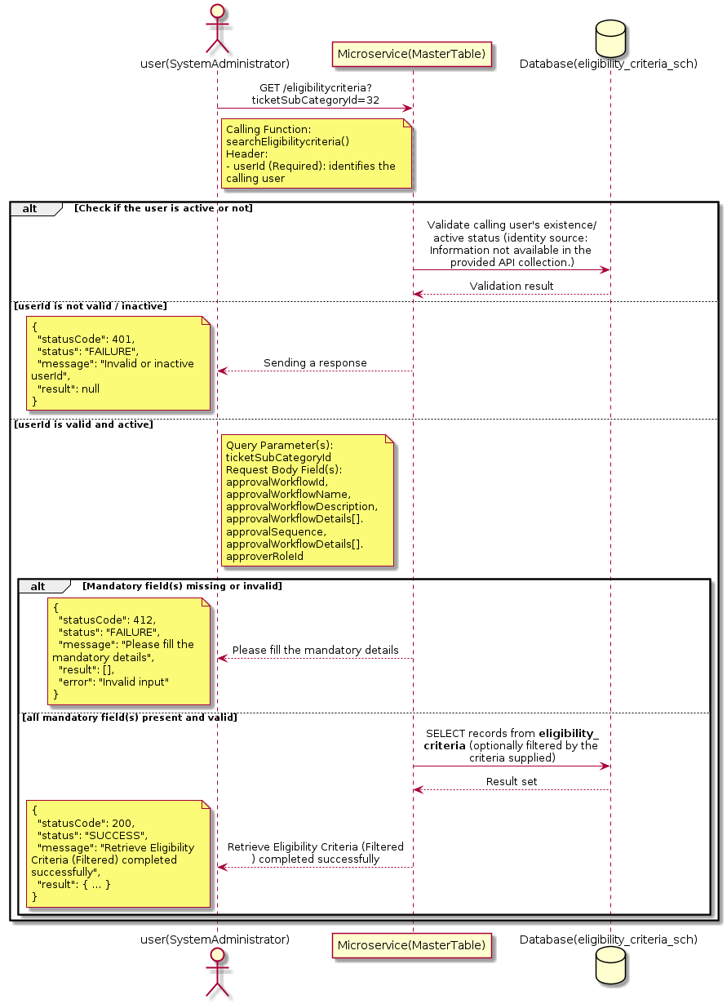

3.4.1.3 API Endpoint
Method | GET
URL | http://localhost:7002/srv2/genie/eligibilitycriteria?ticketSubCategoryId=32
Headers | userId: 67 Content-Type: application/json
Authorization | Not present in the captured request. Information not available in the provided API collection.
Content-Type | Content-Type: application/json
Query Parameters | ticketSubCategoryId = 32
Path Variables | None
Request Body:
{
"approvalWorkflowId": 1,
"approvalWorkflowName": "Reporting Manager Updated",
"approvalWorkflowDescription": "Updated description",
"approvalWorkflowDetails": [
{
"approvalSequence": 1,
"approverRoleId": 7
}
]
}
Response Body (illustrative — see 3.x.4.5 Success Response for details):
The source Postman collection does not include a captured sample response for this request (the response array is empty). Information not available in the provided API collection. Section 3.4.1.4.5 below presents the response envelope inferred from the standard response wrapper used consistently by this platform's services.

3.4.1.4 Detailed Process Flow

3.4.1.4.1 Request Initiation
The flow begins when System Administrator (or a calling microservice on their behalf) invokes the GET endpoint http://localhost:7002/srv2/genie/eligibilitycriteria?ticketSubCategoryId=32. The request must include the mandatory `userId` header used by the Master Table Microservice to identify the calling user for auditing purposes. The endpoint also expects one or more query parameters as listed in the API Endpoint section. The request carries a JSON payload in the request body which the Controller binds to its Data Transfer Object (DTO) before any processing begins. At the Controller layer, Spring Boot's request-mapping infrastructure routes the call to the appropriate handler method (`searchEligibilitycriteria`), and Bean Validation annotations (if configured on the DTO) perform structural validation before the request reaches the Service layer. Information not available in the provided API collection. regarding the exact validation annotations used in the source code.

3.4.1.4.2 User Validation
The Master Table Microservice relies on the `userId` header to identify the calling user. Based on the pattern observed consistently across this API collection, the platform's authentication/authorization is expected to be enforced upstream (e.g., by an API Gateway or a shared security filter) using this identifier; the Postman collection does not include an `Authorization` / `Bearer` token header on this request, so the exact authentication mechanism (JWT validation, session lookup, or gateway-level SSO) is Information not available in the provided API collection. Role-based authorization — i.e., confirming that the user identified by `userId` holds a role/permission entitled to perform this operation — is expected to be enforced by the Service layer (see Section 8 – Controller Analysis and Section 14 – Authentication & Authorization), but the specific role/permission checks are Information not available in the provided API collection.

3.4.1.4.3 Business Logic
The Service layer inspects the supplied query parameters, builds the corresponding filter/predicate, and forwards it to the Repository. If a parameter is absent, the corresponding filter is typically skipped rather than treated as an error. The key fields exchanged for this operation, as observed in the sample payload, are: `approvalWorkflowId`, `approvalWorkflowName`, `approvalWorkflowDescription`, `approvalWorkflowDetails[].approvalSequence`, `approvalWorkflowDetails[].approverRoleId`.

3.4.1.4.4 Database Interaction
The Repository layer (Spring Data JPA) interacts with the underlying relational database that backs the Eligibility Criteria master table. The primary operation issued is a **SELECT** against the table associated with Eligibility Criteria. No write operations occur; the query is scoped using the supplied filter parameters, translated into a JPA derived-query or `@Query`/native query. The exact table name, column names, primary/foreign key definitions, and JPA repository method signatures are not included in the Postman collection; therefore, precise schema details are information not available in the provided api collection.

3.4.1.4.5 Success Response
Status Code: 200 OK. Sample response envelope (illustrative — the source collection did not capture a sample response for this API):
{
"statusCode": 200,
"status": "SUCCESS",
"message": "Retrieve Eligibility Criteria (Filtered) completed successfully",
"result": [
{
"id": 1,
"name": "Sample Eligibility Criteria",
"isActive": 1
}
],
"error": null,
"corelationId": "c6f2a1e4-2b3d-4a9e-9f1a-1234567890ab",
"url": null
}

3.4.1.4.6 Conclusion
This API provides a well-defined, single-purpose capability within the Master Table Microservice for retrieve eligibility criteria (filtered). The Controller → Service → Repository → Database layering keeps request validation, business rules, and persistence concerns separated, which allows the Eligibility Criteria master data to be maintained consistently and safely by authorized administrators while remaining available for consumption by every other module that depends on this reference data.

3.5 Event & Notification APIs (Event APIs)
Maintains the catalogue of system events, their recipients, and the notification configuration (who is notified, when, and under what filter conditions) that drives the platform’s email/alert engine.

3.5.1 Retrieve All Event & Notification — Fetch All Events

3.5.1.1 Overview
Purpose: To retrieve the complete list of Event & Notification master records configured in the Master Table Microservice, so that consuming screens and downstream services can populate dropdowns, grids, and configuration views.
Business Requirement: Every screen and workflow that references Event & Notification data (creation forms, filters, reports) needs an authoritative, always-current list of active Event & Notification values sourced from a single master table rather than being hard-coded.
Who Uses the API: System Administrator / Notification Administrator, and any internal microservice/UI module that needs to render Event & Notification options.
Business Flow: Client sends a GET request → Controller delegates to the Service layer → Service layer calls the Repository → Repository queries the Event & Notification table → the result set is mapped to response DTOs and returned to the Client.

3.5.1.2 Sequence Diagram
The diagram below illustrates the end-to-end interaction for "Retrieve All Event & Notification — Fetch All Events" across the Client, Controller, Service, Repository, and Database layers.
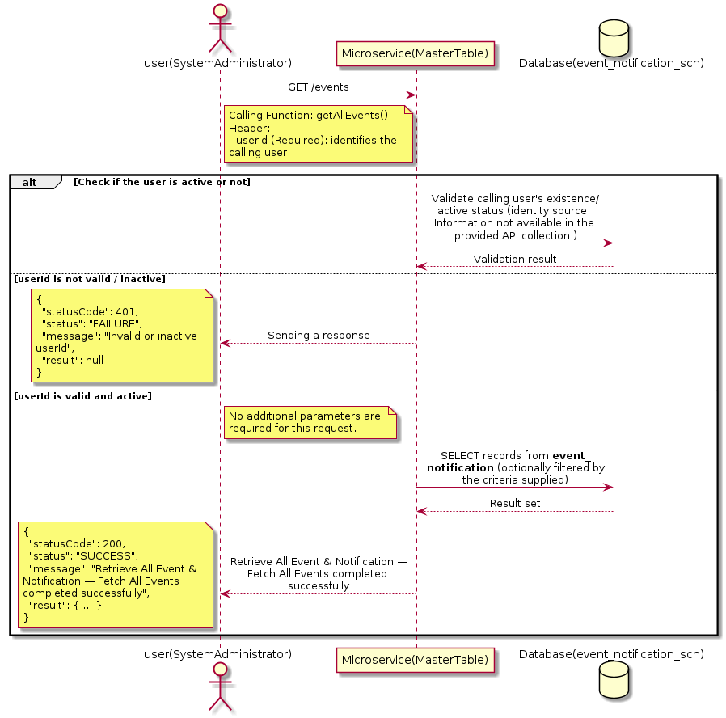

3.5.1.3 API Endpoint
Method | GET
URL | http://localhost:7002/srv2/genie/events
Headers | userId: 67
Authorization | Not present in the captured request. Information not available in the provided API collection.
Content-Type | application/json (assumed)
Query Parameters | None
Path Variables | None
Request Body:
Not applicable — this operation does not accept a request body.
Response Body (illustrative — see 3.x.4.5 Success Response for details):
The source Postman collection does not include a captured sample response for this request (the response array is empty). Information not available in the provided API collection. Section 3.5.1.4.5 below presents the response envelope inferred from the standard response wrapper used consistently by this platform's services.

3.5.1.4 Detailed Process Flow

3.5.1.4.1 Request Initiation
The flow begins when System Administrator (or a calling microservice on their behalf) invokes the GET endpoint http://localhost:7002/srv2/genie/events. The request must include the mandatory `userId` header used by the Master Table Microservice to identify the calling user for auditing purposes. At the Controller layer, Spring Boot's request-mapping infrastructure routes the call to the appropriate handler method (`getAllEvents`), and Bean Validation annotations (if configured on the DTO) perform structural validation before the request reaches the Service layer. Information not available in the provided API collection. regarding the exact validation annotations used in the source code.

3.5.1.4.2 User Validation
The Master Table Microservice relies on the `userId` header to identify the calling user. Based on the pattern observed consistently across this API collection, the platform's authentication/authorization is expected to be enforced upstream (e.g., by an API Gateway or a shared security filter) using this identifier; the Postman collection does not include an `Authorization` / `Bearer` token header on this request, so the exact authentication mechanism (JWT validation, session lookup, or gateway-level SSO) is Information not available in the provided API collection. Role-based authorization — i.e., confirming that the user identified by `userId` holds a role/permission entitled to perform this operation — is expected to be enforced by the Service layer (see Section 8 – Controller Analysis and Section 14 – Authentication & Authorization), but the specific role/permission checks are Information not available in the provided API collection.

3.5.1.4.3 Business Logic
The Service layer contains no conditional business branching for this operation beyond invoking the Repository to fetch all Event & Notification records. Depending on the record volume, the Service layer may apply default sorting (e.g., by name or creation order) before returning the list.

3.5.1.4.4 Database Interaction
The Repository layer (Spring Data JPA) interacts with the underlying relational database that backs the Event & Notification master table. The primary operation issued is a **SELECT** against the table associated with Event & Notification. No write operations occur; the query returns all rows that satisfy the entity's default scope (typically active records). The exact table name, column names, primary/foreign key definitions, and JPA repository method signatures are not included in the Postman collection; therefore, precise schema details are information not available in the provided api collection.

3.5.1.4.5 Success Response
Status Code: 200 OK. Sample response envelope (illustrative — the source collection did not capture a sample response for this API):
{
"statusCode": 200,
"status": "SUCCESS",
"message": "Retrieve All Event & Notification — Fetch All Events completed successfully",
"result": [
{
"id": 1,
"name": "Sample Event & Notification",
"isActive": 1
}
],
"error": null,
"corelationId": "c6f2a1e4-2b3d-4a9e-9f1a-1234567890ab",
"url": null
}

3.5.1.4.6 Conclusion
This API provides a well-defined, single-purpose capability within the Master Table Microservice for retrieve all event & notification — fetch all events. The Controller → Service → Repository → Database layering keeps request validation, business rules, and persistence concerns separated, which allows the Event & Notification master data to be maintained consistently and safely by authorized administrators while remaining available for consumption by every other module that depends on this reference data.

3.5.2 Retrieve All Event & Notification — Active Recipients

3.5.2.1 Overview
Purpose: To retrieve the complete list of Event & Notification master records configured in the Master Table Microservice, so that consuming screens and downstream services can populate dropdowns, grids, and configuration views.
Business Requirement: Every screen and workflow that references Event & Notification data (creation forms, filters, reports) needs an authoritative, always-current list of active Event & Notification values sourced from a single master table rather than being hard-coded.
Who Uses the API: System Administrator / Notification Administrator, and any internal microservice/UI module that needs to render Event & Notification options.
Business Flow: Client sends a GET request → Controller delegates to the Service layer → Service layer calls the Repository → Repository queries the Event & Notification table → the result set is mapped to response DTOs and returned to the Client.

3.5.2.2 Sequence Diagram
The diagram below illustrates the end-to-end interaction for "Retrieve All Event & Notification — Active Recipients" across the Client, Controller, Service, Repository, and Database layers.
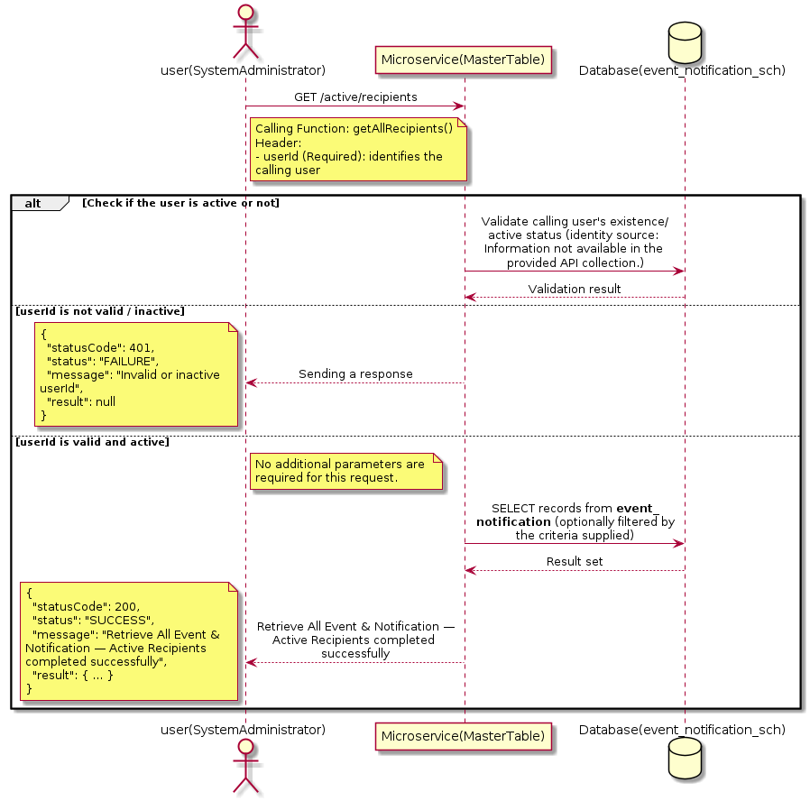

3.5.2.3 API Endpoint
Method | GET
URL | http://localhost:7002/srv2/genie/active/recipients
Headers | userId: 67
Authorization | Not present in the captured request. Information not available in the provided API collection.
Content-Type | application/json (assumed)
Query Parameters | None
Path Variables | None
Request Body:
Not applicable — this operation does not accept a request body.
Response Body (illustrative — see 3.x.4.5 Success Response for details):
The source Postman collection does not include a captured sample response for this request (the response array is empty). Information not available in the provided API collection. Section 3.5.2.4.5 below presents the response envelope inferred from the standard response wrapper used consistently by this platform's services.

3.5.2.4 Detailed Process Flow

3.5.2.4.1 Request Initiation
The flow begins when System Administrator (or a calling microservice on their behalf) invokes the GET endpoint http://localhost:7002/srv2/genie/active/recipients. The request must include the mandatory `userId` header used by the Master Table Microservice to identify the calling user for auditing purposes. At the Controller layer, Spring Boot's request-mapping infrastructure routes the call to the appropriate handler method (`getAllRecipients`), and Bean Validation annotations (if configured on the DTO) perform structural validation before the request reaches the Service layer. Information not available in the provided API collection. regarding the exact validation annotations used in the source code.

3.5.2.4.2 User Validation
The Master Table Microservice relies on the `userId` header to identify the calling user. Based on the pattern observed consistently across this API collection, the platform's authentication/authorization is expected to be enforced upstream (e.g., by an API Gateway or a shared security filter) using this identifier; the Postman collection does not include an `Authorization` / `Bearer` token header on this request, so the exact authentication mechanism (JWT validation, session lookup, or gateway-level SSO) is Information not available in the provided API collection. Role-based authorization — i.e., confirming that the user identified by `userId` holds a role/permission entitled to perform this operation — is expected to be enforced by the Service layer (see Section 8 – Controller Analysis and Section 14 – Authentication & Authorization), but the specific role/permission checks are Information not available in the provided API collection.

3.5.2.4.3 Business Logic
The Service layer contains no conditional business branching for this operation beyond invoking the Repository to fetch all Event & Notification records. Depending on the record volume, the Service layer may apply default sorting (e.g., by name or creation order) before returning the list.

3.5.2.4.4 Database Interaction
The Repository layer (Spring Data JPA) interacts with the underlying relational database that backs the Event & Notification master table. The primary operation issued is a **SELECT** against the table associated with Event & Notification. No write operations occur; the query returns all rows that satisfy the entity's default scope (typically active records). The exact table name, column names, primary/foreign key definitions, and JPA repository method signatures are not included in the Postman collection; therefore, precise schema details are information not available in the provided api collection.

3.5.2.4.5 Success Response
Status Code: 200 OK. Sample response envelope (illustrative — the source collection did not capture a sample response for this API):
{
"statusCode": 200,
"status": "SUCCESS",
"message": "Retrieve All Event & Notification — Active Recipients completed successfully",
"result": [
{
"id": 1,
"name": "Sample Event & Notification",
"isActive": 1
}
],
"error": null,
"corelationId": "c6f2a1e4-2b3d-4a9e-9f1a-1234567890ab",
"url": null
}

3.5.2.4.6 Conclusion
This API provides a well-defined, single-purpose capability within the Master Table Microservice for retrieve all event & notification — active recipients. The Controller → Service → Repository → Database layering keeps request validation, business rules, and persistence concerns separated, which allows the Event & Notification master data to be maintained consistently and safely by authorized administrators while remaining available for consumption by every other module that depends on this reference data.

3.5.3 Retrieve All Event & Notification — Non-Role Recipients

3.5.3.1 Overview
Purpose: To retrieve the complete list of Event & Notification master records configured in the Master Table Microservice, so that consuming screens and downstream services can populate dropdowns, grids, and configuration views.
Business Requirement: Every screen and workflow that references Event & Notification data (creation forms, filters, reports) needs an authoritative, always-current list of active Event & Notification values sourced from a single master table rather than being hard-coded.
Who Uses the API: System Administrator / Notification Administrator, and any internal microservice/UI module that needs to render Event & Notification options.
Business Flow: Client sends a GET request → Controller delegates to the Service layer → Service layer calls the Repository → Repository queries the Event & Notification table → the result set is mapped to response DTOs and returned to the Client.

3.5.3.2 Sequence Diagram
The diagram below illustrates the end-to-end interaction for "Retrieve All Event & Notification — Non-Role Recipients" across the Client, Controller, Service, Repository, and Database layers.
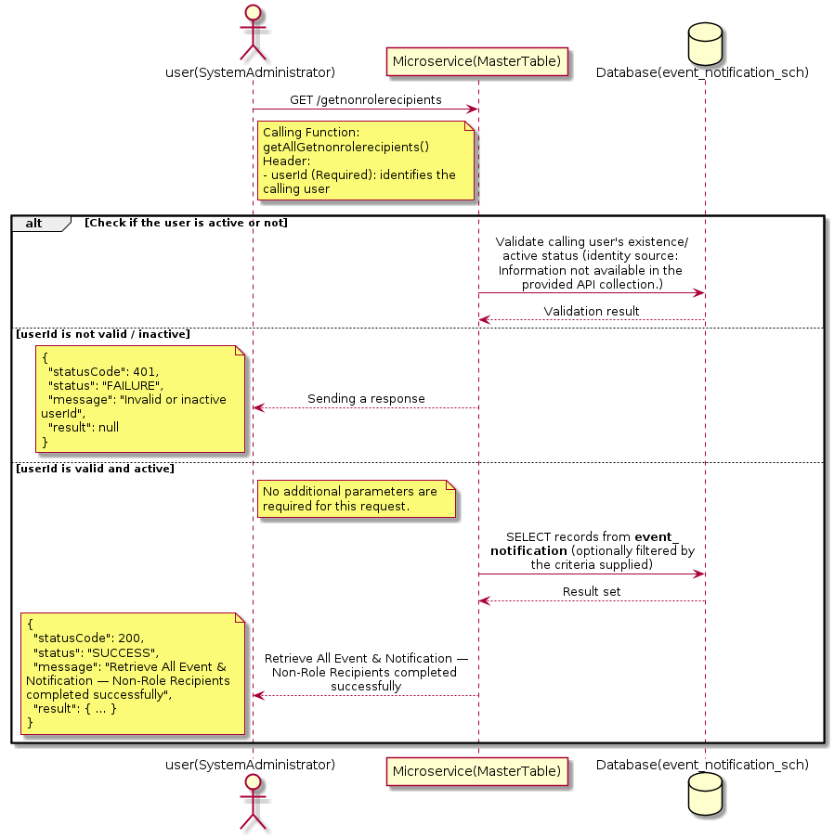

3.5.3.3 API Endpoint
Method | GET
URL | http://localhost:7002/srv2/genie/getnonrolerecipients
Headers | userId: 67
Authorization | Not present in the captured request. Information not available in the provided API collection.
Content-Type | application/json (assumed)
Query Parameters | None
Path Variables | None
Request Body:
Not applicable — this operation does not accept a request body.
Response Body (illustrative — see 3.x.4.5 Success Response for details):
The source Postman collection does not include a captured sample response for this request (the response array is empty). Information not available in the provided API collection. Section 3.5.3.4.5 below presents the response envelope inferred from the standard response wrapper used consistently by this platform's services.

3.5.3.4 Detailed Process Flow

3.5.3.4.1 Request Initiation
The flow begins when System Administrator (or a calling microservice on their behalf) invokes the GET endpoint http://localhost:7002/srv2/genie/getnonrolerecipients. The request must include the mandatory `userId` header used by the Master Table Microservice to identify the calling user for auditing purposes. At the Controller layer, Spring Boot's request-mapping infrastructure routes the call to the appropriate handler method (`getAllGetnonrolerecipients`), and Bean Validation annotations (if configured on the DTO) perform structural validation before the request reaches the Service layer. Information not available in the provided API collection. regarding the exact validation annotations used in the source code.

3.5.3.4.2 User Validation
The Master Table Microservice relies on the `userId` header to identify the calling user. Based on the pattern observed consistently across this API collection, the platform's authentication/authorization is expected to be enforced upstream (e.g., by an API Gateway or a shared security filter) using this identifier; the Postman collection does not include an `Authorization` / `Bearer` token header on this request, so the exact authentication mechanism (JWT validation, session lookup, or gateway-level SSO) is Information not available in the provided API collection. Role-based authorization — i.e., confirming that the user identified by `userId` holds a role/permission entitled to perform this operation — is expected to be enforced by the Service layer (see Section 8 – Controller Analysis and Section 14 – Authentication & Authorization), but the specific role/permission checks are Information not available in the provided API collection.

3.5.3.4.3 Business Logic
The Service layer contains no conditional business branching for this operation beyond invoking the Repository to fetch all Event & Notification records. Depending on the record volume, the Service layer may apply default sorting (e.g., by name or creation order) before returning the list.

3.5.3.4.4 Database Interaction
The Repository layer (Spring Data JPA) interacts with the underlying relational database that backs the Event & Notification master table. The primary operation issued is a **SELECT** against the table associated with Event & Notification. No write operations occur; the query returns all rows that satisfy the entity's default scope (typically active records). The exact table name, column names, primary/foreign key definitions, and JPA repository method signatures are not included in the Postman collection; therefore, precise schema details are information not available in the provided api collection.

3.5.3.4.5 Success Response
Status Code: 200 OK. Sample response envelope (illustrative — the source collection did not capture a sample response for this API):
{
"statusCode": 200,
"status": "SUCCESS",
"message": "Retrieve All Event & Notification — Non-Role Recipients completed successfully",
"result": [
{
"id": 1,
"name": "Sample Event & Notification",
"isActive": 1
}
],
"error": null,
"corelationId": "c6f2a1e4-2b3d-4a9e-9f1a-1234567890ab",
"url": null
}

3.5.3.4.6 Conclusion
This API provides a well-defined, single-purpose capability within the Master Table Microservice for retrieve all event & notification — non-role recipients. The Controller → Service → Repository → Database layering keeps request validation, business rules, and persistence concerns separated, which allows the Event & Notification master data to be maintained consistently and safely by authorized administrators while remaining available for consumption by every other module that depends on this reference data.

3.5.4 Retrieve All Event & Notification — Default Settings

3.5.4.1 Overview
Purpose: To retrieve the complete list of Event & Notification master records configured in the Master Table Microservice, so that consuming screens and downstream services can populate dropdowns, grids, and configuration views.
Business Requirement: Every screen and workflow that references Event & Notification data (creation forms, filters, reports) needs an authoritative, always-current list of active Event & Notification values sourced from a single master table rather than being hard-coded.
Who Uses the API: System Administrator / Notification Administrator, and any internal microservice/UI module that needs to render Event & Notification options.
Business Flow: Client sends a GET request → Controller delegates to the Service layer → Service layer calls the Repository → Repository queries the Event & Notification table → the result set is mapped to response DTOs and returned to the Client.

3.5.4.2 Sequence Diagram
The diagram below illustrates the end-to-end interaction for "Retrieve All Event & Notification — Default Settings" across the Client, Controller, Service, Repository, and Database layers.
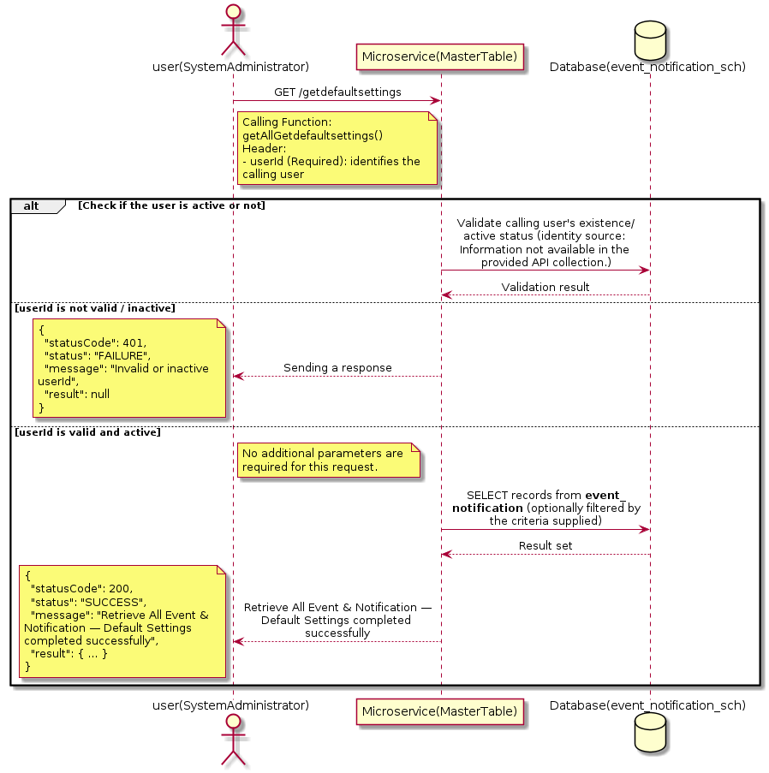

3.5.4.3 API Endpoint
Method | GET
URL | http://localhost:7002/srv2/genie/getdefaultsettings
Headers | userId: 67
Authorization | Not present in the captured request. Information not available in the provided API collection.
Content-Type | application/json (assumed)
Query Parameters | None
Path Variables | None
Request Body:
Not applicable — this operation does not accept a request body.
Response Body (illustrative — see 3.x.4.5 Success Response for details):
The source Postman collection does not include a captured sample response for this request (the response array is empty). Information not available in the provided API collection. Section 3.5.4.4.5 below presents the response envelope inferred from the standard response wrapper used consistently by this platform's services.

3.5.4.4 Detailed Process Flow

3.5.4.4.1 Request Initiation
The flow begins when System Administrator (or a calling microservice on their behalf) invokes the GET endpoint http://localhost:7002/srv2/genie/getdefaultsettings. The request must include the mandatory `userId` header used by the Master Table Microservice to identify the calling user for auditing purposes. At the Controller layer, Spring Boot's request-mapping infrastructure routes the call to the appropriate handler method (`getAllGetdefaultsettings`), and Bean Validation annotations (if configured on the DTO) perform structural validation before the request reaches the Service layer. Information not available in the provided API collection. regarding the exact validation annotations used in the source code.

3.5.4.4.2 User Validation
The Master Table Microservice relies on the `userId` header to identify the calling user. Based on the pattern observed consistently across this API collection, the platform's authentication/authorization is expected to be enforced upstream (e.g., by an API Gateway or a shared security filter) using this identifier; the Postman collection does not include an `Authorization` / `Bearer` token header on this request, so the exact authentication mechanism (JWT validation, session lookup, or gateway-level SSO) is Information not available in the provided API collection. Role-based authorization — i.e., confirming that the user identified by `userId` holds a role/permission entitled to perform this operation — is expected to be enforced by the Service layer (see Section 8 – Controller Analysis and Section 14 – Authentication & Authorization), but the specific role/permission checks are Information not available in the provided API collection.

3.5.4.4.3 Business Logic
The Service layer contains no conditional business branching for this operation beyond invoking the Repository to fetch all Event & Notification records. Depending on the record volume, the Service layer may apply default sorting (e.g., by name or creation order) before returning the list.

3.5.4.4.4 Database Interaction
The Repository layer (Spring Data JPA) interacts with the underlying relational database that backs the Event & Notification master table. The primary operation issued is a **SELECT** against the table associated with Event & Notification. No write operations occur; the query returns all rows that satisfy the entity's default scope (typically active records). The exact table name, column names, primary/foreign key definitions, and JPA repository method signatures are not included in the Postman collection; therefore, precise schema details are information not available in the provided api collection.

3.5.4.4.5 Success Response
Status Code: 200 OK. Sample response envelope (illustrative — the source collection did not capture a sample response for this API):
{
"statusCode": 200,
"status": "SUCCESS",
"message": "Retrieve All Event & Notification — Default Settings completed successfully",
"result": [
{
"id": 1,
"name": "Sample Event & Notification",
"isActive": 1
}
],
"error": null,
"corelationId": "c6f2a1e4-2b3d-4a9e-9f1a-1234567890ab",
"url": null
}

3.5.4.4.6 Conclusion
This API provides a well-defined, single-purpose capability within the Master Table Microservice for retrieve all event & notification — default settings. The Controller → Service → Repository → Database layering keeps request validation, business rules, and persistence concerns separated, which allows the Event & Notification master data to be maintained consistently and safely by authorized administrators while remaining available for consumption by every other module that depends on this reference data.

3.5.5 Create Event & Notification — create event reciepients

3.5.5.1 Overview
Purpose: To create a new Event & Notification master record in the system, allowing administrators to extend the master-data catalogue that other modules (ticketing, workflow, notifications) depend on.
Business Requirement: Business/process owners need a controlled way to add new Event & Notification values so that the platform's classification, routing, and reporting capabilities can evolve as the organization changes.
Who Uses the API: System Administrator / Notification Administrator responsible for master-data configuration.
Business Flow: Client sends a POST request with the new Event & Notification payload → Controller validates the payload (mandatory fields, formats) → Service layer applies business rules (e.g., duplicate-name check) → Repository persists the new record → the created record (with generated identifier) is returned to the Client.

3.5.5.2 Sequence Diagram
The diagram below illustrates the end-to-end interaction for "Create Event & Notification — create event reciepients" across the Client, Controller, Service, Repository, and Database layers.
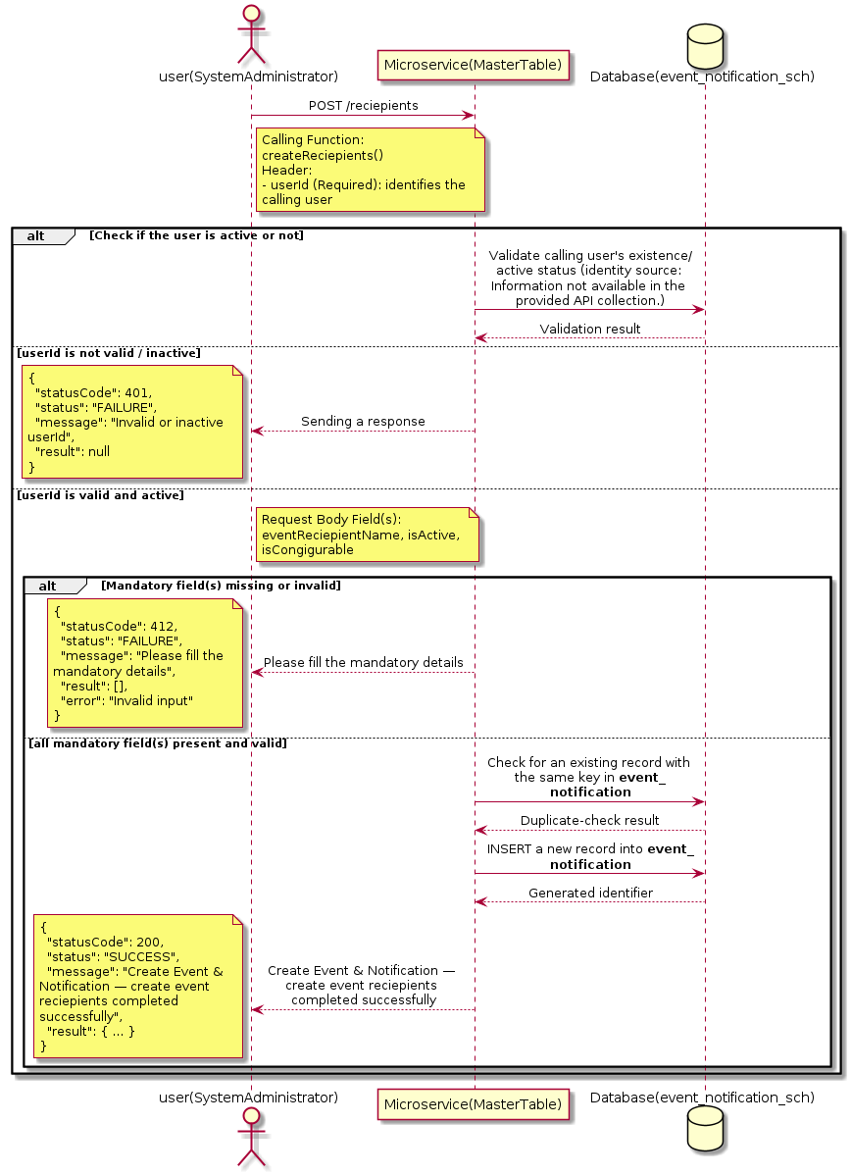

3.5.5.3 API Endpoint
Method | POST
URL | http://localhost:7002/srv2/genie/reciepients
Headers | userId: 67 Content-Type: application/json (assumed based on JSON request payload; Information not available in the provided API collection.)
Authorization | Not present in the captured request. Information not available in the provided API collection.
Content-Type | Content-Type: application/json (assumed based on JSON request payload; Information not available in the provided API collection.)
Query Parameters | None
Path Variables | None
Request Body:
{
"eventReciepientName": "Test Recipient",
"isActive": "1",
"isCongigurable": "1"
}
Response Body (illustrative — see 3.x.4.5 Success Response for details):
The source Postman collection does not include a captured sample response for this request (the response array is empty). Information not available in the provided API collection. Section 3.5.5.4.5 below presents the response envelope inferred from the standard response wrapper used consistently by this platform's services.

3.5.5.4 Detailed Process Flow

3.5.5.4.1 Request Initiation
The flow begins when System Administrator (or a calling microservice on their behalf) invokes the POST endpoint http://localhost:7002/srv2/genie/reciepients. The request must include the mandatory `userId` header used by the Master Table Microservice to identify the calling user for auditing purposes. The request carries a JSON payload in the request body which the Controller binds to its Data Transfer Object (DTO) before any processing begins. At the Controller layer, Spring Boot's request-mapping infrastructure routes the call to the appropriate handler method (`createReciepients`), and Bean Validation annotations (if configured on the DTO) perform structural validation before the request reaches the Service layer. Information not available in the provided API collection. regarding the exact validation annotations used in the source code.

3.5.5.4.2 User Validation
The Master Table Microservice relies on the `userId` header to identify the calling user. Based on the pattern observed consistently across this API collection, the platform's authentication/authorization is expected to be enforced upstream (e.g., by an API Gateway or a shared security filter) using this identifier; the Postman collection does not include an `Authorization` / `Bearer` token header on this request, so the exact authentication mechanism (JWT validation, session lookup, or gateway-level SSO) is Information not available in the provided API collection. Role-based authorization — i.e., confirming that the user identified by `userId` holds a role/permission entitled to perform this operation — is expected to be enforced by the Service layer (see Section 8 – Controller Analysis and Section 14 – Authentication & Authorization), but the specific role/permission checks are Information not available in the provided API collection.

3.5.5.4.3 Business Logic
The Service layer performs the following: (1) validates that mandatory fields are present and correctly formatted, (2) checks for duplicates (e.g., an existing Event & Notification with the same name/code), (3) sets system-managed fields (e.g., `isActive = 1`, `createdBy`, timestamps) where applicable, and (4) persists the new record via the Repository. If any validation fails, the Service layer returns a business error rather than proceeding to persistence. The key fields exchanged for this operation, as observed in the sample payload, are: `eventReciepientName`, `isActive`, `isCongigurable`.

3.5.5.4.4 Database Interaction
The Repository layer (Spring Data JPA) interacts with the underlying relational database that backs the Event & Notification master table. The primary operation issued is a **INSERT** against the table associated with Event & Notification. A new row is inserted into the master table; if the entity has related child records (as seen in nested request payload arrays), corresponding child-table inserts are performed within the same transaction. The exact table name, column names, primary/foreign key definitions, and JPA repository method signatures are not included in the Postman collection; therefore, precise schema details are information not available in the provided api collection.

3.5.5.4.5 Success Response
Status Code: 200 OK. Sample response envelope (illustrative — the source collection did not capture a sample response for this API):
{
"statusCode": 200,
"status": "SUCCESS",
"message": "Create Event & Notification — create event reciepients completed successfully",
"result": {
"id": 101,
"eventReciepientName": "Test Recipient",
"isActive": "1",
"isCongigurable": "1"
},
"error": null,
"corelationId": "c6f2a1e4-2b3d-4a9e-9f1a-1234567890ab",
"url": null
}

3.5.5.4.6 Conclusion
This API provides a well-defined, single-purpose capability within the Master Table Microservice for create event & notification — create event reciepients. The Controller → Service → Repository → Database layering keeps request validation, business rules, and persistence concerns separated, which allows the Event & Notification master data to be maintained consistently and safely by authorized administrators while remaining available for consumption by every other module that depends on this reference data.

3.5.6 Search / List Event & Notification — Get Event Recipients

3.5.6.1 Overview
Purpose: To search and list Event & Notification records based on a search payload (e.g., free-text search or structured criteria), supporting list/grid screens that need paginated or filtered master data.
Business Requirement: List/search screens for Event & Notification configuration need server-side search so that administrators can locate specific records in large master tables without scanning the full data set.
Who Uses the API: System Administrator / Notification Administrator operating the Event & Notification configuration/list screen.
Business Flow: Client sends a POST request with a search payload → Controller validates the payload → Service layer constructs the search/query logic → Repository executes the search against the Event & Notification table → matching records are returned to the Client.

3.5.6.2 Sequence Diagram
The diagram below illustrates the end-to-end interaction for "Search / List Event & Notification — Get Event Recipients" across the Client, Controller, Service, Repository, and Database layers.
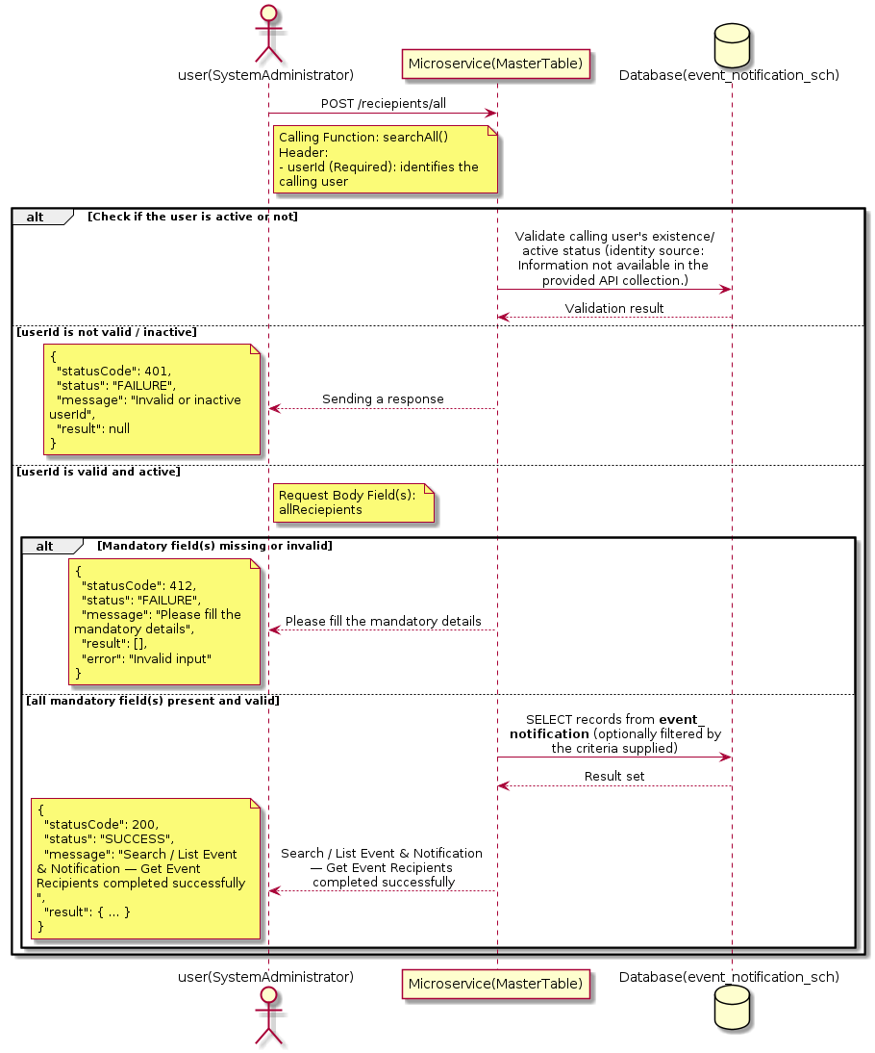

3.5.6.3 API Endpoint
Method | POST
URL | http://localhost:7002/srv2/genie/reciepients/all
Headers | userId: 67 Content-Type: application/json
Authorization | Not present in the captured request. Information not available in the provided API collection.
Content-Type | Content-Type: application/json
Query Parameters | None
Path Variables | None
Request Body:
{
"allReciepients": false
}
Response Body (illustrative — see 3.x.4.5 Success Response for details):
The source Postman collection does not include a captured sample response for this request (the response array is empty). Information not available in the provided API collection. Section 3.5.6.4.5 below presents the response envelope inferred from the standard response wrapper used consistently by this platform's services.

3.5.6.4 Detailed Process Flow

3.5.6.4.1 Request Initiation
The flow begins when System Administrator (or a calling microservice on their behalf) invokes the POST endpoint http://localhost:7002/srv2/genie/reciepients/all. The request must include the mandatory `userId` header used by the Master Table Microservice to identify the calling user for auditing purposes. The request carries a JSON payload in the request body which the Controller binds to its Data Transfer Object (DTO) before any processing begins. At the Controller layer, Spring Boot's request-mapping infrastructure routes the call to the appropriate handler method (`searchAll`), and Bean Validation annotations (if configured on the DTO) perform structural validation before the request reaches the Service layer. Information not available in the provided API collection. regarding the exact validation annotations used in the source code.

3.5.6.4.2 User Validation
The Master Table Microservice relies on the `userId` header to identify the calling user. Based on the pattern observed consistently across this API collection, the platform's authentication/authorization is expected to be enforced upstream (e.g., by an API Gateway or a shared security filter) using this identifier; the Postman collection does not include an `Authorization` / `Bearer` token header on this request, so the exact authentication mechanism (JWT validation, session lookup, or gateway-level SSO) is Information not available in the provided API collection. Role-based authorization — i.e., confirming that the user identified by `userId` holds a role/permission entitled to perform this operation — is expected to be enforced by the Service layer (see Section 8 – Controller Analysis and Section 14 – Authentication & Authorization), but the specific role/permission checks are Information not available in the provided API collection.

3.5.6.4.3 Business Logic
The Service layer evaluates the search payload; if the search text/criteria is empty, the operation typically behaves like a full list (all Event & Notification records); if populated, it is used to build a case-insensitive `LIKE`/contains predicate against the relevant column(s). The key fields exchanged for this operation, as observed in the sample payload, are: `allReciepients`.

3.5.6.4.4 Database Interaction
The Repository layer (Spring Data JPA) interacts with the underlying relational database that backs the Event & Notification master table. The primary operation issued is a **SELECT** against the table associated with Event & Notification. No write operations occur; the search is typically implemented using a JPA derived query method or a native/JPQL query with `LIKE` predicates. The exact table name, column names, primary/foreign key definitions, and JPA repository method signatures are not included in the Postman collection; therefore, precise schema details are information not available in the provided api collection.

3.5.6.4.5 Success Response
Status Code: 200 OK. Sample response envelope (illustrative — the source collection did not capture a sample response for this API):
{
"statusCode": 200,
"status": "SUCCESS",
"message": "Search / List Event & Notification — Get Event Recipients completed successfully",
"result": [
{
"id": 1,
"name": "Sample Event & Notification",
"isActive": 1
}
],
"error": null,
"corelationId": "c6f2a1e4-2b3d-4a9e-9f1a-1234567890ab",
"url": null
}

3.5.6.4.6 Conclusion
This API provides a well-defined, single-purpose capability within the Master Table Microservice for search / list event & notification — get event recipients. The Controller → Service → Repository → Database layering keeps request validation, business rules, and persistence concerns separated, which allows the Event & Notification master data to be maintained consistently and safely by authorized administrators while remaining available for consumption by every other module that depends on this reference data.
3.5.7 Create Event & Notification — Create Event

3.5.7.1 Overview
Purpose: To create a new Event & Notification master record in the system, allowing administrators to extend the master-data catalogue that other modules (ticketing, workflow, notifications) depend on.
Business Requirement: Business/process owners need a controlled way to add new Event & Notification values so that the platform's classification, routing, and reporting capabilities can evolve as the organization changes.
Who Uses the API: System Administrator / Notification Administrator responsible for master-data configuration.
Business Flow: Client sends a POST request with the new Event & Notification payload → Controller validates the payload (mandatory fields, formats) → Service layer applies business rules (e.g., duplicate-name check) → Repository persists the new record → the created record (with generated identifier) is returned to the Client.

3.5.7.2 Sequence Diagram
The diagram below illustrates the end-to-end interaction for "Create Event & Notification — Create Event" across the Client, Controller, Service, Repository, and Database layers.
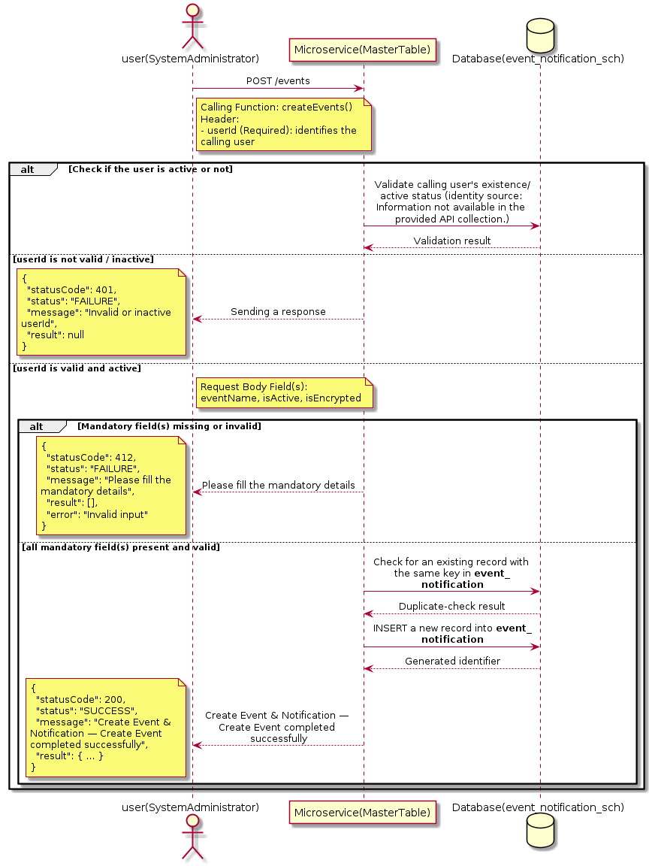

3.5.7.3 API Endpoint
Method | POST
URL | http://localhost:7002/srv2/genie/events
Headers | userId: 67 Content-Type: application/json
Authorization | Not present in the captured request. Information not available in the provided API collection.
Content-Type | Content-Type: application/json
Query Parameters | None
Path Variables | None
Request Body:
{
"eventName": "Simple Test Event",
"isActive": "1",
"isEncrypted": "0",
"to": [],
"cc": [],
"bcc": []
}
Response Body (illustrative — see 3.x.4.5 Success Response for details):
The source Postman collection does not include a captured sample response for this request (the response array is empty). Information not available in the provided API collection. Section 3.5.7.4.5 below presents the response envelope inferred from the standard response wrapper used consistently by this platform's services.

3.5.7.4 Detailed Process Flow

3.5.7.4.1 Request Initiation
The flow begins when System Administrator (or a calling microservice on their behalf) invokes the POST endpoint http://localhost:7002/srv2/genie/events. The request must include the mandatory `userId` header used by the Master Table Microservice to identify the calling user for auditing purposes. The request carries a JSON payload in the request body which the Controller binds to its Data Transfer Object (DTO) before any processing begins. At the Controller layer, Spring Boot's request-mapping infrastructure routes the call to the appropriate handler method (`createEvents`), and Bean Validation annotations (if configured on the DTO) perform structural validation before the request reaches the Service layer. Information not available in the provided API collection. regarding the exact validation annotations used in the source code.

3.5.7.4.2 User Validation
The Master Table Microservice relies on the `userId` header to identify the calling user. Based on the pattern observed consistently across this API collection, the platform's authentication/authorization is expected to be enforced upstream (e.g., by an API Gateway or a shared security filter) using this identifier; the Postman collection does not include an `Authorization` / `Bearer` token header on this request, so the exact authentication mechanism (JWT validation, session lookup, or gateway-level SSO) is Information not available in the provided API collection. Role-based authorization — i.e., confirming that the user identified by `userId` holds a role/permission entitled to perform this operation — is expected to be enforced by the Service layer (see Section 8 – Controller Analysis and Section 14 – Authentication & Authorization), but the specific role/permission checks are Information not available in the provided API collection.

3.5.7.4.3 Business Logic
The Service layer performs the following: (1) validates that mandatory fields are present and correctly formatted, (2) checks for duplicates (e.g., an existing Event & Notification with the same name/code), (3) sets system-managed fields (e.g., `isActive = 1`, `createdBy`, timestamps) where applicable, and (4) persists the new record via the Repository. If any validation fails, the Service layer returns a business error rather than proceeding to persistence. The key fields exchanged for this operation, as observed in the sample payload, are: `eventName`, `isActive`, `isEncrypted`.

3.5.7.4.4 Database Interaction
The Repository layer (Spring Data JPA) interacts with the underlying relational database that backs the Event & Notification master table. The primary operation issued is a **INSERT** against the table associated with Event & Notification. A new row is inserted into the master table; if the entity has related child records (as seen in nested request payload arrays), corresponding child-table inserts are performed within the same transaction. The exact table name, column names, primary/foreign key definitions, and JPA repository method signatures are not included in the Postman collection; therefore, precise schema details are information not available in the provided api collection.

3.5.7.4.5 Success Response
Status Code: 200 OK. Sample response envelope (illustrative — the source collection did not capture a sample response for this API):
{
"statusCode": 200,
"status": "SUCCESS",
"message": "Create Event & Notification — Create Event completed successfully",
"result": {
"id": 101,
"eventName": "Simple Test Event",
"isActive": "1",
"isEncrypted": "0"
},
"error": null,
"corelationId": "c6f2a1e4-2b3d-4a9e-9f1a-1234567890ab",
"url": null
}

3.5.7.4.6 Conclusion
This API provides a well-defined, single-purpose capability within the Master Table Microservice for create event & notification — create event. The Controller → Service → Repository → Database layering keeps request validation, business rules, and persistence concerns separated, which allows the Event & Notification master data to be maintained consistently and safely by authorized administrators while remaining available for consumption by every other module that depends on this reference data.

3.5.8 Search / List Event & Notification — Get Event By ID

3.5.8.1 Overview
Purpose: To search and list Event & Notification records based on a search payload (e.g., free-text search or structured criteria), supporting list/grid screens that need paginated or filtered master data.
Business Requirement: List/search screens for Event & Notification configuration need server-side search so that administrators can locate specific records in large master tables without scanning the full data set.
Who Uses the API: System Administrator / Notification Administrator operating the Event & Notification configuration/list screen.
Business Flow: Client sends a POST request with a search payload → Controller validates the payload → Service layer constructs the search/query logic → Repository executes the search against the Event & Notification table → matching records are returned to the Client.

3.5.8.2 Sequence Diagram
The diagram below illustrates the end-to-end interaction for "Search / List Event & Notification — Get Event By ID" across the Client, Controller, Service, Repository, and Database layers.
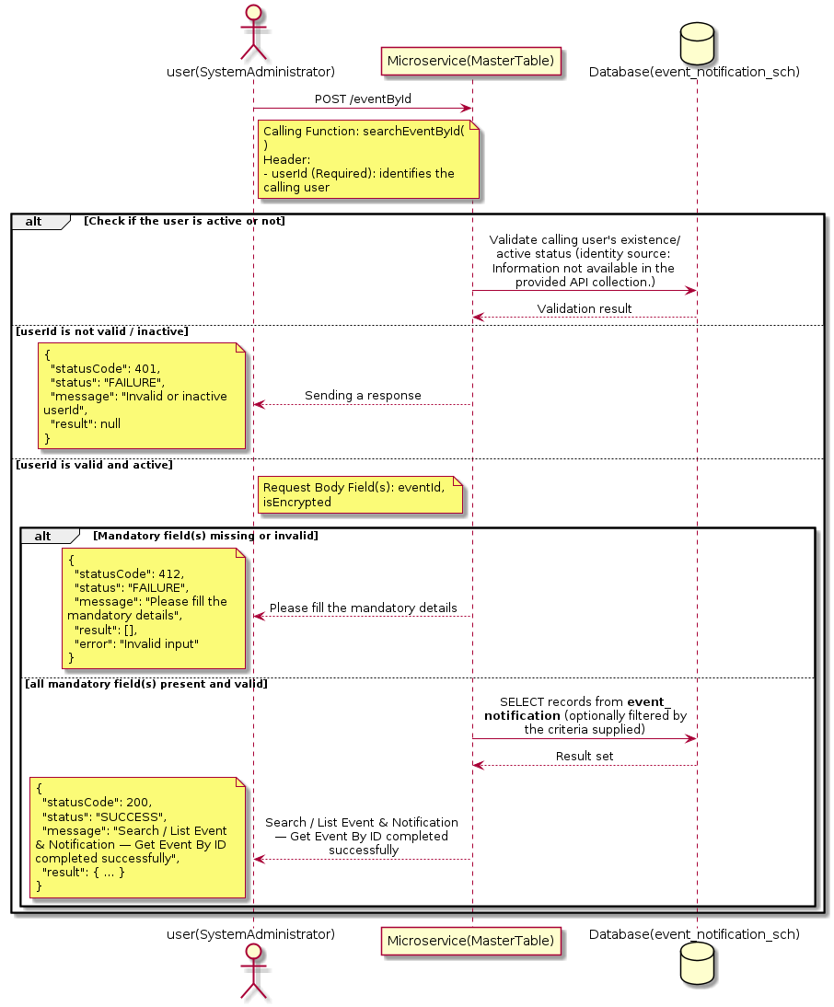

3.5.8.3 API Endpoint
Method | POST
URL | http://localhost:7002/srv2/genie/eventById
Headers | userId: 67 Content-Type: application/json
Authorization | Not present in the captured request. Information not available in the provided API collection.
Content-Type | Content-Type: application/json
Query Parameters | None
Path Variables | None
Request Body:
{
"eventId": 31,
"isEncrypted": "0"
}
Response Body (illustrative — see 3.x.4.5 Success Response for details):
The source Postman collection does not include a captured sample response for this request (the response array is empty). Information not available in the provided API collection. Section 3.5.8.4.5 below presents the response envelope inferred from the standard response wrapper used consistently by this platform's services.

3.5.8.4 Detailed Process Flow

3.5.8.4.1 Request Initiation
The flow begins when System Administrator (or a calling microservice on their behalf) invokes the POST endpoint http://localhost:7002/srv2/genie/eventById. The request must include the mandatory `userId` header used by the Master Table Microservice to identify the calling user for auditing purposes. The request carries a JSON payload in the request body which the Controller binds to its Data Transfer Object (DTO) before any processing begins. At the Controller layer, Spring Boot's request-mapping infrastructure routes the call to the appropriate handler method (`searchEventById`), and Bean Validation annotations (if configured on the DTO) perform structural validation before the request reaches the Service layer. Information not available in the provided API collection. regarding the exact validation annotations used in the source code.

3.5.8.4.2 User Validation
The Master Table Microservice relies on the `userId` header to identify the calling user. Based on the pattern observed consistently across this API collection, the platform's authentication/authorization is expected to be enforced upstream (e.g., by an API Gateway or a shared security filter) using this identifier; the Postman collection does not include an `Authorization` / `Bearer` token header on this request, so the exact authentication mechanism (JWT validation, session lookup, or gateway-level SSO) is Information not available in the provided API collection. Role-based authorization — i.e., confirming that the user identified by `userId` holds a role/permission entitled to perform this operation — is expected to be enforced by the Service layer (see Section 8 – Controller Analysis and Section 14 – Authentication & Authorization), but the specific role/permission checks are Information not available in the provided API collection.

3.5.8.4.3 Business Logic
The Service layer evaluates the search payload; if the search text/criteria is empty, the operation typically behaves like a full list (all Event & Notification records); if populated, it is used to build a case-insensitive `LIKE`/contains predicate against the relevant column(s). The key fields exchanged for this operation, as observed in the sample payload, are: `eventId`, `isEncrypted`.

3.5.8.4.4 Database Interaction
The Repository layer (Spring Data JPA) interacts with the underlying relational database that backs the Event & Notification master table. The primary operation issued is a **SELECT** against the table associated with Event & Notification. No write operations occur; the search is typically implemented using a JPA derived query method or a native/JPQL query with `LIKE` predicates. The exact table name, column names, primary/foreign key definitions, and JPA repository method signatures are not included in the Postman collection; therefore, precise schema details are information not available in the provided api collection.

3.5.8.4.5 Success Response
Status Code: 200 OK. Sample response envelope (illustrative — the source collection did not capture a sample response for this API):
{
"statusCode": 200,
"status": "SUCCESS",
"message": "Search / List Event & Notification — Get Event By ID completed successfully",
"result": [
{
"id": 1,
"name": "Sample Event & Notification",
"isActive": 1
}
],
"error": null,
"corelationId": "c6f2a1e4-2b3d-4a9e-9f1a-1234567890ab",
"url": null
}

3.5.8.4.6 Conclusion
This API provides a well-defined, single-purpose capability within the Master Table Microservice for search / list event & notification — get event by id. The Controller → Service → Repository → Database layering keeps request validation, business rules, and persistence concerns separated, which allows the Event & Notification master data to be maintained consistently and safely by authorized administrators while remaining available for consumption by every other module that depends on this reference data.
3.5.9 Enable / Disable Event & Notification — Enable/Disable Event

3.5.9.1 Overview
Purpose: To enable or disable (soft-delete) a Event & Notification master record, allowing administrators to retire a record from active use while preserving it for historical/audit purposes.
Business Requirement: Rather than physically deleting a Event & Notification record (which could break referential integrity with historical tickets/records that reference it), the business requires a reversible enable/disable mechanism.
Who Uses the API: System Administrator / Notification Administrator responsible for activating/deactivating configuration values.
Business Flow: Client sends a request carrying the Event & Notification identifier and the desired active/inactive flag → Controller validates the payload → Service layer fetches the record and flips its status flag → Repository persists the change → the updated status is returned to the Client.

3.5.9.2 Sequence Diagram
The diagram below illustrates the end-to-end interaction for "Enable / Disable Event & Notification — Enable/Disable Event" across the Client, Controller, Service, Repository, and Database layers.
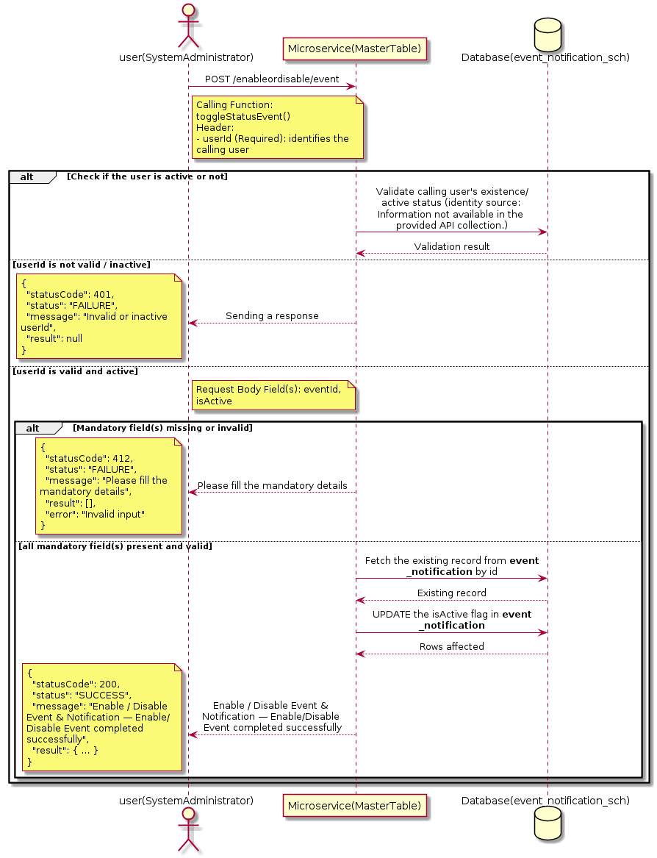

3.5.9.3 API Endpoint
Method | POST
URL | http://localhost:7002/srv2/genie/enableordisable/event
Headers | userId: 67 Content-Type: application/json
Authorization | Not present in the captured request. Information not available in the provided API collection.
Content-Type | Content-Type: application/json
Query Parameters | None
Path Variables | None
Request Body:
{
"eventId": 1,
"isActive": "0"
}
Response Body (illustrative — see 3.x.4.5 Success Response for details):
The source Postman collection does not include a captured sample response for this request (the response array is empty). Information not available in the provided API collection. Section 3.5.9.4.5 below presents the response envelope inferred from the standard response wrapper used consistently by this platform's services.

3.5.9.4 Detailed Process Flow

3.5.9.4.1 Request Initiation
The flow begins when System Administrator (or a calling microservice on their behalf) invokes the POST endpoint http://localhost:7002/srv2/genie/enableordisable/event. The request must include the mandatory `userId` header used by the Master Table Microservice to identify the calling user for auditing purposes. The request carries a JSON payload in the request body which the Controller binds to its Data Transfer Object (DTO) before any processing begins. At the Controller layer, Spring Boot's request-mapping infrastructure routes the call to the appropriate handler method (`toggleStatusEvent`), and Bean Validation annotations (if configured on the DTO) perform structural validation before the request reaches the Service layer. Information not available in the provided API collection. regarding the exact validation annotations used in the source code.

3.5.9.4.2 User Validation
The Master Table Microservice relies on the `userId` header to identify the calling user. Based on the pattern observed consistently across this API collection, the platform's authentication/authorization is expected to be enforced upstream (e.g., by an API Gateway or a shared security filter) using this identifier; the Postman collection does not include an `Authorization` / `Bearer` token header on this request, so the exact authentication mechanism (JWT validation, session lookup, or gateway-level SSO) is Information not available in the provided API collection. Role-based authorization — i.e., confirming that the user identified by `userId` holds a role/permission entitled to perform this operation — is expected to be enforced by the Service layer (see Section 8 – Controller Analysis and Section 14 – Authentication & Authorization), but the specific role/permission checks are Information not available in the provided API collection.

3.5.9.4.3 Business Logic
The Service layer fetches the existing Event & Notification record by its identifier and flips the `isActive` flag to the value supplied in the request. No other attributes of the record are modified by this operation. The key fields exchanged for this operation, as observed in the sample payload, are: `eventId`, `isActive`.

3.5.9.4.4 Database Interaction
The Repository layer (Spring Data JPA) interacts with the underlying relational database that backs the Event & Notification master table. The primary operation issued is a **UPDATE** against the table associated with Event & Notification. Only the `is_active` (status) column is updated for the row identified by the primary key; all other columns remain unchanged. The exact table name, column names, primary/foreign key definitions, and JPA repository method signatures are not included in the Postman collection; therefore, precise schema details are information not available in the provided api collection.

3.5.9.4.5 Success Response
Status Code: 200 OK. Sample response envelope (illustrative — the source collection did not capture a sample response for this API):
{
"statusCode": 200,
"status": "SUCCESS",
"message": "Enable / Disable Event & Notification — Enable/Disable Event completed successfully",
"result": {
"id": 1,
"isActive": 1
},
"error": null,
"corelationId": "c6f2a1e4-2b3d-4a9e-9f1a-1234567890ab",
"url": null
}

3.5.9.4.6 Conclusion
This API provides a well-defined, single-purpose capability within the Master Table Microservice for enable / disable event & notification — enable/disable event. The Controller → Service → Repository → Database layering keeps request validation, business rules, and persistence concerns separated, which allows the Event & Notification master data to be maintained consistently and safely by authorized administrators while remaining available for consumption by every other module that depends on this reference data.
3.5.10 Update Event & Notification — Update Event/id

3.5.10.1 Overview
Purpose: To update an existing Event & Notification master record, allowing administrators to correct or evolve master-data attributes without impacting the record's identity/history.
Business Requirement: Master data changes over time (renames, corrections, re-classification); the platform must allow controlled updates while preserving referential integrity for records that already reference this Event & Notification.
Who Uses the API: System Administrator / Notification Administrator responsible for maintaining master-data accuracy.
Business Flow: Client sends a PUT/PATCH request with the updated Event & Notification payload → Controller validates the payload → Service layer fetches the existing record, applies the changes, and re-validates business rules → Repository persists the updated record → the updated record is returned to the Client.

3.5.10.2 Sequence Diagram
The diagram below illustrates the end-to-end interaction for "Update Event & Notification — Update Event/id" across the Client, Controller, Service, Repository, and Database layers.
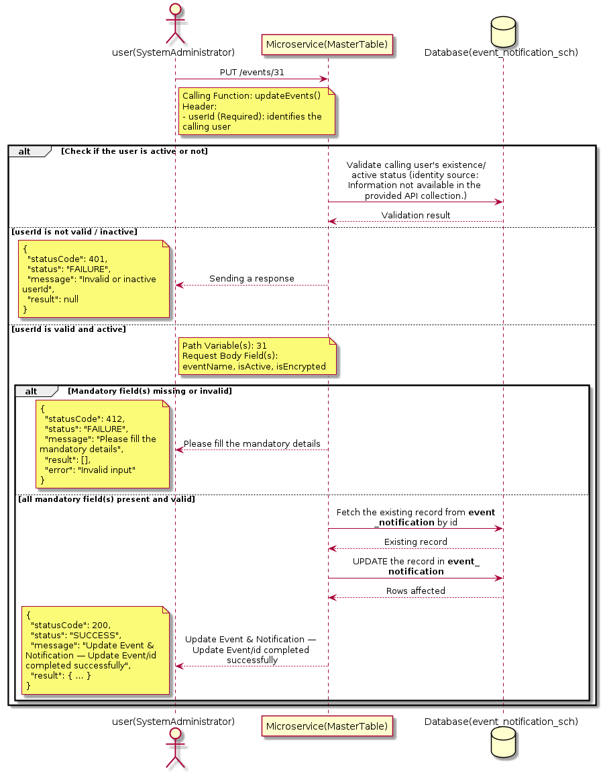

3.5.10.3 API Endpoint
Method | PUT
URL | http://localhost:7002/srv2/genie/events/31
Headers | userId: 67 Content-Type: application/json
Authorization | Not present in the captured request. Information not available in the provided API collection.
Content-Type | Content-Type: application/json
Query Parameters | None
Path Variables | 31
Request Body:
{
"eventName": "Create Ticket Updated",
"isActive": "1",
"isEncrypted": "0",
"to": [
17,
18,
19
],
"cc": [
14
],
"bcc": []
}
Response Body (illustrative — see 3.x.4.5 Success Response for details):
The source Postman collection does not include a captured sample response for this request (the response array is empty). Information not available in the provided API collection. Section 3.5.10.4.5 below presents the response envelope inferred from the standard response wrapper used consistently by this platform's services.

3.5.10.4 Detailed Process Flow

3.5.10.4.1 Request Initiation
The flow begins when System Administrator (or a calling microservice on their behalf) invokes the PUT endpoint http://localhost:7002/srv2/genie/events/31. The request must include the mandatory `userId` header used by the Master Table Microservice to identify the calling user for auditing purposes. The request carries a JSON payload in the request body which the Controller binds to its Data Transfer Object (DTO) before any processing begins. At the Controller layer, Spring Boot's request-mapping infrastructure routes the call to the appropriate handler method (`updateEvents`), and Bean Validation annotations (if configured on the DTO) perform structural validation before the request reaches the Service layer. Information not available in the provided API collection. regarding the exact validation annotations used in the source code.

3.5.10.4.2 User Validation
The Master Table Microservice relies on the `userId` header to identify the calling user. Based on the pattern observed consistently across this API collection, the platform's authentication/authorization is expected to be enforced upstream (e.g., by an API Gateway or a shared security filter) using this identifier; the Postman collection does not include an `Authorization` / `Bearer` token header on this request, so the exact authentication mechanism (JWT validation, session lookup, or gateway-level SSO) is Information not available in the provided API collection. Role-based authorization — i.e., confirming that the user identified by `userId` holds a role/permission entitled to perform this operation — is expected to be enforced by the Service layer (see Section 8 – Controller Analysis and Section 14 – Authentication & Authorization), but the specific role/permission checks are Information not available in the provided API collection.

3.5.10.4.3 Business Logic
The Service layer fetches the existing Event & Notification record by its identifier, verifies it exists, applies the incoming changes field by field, re-validates business rules (e.g., uniqueness of a renamed field), and persists the updated entity via the Repository. If the record does not exist, the operation is rejected with a not-found error. The key fields exchanged for this operation, as observed in the sample payload, are: `eventName`, `isActive`, `isEncrypted`.

3.5.10.4.4 Database Interaction
The Repository layer (Spring Data JPA) interacts with the underlying relational database that backs the Event & Notification master table. The primary operation issued is a **UPDATE** against the table associated with Event & Notification. The existing row is located by primary key and updated; if the entity has related child records, the existing child rows are typically replaced/updated within the same transaction. The exact table name, column names, primary/foreign key definitions, and JPA repository method signatures are not included in the Postman collection; therefore, precise schema details are information not available in the provided api collection.

3.5.10.4.5 Success Response
Status Code: 200 OK. Sample response envelope (illustrative — the source collection did not capture a sample response for this API):
{
"statusCode": 200,
"status": "SUCCESS",
"message": "Update Event & Notification — Update Event/id completed successfully",
"result": {
"id": "31",
"isActive": 1
},
"error": null,
"corelationId": "c6f2a1e4-2b3d-4a9e-9f1a-1234567890ab",
"url": null
}

3.5.10.4.6 Conclusion
This API provides a well-defined, single-purpose capability within the Master Table Microservice for update event & notification — update event/id. The Controller → Service → Repository → Database layering keeps request validation, business rules, and persistence concerns separated, which allows the Event & Notification master data to be maintained consistently and safely by authorized administrators while remaining available for consumption by every other module that depends on this reference data.

3.5.11 Update Event & Notification — Update Event Recipient

3.5.11.1 Overview
Purpose: To update an existing Event & Notification master record, allowing administrators to correct or evolve master-data attributes without impacting the record's identity/history.
Business Requirement: Master data changes over time (renames, corrections, re-classification); the platform must allow controlled updates while preserving referential integrity for records that already reference this Event & Notification.
Who Uses the API: System Administrator / Notification Administrator responsible for maintaining master-data accuracy.
Business Flow: Client sends a PUT/PATCH request with the updated Event & Notification payload → Controller validates the payload → Service layer fetches the existing record, applies the changes, and re-validates business rules → Repository persists the updated record → the updated record is returned to the Client.

3.5.11.2 Sequence Diagram
The diagram below illustrates the end-to-end interaction for "Update Event & Notification — Update Event Recipient" across the Client, Controller, Service, Repository, and Database layers.
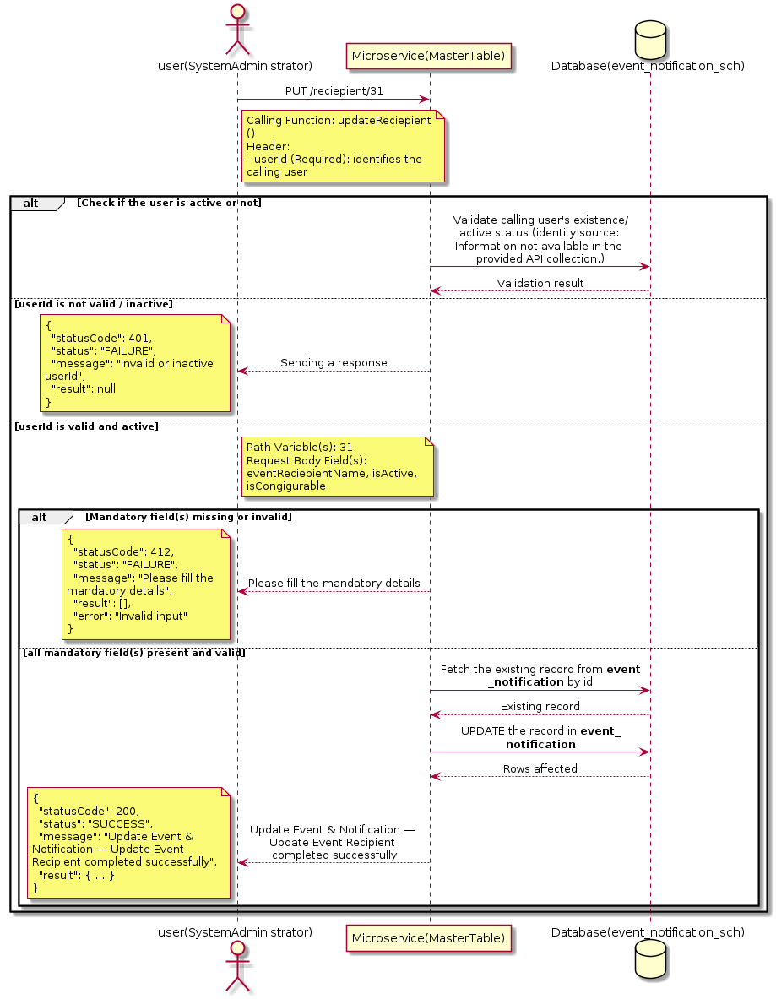

3.5.11.3 API Endpoint
Method | PUT
URL | http://localhost:7002/srv2/genie/reciepient/31
Headers | userId: 67 Content-Type: application/json
Authorization | Not present in the captured request. Information not available in the provided API collection.
Content-Type | Content-Type: application/json
Query Parameters | None
Path Variables | 31
Request Body:
{
"eventReciepientName": "Updated Recipient",
"isActive": "1",
"isCongigurable": "1"
}
Response Body (illustrative — see 3.x.4.5 Success Response for details):
The source Postman collection does not include a captured sample response for this request (the response array is empty). Information not available in the provided API collection. Section 3.5.11.4.5 below presents the response envelope inferred from the standard response wrapper used consistently by this platform's services.

3.5.11.4 Detailed Process Flow

3.5.11.4.1 Request Initiation
The flow begins when System Administrator (or a calling microservice on their behalf) invokes the PUT endpoint http://localhost:7002/srv2/genie/reciepient/31. The request must include the mandatory `userId` header used by the Master Table Microservice to identify the calling user for auditing purposes. The request carries a JSON payload in the request body which the Controller binds to its Data Transfer Object (DTO) before any processing begins. At the Controller layer, Spring Boot's request-mapping infrastructure routes the call to the appropriate handler method (`updateReciepient`), and Bean Validation annotations (if configured on the DTO) perform structural validation before the request reaches the Service layer. Information not available in the provided API collection. regarding the exact validation annotations used in the source code.

3.5.11.4.2 User Validation
The Master Table Microservice relies on the `userId` header to identify the calling user. Based on the pattern observed consistently across this API collection, the platform's authentication/authorization is expected to be enforced upstream (e.g., by an API Gateway or a shared security filter) using this identifier; the Postman collection does not include an `Authorization` / `Bearer` token header on this request, so the exact authentication mechanism (JWT validation, session lookup, or gateway-level SSO) is Information not available in the provided API collection. Role-based authorization — i.e., confirming that the user identified by `userId` holds a role/permission entitled to perform this operation — is expected to be enforced by the Service layer (see Section 8 – Controller Analysis and Section 14 – Authentication & Authorization), but the specific role/permission checks are Information not available in the provided API collection.

3.5.11.4.3 Business Logic
The Service layer fetches the existing Event & Notification record by its identifier, verifies it exists, applies the incoming changes field by field, re-validates business rules (e.g., uniqueness of a renamed field), and persists the updated entity via the Repository. If the record does not exist, the operation is rejected with a not-found error. The key fields exchanged for this operation, as observed in the sample payload, are: `eventReciepientName`, `isActive`, `isCongigurable`.

3.5.11.4.4 Database Interaction
The Repository layer (Spring Data JPA) interacts with the underlying relational database that backs the Event & Notification master table. The primary operation issued is a **UPDATE** against the table associated with Event & Notification. The existing row is located by primary key and updated; if the entity has related child records, the existing child rows are typically replaced/updated within the same transaction. The exact table name, column names, primary/foreign key definitions, and JPA repository method signatures are not included in the Postman collection; therefore, precise schema details are information not available in the provided api collection.

3.5.11.4.5 Success Response
Status Code: 200 OK. Sample response envelope (illustrative — the source collection did not capture a sample response for this API):
{
"statusCode": 200,
"status": "SUCCESS",
"message": "Update Event & Notification — Update Event Recipient completed successfully",
"result": {
"id": "31",
"isActive": 1
},
"error": null,
"corelationId": "c6f2a1e4-2b3d-4a9e-9f1a-1234567890ab",
"url": null
}

3.5.11.4.6 Conclusion
This API provides a well-defined, single-purpose capability within the Master Table Microservice for update event & notification — update event recipient. The Controller → Service → Repository → Database layering keeps request validation, business rules, and persistence concerns separated, which allows the Event & Notification master data to be maintained consistently and safely by authorized administrators while remaining available for consumption by every other module that depends on this reference data.

3.5.12 Create Event & Notification — eventbyrole

3.5.12.1 Overview
Purpose: To create a new Event & Notification master record in the system, allowing administrators to extend the master-data catalogue that other modules (ticketing, workflow, notifications) depend on.
Business Requirement: Business/process owners need a controlled way to add new Event & Notification values so that the platform's classification, routing, and reporting capabilities can evolve as the organization changes.
Who Uses the API: System Administrator / Notification Administrator responsible for master-data configuration.
Business Flow: Client sends a POST request with the new Event & Notification payload → Controller validates the payload (mandatory fields, formats) → Service layer applies business rules (e.g., duplicate-name check) → Repository persists the new record → the created record (with generated identifier) is returned to the Client.

3.5.12.2 Sequence Diagram
The diagram below illustrates the end-to-end interaction for "Create Event & Notification — eventbyrole" across the Client, Controller, Service, Repository, and Database layers.
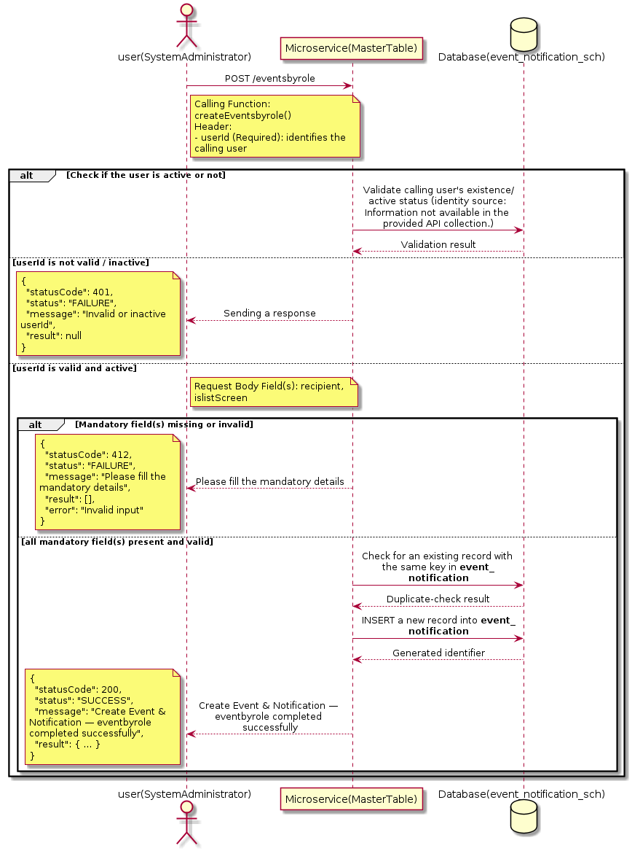

3.5.12.3 API Endpoint
Method | POST
URL | http://localhost:7002/srv2/genie/eventsbyrole
Headers | userId: 67 Content-Type: application/json
Authorization | Not present in the captured request. Information not available in the provided API collection.
Content-Type | Content-Type: application/json
Query Parameters | None
Path Variables | None
Request Body:
{
"recipient": "1",
"islistScreen": true
}
Response Body (illustrative — see 3.x.4.5 Success Response for details):
The source Postman collection does not include a captured sample response for this request (the response array is empty). Information not available in the provided API collection. Section 3.5.12.4.5 below presents the response envelope inferred from the standard response wrapper used consistently by this platform's services.

3.5.12.4 Detailed Process Flow

3.5.12.4.1 Request Initiation
The flow begins when System Administrator (or a calling microservice on their behalf) invokes the POST endpoint http://localhost:7002/srv2/genie/eventsbyrole. The request must include the mandatory `userId` header used by the Master Table Microservice to identify the calling user for auditing purposes. The request carries a JSON payload in the request body which the Controller binds to its Data Transfer Object (DTO) before any processing begins. At the Controller layer, Spring Boot's request-mapping infrastructure routes the call to the appropriate handler method (`createEventsbyrole`), and Bean Validation annotations (if configured on the DTO) perform structural validation before the request reaches the Service layer. Information not available in the provided API collection. regarding the exact validation annotations used in the source code.

3.5.12.4.2 User Validation
The Master Table Microservice relies on the `userId` header to identify the calling user. Based on the pattern observed consistently across this API collection, the platform's authentication/authorization is expected to be enforced upstream (e.g., by an API Gateway or a shared security filter) using this identifier; the Postman collection does not include an `Authorization` / `Bearer` token header on this request, so the exact authentication mechanism (JWT validation, session lookup, or gateway-level SSO) is Information not available in the provided API collection. Role-based authorization — i.e., confirming that the user identified by `userId` holds a role/permission entitled to perform this operation — is expected to be enforced by the Service layer (see Section 8 – Controller Analysis and Section 14 – Authentication & Authorization), but the specific role/permission checks are Information not available in the provided API collection.

3.5.12.4.3 Business Logic
The Service layer performs the following: (1) validates that mandatory fields are present and correctly formatted, (2) checks for duplicates (e.g., an existing Event & Notification with the same name/code), (3) sets system-managed fields (e.g., `isActive = 1`, `createdBy`, timestamps) where applicable, and (4) persists the new record via the Repository. If any validation fails, the Service layer returns a business error rather than proceeding to persistence. The key fields exchanged for this operation, as observed in the sample payload, are: `recipient`, `islistScreen`.

3.5.12.4.4 Database Interaction
The Repository layer (Spring Data JPA) interacts with the underlying relational database that backs the Event & Notification master table. The primary operation issued is a **INSERT** against the table associated with Event & Notification. A new row is inserted into the master table; if the entity has related child records (as seen in nested request payload arrays), corresponding child-table inserts are performed within the same transaction. The exact table name, column names, primary/foreign key definitions, and JPA repository method signatures are not included in the Postman collection; therefore, precise schema details are information not available in the provided api collection.

3.5.12.4.5 Success Response
Status Code: 200 OK. Sample response envelope (illustrative — the source collection did not capture a sample response for this API):
{
"statusCode": 200,
"status": "SUCCESS",
"message": "Create Event & Notification — eventbyrole completed successfully",
"result": {
"id": 101,
"recipient": "1",
"islistScreen": true
},
"error": null,
"corelationId": "c6f2a1e4-2b3d-4a9e-9f1a-1234567890ab",
"url": null
}

3.5.12.4.6 Conclusion
This API provides a well-defined, single-purpose capability within the Master Table Microservice for create event & notification — eventbyrole. The Controller → Service → Repository → Database layering keeps request validation, business rules, and persistence concerns separated, which allows the Event & Notification master data to be maintained consistently and safely by authorized administrators while remaining available for consumption by every other module that depends on this reference data.

3.5.13 Update Event & Notification — Event Role Mandatory Mapping (Default Settings)

3.5.13.1 Overview
Purpose: To update an existing Event & Notification master record, allowing administrators to correct or evolve master-data attributes without impacting the record's identity/history.
Business Requirement: Master data changes over time (renames, corrections, re-classification); the platform must allow controlled updates while preserving referential integrity for records that already reference this Event & Notification.
Who Uses the API: System Administrator / Notification Administrator responsible for maintaining master-data accuracy.
Business Flow: Client sends a PUT/PATCH request with the updated Event & Notification payload → Controller validates the payload → Service layer fetches the existing record, applies the changes, and re-validates business rules → Repository persists the updated record → the updated record is returned to the Client.

3.5.13.2 Sequence Diagram
The diagram below illustrates the end-to-end interaction for "Update Event & Notification — Event Role Mandatory Mapping (Default Settings)" across the Client, Controller, Service, Repository, and Database layers.
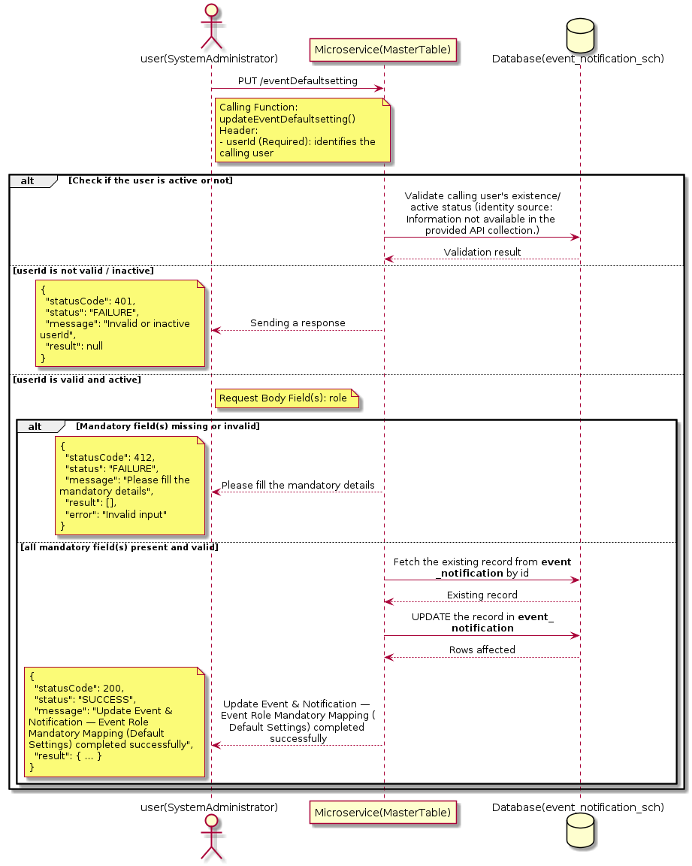

3.5.13.3 API Endpoint
Method | PUT
URL | http://localhost:7002/srv2/genie/eventDefaultsetting
Headers | userId: 67 Content-Type: application/json
Authorization | Not present in the captured request. Information not available in the provided API collection.
Content-Type | Content-Type: application/json
Query Parameters | None
Path Variables | None
Request Body:
{
"eventId": [
1,
2
],
"role": 1
}
Response Body (illustrative — see 3.x.4.5 Success Response for details):
The source Postman collection does not include a captured sample response for this request (the response array is empty). Information not available in the provided API collection. Section 3.5.13.4.5 below presents the response envelope inferred from the standard response wrapper used consistently by this platform's services.

3.5.13.4 Detailed Process Flow

3.5.13.4.1 Request Initiation
The flow begins when System Administrator (or a calling microservice on their behalf) invokes the PUT endpoint http://localhost:7002/srv2/genie/eventDefaultsetting. The request must include the mandatory `userId` header used by the Master Table Microservice to identify the calling user for auditing purposes. The request carries a JSON payload in the request body which the Controller binds to its Data Transfer Object (DTO) before any processing begins. At the Controller layer, Spring Boot's request-mapping infrastructure routes the call to the appropriate handler method (`updateEventDefaultsetting`), and Bean Validation annotations (if configured on the DTO) perform structural validation before the request reaches the Service layer. Information not available in the provided API collection. regarding the exact validation annotations used in the source code.

3.5.13.4.2 User Validation
The Master Table Microservice relies on the `userId` header to identify the calling user. Based on the pattern observed consistently across this API collection, the platform's authentication/authorization is expected to be enforced upstream (e.g., by an API Gateway or a shared security filter) using this identifier; the Postman collection does not include an `Authorization` / `Bearer` token header on this request, so the exact authentication mechanism (JWT validation, session lookup, or gateway-level SSO) is Information not available in the provided API collection. Role-based authorization — i.e., confirming that the user identified by `userId` holds a role/permission entitled to perform this operation — is expected to be enforced by the Service layer (see Section 8 – Controller Analysis and Section 14 – Authentication & Authorization), but the specific role/permission checks are Information not available in the provided API collection.

3.5.13.4.3 Business Logic
The Service layer fetches the existing Event & Notification record by its identifier, verifies it exists, applies the incoming changes field by field, re-validates business rules (e.g., uniqueness of a renamed field), and persists the updated entity via the Repository. If the record does not exist, the operation is rejected with a not-found error. The key fields exchanged for this operation, as observed in the sample payload, are: `role`.

3.5.13.4.4 Database Interaction
The Repository layer (Spring Data JPA) interacts with the underlying relational database that backs the Event & Notification master table. The primary operation issued is a **UPDATE** against the table associated with Event & Notification. The existing row is located by primary key and updated; if the entity has related child records, the existing child rows are typically replaced/updated within the same transaction. The exact table name, column names, primary/foreign key definitions, and JPA repository method signatures are not included in the Postman collection; therefore, precise schema details are information not available in the provided api collection.

3.5.13.4.5 Success Response
Status Code: 200 OK. Sample response envelope (illustrative — the source collection did not capture a sample response for this API):
{
"statusCode": 200,
"status": "SUCCESS",
"message": "Update Event & Notification — Event Role Mandatory Mapping (Default Settings) completed successfully",
"result": {
"id": 1,
"isActive": 1
},
"error": null,
"corelationId": "c6f2a1e4-2b3d-4a9e-9f1a-1234567890ab",
"url": null
}

3.5.13.4.6 Conclusion
This API provides a well-defined, single-purpose capability within the Master Table Microservice for update event & notification — event role mandatory mapping (default settings). The Controller → Service → Repository → Database layering keeps request validation, business rules, and persistence concerns separated, which allows the Event & Notification master data to be maintained consistently and safely by authorized administrators while remaining available for consumption by every other module that depends on this reference data.

3.5.14 Search / List Event & Notification — Get Default Settings By Recipient

3.5.14.1 Overview
Purpose: To search and list Event & Notification records based on a search payload (e.g., free-text search or structured criteria), supporting list/grid screens that need paginated or filtered master data.
Business Requirement: List/search screens for Event & Notification configuration need server-side search so that administrators can locate specific records in large master tables without scanning the full data set.
Who Uses the API: System Administrator / Notification Administrator operating the Event & Notification configuration/list screen.
Business Flow: Client sends a POST request with a search payload → Controller validates the payload → Service layer constructs the search/query logic → Repository executes the search against the Event & Notification table → matching records are returned to the Client.

3.5.14.2 Sequence Diagram
The diagram below illustrates the end-to-end interaction for "Search / List Event & Notification — Get Default Settings By Recipient" across the Client, Controller, Service, Repository, and Database layers.
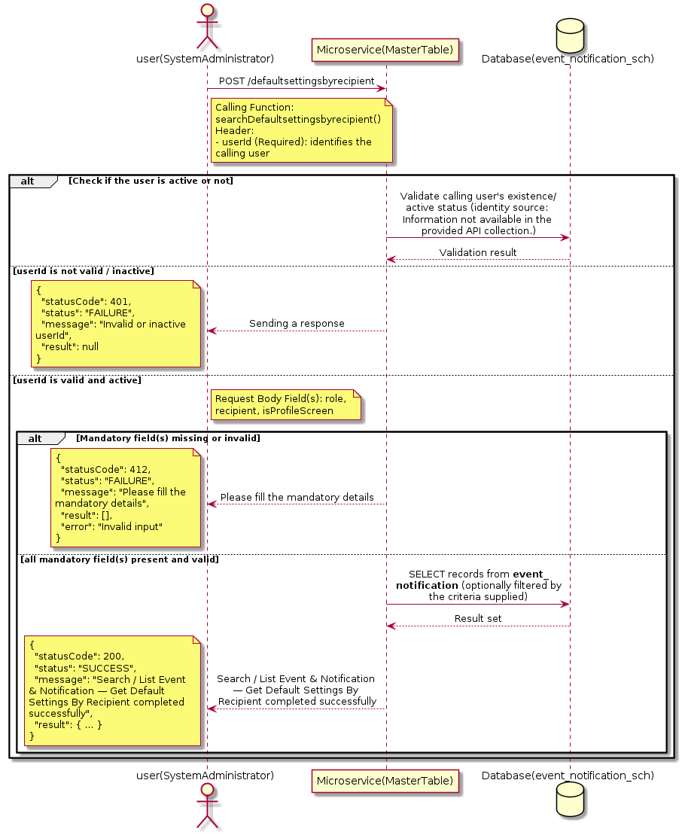

3.5.14.3 API Endpoint
Method | POST
URL | http://localhost:7002/srv2/genie/defaultsettingsbyrecipient
Headers | userId: 67 Content-Type: application/json
Authorization | Not present in the captured request. Information not available in the provided API collection.
Content-Type | Content-Type: application/json
Query Parameters | None
Path Variables | None
Request Body:
{
"role": 1,
"recipient": "ticket owner",
"isProfileScreen": "false"
}
Response Body (illustrative — see 3.x.4.5 Success Response for details):
The source Postman collection does not include a captured sample response for this request (the response array is empty). Information not available in the provided API collection. Section 3.5.14.4.5 below presents the response envelope inferred from the standard response wrapper used consistently by this platform's services.

3.5.14.4 Detailed Process Flow

3.5.14.4.1 Request Initiation
The flow begins when System Administrator (or a calling microservice on their behalf) invokes the POST endpoint http://localhost:7002/srv2/genie/defaultsettingsbyrecipient. The request must include the mandatory `userId` header used by the Master Table Microservice to identify the calling user for auditing purposes. The request carries a JSON payload in the request body which the Controller binds to its Data Transfer Object (DTO) before any processing begins. At the Controller layer, Spring Boot's request-mapping infrastructure routes the call to the appropriate handler method (`searchDefaultsettingsbyrecipient`), and Bean Validation annotations (if configured on the DTO) perform structural validation before the request reaches the Service layer. Information not available in the provided API collection. regarding the exact validation annotations used in the source code.

3.5.14.4.2 User Validation
The Master Table Microservice relies on the `userId` header to identify the calling user. Based on the pattern observed consistently across this API collection, the platform's authentication/authorization is expected to be enforced upstream (e.g., by an API Gateway or a shared security filter) using this identifier; the Postman collection does not include an `Authorization` / `Bearer` token header on this request, so the exact authentication mechanism (JWT validation, session lookup, or gateway-level SSO) is Information not available in the provided API collection. Role-based authorization — i.e., confirming that the user identified by `userId` holds a role/permission entitled to perform this operation — is expected to be enforced by the Service layer (see Section 8 – Controller Analysis and Section 14 – Authentication & Authorization), but the specific role/permission checks are Information not available in the provided API collection.

3.5.14.4.3 Business Logic
The Service layer evaluates the search payload; if the search text/criteria is empty, the operation typically behaves like a full list (all Event & Notification records); if populated, it is used to build a case-insensitive `LIKE`/contains predicate against the relevant column(s). The key fields exchanged for this operation, as observed in the sample payload, are: `role`, `recipient`, `isProfileScreen`.

3.5.14.4.4 Database Interaction
The Repository layer (Spring Data JPA) interacts with the underlying relational database that backs the Event & Notification master table. The primary operation issued is a **SELECT** against the table associated with Event & Notification. No write operations occur; the search is typically implemented using a JPA derived query method or a native/JPQL query with `LIKE` predicates. The exact table name, column names, primary/foreign key definitions, and JPA repository method signatures are not included in the Postman collection; therefore, precise schema details are information not available in the provided api collection.

3.5.14.4.5 Success Response
Status Code: 200 OK. Sample response envelope (illustrative — the source collection did not capture a sample response for this API):
{
"statusCode": 200,
"status": "SUCCESS",
"message": "Search / List Event & Notification — Get Default Settings By Recipient completed successfully",
"result": [
{
"id": 1,
"name": "Sample Event & Notification",
"isActive": 1
}
],
"error": null,
"corelationId": "c6f2a1e4-2b3d-4a9e-9f1a-1234567890ab",
"url": null
}

3.5.14.4.6 Conclusion
This API provides a well-defined, single-purpose capability within the Master Table Microservice for search / list event & notification — get default settings by recipient. The Controller → Service → Repository → Database layering keeps request validation, business rules, and persistence concerns separated, which allows the Event & Notification master data to be maintained consistently and safely by authorized administrators while remaining available for consumption by every other module that depends on this reference data.

3.5.15 Search / List Event & Notification — Get Events According to Recipient

3.5.15.1 Overview
Purpose: To search and list Event & Notification records based on a search payload (e.g., free-text search or structured criteria), supporting list/grid screens that need paginated or filtered master data.
Business Requirement: List/search screens for Event & Notification configuration need server-side search so that administrators can locate specific records in large master tables without scanning the full data set.
Who Uses the API: System Administrator / Notification Administrator operating the Event & Notification configuration/list screen.
Business Flow: Client sends a POST request with a search payload → Controller validates the payload → Service layer constructs the search/query logic → Repository executes the search against the Event & Notification table → matching records are returned to the Client.

3.5.15.2 Sequence Diagram
The diagram below illustrates the end-to-end interaction for "Search / List Event & Notification — Get Events According to Recipient" across the Client, Controller, Service, Repository, and Database layers.
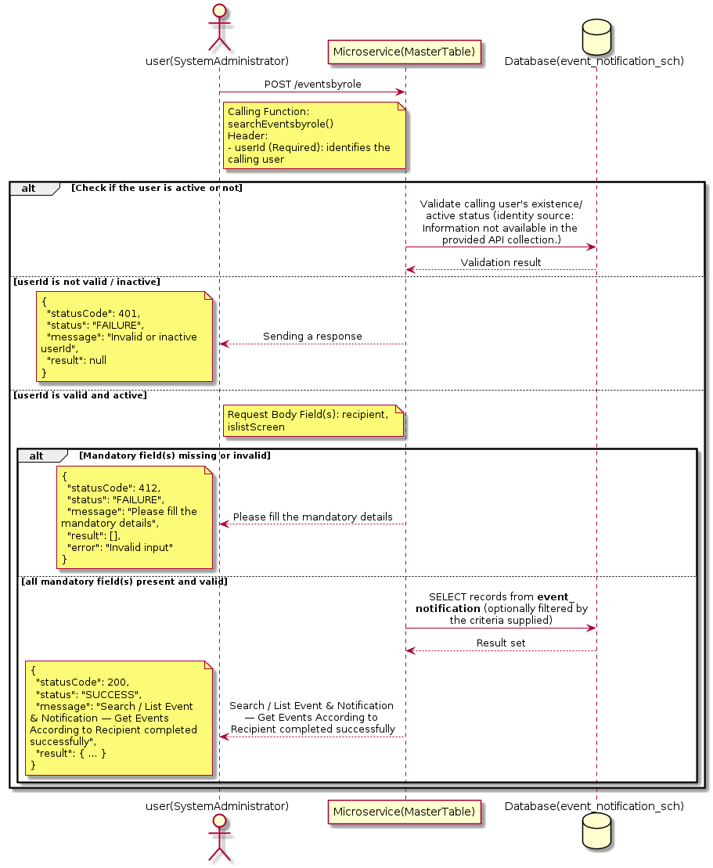

3.5.15.3 API Endpoint
Method | POST
URL | http://localhost:7002/srv2/genie/eventsbyrole
Headers | userId: 67 Content-Type: application/json
Authorization | Not present in the captured request. Information not available in the provided API collection.
Content-Type | Content-Type: application/json
Query Parameters | None
Path Variables | None
Request Body:
{
"recipient": "ticket owner",
"islistScreen": true
}
Response Body (illustrative — see 3.x.4.5 Success Response for details):
The source Postman collection does not include a captured sample response for this request (the response array is empty). Information not available in the provided API collection. Section 3.5.15.4.5 below presents the response envelope inferred from the standard response wrapper used consistently by this platform's services.

3.5.15.4 Detailed Process Flow

3.5.15.4.1 Request Initiation
The flow begins when System Administrator (or a calling microservice on their behalf) invokes the POST endpoint http://localhost:7002/srv2/genie/eventsbyrole. The request must include the mandatory `userId` header used by the Master Table Microservice to identify the calling user for auditing purposes. The request carries a JSON payload in the request body which the Controller binds to its Data Transfer Object (DTO) before any processing begins. At the Controller layer, Spring Boot's request-mapping infrastructure routes the call to the appropriate handler method (`searchEventsbyrole`), and Bean Validation annotations (if configured on the DTO) perform structural validation before the request reaches the Service layer. Information not available in the provided API collection. regarding the exact validation annotations used in the source code.

3.5.15.4.2 User Validation
The Master Table Microservice relies on the `userId` header to identify the calling user. Based on the pattern observed consistently across this API collection, the platform's authentication/authorization is expected to be enforced upstream (e.g., by an API Gateway or a shared security filter) using this identifier; the Postman collection does not include an `Authorization` / `Bearer` token header on this request, so the exact authentication mechanism (JWT validation, session lookup, or gateway-level SSO) is Information not available in the provided API collection. Role-based authorization — i.e., confirming that the user identified by `userId` holds a role/permission entitled to perform this operation — is expected to be enforced by the Service layer (see Section 8 – Controller Analysis and Section 14 – Authentication & Authorization), but the specific role/permission checks are Information not available in the provided API collection.

3.5.15.4.3 Business Logic
The Service layer evaluates the search payload; if the search text/criteria is empty, the operation typically behaves like a full list (all Event & Notification records); if populated, it is used to build a case-insensitive `LIKE`/contains predicate against the relevant column(s). The key fields exchanged for this operation, as observed in the sample payload, are: `recipient`, `islistScreen`.

3.5.15.4.4 Database Interaction
The Repository layer (Spring Data JPA) interacts with the underlying relational database that backs the Event & Notification master table. The primary operation issued is a **SELECT** against the table associated with Event & Notification. No write operations occur; the search is typically implemented using a JPA derived query method or a native/JPQL query with `LIKE` predicates. The exact table name, column names, primary/foreign key definitions, and JPA repository method signatures are not included in the Postman collection; therefore, precise schema details are information not available in the provided api collection.

3.5.15.4.5 Success Response
Status Code: 200 OK. Sample response envelope (illustrative — the source collection did not capture a sample response for this API):
{
"statusCode": 200,
"status": "SUCCESS",
"message": "Search / List Event & Notification — Get Events According to Recipient completed successfully",
"result": [
{
"id": 1,
"name": "Sample Event & Notification",
"isActive": 1
}
],
"error": null,
"corelationId": "c6f2a1e4-2b3d-4a9e-9f1a-1234567890ab",
"url": null
}

3.5.15.4.6 Conclusion
This API provides a well-defined, single-purpose capability within the Master Table Microservice for search / list event & notification — get events according to recipient. The Controller → Service → Repository → Database layering keeps request validation, business rules, and persistence concerns separated, which allows the Event & Notification master data to be maintained consistently and safely by authorized administrators while remaining available for consumption by every other module that depends on this reference data.

3.5.16 Enable / Disable Event & Notification — enabledisablenottification

3.5.16.1 Overview
Purpose: To enable or disable (soft-delete) a Event & Notification master record, allowing administrators to retire a record from active use while preserving it for historical/audit purposes.
Business Requirement: Rather than physically deleting a Event & Notification record (which could break referential integrity with historical tickets/records that reference it), the business requires a reversible enable/disable mechanism.
Who Uses the API: System Administrator / Notification Administrator responsible for activating/deactivating configuration values.
Business Flow: Client sends a request carrying the Event & Notification identifier and the desired active/inactive flag → Controller validates the payload → Service layer fetches the record and flips its status flag → Repository persists the change → the updated status is returned to the Client.

3.5.16.2 Sequence Diagram
The diagram below illustrates the end-to-end interaction for "Enable / Disable Event & Notification — enabledisablenottification" across the Client, Controller, Service, Repository, and Database layers.
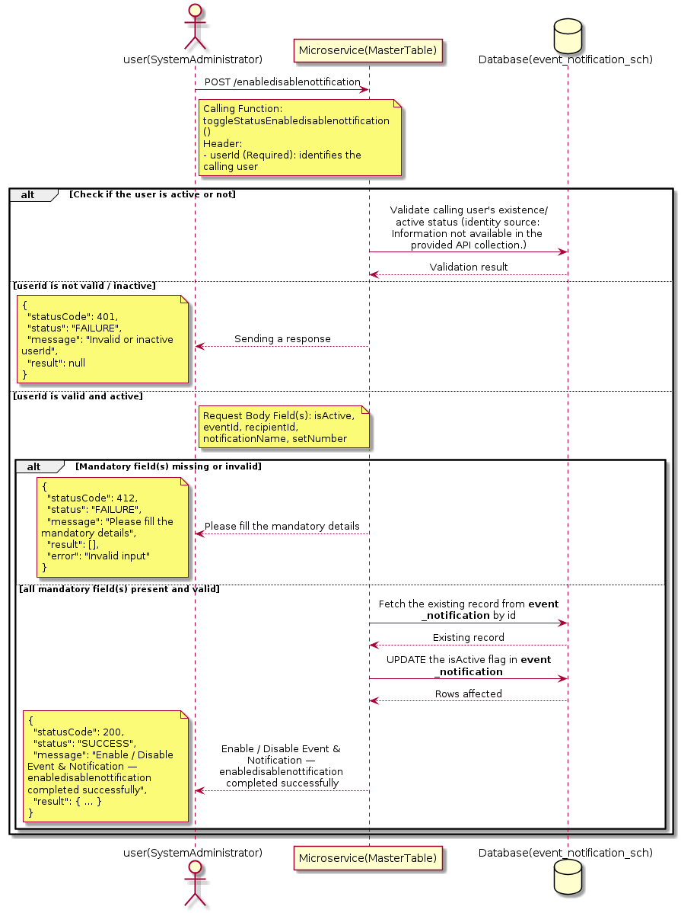

3.5.16.3 API Endpoint
Method | POST
URL | http://localhost:7002/srv2/genie/enabledisablenottification
Headers | userId: 67 Content-Type: application/json
Authorization | Not present in the captured request. Information not available in the provided API collection.
Content-Type | Content-Type: application/json
Query Parameters | None
Path Variables | None
Request Body:
{
"isActive": "1",
"eventId": 31,
"recipientId": 1,
"notificationName": "Test Notification1",
"setNumber": 1
}
Response Body (illustrative — see 3.x.4.5 Success Response for details):
The source Postman collection does not include a captured sample response for this request (the response array is empty). Information not available in the provided API collection. Section 3.5.16.4.5 below presents the response envelope inferred from the standard response wrapper used consistently by this platform's services.

3.5.16.4 Detailed Process Flow

3.5.16.4.1 Request Initiation
The flow begins when System Administrator (or a calling microservice on their behalf) invokes the POST endpoint http://localhost:7002/srv2/genie/enabledisablenottification. The request must include the mandatory `userId` header used by the Master Table Microservice to identify the calling user for auditing purposes. The request carries a JSON payload in the request body which the Controller binds to its Data Transfer Object (DTO) before any processing begins. At the Controller layer, Spring Boot's request-mapping infrastructure routes the call to the appropriate handler method (`toggleStatusEnabledisablenottification`), and Bean Validation annotations (if configured on the DTO) perform structural validation before the request reaches the Service layer. Information not available in the provided API collection. regarding the exact validation annotations used in the source code.

3.5.16.4.2 User Validation
The Master Table Microservice relies on the `userId` header to identify the calling user. Based on the pattern observed consistently across this API collection, the platform's authentication/authorization is expected to be enforced upstream (e.g., by an API Gateway or a shared security filter) using this identifier; the Postman collection does not include an `Authorization` / `Bearer` token header on this request, so the exact authentication mechanism (JWT validation, session lookup, or gateway-level SSO) is Information not available in the provided API collection. Role-based authorization — i.e., confirming that the user identified by `userId` holds a role/permission entitled to perform this operation — is expected to be enforced by the Service layer (see Section 8 – Controller Analysis and Section 14 – Authentication & Authorization), but the specific role/permission checks are Information not available in the provided API collection.

3.5.16.4.3 Business Logic
The Service layer fetches the existing Event & Notification record by its identifier and flips the `isActive` flag to the value supplied in the request. No other attributes of the record are modified by this operation. The key fields exchanged for this operation, as observed in the sample payload, are: `isActive`, `eventId`, `recipientId`, `notificationName`, `setNumber`.

3.5.16.4.4 Database Interaction
The Repository layer (Spring Data JPA) interacts with the underlying relational database that backs the Event & Notification master table. The primary operation issued is a **UPDATE** against the table associated with Event & Notification. Only the `is_active` (status) column is updated for the row identified by the primary key; all other columns remain unchanged. The exact table name, column names, primary/foreign key definitions, and JPA repository method signatures are not included in the Postman collection; therefore, precise schema details are information not available in the provided api collection.

3.5.16.4.5 Success Response
Status Code: 200 OK. Sample response envelope (illustrative — the source collection did not capture a sample response for this API):
{
"statusCode": 200,
"status": "SUCCESS",
"message": "Enable / Disable Event & Notification — enabledisablenottification completed successfully",
"result": {
"id": 1,
"isActive": 1
},
"error": null,
"corelationId": "c6f2a1e4-2b3d-4a9e-9f1a-1234567890ab",
"url": null
}

3.5.16.4.6 Conclusion
This API provides a well-defined, single-purpose capability within the Master Table Microservice for enable / disable event & notification — enabledisablenottification. The Controller → Service → Repository → Database layering keeps request validation, business rules, and persistence concerns separated, which allows the Event & Notification master data to be maintained consistently and safely by authorized administrators while remaining available for consumption by every other module that depends on this reference data.

3.5.17 Search / List Event & Notification — getallnotificationconfiguration

3.5.17.1 Overview
Purpose: To search and list Event & Notification records based on a search payload (e.g., free-text search or structured criteria), supporting list/grid screens that need paginated or filtered master data.
Business Requirement: List/search screens for Event & Notification configuration need server-side search so that administrators can locate specific records in large master tables without scanning the full data set.
Who Uses the API: System Administrator / Notification Administrator operating the Event & Notification configuration/list screen.
Business Flow: Client sends a POST request with a search payload → Controller validates the payload → Service layer constructs the search/query logic → Repository executes the search against the Event & Notification table → matching records are returned to the Client.

3.5.17.2 Sequence Diagram
The diagram below illustrates the end-to-end interaction for "Search / List Event & Notification — getallnotificationconfiguration" across the Client, Controller, Service, Repository, and Database layers.
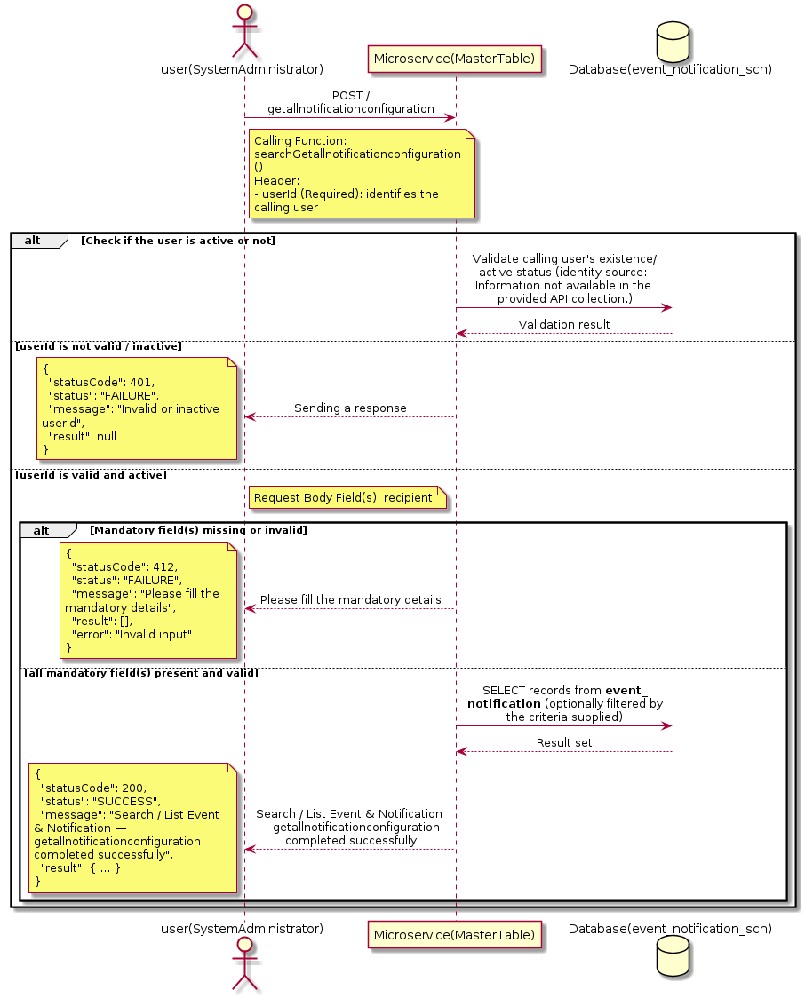

3.5.17.3 API Endpoint
Method | POST
URL | http://localhost:7002/srv2/genie/getallnotificationconfiguration
Headers | userId: 67 Content-Type: application/json
Authorization | Not present in the captured request. Information not available in the provided API collection.
Content-Type | Content-Type: application/json
Query Parameters | None
Path Variables | None
Request Body:
{
"recipient": "test"
}
Response Body (illustrative — see 3.x.4.5 Success Response for details):
The source Postman collection does not include a captured sample response for this request (the response array is empty). Information not available in the provided API collection. Section 3.5.17.4.5 below presents the response envelope inferred from the standard response wrapper used consistently by this platform's services.

3.5.17.4 Detailed Process Flow

3.5.17.4.1 Request Initiation
The flow begins when System Administrator (or a calling microservice on their behalf) invokes the POST endpoint http://localhost:7002/srv2/genie/getallnotificationconfiguration. The request must include the mandatory `userId` header used by the Master Table Microservice to identify the calling user for auditing purposes. The request carries a JSON payload in the request body which the Controller binds to its Data Transfer Object (DTO) before any processing begins. At the Controller layer, Spring Boot's request-mapping infrastructure routes the call to the appropriate handler method (`searchGetallnotificationconfiguration`), and Bean Validation annotations (if configured on the DTO) perform structural validation before the request reaches the Service layer. Information not available in the provided API collection. regarding the exact validation annotations used in the source code.

3.5.17.4.2 User Validation
The Master Table Microservice relies on the `userId` header to identify the calling user. Based on the pattern observed consistently across this API collection, the platform's authentication/authorization is expected to be enforced upstream (e.g., by an API Gateway or a shared security filter) using this identifier; the Postman collection does not include an `Authorization` / `Bearer` token header on this request, so the exact authentication mechanism (JWT validation, session lookup, or gateway-level SSO) is Information not available in the provided API collection. Role-based authorization — i.e., confirming that the user identified by `userId` holds a role/permission entitled to perform this operation — is expected to be enforced by the Service layer (see Section 8 – Controller Analysis and Section 14 – Authentication & Authorization), but the specific role/permission checks are Information not available in the provided API collection.

3.5.17.4.3 Business Logic
The Service layer evaluates the search payload; if the search text/criteria is empty, the operation typically behaves like a full list (all Event & Notification records); if populated, it is used to build a case-insensitive `LIKE`/contains predicate against the relevant column(s). The key fields exchanged for this operation, as observed in the sample payload, are: `recipient`.

3.5.17.4.4 Database Interaction
The Repository layer (Spring Data JPA) interacts with the underlying relational database that backs the Event & Notification master table. The primary operation issued is a **SELECT** against the table associated with Event & Notification. No write operations occur; the search is typically implemented using a JPA derived query method or a native/JPQL query with `LIKE` predicates. The exact table name, column names, primary/foreign key definitions, and JPA repository method signatures are not included in the Postman collection; therefore, precise schema details are information not available in the provided api collection.

3.5.17.4.5 Success Response
Status Code: 200 OK. Sample response envelope (illustrative — the source collection did not capture a sample response for this API):
{
"statusCode": 200,
"status": "SUCCESS",
"message": "Search / List Event & Notification — getallnotificationconfiguration completed successfully",
"result": [
{
"id": 1,
"name": "Sample Event & Notification",
"isActive": 1
}
],
"error": null,
"corelationId": "c6f2a1e4-2b3d-4a9e-9f1a-1234567890ab",
"url": null
}

3.5.17.4.6 Conclusion
This API provides a well-defined, single-purpose capability within the Master Table Microservice for search / list event & notification — getallnotificationconfiguration. The Controller → Service → Repository → Database layering keeps request validation, business rules, and persistence concerns separated, which allows the Event & Notification master data to be maintained consistently and safely by authorized administrators while remaining available for consumption by every other module that depends on this reference data.
3.5.18 Enable / Disable Event & Notification — enabledsiableDefaultsettings

3.5.18.1 Overview
Purpose: To enable or disable (soft-delete) a Event & Notification master record, allowing administrators to retire a record from active use while preserving it for historical/audit purposes.
Business Requirement: Rather than physically deleting a Event & Notification record (which could break referential integrity with historical tickets/records that reference it), the business requires a reversible enable/disable mechanism.
Who Uses the API: System Administrator / Notification Administrator responsible for activating/deactivating configuration values.
Business Flow: Client sends a request carrying the Event & Notification identifier and the desired active/inactive flag → Controller validates the payload → Service layer fetches the record and flips its status flag → Repository persists the change → the updated status is returned to the Client.

3.5.18.2 Sequence Diagram
The diagram below illustrates the end-to-end interaction for "Enable / Disable Event & Notification — enabledsiableDefaultsettings" across the Client, Controller, Service, Repository, and Database layers.
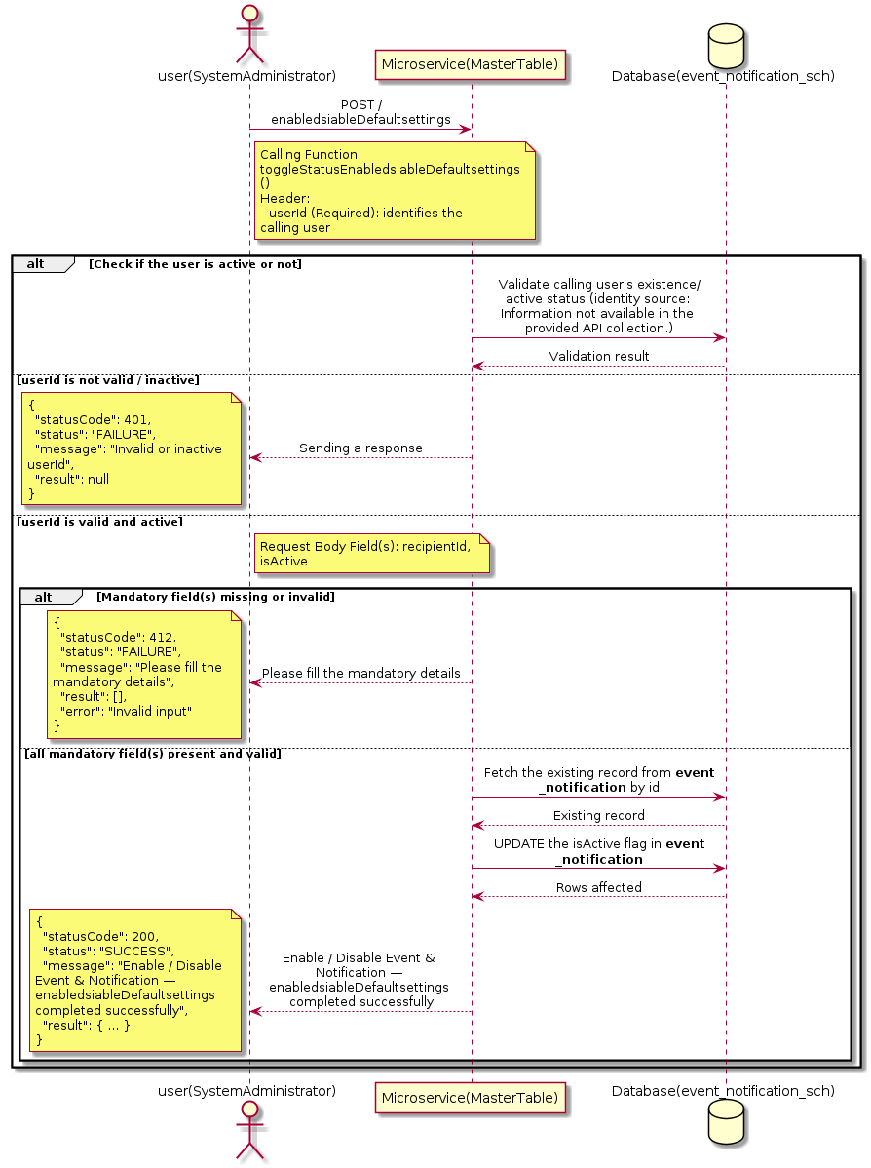

3.5.18.3 API Endpoint
Method | POST
URL | http://localhost:7002/srv2/genie/enabledsiableDefaultsettings
Headers | userId: 67 Content-Type: application/json
Authorization | Not present in the captured request. Information not available in the provided API collection.
Content-Type | Content-Type: application/json
Query Parameters | None
Path Variables | None
Request Body:
{
"recipientId": 1,
"isActive": "1"
}
Response Body (illustrative — see 3.x.4.5 Success Response for details):
The source Postman collection does not include a captured sample response for this request (the response array is empty). Information not available in the provided API collection. Section 3.5.18.4.5 below presents the response envelope inferred from the standard response wrapper used consistently by this platform's services.

3.5.18.4 Detailed Process Flow

3.5.18.4.1 Request Initiation
The flow begins when System Administrator (or a calling microservice on their behalf) invokes the POST endpoint http://localhost:7002/srv2/genie/enabledsiableDefaultsettings. The request must include the mandatory `userId` header used by the Master Table Microservice to identify the calling user for auditing purposes. The request carries a JSON payload in the request body which the Controller binds to its Data Transfer Object (DTO) before any processing begins. At the Controller layer, Spring Boot's request-mapping infrastructure routes the call to the appropriate handler method (`toggleStatusEnabledsiableDefaultsettings`), and Bean Validation annotations (if configured on the DTO) perform structural validation before the request reaches the Service layer. Information not available in the provided API collection. regarding the exact validation annotations used in the source code.

3.5.18.4.2 User Validation
The Master Table Microservice relies on the `userId` header to identify the calling user. Based on the pattern observed consistently across this API collection, the platform's authentication/authorization is expected to be enforced upstream (e.g., by an API Gateway or a shared security filter) using this identifier; the Postman collection does not include an `Authorization` / `Bearer` token header on this request, so the exact authentication mechanism (JWT validation, session lookup, or gateway-level SSO) is Information not available in the provided API collection. Role-based authorization — i.e., confirming that the user identified by `userId` holds a role/permission entitled to perform this operation — is expected to be enforced by the Service layer (see Section 8 – Controller Analysis and Section 14 – Authentication & Authorization), but the specific role/permission checks are Information not available in the provided API collection.

3.5.18.4.3 Business Logic
The Service layer fetches the existing Event & Notification record by its identifier and flips the `isActive` flag to the value supplied in the request. No other attributes of the record are modified by this operation. The key fields exchanged for this operation, as observed in the sample payload, are: `recipientId`, `isActive`.

3.5.18.4.4 Database Interaction
The Repository layer (Spring Data JPA) interacts with the underlying relational database that backs the Event & Notification master table. The primary operation issued is a **UPDATE** against the table associated with Event & Notification. Only the `is_active` (status) column is updated for the row identified by the primary key; all other columns remain unchanged. The exact table name, column names, primary/foreign key definitions, and JPA repository method signatures are not included in the Postman collection; therefore, precise schema details are information not available in the provided api collection.

3.5.18.4.5 Success Response
Status Code: 200 OK. Sample response envelope (illustrative — the source collection did not capture a sample response for this API):
{
"statusCode": 200,
"status": "SUCCESS",
"message": "Enable / Disable Event & Notification — enabledsiableDefaultsettings completed successfully",
"result": {
"id": 1,
"isActive": 1
},
"error": null,
"corelationId": "c6f2a1e4-2b3d-4a9e-9f1a-1234567890ab",
"url": null
}

3.5.18.4.6 Conclusion
This API provides a well-defined, single-purpose capability within the Master Table Microservice for enable / disable event & notification — enabledsiabledefaultsettings. The Controller → Service → Repository → Database layering keeps request validation, business rules, and persistence concerns separated, which allows the Event & Notification master data to be maintained consistently and safely by authorized administrators while remaining available for consumption by every other module that depends on this reference data.

3.5.19 Update Event & Notification — Update Event Recipients (Notification Config)

3.5.19.1 Overview
Purpose: To update an existing Event & Notification master record, allowing administrators to correct or evolve master-data attributes without impacting the record's identity/history.
Business Requirement: Master data changes over time (renames, corrections, re-classification); the platform must allow controlled updates while preserving referential integrity for records that already reference this Event & Notification.
Who Uses the API: System Administrator / Notification Administrator responsible for maintaining master-data accuracy.
Business Flow: Client sends a PUT/PATCH request with the updated Event & Notification payload → Controller validates the payload → Service layer fetches the existing record, applies the changes, and re-validates business rules → Repository persists the updated record → the updated record is returned to the Client.

3.5.19.2 Sequence Diagram
The diagram below illustrates the end-to-end interaction for "Update Event & Notification — Update Event Recipients (Notification Config)" across the Client, Controller, Service, Repository, and Database layers.
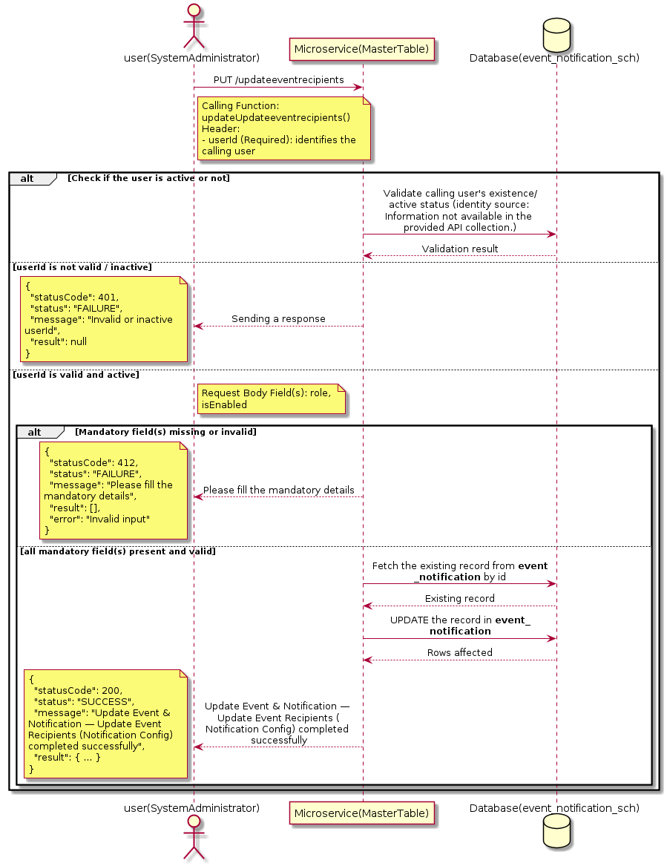

3.5.19.3 API Endpoint
Method | PUT
URL | http://localhost:7002/srv2/genie/updateeventrecipients
Headers | userId: 67 Content-Type: application/json
Authorization | Not present in the captured request. Information not available in the provided API collection.
Content-Type | Content-Type: application/json
Query Parameters | None
Path Variables | None
Request Body:
{
"eventId": [
31
],
"role": 12,
"isEnabled": "1"
}
Response Body (illustrative — see 3.x.4.5 Success Response for details):
The source Postman collection does not include a captured sample response for this request (the response array is empty). Information not available in the provided API collection. Section 3.5.19.4.5 below presents the response envelope inferred from the standard response wrapper used consistently by this platform's services.

3.5.19.4 Detailed Process Flow

3.5.19.4.1 Request Initiation
The flow begins when System Administrator (or a calling microservice on their behalf) invokes the PUT endpoint http://localhost:7002/srv2/genie/updateeventrecipients. The request must include the mandatory `userId` header used by the Master Table Microservice to identify the calling user for auditing purposes. The request carries a JSON payload in the request body which the Controller binds to its Data Transfer Object (DTO) before any processing begins. At the Controller layer, Spring Boot's request-mapping infrastructure routes the call to the appropriate handler method (`updateUpdateeventrecipients`), and Bean Validation annotations (if configured on the DTO) perform structural validation before the request reaches the Service layer. Information not available in the provided API collection. regarding the exact validation annotations used in the source code.

3.5.19.4.2 User Validation
The Master Table Microservice relies on the `userId` header to identify the calling user. Based on the pattern observed consistently across this API collection, the platform's authentication/authorization is expected to be enforced upstream (e.g., by an API Gateway or a shared security filter) using this identifier; the Postman collection does not include an `Authorization` / `Bearer` token header on this request, so the exact authentication mechanism (JWT validation, session lookup, or gateway-level SSO) is Information not available in the provided API collection. Role-based authorization — i.e., confirming that the user identified by `userId` holds a role/permission entitled to perform this operation — is expected to be enforced by the Service layer (see Section 8 – Controller Analysis and Section 14 – Authentication & Authorization), but the specific role/permission checks are Information not available in the provided API collection.

3.5.19.4.3 Business Logic
The Service layer fetches the existing Event & Notification record by its identifier, verifies it exists, applies the incoming changes field by field, re-validates business rules (e.g., uniqueness of a renamed field), and persists the updated entity via the Repository. If the record does not exist, the operation is rejected with a not-found error. The key fields exchanged for this operation, as observed in the sample payload, are: `role`, `isEnabled`.

3.5.19.4.4 Database Interaction
The Repository layer (Spring Data JPA) interacts with the underlying relational database that backs the Event & Notification master table. The primary operation issued is a **UPDATE** against the table associated with Event & Notification. The existing row is located by primary key and updated; if the entity has related child records, the existing child rows are typically replaced/updated within the same transaction. The exact table name, column names, primary/foreign key definitions, and JPA repository method signatures are not included in the Postman collection; therefore, precise schema details are information not available in the provided api collection.

3.5.19.4.5 Success Response
Status Code: 200 OK. Sample response envelope (illustrative — the source collection did not capture a sample response for this API):
{
"statusCode": 200,
"status": "SUCCESS",
"message": "Update Event & Notification — Update Event Recipients (Notification Config) completed successfully",
"result": {
"id": 1,
"isActive": 1
},
"error": null,
"corelationId": "c6f2a1e4-2b3d-4a9e-9f1a-1234567890ab",
"url": null
}

3.5.19.4.6 Conclusion
This API provides a well-defined, single-purpose capability within the Master Table Microservice for update event & notification — update event recipients (notification config). The Controller → Service → Repository → Database layering keeps request validation, business rules, and persistence concerns separated, which allows the Event & Notification master data to be maintained consistently and safely by authorized administrators while remaining available for consumption by every other module that depends on this reference data.

3.5.20 Update Event & Notification — Update Notification Configuration for CSR Manager

3.5.20.1 Overview
Purpose: To update an existing Event & Notification master record, allowing administrators to correct or evolve master-data attributes without impacting the record's identity/history.
Business Requirement: Master data changes over time (renames, corrections, re-classification); the platform must allow controlled updates while preserving referential integrity for records that already reference this Event & Notification.
Who Uses the API: System Administrator / Notification Administrator responsible for maintaining master-data accuracy.
Business Flow: Client sends a PUT/PATCH request with the updated Event & Notification payload → Controller validates the payload → Service layer fetches the existing record, applies the changes, and re-validates business rules → Repository persists the updated record → the updated record is returned to the Client.

3.5.20.2 Sequence Diagram
The diagram below illustrates the end-to-end interaction for "Update Event & Notification — Update Notification Configuration for CSR Manager" across the Client, Controller, Service, Repository, and Database layers.
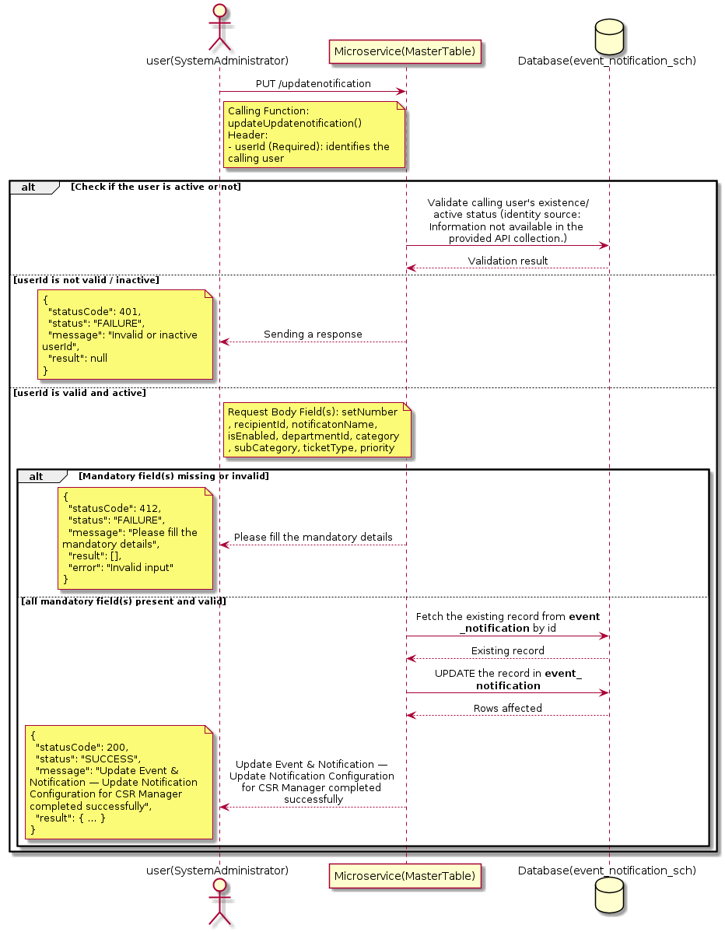

3.5.20.3 API Endpoint
Method | PUT
URL | http://localhost:7002/srv2/genie/updatenotification
Headers | userId: 67 Content-Type: application/json
Authorization | Not present in the captured request. Information not available in the provided API collection.
Content-Type | Content-Type: application/json
Query Parameters | None
Path Variables | None
Request Body:
{
"eventId": [
31
],
"setNumber": 1,
"recipientId": 14,
"notificatonName": "Updated Config with Filters",
"isEnabled": "1",
"departmentId": 1,
"category": 1,
"subCategory": 1,
"ticketType": 1,
"priority": 1
}
Response Body (illustrative — see 3.x.4.5 Success Response for details):
The source Postman collection does not include a captured sample response for this request (the response array is empty). Information not available in the provided API collection. Section 3.5.20.4.5 below presents the response envelope inferred from the standard response wrapper used consistently by this platform's services.

3.5.20.4 Detailed Process Flow

3.5.20.4.1 Request Initiation
The flow begins when System Administrator (or a calling microservice on their behalf) invokes the PUT endpoint http://localhost:7002/srv2/genie/updatenotification. The request must include the mandatory `userId` header used by the Master Table Microservice to identify the calling user for auditing purposes. The request carries a JSON payload in the request body which the Controller binds to its Data Transfer Object (DTO) before any processing begins. At the Controller layer, Spring Boot's request-mapping infrastructure routes the call to the appropriate handler method (`updateUpdatenotification`), and Bean Validation annotations (if configured on the DTO) perform structural validation before the request reaches the Service layer. Information not available in the provided API collection. regarding the exact validation annotations used in the source code.

3.5.20.4.2 User Validation
The Master Table Microservice relies on the `userId` header to identify the calling user. Based on the pattern observed consistently across this API collection, the platform's authentication/authorization is expected to be enforced upstream (e.g., by an API Gateway or a shared security filter) using this identifier; the Postman collection does not include an `Authorization` / `Bearer` token header on this request, so the exact authentication mechanism (JWT validation, session lookup, or gateway-level SSO) is Information not available in the provided API collection. Role-based authorization — i.e., confirming that the user identified by `userId` holds a role/permission entitled to perform this operation — is expected to be enforced by the Service layer (see Section 8 – Controller Analysis and Section 14 – Authentication & Authorization), but the specific role/permission checks are Information not available in the provided API collection.

3.5.20.4.3 Business Logic
The Service layer fetches the existing Event & Notification record by its identifier, verifies it exists, applies the incoming changes field by field, re-validates business rules (e.g., uniqueness of a renamed field), and persists the updated entity via the Repository. If the record does not exist, the operation is rejected with a not-found error. The key fields exchanged for this operation, as observed in the sample payload, are: `setNumber`, `recipientId`, `notificatonName`, `isEnabled`, `departmentId`, `category`, `subCategory`, `ticketType`, `priority`.

3.5.20.4.4 Database Interaction
The Repository layer (Spring Data JPA) interacts with the underlying relational database that backs the Event & Notification master table. The primary operation issued is a **UPDATE** against the table associated with Event & Notification. The existing row is located by primary key and updated; if the entity has related child records, the existing child rows are typically replaced/updated within the same transaction. The exact table name, column names, primary/foreign key definitions, and JPA repository method signatures are not included in the Postman collection; therefore, precise schema details are information not available in the provided api collection.

3.5.20.4.5 Success Response
Status Code: 200 OK. Sample response envelope (illustrative — the source collection did not capture a sample response for this API):
{
"statusCode": 200,
"status": "SUCCESS",
"message": "Update Event & Notification — Update Notification Configuration for CSR Manager completed successfully",
"result": {
"id": 1,
"isActive": 1
},
"error": null,
"corelationId": "c6f2a1e4-2b3d-4a9e-9f1a-1234567890ab",
"url": null
}

3.5.20.4.6 Conclusion
This API provides a well-defined, single-purpose capability within the Master Table Microservice for update event & notification — update notification configuration for csr manager. The Controller → Service → Repository → Database layering keeps request validation, business rules, and persistence concerns separated, which allows the Event & Notification master data to be maintained consistently and safely by authorized administrators while remaining available for consumption by every other module that depends on this reference data.

3.5.21 Search / List Event & Notification — Get Notification Configuration for CSR Manager

3.5.21.1 Overview
Purpose: To search and list Event & Notification records based on a search payload (e.g., free-text search or structured criteria), supporting list/grid screens that need paginated or filtered master data.
Business Requirement: List/search screens for Event & Notification configuration need server-side search so that administrators can locate specific records in large master tables without scanning the full data set.
Who Uses the API: System Administrator / Notification Administrator operating the Event & Notification configuration/list screen.
Business Flow: Client sends a POST request with a search payload → Controller validates the payload → Service layer constructs the search/query logic → Repository executes the search against the Event & Notification table → matching records are returned to the Client.

3.5.21.2 Sequence Diagram
The diagram below illustrates the end-to-end interaction for "Search / List Event & Notification — Get Notification Configuration for CSR Manager" across the Client, Controller, Service, Repository, and Database layers.
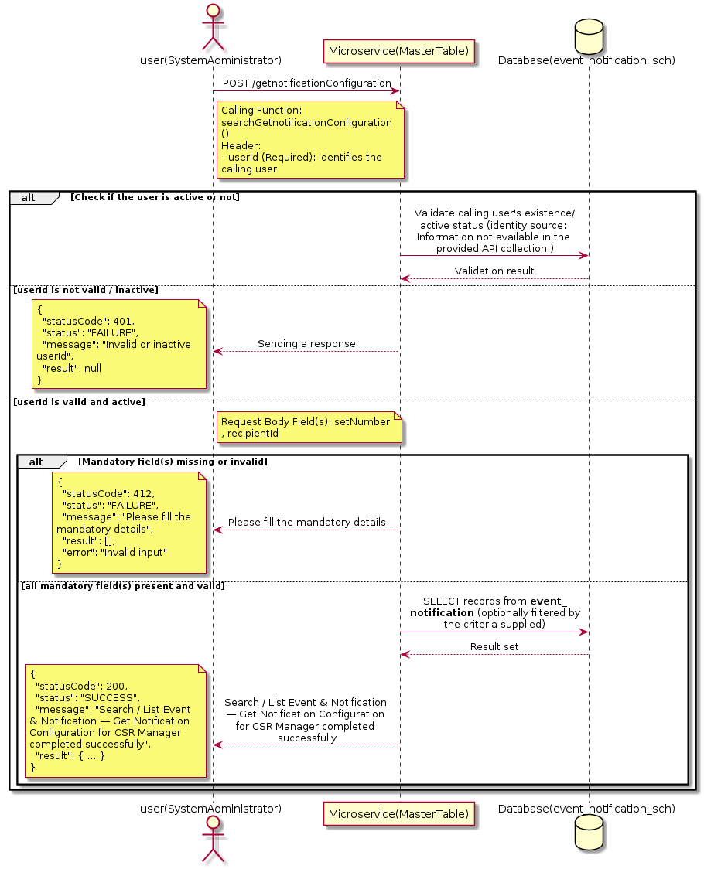

3.5.21.3 API Endpoint
Method | POST
URL | http://localhost:7002/srv2/genie/getnotificationConfiguration
Headers | userId: 67 Content-Type: application/json
Authorization | Not present in the captured request. Information not available in the provided API collection.
Content-Type | Content-Type: application/json
Query Parameters | None
Path Variables | None
Request Body:
{
"setNumber": 1,
"recipientId": 14
}
Response Body (illustrative — see 3.x.4.5 Success Response for details):
The source Postman collection does not include a captured sample response for this request (the response array is empty). Information not available in the provided API collection. Section 3.5.21.4.5 below presents the response envelope inferred from the standard response wrapper used consistently by this platform's services.

3.5.21.4 Detailed Process Flow

3.5.21.4.1 Request Initiation
The flow begins when System Administrator (or a calling microservice on their behalf) invokes the POST endpoint http://localhost:7002/srv2/genie/getnotificationConfiguration. The request must include the mandatory `userId` header used by the Master Table Microservice to identify the calling user for auditing purposes. The request carries a JSON payload in the request body which the Controller binds to its Data Transfer Object (DTO) before any processing begins. At the Controller layer, Spring Boot's request-mapping infrastructure routes the call to the appropriate handler method (`searchGetnotificationConfiguration`), and Bean Validation annotations (if configured on the DTO) perform structural validation before the request reaches the Service layer. Information not available in the provided API collection. regarding the exact validation annotations used in the source code.

3.5.21.4.2 User Validation
The Master Table Microservice relies on the `userId` header to identify the calling user. Based on the pattern observed consistently across this API collection, the platform's authentication/authorization is expected to be enforced upstream (e.g., by an API Gateway or a shared security filter) using this identifier; the Postman collection does not include an `Authorization` / `Bearer` token header on this request, so the exact authentication mechanism (JWT validation, session lookup, or gateway-level SSO) is Information not available in the provided API collection. Role-based authorization — i.e., confirming that the user identified by `userId` holds a role/permission entitled to perform this operation — is expected to be enforced by the Service layer (see Section 8 – Controller Analysis and Section 14 – Authentication & Authorization), but the specific role/permission checks are Information not available in the provided API collection.

3.5.21.4.3 Business Logic
The Service layer evaluates the search payload; if the search text/criteria is empty, the operation typically behaves like a full list (all Event & Notification records); if populated, it is used to build a case-insensitive `LIKE`/contains predicate against the relevant column(s). The key fields exchanged for this operation, as observed in the sample payload, are: `setNumber`, `recipientId`.

3.5.21.4.4 Database Interaction
The Repository layer (Spring Data JPA) interacts with the underlying relational database that backs the Event & Notification master table. The primary operation issued is a **SELECT** against the table associated with Event & Notification. No write operations occur; the search is typically implemented using a JPA derived query method or a native/JPQL query with `LIKE` predicates. The exact table name, column names, primary/foreign key definitions, and JPA repository method signatures are not included in the Postman collection; therefore, precise schema details are information not available in the provided api collection.

3.5.21.4.5 Success Response
Status Code: 200 OK. Sample response envelope (illustrative — the source collection did not capture a sample response for this API):
{
"statusCode": 200,
"status": "SUCCESS",
"message": "Search / List Event & Notification — Get Notification Configuration for CSR Manager completed successfully",
"result": [
{
"id": 1,
"name": "Sample Event & Notification",
"isActive": 1
}
],
"error": null,
"corelationId": "c6f2a1e4-2b3d-4a9e-9f1a-1234567890ab",
"url": null
}

3.5.21.4.6 Conclusion
This API provides a well-defined, single-purpose capability within the Master Table Microservice for search / list event & notification — get notification configuration for csr manager. The Controller → Service → Repository → Database layering keeps request validation, business rules, and persistence concerns separated, which allows the Event & Notification master data to be maintained consistently and safely by authorized administrators while remaining available for consumption by every other module that depends on this reference data.

3.5.22 Create Event & Notification — create notifications

3.5.22.1 Overview
Purpose: To create a new Event & Notification master record in the system, allowing administrators to extend the master-data catalogue that other modules (ticketing, workflow, notifications) depend on.
Business Requirement: Business/process owners need a controlled way to add new Event & Notification values so that the platform's classification, routing, and reporting capabilities can evolve as the organization changes.
Who Uses the API: System Administrator / Notification Administrator responsible for master-data configuration.
Business Flow: Client sends a POST request with the new Event & Notification payload → Controller validates the payload (mandatory fields, formats) → Service layer applies business rules (e.g., duplicate-name check) → Repository persists the new record → the created record (with generated identifier) is returned to the Client.

3.5.22.2 Sequence Diagram
The diagram below illustrates the end-to-end interaction for "Create Event & Notification — create notifications" across the Client, Controller, Service, Repository, and Database layers.
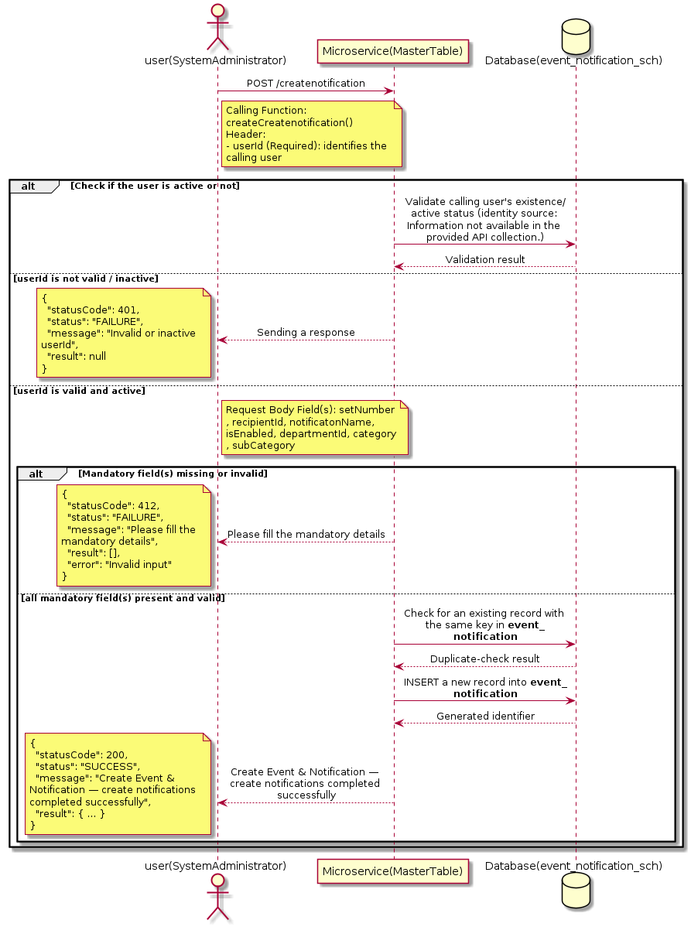

3.5.22.3 API Endpoint
Method | POST
URL | http://localhost:7002/srv2/genie/createnotification
Headers | userId: 67 Content-Type: application/json
Authorization | Not present in the captured request. Information not available in the provided API collection.
Content-Type | Content-Type: application/json
Query Parameters | None
Path Variables | None
Request Body:
{
"eventId": [
32
],
"setNumber": 1,
"recipientId": 14,
"notificatonName": "Ticket Owner Notification Configuration",
"isEnabled": "1",
"departmentId": 1,
"category": 1,
"subCategory": 1
}
Response Body (illustrative — see 3.x.4.5 Success Response for details):
The source Postman collection does not include a captured sample response for this request (the response array is empty). Information not available in the provided API collection. Section 3.5.22.4.5 below presents the response envelope inferred from the standard response wrapper used consistently by this platform's services.

3.5.22.4 Detailed Process Flow

3.5.22.4.1 Request Initiation
The flow begins when System Administrator (or a calling microservice on their behalf) invokes the POST endpoint http://localhost:7002/srv2/genie/createnotification. The request must include the mandatory `userId` header used by the Master Table Microservice to identify the calling user for auditing purposes. The request carries a JSON payload in the request body which the Controller binds to its Data Transfer Object (DTO) before any processing begins. At the Controller layer, Spring Boot's request-mapping infrastructure routes the call to the appropriate handler method (`createCreatenotification`), and Bean Validation annotations (if configured on the DTO) perform structural validation before the request reaches the Service layer. Information not available in the provided API collection. regarding the exact validation annotations used in the source code.

3.5.22.4.2 User Validation
The Master Table Microservice relies on the `userId` header to identify the calling user. Based on the pattern observed consistently across this API collection, the platform's authentication/authorization is expected to be enforced upstream (e.g., by an API Gateway or a shared security filter) using this identifier; the Postman collection does not include an `Authorization` / `Bearer` token header on this request, so the exact authentication mechanism (JWT validation, session lookup, or gateway-level SSO) is Information not available in the provided API collection. Role-based authorization — i.e., confirming that the user identified by `userId` holds a role/permission entitled to perform this operation — is expected to be enforced by the Service layer (see Section 8 – Controller Analysis and Section 14 – Authentication & Authorization), but the specific role/permission checks are Information not available in the provided API collection.

3.5.22.4.3 Business Logic
The Service layer performs the following: (1) validates that mandatory fields are present and correctly formatted, (2) checks for duplicates (e.g., an existing Event & Notification with the same name/code), (3) sets system-managed fields (e.g., `isActive = 1`, `createdBy`, timestamps) where applicable, and (4) persists the new record via the Repository. If any validation fails, the Service layer returns a business error rather than proceeding to persistence. The key fields exchanged for this operation, as observed in the sample payload, are: `setNumber`, `recipientId`, `notificatonName`, `isEnabled`, `departmentId`, `category`, `subCategory`.

3.5.22.4.4 Database Interaction
The Repository layer (Spring Data JPA) interacts with the underlying relational database that backs the Event & Notification master table. The primary operation issued is a **INSERT** against the table associated with Event & Notification. A new row is inserted into the master table; if the entity has related child records (as seen in nested request payload arrays), corresponding child-table inserts are performed within the same transaction. The exact table name, column names, primary/foreign key definitions, and JPA repository method signatures are not included in the Postman collection; therefore, precise schema details are information not available in the provided api collection.

3.5.22.4.5 Success Response
Status Code: 200 OK. Sample response envelope (illustrative — the source collection did not capture a sample response for this API):
{
"statusCode": 200,
"status": "SUCCESS",
"message": "Create Event & Notification — create notifications completed successfully",
"result": {
"id": 101,
"setNumber": 1,
"recipientId": 14,
"notificatonName": "Ticket Owner Notification Configuration",
"isEnabled": "1",
"departmentId": 1,
"category": 1,
"subCategory": 1
},
"error": null,
"corelationId": "c6f2a1e4-2b3d-4a9e-9f1a-1234567890ab",
"url": null
}

3.5.22.4.6 Conclusion
This API provides a well-defined, single-purpose capability within the Master Table Microservice for create event & notification — create notifications. The Controller → Service → Repository → Database layering keeps request validation, business rules, and persistence concerns separated, which allows the Event & Notification master data to be maintained consistently and safely by authorized administrators while remaining available for consumption by every other module that depends on this reference data.

3.6 General / File Settings APIs (General Settings)
Maintains cross-cutting configuration such as file-upload constraints and provides the platform’s global search capability across master data.

3.6.1 Retrieve All General / File Settings

3.6.1.1 Overview
Purpose: To retrieve the complete list of General / File Settings master records configured in the Master Table Microservice, so that consuming screens and downstream services can populate dropdowns, grids, and configuration views.
Business Requirement: Every screen and workflow that references General / File Settings data (creation forms, filters, reports) needs an authoritative, always-current list of active General / File Settings values sourced from a single master table rather than being hard-coded.
Who Uses the API: System Administrator, and any internal microservice/UI module that needs to render General / File Settings options.
Business Flow: Client sends a GET request → Controller delegates to the Service layer → Service layer calls the Repository → Repository queries the General / File Settings table → the result set is mapped to response DTOs and returned to the Client.

3.6.1.2 Sequence Diagram
The diagram below illustrates the end-to-end interaction for "Retrieve All General / File Settings" across the Client, Controller, Service, Repository, and Database layers.
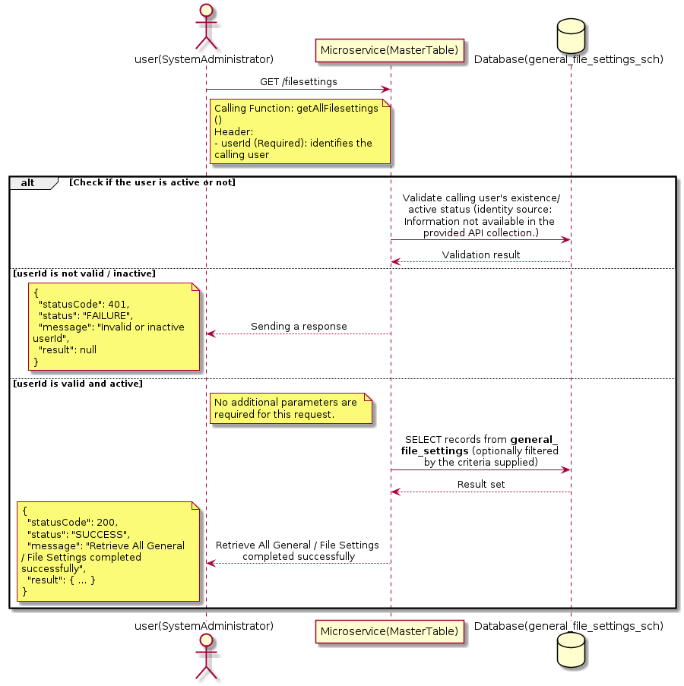

3.6.1.3 API Endpoint
Method | GET
URL | http://localhost:7002/srv2/genie/filesettings
Headers | userId: 67
Authorization | Not present in the captured request. Information not available in the provided API collection.
Content-Type | application/json (assumed)
Query Parameters | None
Path Variables | None
Request Body:
Not applicable — this operation does not accept a request body.
Response Body (illustrative — see 3.x.4.5 Success Response for details):
The source Postman collection does not include a captured sample response for this request (the response array is empty). Information not available in the provided API collection. Section 3.6.1.4.5 below presents the response envelope inferred from the standard response wrapper used consistently by this platform's services.

3.6.1.4 Detailed Process Flow

3.6.1.4.1 Request Initiation
The flow begins when System Administrator (or a calling microservice on their behalf) invokes the GET endpoint http://localhost:7002/srv2/genie/filesettings. The request must include the mandatory `userId` header used by the Master Table Microservice to identify the calling user for auditing purposes. At the Controller layer, Spring Boot's request-mapping infrastructure routes the call to the appropriate handler method (`getAllFilesettings`), and Bean Validation annotations (if configured on the DTO) perform structural validation before the request reaches the Service layer. Information not available in the provided API collection. regarding the exact validation annotations used in the source code.

3.6.1.4.2 User Validation
The Master Table Microservice relies on the `userId` header to identify the calling user. Based on the pattern observed consistently across this API collection, the platform's authentication/authorization is expected to be enforced upstream (e.g., by an API Gateway or a shared security filter) using this identifier; the Postman collection does not include an `Authorization` / `Bearer` token header on this request, so the exact authentication mechanism (JWT validation, session lookup, or gateway-level SSO) is Information not available in the provided API collection. Role-based authorization — i.e., confirming that the user identified by `userId` holds a role/permission entitled to perform this operation — is expected to be enforced by the Service layer (see Section 8 – Controller Analysis and Section 14 – Authentication & Authorization), but the specific role/permission checks are Information not available in the provided API collection.

3.6.1.4.3 Business Logic
The Service layer contains no conditional business branching for this operation beyond invoking the Repository to fetch all General / File Settings records. Depending on the record volume, the Service layer may apply default sorting (e.g., by name or creation order) before returning the list.

3.6.1.4.4 Database Interaction
The Repository layer (Spring Data JPA) interacts with the underlying relational database that backs the General / File Settings master table. The primary operation issued is a **SELECT** against the table associated with General / File Settings. No write operations occur; the query returns all rows that satisfy the entity's default scope (typically active records). The exact table name, column names, primary/foreign key definitions, and JPA repository method signatures are not included in the Postman collection; therefore, precise schema details are information not available in the provided api collection.

3.6.1.4.5 Success Response
Status Code: 200 OK. Sample response envelope (illustrative — the source collection did not capture a sample response for this API):
{
"statusCode": 200,
"status": "SUCCESS",
"message": "Retrieve All General / File Settings completed successfully",
"result": [
{
"id": 1,
"name": "Sample General / File Settings",
"isActive": 1
}
],
"error": null,
"corelationId": "c6f2a1e4-2b3d-4a9e-9f1a-1234567890ab",
"url": null
}

3.6.1.4.6 Conclusion
This API provides a well-defined, single-purpose capability within the Master Table Microservice for retrieve all general / file settings. The Controller → Service → Repository → Database layering keeps request validation, business rules, and persistence concerns separated, which allows the General / File Settings master data to be maintained consistently and safely by authorized administrators while remaining available for consumption by every other module that depends on this reference data.

3.6.2 Update General / File Settings

3.6.2.1 Overview
Purpose: To update an existing General / File Settings master record, allowing administrators to correct or evolve master-data attributes without impacting the record's identity/history.
Business Requirement: Master data changes over time (renames, corrections, re-classification); the platform must allow controlled updates while preserving referential integrity for records that already reference this General / File Settings.
Who Uses the API: System Administrator responsible for maintaining master-data accuracy.
Business Flow: Client sends a PUT/PATCH request with the updated General / File Settings payload → Controller validates the payload → Service layer fetches the existing record, applies the changes, and re-validates business rules → Repository persists the updated record → the updated record is returned to the Client.

3.6.2.2 Sequence Diagram
The diagram below illustrates the end-to-end interaction for "Update General / File Settings" across the Client, Controller, Service, Repository, and Database layers.
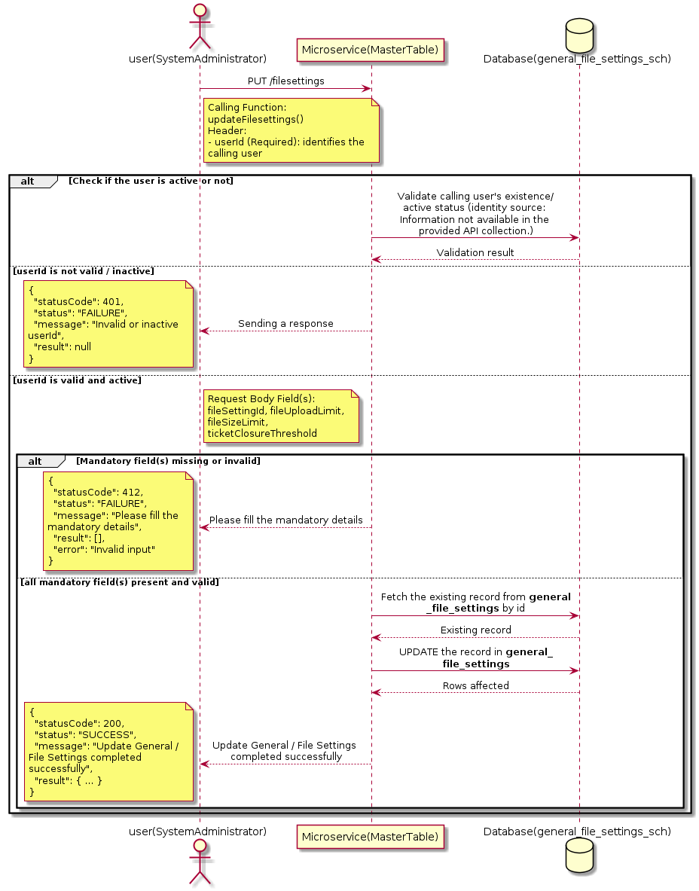

3.6.2.3 API Endpoint
Method | PUT
URL | http://localhost:7002/srv2/genie/filesettings
Headers | userId: 67 Content-Type: application/json (assumed based on JSON request payload; Information not available in the provided API collection.)
Authorization | Not present in the captured request. Information not available in the provided API collection.
Content-Type | Content-Type: application/json (assumed based on JSON request payload; Information not available in the provided API collection.)
Query Parameters | None
Path Variables | None
Request Body:
{
"fileSettingId": 1,
"fileUploadLimit": 5,
"fileSizeLimit": 3,
"supportingFileTypes": [
"doc",
"docx",
"png",
"xls",
"pdf",
"xlsx",
"csv",
"txt",
"jpg"
],
"ticketClosureThreshold": 15
}
Response Body (illustrative — see 3.x.4.5 Success Response for details):
The source Postman collection does not include a captured sample response for this request (the response array is empty). Information not available in the provided API collection. Section 3.6.2.4.5 below presents the response envelope inferred from the standard response wrapper used consistently by this platform's services.

3.6.2.4 Detailed Process Flow

3.6.2.4.1 Request Initiation
The flow begins when System Administrator (or a calling microservice on their behalf) invokes the PUT endpoint http://localhost:7002/srv2/genie/filesettings. The request must include the mandatory `userId` header used by the Master Table Microservice to identify the calling user for auditing purposes. The request carries a JSON payload in the request body which the Controller binds to its Data Transfer Object (DTO) before any processing begins. At the Controller layer, Spring Boot's request-mapping infrastructure routes the call to the appropriate handler method (`updateFilesettings`), and Bean Validation annotations (if configured on the DTO) perform structural validation before the request reaches the Service layer. Information not available in the provided API collection. regarding the exact validation annotations used in the source code.

3.6.2.4.2 User Validation
The Master Table Microservice relies on the `userId` header to identify the calling user. Based on the pattern observed consistently across this API collection, the platform's authentication/authorization is expected to be enforced upstream (e.g., by an API Gateway or a shared security filter) using this identifier; the Postman collection does not include an `Authorization` / `Bearer` token header on this request, so the exact authentication mechanism (JWT validation, session lookup, or gateway-level SSO) is Information not available in the provided API collection. Role-based authorization — i.e., confirming that the user identified by `userId` holds a role/permission entitled to perform this operation — is expected to be enforced by the Service layer (see Section 8 – Controller Analysis and Section 14 – Authentication & Authorization), but the specific role/permission checks are Information not available in the provided API collection.

3.6.2.4.3 Business Logic
The Service layer fetches the existing General / File Settings record by its identifier, verifies it exists, applies the incoming changes field by field, re-validates business rules (e.g., uniqueness of a renamed field), and persists the updated entity via the Repository. If the record does not exist, the operation is rejected with a not-found error. The key fields exchanged for this operation, as observed in the sample payload, are: `fileSettingId`, `fileUploadLimit`, `fileSizeLimit`, `ticketClosureThreshold`.

3.6.2.4.4 Database Interaction
The Repository layer (Spring Data JPA) interacts with the underlying relational database that backs the General / File Settings master table. The primary operation issued is a **UPDATE** against the table associated with General / File Settings. The existing row is located by primary key and updated; if the entity has related child records, the existing child rows are typically replaced/updated within the same transaction. The exact table name, column names, primary/foreign key definitions, and JPA repository method signatures are not included in the Postman collection; therefore, precise schema details are information not available in the provided api collection.

3.6.2.4.5 Success Response
Status Code: 200 OK. Sample response envelope (illustrative — the source collection did not capture a sample response for this API):
{
"statusCode": 200,
"status": "SUCCESS",
"message": "Update General / File Settings completed successfully",
"result": {
"id": 1,
"isActive": 1
},
"error": null,
"corelationId": "c6f2a1e4-2b3d-4a9e-9f1a-1234567890ab",
"url": null
}

3.6.2.4.6 Conclusion
This API provides a well-defined, single-purpose capability within the Master Table Microservice for update general / file settings. The Controller → Service → Repository → Database layering keeps request validation, business rules, and persistence concerns separated, which allows the General / File Settings master data to be maintained consistently and safely by authorized administrators while remaining available for consumption by every other module that depends on this reference data.

3.6.3 Search / List General / File Settings

3.6.3.1 Overview
Purpose: To search and list General / File Settings records based on a search payload (e.g., free-text search or structured criteria), supporting list/grid screens that need paginated or filtered master data.
Business Requirement: List/search screens for General / File Settings configuration need server-side search so that administrators can locate specific records in large master tables without scanning the full data set.
Who Uses the API: System Administrator operating the General / File Settings configuration/list screen.
Business Flow: Client sends a POST request with a search payload → Controller validates the payload → Service layer constructs the search/query logic → Repository executes the search against the General / File Settings table → matching records are returned to the Client.

3.6.3.2 Sequence Diagram
The diagram below illustrates the end-to-end interaction for "Search / List General / File Settings" across the Client, Controller, Service, Repository, and Database layers.
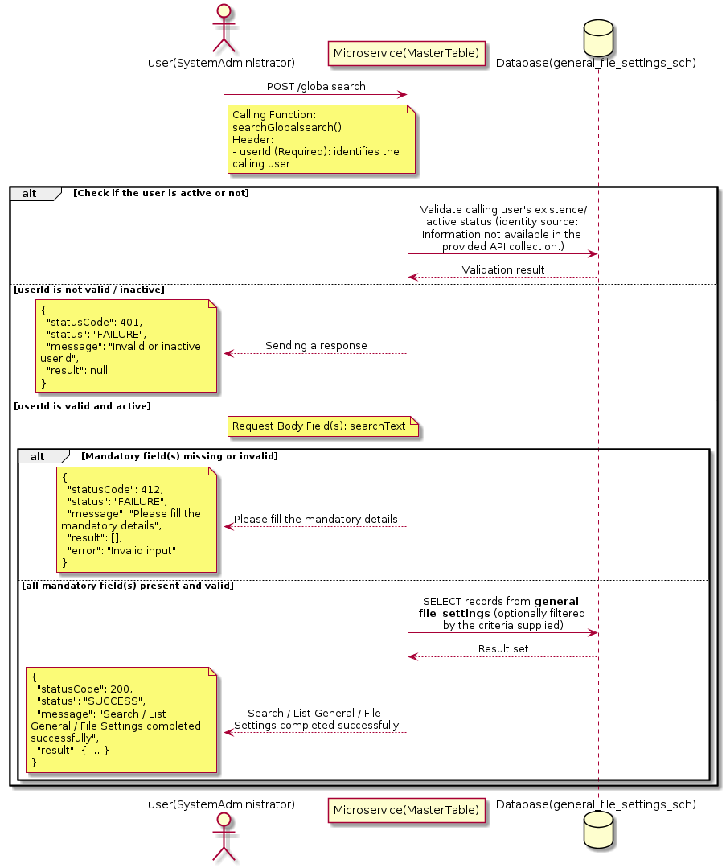

3.6.3.3 API Endpoint
Method | POST
URL | http://localhost:7002/srv2/genie/globalsearch
Headers | userId: 67 Content-Type: application/json (assumed based on JSON request payload; Information not available in the provided API collection.)
Authorization | Not present in the captured request. Information not available in the provided API collection.
Content-Type | Content-Type: application/json (assumed based on JSON request payload; Information not available in the provided API collection.)
Query Parameters | None
Path Variables | None
Request Body:
{
"searchText": "test"
}
Response Body (illustrative — see 3.x.4.5 Success Response for details):
The source Postman collection does not include a captured sample response for this request (the response array is empty). Information not available in the provided API collection. Section 3.6.3.4.5 below presents the response envelope inferred from the standard response wrapper used consistently by this platform's services.

3.6.3.4 Detailed Process Flow

3.6.3.4.1 Request Initiation
The flow begins when System Administrator (or a calling microservice on their behalf) invokes the POST endpoint http://localhost:7002/srv2/genie/globalsearch. The request must include the mandatory `userId` header used by the Master Table Microservice to identify the calling user for auditing purposes. The request carries a JSON payload in the request body which the Controller binds to its Data Transfer Object (DTO) before any processing begins. At the Controller layer, Spring Boot's request-mapping infrastructure routes the call to the appropriate handler method (`searchGlobalsearch`), and Bean Validation annotations (if configured on the DTO) perform structural validation before the request reaches the Service layer. Information not available in the provided API collection. regarding the exact validation annotations used in the source code.

3.6.3.4.2 User Validation
The Master Table Microservice relies on the `userId` header to identify the calling user. Based on the pattern observed consistently across this API collection, the platform's authentication/authorization is expected to be enforced upstream (e.g., by an API Gateway or a shared security filter) using this identifier; the Postman collection does not include an `Authorization` / `Bearer` token header on this request, so the exact authentication mechanism (JWT validation, session lookup, or gateway-level SSO) is Information not available in the provided API collection. Role-based authorization — i.e., confirming that the user identified by `userId` holds a role/permission entitled to perform this operation — is expected to be enforced by the Service layer (see Section 8 – Controller Analysis and Section 14 – Authentication & Authorization), but the specific role/permission checks are Information not available in the provided API collection.

3.6.3.4.3 Business Logic
The Service layer evaluates the search payload; if the search text/criteria is empty, the operation typically behaves like a full list (all General / File Settings records); if populated, it is used to build a case-insensitive `LIKE`/contains predicate against the relevant column(s). The key fields exchanged for this operation, as observed in the sample payload, are: `searchText`.

3.6.3.4.4 Database Interaction
The Repository layer (Spring Data JPA) interacts with the underlying relational database that backs the General / File Settings master table. The primary operation issued is a **SELECT** against the table associated with General / File Settings. No write operations occur; the search is typically implemented using a JPA derived query method or a native/JPQL query with `LIKE` predicates. The exact table name, column names, primary/foreign key definitions, and JPA repository method signatures are not included in the Postman collection; therefore, precise schema details are information not available in the provided api collection.

3.6.3.4.5 Success Response
Status Code: 200 OK. Sample response envelope (illustrative — the source collection did not capture a sample response for this API):
{
"statusCode": 200,
"status": "SUCCESS",
"message": "Search / List General / File Settings completed successfully",
"result": [
{
"id": 1,
"name": "Sample General / File Settings",
"isActive": 1
}
],
"error": null,
"corelationId": "c6f2a1e4-2b3d-4a9e-9f1a-1234567890ab",
"url": null
}

3.6.3.4.6 Conclusion
This API provides a well-defined, single-purpose capability within the Master Table Microservice for search / list general / file settings. The Controller → Service → Repository → Database layering keeps request validation, business rules, and persistence concerns separated, which allows the General / File Settings master data to be maintained consistently and safely by authorized administrators while remaining available for consumption by every other module that depends on this reference data.

3.7 General Status APIs (General-Status APIs)
Maintains the generic status master (e.g., ticket/record lifecycle states) that is referenced by workflow and reporting features across the platform.

3.7.1 Retrieve All General Status

3.7.1.1 Overview
Purpose: To retrieve the complete list of General Status master records configured in the Master Table Microservice, so that consuming screens and downstream services can populate dropdowns, grids, and configuration views.
Business Requirement: Every screen and workflow that references General Status data (creation forms, filters, reports) needs an authoritative, always-current list of active General Status values sourced from a single master table rather than being hard-coded.
Who Uses the API: System Administrator, and any internal microservice/UI module that needs to render General Status options.
Business Flow: Client sends a GET request → Controller delegates to the Service layer → Service layer calls the Repository → Repository queries the General Status table → the result set is mapped to response DTOs and returned to the Client.

3.7.1.2 Sequence Diagram
The diagram below illustrates the end-to-end interaction for "Retrieve All General Status" across the Client, Controller, Service, Repository, and Database layers.
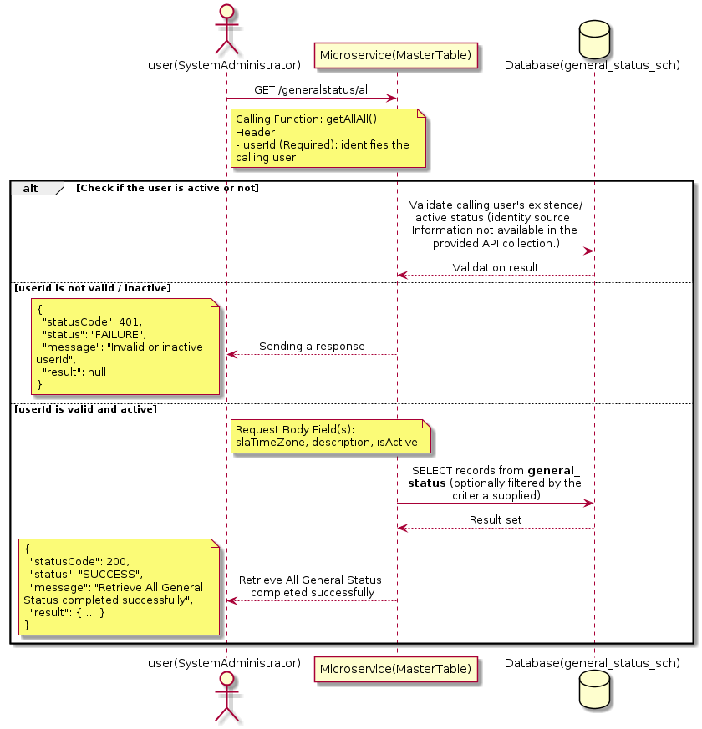

3.7.1.3 API Endpoint
Method | GET
URL | http://localhost:7002/srv2/genie/generalstatus/all
Headers | Content-Type: application/json userId: 879
Authorization | Not present in the captured request. Information not available in the provided API collection.
Content-Type | Content-Type: application/json
Query Parameters | None
Path Variables | None
Request Body:
{
"slaTimeZone": "CST",
"description": "Central Standard Time",
"isActive": "1"
}
Response Body (illustrative — see 3.x.4.5 Success Response for details):
The source Postman collection does not include a captured sample response for this request (the response array is empty). Information not available in the provided API collection. Section 3.7.1.4.5 below presents the response envelope inferred from the standard response wrapper used consistently by this platform's services.

3.7.1.4 Detailed Process Flow

3.7.1.4.1 Request Initiation
The flow begins when System Administrator (or a calling microservice on their behalf) invokes the GET endpoint http://localhost:7002/srv2/genie/generalstatus/all. The request must include the mandatory `userId` header used by the Master Table Microservice to identify the calling user for auditing purposes. The request carries a JSON payload in the request body which the Controller binds to its Data Transfer Object (DTO) before any processing begins. At the Controller layer, Spring Boot's request-mapping infrastructure routes the call to the appropriate handler method (`getAllAll`), and Bean Validation annotations (if configured on the DTO) perform structural validation before the request reaches the Service layer. Information not available in the provided API collection. regarding the exact validation annotations used in the source code.

3.7.1.4.2 User Validation
The Master Table Microservice relies on the `userId` header to identify the calling user. Based on the pattern observed consistently across this API collection, the platform's authentication/authorization is expected to be enforced upstream (e.g., by an API Gateway or a shared security filter) using this identifier; the Postman collection does not include an `Authorization` / `Bearer` token header on this request, so the exact authentication mechanism (JWT validation, session lookup, or gateway-level SSO) is Information not available in the provided API collection. Role-based authorization — i.e., confirming that the user identified by `userId` holds a role/permission entitled to perform this operation — is expected to be enforced by the Service layer (see Section 8 – Controller Analysis and Section 14 – Authentication & Authorization), but the specific role/permission checks are Information not available in the provided API collection.

3.7.1.4.3 Business Logic
The Service layer contains no conditional business branching for this operation beyond invoking the Repository to fetch all General Status records. Depending on the record volume, the Service layer may apply default sorting (e.g., by name or creation order) before returning the list. The key fields exchanged for this operation, as observed in the sample payload, are: `slaTimeZone`, `description`, `isActive`.

3.7.1.4.4 Database Interaction
The Repository layer (Spring Data JPA) interacts with the underlying relational database that backs the General Status master table. The primary operation issued is a **SELECT** against the table associated with General Status. No write operations occur; the query returns all rows that satisfy the entity's default scope (typically active records). The exact table name, column names, primary/foreign key definitions, and JPA repository method signatures are not included in the Postman collection; therefore, precise schema details are information not available in the provided api collection.

3.7.1.4.5 Success Response
Status Code: 200 OK. Sample response envelope (illustrative — the source collection did not capture a sample response for this API):
{
"statusCode": 200,
"status": "SUCCESS",
"message": "Retrieve All General Status completed successfully",
"result": [
{
"id": 1,
"name": "Sample General Status",
"isActive": 1
}
],
"error": null,
"corelationId": "c6f2a1e4-2b3d-4a9e-9f1a-1234567890ab",
"url": null
}

3.7.1.4.6 Conclusion
This API provides a well-defined, single-purpose capability within the Master Table Microservice for retrieve all general status. The Controller → Service → Repository → Database layering keeps request validation, business rules, and persistence concerns separated, which allows the General Status master data to be maintained consistently and safely by authorized administrators while remaining available for consumption by every other module that depends on this reference data.

3.7.2 Create General Status

3.7.2.1 Overview
Purpose: To create a new General Status master record in the system, allowing administrators to extend the master-data catalogue that other modules (ticketing, workflow, notifications) depend on.
Business Requirement: Business/process owners need a controlled way to add new General Status values so that the platform's classification, routing, and reporting capabilities can evolve as the organization changes.
Who Uses the API: System Administrator responsible for master-data configuration.
Business Flow: Client sends a POST request with the new General Status payload → Controller validates the payload (mandatory fields, formats) → Service layer applies business rules (e.g., duplicate-name check) → Repository persists the new record → the created record (with generated identifier) is returned to the Client.

3.7.2.2 Sequence Diagram
The diagram below illustrates the end-to-end interaction for "Create General Status" across the Client, Controller, Service, Repository, and Database layers.
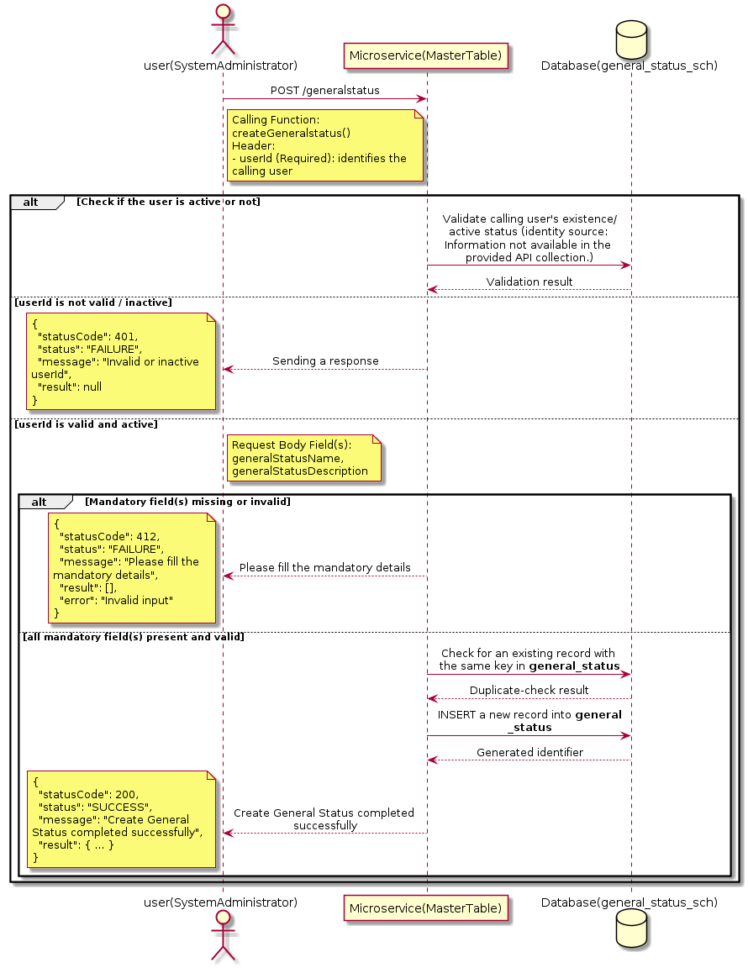

3.7.2.3 API Endpoint
Method | POST
URL | http://localhost:7002/srv2/genie/generalstatus
Headers | Content-Type: application/json userId: 879
Authorization | Not present in the captured request. Information not available in the provided API collection.
Content-Type | Content-Type: application/json
Query Parameters | None
Path Variables | None
Request Body:
{
"generalStatusName": "In Progress",
"generalStatusDescription": "Status for in progress records"
}
Response Body (illustrative — see 3.x.4.5 Success Response for details):
The source Postman collection does not include a captured sample response for this request (the response array is empty). Information not available in the provided API collection. Section 3.7.2.4.5 below presents the response envelope inferred from the standard response wrapper used consistently by this platform's services.

3.7.2.4 Detailed Process Flow

3.7.2.4.1 Request Initiation
The flow begins when System Administrator (or a calling microservice on their behalf) invokes the POST endpoint http://localhost:7002/srv2/genie/generalstatus. The request must include the mandatory `userId` header used by the Master Table Microservice to identify the calling user for auditing purposes. The request carries a JSON payload in the request body which the Controller binds to its Data Transfer Object (DTO) before any processing begins. At the Controller layer, Spring Boot's request-mapping infrastructure routes the call to the appropriate handler method (`createGeneralstatus`), and Bean Validation annotations (if configured on the DTO) perform structural validation before the request reaches the Service layer. Information not available in the provided API collection. regarding the exact validation annotations used in the source code.

3.7.2.4.2 User Validation
The Master Table Microservice relies on the `userId` header to identify the calling user. Based on the pattern observed consistently across this API collection, the platform's authentication/authorization is expected to be enforced upstream (e.g., by an API Gateway or a shared security filter) using this identifier; the Postman collection does not include an `Authorization` / `Bearer` token header on this request, so the exact authentication mechanism (JWT validation, session lookup, or gateway-level SSO) is Information not available in the provided API collection. Role-based authorization — i.e., confirming that the user identified by `userId` holds a role/permission entitled to perform this operation — is expected to be enforced by the Service layer (see Section 8 – Controller Analysis and Section 14 – Authentication & Authorization), but the specific role/permission checks are Information not available in the provided API collection.

3.7.2.4.3 Business Logic
The Service layer performs the following: (1) validates that mandatory fields are present and correctly formatted, (2) checks for duplicates (e.g., an existing General Status with the same name/code), (3) sets system-managed fields (e.g., `isActive = 1`, `createdBy`, timestamps) where applicable, and (4) persists the new record via the Repository. If any validation fails, the Service layer returns a business error rather than proceeding to persistence. The key fields exchanged for this operation, as observed in the sample payload, are: `generalStatusName`, `generalStatusDescription`.

3.7.2.4.4 Database Interaction
The Repository layer (Spring Data JPA) interacts with the underlying relational database that backs the General Status master table. The primary operation issued is a **INSERT** against the table associated with General Status. A new row is inserted into the master table; if the entity has related child records (as seen in nested request payload arrays), corresponding child-table inserts are performed within the same transaction. The exact table name, column names, primary/foreign key definitions, and JPA repository method signatures are not included in the Postman collection; therefore, precise schema details are information not available in the provided api collection.

3.7.2.4.5 Success Response
Status Code: 200 OK. Sample response envelope (illustrative — the source collection did not capture a sample response for this API):
{
"statusCode": 200,
"status": "SUCCESS",
"message": "Create General Status completed successfully",
"result": {
"id": 101,
"generalStatusName": "In Progress",
"generalStatusDescription": "Status for in progress records"
},
"error": null,
"corelationId": "c6f2a1e4-2b3d-4a9e-9f1a-1234567890ab",
"url": null
}

3.7.2.4.6 Conclusion
This API provides a well-defined, single-purpose capability within the Master Table Microservice for create general status. The Controller → Service → Repository → Database layering keeps request validation, business rules, and persistence concerns separated, which allows the General Status master data to be maintained consistently and safely by authorized administrators while remaining available for consumption by every other module that depends on this reference data.

3.7.3 Update General Status

3.7.3.1 Overview
Purpose: To update an existing General Status master record, allowing administrators to correct or evolve master-data attributes without impacting the record's identity/history.
Business Requirement: Master data changes over time (renames, corrections, re-classification); the platform must allow controlled updates while preserving referential integrity for records that already reference this General Status.
Who Uses the API: System Administrator responsible for maintaining master-data accuracy.
Business Flow: Client sends a PUT/PATCH request with the updated General Status payload → Controller validates the payload → Service layer fetches the existing record, applies the changes, and re-validates business rules → Repository persists the updated record → the updated record is returned to the Client.

3.7.3.2 Sequence Diagram
The diagram below illustrates the end-to-end interaction for "Update General Status" across the Client, Controller, Service, Repository, and Database layers.
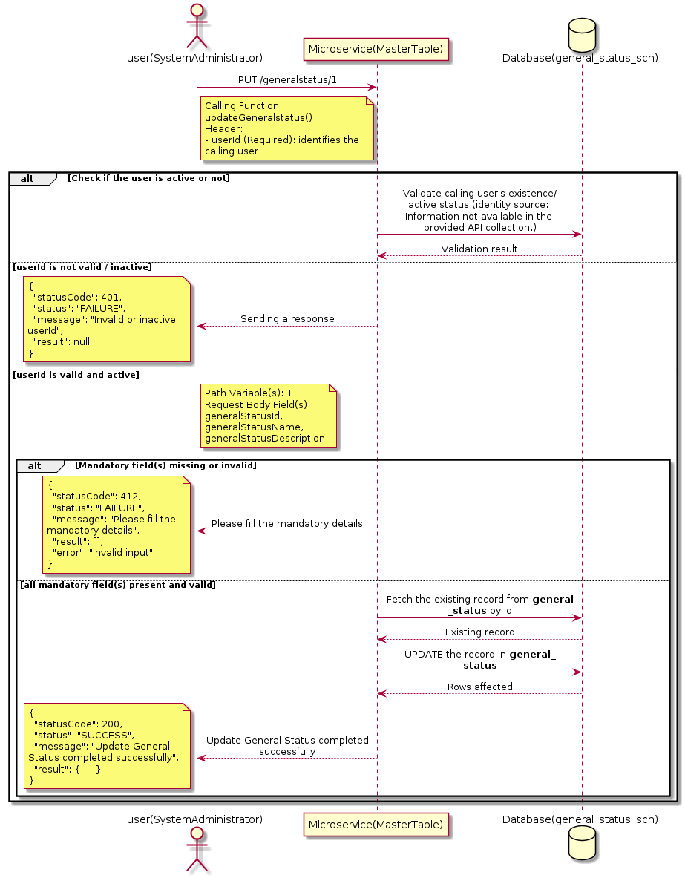

3.7.3.3 API Endpoint
Method | PUT
URL | http://localhost:7002/srv2/genie/generalstatus/1
Headers | Content-Type: application/json userId: 879
Authorization | Not present in the captured request. Information not available in the provided API collection.
Content-Type | Content-Type: application/json
Query Parameters | None
Path Variables | 1
Request Body:
{
"generalStatusId": 1,
"generalStatusName": "Awaiting Clarification Updated",
"generalStatusDescription": "Updated description for clarification"
}
Response Body (illustrative — see 3.x.4.5 Success Response for details):
The source Postman collection does not include a captured sample response for this request (the response array is empty). Information not available in the provided API collection. Section 3.7.3.4.5 below presents the response envelope inferred from the standard response wrapper used consistently by this platform's services.

3.7.3.4 Detailed Process Flow

3.7.3.4.1 Request Initiation
The flow begins when System Administrator (or a calling microservice on their behalf) invokes the PUT endpoint http://localhost:7002/srv2/genie/generalstatus/1. The request must include the mandatory `userId` header used by the Master Table Microservice to identify the calling user for auditing purposes. The request carries a JSON payload in the request body which the Controller binds to its Data Transfer Object (DTO) before any processing begins. At the Controller layer, Spring Boot's request-mapping infrastructure routes the call to the appropriate handler method (`updateGeneralstatus`), and Bean Validation annotations (if configured on the DTO) perform structural validation before the request reaches the Service layer. Information not available in the provided API collection. regarding the exact validation annotations used in the source code.

3.7.3.4.2 User Validation
The Master Table Microservice relies on the `userId` header to identify the calling user. Based on the pattern observed consistently across this API collection, the platform's authentication/authorization is expected to be enforced upstream (e.g., by an API Gateway or a shared security filter) using this identifier; the Postman collection does not include an `Authorization` / `Bearer` token header on this request, so the exact authentication mechanism (JWT validation, session lookup, or gateway-level SSO) is Information not available in the provided API collection. Role-based authorization — i.e., confirming that the user identified by `userId` holds a role/permission entitled to perform this operation — is expected to be enforced by the Service layer (see Section 8 – Controller Analysis and Section 14 – Authentication & Authorization), but the specific role/permission checks are Information not available in the provided API collection.

3.7.3.4.3 Business Logic
The Service layer fetches the existing General Status record by its identifier, verifies it exists, applies the incoming changes field by field, re-validates business rules (e.g., uniqueness of a renamed field), and persists the updated entity via the Repository. If the record does not exist, the operation is rejected with a not-found error. The key fields exchanged for this operation, as observed in the sample payload, are: `generalStatusId`, `generalStatusName`, `generalStatusDescription`.

3.7.3.4.4 Database Interaction
The Repository layer (Spring Data JPA) interacts with the underlying relational database that backs the General Status master table. The primary operation issued is a **UPDATE** against the table associated with General Status. The existing row is located by primary key and updated; if the entity has related child records, the existing child rows are typically replaced/updated within the same transaction. The exact table name, column names, primary/foreign key definitions, and JPA repository method signatures are not included in the Postman collection; therefore, precise schema details are information not available in the provided api collection.

3.7.3.4.5 Success Response
Status Code: 200 OK. Sample response envelope (illustrative — the source collection did not capture a sample response for this API):
{
"statusCode": 200,
"status": "SUCCESS",
"message": "Update General Status completed successfully",
"result": {
"id": "1",
"isActive": 1
},
"error": null,
"corelationId": "c6f2a1e4-2b3d-4a9e-9f1a-1234567890ab",
"url": null
}

3.7.3.4.6 Conclusion
This API provides a well-defined, single-purpose capability within the Master Table Microservice for update general status. The Controller → Service → Repository → Database layering keeps request validation, business rules, and persistence concerns separated, which allows the General Status master data to be maintained consistently and safely by authorized administrators while remaining available for consumption by every other module that depends on this reference data.

3.7.4 Enable / Disable General Status

3.7.4.1 Overview
Purpose: To enable or disable (soft-delete) a General Status master record, allowing administrators to retire a record from active use while preserving it for historical/audit purposes.
Business Requirement: Rather than physically deleting a General Status record (which could break referential integrity with historical tickets/records that reference it), the business requires a reversible enable/disable mechanism.
Who Uses the API: System Administrator responsible for activating/deactivating configuration values.
Business Flow: Client sends a request carrying the General Status identifier and the desired active/inactive flag → Controller validates the payload → Service layer fetches the record and flips its status flag → Repository persists the change → the updated status is returned to the Client.

3.7.4.2 Sequence Diagram
The diagram below illustrates the end-to-end interaction for "Enable / Disable General Status" across the Client, Controller, Service, Repository, and Database layers.
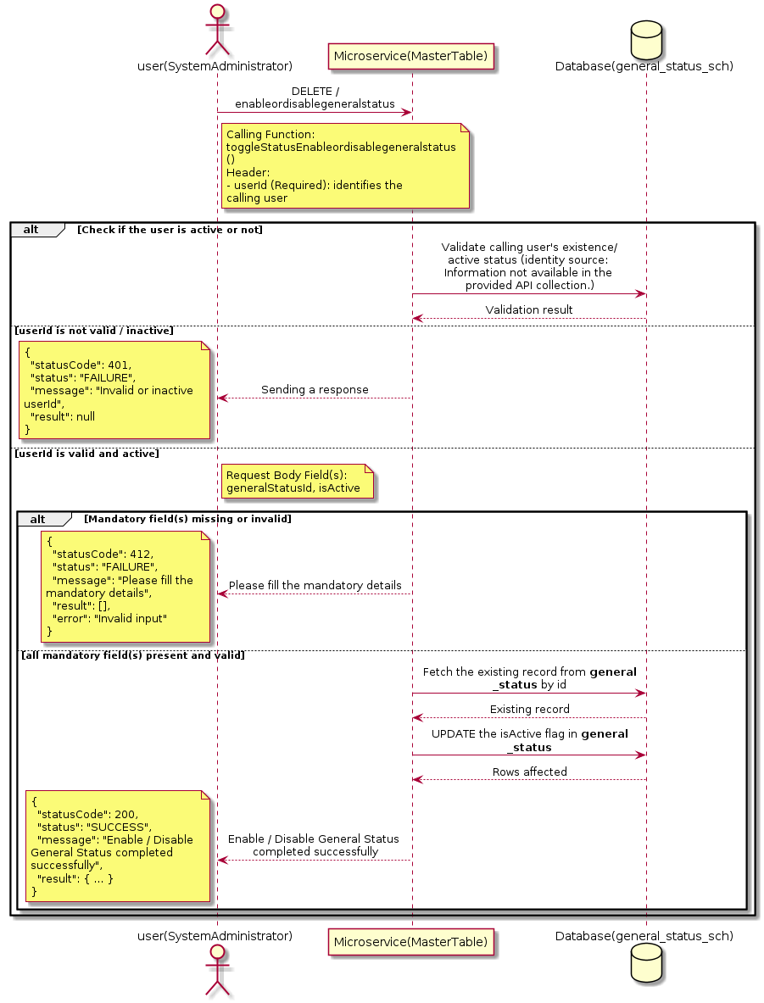

3.7.4.3 API Endpoint
Method | DELETE
URL | http://localhost:7002/srv2/genie/enableordisablegeneralstatus
Headers | userId: 67 Content-Type: application/json
Authorization | Not present in the captured request. Information not available in the provided API collection.
Content-Type | Content-Type: application/json
Query Parameters | None
Path Variables | None
Request Body:
{
"generalStatusId": 6,
"isActive": 1
}
Response Body (illustrative — see 3.x.4.5 Success Response for details):
The source Postman collection does not include a captured sample response for this request (the response array is empty). Information not available in the provided API collection. Section 3.7.4.4.5 below presents the response envelope inferred from the standard response wrapper used consistently by this platform's services.

3.7.4.4 Detailed Process Flow

3.7.4.4.1 Request Initiation
The flow begins when System Administrator (or a calling microservice on their behalf) invokes the DELETE endpoint http://localhost:7002/srv2/genie/enableordisablegeneralstatus. The request must include the mandatory `userId` header used by the Master Table Microservice to identify the calling user for auditing purposes. The request carries a JSON payload in the request body which the Controller binds to its Data Transfer Object (DTO) before any processing begins. At the Controller layer, Spring Boot's request-mapping infrastructure routes the call to the appropriate handler method (`toggleStatusEnableordisablegeneralstatus`), and Bean Validation annotations (if configured on the DTO) perform structural validation before the request reaches the Service layer. Information not available in the provided API collection. regarding the exact validation annotations used in the source code.

3.7.4.4.2 User Validation
The Master Table Microservice relies on the `userId` header to identify the calling user. Based on the pattern observed consistently across this API collection, the platform's authentication/authorization is expected to be enforced upstream (e.g., by an API Gateway or a shared security filter) using this identifier; the Postman collection does not include an `Authorization` / `Bearer` token header on this request, so the exact authentication mechanism (JWT validation, session lookup, or gateway-level SSO) is Information not available in the provided API collection. Role-based authorization — i.e., confirming that the user identified by `userId` holds a role/permission entitled to perform this operation — is expected to be enforced by the Service layer (see Section 8 – Controller Analysis and Section 14 – Authentication & Authorization), but the specific role/permission checks are Information not available in the provided API collection.

3.7.4.4.3 Business Logic
The Service layer fetches the existing General Status record by its identifier and flips the `isActive` flag to the value supplied in the request. No other attributes of the record are modified by this operation. The key fields exchanged for this operation, as observed in the sample payload, are: `generalStatusId`, `isActive`.

3.7.4.4.4 Database Interaction
The Repository layer (Spring Data JPA) interacts with the underlying relational database that backs the General Status master table. The primary operation issued is a **UPDATE** against the table associated with General Status. Only the `is_active` (status) column is updated for the row identified by the primary key; all other columns remain unchanged. The exact table name, column names, primary/foreign key definitions, and JPA repository method signatures are not included in the Postman collection; therefore, precise schema details are information not available in the provided api collection.

3.7.4.4.5 Success Response
Status Code: 200 OK. Sample response envelope (illustrative — the source collection did not capture a sample response for this API):
{
"statusCode": 200,
"status": "SUCCESS",
"message": "Enable / Disable General Status completed successfully",
"result": {
"id": 1,
"isActive": 1
},
"error": null,
"corelationId": "c6f2a1e4-2b3d-4a9e-9f1a-1234567890ab",
"url": null
}

3.7.4.4.6 Conclusion
This API provides a well-defined, single-purpose capability within the Master Table Microservice for enable / disable general status. The Controller → Service → Repository → Database layering keeps request validation, business rules, and persistence concerns separated, which allows the General Status master data to be maintained consistently and safely by authorized administrators while remaining available for consumption by every other module that depends on this reference data.

3.8 Group & Auto-Assignment APIs (Group APIs)
Maintains CSR/approver groups and the automatic-assignment rules that route incoming tickets to the correct group based on category/sub-category.

3.8.1 Create Group & Auto-Assignment — create/group

3.8.1.1 Overview
Purpose: To create a new Group & Auto-Assignment master record in the system, allowing administrators to extend the master-data catalogue that other modules (ticketing, workflow, notifications) depend on.
Business Requirement: Business/process owners need a controlled way to add new Group & Auto-Assignment values so that the platform's classification, routing, and reporting capabilities can evolve as the organization changes.
Who Uses the API: System Administrator / CSR Manager responsible for master-data configuration.
Business Flow: Client sends a POST request with the new Group & Auto-Assignment payload → Controller validates the payload (mandatory fields, formats) → Service layer applies business rules (e.g., duplicate-name check) → Repository persists the new record → the created record (with generated identifier) is returned to the Client.

3.8.1.2 Sequence Diagram
The diagram below illustrates the end-to-end interaction for "Create Group & Auto-Assignment — create/group" across the Client, Controller, Service, Repository, and Database layers.
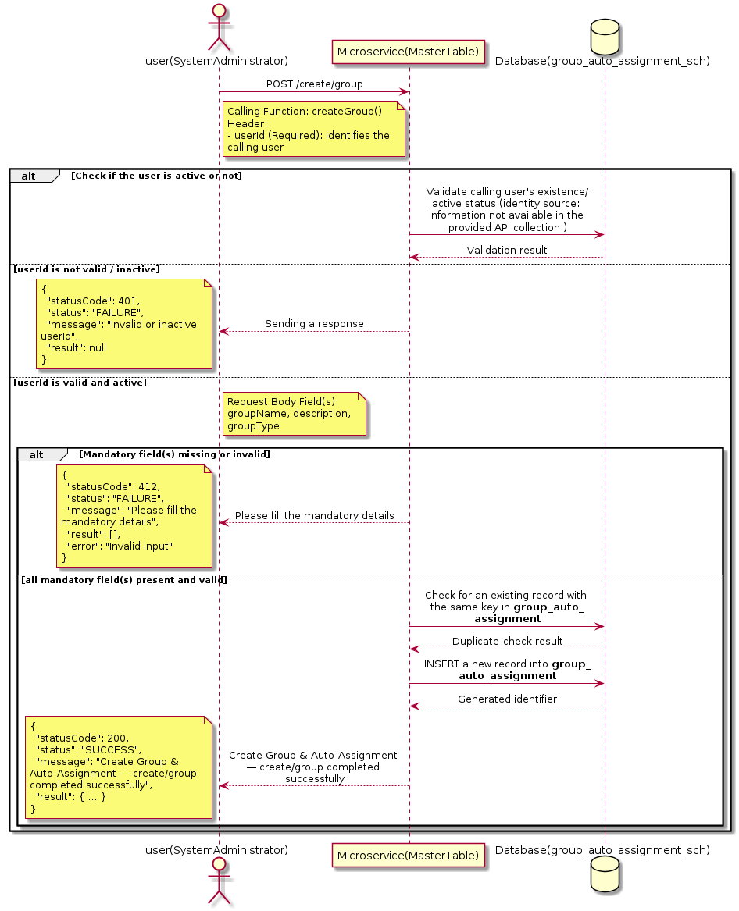

3.8.1.3 API Endpoint
Method | POST
URL | http://localhost:7002/srv2/genie/create/group
Headers | userId: 67 Content-Type: application/json (assumed based on JSON request payload; Information not available in the provided API collection.)
Authorization | Not present in the captured request. Information not available in the provided API collection.
Content-Type | Content-Type: application/json (assumed based on JSON request payload; Information not available in the provided API collection.)
Query Parameters | None
Path Variables | None
Request Body:
{
"groupName": "TestGroup001",
"csrId": [
67
],
"description": "Test Group",
"groupType": "CSR"
}
Response Body (illustrative — see 3.x.4.5 Success Response for details):
The source Postman collection does not include a captured sample response for this request (the response array is empty). Information not available in the provided API collection. Section 3.8.1.4.5 below presents the response envelope inferred from the standard response wrapper used consistently by this platform's services.

3.8.1.4 Detailed Process Flow

3.8.1.4.1 Request Initiation
The flow begins when System Administrator (or a calling microservice on their behalf) invokes the POST endpoint http://localhost:7002/srv2/genie/create/group. The request must include the mandatory `userId` header used by the Master Table Microservice to identify the calling user for auditing purposes. The request carries a JSON payload in the request body which the Controller binds to its Data Transfer Object (DTO) before any processing begins. At the Controller layer, Spring Boot's request-mapping infrastructure routes the call to the appropriate handler method (`createGroup`), and Bean Validation annotations (if configured on the DTO) perform structural validation before the request reaches the Service layer. Information not available in the provided API collection. regarding the exact validation annotations used in the source code.

3.8.1.4.2 User Validation
The Master Table Microservice relies on the `userId` header to identify the calling user. Based on the pattern observed consistently across this API collection, the platform's authentication/authorization is expected to be enforced upstream (e.g., by an API Gateway or a shared security filter) using this identifier; the Postman collection does not include an `Authorization` / `Bearer` token header on this request, so the exact authentication mechanism (JWT validation, session lookup, or gateway-level SSO) is Information not available in the provided API collection. Role-based authorization — i.e., confirming that the user identified by `userId` holds a role/permission entitled to perform this operation — is expected to be enforced by the Service layer (see Section 8 – Controller Analysis and Section 14 – Authentication & Authorization), but the specific role/permission checks are Information not available in the provided API collection.

3.8.1.4.3 Business Logic
The Service layer performs the following: (1) validates that mandatory fields are present and correctly formatted, (2) checks for duplicates (e.g., an existing Group & Auto-Assignment with the same name/code), (3) sets system-managed fields (e.g., `isActive = 1`, `createdBy`, timestamps) where applicable, and (4) persists the new record via the Repository. If any validation fails, the Service layer returns a business error rather than proceeding to persistence. The key fields exchanged for this operation, as observed in the sample payload, are: `groupName`, `description`, `groupType`.

3.8.1.4.4 Database Interaction
The Repository layer (Spring Data JPA) interacts with the underlying relational database that backs the Group & Auto-Assignment master table. The primary operation issued is a **INSERT** against the table associated with Group & Auto-Assignment. A new row is inserted into the master table; if the entity has related child records (as seen in nested request payload arrays), corresponding child-table inserts are performed within the same transaction. The exact table name, column names, primary/foreign key definitions, and JPA repository method signatures are not included in the Postman collection; therefore, precise schema details are information not available in the provided api collection.

3.8.1.4.5 Success Response
Status Code: 200 OK. Sample response envelope (illustrative — the source collection did not capture a sample response for this API):
{
"statusCode": 200,
"status": "SUCCESS",
"message": "Create Group & Auto-Assignment — create/group completed successfully",
"result": {
"id": 101,
"groupName": "TestGroup001",
"description": "Test Group",
"groupType": "CSR"
},
"error": null,
"corelationId": "c6f2a1e4-2b3d-4a9e-9f1a-1234567890ab",
"url": null
}

3.8.1.4.6 Conclusion
This API provides a well-defined, single-purpose capability within the Master Table Microservice for create group & auto-assignment — create/group. The Controller → Service → Repository → Database layering keeps request validation, business rules, and persistence concerns separated, which allows the Group & Auto-Assignment master data to be maintained consistently and safely by authorized administrators while remaining available for consumption by every other module that depends on this reference data.

3.8.2 Retrieve All Group & Auto-Assignment — approve/group

3.8.2.1 Overview
Purpose: To retrieve the complete list of Group & Auto-Assignment master records configured in the Master Table Microservice, so that consuming screens and downstream services can populate dropdowns, grids, and configuration views.
Business Requirement: Every screen and workflow that references Group & Auto-Assignment data (creation forms, filters, reports) needs an authoritative, always-current list of active Group & Auto-Assignment values sourced from a single master table rather than being hard-coded.
Who Uses the API: System Administrator / CSR Manager, and any internal microservice/UI module that needs to render Group & Auto-Assignment options.
Business Flow: Client sends a GET request → Controller delegates to the Service layer → Service layer calls the Repository → Repository queries the Group & Auto-Assignment table → the result set is mapped to response DTOs and returned to the Client.

3.8.2.2 Sequence Diagram
The diagram below illustrates the end-to-end interaction for "Retrieve All Group & Auto-Assignment — approve/group" across the Client, Controller, Service, Repository, and Database layers.
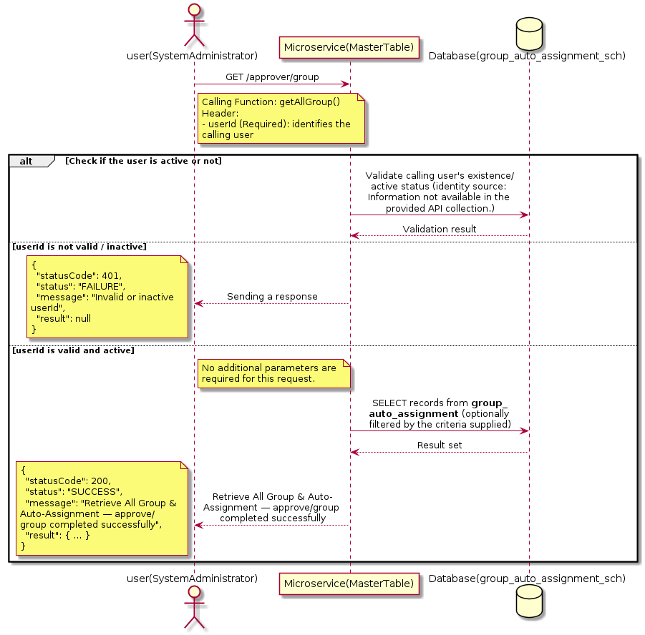

3.8.2.3 API Endpoint
Method | GET
URL | http://localhost:7002/srv2/genie/approver/group
Headers | userId: 67
Authorization | Not present in the captured request. Information not available in the provided API collection.
Content-Type | application/json (assumed)
Query Parameters | None
Path Variables | None
Request Body:
Not applicable — this operation does not accept a request body.
Response Body (illustrative — see 3.x.4.5 Success Response for details):
The source Postman collection does not include a captured sample response for this request (the response array is empty). Information not available in the provided API collection. Section 3.8.2.4.5 below presents the response envelope inferred from the standard response wrapper used consistently by this platform's services.

3.8.2.4 Detailed Process Flow

3.8.2.4.1 Request Initiation
The flow begins when System Administrator (or a calling microservice on their behalf) invokes the GET endpoint http://localhost:7002/srv2/genie/approver/group. The request must include the mandatory `userId` header used by the Master Table Microservice to identify the calling user for auditing purposes. At the Controller layer, Spring Boot's request-mapping infrastructure routes the call to the appropriate handler method (`getAllGroup`), and Bean Validation annotations (if configured on the DTO) perform structural validation before the request reaches the Service layer. Information not available in the provided API collection. regarding the exact validation annotations used in the source code.

3.8.2.4.2 User Validation
The Master Table Microservice relies on the `userId` header to identify the calling user. Based on the pattern observed consistently across this API collection, the platform's authentication/authorization is expected to be enforced upstream (e.g., by an API Gateway or a shared security filter) using this identifier; the Postman collection does not include an `Authorization` / `Bearer` token header on this request, so the exact authentication mechanism (JWT validation, session lookup, or gateway-level SSO) is Information not available in the provided API collection. Role-based authorization — i.e., confirming that the user identified by `userId` holds a role/permission entitled to perform this operation — is expected to be enforced by the Service layer (see Section 8 – Controller Analysis and Section 14 – Authentication & Authorization), but the specific role/permission checks are Information not available in the provided API collection.

3.8.2.4.3 Business Logic
The Service layer contains no conditional business branching for this operation beyond invoking the Repository to fetch all Group & Auto-Assignment records. Depending on the record volume, the Service layer may apply default sorting (e.g., by name or creation order) before returning the list.

3.8.2.4.4 Database Interaction
The Repository layer (Spring Data JPA) interacts with the underlying relational database that backs the Group & Auto-Assignment master table. The primary operation issued is a **SELECT** against the table associated with Group & Auto-Assignment. No write operations occur; the query returns all rows that satisfy the entity's default scope (typically active records). The exact table name, column names, primary/foreign key definitions, and JPA repository method signatures are not included in the Postman collection; therefore, precise schema details are information not available in the provided api collection.

3.8.2.4.5 Success Response
Status Code: 200 OK. Sample response envelope (illustrative — the source collection did not capture a sample response for this API):
{
"statusCode": 200,
"status": "SUCCESS",
"message": "Retrieve All Group & Auto-Assignment — approve/group completed successfully",
"result": [
{
"id": 1,
"name": "Sample Group & Auto-Assignment",
"isActive": 1
}
],
"error": null,
"corelationId": "c6f2a1e4-2b3d-4a9e-9f1a-1234567890ab",
"url": null
}

3.8.2.4.6 Conclusion
This API provides a well-defined, single-purpose capability within the Master Table Microservice for retrieve all group & auto-assignment — approve/group. The Controller → Service → Repository → Database layering keeps request validation, business rules, and persistence concerns separated, which allows the Group & Auto-Assignment master data to be maintained consistently and safely by authorized administrators while remaining available for consumption by every other module that depends on this reference data.

3.8.3 Retrieve All Group & Auto-Assignment — automatedactions/all

3.8.3.1 Overview
Purpose: To retrieve the complete list of Group & Auto-Assignment master records configured in the Master Table Microservice, so that consuming screens and downstream services can populate dropdowns, grids, and configuration views.
Business Requirement: Every screen and workflow that references Group & Auto-Assignment data (creation forms, filters, reports) needs an authoritative, always-current list of active Group & Auto-Assignment values sourced from a single master table rather than being hard-coded.
Who Uses the API: System Administrator / CSR Manager, and any internal microservice/UI module that needs to render Group & Auto-Assignment options.
Business Flow: Client sends a GET request → Controller delegates to the Service layer → Service layer calls the Repository → Repository queries the Group & Auto-Assignment table → the result set is mapped to response DTOs and returned to the Client.

3.8.3.2 Sequence Diagram
The diagram below illustrates the end-to-end interaction for "Retrieve All Group & Auto-Assignment — automatedactions/all" across the Client, Controller, Service, Repository, and Database layers.
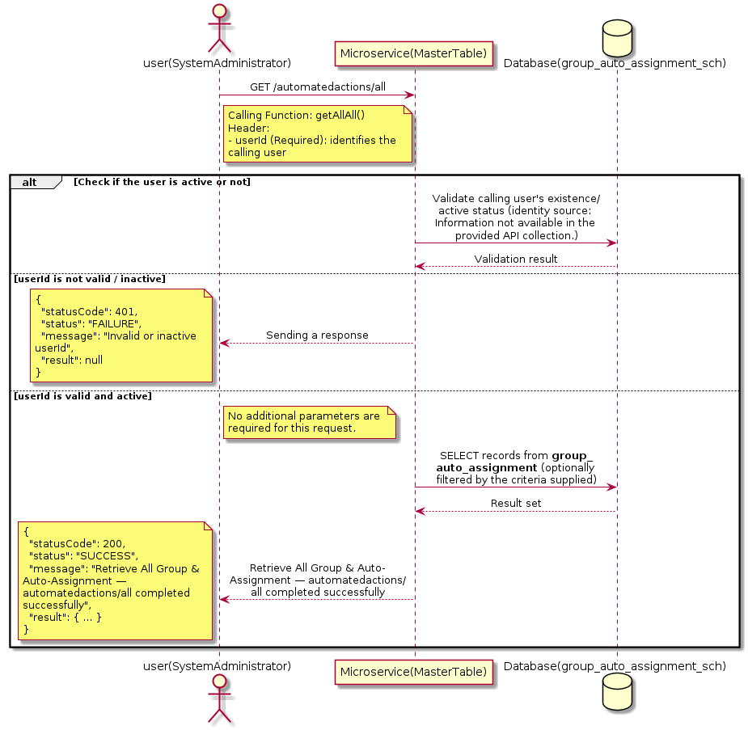

3.8.3.3 API Endpoint
Method | GET
URL | http://localhost:7002/srv2/genie/automatedactions/all
Headers | userId: 879
Authorization | Not present in the captured request. Information not available in the provided API collection.
Content-Type | application/json (assumed)
Query Parameters | None
Path Variables | None
Request Body:
Not applicable — this operation does not accept a request body.
Response Body (illustrative — see 3.x.4.5 Success Response for details):
The source Postman collection does not include a captured sample response for this request (the response array is empty). Information not available in the provided API collection. Section 3.8.3.4.5 below presents the response envelope inferred from the standard response wrapper used consistently by this platform's services.

3.8.3.4 Detailed Process Flow

3.8.3.4.1 Request Initiation
The flow begins when System Administrator (or a calling microservice on their behalf) invokes the GET endpoint http://localhost:7002/srv2/genie/automatedactions/all. The request must include the mandatory `userId` header used by the Master Table Microservice to identify the calling user for auditing purposes. At the Controller layer, Spring Boot's request-mapping infrastructure routes the call to the appropriate handler method (`getAllAll`), and Bean Validation annotations (if configured on the DTO) perform structural validation before the request reaches the Service layer. Information not available in the provided API collection. regarding the exact validation annotations used in the source code.

3.8.3.4.2 User Validation
The Master Table Microservice relies on the `userId` header to identify the calling user. Based on the pattern observed consistently across this API collection, the platform's authentication/authorization is expected to be enforced upstream (e.g., by an API Gateway or a shared security filter) using this identifier; the Postman collection does not include an `Authorization` / `Bearer` token header on this request, so the exact authentication mechanism (JWT validation, session lookup, or gateway-level SSO) is Information not available in the provided API collection. Role-based authorization — i.e., confirming that the user identified by `userId` holds a role/permission entitled to perform this operation — is expected to be enforced by the Service layer (see Section 8 – Controller Analysis and Section 14 – Authentication & Authorization), but the specific role/permission checks are Information not available in the provided API collection.

3.8.3.4.3 Business Logic
The Service layer contains no conditional business branching for this operation beyond invoking the Repository to fetch all Group & Auto-Assignment records. Depending on the record volume, the Service layer may apply default sorting (e.g., by name or creation order) before returning the list.

3.8.3.4.4 Database Interaction
The Repository layer (Spring Data JPA) interacts with the underlying relational database that backs the Group & Auto-Assignment master table. The primary operation issued is a **SELECT** against the table associated with Group & Auto-Assignment. No write operations occur; the query returns all rows that satisfy the entity's default scope (typically active records). The exact table name, column names, primary/foreign key definitions, and JPA repository method signatures are not included in the Postman collection; therefore, precise schema details are information not available in the provided api collection.

3.8.3.4.5 Success Response
Status Code: 200 OK. Sample response envelope (illustrative — the source collection did not capture a sample response for this API):
{
"statusCode": 200,
"status": "SUCCESS",
"message": "Retrieve All Group & Auto-Assignment — automatedactions/all completed successfully",
"result": [
{
"id": 1,
"name": "Sample Group & Auto-Assignment",
"isActive": 1
}
],
"error": null,
"corelationId": "c6f2a1e4-2b3d-4a9e-9f1a-1234567890ab",
"url": null
}

3.8.3.4.6 Conclusion
This API provides a well-defined, single-purpose capability within the Master Table Microservice for retrieve all group & auto-assignment — automatedactions/all. The Controller → Service → Repository → Database layering keeps request validation, business rules, and persistence concerns separated, which allows the Group & Auto-Assignment master data to be maintained consistently and safely by authorized administrators while remaining available for consumption by every other module that depends on this reference data.

3.8.4 Update Group & Auto-Assignment

3.8.4.1 Overview
Purpose: To update an existing Group & Auto-Assignment master record, allowing administrators to correct or evolve master-data attributes without impacting the record's identity/history.
Business Requirement: Master data changes over time (renames, corrections, re-classification); the platform must allow controlled updates while preserving referential integrity for records that already reference this Group & Auto-Assignment.
Who Uses the API: System Administrator / CSR Manager responsible for maintaining master-data accuracy.
Business Flow: Client sends a PUT/PATCH request with the updated Group & Auto-Assignment payload → Controller validates the payload → Service layer fetches the existing record, applies the changes, and re-validates business rules → Repository persists the updated record → the updated record is returned to the Client.

3.8.4.2 Sequence Diagram
The diagram below illustrates the end-to-end interaction for "Update Group & Auto-Assignment" across the Client, Controller, Service, Repository, and Database layers.
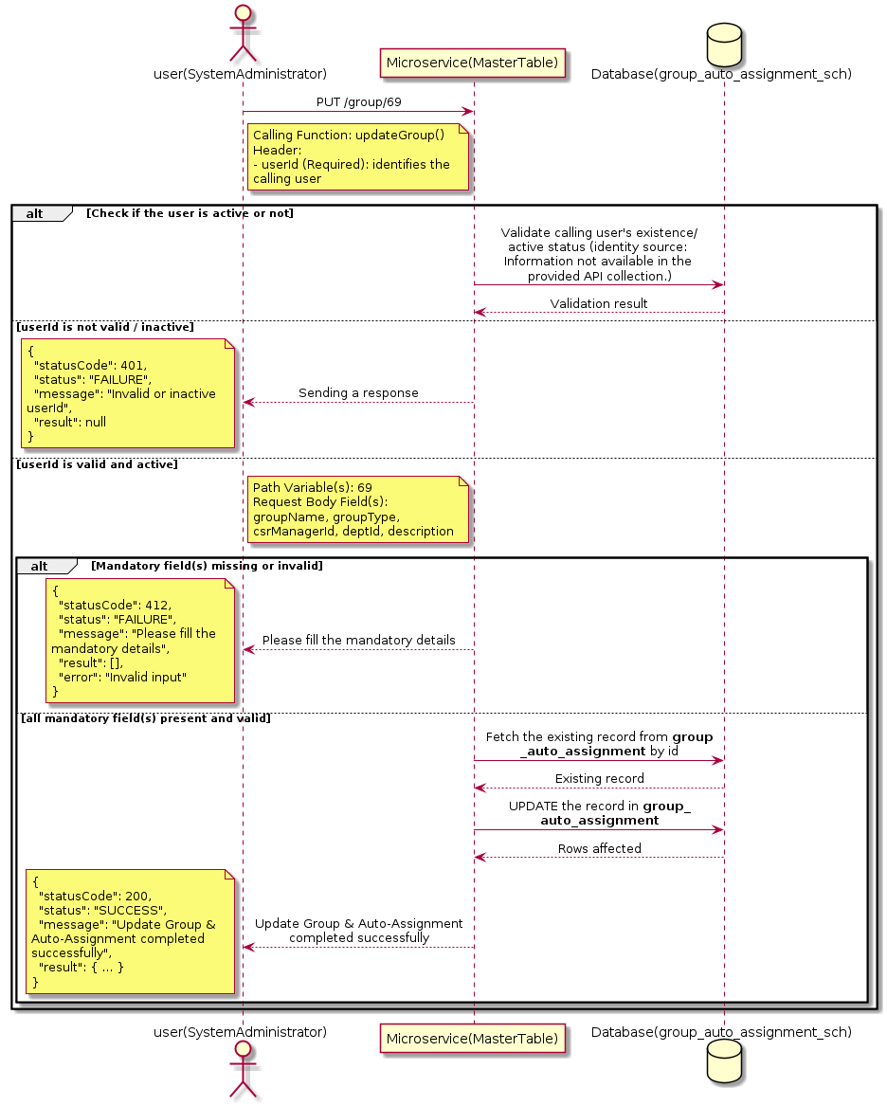

3.8.4.3 API Endpoint
Method | PUT
URL | http://localhost:7002/srv2/genie/group/69
Headers | userId: 67 Accept: application/json Content-Type: application/json
Authorization | Not present in the captured request. Information not available in the provided API collection.
Content-Type | Content-Type: application/json
Query Parameters | None
Path Variables | 69
Request Body:
{
"groupName": "UpdatedGroupName",
"csrId": [
67,
91
],
"groupType": "Approvers group",
"csrManagerId": 4590,
"deptId": 2,
"description": "Updated Test Group"
}
Response Body (illustrative — see 3.x.4.5 Success Response for details):
The source Postman collection does not include a captured sample response for this request (the response array is empty). Information not available in the provided API collection. Section 3.8.4.4.5 below presents the response envelope inferred from the standard response wrapper used consistently by this platform's services.

3.8.4.4 Detailed Process Flow

3.8.4.4.1 Request Initiation
The flow begins when System Administrator (or a calling microservice on their behalf) invokes the PUT endpoint http://localhost:7002/srv2/genie/group/69. The request must include the mandatory `userId` header used by the Master Table Microservice to identify the calling user for auditing purposes. The request carries a JSON payload in the request body which the Controller binds to its Data Transfer Object (DTO) before any processing begins. At the Controller layer, Spring Boot's request-mapping infrastructure routes the call to the appropriate handler method (`updateGroup`), and Bean Validation annotations (if configured on the DTO) perform structural validation before the request reaches the Service layer. Information not available in the provided API collection. regarding the exact validation annotations used in the source code.

3.8.4.4.2 User Validation
The Master Table Microservice relies on the `userId` header to identify the calling user. Based on the pattern observed consistently across this API collection, the platform's authentication/authorization is expected to be enforced upstream (e.g., by an API Gateway or a shared security filter) using this identifier; the Postman collection does not include an `Authorization` / `Bearer` token header on this request, so the exact authentication mechanism (JWT validation, session lookup, or gateway-level SSO) is Information not available in the provided API collection. Role-based authorization — i.e., confirming that the user identified by `userId` holds a role/permission entitled to perform this operation — is expected to be enforced by the Service layer (see Section 8 – Controller Analysis and Section 14 – Authentication & Authorization), but the specific role/permission checks are Information not available in the provided API collection.

3.8.4.4.3 Business Logic
The Service layer fetches the existing Group & Auto-Assignment record by its identifier, verifies it exists, applies the incoming changes field by field, re-validates business rules (e.g., uniqueness of a renamed field), and persists the updated entity via the Repository. If the record does not exist, the operation is rejected with a not-found error. The key fields exchanged for this operation, as observed in the sample payload, are: `groupName`, `groupType`, `csrManagerId`, `deptId`, `description`.

3.8.4.4.4 Database Interaction
The Repository layer (Spring Data JPA) interacts with the underlying relational database that backs the Group & Auto-Assignment master table. The primary operation issued is a **UPDATE** against the table associated with Group & Auto-Assignment. The existing row is located by primary key and updated; if the entity has related child records, the existing child rows are typically replaced/updated within the same transaction. The exact table name, column names, primary/foreign key definitions, and JPA repository method signatures are not included in the Postman collection; therefore, precise schema details are information not available in the provided api collection.

3.8.4.4.5 Success Response
Status Code: 200 OK. Sample response envelope (illustrative — the source collection did not capture a sample response for this API):
{
"statusCode": 200,
"status": "SUCCESS",
"message": "Update Group & Auto-Assignment completed successfully",
"result": {
"id": "69",
"isActive": 1
},
"error": null,
"corelationId": "c6f2a1e4-2b3d-4a9e-9f1a-1234567890ab",
"url": null
}

3.8.4.4.6 Conclusion
This API provides a well-defined, single-purpose capability within the Master Table Microservice for update group & auto-assignment. The Controller → Service → Repository → Database layering keeps request validation, business rules, and persistence concerns separated, which allows the Group & Auto-Assignment master data to be maintained consistently and safely by authorized administrators while remaining available for consumption by every other module that depends on this reference data.

3.8.5 Search / List Group & Auto-Assignment — getAllGrop

3.8.5.1 Overview
Purpose: To search and list Group & Auto-Assignment records based on a search payload (e.g., free-text search or structured criteria), supporting list/grid screens that need paginated or filtered master data.
Business Requirement: List/search screens for Group & Auto-Assignment configuration need server-side search so that administrators can locate specific records in large master tables without scanning the full data set.
Who Uses the API: System Administrator / CSR Manager operating the Group & Auto-Assignment configuration/list screen.
Business Flow: Client sends a POST request with a search payload → Controller validates the payload → Service layer constructs the search/query logic → Repository executes the search against the Group & Auto-Assignment table → matching records are returned to the Client.

3.8.5.2 Sequence Diagram
The diagram below illustrates the end-to-end interaction for "Search / List Group & Auto-Assignment — getAllGrop" across the Client, Controller, Service, Repository, and Database layers.
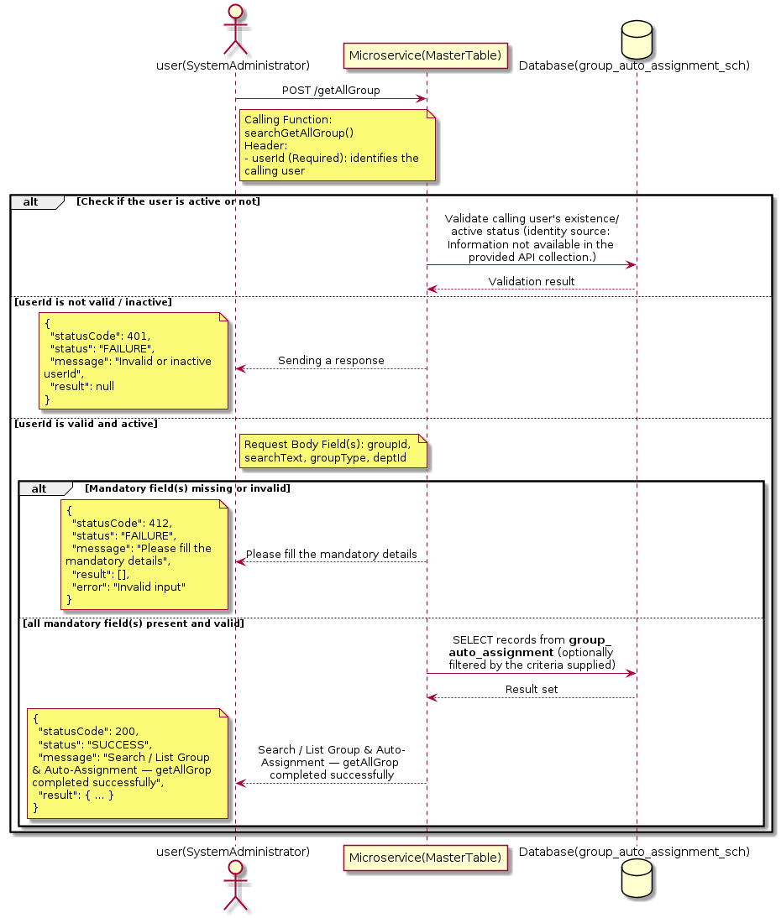

3.8.5.3 API Endpoint
Method | POST
URL | http://localhost:7002/srv2/genie/getAllGroup
Headers | userId: 67 Accept: application/json Content-Type: application/json
Authorization | Not present in the captured request. Information not available in the provided API collection.
Content-Type | Content-Type: application/json
Query Parameters | None
Path Variables | None
Request Body:
{
"groupId": 0,
"searchText": "",
"groupType": "",
"deptId": 2
}
Response Body (illustrative — see 3.x.4.5 Success Response for details):
The source Postman collection does not include a captured sample response for this request (the response array is empty). Information not available in the provided API collection. Section 3.8.5.4.5 below presents the response envelope inferred from the standard response wrapper used consistently by this platform's services.

3.8.5.4 Detailed Process Flow

3.8.5.4.1 Request Initiation
The flow begins when System Administrator (or a calling microservice on their behalf) invokes the POST endpoint http://localhost:7002/srv2/genie/getAllGroup. The request must include the mandatory `userId` header used by the Master Table Microservice to identify the calling user for auditing purposes. The request carries a JSON payload in the request body which the Controller binds to its Data Transfer Object (DTO) before any processing begins. At the Controller layer, Spring Boot's request-mapping infrastructure routes the call to the appropriate handler method (`searchGetAllGroup`), and Bean Validation annotations (if configured on the DTO) perform structural validation before the request reaches the Service layer. Information not available in the provided API collection. regarding the exact validation annotations used in the source code.

3.8.5.4.2 User Validation
The Master Table Microservice relies on the `userId` header to identify the calling user. Based on the pattern observed consistently across this API collection, the platform's authentication/authorization is expected to be enforced upstream (e.g., by an API Gateway or a shared security filter) using this identifier; the Postman collection does not include an `Authorization` / `Bearer` token header on this request, so the exact authentication mechanism (JWT validation, session lookup, or gateway-level SSO) is Information not available in the provided API collection. Role-based authorization — i.e., confirming that the user identified by `userId` holds a role/permission entitled to perform this operation — is expected to be enforced by the Service layer (see Section 8 – Controller Analysis and Section 14 – Authentication & Authorization), but the specific role/permission checks are Information not available in the provided API collection.

3.8.5.4.3 Business Logic
The Service layer evaluates the search payload; if the search text/criteria is empty, the operation typically behaves like a full list (all Group & Auto-Assignment records); if populated, it is used to build a case-insensitive `LIKE`/contains predicate against the relevant column(s). The key fields exchanged for this operation, as observed in the sample payload, are: `groupId`, `searchText`, `groupType`, `deptId`.

3.8.5.4.4 Database Interaction
The Repository layer (Spring Data JPA) interacts with the underlying relational database that backs the Group & Auto-Assignment master table. The primary operation issued is a **SELECT** against the table associated with Group & Auto-Assignment. No write operations occur; the search is typically implemented using a JPA derived query method or a native/JPQL query with `LIKE` predicates. The exact table name, column names, primary/foreign key definitions, and JPA repository method signatures are not included in the Postman collection; therefore, precise schema details are information not available in the provided api collection.

3.8.5.4.5 Success Response
Status Code: 200 OK. Sample response envelope (illustrative — the source collection did not capture a sample response for this API):
{
"statusCode": 200,
"status": "SUCCESS",
"message": "Search / List Group & Auto-Assignment — getAllGrop completed successfully",
"result": [
{
"id": 1,
"name": "Sample Group & Auto-Assignment",
"isActive": 1
}
],
"error": null,
"corelationId": "c6f2a1e4-2b3d-4a9e-9f1a-1234567890ab",
"url": null
}

3.8.5.4.6 Conclusion
This API provides a well-defined, single-purpose capability within the Master Table Microservice for search / list group & auto-assignment — getallgrop. The Controller → Service → Repository → Database layering keeps request validation, business rules, and persistence concerns separated, which allows the Group & Auto-Assignment master data to be maintained consistently and safely by authorized administrators while remaining available for consumption by every other module that depends on this reference data.

3.8.6 Create Group & Auto-Assignment — autoassign

3.8.6.1 Overview
Purpose: To create a new Group & Auto-Assignment master record in the system, allowing administrators to extend the master-data catalogue that other modules (ticketing, workflow, notifications) depend on.
Business Requirement: Business/process owners need a controlled way to add new Group & Auto-Assignment values so that the platform's classification, routing, and reporting capabilities can evolve as the organization changes.
Who Uses the API: System Administrator / CSR Manager responsible for master-data configuration.
Business Flow: Client sends a POST request with the new Group & Auto-Assignment payload → Controller validates the payload (mandatory fields, formats) → Service layer applies business rules (e.g., duplicate-name check) → Repository persists the new record → the created record (with generated identifier) is returned to the Client.

3.8.6.2 Sequence Diagram
The diagram below illustrates the end-to-end interaction for "Create Group & Auto-Assignment — autoassign" across the Client, Controller, Service, Repository, and Database layers.
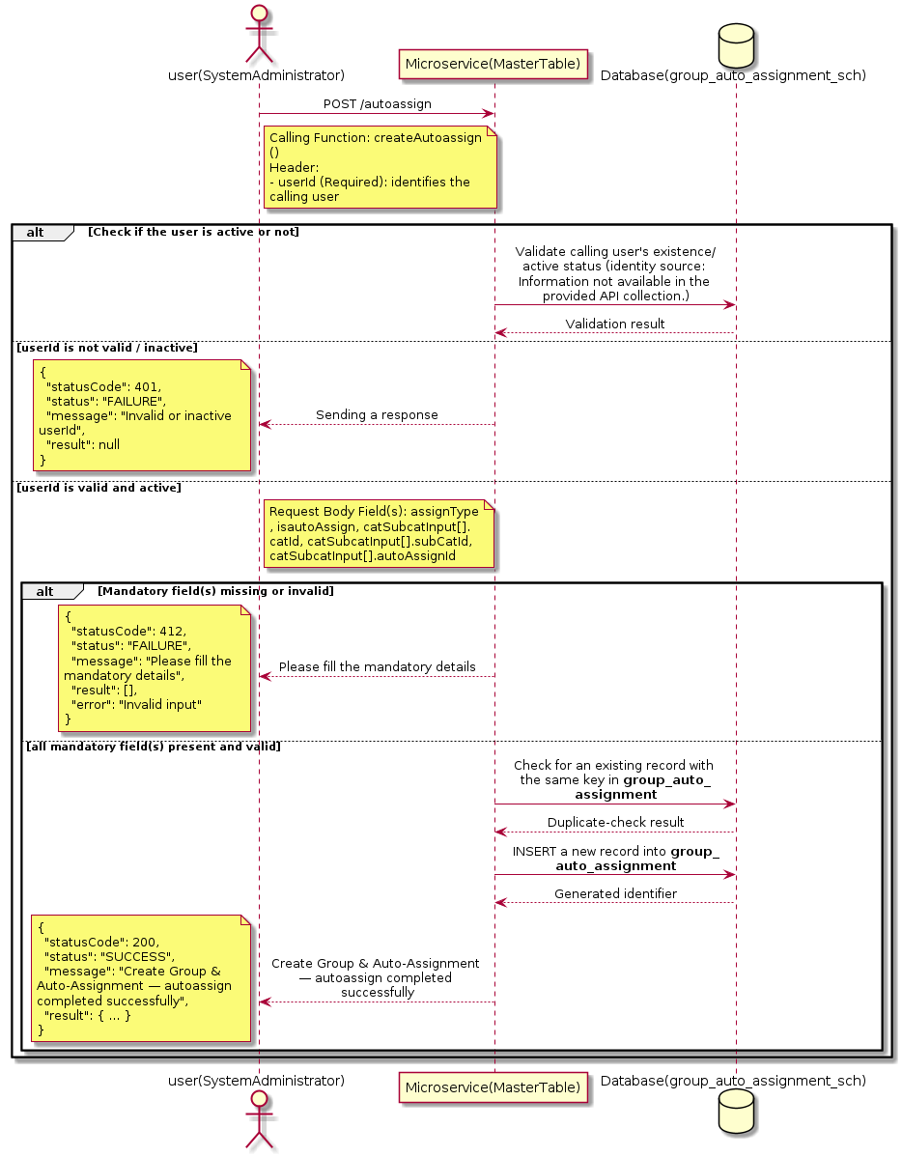

3.8.6.3 API Endpoint
Method | POST
URL | http://localhost:7002/srv2/genie/autoassign
Headers | userId: 67 Accept: application/json Content-Type: application/json
Authorization | Not present in the captured request. Information not available in the provided API collection.
Content-Type | Content-Type: application/json
Query Parameters | None
Path Variables | None
Request Body:
{
"assignType": "group",
"isautoAssign": "1",
"catSubcatInput": [
{
"catId": 93,
"subCatId": 0,
"autoAssignId": 67
}
]
}
Response Body (illustrative — see 3.x.4.5 Success Response for details):
The source Postman collection does not include a captured sample response for this request (the response array is empty). Information not available in the provided API collection. Section 3.8.6.4.5 below presents the response envelope inferred from the standard response wrapper used consistently by this platform's services.

3.8.6.4 Detailed Process Flow

3.8.6.4.1 Request Initiation
The flow begins when System Administrator (or a calling microservice on their behalf) invokes the POST endpoint http://localhost:7002/srv2/genie/autoassign. The request must include the mandatory `userId` header used by the Master Table Microservice to identify the calling user for auditing purposes. The request carries a JSON payload in the request body which the Controller binds to its Data Transfer Object (DTO) before any processing begins. At the Controller layer, Spring Boot's request-mapping infrastructure routes the call to the appropriate handler method (`createAutoassign`), and Bean Validation annotations (if configured on the DTO) perform structural validation before the request reaches the Service layer. Information not available in the provided API collection. regarding the exact validation annotations used in the source code.

3.8.6.4.2 User Validation
The Master Table Microservice relies on the `userId` header to identify the calling user. Based on the pattern observed consistently across this API collection, the platform's authentication/authorization is expected to be enforced upstream (e.g., by an API Gateway or a shared security filter) using this identifier; the Postman collection does not include an `Authorization` / `Bearer` token header on this request, so the exact authentication mechanism (JWT validation, session lookup, or gateway-level SSO) is Information not available in the provided API collection. Role-based authorization — i.e., confirming that the user identified by `userId` holds a role/permission entitled to perform this operation — is expected to be enforced by the Service layer (see Section 8 – Controller Analysis and Section 14 – Authentication & Authorization), but the specific role/permission checks are Information not available in the provided API collection.

3.8.6.4.3 Business Logic
The Service layer performs the following: (1) validates that mandatory fields are present and correctly formatted, (2) checks for duplicates (e.g., an existing Group & Auto-Assignment with the same name/code), (3) sets system-managed fields (e.g., `isActive = 1`, `createdBy`, timestamps) where applicable, and (4) persists the new record via the Repository. If any validation fails, the Service layer returns a business error rather than proceeding to persistence. The key fields exchanged for this operation, as observed in the sample payload, are: `assignType`, `isautoAssign`, `catSubcatInput[].catId`, `catSubcatInput[].subCatId`, `catSubcatInput[].autoAssignId`.

3.8.6.4.4 Database Interaction
The Repository layer (Spring Data JPA) interacts with the underlying relational database that backs the Group & Auto-Assignment master table. The primary operation issued is a **INSERT** against the table associated with Group & Auto-Assignment. A new row is inserted into the master table; if the entity has related child records (as seen in nested request payload arrays), corresponding child-table inserts are performed within the same transaction. The exact table name, column names, primary/foreign key definitions, and JPA repository method signatures are not included in the Postman collection; therefore, precise schema details are information not available in the provided api collection.

3.8.6.4.5 Success Response
Status Code: 200 OK. Sample response envelope (illustrative — the source collection did not capture a sample response for this API):
{
"statusCode": 200,
"status": "SUCCESS",
"message": "Create Group & Auto-Assignment — autoassign completed successfully",
"result": {
"id": 101,
"assignType": "group",
"isautoAssign": "1",
"catSubcatInput[].catId": 93,
"catSubcatInput[].subCatId": 0,
"catSubcatInput[].autoAssignId": 67
},
"error": null,
"corelationId": "c6f2a1e4-2b3d-4a9e-9f1a-1234567890ab",
"url": null
}

3.8.6.4.6 Conclusion
This API provides a well-defined, single-purpose capability within the Master Table Microservice for create group & auto-assignment — autoassign. The Controller → Service → Repository → Database layering keeps request validation, business rules, and persistence concerns separated, which allows the Group & Auto-Assignment master data to be maintained consistently and safely by authorized administrators while remaining available for consumption by every other module that depends on this reference data.

3.8.7 Search / List Group & Auto-Assignment — autoassin/all

3.8.7.1 Overview
Purpose: To search and list Group & Auto-Assignment records based on a search payload (e.g., free-text search or structured criteria), supporting list/grid screens that need paginated or filtered master data.
Business Requirement: List/search screens for Group & Auto-Assignment configuration need server-side search so that administrators can locate specific records in large master tables without scanning the full data set.
Who Uses the API: System Administrator / CSR Manager operating the Group & Auto-Assignment configuration/list screen.
Business Flow: Client sends a POST request with a search payload → Controller validates the payload → Service layer constructs the search/query logic → Repository executes the search against the Group & Auto-Assignment table → matching records are returned to the Client.

3.8.7.2 Sequence Diagram
The diagram below illustrates the end-to-end interaction for "Search / List Group & Auto-Assignment — autoassin/all" across the Client, Controller, Service, Repository, and Database layers.
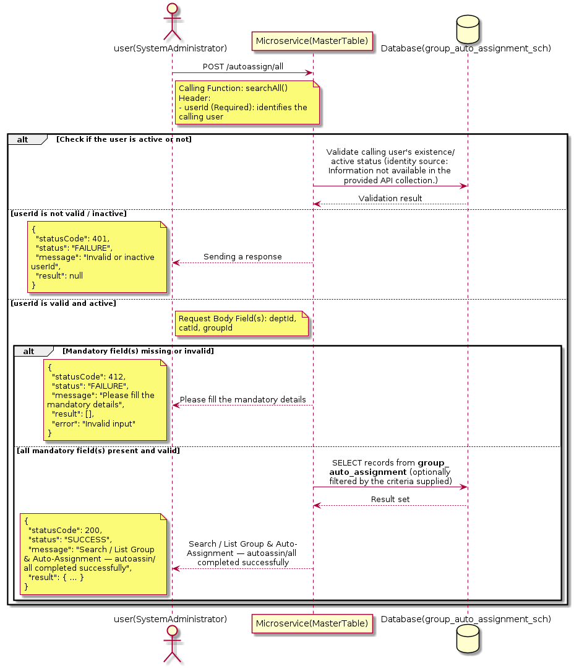

3.8.7.3 API Endpoint
Method | POST
URL | http://172.30.72.35:7002/srv2/genie/autoassign/all
Headers | userId: 4588 Accept: application/json Content-Type: application/json
Authorization | Not present in the captured request. Information not available in the provided API collection.
Content-Type | Content-Type: application/json
Query Parameters | None
Path Variables | None
Request Body:
{
"deptId": 2,
"catId": 93,
"groupId": 69
}
Response Body (illustrative — see 3.x.4.5 Success Response for details):
The source Postman collection does not include a captured sample response for this request (the response array is empty). Information not available in the provided API collection. Section 3.8.7.4.5 below presents the response envelope inferred from the standard response wrapper used consistently by this platform's services.

3.8.7.4 Detailed Process Flow

3.8.7.4.1 Request Initiation
The flow begins when System Administrator (or a calling microservice on their behalf) invokes the POST endpoint http://172.30.72.35:7002/srv2/genie/autoassign/all. The request must include the mandatory `userId` header used by the Master Table Microservice to identify the calling user for auditing purposes. The request carries a JSON payload in the request body which the Controller binds to its Data Transfer Object (DTO) before any processing begins. At the Controller layer, Spring Boot's request-mapping infrastructure routes the call to the appropriate handler method (`searchAll`), and Bean Validation annotations (if configured on the DTO) perform structural validation before the request reaches the Service layer. Information not available in the provided API collection. regarding the exact validation annotations used in the source code.

3.8.7.4.2 User Validation
The Master Table Microservice relies on the `userId` header to identify the calling user. Based on the pattern observed consistently across this API collection, the platform's authentication/authorization is expected to be enforced upstream (e.g., by an API Gateway or a shared security filter) using this identifier; the Postman collection does not include an `Authorization` / `Bearer` token header on this request, so the exact authentication mechanism (JWT validation, session lookup, or gateway-level SSO) is Information not available in the provided API collection. Role-based authorization — i.e., confirming that the user identified by `userId` holds a role/permission entitled to perform this operation — is expected to be enforced by the Service layer (see Section 8 – Controller Analysis and Section 14 – Authentication & Authorization), but the specific role/permission checks are Information not available in the provided API collection.

3.8.7.4.3 Business Logic
The Service layer evaluates the search payload; if the search text/criteria is empty, the operation typically behaves like a full list (all Group & Auto-Assignment records); if populated, it is used to build a case-insensitive `LIKE`/contains predicate against the relevant column(s). The key fields exchanged for this operation, as observed in the sample payload, are: `deptId`, `catId`, `groupId`.

3.8.7.4.4 Database Interaction
The Repository layer (Spring Data JPA) interacts with the underlying relational database that backs the Group & Auto-Assignment master table. The primary operation issued is a **SELECT** against the table associated with Group & Auto-Assignment. No write operations occur; the search is typically implemented using a JPA derived query method or a native/JPQL query with `LIKE` predicates. The exact table name, column names, primary/foreign key definitions, and JPA repository method signatures are not included in the Postman collection; therefore, precise schema details are information not available in the provided api collection.

3.8.7.4.5 Success Response
Status Code: 200 OK. Sample response envelope (illustrative — the source collection did not capture a sample response for this API):
{
"statusCode": 200,
"status": "SUCCESS",
"message": "Search / List Group & Auto-Assignment — autoassin/all completed successfully",
"result": [
{
"id": 1,
"name": "Sample Group & Auto-Assignment",
"isActive": 1
}
],
"error": null,
"corelationId": "c6f2a1e4-2b3d-4a9e-9f1a-1234567890ab",
"url": null
}

3.8.7.4.6 Conclusion
This API provides a well-defined, single-purpose capability within the Master Table Microservice for search / list group & auto-assignment — autoassin/all. The Controller → Service → Repository → Database layering keeps request validation, business rules, and persistence concerns separated, which allows the Group & Auto-Assignment master data to be maintained consistently and safely by authorized administrators while remaining available for consumption by every other module that depends on this reference data.

3.8.8 Search / List Group & Auto-Assignment — group/autoassign

3.8.8.1 Overview
Purpose: To search and list Group & Auto-Assignment records based on a search payload (e.g., free-text search or structured criteria), supporting list/grid screens that need paginated or filtered master data.
Business Requirement: List/search screens for Group & Auto-Assignment configuration need server-side search so that administrators can locate specific records in large master tables without scanning the full data set.
Who Uses the API: System Administrator / CSR Manager operating the Group & Auto-Assignment configuration/list screen.
Business Flow: Client sends a POST request with a search payload → Controller validates the payload → Service layer constructs the search/query logic → Repository executes the search against the Group & Auto-Assignment table → matching records are returned to the Client.

3.8.8.2 Sequence Diagram
The diagram below illustrates the end-to-end interaction for "Search / List Group & Auto-Assignment — group/autoassign" across the Client, Controller, Service, Repository, and Database layers.
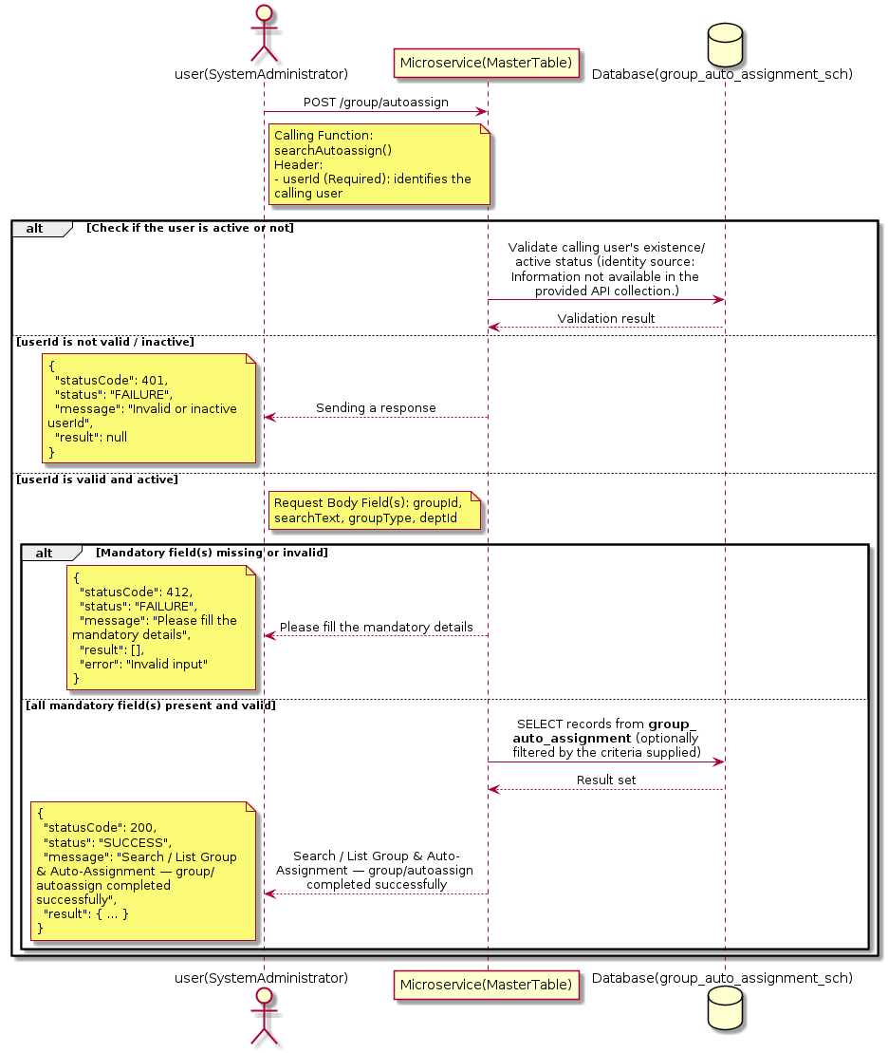

3.8.8.3 API Endpoint
Method | POST
URL | http://localhost:7002/srv2/genie/group/autoassign
Headers | userId: 67 Accept: application/json Content-Type: application/json
Authorization | Not present in the captured request. Information not available in the provided API collection.
Content-Type | Content-Type: application/json
Query Parameters | None
Path Variables | None
Request Body:
{
"groupId": 69,
"searchText": "",
"groupType": "Approvers group",
"deptId": 2
}
Response Body (illustrative — see 3.x.4.5 Success Response for details):
The source Postman collection does not include a captured sample response for this request (the response array is empty). Information not available in the provided API collection. Section 3.8.8.4.5 below presents the response envelope inferred from the standard response wrapper used consistently by this platform's services.

3.8.8.4 Detailed Process Flow

3.8.8.4.1 Request Initiation
The flow begins when System Administrator (or a calling microservice on their behalf) invokes the POST endpoint http://localhost:7002/srv2/genie/group/autoassign. The request must include the mandatory `userId` header used by the Master Table Microservice to identify the calling user for auditing purposes. The request carries a JSON payload in the request body which the Controller binds to its Data Transfer Object (DTO) before any processing begins. At the Controller layer, Spring Boot's request-mapping infrastructure routes the call to the appropriate handler method (`searchAutoassign`), and Bean Validation annotations (if configured on the DTO) perform structural validation before the request reaches the Service layer. Information not available in the provided API collection. regarding the exact validation annotations used in the source code.

3.8.8.4.2 User Validation
The Master Table Microservice relies on the `userId` header to identify the calling user. Based on the pattern observed consistently across this API collection, the platform's authentication/authorization is expected to be enforced upstream (e.g., by an API Gateway or a shared security filter) using this identifier; the Postman collection does not include an `Authorization` / `Bearer` token header on this request, so the exact authentication mechanism (JWT validation, session lookup, or gateway-level SSO) is Information not available in the provided API collection. Role-based authorization — i.e., confirming that the user identified by `userId` holds a role/permission entitled to perform this operation — is expected to be enforced by the Service layer (see Section 8 – Controller Analysis and Section 14 – Authentication & Authorization), but the specific role/permission checks are Information not available in the provided API collection.

3.8.8.4.3 Business Logic
The Service layer evaluates the search payload; if the search text/criteria is empty, the operation typically behaves like a full list (all Group & Auto-Assignment records); if populated, it is used to build a case-insensitive `LIKE`/contains predicate against the relevant column(s). The key fields exchanged for this operation, as observed in the sample payload, are: `groupId`, `searchText`, `groupType`, `deptId`.

3.8.8.4.4 Database Interaction
The Repository layer (Spring Data JPA) interacts with the underlying relational database that backs the Group & Auto-Assignment master table. The primary operation issued is a **SELECT** against the table associated with Group & Auto-Assignment. No write operations occur; the search is typically implemented using a JPA derived query method or a native/JPQL query with `LIKE` predicates. The exact table name, column names, primary/foreign key definitions, and JPA repository method signatures are not included in the Postman collection; therefore, precise schema details are information not available in the provided api collection.

3.8.8.4.5 Success Response
Status Code: 200 OK. Sample response envelope (illustrative — the source collection did not capture a sample response for this API):
{
"statusCode": 200,
"status": "SUCCESS",
"message": "Search / List Group & Auto-Assignment — group/autoassign completed successfully",
"result": [
{
"id": 1,
"name": "Sample Group & Auto-Assignment",
"isActive": 1
}
],
"error": null,
"corelationId": "c6f2a1e4-2b3d-4a9e-9f1a-1234567890ab",
"url": null
}

3.8.8.4.6 Conclusion
This API provides a well-defined, single-purpose capability within the Master Table Microservice for search / list group & auto-assignment — group/autoassign. The Controller → Service → Repository → Database layering keeps request validation, business rules, and persistence concerns separated, which allows the Group & Auto-Assignment master data to be maintained consistently and safely by authorized administrators while remaining available for consumption by every other module that depends on this reference data.

3.8.9 Enable / Disable Group & Auto-Assignment

3.8.9.1 Overview
Purpose: To enable or disable (soft-delete) a Group & Auto-Assignment master record, allowing administrators to retire a record from active use while preserving it for historical/audit purposes.
Business Requirement: Rather than physically deleting a Group & Auto-Assignment record (which could break referential integrity with historical tickets/records that reference it), the business requires a reversible enable/disable mechanism.
Who Uses the API: System Administrator / CSR Manager responsible for activating/deactivating configuration values.
Business Flow: Client sends a request carrying the Group & Auto-Assignment identifier and the desired active/inactive flag → Controller validates the payload → Service layer fetches the record and flips its status flag → Repository persists the change → the updated status is returned to the Client.

3.8.9.2 Sequence Diagram
The diagram below illustrates the end-to-end interaction for "Enable / Disable Group & Auto-Assignment" across the Client, Controller, Service, Repository, and Database layers.
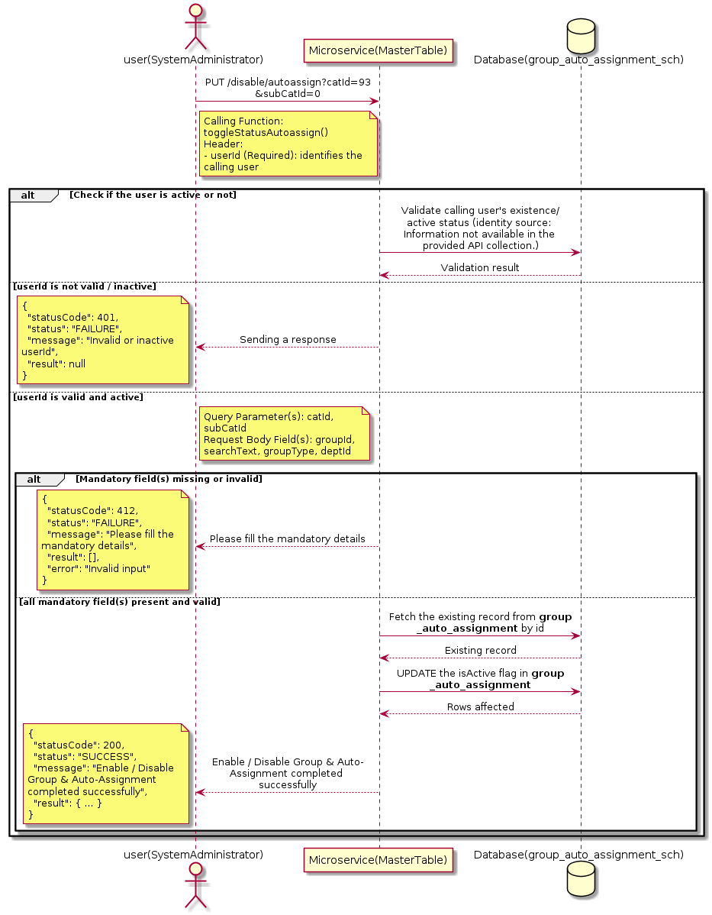

3.8.9.3 API Endpoint
Method | PUT
URL | http://localhost:7002/srv2/genie/disable/autoassign?catId=93&subCatId=0
Headers | userId: 67 Accept: application/json Content-Type: application/json
Authorization | Not present in the captured request. Information not available in the provided API collection.
Content-Type | Content-Type: application/json
Query Parameters | catId = 93 subCatId = 0
Path Variables | None
Request Body:
{
"groupId": 69,
"searchText": "",
"groupType": "Approvers group",
"deptId": 2
}
Response Body (illustrative — see 3.x.4.5 Success Response for details):
The source Postman collection does not include a captured sample response for this request (the response array is empty). Information not available in the provided API collection. Section 3.8.9.4.5 below presents the response envelope inferred from the standard response wrapper used consistently by this platform's services.

3.8.9.4 Detailed Process Flow

3.8.9.4.1 Request Initiation
The flow begins when System Administrator (or a calling microservice on their behalf) invokes the PUT endpoint http://localhost:7002/srv2/genie/disable/autoassign?catId=93&subCatId=0. The request must include the mandatory `userId` header used by the Master Table Microservice to identify the calling user for auditing purposes. The endpoint also expects one or more query parameters as listed in the API Endpoint section. The request carries a JSON payload in the request body which the Controller binds to its Data Transfer Object (DTO) before any processing begins. At the Controller layer, Spring Boot's request-mapping infrastructure routes the call to the appropriate handler method (`toggleStatusAutoassign`), and Bean Validation annotations (if configured on the DTO) perform structural validation before the request reaches the Service layer. Information not available in the provided API collection. regarding the exact validation annotations used in the source code.

3.8.9.4.2 User Validation
The Master Table Microservice relies on the `userId` header to identify the calling user. Based on the pattern observed consistently across this API collection, the platform's authentication/authorization is expected to be enforced upstream (e.g., by an API Gateway or a shared security filter) using this identifier; the Postman collection does not include an `Authorization` / `Bearer` token header on this request, so the exact authentication mechanism (JWT validation, session lookup, or gateway-level SSO) is Information not available in the provided API collection. Role-based authorization — i.e., confirming that the user identified by `userId` holds a role/permission entitled to perform this operation — is expected to be enforced by the Service layer (see Section 8 – Controller Analysis and Section 14 – Authentication & Authorization), but the specific role/permission checks are Information not available in the provided API collection.

3.8.9.4.3 Business Logic
The Service layer fetches the existing Group & Auto-Assignment record by its identifier and flips the `isActive` flag to the value supplied in the request. No other attributes of the record are modified by this operation. The key fields exchanged for this operation, as observed in the sample payload, are: `groupId`, `searchText`, `groupType`, `deptId`.

3.8.9.4.4 Database Interaction
The Repository layer (Spring Data JPA) interacts with the underlying relational database that backs the Group & Auto-Assignment master table. The primary operation issued is a **UPDATE** against the table associated with Group & Auto-Assignment. Only the `is_active` (status) column is updated for the row identified by the primary key; all other columns remain unchanged. The exact table name, column names, primary/foreign key definitions, and JPA repository method signatures are not included in the Postman collection; therefore, precise schema details are information not available in the provided api collection.

3.8.9.4.5 Success Response
Status Code: 200 OK. Sample response envelope (illustrative — the source collection did not capture a sample response for this API):
{
"statusCode": 200,
"status": "SUCCESS",
"message": "Enable / Disable Group & Auto-Assignment completed successfully",
"result": {
"id": 1,
"isActive": 1
},
"error": null,
"corelationId": "c6f2a1e4-2b3d-4a9e-9f1a-1234567890ab",
"url": null
}

3.8.9.4.6 Conclusion
This API provides a well-defined, single-purpose capability within the Master Table Microservice for enable / disable group & auto-assignment. The Controller → Service → Repository → Database layering keeps request validation, business rules, and persistence concerns separated, which allows the Group & Auto-Assignment master data to be maintained consistently and safely by authorized administrators while remaining available for consumption by every other module that depends on this reference data.

3.8.10 Create Group & Auto-Assignment — categoryorsubcategory/autoassign

3.8.10.1 Overview
Purpose: To create a new Group & Auto-Assignment master record in the system, allowing administrators to extend the master-data catalogue that other modules (ticketing, workflow, notifications) depend on.
Business Requirement: Business/process owners need a controlled way to add new Group & Auto-Assignment values so that the platform's classification, routing, and reporting capabilities can evolve as the organization changes.
Who Uses the API: System Administrator / CSR Manager responsible for master-data configuration.
Business Flow: Client sends a POST request with the new Group & Auto-Assignment payload → Controller validates the payload (mandatory fields, formats) → Service layer applies business rules (e.g., duplicate-name check) → Repository persists the new record → the created record (with generated identifier) is returned to the Client.

3.8.10.2 Sequence Diagram
The diagram below illustrates the end-to-end interaction for "Create Group & Auto-Assignment — categoryorsubcategory/autoassign" across the Client, Controller, Service, Repository, and Database layers.
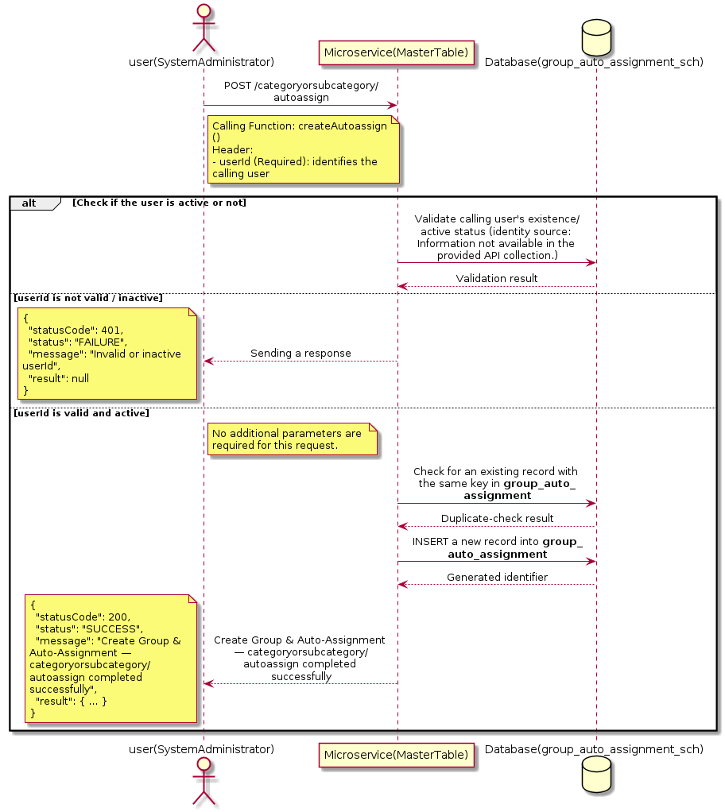

3.8.10.3 API Endpoint
Method | POST
URL | http://localhost:7002/srv2/genie/categoryorsubcategory/autoassign
Headers | userId: 67 Accept: application/json Content-Type: application/json
Authorization | Not present in the captured request. Information not available in the provided API collection.
Content-Type | Content-Type: application/json
Query Parameters | None
Path Variables | None
Request Body:
{
"catId": [
93
],
"subCatId": [
0
]
}
Response Body (illustrative — see 3.x.4.5 Success Response for details):
The source Postman collection does not include a captured sample response for this request (the response array is empty). Information not available in the provided API collection. Section 3.8.10.4.5 below presents the response envelope inferred from the standard response wrapper used consistently by this platform's services.

3.8.10.4 Detailed Process Flow

3.8.10.4.1 Request Initiation
The flow begins when System Administrator (or a calling microservice on their behalf) invokes the POST endpoint http://localhost:7002/srv2/genie/categoryorsubcategory/autoassign. The request must include the mandatory `userId` header used by the Master Table Microservice to identify the calling user for auditing purposes. The request carries a JSON payload in the request body which the Controller binds to its Data Transfer Object (DTO) before any processing begins. At the Controller layer, Spring Boot's request-mapping infrastructure routes the call to the appropriate handler method (`createAutoassign`), and Bean Validation annotations (if configured on the DTO) perform structural validation before the request reaches the Service layer. Information not available in the provided API collection. regarding the exact validation annotations used in the source code.

3.8.10.4.2 User Validation
The Master Table Microservice relies on the `userId` header to identify the calling user. Based on the pattern observed consistently across this API collection, the platform's authentication/authorization is expected to be enforced upstream (e.g., by an API Gateway or a shared security filter) using this identifier; the Postman collection does not include an `Authorization` / `Bearer` token header on this request, so the exact authentication mechanism (JWT validation, session lookup, or gateway-level SSO) is Information not available in the provided API collection. Role-based authorization — i.e., confirming that the user identified by `userId` holds a role/permission entitled to perform this operation — is expected to be enforced by the Service layer (see Section 8 – Controller Analysis and Section 14 – Authentication & Authorization), but the specific role/permission checks are Information not available in the provided API collection.

3.8.10.4.3 Business Logic
The Service layer performs the following: (1) validates that mandatory fields are present and correctly formatted, (2) checks for duplicates (e.g., an existing Group & Auto-Assignment with the same name/code), (3) sets system-managed fields (e.g., `isActive = 1`, `createdBy`, timestamps) where applicable, and (4) persists the new record via the Repository. If any validation fails, the Service layer returns a business error rather than proceeding to persistence.

3.8.10.4.4 Database Interaction
The Repository layer (Spring Data JPA) interacts with the underlying relational database that backs the Group & Auto-Assignment master table. The primary operation issued is a **INSERT** against the table associated with Group & Auto-Assignment. A new row is inserted into the master table; if the entity has related child records (as seen in nested request payload arrays), corresponding child-table inserts are performed within the same transaction. The exact table name, column names, primary/foreign key definitions, and JPA repository method signatures are not included in the Postman collection; therefore, precise schema details are information not available in the provided api collection.

3.8.10.4.5 Success Response
Status Code: 200 OK. Sample response envelope (illustrative — the source collection did not capture a sample response for this API):
{
"statusCode": 200,
"status": "SUCCESS",
"message": "Create Group & Auto-Assignment — categoryorsubcategory/autoassign completed successfully",
"result": {
"id": 101
},
"error": null,
"corelationId": "c6f2a1e4-2b3d-4a9e-9f1a-1234567890ab",
"url": null
}

3.8.10.4.6 Conclusion
This API provides a well-defined, single-purpose capability within the Master Table Microservice for create group & auto-assignment — categoryorsubcategory/autoassign. The Controller → Service → Repository → Database layering keeps request validation, business rules, and persistence concerns separated, which allows the Group & Auto-Assignment master data to be maintained consistently and safely by authorized administrators while remaining available for consumption by every other module that depends on this reference data.

3.8.11 Create Group & Auto-Assignment — group/id

3.8.11.1 Overview
Purpose: To create a new Group & Auto-Assignment master record in the system, allowing administrators to extend the master-data catalogue that other modules (ticketing, workflow, notifications) depend on.
Business Requirement: Business/process owners need a controlled way to add new Group & Auto-Assignment values so that the platform's classification, routing, and reporting capabilities can evolve as the organization changes.
Who Uses the API: System Administrator / CSR Manager responsible for master-data configuration.
Business Flow: Client sends a POST request with the new Group & Auto-Assignment payload → Controller validates the payload (mandatory fields, formats) → Service layer applies business rules (e.g., duplicate-name check) → Repository persists the new record → the created record (with generated identifier) is returned to the Client.

3.8.11.2 Sequence Diagram
The diagram below illustrates the end-to-end interaction for "Create Group & Auto-Assignment — group/id" across the Client, Controller, Service, Repository, and Database layers.
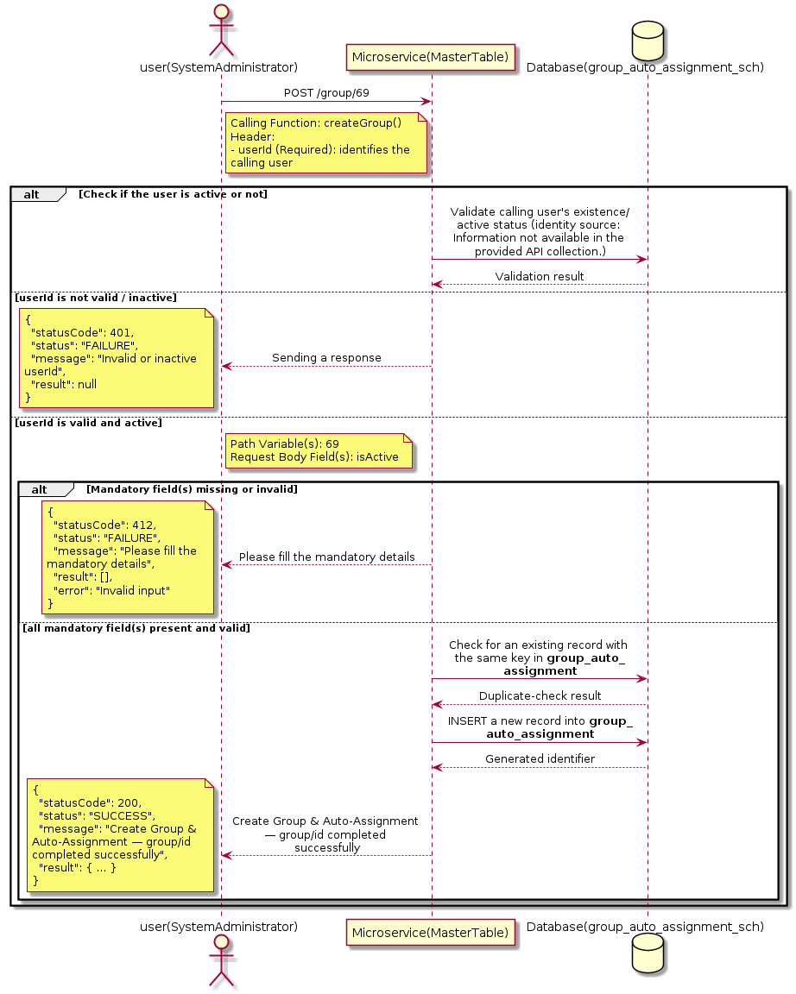

3.8.11.3 API Endpoint
Method | POST
URL | http://172.30.72.35:7002/srv2/genie/group/69
Headers | userId: 4588 Accept: application/json Content-Type: application/json
Authorization | Not present in the captured request. Information not available in the provided API collection.
Content-Type | Content-Type: application/json
Query Parameters | None
Path Variables | 69
Request Body:
{
"isActive": "1"
}
Response Body (illustrative — see 3.x.4.5 Success Response for details):
The source Postman collection does not include a captured sample response for this request (the response array is empty). Information not available in the provided API collection. Section 3.8.11.4.5 below presents the response envelope inferred from the standard response wrapper used consistently by this platform's services.

3.8.11.4 Detailed Process Flow

3.8.11.4.1 Request Initiation
The flow begins when System Administrator (or a calling microservice on their behalf) invokes the POST endpoint http://172.30.72.35:7002/srv2/genie/group/69. The request must include the mandatory `userId` header used by the Master Table Microservice to identify the calling user for auditing purposes. The request carries a JSON payload in the request body which the Controller binds to its Data Transfer Object (DTO) before any processing begins. At the Controller layer, Spring Boot's request-mapping infrastructure routes the call to the appropriate handler method (`createGroup`), and Bean Validation annotations (if configured on the DTO) perform structural validation before the request reaches the Service layer. Information not available in the provided API collection. regarding the exact validation annotations used in the source code.

3.8.11.4.2 User Validation
The Master Table Microservice relies on the `userId` header to identify the calling user. Based on the pattern observed consistently across this API collection, the platform's authentication/authorization is expected to be enforced upstream (e.g., by an API Gateway or a shared security filter) using this identifier; the Postman collection does not include an `Authorization` / `Bearer` token header on this request, so the exact authentication mechanism (JWT validation, session lookup, or gateway-level SSO) is Information not available in the provided API collection. Role-based authorization — i.e., confirming that the user identified by `userId` holds a role/permission entitled to perform this operation — is expected to be enforced by the Service layer (see Section 8 – Controller Analysis and Section 14 – Authentication & Authorization), but the specific role/permission checks are Information not available in the provided API collection.

3.8.11.4.3 Business Logic
The Service layer performs the following: (1) validates that mandatory fields are present and correctly formatted, (2) checks for duplicates (e.g., an existing Group & Auto-Assignment with the same name/code), (3) sets system-managed fields (e.g., `isActive = 1`, `createdBy`, timestamps) where applicable, and (4) persists the new record via the Repository. If any validation fails, the Service layer returns a business error rather than proceeding to persistence. The key fields exchanged for this operation, as observed in the sample payload, are: `isActive`.

3.8.11.4.4 Database Interaction
The Repository layer (Spring Data JPA) interacts with the underlying relational database that backs the Group & Auto-Assignment master table. The primary operation issued is a **INSERT** against the table associated with Group & Auto-Assignment. A new row is inserted into the master table; if the entity has related child records (as seen in nested request payload arrays), corresponding child-table inserts are performed within the same transaction. The exact table name, column names, primary/foreign key definitions, and JPA repository method signatures are not included in the Postman collection; therefore, precise schema details are information not available in the provided api collection.

3.8.11.4.5 Success Response
Status Code: 200 OK. Sample response envelope (illustrative — the source collection did not capture a sample response for this API):
{
"statusCode": 200,
"status": "SUCCESS",
"message": "Create Group & Auto-Assignment — group/id completed successfully",
"result": {
"id": 101,
"isActive": "1"
},
"error": null,
"corelationId": "c6f2a1e4-2b3d-4a9e-9f1a-1234567890ab",
"url": null
}

3.8.11.4.6 Conclusion
This API provides a well-defined, single-purpose capability within the Master Table Microservice for create group & auto-assignment — group/id. The Controller → Service → Repository → Database layering keeps request validation, business rules, and persistence concerns separated, which allows the Group & Auto-Assignment master data to be maintained consistently and safely by authorized administrators while remaining available for consumption by every other module that depends on this reference data.
3.9 Location APIs (Location APIs)
Maintains the location/site master used for employee, department and ticket association.

3.9.1 Retrieve Location by ID

3.9.1.1 Overview
Purpose: To retrieve a single Location record identified by its unique identifier, typically used to pre-populate an edit screen or to validate a reference before use.
Business Requirement: Edit screens, validation routines, and cross-service lookups need to resolve a single Location record by its identifier reliably and quickly.
Who Uses the API: System Administrator / HR Administrator, and internal services validating a Location reference (e.g., ticket creation, workflow configuration).
Business Flow: Client sends a GET request with the identifier in the URL path → Controller extracts the path variable → Service layer requests the Repository to fetch the record → if found, the record is mapped and returned; if not found, a 404 is returned.

3.9.1.2 Sequence Diagram
The diagram below illustrates the end-to-end interaction for "Retrieve Location by ID" across the Client, Controller, Service, Repository, and Database layers.
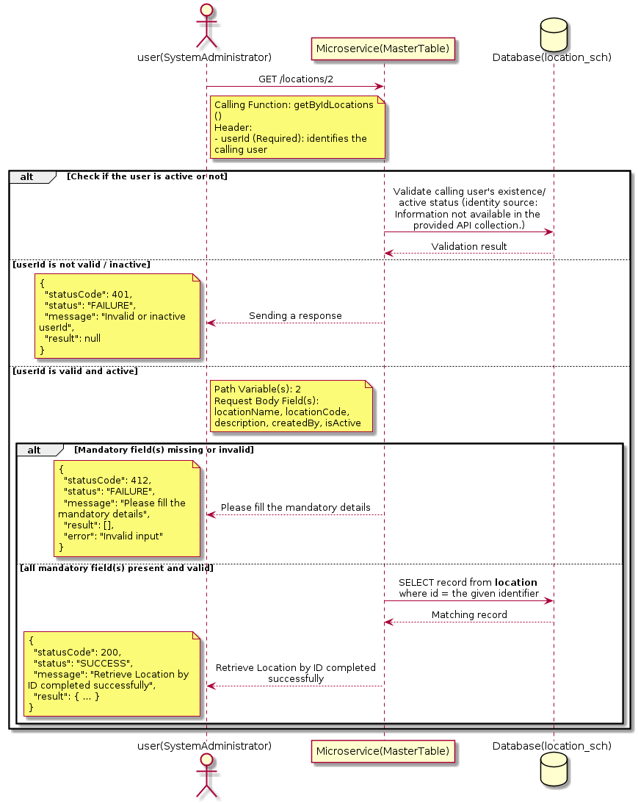

3.9.1.3 API Endpoint
Method | GET
URL | http://localhost:7002/srv2/genie/locations/2
Headers | userId: 67
Authorization | Not present in the captured request. Information not available in the provided API collection.
Content-Type | application/json (assumed)
Query Parameters | None
Path Variables | 2
Request Body:
{
"locationName": "Test Location",
"locationCode": "LOC001",
"description": "Test location",
"createdBy": 67,
"isActive": "1"
}
Response Body (illustrative — see 3.x.4.5 Success Response for details):
The source Postman collection does not include a captured sample response for this request (the response array is empty). Information not available in the provided API collection. Section 3.9.1.4.5 below presents the response envelope inferred from the standard response wrapper used consistently by this platform's services.

3.9.1.4 Detailed Process Flow

3.9.1.4.1 Request Initiation
The flow begins when System Administrator (or a calling microservice on their behalf) invokes the GET endpoint http://localhost:7002/srv2/genie/locations/2. The request must include the mandatory `userId` header used by the Master Table Microservice to identify the calling user for auditing purposes. The request carries a JSON payload in the request body which the Controller binds to its Data Transfer Object (DTO) before any processing begins. At the Controller layer, Spring Boot's request-mapping infrastructure routes the call to the appropriate handler method (`getByIdLocations`), and Bean Validation annotations (if configured on the DTO) perform structural validation before the request reaches the Service layer. Information not available in the provided API collection. regarding the exact validation annotations used in the source code.

3.9.1.4.2 User Validation
The Master Table Microservice relies on the `userId` header to identify the calling user. Based on the pattern observed consistently across this API collection, the platform's authentication/authorization is expected to be enforced upstream (e.g., by an API Gateway or a shared security filter) using this identifier; the Postman collection does not include an `Authorization` / `Bearer` token header on this request, so the exact authentication mechanism (JWT validation, session lookup, or gateway-level SSO) is Information not available in the provided API collection. Role-based authorization — i.e., confirming that the user identified by `userId` holds a role/permission entitled to perform this operation — is expected to be enforced by the Service layer (see Section 8 – Controller Analysis and Section 14 – Authentication & Authorization), but the specific role/permission checks are Information not available in the provided API collection.

3.9.1.4.3 Business Logic
The Service layer forwards the identifier to the Repository. If no record is found for the given identifier, the Service layer raises a not-found condition that the Controller/global exception handler converts into an HTTP 404 response. The key fields exchanged for this operation, as observed in the sample payload, are: `locationName`, `locationCode`, `description`, `createdBy`, `isActive`.

3.9.1.4.4 Database Interaction
The Repository layer (Spring Data JPA) interacts with the underlying relational database that backs the Location master table. The primary operation issued is a **SELECT** against the table associated with Location. No write operations occur; a single-row lookup is performed using the primary key. The exact table name, column names, primary/foreign key definitions, and JPA repository method signatures are not included in the Postman collection; therefore, precise schema details are information not available in the provided api collection.

3.9.1.4.5 Success Response
Status Code: 200 OK. Sample response envelope (illustrative — the source collection did not capture a sample response for this API):
{
"statusCode": 200,
"status": "SUCCESS",
"message": "Retrieve Location by ID completed successfully",
"result": {
"id": 1,
"name": "Sample Location",
"isActive": 1
},
"error": null,
"corelationId": "c6f2a1e4-2b3d-4a9e-9f1a-1234567890ab",
"url": null
}

3.9.1.4.6 Conclusion
This API provides a well-defined, single-purpose capability within the Master Table Microservice for retrieve location by id. The Controller → Service → Repository → Database layering keeps request validation, business rules, and persistence concerns separated, which allows the Location master data to be maintained consistently and safely by authorized administrators while remaining available for consumption by every other module that depends on this reference data.

3.9.2 Retrieve All Location — locations

3.9.2.1 Overview
Purpose: To retrieve the complete list of Location master records configured in the Master Table Microservice, so that consuming screens and downstream services can populate dropdowns, grids, and configuration views.
Business Requirement: Every screen and workflow that references Location data (creation forms, filters, reports) needs an authoritative, always-current list of active Location values sourced from a single master table rather than being hard-coded.
Who Uses the API: System Administrator / HR Administrator, and any internal microservice/UI module that needs to render Location options.
Business Flow: Client sends a GET request → Controller delegates to the Service layer → Service layer calls the Repository → Repository queries the Location table → the result set is mapped to response DTOs and returned to the Client.

3.9.2.2 Sequence Diagram
The diagram below illustrates the end-to-end interaction for "Retrieve All Location — locations" across the Client, Controller, Service, Repository, and Database layers.
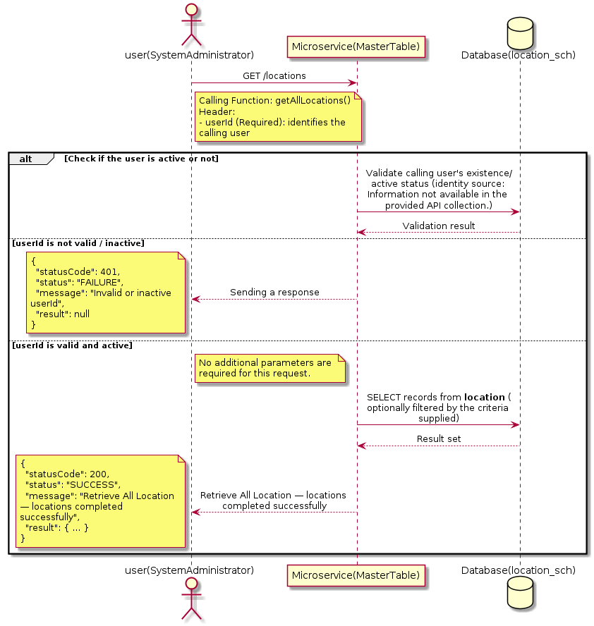

3.9.2.3 API Endpoint
Method | GET
URL | http://localhost:7002/srv2/genie/locations
Headers | No custom headers captured in the source collection.
Authorization | Not present in the captured request. Information not available in the provided API collection.
Content-Type | application/json (assumed)
Query Parameters | None
Path Variables | None
Request Body:
Not applicable — this operation does not accept a request body.
Response Body (illustrative — see 3.x.4.5 Success Response for details):
The source Postman collection does not include a captured sample response for this request (the response array is empty). Information not available in the provided API collection. Section 3.9.2.4.5 below presents the response envelope inferred from the standard response wrapper used consistently by this platform's services.

3.9.2.4 Detailed Process Flow

3.9.2.4.1 Request Initiation
The flow begins when System Administrator (or a calling microservice on their behalf) invokes the GET endpoint http://localhost:7002/srv2/genie/locations. The request must include the mandatory `userId` header used by the Master Table Microservice to identify the calling user for auditing purposes. At the Controller layer, Spring Boot's request-mapping infrastructure routes the call to the appropriate handler method (`getAllLocations`), and Bean Validation annotations (if configured on the DTO) perform structural validation before the request reaches the Service layer. Information not available in the provided API collection. regarding the exact validation annotations used in the source code.

3.9.2.4.2 User Validation
The Master Table Microservice relies on the `userId` header to identify the calling user. Based on the pattern observed consistently across this API collection, the platform's authentication/authorization is expected to be enforced upstream (e.g., by an API Gateway or a shared security filter) using this identifier; the Postman collection does not include an `Authorization` / `Bearer` token header on this request, so the exact authentication mechanism (JWT validation, session lookup, or gateway-level SSO) is Information not available in the provided API collection. Role-based authorization — i.e., confirming that the user identified by `userId` holds a role/permission entitled to perform this operation — is expected to be enforced by the Service layer (see Section 8 – Controller Analysis and Section 14 – Authentication & Authorization), but the specific role/permission checks are Information not available in the provided API collection.

3.9.2.4.3 Business Logic
The Service layer contains no conditional business branching for this operation beyond invoking the Repository to fetch all Location records. Depending on the record volume, the Service layer may apply default sorting (e.g., by name or creation order) before returning the list.

3.9.2.4.4 Database Interaction
The Repository layer (Spring Data JPA) interacts with the underlying relational database that backs the Location master table. The primary operation issued is a **SELECT** against the table associated with Location. No write operations occur; the query returns all rows that satisfy the entity's default scope (typically active records). The exact table name, column names, primary/foreign key definitions, and JPA repository method signatures are not included in the Postman collection; therefore, precise schema details are information not available in the provided api collection.

3.9.2.4.5 Success Response
Status Code: 200 OK. Sample response envelope (illustrative — the source collection did not capture a sample response for this API):
{
"statusCode": 200,
"status": "SUCCESS",
"message": "Retrieve All Location — locations completed successfully",
"result": [
{
"id": 1,
"name": "Sample Location",
"isActive": 1
}
],
"error": null,
"corelationId": "c6f2a1e4-2b3d-4a9e-9f1a-1234567890ab",
"url": null
}

3.9.2.4.6 Conclusion
This API provides a well-defined, single-purpose capability within the Master Table Microservice for retrieve all location — locations. The Controller → Service → Repository → Database layering keeps request validation, business rules, and persistence concerns separated, which allows the Location master data to be maintained consistently and safely by authorized administrators while remaining available for consumption by every other module that depends on this reference data.

3.9.3 Retrieve All Location — location/all

3.9.3.1 Overview
Purpose: To retrieve the complete list of Location master records configured in the Master Table Microservice, so that consuming screens and downstream services can populate dropdowns, grids, and configuration views.
Business Requirement: Every screen and workflow that references Location data (creation forms, filters, reports) needs an authoritative, always-current list of active Location values sourced from a single master table rather than being hard-coded.
Who Uses the API: System Administrator / HR Administrator, and any internal microservice/UI module that needs to render Location options.
Business Flow: Client sends a GET request → Controller delegates to the Service layer → Service layer calls the Repository → Repository queries the Location table → the result set is mapped to response DTOs and returned to the Client.

3.9.3.2 Sequence Diagram
The diagram below illustrates the end-to-end interaction for "Retrieve All Location — location/all" across the Client, Controller, Service, Repository, and Database layers.
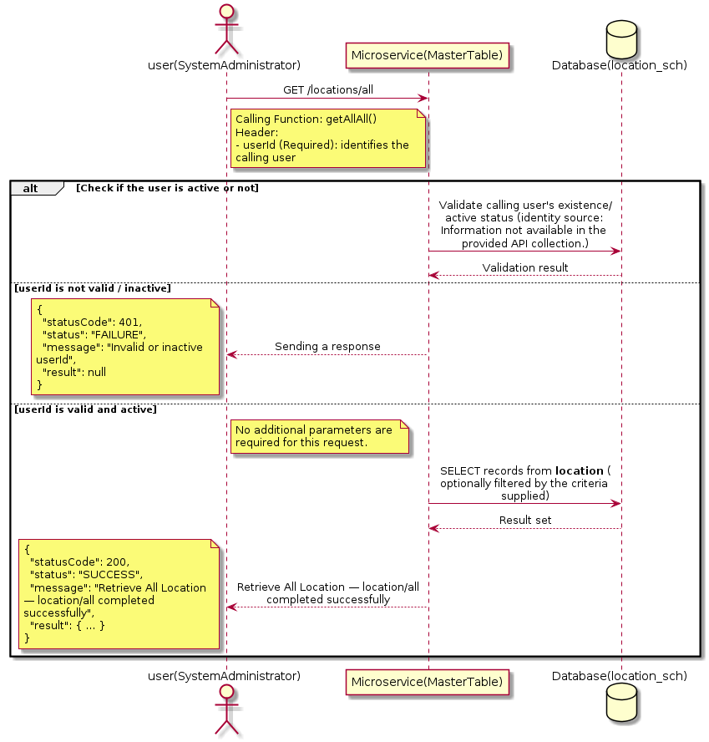

3.9.3.3 API Endpoint
Method | GET
URL | http://localhost:7002/srv2/genie/locations/all
Headers | No custom headers captured in the source collection.
Authorization | Not present in the captured request. Information not available in the provided API collection.
Content-Type | application/json (assumed)
Query Parameters | None
Path Variables | None
Request Body:
Not applicable — this operation does not accept a request body.
Response Body (illustrative — see 3.x.4.5 Success Response for details):
The source Postman collection does not include a captured sample response for this request (the response array is empty). Information not available in the provided API collection. Section 3.9.3.4.5 below presents the response envelope inferred from the standard response wrapper used consistently by this platform's services.

3.9.3.4 Detailed Process Flow

3.9.3.4.1 Request Initiation
The flow begins when System Administrator (or a calling microservice on their behalf) invokes the GET endpoint http://localhost:7002/srv2/genie/locations/all. The request must include the mandatory `userId` header used by the Master Table Microservice to identify the calling user for auditing purposes. At the Controller layer, Spring Boot's request-mapping infrastructure routes the call to the appropriate handler method (`getAllAll`), and Bean Validation annotations (if configured on the DTO) perform structural validation before the request reaches the Service layer. Information not available in the provided API collection. regarding the exact validation annotations used in the source code.

3.9.3.4.2 User Validation
The Master Table Microservice relies on the `userId` header to identify the calling user. Based on the pattern observed consistently across this API collection, the platform's authentication/authorization is expected to be enforced upstream (e.g., by an API Gateway or a shared security filter) using this identifier; the Postman collection does not include an `Authorization` / `Bearer` token header on this request, so the exact authentication mechanism (JWT validation, session lookup, or gateway-level SSO) is Information not available in the provided API collection. Role-based authorization — i.e., confirming that the user identified by `userId` holds a role/permission entitled to perform this operation — is expected to be enforced by the Service layer (see Section 8 – Controller Analysis and Section 14 – Authentication & Authorization), but the specific role/permission checks are Information not available in the provided API collection.

3.9.3.4.3 Business Logic
The Service layer contains no conditional business branching for this operation beyond invoking the Repository to fetch all Location records. Depending on the record volume, the Service layer may apply default sorting (e.g., by name or creation order) before returning the list.

3.9.3.4.4 Database Interaction
The Repository layer (Spring Data JPA) interacts with the underlying relational database that backs the Location master table. The primary operation issued is a **SELECT** against the table associated with Location. No write operations occur; the query returns all rows that satisfy the entity's default scope (typically active records). The exact table name, column names, primary/foreign key definitions, and JPA repository method signatures are not included in the Postman collection; therefore, precise schema details are information not available in the provided api collection.

3.9.3.4.5 Success Response
Status Code: 200 OK. Sample response envelope (illustrative — the source collection did not capture a sample response for this API):
{
"statusCode": 200,
"status": "SUCCESS",
"message": "Retrieve All Location — location/all completed successfully",
"result": [
{
"id": 1,
"name": "Sample Location",
"isActive": 1
}
],
"error": null,
"corelationId": "c6f2a1e4-2b3d-4a9e-9f1a-1234567890ab",
"url": null
}

3.9.3.4.6 Conclusion
This API provides a well-defined, single-purpose capability within the Master Table Microservice for retrieve all location — location/all. The Controller → Service → Repository → Database layering keeps request validation, business rules, and persistence concerns separated, which allows the Location master data to be maintained consistently and safely by authorized administrators while remaining available for consumption by every other module that depends on this reference data.

3.9.4 Update Location

3.9.4.1 Overview
Purpose: To update an existing Location master record, allowing administrators to correct or evolve master-data attributes without impacting the record's identity/history.
Business Requirement: Master data changes over time (renames, corrections, re-classification); the platform must allow controlled updates while preserving referential integrity for records that already reference this Location.
Who Uses the API: System Administrator / HR Administrator responsible for maintaining master-data accuracy.
Business Flow: Client sends a PUT/PATCH request with the updated Location payload → Controller validates the payload → Service layer fetches the existing record, applies the changes, and re-validates business rules → Repository persists the updated record → the updated record is returned to the Client.

3.9.4.2 Sequence Diagram
The diagram below illustrates the end-to-end interaction for "Update Location" across the Client, Controller, Service, Repository, and Database layers.
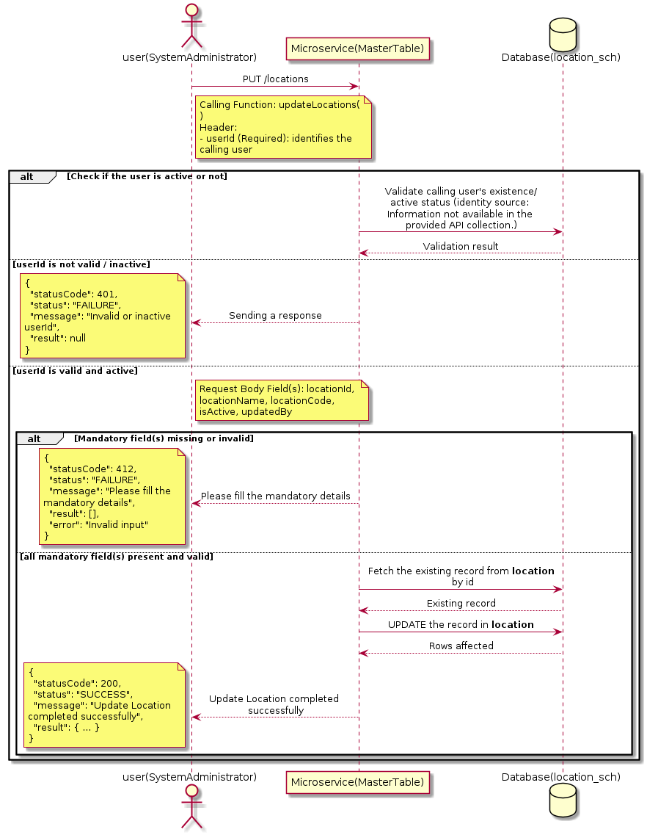

3.9.4.3 API Endpoint
Method | PUT
URL | http://localhost:7002/srv2/genie/locations
Headers | userId: 67 Content-Type: application/json (assumed based on JSON request payload; Information not available in the provided API collection.)
Authorization | Not present in the captured request. Information not available in the provided API collection.
Content-Type | Content-Type: application/json (assumed based on JSON request payload; Information not available in the provided API collection.)
Query Parameters | None
Path Variables | None
Request Body:
{
"locationId": 2,
"locationName": "Updated Test Location",
"locationCode": "LOC002",
"isActive": "1",
"updatedBy": 67
}
Response Body (illustrative — see 3.x.4.5 Success Response for details):
The source Postman collection does not include a captured sample response for this request (the response array is empty). Information not available in the provided API collection. Section 3.9.4.4.5 below presents the response envelope inferred from the standard response wrapper used consistently by this platform's services.

3.9.4.4 Detailed Process Flow

3.9.4.4.1 Request Initiation
The flow begins when System Administrator (or a calling microservice on their behalf) invokes the PUT endpoint http://localhost:7002/srv2/genie/locations. The request must include the mandatory `userId` header used by the Master Table Microservice to identify the calling user for auditing purposes. The request carries a JSON payload in the request body which the Controller binds to its Data Transfer Object (DTO) before any processing begins. At the Controller layer, Spring Boot's request-mapping infrastructure routes the call to the appropriate handler method (`updateLocations`), and Bean Validation annotations (if configured on the DTO) perform structural validation before the request reaches the Service layer. Information not available in the provided API collection. regarding the exact validation annotations used in the source code.

3.9.4.4.2 User Validation
The Master Table Microservice relies on the `userId` header to identify the calling user. Based on the pattern observed consistently across this API collection, the platform's authentication/authorization is expected to be enforced upstream (e.g., by an API Gateway or a shared security filter) using this identifier; the Postman collection does not include an `Authorization` / `Bearer` token header on this request, so the exact authentication mechanism (JWT validation, session lookup, or gateway-level SSO) is Information not available in the provided API collection. Role-based authorization — i.e., confirming that the user identified by `userId` holds a role/permission entitled to perform this operation — is expected to be enforced by the Service layer (see Section 8 – Controller Analysis and Section 14 – Authentication & Authorization), but the specific role/permission checks are Information not available in the provided API collection.

3.9.4.4.3 Business Logic
The Service layer fetches the existing Location record by its identifier, verifies it exists, applies the incoming changes field by field, re-validates business rules (e.g., uniqueness of a renamed field), and persists the updated entity via the Repository. If the record does not exist, the operation is rejected with a not-found error. The key fields exchanged for this operation, as observed in the sample payload, are: `locationId`, `locationName`, `locationCode`, `isActive`, `updatedBy`.

3.9.4.4.4 Database Interaction
The Repository layer (Spring Data JPA) interacts with the underlying relational database that backs the Location master table. The primary operation issued is a **UPDATE** against the table associated with Location. The existing row is located by primary key and updated; if the entity has related child records, the existing child rows are typically replaced/updated within the same transaction. The exact table name, column names, primary/foreign key definitions, and JPA repository method signatures are not included in the Postman collection; therefore, precise schema details are information not available in the provided api collection.

3.9.4.4.5 Success Response
Status Code: 200 OK. Sample response envelope (illustrative — the source collection did not capture a sample response for this API):
{
"statusCode": 200,
"status": "SUCCESS",
"message": "Update Location completed successfully",
"result": {
"id": 1,
"isActive": 1
},
"error": null,
"corelationId": "c6f2a1e4-2b3d-4a9e-9f1a-1234567890ab",
"url": null
}

3.9.4.4.6 Conclusion
This API provides a well-defined, single-purpose capability within the Master Table Microservice for update location. The Controller → Service → Repository → Database layering keeps request validation, business rules, and persistence concerns separated, which allows the Location master data to be maintained consistently and safely by authorized administrators while remaining available for consumption by every other module that depends on this reference data.

3.9.5 Create Location

3.9.5.1 Overview
Purpose: To create a new Location master record in the system, allowing administrators to extend the master-data catalogue that other modules (ticketing, workflow, notifications) depend on.
Business Requirement: Business/process owners need a controlled way to add new Location values so that the platform's classification, routing, and reporting capabilities can evolve as the organization changes.
Who Uses the API: System Administrator / HR Administrator responsible for master-data configuration.
Business Flow: Client sends a POST request with the new Location payload → Controller validates the payload (mandatory fields, formats) → Service layer applies business rules (e.g., duplicate-name check) → Repository persists the new record → the created record (with generated identifier) is returned to the Client.

3.9.5.2 Sequence Diagram
The diagram below illustrates the end-to-end interaction for "Create Location" across the Client, Controller, Service, Repository, and Database layers.
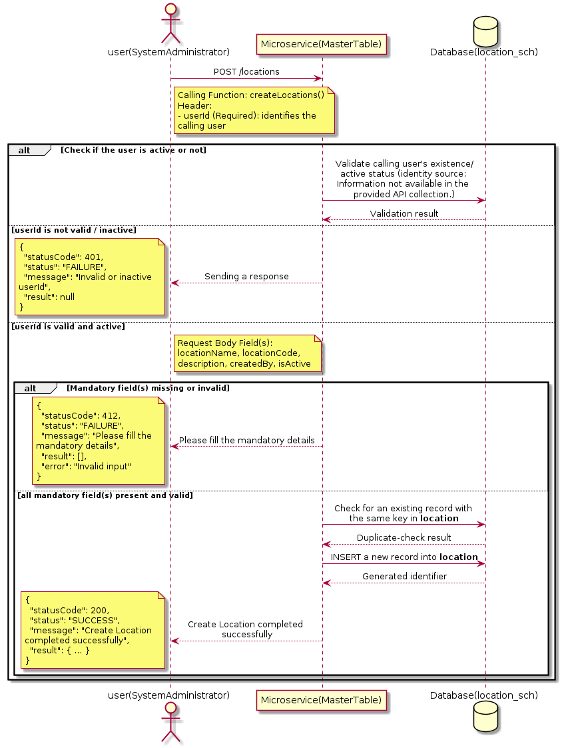

3.9.5.3 API Endpoint
Method | POST
URL | http://localhost:7002/srv2/genie/locations
Headers | userId: 67 Content-Type: application/json (assumed based on JSON request payload; Information not available in the provided API collection.)
Authorization | Not present in the captured request. Information not available in the provided API collection.
Content-Type | Content-Type: application/json (assumed based on JSON request payload; Information not available in the provided API collection.)
Query Parameters | None
Path Variables | None
Request Body:
{
"locationName": "Test Location New 2",
"locationCode": "LOC777",
"description": "Test location for baseline",
"createdBy": 67,
"isActive": "1"
}
Response Body (illustrative — see 3.x.4.5 Success Response for details):
The source Postman collection does not include a captured sample response for this request (the response array is empty). Information not available in the provided API collection. Section 3.9.5.4.5 below presents the response envelope inferred from the standard response wrapper used consistently by this platform's services.

3.9.5.4 Detailed Process Flow

3.9.5.4.1 Request Initiation
The flow begins when System Administrator (or a calling microservice on their behalf) invokes the POST endpoint http://localhost:7002/srv2/genie/locations. The request must include the mandatory `userId` header used by the Master Table Microservice to identify the calling user for auditing purposes. The request carries a JSON payload in the request body which the Controller binds to its Data Transfer Object (DTO) before any processing begins. At the Controller layer, Spring Boot's request-mapping infrastructure routes the call to the appropriate handler method (`createLocations`), and Bean Validation annotations (if configured on the DTO) perform structural validation before the request reaches the Service layer. Information not available in the provided API collection. regarding the exact validation annotations used in the source code.

3.9.5.4.2 User Validation
The Master Table Microservice relies on the `userId` header to identify the calling user. Based on the pattern observed consistently across this API collection, the platform's authentication/authorization is expected to be enforced upstream (e.g., by an API Gateway or a shared security filter) using this identifier; the Postman collection does not include an `Authorization` / `Bearer` token header on this request, so the exact authentication mechanism (JWT validation, session lookup, or gateway-level SSO) is Information not available in the provided API collection. Role-based authorization — i.e., confirming that the user identified by `userId` holds a role/permission entitled to perform this operation — is expected to be enforced by the Service layer (see Section 8 – Controller Analysis and Section 14 – Authentication & Authorization), but the specific role/permission checks are Information not available in the provided API collection.

3.9.5.4.3 Business Logic
The Service layer performs the following: (1) validates that mandatory fields are present and correctly formatted, (2) checks for duplicates (e.g., an existing Location with the same name/code), (3) sets system-managed fields (e.g., `isActive = 1`, `createdBy`, timestamps) where applicable, and (4) persists the new record via the Repository. If any validation fails, the Service layer returns a business error rather than proceeding to persistence. The key fields exchanged for this operation, as observed in the sample payload, are: `locationName`, `locationCode`, `description`, `createdBy`, `isActive`.

3.9.5.4.4 Database Interaction
The Repository layer (Spring Data JPA) interacts with the underlying relational database that backs the Location master table. The primary operation issued is a **INSERT** against the table associated with Location. A new row is inserted into the master table; if the entity has related child records (as seen in nested request payload arrays), corresponding child-table inserts are performed within the same transaction. The exact table name, column names, primary/foreign key definitions, and JPA repository method signatures are not included in the Postman collection; therefore, precise schema details are information not available in the provided api collection.

3.9.5.4.5 Success Response
Status Code: 200 OK. Sample response envelope (illustrative — the source collection did not capture a sample response for this API):
{
"statusCode": 200,
"status": "SUCCESS",
"message": "Create Location completed successfully",
"result": {
"id": 101,
"locationName": "Test Location New 2",
"locationCode": "LOC777",
"description": "Test location for baseline",
"createdBy": 67,
"isActive": "1"
},
"error": null,
"corelationId": "c6f2a1e4-2b3d-4a9e-9f1a-1234567890ab",
"url": null
}

3.9.5.4.6 Conclusion
This API provides a well-defined, single-purpose capability within the Master Table Microservice for create location. The Controller → Service → Repository → Database layering keeps request validation, business rules, and persistence concerns separated, which allows the Location master data to be maintained consistently and safely by authorized administrators while remaining available for consumption by every other module that depends on this reference data.

3.10 Master Table / Lookup Configuration APIs (Look Up)
Provides the generic, metadata-driven master-table engine: table definitions, lookup fields, operators, values, urgency/impact/priority derivation rules and dynamic lookup-rule conditions that other modules use to resolve dropdown values and priority calculations.

3.10.1 Create Master Table / Lookup Configuration — create/mastertable

3.10.1.1 Overview
Purpose: To create a new Master Table / Lookup Configuration master record in the system, allowing administrators to extend the master-data catalogue that other modules (ticketing, workflow, notifications) depend on.
Business Requirement: Business/process owners need a controlled way to add new Master Table / Lookup Configuration values so that the platform's classification, routing, and reporting capabilities can evolve as the organization changes.
Who Uses the API: System Administrator / Application Configuration Team responsible for master-data configuration.
Business Flow: Client sends a POST request with the new Master Table / Lookup Configuration payload → Controller validates the payload (mandatory fields, formats) → Service layer applies business rules (e.g., duplicate-name check) → Repository persists the new record → the created record (with generated identifier) is returned to the Client.

3.10.1.2 Sequence Diagram
The diagram below illustrates the end-to-end interaction for "Create Master Table / Lookup Configuration — create/mastertable" across the Client, Controller, Service, Repository, and Database layers.
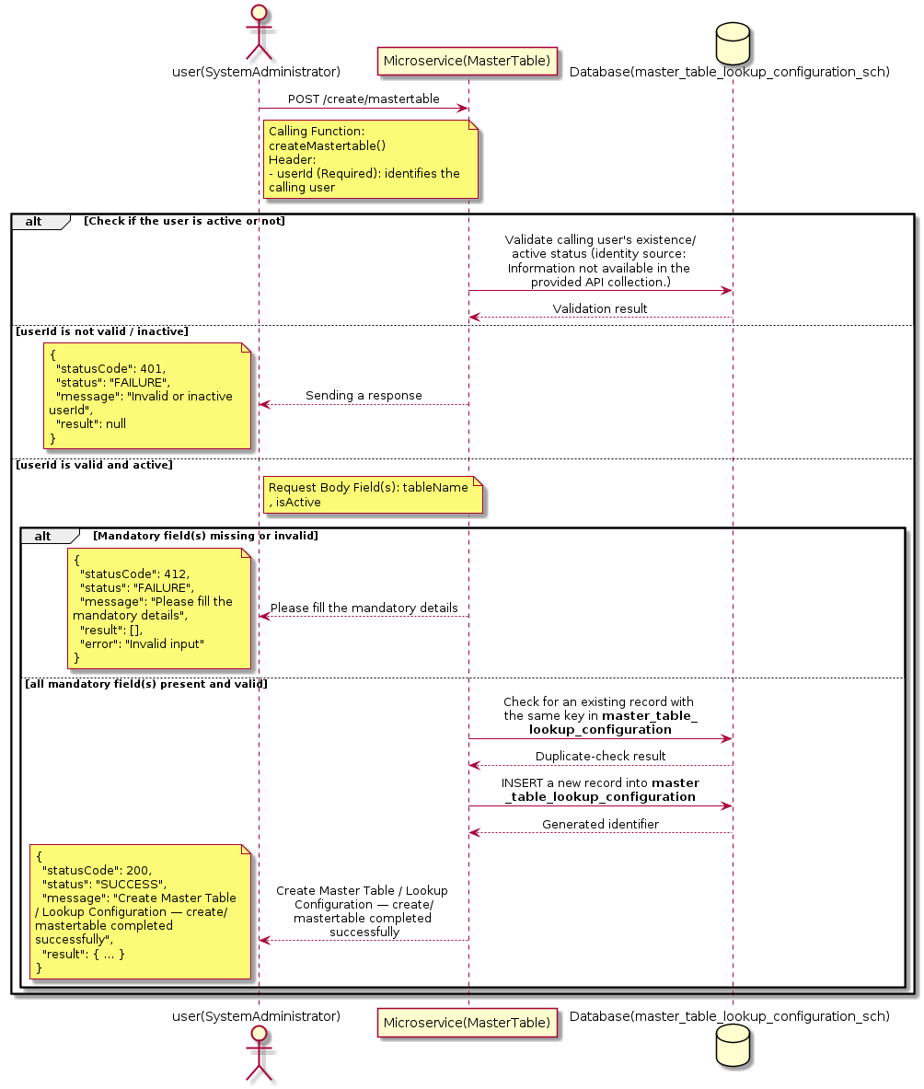

3.10.1.3 API Endpoint
Method | POST
URL | http://localhost:7002/srv2/genie/create/mastertable
Headers | Content-Type: application/json userId: 879
Authorization | Not present in the captured request. Information not available in the provided API collection.
Content-Type | Content-Type: application/json
Query Parameters | None
Path Variables | None
Request Body:
{
"tableName": "test_table",
"isActive": 1
}
Response Body (illustrative — see 3.x.4.5 Success Response for details):
The source Postman collection does not include a captured sample response for this request (the response array is empty). Information not available in the provided API collection. Section 3.10.1.4.5 below presents the response envelope inferred from the standard response wrapper used consistently by this platform's services.

3.10.1.4 Detailed Process Flow

3.10.1.4.1 Request Initiation
The flow begins when System Administrator (or a calling microservice on their behalf) invokes the POST endpoint http://localhost:7002/srv2/genie/create/mastertable. The request must include the mandatory `userId` header used by the Master Table Microservice to identify the calling user for auditing purposes. The request carries a JSON payload in the request body which the Controller binds to its Data Transfer Object (DTO) before any processing begins. At the Controller layer, Spring Boot's request-mapping infrastructure routes the call to the appropriate handler method (`createMastertable`), and Bean Validation annotations (if configured on the DTO) perform structural validation before the request reaches the Service layer. Information not available in the provided API collection. regarding the exact validation annotations used in the source code.

3.10.1.4.2 User Validation
The Master Table Microservice relies on the `userId` header to identify the calling user. Based on the pattern observed consistently across this API collection, the platform's authentication/authorization is expected to be enforced upstream (e.g., by an API Gateway or a shared security filter) using this identifier; the Postman collection does not include an `Authorization` / `Bearer` token header on this request, so the exact authentication mechanism (JWT validation, session lookup, or gateway-level SSO) is Information not available in the provided API collection. Role-based authorization — i.e., confirming that the user identified by `userId` holds a role/permission entitled to perform this operation — is expected to be enforced by the Service layer (see Section 8 – Controller Analysis and Section 14 – Authentication & Authorization), but the specific role/permission checks are Information not available in the provided API collection.

3.10.1.4.3 Business Logic
The Service layer performs the following: (1) validates that mandatory fields are present and correctly formatted, (2) checks for duplicates (e.g., an existing Master Table / Lookup Configuration with the same name/code), (3) sets system-managed fields (e.g., `isActive = 1`, `createdBy`, timestamps) where applicable, and (4) persists the new record via the Repository. If any validation fails, the Service layer returns a business error rather than proceeding to persistence. The key fields exchanged for this operation, as observed in the sample payload, are: `tableName`, `isActive`.

3.10.1.4.4 Database Interaction
The Repository layer (Spring Data JPA) interacts with the underlying relational database that backs the Master Table / Lookup Configuration master table. The primary operation issued is a **INSERT** against the table associated with Master Table / Lookup Configuration. A new row is inserted into the master table; if the entity has related child records (as seen in nested request payload arrays), corresponding child-table inserts are performed within the same transaction. The exact table name, column names, primary/foreign key definitions, and JPA repository method signatures are not included in the Postman collection; therefore, precise schema details are information not available in the provided api collection.

3.10.1.4.5 Success Response
Status Code: 200 OK. Sample response envelope (illustrative — the source collection did not capture a sample response for this API):
{
"statusCode": 200,
"status": "SUCCESS",
"message": "Create Master Table / Lookup Configuration — create/mastertable completed successfully",
"result": {
"id": 101,
"tableName": "test_table",
"isActive": 1
},
"error": null,
"corelationId": "c6f2a1e4-2b3d-4a9e-9f1a-1234567890ab",
"url": null
}

3.10.1.4.6 Conclusion
This API provides a well-defined, single-purpose capability within the Master Table Microservice for create master table / lookup configuration — create/mastertable. The Controller → Service → Repository → Database layering keeps request validation, business rules, and persistence concerns separated, which allows the Master Table / Lookup Configuration master data to be maintained consistently and safely by authorized administrators while remaining available for consumption by every other module that depends on this reference data.

3.10.2 Update Master Table / Lookup Configuration — urgency/urgency{id}

3.10.2.1 Overview
Purpose: To update an existing Master Table / Lookup Configuration master record, allowing administrators to correct or evolve master-data attributes without impacting the record's identity/history.
Business Requirement: Master data changes over time (renames, corrections, re-classification); the platform must allow controlled updates while preserving referential integrity for records that already reference this Master Table / Lookup Configuration.
Who Uses the API: System Administrator / Application Configuration Team responsible for maintaining master-data accuracy.
Business Flow: Client sends a PUT/PATCH request with the updated Master Table / Lookup Configuration payload → Controller validates the payload → Service layer fetches the existing record, applies the changes, and re-validates business rules → Repository persists the updated record → the updated record is returned to the Client.

3.10.2.2 Sequence Diagram
The diagram below illustrates the end-to-end interaction for "Update Master Table / Lookup Configuration — urgency/urgency{id}" across the Client, Controller, Service, Repository, and Database layers.
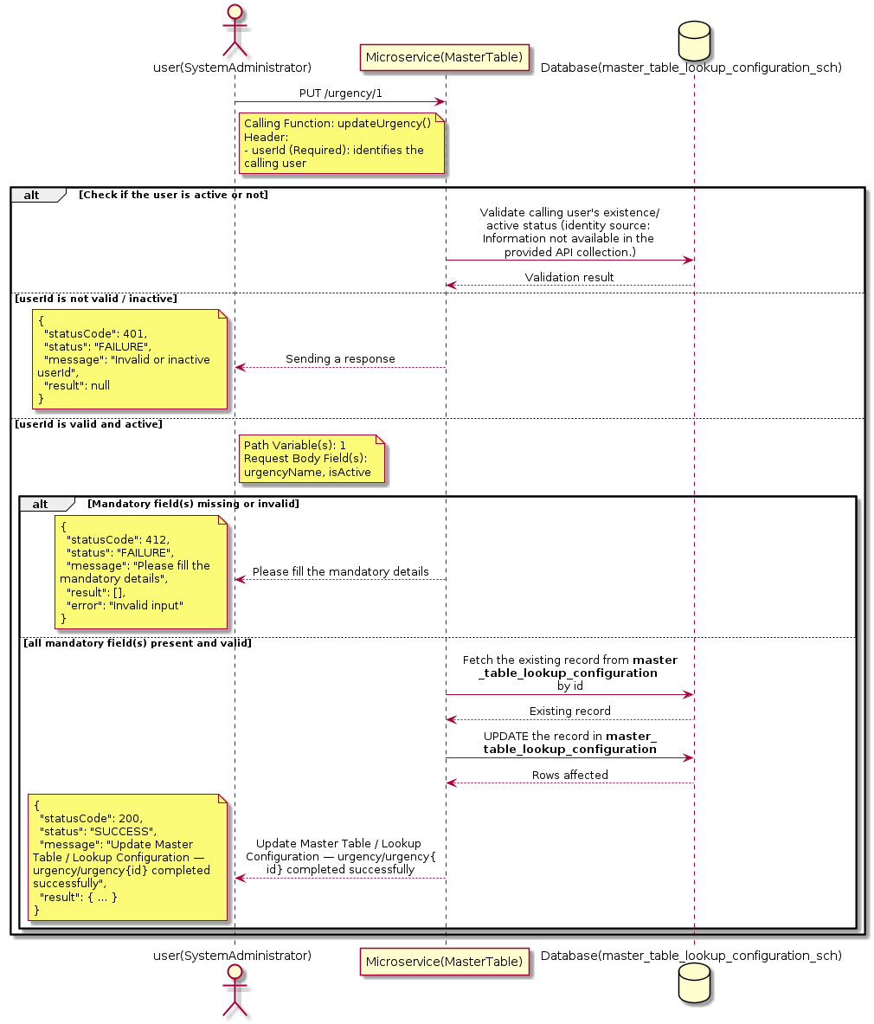

3.10.2.3 API Endpoint
Method | PUT
URL | http://localhost:7002/srv2/genie/urgency/1
Headers | Content-Type: application/json userId: 67
Authorization | Not present in the captured request. Information not available in the provided API collection.
Content-Type | Content-Type: application/json
Query Parameters | None
Path Variables | 1
Request Body:
{
"urgencyName": "Critical",
"isActive": 1
}
Response Body (illustrative — see 3.x.4.5 Success Response for details):
The source Postman collection does not include a captured sample response for this request (the response array is empty). Information not available in the provided API collection. Section 3.10.2.4.5 below presents the response envelope inferred from the standard response wrapper used consistently by this platform's services.

3.10.2.4 Detailed Process Flow

3.10.2.4.1 Request Initiation
The flow begins when System Administrator (or a calling microservice on their behalf) invokes the PUT endpoint http://localhost:7002/srv2/genie/urgency/1. The request must include the mandatory `userId` header used by the Master Table Microservice to identify the calling user for auditing purposes. The request carries a JSON payload in the request body which the Controller binds to its Data Transfer Object (DTO) before any processing begins. At the Controller layer, Spring Boot's request-mapping infrastructure routes the call to the appropriate handler method (`updateUrgency`), and Bean Validation annotations (if configured on the DTO) perform structural validation before the request reaches the Service layer. Information not available in the provided API collection. regarding the exact validation annotations used in the source code.

3.10.2.4.2 User Validation
The Master Table Microservice relies on the `userId` header to identify the calling user. Based on the pattern observed consistently across this API collection, the platform's authentication/authorization is expected to be enforced upstream (e.g., by an API Gateway or a shared security filter) using this identifier; the Postman collection does not include an `Authorization` / `Bearer` token header on this request, so the exact authentication mechanism (JWT validation, session lookup, or gateway-level SSO) is Information not available in the provided API collection. Role-based authorization — i.e., confirming that the user identified by `userId` holds a role/permission entitled to perform this operation — is expected to be enforced by the Service layer (see Section 8 – Controller Analysis and Section 14 – Authentication & Authorization), but the specific role/permission checks are Information not available in the provided API collection.

3.10.2.4.3 Business Logic
The Service layer fetches the existing Master Table / Lookup Configuration record by its identifier, verifies it exists, applies the incoming changes field by field, re-validates business rules (e.g., uniqueness of a renamed field), and persists the updated entity via the Repository. If the record does not exist, the operation is rejected with a not-found error. The key fields exchanged for this operation, as observed in the sample payload, are: `urgencyName`, `isActive`.

3.10.2.4.4 Database Interaction
The Repository layer (Spring Data JPA) interacts with the underlying relational database that backs the Master Table / Lookup Configuration master table. The primary operation issued is a **UPDATE** against the table associated with Master Table / Lookup Configuration. The existing row is located by primary key and updated; if the entity has related child records, the existing child rows are typically replaced/updated within the same transaction. The exact table name, column names, primary/foreign key definitions, and JPA repository method signatures are not included in the Postman collection; therefore, precise schema details are information not available in the provided api collection.

3.10.2.4.5 Success Response
Status Code: 200 OK. Sample response envelope (illustrative — the source collection did not capture a sample response for this API):
{
"statusCode": 200,
"status": "SUCCESS",
"message": "Update Master Table / Lookup Configuration — urgency/urgency{id} completed successfully",
"result": {
"id": "1",
"isActive": 1
},
"error": null,
"corelationId": "c6f2a1e4-2b3d-4a9e-9f1a-1234567890ab",
"url": null
}

3.10.2.4.6 Conclusion
This API provides a well-defined, single-purpose capability within the Master Table Microservice for update master table / lookup configuration — urgency/urgency{id}. The Controller → Service → Repository → Database layering keeps request validation, business rules, and persistence concerns separated, which allows the Master Table / Lookup Configuration master data to be maintained consistently and safely by authorized administrators while remaining available for consumption by every other module that depends on this reference data.

3.10.3 Update Master Table / Lookup Configuration — updatelookuprule/id

3.10.3.1 Overview
Purpose: To update an existing Master Table / Lookup Configuration master record, allowing administrators to correct or evolve master-data attributes without impacting the record's identity/history.
Business Requirement: Master data changes over time (renames, corrections, re-classification); the platform must allow controlled updates while preserving referential integrity for records that already reference this Master Table / Lookup Configuration.
Who Uses the API: System Administrator / Application Configuration Team responsible for maintaining master-data accuracy.
Business Flow: Client sends a PUT/PATCH request with the updated Master Table / Lookup Configuration payload → Controller validates the payload → Service layer fetches the existing record, applies the changes, and re-validates business rules → Repository persists the updated record → the updated record is returned to the Client.

3.10.3.2 Sequence Diagram
The diagram below illustrates the end-to-end interaction for "Update Master Table / Lookup Configuration — updatelookuprule/id" across the Client, Controller, Service, Repository, and Database layers.
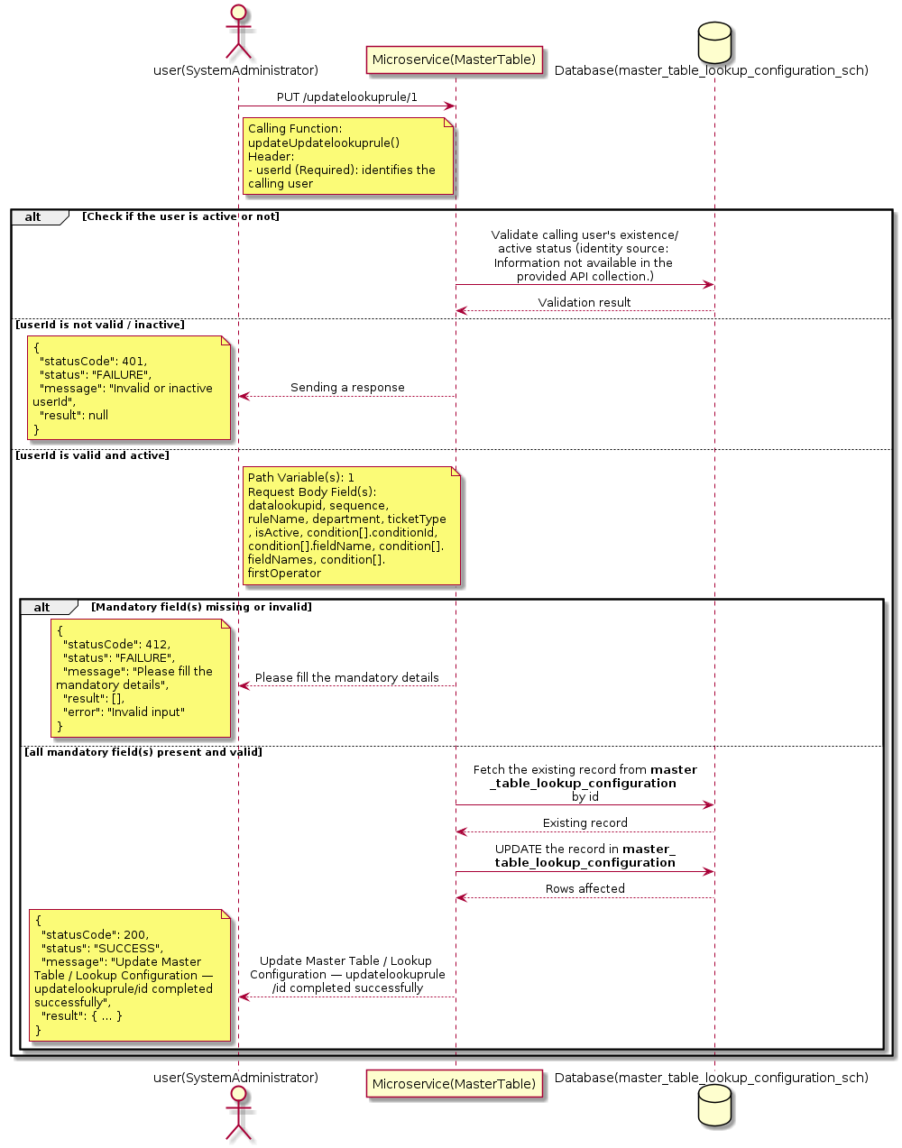

3.10.3.3 API Endpoint
Method | PUT
URL | http://localhost:7002/srv2/genie/updatelookuprule/1
Headers | Content-Type: application/json userId: 67
Authorization | Not present in the captured request. Information not available in the provided API collection.
Content-Type | Content-Type: application/json
Query Parameters | None
Path Variables | 1
Request Body:
{
"datalookupid": 1,
"sequence": 1,
"ruleName": "Urgency High Rule",
"department": 1,
"ticketType": 2,
"isActive": 1,
"condition": [
{
"conditionId": 2,
"fieldName": 2,
"fieldNames": "urgency",
"firstOperator": 3,
"firstOperatorName": "equals",
"value": "High",
"lastOperator": 3,
"lastOperatorName": "equals",
"sequence": 1,
"isActive": 1
}
]
}
Response Body (illustrative — see 3.x.4.5 Success Response for details):
The source Postman collection does not include a captured sample response for this request (the response array is empty). Information not available in the provided API collection. Section 3.10.3.4.5 below presents the response envelope inferred from the standard response wrapper used consistently by this platform's services.

3.10.3.4 Detailed Process Flow

3.10.3.4.1 Request Initiation
The flow begins when System Administrator (or a calling microservice on their behalf) invokes the PUT endpoint http://localhost:7002/srv2/genie/updatelookuprule/1. The request must include the mandatory `userId` header used by the Master Table Microservice to identify the calling user for auditing purposes. The request carries a JSON payload in the request body which the Controller binds to its Data Transfer Object (DTO) before any processing begins. At the Controller layer, Spring Boot's request-mapping infrastructure routes the call to the appropriate handler method (`updateUpdatelookuprule`), and Bean Validation annotations (if configured on the DTO) perform structural validation before the request reaches the Service layer. Information not available in the provided API collection. regarding the exact validation annotations used in the source code.

3.10.3.4.2 User Validation
The Master Table Microservice relies on the `userId` header to identify the calling user. Based on the pattern observed consistently across this API collection, the platform's authentication/authorization is expected to be enforced upstream (e.g., by an API Gateway or a shared security filter) using this identifier; the Postman collection does not include an `Authorization` / `Bearer` token header on this request, so the exact authentication mechanism (JWT validation, session lookup, or gateway-level SSO) is Information not available in the provided API collection. Role-based authorization — i.e., confirming that the user identified by `userId` holds a role/permission entitled to perform this operation — is expected to be enforced by the Service layer (see Section 8 – Controller Analysis and Section 14 – Authentication & Authorization), but the specific role/permission checks are Information not available in the provided API collection.

3.10.3.4.3 Business Logic
The Service layer fetches the existing Master Table / Lookup Configuration record by its identifier, verifies it exists, applies the incoming changes field by field, re-validates business rules (e.g., uniqueness of a renamed field), and persists the updated entity via the Repository. If the record does not exist, the operation is rejected with a not-found error. The key fields exchanged for this operation, as observed in the sample payload, are: `datalookupid`, `sequence`, `ruleName`, `department`, `ticketType`, `isActive`, `condition[].conditionId`, `condition[].fieldName`, `condition[].fieldNames`, `condition[].firstOperator`, `condition[].firstOperatorName`, `condition[].value`.

3.10.3.4.4 Database Interaction
The Repository layer (Spring Data JPA) interacts with the underlying relational database that backs the Master Table / Lookup Configuration master table. The primary operation issued is a **UPDATE** against the table associated with Master Table / Lookup Configuration. The existing row is located by primary key and updated; if the entity has related child records, the existing child rows are typically replaced/updated within the same transaction. The exact table name, column names, primary/foreign key definitions, and JPA repository method signatures are not included in the Postman collection; therefore, precise schema details are information not available in the provided api collection.

3.10.3.4.5 Success Response
Status Code: 200 OK. Sample response envelope (illustrative — the source collection did not capture a sample response for this API):
{
"statusCode": 200,
"status": "SUCCESS",
"message": "Update Master Table / Lookup Configuration — updatelookuprule/id completed successfully",
"result": {
"id": "1",
"isActive": 1
},
"error": null,
"corelationId": "c6f2a1e4-2b3d-4a9e-9f1a-1234567890ab",
"url": null
}

3.10.3.4.6 Conclusion
This API provides a well-defined, single-purpose capability within the Master Table Microservice for update master table / lookup configuration — updatelookuprule/id. The Controller → Service → Repository → Database layering keeps request validation, business rules, and persistence concerns separated, which allows the Master Table / Lookup Configuration master data to be maintained consistently and safely by authorized administrators while remaining available for consumption by every other module that depends on this reference data.

3.10.4 Update Master Table / Lookup Configuration — update/mastertable

3.10.4.1 Overview
Purpose: To update an existing Master Table / Lookup Configuration master record, allowing administrators to correct or evolve master-data attributes without impacting the record's identity/history.
Business Requirement: Master data changes over time (renames, corrections, re-classification); the platform must allow controlled updates while preserving referential integrity for records that already reference this Master Table / Lookup Configuration.
Who Uses the API: System Administrator / Application Configuration Team responsible for maintaining master-data accuracy.
Business Flow: Client sends a PUT/PATCH request with the updated Master Table / Lookup Configuration payload → Controller validates the payload → Service layer fetches the existing record, applies the changes, and re-validates business rules → Repository persists the updated record → the updated record is returned to the Client.

3.10.4.2 Sequence Diagram
The diagram below illustrates the end-to-end interaction for "Update Master Table / Lookup Configuration — update/mastertable" across the Client, Controller, Service, Repository, and Database layers.
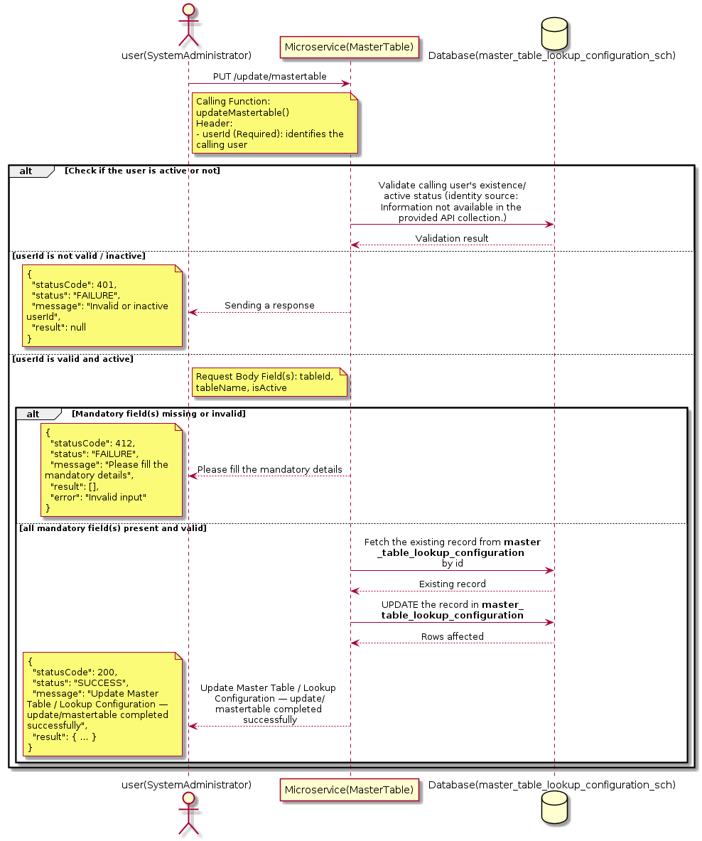

3.10.4.3 API Endpoint
Method | PUT
URL | http://localhost:7002/srv2/genie/update/mastertable
Headers | Content-Type: application/json userId: 879
Authorization | Not present in the captured request. Information not available in the provided API collection.
Content-Type | Content-Type: application/json
Query Parameters | None
Path Variables | None
Request Body:
{
"tableId": 10,
"tableName": "priority",
"isActive": 1
}
Response Body (illustrative — see 3.x.4.5 Success Response for details):
The source Postman collection does not include a captured sample response for this request (the response array is empty). Information not available in the provided API collection. Section 3.10.4.4.5 below presents the response envelope inferred from the standard response wrapper used consistently by this platform's services.

3.10.4.4 Detailed Process Flow

3.10.4.4.1 Request Initiation
The flow begins when System Administrator (or a calling microservice on their behalf) invokes the PUT endpoint http://localhost:7002/srv2/genie/update/mastertable. The request must include the mandatory `userId` header used by the Master Table Microservice to identify the calling user for auditing purposes. The request carries a JSON payload in the request body which the Controller binds to its Data Transfer Object (DTO) before any processing begins. At the Controller layer, Spring Boot's request-mapping infrastructure routes the call to the appropriate handler method (`updateMastertable`), and Bean Validation annotations (if configured on the DTO) perform structural validation before the request reaches the Service layer. Information not available in the provided API collection. regarding the exact validation annotations used in the source code.

3.10.4.4.2 User Validation
The Master Table Microservice relies on the `userId` header to identify the calling user. Based on the pattern observed consistently across this API collection, the platform's authentication/authorization is expected to be enforced upstream (e.g., by an API Gateway or a shared security filter) using this identifier; the Postman collection does not include an `Authorization` / `Bearer` token header on this request, so the exact authentication mechanism (JWT validation, session lookup, or gateway-level SSO) is Information not available in the provided API collection. Role-based authorization — i.e., confirming that the user identified by `userId` holds a role/permission entitled to perform this operation — is expected to be enforced by the Service layer (see Section 8 – Controller Analysis and Section 14 – Authentication & Authorization), but the specific role/permission checks are Information not available in the provided API collection.

3.10.4.4.3 Business Logic
The Service layer fetches the existing Master Table / Lookup Configuration record by its identifier, verifies it exists, applies the incoming changes field by field, re-validates business rules (e.g., uniqueness of a renamed field), and persists the updated entity via the Repository. If the record does not exist, the operation is rejected with a not-found error. The key fields exchanged for this operation, as observed in the sample payload, are: `tableId`, `tableName`, `isActive`.

3.10.4.4.4 Database Interaction
The Repository layer (Spring Data JPA) interacts with the underlying relational database that backs the Master Table / Lookup Configuration master table. The primary operation issued is a **UPDATE** against the table associated with Master Table / Lookup Configuration. The existing row is located by primary key and updated; if the entity has related child records, the existing child rows are typically replaced/updated within the same transaction. The exact table name, column names, primary/foreign key definitions, and JPA repository method signatures are not included in the Postman collection; therefore, precise schema details are information not available in the provided api collection.

3.10.4.4.5 Success Response
Status Code: 200 OK. Sample response envelope (illustrative — the source collection did not capture a sample response for this API):
{
"statusCode": 200,
"status": "SUCCESS",
"message": "Update Master Table / Lookup Configuration — update/mastertable completed successfully",
"result": {
"id": 1,
"isActive": 1
},
"error": null,
"corelationId": "c6f2a1e4-2b3d-4a9e-9f1a-1234567890ab",
"url": null
}

3.10.4.4.6 Conclusion
This API provides a well-defined, single-purpose capability within the Master Table Microservice for update master table / lookup configuration — update/mastertable. The Controller → Service → Repository → Database layering keeps request validation, business rules, and persistence concerns separated, which allows the Master Table / Lookup Configuration master data to be maintained consistently and safely by authorized administrators while remaining available for consumption by every other module that depends on this reference data.

3.10.5 Update Master Table / Lookup Configuration — operator/id

3.10.5.1 Overview
Purpose: To update an existing Master Table / Lookup Configuration master record, allowing administrators to correct or evolve master-data attributes without impacting the record's identity/history.
Business Requirement: Master data changes over time (renames, corrections, re-classification); the platform must allow controlled updates while preserving referential integrity for records that already reference this Master Table / Lookup Configuration.
Who Uses the API: System Administrator / Application Configuration Team responsible for maintaining master-data accuracy.
Business Flow: Client sends a PUT/PATCH request with the updated Master Table / Lookup Configuration payload → Controller validates the payload → Service layer fetches the existing record, applies the changes, and re-validates business rules → Repository persists the updated record → the updated record is returned to the Client.

3.10.5.2 Sequence Diagram
The diagram below illustrates the end-to-end interaction for "Update Master Table / Lookup Configuration — operator/id" across the Client, Controller, Service, Repository, and Database layers.
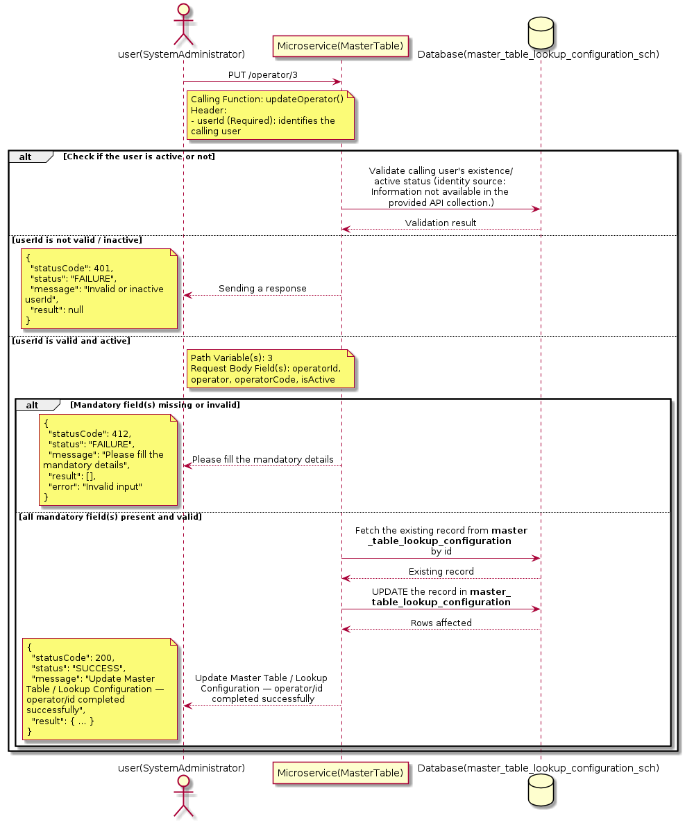

3.10.5.3 API Endpoint
Method | PUT
URL | http://localhost:7002/srv2/genie/operator/3
Headers | Content-Type: application/json userId: 67
Authorization | Not present in the captured request. Information not available in the provided API collection.
Content-Type | Content-Type: application/json
Query Parameters | None
Path Variables | 3
Request Body:
{
"operatorId": 3,
"operator": "Equals",
"operatorCode": "=",
"isActive": 1
}
Response Body (illustrative — see 3.x.4.5 Success Response for details):
The source Postman collection does not include a captured sample response for this request (the response array is empty). Information not available in the provided API collection. Section 3.10.5.4.5 below presents the response envelope inferred from the standard response wrapper used consistently by this platform's services.

3.10.5.4 Detailed Process Flow

3.10.5.4.1 Request Initiation
The flow begins when System Administrator (or a calling microservice on their behalf) invokes the PUT endpoint http://localhost:7002/srv2/genie/operator/3. The request must include the mandatory `userId` header used by the Master Table Microservice to identify the calling user for auditing purposes. The request carries a JSON payload in the request body which the Controller binds to its Data Transfer Object (DTO) before any processing begins. At the Controller layer, Spring Boot's request-mapping infrastructure routes the call to the appropriate handler method (`updateOperator`), and Bean Validation annotations (if configured on the DTO) perform structural validation before the request reaches the Service layer. Information not available in the provided API collection. regarding the exact validation annotations used in the source code.

3.10.5.4.2 User Validation
The Master Table Microservice relies on the `userId` header to identify the calling user. Based on the pattern observed consistently across this API collection, the platform's authentication/authorization is expected to be enforced upstream (e.g., by an API Gateway or a shared security filter) using this identifier; the Postman collection does not include an `Authorization` / `Bearer` token header on this request, so the exact authentication mechanism (JWT validation, session lookup, or gateway-level SSO) is Information not available in the provided API collection. Role-based authorization — i.e., confirming that the user identified by `userId` holds a role/permission entitled to perform this operation — is expected to be enforced by the Service layer (see Section 8 – Controller Analysis and Section 14 – Authentication & Authorization), but the specific role/permission checks are Information not available in the provided API collection.

3.10.5.4.3 Business Logic
The Service layer fetches the existing Master Table / Lookup Configuration record by its identifier, verifies it exists, applies the incoming changes field by field, re-validates business rules (e.g., uniqueness of a renamed field), and persists the updated entity via the Repository. If the record does not exist, the operation is rejected with a not-found error. The key fields exchanged for this operation, as observed in the sample payload, are: `operatorId`, `operator`, `operatorCode`, `isActive`.

3.10.5.4.4 Database Interaction
The Repository layer (Spring Data JPA) interacts with the underlying relational database that backs the Master Table / Lookup Configuration master table. The primary operation issued is a **UPDATE** against the table associated with Master Table / Lookup Configuration. The existing row is located by primary key and updated; if the entity has related child records, the existing child rows are typically replaced/updated within the same transaction. The exact table name, column names, primary/foreign key definitions, and JPA repository method signatures are not included in the Postman collection; therefore, precise schema details are information not available in the provided api collection.

3.10.5.4.5 Success Response
Status Code: 200 OK. Sample response envelope (illustrative — the source collection did not capture a sample response for this API):
{
"statusCode": 200,
"status": "SUCCESS",
"message": "Update Master Table / Lookup Configuration — operator/id completed successfully",
"result": {
"id": "3",
"isActive": 1
},
"error": null,
"corelationId": "c6f2a1e4-2b3d-4a9e-9f1a-1234567890ab",
"url": null
}

3.10.5.4.6 Conclusion
This API provides a well-defined, single-purpose capability within the Master Table Microservice for update master table / lookup configuration — operator/id. The Controller → Service → Repository → Database layering keeps request validation, business rules, and persistence concerns separated, which allows the Master Table / Lookup Configuration master data to be maintained consistently and safely by authorized administrators while remaining available for consumption by every other module that depends on this reference data.

3.10.6 Update Master Table / Lookup Configuration — lookupfiled/id

3.10.6.1 Overview
Purpose: To update an existing Master Table / Lookup Configuration master record, allowing administrators to correct or evolve master-data attributes without impacting the record's identity/history.
Business Requirement: Master data changes over time (renames, corrections, re-classification); the platform must allow controlled updates while preserving referential integrity for records that already reference this Master Table / Lookup Configuration.
Who Uses the API: System Administrator / Application Configuration Team responsible for maintaining master-data accuracy.
Business Flow: Client sends a PUT/PATCH request with the updated Master Table / Lookup Configuration payload → Controller validates the payload → Service layer fetches the existing record, applies the changes, and re-validates business rules → Repository persists the updated record → the updated record is returned to the Client.

3.10.6.2 Sequence Diagram
The diagram below illustrates the end-to-end interaction for "Update Master Table / Lookup Configuration — lookupfiled/id" across the Client, Controller, Service, Repository, and Database layers.
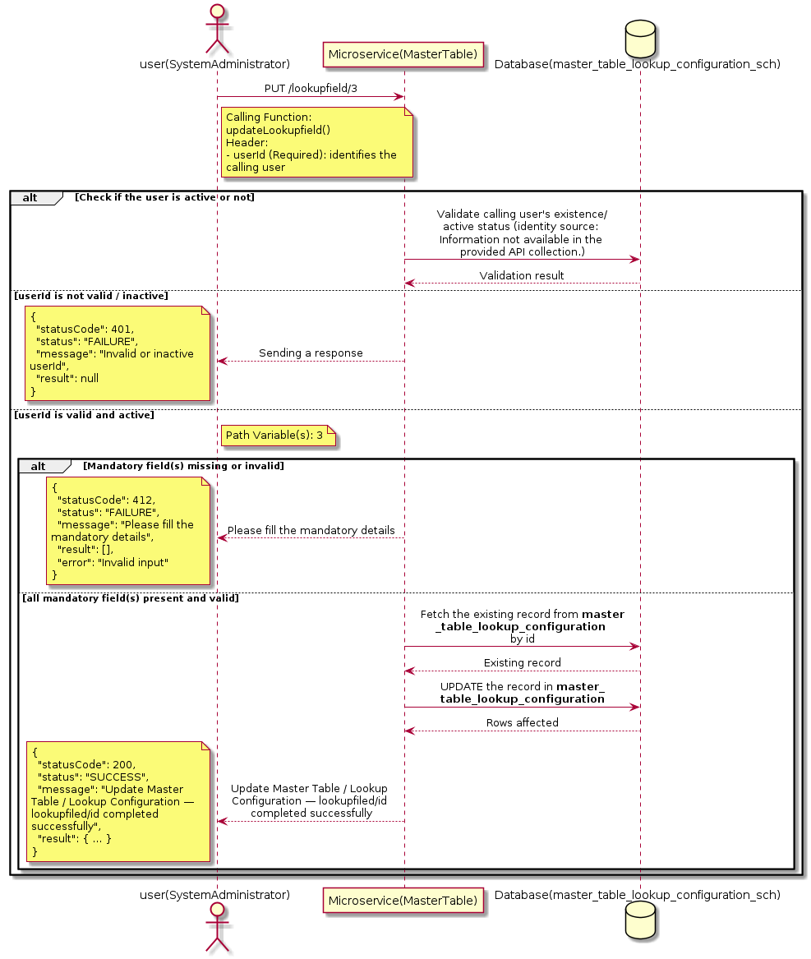

3.10.6.3 API Endpoint
Method | PUT
URL | http://localhost:7002/srv2/genie/lookupfield/3
Headers | Content-Type: application/json userId: 67
Authorization | Not present in the captured request. Information not available in the provided API collection.
Content-Type | Content-Type: application/json
Query Parameters | None
Path Variables | 3
Request Body:
{
"lookupFieldId": 3,
"fieldName": "priority_name",
"tableName": "priority_name",
"columnName": "priority_name",
"isActive": 1
}}
Response Body (illustrative — see 3.x.4.5 Success Response for details):
The source Postman collection does not include a captured sample response for this request (the response array is empty). Information not available in the provided API collection. Section 3.10.6.4.5 below presents the response envelope inferred from the standard response wrapper used consistently by this platform's services.

3.10.6.4 Detailed Process Flow

3.10.6.4.1 Request Initiation
The flow begins when System Administrator (or a calling microservice on their behalf) invokes the PUT endpoint http://localhost:7002/srv2/genie/lookupfield/3. The request must include the mandatory `userId` header used by the Master Table Microservice to identify the calling user for auditing purposes. The request carries a JSON payload in the request body which the Controller binds to its Data Transfer Object (DTO) before any processing begins. At the Controller layer, Spring Boot's request-mapping infrastructure routes the call to the appropriate handler method (`updateLookupfield`), and Bean Validation annotations (if configured on the DTO) perform structural validation before the request reaches the Service layer. Information not available in the provided API collection. regarding the exact validation annotations used in the source code.

3.10.6.4.2 User Validation
The Master Table Microservice relies on the `userId` header to identify the calling user. Based on the pattern observed consistently across this API collection, the platform's authentication/authorization is expected to be enforced upstream (e.g., by an API Gateway or a shared security filter) using this identifier; the Postman collection does not include an `Authorization` / `Bearer` token header on this request, so the exact authentication mechanism (JWT validation, session lookup, or gateway-level SSO) is Information not available in the provided API collection. Role-based authorization — i.e., confirming that the user identified by `userId` holds a role/permission entitled to perform this operation — is expected to be enforced by the Service layer (see Section 8 – Controller Analysis and Section 14 – Authentication & Authorization), but the specific role/permission checks are Information not available in the provided API collection.

3.10.6.4.3 Business Logic
The Service layer fetches the existing Master Table / Lookup Configuration record by its identifier, verifies it exists, applies the incoming changes field by field, re-validates business rules (e.g., uniqueness of a renamed field), and persists the updated entity via the Repository. If the record does not exist, the operation is rejected with a not-found error.

3.10.6.4.4 Database Interaction
The Repository layer (Spring Data JPA) interacts with the underlying relational database that backs the Master Table / Lookup Configuration master table. The primary operation issued is a **UPDATE** against the table associated with Master Table / Lookup Configuration. The existing row is located by primary key and updated; if the entity has related child records, the existing child rows are typically replaced/updated within the same transaction. The exact table name, column names, primary/foreign key definitions, and JPA repository method signatures are not included in the Postman collection; therefore, precise schema details are information not available in the provided api collection.

3.10.6.4.5 Success Response
Status Code: 200 OK. Sample response envelope (illustrative — the source collection did not capture a sample response for this API):
{
"statusCode": 200,
"status": "SUCCESS",
"message": "Update Master Table / Lookup Configuration — lookupfiled/id completed successfully",
"result": {
"id": "3",
"isActive": 1
},
"error": null,
"corelationId": "c6f2a1e4-2b3d-4a9e-9f1a-1234567890ab",
"url": null
}

3.10.6.4.6 Conclusion
This API provides a well-defined, single-purpose capability within the Master Table Microservice for update master table / lookup configuration — lookupfiled/id. The Controller → Service → Repository → Database layering keeps request validation, business rules, and persistence concerns separated, which allows the Master Table / Lookup Configuration master data to be maintained consistently and safely by authorized administrators while remaining available for consumption by every other module that depends on this reference data.

3.10.7 Update Master Table / Lookup Configuration — impact/id

3.10.7.1 Overview
Purpose: To update an existing Master Table / Lookup Configuration master record, allowing administrators to correct or evolve master-data attributes without impacting the record's identity/history.
Business Requirement: Master data changes over time (renames, corrections, re-classification); the platform must allow controlled updates while preserving referential integrity for records that already reference this Master Table / Lookup Configuration.
Who Uses the API: System Administrator / Application Configuration Team responsible for maintaining master-data accuracy.
Business Flow: Client sends a PUT/PATCH request with the updated Master Table / Lookup Configuration payload → Controller validates the payload → Service layer fetches the existing record, applies the changes, and re-validates business rules → Repository persists the updated record → the updated record is returned to the Client.

3.10.7.2 Sequence Diagram
The diagram below illustrates the end-to-end interaction for "Update Master Table / Lookup Configuration — impact/id" across the Client, Controller, Service, Repository, and Database layers.
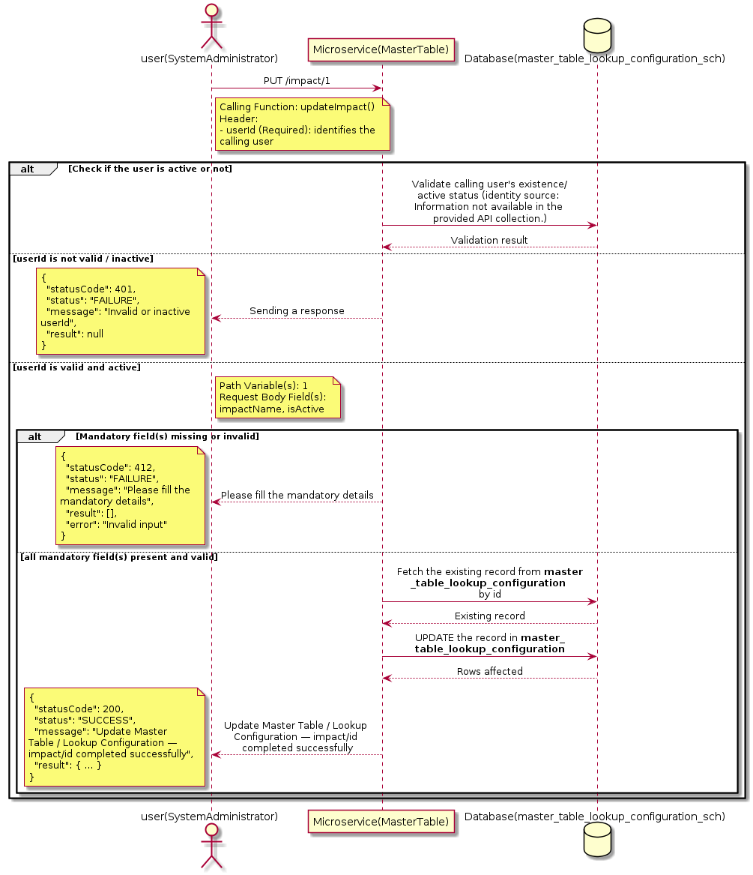

3.10.7.3 API Endpoint
Method | PUT
URL | http://localhost:7002/srv2/genie/impact/1
Headers | Content-Type: application/json userId: 67
Authorization | Not present in the captured request. Information not available in the provided API collection.
Content-Type | Content-Type: application/json
Query Parameters | None
Path Variables | 1
Request Body:
{
"impactName": "high",
"isActive": 1
}
Response Body (illustrative — see 3.x.4.5 Success Response for details):
The source Postman collection does not include a captured sample response for this request (the response array is empty). Information not available in the provided API collection. Section 3.10.7.4.5 below presents the response envelope inferred from the standard response wrapper used consistently by this platform's services.

3.10.7.4 Detailed Process Flow

3.10.7.4.1 Request Initiation
The flow begins when System Administrator (or a calling microservice on their behalf) invokes the PUT endpoint http://localhost:7002/srv2/genie/impact/1. The request must include the mandatory `userId` header used by the Master Table Microservice to identify the calling user for auditing purposes. The request carries a JSON payload in the request body which the Controller binds to its Data Transfer Object (DTO) before any processing begins. At the Controller layer, Spring Boot's request-mapping infrastructure routes the call to the appropriate handler method (`updateImpact`), and Bean Validation annotations (if configured on the DTO) perform structural validation before the request reaches the Service layer. Information not available in the provided API collection. regarding the exact validation annotations used in the source code.

3.10.7.4.2 User Validation
The Master Table Microservice relies on the `userId` header to identify the calling user. Based on the pattern observed consistently across this API collection, the platform's authentication/authorization is expected to be enforced upstream (e.g., by an API Gateway or a shared security filter) using this identifier; the Postman collection does not include an `Authorization` / `Bearer` token header on this request, so the exact authentication mechanism (JWT validation, session lookup, or gateway-level SSO) is Information not available in the provided API collection. Role-based authorization — i.e., confirming that the user identified by `userId` holds a role/permission entitled to perform this operation — is expected to be enforced by the Service layer (see Section 8 – Controller Analysis and Section 14 – Authentication & Authorization), but the specific role/permission checks are Information not available in the provided API collection.

3.10.7.4.3 Business Logic
The Service layer fetches the existing Master Table / Lookup Configuration record by its identifier, verifies it exists, applies the incoming changes field by field, re-validates business rules (e.g., uniqueness of a renamed field), and persists the updated entity via the Repository. If the record does not exist, the operation is rejected with a not-found error. The key fields exchanged for this operation, as observed in the sample payload, are: `impactName`, `isActive`.

3.10.7.4.4 Database Interaction
The Repository layer (Spring Data JPA) interacts with the underlying relational database that backs the Master Table / Lookup Configuration master table. The primary operation issued is a **UPDATE** against the table associated with Master Table / Lookup Configuration. The existing row is located by primary key and updated; if the entity has related child records, the existing child rows are typically replaced/updated within the same transaction. The exact table name, column names, primary/foreign key definitions, and JPA repository method signatures are not included in the Postman collection; therefore, precise schema details are information not available in the provided api collection.

3.10.7.4.5 Success Response
Status Code: 200 OK. Sample response envelope (illustrative — the source collection did not capture a sample response for this API):
{
"statusCode": 200,
"status": "SUCCESS",
"message": "Update Master Table / Lookup Configuration — impact/id completed successfully",
"result": {
"id": "1",
"isActive": 1
},
"error": null,
"corelationId": "c6f2a1e4-2b3d-4a9e-9f1a-1234567890ab",
"url": null
}

3.10.7.4.6 Conclusion
This API provides a well-defined, single-purpose capability within the Master Table Microservice for update master table / lookup configuration — impact/id. The Controller → Service → Repository → Database layering keeps request validation, business rules, and persistence concerns separated, which allows the Master Table / Lookup Configuration master data to be maintained consistently and safely by authorized administrators while remaining available for consumption by every other module that depends on this reference data.

3.10.8 Create Master Table / Lookup Configuration — value

3.10.8.1 Overview
Purpose: To create a new Master Table / Lookup Configuration master record in the system, allowing administrators to extend the master-data catalogue that other modules (ticketing, workflow, notifications) depend on.
Business Requirement: Business/process owners need a controlled way to add new Master Table / Lookup Configuration values so that the platform's classification, routing, and reporting capabilities can evolve as the organization changes.
Who Uses the API: System Administrator / Application Configuration Team responsible for master-data configuration.
Business Flow: Client sends a POST request with the new Master Table / Lookup Configuration payload → Controller validates the payload (mandatory fields, formats) → Service layer applies business rules (e.g., duplicate-name check) → Repository persists the new record → the created record (with generated identifier) is returned to the Client.

3.10.8.2 Sequence Diagram
The diagram below illustrates the end-to-end interaction for "Create Master Table / Lookup Configuration — value" across the Client, Controller, Service, Repository, and Database layers.
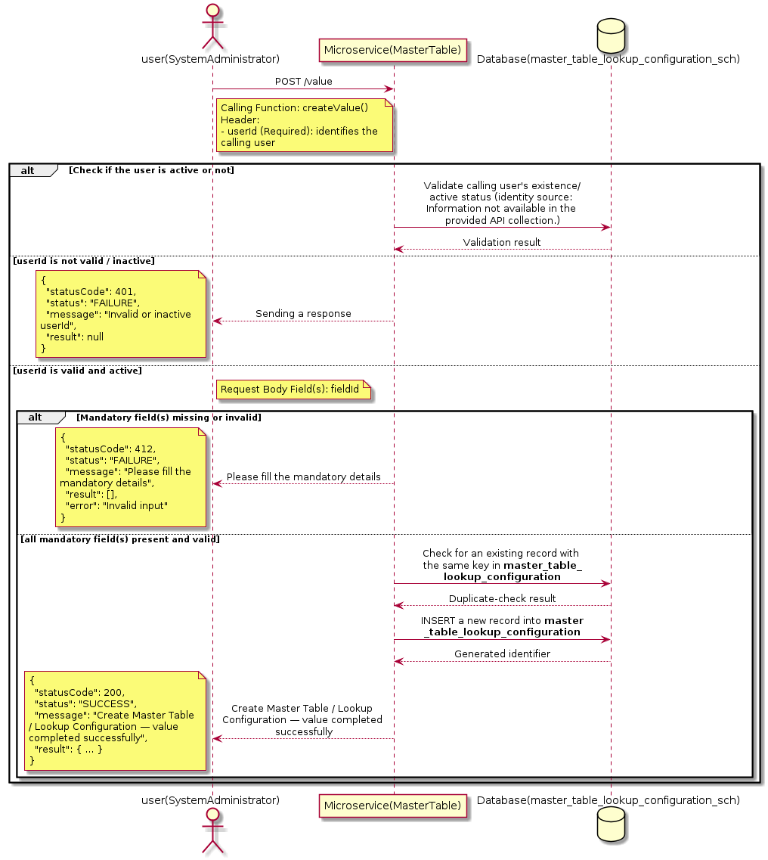

3.10.8.3 API Endpoint
Method | POST
URL | http://localhost:7002/srv2/genie/value
Headers | Content-Type: application/json userId: 67
Authorization | Not present in the captured request. Information not available in the provided API collection.
Content-Type | Content-Type: application/json
Query Parameters | None
Path Variables | None
Request Body:
{
"fieldId": 2,
"values": []
}
Response Body (illustrative — see 3.x.4.5 Success Response for details):
The source Postman collection does not include a captured sample response for this request (the response array is empty). Information not available in the provided API collection. Section 3.10.8.4.5 below presents the response envelope inferred from the standard response wrapper used consistently by this platform's services.

3.10.8.4 Detailed Process Flow

3.10.8.4.1 Request Initiation
The flow begins when System Administrator (or a calling microservice on their behalf) invokes the POST endpoint http://localhost:7002/srv2/genie/value. The request must include the mandatory `userId` header used by the Master Table Microservice to identify the calling user for auditing purposes. The request carries a JSON payload in the request body which the Controller binds to its Data Transfer Object (DTO) before any processing begins. At the Controller layer, Spring Boot's request-mapping infrastructure routes the call to the appropriate handler method (`createValue`), and Bean Validation annotations (if configured on the DTO) perform structural validation before the request reaches the Service layer. Information not available in the provided API collection. regarding the exact validation annotations used in the source code.

3.10.8.4.2 User Validation
The Master Table Microservice relies on the `userId` header to identify the calling user. Based on the pattern observed consistently across this API collection, the platform's authentication/authorization is expected to be enforced upstream (e.g., by an API Gateway or a shared security filter) using this identifier; the Postman collection does not include an `Authorization` / `Bearer` token header on this request, so the exact authentication mechanism (JWT validation, session lookup, or gateway-level SSO) is Information not available in the provided API collection. Role-based authorization — i.e., confirming that the user identified by `userId` holds a role/permission entitled to perform this operation — is expected to be enforced by the Service layer (see Section 8 – Controller Analysis and Section 14 – Authentication & Authorization), but the specific role/permission checks are Information not available in the provided API collection.

3.10.8.4.3 Business Logic
The Service layer performs the following: (1) validates that mandatory fields are present and correctly formatted, (2) checks for duplicates (e.g., an existing Master Table / Lookup Configuration with the same name/code), (3) sets system-managed fields (e.g., `isActive = 1`, `createdBy`, timestamps) where applicable, and (4) persists the new record via the Repository. If any validation fails, the Service layer returns a business error rather than proceeding to persistence. The key fields exchanged for this operation, as observed in the sample payload, are: `fieldId`.

3.10.8.4.4 Database Interaction
The Repository layer (Spring Data JPA) interacts with the underlying relational database that backs the Master Table / Lookup Configuration master table. The primary operation issued is a **INSERT** against the table associated with Master Table / Lookup Configuration. A new row is inserted into the master table; if the entity has related child records (as seen in nested request payload arrays), corresponding child-table inserts are performed within the same transaction. The exact table name, column names, primary/foreign key definitions, and JPA repository method signatures are not included in the Postman collection; therefore, precise schema details are information not available in the provided api collection.

3.10.8.4.5 Success Response
Status Code: 200 OK. Sample response envelope (illustrative — the source collection did not capture a sample response for this API):
{
"statusCode": 200,
"status": "SUCCESS",
"message": "Create Master Table / Lookup Configuration — value completed successfully",
"result": {
"id": 101,
"fieldId": 2
},
"error": null,
"corelationId": "c6f2a1e4-2b3d-4a9e-9f1a-1234567890ab",
"url": null
}

3.10.8.4.6 Conclusion
This API provides a well-defined, single-purpose capability within the Master Table Microservice for create master table / lookup configuration — value. The Controller → Service → Repository → Database layering keeps request validation, business rules, and persistence concerns separated, which allows the Master Table / Lookup Configuration master data to be maintained consistently and safely by authorized administrators while remaining available for consumption by every other module that depends on this reference data.

3.10.9 Create Master Table / Lookup Configuration — urgency

3.10.9.1 Overview
Purpose: To create a new Master Table / Lookup Configuration master record in the system, allowing administrators to extend the master-data catalogue that other modules (ticketing, workflow, notifications) depend on.
Business Requirement: Business/process owners need a controlled way to add new Master Table / Lookup Configuration values so that the platform's classification, routing, and reporting capabilities can evolve as the organization changes.
Who Uses the API: System Administrator / Application Configuration Team responsible for master-data configuration.
Business Flow: Client sends a POST request with the new Master Table / Lookup Configuration payload → Controller validates the payload (mandatory fields, formats) → Service layer applies business rules (e.g., duplicate-name check) → Repository persists the new record → the created record (with generated identifier) is returned to the Client.

3.10.9.2 Sequence Diagram
The diagram below illustrates the end-to-end interaction for "Create Master Table / Lookup Configuration — urgency" across the Client, Controller, Service, Repository, and Database layers.
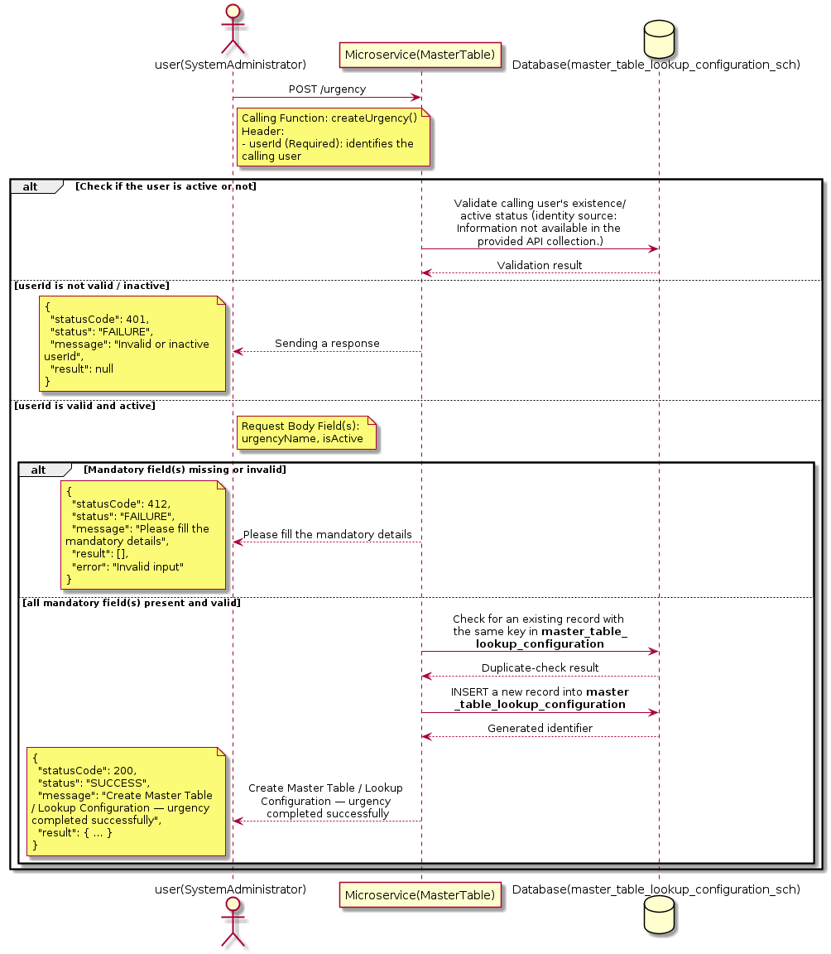

3.10.9.3 API Endpoint
Method | POST
URL | http://localhost:7002/srv2/genie/urgency
Headers | Content-Type: application/json userId: 67
Authorization | Not present in the captured request. Information not available in the provided API collection.
Content-Type | Content-Type: application/json
Query Parameters | None
Path Variables | None
Request Body:
{
"urgencyName": "high",
"isActive": "1"
}
Response Body (illustrative — see 3.x.4.5 Success Response for details):
The source Postman collection does not include a captured sample response for this request (the response array is empty). Information not available in the provided API collection. Section 3.10.9.4.5 below presents the response envelope inferred from the standard response wrapper used consistently by this platform's services.

3.10.9.4 Detailed Process Flow

3.10.9.4.1 Request Initiation
The flow begins when System Administrator (or a calling microservice on their behalf) invokes the POST endpoint http://localhost:7002/srv2/genie/urgency. The request must include the mandatory `userId` header used by the Master Table Microservice to identify the calling user for auditing purposes. The request carries a JSON payload in the request body which the Controller binds to its Data Transfer Object (DTO) before any processing begins. At the Controller layer, Spring Boot's request-mapping infrastructure routes the call to the appropriate handler method (`createUrgency`), and Bean Validation annotations (if configured on the DTO) perform structural validation before the request reaches the Service layer. Information not available in the provided API collection. regarding the exact validation annotations used in the source code.

3.10.9.4.2 User Validation
The Master Table Microservice relies on the `userId` header to identify the calling user. Based on the pattern observed consistently across this API collection, the platform's authentication/authorization is expected to be enforced upstream (e.g., by an API Gateway or a shared security filter) using this identifier; the Postman collection does not include an `Authorization` / `Bearer` token header on this request, so the exact authentication mechanism (JWT validation, session lookup, or gateway-level SSO) is Information not available in the provided API collection. Role-based authorization — i.e., confirming that the user identified by `userId` holds a role/permission entitled to perform this operation — is expected to be enforced by the Service layer (see Section 8 – Controller Analysis and Section 14 – Authentication & Authorization), but the specific role/permission checks are Information not available in the provided API collection.

3.10.9.4.3 Business Logic
The Service layer performs the following: (1) validates that mandatory fields are present and correctly formatted, (2) checks for duplicates (e.g., an existing Master Table / Lookup Configuration with the same name/code), (3) sets system-managed fields (e.g., `isActive = 1`, `createdBy`, timestamps) where applicable, and (4) persists the new record via the Repository. If any validation fails, the Service layer returns a business error rather than proceeding to persistence. The key fields exchanged for this operation, as observed in the sample payload, are: `urgencyName`, `isActive`.

3.10.9.4.4 Database Interaction
The Repository layer (Spring Data JPA) interacts with the underlying relational database that backs the Master Table / Lookup Configuration master table. The primary operation issued is a **INSERT** against the table associated with Master Table / Lookup Configuration. A new row is inserted into the master table; if the entity has related child records (as seen in nested request payload arrays), corresponding child-table inserts are performed within the same transaction. The exact table name, column names, primary/foreign key definitions, and JPA repository method signatures are not included in the Postman collection; therefore, precise schema details are information not available in the provided api collection.

3.10.9.4.5 Success Response
Status Code: 200 OK. Sample response envelope (illustrative — the source collection did not capture a sample response for this API):
{
"statusCode": 200,
"status": "SUCCESS",
"message": "Create Master Table / Lookup Configuration — urgency completed successfully",
"result": {
"id": 101,
"urgencyName": "high",
"isActive": "1"
},
"error": null,
"corelationId": "c6f2a1e4-2b3d-4a9e-9f1a-1234567890ab",
"url": null
}

3.10.9.4.6 Conclusion
This API provides a well-defined, single-purpose capability within the Master Table Microservice for create master table / lookup configuration — urgency. The Controller → Service → Repository → Database layering keeps request validation, business rules, and persistence concerns separated, which allows the Master Table / Lookup Configuration master data to be maintained consistently and safely by authorized administrators while remaining available for consumption by every other module that depends on this reference data.

3.10.10 Create Master Table / Lookup Configuration — priority Values

3.10.10.1 Overview
Purpose: To create a new Master Table / Lookup Configuration master record in the system, allowing administrators to extend the master-data catalogue that other modules (ticketing, workflow, notifications) depend on.
Business Requirement: Business/process owners need a controlled way to add new Master Table / Lookup Configuration values so that the platform's classification, routing, and reporting capabilities can evolve as the organization changes.
Who Uses the API: System Administrator / Application Configuration Team responsible for master-data configuration.
Business Flow: Client sends a POST request with the new Master Table / Lookup Configuration payload → Controller validates the payload (mandatory fields, formats) → Service layer applies business rules (e.g., duplicate-name check) → Repository persists the new record → the created record (with generated identifier) is returned to the Client.

3.10.10.2 Sequence Diagram
The diagram below illustrates the end-to-end interaction for "Create Master Table / Lookup Configuration — priority Values" across the Client, Controller, Service, Repository, and Database layers.
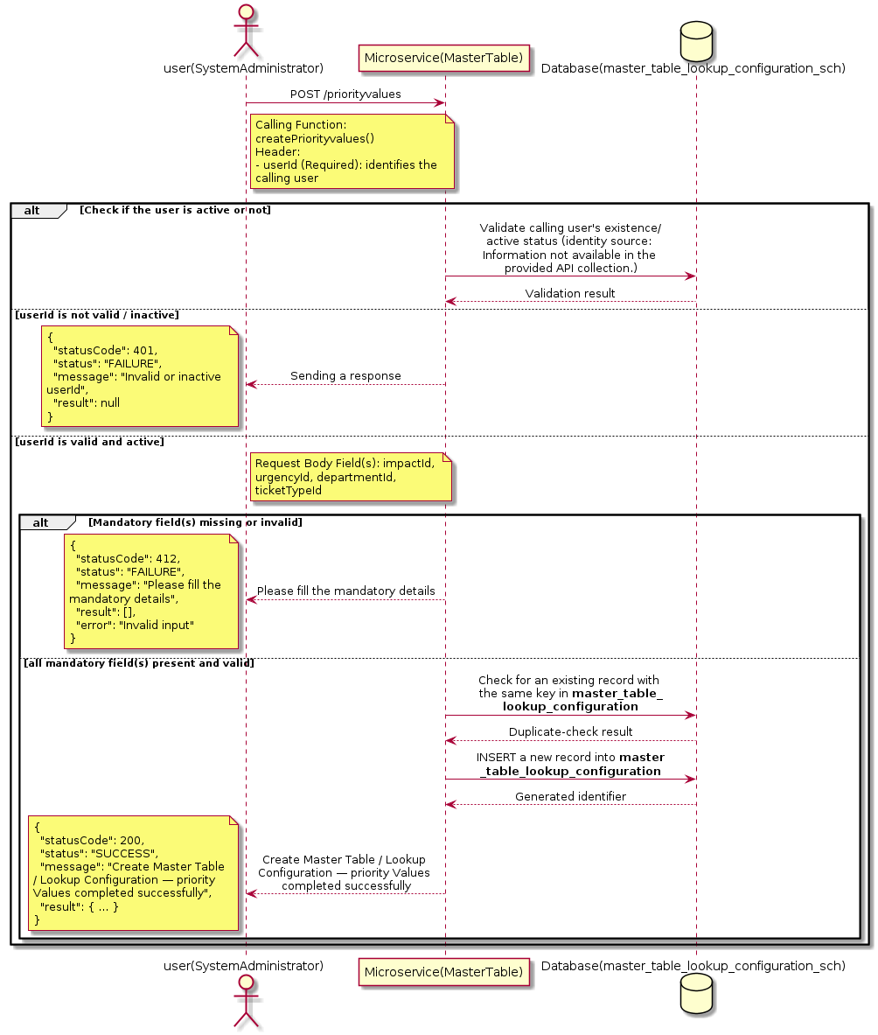

3.10.10.3 API Endpoint
Method | POST
URL | http://localhost:7002/srv2/genie/priorityvalues
Headers | Content-Type: application/json userId: 67
Authorization | Not present in the captured request. Information not available in the provided API collection.
Content-Type | Content-Type: application/json
Query Parameters | None
Path Variables | None
Request Body:
{
"impactId": 1,
"urgencyId": 1,
"departmentId": 1,
"ticketTypeId": 2
}
Response Body (illustrative — see 3.x.4.5 Success Response for details):
The source Postman collection does not include a captured sample response for this request (the response array is empty). Information not available in the provided API collection. Section 3.10.10.4.5 below presents the response envelope inferred from the standard response wrapper used consistently by this platform's services.

3.10.10.4 Detailed Process Flow

3.10.10.4.1 Request Initiation
The flow begins when System Administrator (or a calling microservice on their behalf) invokes the POST endpoint http://localhost:7002/srv2/genie/priorityvalues. The request must include the mandatory `userId` header used by the Master Table Microservice to identify the calling user for auditing purposes. The request carries a JSON payload in the request body which the Controller binds to its Data Transfer Object (DTO) before any processing begins. At the Controller layer, Spring Boot's request-mapping infrastructure routes the call to the appropriate handler method (`createPriorityvalues`), and Bean Validation annotations (if configured on the DTO) perform structural validation before the request reaches the Service layer. Information not available in the provided API collection. regarding the exact validation annotations used in the source code.

3.10.10.4.2 User Validation
The Master Table Microservice relies on the `userId` header to identify the calling user. Based on the pattern observed consistently across this API collection, the platform's authentication/authorization is expected to be enforced upstream (e.g., by an API Gateway or a shared security filter) using this identifier; the Postman collection does not include an `Authorization` / `Bearer` token header on this request, so the exact authentication mechanism (JWT validation, session lookup, or gateway-level SSO) is Information not available in the provided API collection. Role-based authorization — i.e., confirming that the user identified by `userId` holds a role/permission entitled to perform this operation — is expected to be enforced by the Service layer (see Section 8 – Controller Analysis and Section 14 – Authentication & Authorization), but the specific role/permission checks are Information not available in the provided API collection.

3.10.10.4.3 Business Logic
The Service layer performs the following: (1) validates that mandatory fields are present and correctly formatted, (2) checks for duplicates (e.g., an existing Master Table / Lookup Configuration with the same name/code), (3) sets system-managed fields (e.g., `isActive = 1`, `createdBy`, timestamps) where applicable, and (4) persists the new record via the Repository. If any validation fails, the Service layer returns a business error rather than proceeding to persistence. The key fields exchanged for this operation, as observed in the sample payload, are: `impactId`, `urgencyId`, `departmentId`, `ticketTypeId`.

3.10.10.4.4 Database Interaction
The Repository layer (Spring Data JPA) interacts with the underlying relational database that backs the Master Table / Lookup Configuration master table. The primary operation issued is a **INSERT** against the table associated with Master Table / Lookup Configuration. A new row is inserted into the master table; if the entity has related child records (as seen in nested request payload arrays), corresponding child-table inserts are performed within the same transaction. The exact table name, column names, primary/foreign key definitions, and JPA repository method signatures are not included in the Postman collection; therefore, precise schema details are information not available in the provided api collection.

3.10.10.4.5 Success Response
Status Code: 200 OK. Sample response envelope (illustrative — the source collection did not capture a sample response for this API):
{
"statusCode": 200,
"status": "SUCCESS",
"message": "Create Master Table / Lookup Configuration — priority Values completed successfully",
"result": {
"id": 101,
"impactId": 1,
"urgencyId": 1,
"departmentId": 1,
"ticketTypeId": 2
},
"error": null,
"corelationId": "c6f2a1e4-2b3d-4a9e-9f1a-1234567890ab",
"url": null
}

3.10.10.4.6 Conclusion
This API provides a well-defined, single-purpose capability within the Master Table Microservice for create master table / lookup configuration — priority values. The Controller → Service → Repository → Database layering keeps request validation, business rules, and persistence concerns separated, which allows the Master Table / Lookup Configuration master data to be maintained consistently and safely by authorized administrators while remaining available for consumption by every other module that depends on this reference data.

3.10.11 Create Master Table / Lookup Configuration — operators

3.10.11.1 Overview
Purpose: To create a new Master Table / Lookup Configuration master record in the system, allowing administrators to extend the master-data catalogue that other modules (ticketing, workflow, notifications) depend on.
Business Requirement: Business/process owners need a controlled way to add new Master Table / Lookup Configuration values so that the platform's classification, routing, and reporting capabilities can evolve as the organization changes.
Who Uses the API: System Administrator / Application Configuration Team responsible for master-data configuration.
Business Flow: Client sends a POST request with the new Master Table / Lookup Configuration payload → Controller validates the payload (mandatory fields, formats) → Service layer applies business rules (e.g., duplicate-name check) → Repository persists the new record → the created record (with generated identifier) is returned to the Client.

3.10.11.2 Sequence Diagram
The diagram below illustrates the end-to-end interaction for "Create Master Table / Lookup Configuration — operators" across the Client, Controller, Service, Repository, and Database layers.
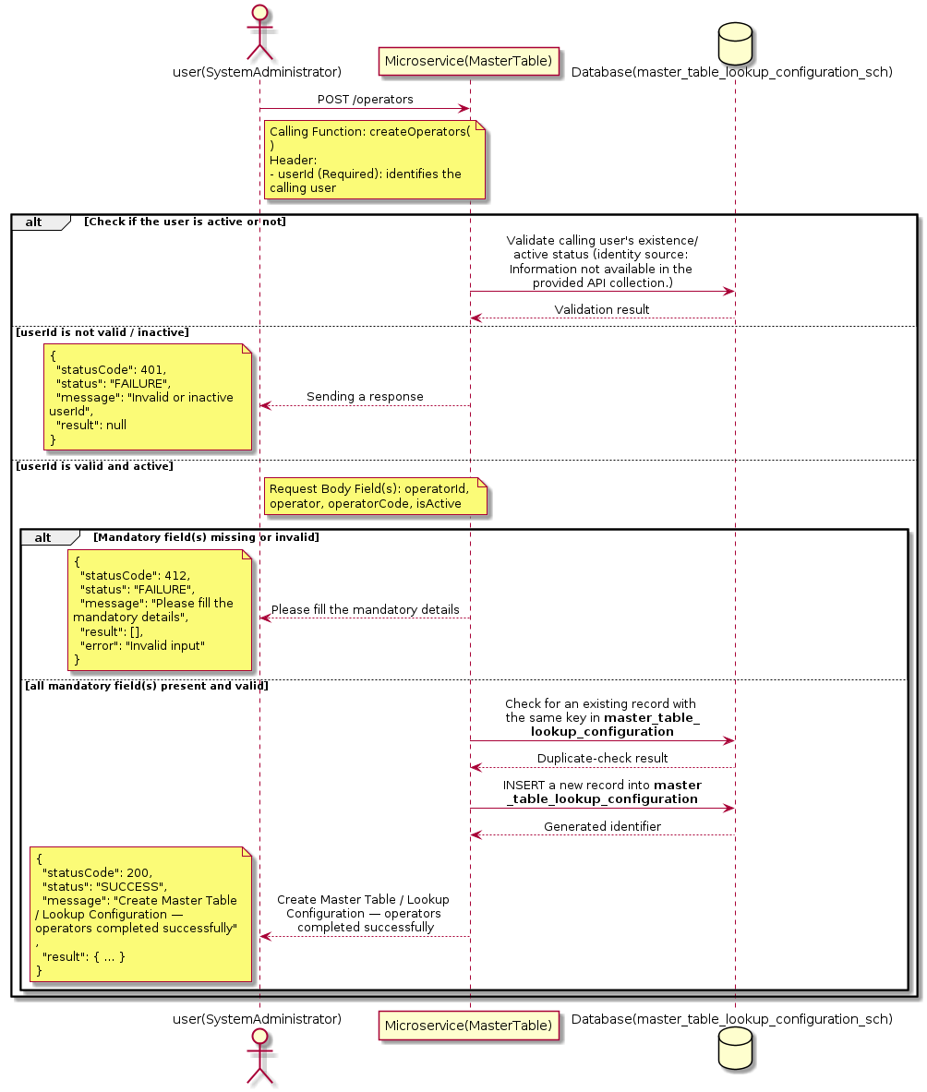

3.10.11.3 API Endpoint
Method | POST
URL | http://localhost:7002/srv2/genie/operators
Headers | Content-Type: application/json userId: 67
Authorization | Not present in the captured request. Information not available in the provided API collection.
Content-Type | Content-Type: application/json
Query Parameters | None
Path Variables | None
Request Body:
{
"operatorId": "0",
"operator": "Not Equals",
"operatorCode": "!=",
"isActive": 1
}
Response Body (illustrative — see 3.x.4.5 Success Response for details):
The source Postman collection does not include a captured sample response for this request (the response array is empty). Information not available in the provided API collection. Section 3.10.11.4.5 below presents the response envelope inferred from the standard response wrapper used consistently by this platform's services.

3.10.11.4 Detailed Process Flow

3.10.11.4.1 Request Initiation
The flow begins when System Administrator (or a calling microservice on their behalf) invokes the POST endpoint http://localhost:7002/srv2/genie/operators. The request must include the mandatory `userId` header used by the Master Table Microservice to identify the calling user for auditing purposes. The request carries a JSON payload in the request body which the Controller binds to its Data Transfer Object (DTO) before any processing begins. At the Controller layer, Spring Boot's request-mapping infrastructure routes the call to the appropriate handler method (`createOperators`), and Bean Validation annotations (if configured on the DTO) perform structural validation before the request reaches the Service layer. Information not available in the provided API collection. regarding the exact validation annotations used in the source code.

3.10.11.4.2 User Validation
The Master Table Microservice relies on the `userId` header to identify the calling user. Based on the pattern observed consistently across this API collection, the platform's authentication/authorization is expected to be enforced upstream (e.g., by an API Gateway or a shared security filter) using this identifier; the Postman collection does not include an `Authorization` / `Bearer` token header on this request, so the exact authentication mechanism (JWT validation, session lookup, or gateway-level SSO) is Information not available in the provided API collection. Role-based authorization — i.e., confirming that the user identified by `userId` holds a role/permission entitled to perform this operation — is expected to be enforced by the Service layer (see Section 8 – Controller Analysis and Section 14 – Authentication & Authorization), but the specific role/permission checks are Information not available in the provided API collection.

3.10.11.4.3 Business Logic
The Service layer performs the following: (1) validates that mandatory fields are present and correctly formatted, (2) checks for duplicates (e.g., an existing Master Table / Lookup Configuration with the same name/code), (3) sets system-managed fields (e.g., `isActive = 1`, `createdBy`, timestamps) where applicable, and (4) persists the new record via the Repository. If any validation fails, the Service layer returns a business error rather than proceeding to persistence. The key fields exchanged for this operation, as observed in the sample payload, are: `operatorId`, `operator`, `operatorCode`, `isActive`.

3.10.11.4.4 Database Interaction
The Repository layer (Spring Data JPA) interacts with the underlying relational database that backs the Master Table / Lookup Configuration master table. The primary operation issued is a **INSERT** against the table associated with Master Table / Lookup Configuration. A new row is inserted into the master table; if the entity has related child records (as seen in nested request payload arrays), corresponding child-table inserts are performed within the same transaction. The exact table name, column names, primary/foreign key definitions, and JPA repository method signatures are not included in the Postman collection; therefore, precise schema details are information not available in the provided api collection.

3.10.11.4.5 Success Response
Status Code: 200 OK. Sample response envelope (illustrative — the source collection did not capture a sample response for this API):
{
"statusCode": 200,
"status": "SUCCESS",
"message": "Create Master Table / Lookup Configuration — operators completed successfully",
"result": {
"id": 101,
"operatorId": "0",
"operator": "Not Equals",
"operatorCode": "!=",
"isActive": 1
},
"error": null,
"corelationId": "c6f2a1e4-2b3d-4a9e-9f1a-1234567890ab",
"url": null
}

3.10.11.4.6 Conclusion
This API provides a well-defined, single-purpose capability within the Master Table Microservice for create master table / lookup configuration — operators. The Controller → Service → Repository → Database layering keeps request validation, business rules, and persistence concerns separated, which allows the Master Table / Lookup Configuration master data to be maintained consistently and safely by authorized administrators while remaining available for consumption by every other module that depends on this reference data.

3.10.12 Create Master Table / Lookup Configuration — lookupfiled

3.10.12.1 Overview
Purpose: To create a new Master Table / Lookup Configuration master record in the system, allowing administrators to extend the master-data catalogue that other modules (ticketing, workflow, notifications) depend on.
Business Requirement: Business/process owners need a controlled way to add new Master Table / Lookup Configuration values so that the platform's classification, routing, and reporting capabilities can evolve as the organization changes.
Who Uses the API: System Administrator / Application Configuration Team responsible for master-data configuration.
Business Flow: Client sends a POST request with the new Master Table / Lookup Configuration payload → Controller validates the payload (mandatory fields, formats) → Service layer applies business rules (e.g., duplicate-name check) → Repository persists the new record → the created record (with generated identifier) is returned to the Client.

3.10.12.2 Sequence Diagram
The diagram below illustrates the end-to-end interaction for "Create Master Table / Lookup Configuration — lookupfiled" across the Client, Controller, Service, Repository, and Database layers.
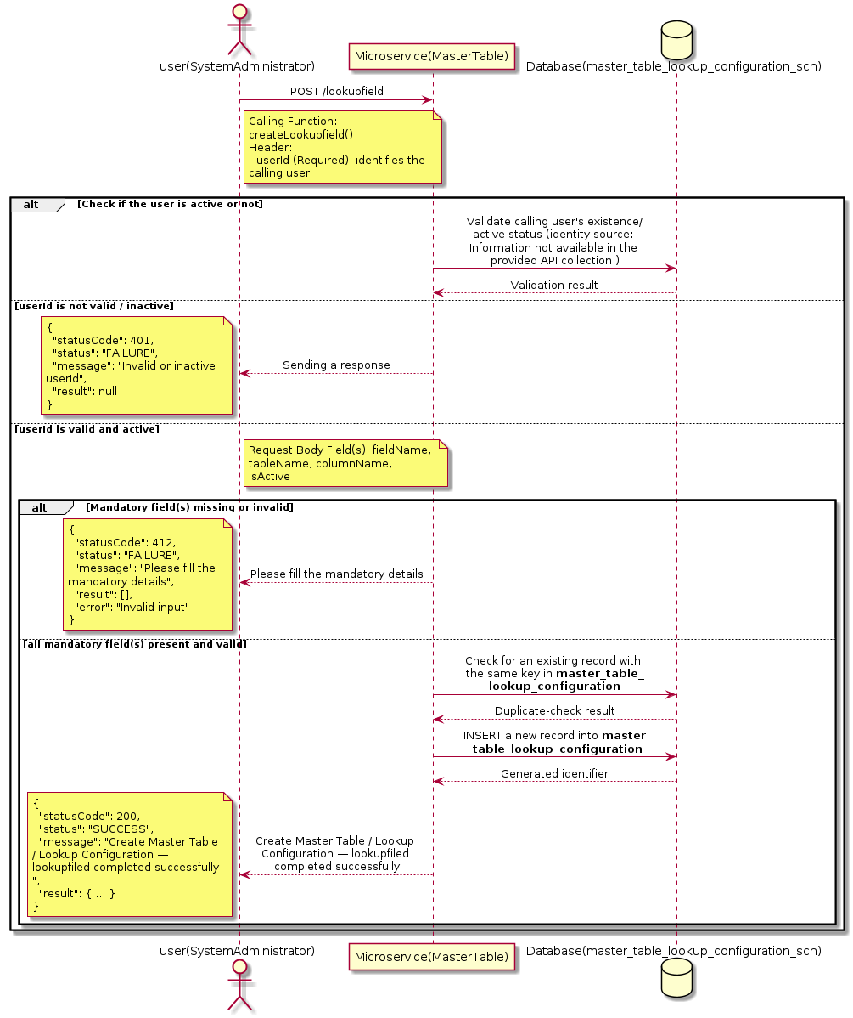

3.10.12.3 API Endpoint
Method | POST
URL | http://localhost:7002/srv2/genie/lookupfield
Headers | Content-Type: application/json userId: 67
Authorization | Not present in the captured request. Information not available in the provided API collection.
Content-Type | Content-Type: application/json
Query Parameters | None
Path Variables | None
Request Body:
{
"fieldName": "Category1",
"tableName": "category",
"columnName": "category_name",
"isActive": 1
}
Response Body (illustrative — see 3.x.4.5 Success Response for details):
The source Postman collection does not include a captured sample response for this request (the response array is empty). Information not available in the provided API collection. Section 3.10.12.4.5 below presents the response envelope inferred from the standard response wrapper used consistently by this platform's services.

3.10.12.4 Detailed Process Flow

3.10.12.4.1 Request Initiation
The flow begins when System Administrator (or a calling microservice on their behalf) invokes the POST endpoint http://localhost:7002/srv2/genie/lookupfield. The request must include the mandatory `userId` header used by the Master Table Microservice to identify the calling user for auditing purposes. The request carries a JSON payload in the request body which the Controller binds to its Data Transfer Object (DTO) before any processing begins. At the Controller layer, Spring Boot's request-mapping infrastructure routes the call to the appropriate handler method (`createLookupfield`), and Bean Validation annotations (if configured on the DTO) perform structural validation before the request reaches the Service layer. Information not available in the provided API collection. regarding the exact validation annotations used in the source code.

3.10.12.4.2 User Validation
The Master Table Microservice relies on the `userId` header to identify the calling user. Based on the pattern observed consistently across this API collection, the platform's authentication/authorization is expected to be enforced upstream (e.g., by an API Gateway or a shared security filter) using this identifier; the Postman collection does not include an `Authorization` / `Bearer` token header on this request, so the exact authentication mechanism (JWT validation, session lookup, or gateway-level SSO) is Information not available in the provided API collection. Role-based authorization — i.e., confirming that the user identified by `userId` holds a role/permission entitled to perform this operation — is expected to be enforced by the Service layer (see Section 8 – Controller Analysis and Section 14 – Authentication & Authorization), but the specific role/permission checks are Information not available in the provided API collection.

3.10.12.4.3 Business Logic
The Service layer performs the following: (1) validates that mandatory fields are present and correctly formatted, (2) checks for duplicates (e.g., an existing Master Table / Lookup Configuration with the same name/code), (3) sets system-managed fields (e.g., `isActive = 1`, `createdBy`, timestamps) where applicable, and (4) persists the new record via the Repository. If any validation fails, the Service layer returns a business error rather than proceeding to persistence. The key fields exchanged for this operation, as observed in the sample payload, are: `fieldName`, `tableName`, `columnName`, `isActive`.

3.10.12.4.4 Database Interaction
The Repository layer (Spring Data JPA) interacts with the underlying relational database that backs the Master Table / Lookup Configuration master table. The primary operation issued is a **INSERT** against the table associated with Master Table / Lookup Configuration. A new row is inserted into the master table; if the entity has related child records (as seen in nested request payload arrays), corresponding child-table inserts are performed within the same transaction. The exact table name, column names, primary/foreign key definitions, and JPA repository method signatures are not included in the Postman collection; therefore, precise schema details are information not available in the provided api collection.

3.10.12.4.5 Success Response
Status Code: 200 OK. Sample response envelope (illustrative — the source collection did not capture a sample response for this API):
{
"statusCode": 200,
"status": "SUCCESS",
"message": "Create Master Table / Lookup Configuration — lookupfiled completed successfully",
"result": {
"id": 101,
"fieldName": "Category1",
"tableName": "category",
"columnName": "category_name",
"isActive": 1
},
"error": null,
"corelationId": "c6f2a1e4-2b3d-4a9e-9f1a-1234567890ab",
"url": null
}

3.10.12.4.6 Conclusion
This API provides a well-defined, single-purpose capability within the Master Table Microservice for create master table / lookup configuration — lookupfiled. The Controller → Service → Repository → Database layering keeps request validation, business rules, and persistence concerns separated, which allows the Master Table / Lookup Configuration master data to be maintained consistently and safely by authorized administrators while remaining available for consumption by every other module that depends on this reference data.

3.10.13 Create Master Table / Lookup Configuration — impacts

3.10.13.1 Overview
Purpose: To create a new Master Table / Lookup Configuration master record in the system, allowing administrators to extend the master-data catalogue that other modules (ticketing, workflow, notifications) depend on.
Business Requirement: Business/process owners need a controlled way to add new Master Table / Lookup Configuration values so that the platform's classification, routing, and reporting capabilities can evolve as the organization changes.
Who Uses the API: System Administrator / Application Configuration Team responsible for master-data configuration.
Business Flow: Client sends a POST request with the new Master Table / Lookup Configuration payload → Controller validates the payload (mandatory fields, formats) → Service layer applies business rules (e.g., duplicate-name check) → Repository persists the new record → the created record (with generated identifier) is returned to the Client.

3.10.13.2 Sequence Diagram
The diagram below illustrates the end-to-end interaction for "Create Master Table / Lookup Configuration — impacts" across the Client, Controller, Service, Repository, and Database layers.
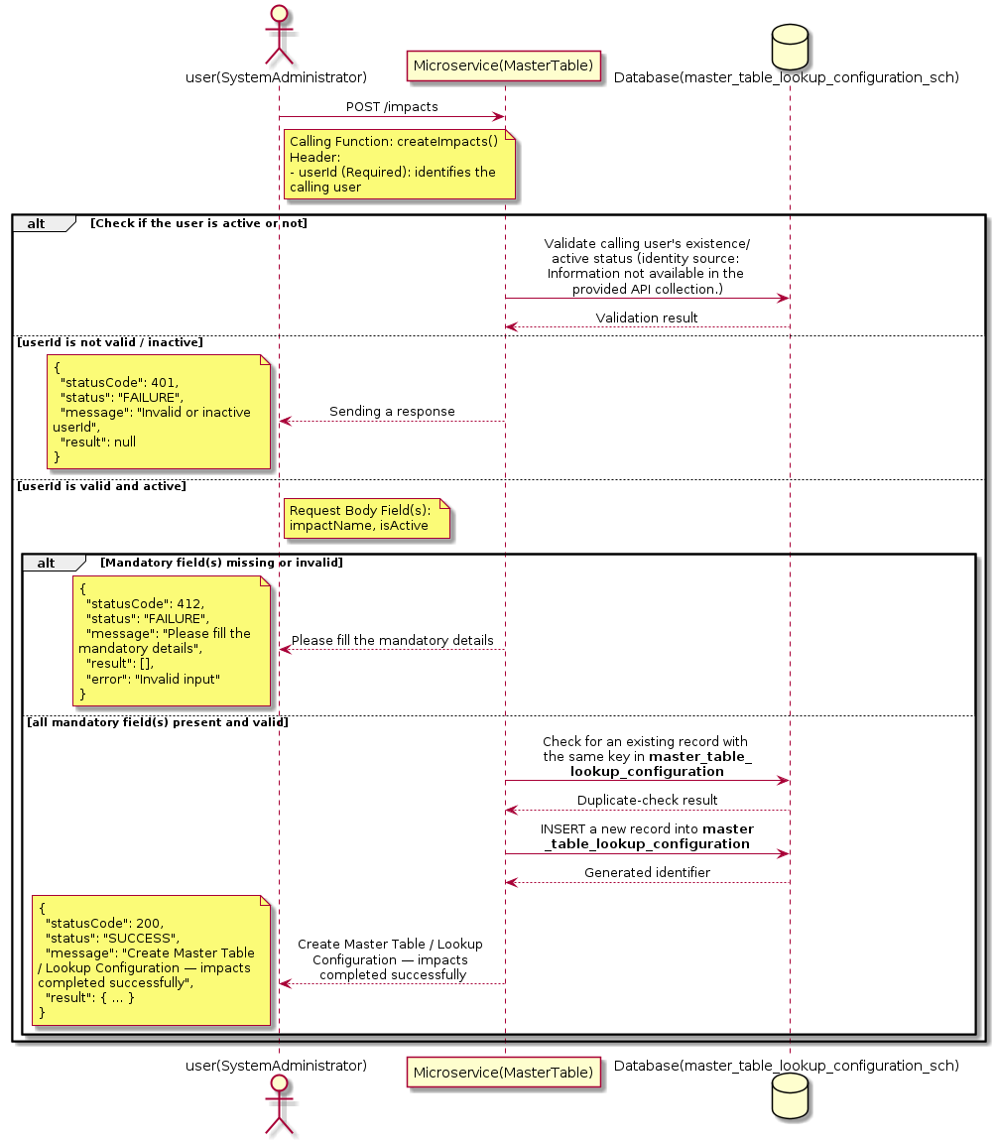

3.10.13.3 API Endpoint
Method | POST
URL | http://localhost:7002/srv2/genie/impacts
Headers | Content-Type: application/json userId: 67
Authorization | Not present in the captured request. Information not available in the provided API collection.
Content-Type | Content-Type: application/json
Query Parameters | None
Path Variables | None
Request Body:
{
"impactName": "high",
"isActive": "1"
}
Response Body (illustrative — see 3.x.4.5 Success Response for details):
The source Postman collection does not include a captured sample response for this request (the response array is empty). Information not available in the provided API collection. Section 3.10.13.4.5 below presents the response envelope inferred from the standard response wrapper used consistently by this platform's services.

3.10.13.4 Detailed Process Flow

3.10.13.4.1 Request Initiation
The flow begins when System Administrator (or a calling microservice on their behalf) invokes the POST endpoint http://localhost:7002/srv2/genie/impacts. The request must include the mandatory `userId` header used by the Master Table Microservice to identify the calling user for auditing purposes. The request carries a JSON payload in the request body which the Controller binds to its Data Transfer Object (DTO) before any processing begins. At the Controller layer, Spring Boot's request-mapping infrastructure routes the call to the appropriate handler method (`createImpacts`), and Bean Validation annotations (if configured on the DTO) perform structural validation before the request reaches the Service layer. Information not available in the provided API collection. regarding the exact validation annotations used in the source code.

3.10.13.4.2 User Validation
The Master Table Microservice relies on the `userId` header to identify the calling user. Based on the pattern observed consistently across this API collection, the platform's authentication/authorization is expected to be enforced upstream (e.g., by an API Gateway or a shared security filter) using this identifier; the Postman collection does not include an `Authorization` / `Bearer` token header on this request, so the exact authentication mechanism (JWT validation, session lookup, or gateway-level SSO) is Information not available in the provided API collection. Role-based authorization — i.e., confirming that the user identified by `userId` holds a role/permission entitled to perform this operation — is expected to be enforced by the Service layer (see Section 8 – Controller Analysis and Section 14 – Authentication & Authorization), but the specific role/permission checks are Information not available in the provided API collection.

3.10.13.4.3 Business Logic
The Service layer performs the following: (1) validates that mandatory fields are present and correctly formatted, (2) checks for duplicates (e.g., an existing Master Table / Lookup Configuration with the same name/code), (3) sets system-managed fields (e.g., `isActive = 1`, `createdBy`, timestamps) where applicable, and (4) persists the new record via the Repository. If any validation fails, the Service layer returns a business error rather than proceeding to persistence. The key fields exchanged for this operation, as observed in the sample payload, are: `impactName`, `isActive`.

3.10.13.4.4 Database Interaction
The Repository layer (Spring Data JPA) interacts with the underlying relational database that backs the Master Table / Lookup Configuration master table. The primary operation issued is a **INSERT** against the table associated with Master Table / Lookup Configuration. A new row is inserted into the master table; if the entity has related child records (as seen in nested request payload arrays), corresponding child-table inserts are performed within the same transaction. The exact table name, column names, primary/foreign key definitions, and JPA repository method signatures are not included in the Postman collection; therefore, precise schema details are information not available in the provided api collection.

3.10.13.4.5 Success Response
Status Code: 200 OK. Sample response envelope (illustrative — the source collection did not capture a sample response for this API):
{
"statusCode": 200,
"status": "SUCCESS",
"message": "Create Master Table / Lookup Configuration — impacts completed successfully",
"result": {
"id": 101,
"impactName": "high",
"isActive": "1"
},
"error": null,
"corelationId": "c6f2a1e4-2b3d-4a9e-9f1a-1234567890ab",
"url": null
}

3.10.13.4.6 Conclusion
This API provides a well-defined, single-purpose capability within the Master Table Microservice for create master table / lookup configuration — impacts. The Controller → Service → Repository → Database layering keeps request validation, business rules, and persistence concerns separated, which allows the Master Table / Lookup Configuration master data to be maintained consistently and safely by authorized administrators while remaining available for consumption by every other module that depends on this reference data.

3.10.14 Search / List Master Table / Lookup Configuration — getmastertables

3.10.14.1 Overview
Purpose: To search and list Master Table / Lookup Configuration records based on a search payload (e.g., free-text search or structured criteria), supporting list/grid screens that need paginated or filtered master data.
Business Requirement: List/search screens for Master Table / Lookup Configuration configuration need server-side search so that administrators can locate specific records in large master tables without scanning the full data set.
Who Uses the API: System Administrator / Application Configuration Team operating the Master Table / Lookup Configuration configuration/list screen.
Business Flow: Client sends a POST request with a search payload → Controller validates the payload → Service layer constructs the search/query logic → Repository executes the search against the Master Table / Lookup Configuration table → matching records are returned to the Client.

3.10.14.2 Sequence Diagram
The diagram below illustrates the end-to-end interaction for "Search / List Master Table / Lookup Configuration — getmastertables" across the Client, Controller, Service, Repository, and Database layers.
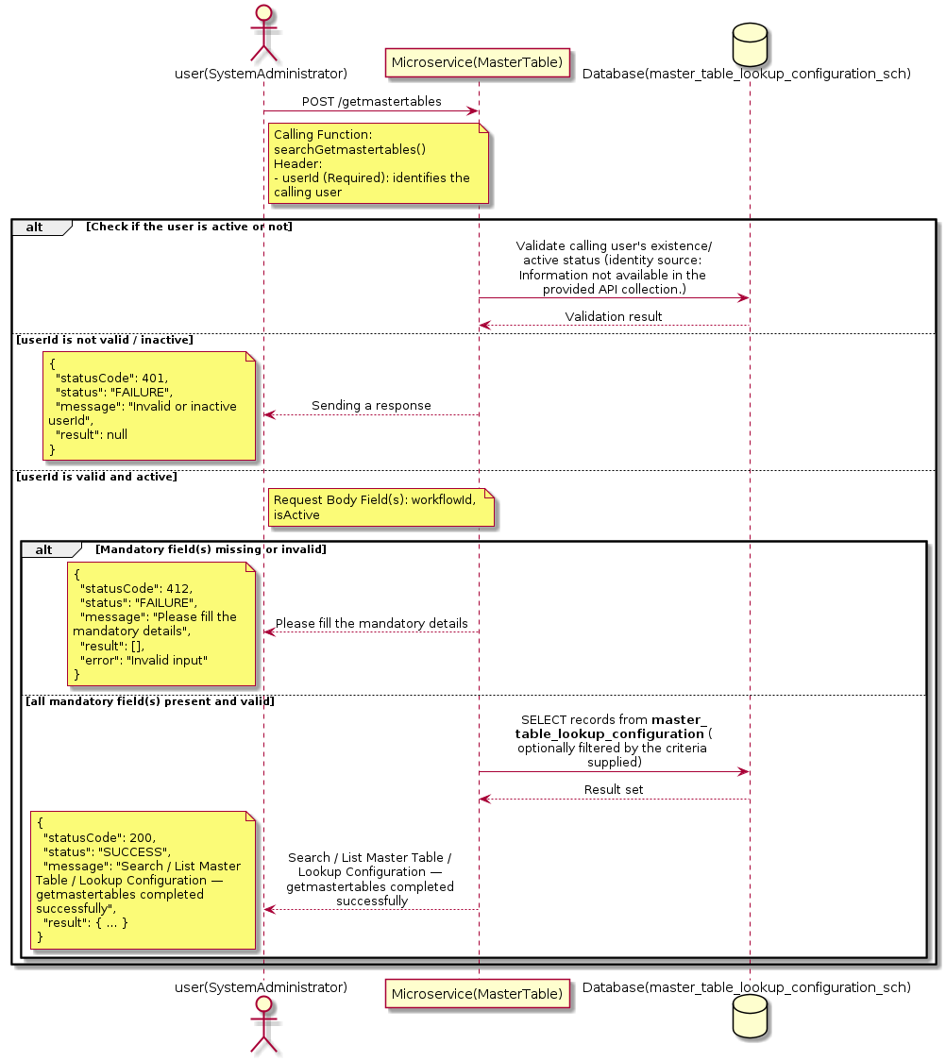

3.10.14.3 API Endpoint
Method | POST
URL | http://localhost:7002/srv2/genie/getmastertables
Headers | Content-Type: application/json userId: 879
Authorization | Not present in the captured request. Information not available in the provided API collection.
Content-Type | Content-Type: application/json
Query Parameters | None
Path Variables | None
Request Body:
{
"workflowId": 1,
"isActive": 1
}
Response Body (illustrative — see 3.x.4.5 Success Response for details):
The source Postman collection does not include a captured sample response for this request (the response array is empty). Information not available in the provided API collection. Section 3.10.14.4.5 below presents the response envelope inferred from the standard response wrapper used consistently by this platform's services.

3.10.14.4 Detailed Process Flow

3.10.14.4.1 Request Initiation
The flow begins when System Administrator (or a calling microservice on their behalf) invokes the POST endpoint http://localhost:7002/srv2/genie/getmastertables. The request must include the mandatory `userId` header used by the Master Table Microservice to identify the calling user for auditing purposes. The request carries a JSON payload in the request body which the Controller binds to its Data Transfer Object (DTO) before any processing begins. At the Controller layer, Spring Boot's request-mapping infrastructure routes the call to the appropriate handler method (`searchGetmastertables`), and Bean Validation annotations (if configured on the DTO) perform structural validation before the request reaches the Service layer. Information not available in the provided API collection. regarding the exact validation annotations used in the source code.

3.10.14.4.2 User Validation
The Master Table Microservice relies on the `userId` header to identify the calling user. Based on the pattern observed consistently across this API collection, the platform's authentication/authorization is expected to be enforced upstream (e.g., by an API Gateway or a shared security filter) using this identifier; the Postman collection does not include an `Authorization` / `Bearer` token header on this request, so the exact authentication mechanism (JWT validation, session lookup, or gateway-level SSO) is Information not available in the provided API collection. Role-based authorization — i.e., confirming that the user identified by `userId` holds a role/permission entitled to perform this operation — is expected to be enforced by the Service layer (see Section 8 – Controller Analysis and Section 14 – Authentication & Authorization), but the specific role/permission checks are Information not available in the provided API collection.

3.10.14.4.3 Business Logic
The Service layer evaluates the search payload; if the search text/criteria is empty, the operation typically behaves like a full list (all Master Table / Lookup Configuration records); if populated, it is used to build a case-insensitive `LIKE`/contains predicate against the relevant column(s). The key fields exchanged for this operation, as observed in the sample payload, are: `workflowId`, `isActive`.

3.10.14.4.4 Database Interaction
The Repository layer (Spring Data JPA) interacts with the underlying relational database that backs the Master Table / Lookup Configuration master table. The primary operation issued is a **SELECT** against the table associated with Master Table / Lookup Configuration. No write operations occur; the search is typically implemented using a JPA derived query method or a native/JPQL query with `LIKE` predicates. The exact table name, column names, primary/foreign key definitions, and JPA repository method signatures are not included in the Postman collection; therefore, precise schema details are information not available in the provided api collection.

3.10.14.4.5 Success Response
Status Code: 200 OK. Sample response envelope (illustrative — the source collection did not capture a sample response for this API):
{
"statusCode": 200,
"status": "SUCCESS",
"message": "Search / List Master Table / Lookup Configuration — getmastertables completed successfully",
"result": [
{
"id": 1,
"name": "Sample Master Table / Lookup Configuration",
"isActive": 1
}
],
"error": null,
"corelationId": "c6f2a1e4-2b3d-4a9e-9f1a-1234567890ab",
"url": null
}

3.10.14.4.6 Conclusion
This API provides a well-defined, single-purpose capability within the Master Table Microservice for search / list master table / lookup configuration — getmastertables. The Controller → Service → Repository → Database layering keeps request validation, business rules, and persistence concerns separated, which allows the Master Table / Lookup Configuration master data to be maintained consistently and safely by authorized administrators while remaining available for consumption by every other module that depends on this reference data.

3.10.15 Search / List Master Table / Lookup Configuration — getlookuprulefordepttype

3.10.15.1 Overview
Purpose: To search and list Master Table / Lookup Configuration records based on a search payload (e.g., free-text search or structured criteria), supporting list/grid screens that need paginated or filtered master data.
Business Requirement: List/search screens for Master Table / Lookup Configuration configuration need server-side search so that administrators can locate specific records in large master tables without scanning the full data set.
Who Uses the API: System Administrator / Application Configuration Team operating the Master Table / Lookup Configuration configuration/list screen.
Business Flow: Client sends a POST request with a search payload → Controller validates the payload → Service layer constructs the search/query logic → Repository executes the search against the Master Table / Lookup Configuration table → matching records are returned to the Client.

3.10.15.2 Sequence Diagram
The diagram below illustrates the end-to-end interaction for "Search / List Master Table / Lookup Configuration — getlookuprulefordepttype" across the Client, Controller, Service, Repository, and Database layers.
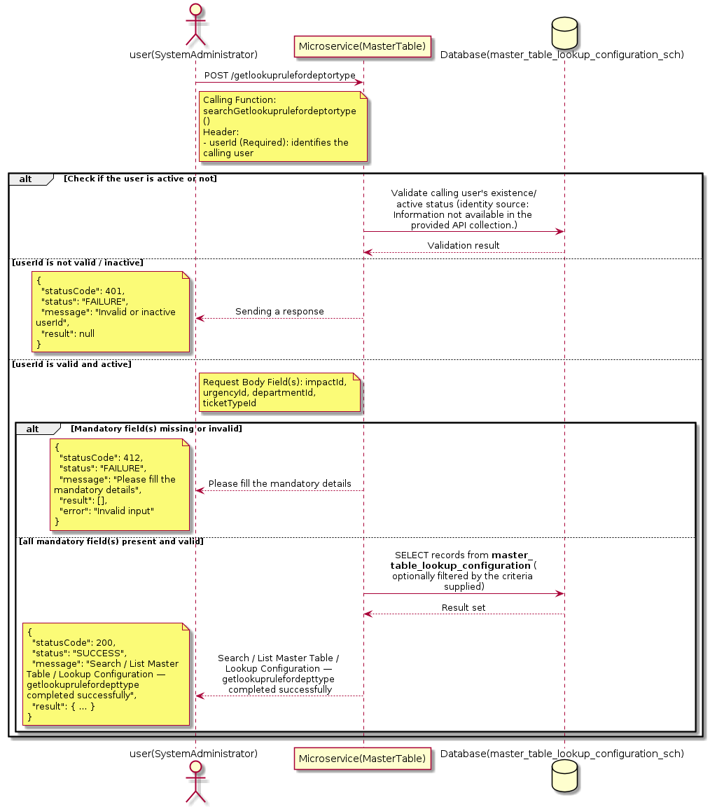

3.10.15.3 API Endpoint
Method | POST
URL | http://localhost:7002/srv2/genie/getlookuprulefordeptortype
Headers | Content-Type: application/json userId: 879
Authorization | Not present in the captured request. Information not available in the provided API collection.
Content-Type | Content-Type: application/json
Query Parameters | None
Path Variables | None
Request Body:
{
"impactId": 1,
"urgencyId": 1,
"departmentId": 1,
"ticketTypeId": 2
}
Response Body (illustrative — see 3.x.4.5 Success Response for details):
The source Postman collection does not include a captured sample response for this request (the response array is empty). Information not available in the provided API collection. Section 3.10.15.4.5 below presents the response envelope inferred from the standard response wrapper used consistently by this platform's services.

3.10.15.4 Detailed Process Flow

3.10.15.4.1 Request Initiation
The flow begins when System Administrator (or a calling microservice on their behalf) invokes the POST endpoint http://localhost:7002/srv2/genie/getlookuprulefordeptortype. The request must include the mandatory `userId` header used by the Master Table Microservice to identify the calling user for auditing purposes. The request carries a JSON payload in the request body which the Controller binds to its Data Transfer Object (DTO) before any processing begins. At the Controller layer, Spring Boot's request-mapping infrastructure routes the call to the appropriate handler method (`searchGetlookuprulefordeptortype`), and Bean Validation annotations (if configured on the DTO) perform structural validation before the request reaches the Service layer. Information not available in the provided API collection. regarding the exact validation annotations used in the source code.

3.10.15.4.2 User Validation
The Master Table Microservice relies on the `userId` header to identify the calling user. Based on the pattern observed consistently across this API collection, the platform's authentication/authorization is expected to be enforced upstream (e.g., by an API Gateway or a shared security filter) using this identifier; the Postman collection does not include an `Authorization` / `Bearer` token header on this request, so the exact authentication mechanism (JWT validation, session lookup, or gateway-level SSO) is Information not available in the provided API collection. Role-based authorization — i.e., confirming that the user identified by `userId` holds a role/permission entitled to perform this operation — is expected to be enforced by the Service layer (see Section 8 – Controller Analysis and Section 14 – Authentication & Authorization), but the specific role/permission checks are Information not available in the provided API collection.

3.10.15.4.3 Business Logic
The Service layer evaluates the search payload; if the search text/criteria is empty, the operation typically behaves like a full list (all Master Table / Lookup Configuration records); if populated, it is used to build a case-insensitive `LIKE`/contains predicate against the relevant column(s). The key fields exchanged for this operation, as observed in the sample payload, are: `impactId`, `urgencyId`, `departmentId`, `ticketTypeId`.

3.10.15.4.4 Database Interaction
The Repository layer (Spring Data JPA) interacts with the underlying relational database that backs the Master Table / Lookup Configuration master table. The primary operation issued is a **SELECT** against the table associated with Master Table / Lookup Configuration. No write operations occur; the search is typically implemented using a JPA derived query method or a native/JPQL query with `LIKE` predicates. The exact table name, column names, primary/foreign key definitions, and JPA repository method signatures are not included in the Postman collection; therefore, precise schema details are information not available in the provided api collection.

3.10.15.4.5 Success Response
Status Code: 200 OK. Sample response envelope (illustrative — the source collection did not capture a sample response for this API):
{
"statusCode": 200,
"status": "SUCCESS",
"message": "Search / List Master Table / Lookup Configuration — getlookuprulefordepttype completed successfully",
"result": [
{
"id": 1,
"name": "Sample Master Table / Lookup Configuration",
"isActive": 1
}
],
"error": null,
"corelationId": "c6f2a1e4-2b3d-4a9e-9f1a-1234567890ab",
"url": null
}

3.10.15.4.6 Conclusion
This API provides a well-defined, single-purpose capability within the Master Table Microservice for search / list master table / lookup configuration — getlookuprulefordepttype. The Controller → Service → Repository → Database layering keeps request validation, business rules, and persistence concerns separated, which allows the Master Table / Lookup Configuration master data to be maintained consistently and safely by authorized administrators while remaining available for consumption by every other module that depends on this reference data.

3.10.16 Search / List Master Table / Lookup Configuration — getlookupfileld (1)

3.10.16.1 Overview
Purpose: To search and list Master Table / Lookup Configuration records based on a search payload (e.g., free-text search or structured criteria), supporting list/grid screens that need paginated or filtered master data.
Business Requirement: List/search screens for Master Table / Lookup Configuration configuration need server-side search so that administrators can locate specific records in large master tables without scanning the full data set.
Who Uses the API: System Administrator / Application Configuration Team operating the Master Table / Lookup Configuration configuration/list screen.
Business Flow: Client sends a POST request with a search payload → Controller validates the payload → Service layer constructs the search/query logic → Repository executes the search against the Master Table / Lookup Configuration table → matching records are returned to the Client.

3.10.16.2 Sequence Diagram
The diagram below illustrates the end-to-end interaction for "Search / List Master Table / Lookup Configuration — getlookupfileld (1)" across the Client, Controller, Service, Repository, and Database layers.
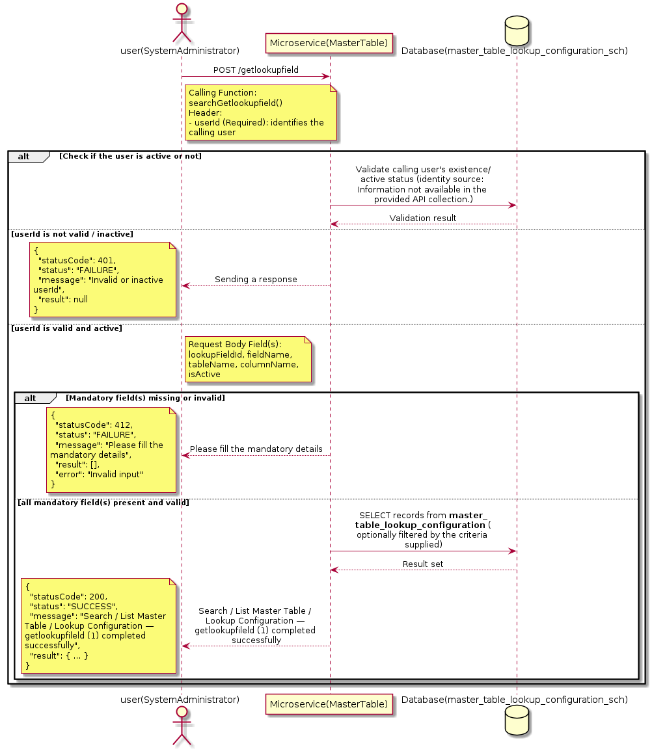

3.10.16.3 API Endpoint
Method | POST
URL | http://localhost:7002/srv2/genie/getlookupfield
Headers | Content-Type: application/json userId: 879
Authorization | Not present in the captured request. Information not available in the provided API collection.
Content-Type | Content-Type: application/json
Query Parameters | None
Path Variables | None
Request Body:
{
"lookupFieldId": 2,
"fieldName": "Urgency",
"tableName": "urgency",
"columnName": "urgent_name",
"isActive": 1
}
Response Body (illustrative — see 3.x.4.5 Success Response for details):
The source Postman collection does not include a captured sample response for this request (the response array is empty). Information not available in the provided API collection. Section 3.10.16.4.5 below presents the response envelope inferred from the standard response wrapper used consistently by this platform's services.

3.10.16.4 Detailed Process Flow

3.10.16.4.1 Request Initiation
The flow begins when System Administrator (or a calling microservice on their behalf) invokes the POST endpoint http://localhost:7002/srv2/genie/getlookupfield. The request must include the mandatory `userId` header used by the Master Table Microservice to identify the calling user for auditing purposes. The request carries a JSON payload in the request body which the Controller binds to its Data Transfer Object (DTO) before any processing begins. At the Controller layer, Spring Boot's request-mapping infrastructure routes the call to the appropriate handler method (`searchGetlookupfield`), and Bean Validation annotations (if configured on the DTO) perform structural validation before the request reaches the Service layer. Information not available in the provided API collection. regarding the exact validation annotations used in the source code.

3.10.16.4.2 User Validation
The Master Table Microservice relies on the `userId` header to identify the calling user. Based on the pattern observed consistently across this API collection, the platform's authentication/authorization is expected to be enforced upstream (e.g., by an API Gateway or a shared security filter) using this identifier; the Postman collection does not include an `Authorization` / `Bearer` token header on this request, so the exact authentication mechanism (JWT validation, session lookup, or gateway-level SSO) is Information not available in the provided API collection. Role-based authorization — i.e., confirming that the user identified by `userId` holds a role/permission entitled to perform this operation — is expected to be enforced by the Service layer (see Section 8 – Controller Analysis and Section 14 – Authentication & Authorization), but the specific role/permission checks are Information not available in the provided API collection.

3.10.16.4.3 Business Logic
The Service layer evaluates the search payload; if the search text/criteria is empty, the operation typically behaves like a full list (all Master Table / Lookup Configuration records); if populated, it is used to build a case-insensitive `LIKE`/contains predicate against the relevant column(s). The key fields exchanged for this operation, as observed in the sample payload, are: `lookupFieldId`, `fieldName`, `tableName`, `columnName`, `isActive`.

3.10.16.4.4 Database Interaction
The Repository layer (Spring Data JPA) interacts with the underlying relational database that backs the Master Table / Lookup Configuration master table. The primary operation issued is a **SELECT** against the table associated with Master Table / Lookup Configuration. No write operations occur; the search is typically implemented using a JPA derived query method or a native/JPQL query with `LIKE` predicates. The exact table name, column names, primary/foreign key definitions, and JPA repository method signatures are not included in the Postman collection; therefore, precise schema details are information not available in the provided api collection.

3.10.16.4.5 Success Response
Status Code: 200 OK. Sample response envelope (illustrative — the source collection did not capture a sample response for this API):
{
"statusCode": 200,
"status": "SUCCESS",
"message": "Search / List Master Table / Lookup Configuration — getlookupfileld (1) completed successfully",
"result": [
{
"id": 1,
"name": "Sample Master Table / Lookup Configuration",
"isActive": 1
}
],
"error": null,
"corelationId": "c6f2a1e4-2b3d-4a9e-9f1a-1234567890ab",
"url": null
}

3.10.16.4.6 Conclusion
This API provides a well-defined, single-purpose capability within the Master Table Microservice for search / list master table / lookup configuration — getlookupfileld (1). The Controller → Service → Repository → Database layering keeps request validation, business rules, and persistence concerns separated, which allows the Master Table / Lookup Configuration master data to be maintained consistently and safely by authorized administrators while remaining available for consumption by every other module that depends on this reference data.

3.10.17 Search / List Master Table / Lookup Configuration — getlookupfileld (2)

3.10.17.1 Overview
Purpose: To search and list Master Table / Lookup Configuration records based on a search payload (e.g., free-text search or structured criteria), supporting list/grid screens that need paginated or filtered master data.
Business Requirement: List/search screens for Master Table / Lookup Configuration configuration need server-side search so that administrators can locate specific records in large master tables without scanning the full data set.
Who Uses the API: System Administrator / Application Configuration Team operating the Master Table / Lookup Configuration configuration/list screen.
Business Flow: Client sends a POST request with a search payload → Controller validates the payload → Service layer constructs the search/query logic → Repository executes the search against the Master Table / Lookup Configuration table → matching records are returned to the Client.

3.10.17.2 Sequence Diagram
The diagram below illustrates the end-to-end interaction for "Search / List Master Table / Lookup Configuration — getlookupfileld (2)" across the Client, Controller, Service, Repository, and Database layers.
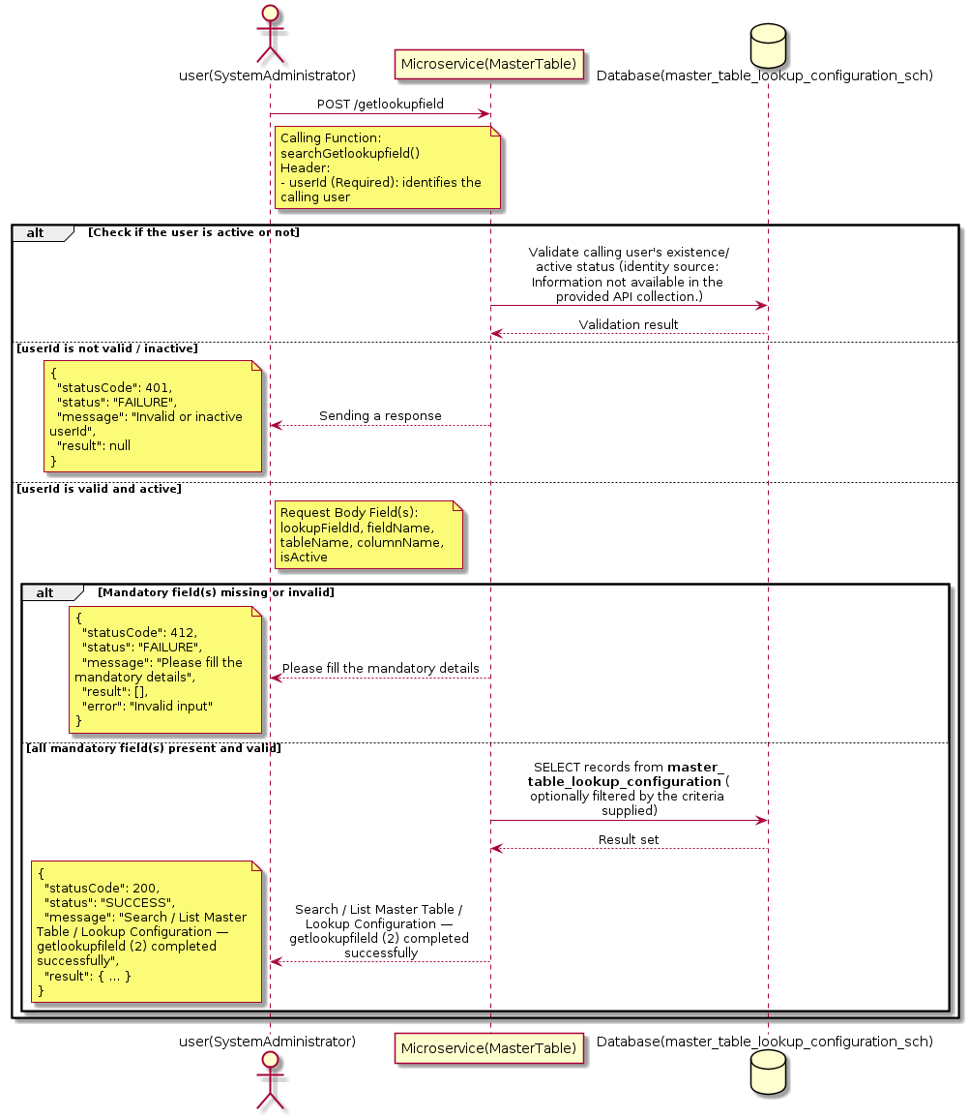

3.10.17.3 API Endpoint
Method | POST
URL | http://localhost:7002/srv2/genie/getlookupfield
Headers | Content-Type: application/json userId: 879
Authorization | Not present in the captured request. Information not available in the provided API collection.
Content-Type | Content-Type: application/json
Query Parameters | None
Path Variables | None
Request Body:
{
"lookupFieldId": 2,
"fieldName": "Urgency",
"tableName": "urgency",
"columnName": "urgent_name",
"isActive": 1
}
Response Body (illustrative — see 3.x.4.5 Success Response for details):
The source Postman collection does not include a captured sample response for this request (the response array is empty). Information not available in the provided API collection. Section 3.10.17.4.5 below presents the response envelope inferred from the standard response wrapper used consistently by this platform's services.

3.10.17.4 Detailed Process Flow

3.10.17.4.1 Request Initiation
The flow begins when System Administrator (or a calling microservice on their behalf) invokes the POST endpoint http://localhost:7002/srv2/genie/getlookupfield. The request must include the mandatory `userId` header used by the Master Table Microservice to identify the calling user for auditing purposes. The request carries a JSON payload in the request body which the Controller binds to its Data Transfer Object (DTO) before any processing begins. At the Controller layer, Spring Boot's request-mapping infrastructure routes the call to the appropriate handler method (`searchGetlookupfield`), and Bean Validation annotations (if configured on the DTO) perform structural validation before the request reaches the Service layer. Information not available in the provided API collection. regarding the exact validation annotations used in the source code.

3.10.17.4.2 User Validation
The Master Table Microservice relies on the `userId` header to identify the calling user. Based on the pattern observed consistently across this API collection, the platform's authentication/authorization is expected to be enforced upstream (e.g., by an API Gateway or a shared security filter) using this identifier; the Postman collection does not include an `Authorization` / `Bearer` token header on this request, so the exact authentication mechanism (JWT validation, session lookup, or gateway-level SSO) is Information not available in the provided API collection. Role-based authorization — i.e., confirming that the user identified by `userId` holds a role/permission entitled to perform this operation — is expected to be enforced by the Service layer (see Section 8 – Controller Analysis and Section 14 – Authentication & Authorization), but the specific role/permission checks are Information not available in the provided API collection.

3.10.17.4.3 Business Logic
The Service layer evaluates the search payload; if the search text/criteria is empty, the operation typically behaves like a full list (all Master Table / Lookup Configuration records); if populated, it is used to build a case-insensitive `LIKE`/contains predicate against the relevant column(s). The key fields exchanged for this operation, as observed in the sample payload, are: `lookupFieldId`, `fieldName`, `tableName`, `columnName`, `isActive`.

3.10.17.4.4 Database Interaction
The Repository layer (Spring Data JPA) interacts with the underlying relational database that backs the Master Table / Lookup Configuration master table. The primary operation issued is a **SELECT** against the table associated with Master Table / Lookup Configuration. No write operations occur; the search is typically implemented using a JPA derived query method or a native/JPQL query with `LIKE` predicates. The exact table name, column names, primary/foreign key definitions, and JPA repository method signatures are not included in the Postman collection; therefore, precise schema details are information not available in the provided api collection.

3.10.17.4.5 Success Response
Status Code: 200 OK. Sample response envelope (illustrative — the source collection did not capture a sample response for this API):
{
"statusCode": 200,
"status": "SUCCESS",
"message": "Search / List Master Table / Lookup Configuration — getlookupfileld (2) completed successfully",
"result": [
{
"id": 1,
"name": "Sample Master Table / Lookup Configuration",
"isActive": 1
}
],
"error": null,
"corelationId": "c6f2a1e4-2b3d-4a9e-9f1a-1234567890ab",
"url": null
}

3.10.17.4.6 Conclusion
This API provides a well-defined, single-purpose capability within the Master Table Microservice for search / list master table / lookup configuration — getlookupfileld (2). The Controller → Service → Repository → Database layering keeps request validation, business rules, and persistence concerns separated, which allows the Master Table / Lookup Configuration master data to be maintained consistently and safely by authorized administrators while remaining available for consumption by every other module that depends on this reference data.

3.10.18 Search / List Master Table / Lookup Configuration — getlookupcondition

3.10.18.1 Overview
Purpose: To search and list Master Table / Lookup Configuration records based on a search payload (e.g., free-text search or structured criteria), supporting list/grid screens that need paginated or filtered master data.
Business Requirement: List/search screens for Master Table / Lookup Configuration configuration need server-side search so that administrators can locate specific records in large master tables without scanning the full data set.
Who Uses the API: System Administrator / Application Configuration Team operating the Master Table / Lookup Configuration configuration/list screen.
Business Flow: Client sends a POST request with a search payload → Controller validates the payload → Service layer constructs the search/query logic → Repository executes the search against the Master Table / Lookup Configuration table → matching records are returned to the Client.

3.10.18.2 Sequence Diagram
The diagram below illustrates the end-to-end interaction for "Search / List Master Table / Lookup Configuration — getlookupcondition" across the Client, Controller, Service, Repository, and Database layers.
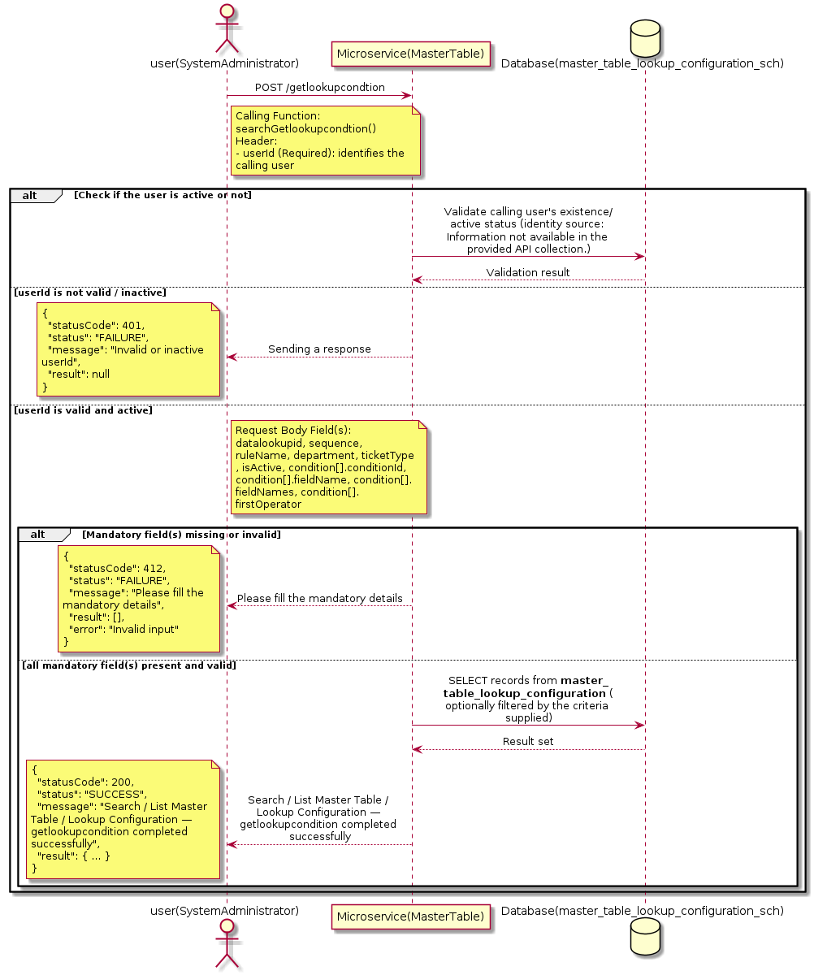

3.10.18.3 API Endpoint
Method | POST
URL | http://localhost:7002/srv2/genie/getlookupcondtion
Headers | Content-Type: application/json userId: 879
Authorization | Not present in the captured request. Information not available in the provided API collection.
Content-Type | Content-Type: application/json
Query Parameters | None
Path Variables | None
Request Body:
{
"datalookupid": 1,
"sequence": 1,
"ruleName": "Urgency High Rule",
"department": 1,
"ticketType": 2,
"isActive": 1,
"condition": [
{
"conditionId": 2,
"fieldName": 2,
"fieldNames": "urgency",
"firstOperator": 3,
"firstOperatorName": "equals",
"value": "High",
"lastOperator": 3,
"lastOperatorName": "equals",
"sequence": 1,
"isActive": 1
}
]
}
Response Body (illustrative — see 3.x.4.5 Success Response for details):
The source Postman collection does not include a captured sample response for this request (the response array is empty). Information not available in the provided API collection. Section 3.10.18.4.5 below presents the response envelope inferred from the standard response wrapper used consistently by this platform's services.

3.10.18.4 Detailed Process Flow

3.10.18.4.1 Request Initiation
The flow begins when System Administrator (or a calling microservice on their behalf) invokes the POST endpoint http://localhost:7002/srv2/genie/getlookupcondtion. The request must include the mandatory `userId` header used by the Master Table Microservice to identify the calling user for auditing purposes. The request carries a JSON payload in the request body which the Controller binds to its Data Transfer Object (DTO) before any processing begins. At the Controller layer, Spring Boot's request-mapping infrastructure routes the call to the appropriate handler method (`searchGetlookupcondtion`), and Bean Validation annotations (if configured on the DTO) perform structural validation before the request reaches the Service layer. Information not available in the provided API collection. regarding the exact validation annotations used in the source code.

3.10.18.4.2 User Validation
The Master Table Microservice relies on the `userId` header to identify the calling user. Based on the pattern observed consistently across this API collection, the platform's authentication/authorization is expected to be enforced upstream (e.g., by an API Gateway or a shared security filter) using this identifier; the Postman collection does not include an `Authorization` / `Bearer` token header on this request, so the exact authentication mechanism (JWT validation, session lookup, or gateway-level SSO) is Information not available in the provided API collection. Role-based authorization — i.e., confirming that the user identified by `userId` holds a role/permission entitled to perform this operation — is expected to be enforced by the Service layer (see Section 8 – Controller Analysis and Section 14 – Authentication & Authorization), but the specific role/permission checks are Information not available in the provided API collection.

3.10.18.4.3 Business Logic
The Service layer evaluates the search payload; if the search text/criteria is empty, the operation typically behaves like a full list (all Master Table / Lookup Configuration records); if populated, it is used to build a case-insensitive `LIKE`/contains predicate against the relevant column(s). The key fields exchanged for this operation, as observed in the sample payload, are: `datalookupid`, `sequence`, `ruleName`, `department`, `ticketType`, `isActive`, `condition[].conditionId`, `condition[].fieldName`, `condition[].fieldNames`, `condition[].firstOperator`, `condition[].firstOperatorName`, `condition[].value`.

3.10.18.4.4 Database Interaction
The Repository layer (Spring Data JPA) interacts with the underlying relational database that backs the Master Table / Lookup Configuration master table. The primary operation issued is a **SELECT** against the table associated with Master Table / Lookup Configuration. No write operations occur; the search is typically implemented using a JPA derived query method or a native/JPQL query with `LIKE` predicates. The exact table name, column names, primary/foreign key definitions, and JPA repository method signatures are not included in the Postman collection; therefore, precise schema details are information not available in the provided api collection.

3.10.18.4.5 Success Response
Status Code: 200 OK. Sample response envelope (illustrative — the source collection did not capture a sample response for this API):
{
"statusCode": 200,
"status": "SUCCESS",
"message": "Search / List Master Table / Lookup Configuration — getlookupcondition completed successfully",
"result": [
{
"id": 1,
"name": "Sample Master Table / Lookup Configuration",
"isActive": 1
}
],
"error": null,
"corelationId": "c6f2a1e4-2b3d-4a9e-9f1a-1234567890ab",
"url": null
}

3.10.18.4.6 Conclusion
This API provides a well-defined, single-purpose capability within the Master Table Microservice for search / list master table / lookup configuration — getlookupcondition. The Controller → Service → Repository → Database layering keeps request validation, business rules, and persistence concerns separated, which allows the Master Table / Lookup Configuration master data to be maintained consistently and safely by authorized administrators while remaining available for consumption by every other module that depends on this reference data.

3.10.19 Create Master Table / Lookup Configuration — createlookuprule

3.10.19.1 Overview
Purpose: To create a new Master Table / Lookup Configuration master record in the system, allowing administrators to extend the master-data catalogue that other modules (ticketing, workflow, notifications) depend on.
Business Requirement: Business/process owners need a controlled way to add new Master Table / Lookup Configuration values so that the platform's classification, routing, and reporting capabilities can evolve as the organization changes.
Who Uses the API: System Administrator / Application Configuration Team responsible for master-data configuration.
Business Flow: Client sends a POST request with the new Master Table / Lookup Configuration payload → Controller validates the payload (mandatory fields, formats) → Service layer applies business rules (e.g., duplicate-name check) → Repository persists the new record → the created record (with generated identifier) is returned to the Client.

3.10.19.2 Sequence Diagram
The diagram below illustrates the end-to-end interaction for "Create Master Table / Lookup Configuration — createlookuprule" across the Client, Controller, Service, Repository, and Database layers.
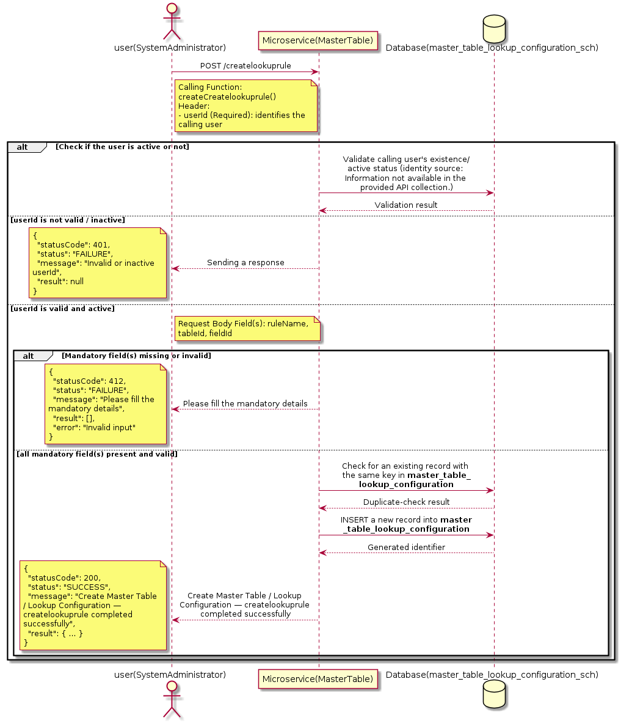

3.10.19.3 API Endpoint
Method | POST
URL | http://localhost:7002/srv2/genie/createlookuprule
Headers | Content-Type: application/json userId: 879
Authorization | Not present in the captured request. Information not available in the provided API collection.
Content-Type | Content-Type: application/json
Query Parameters | None
Path Variables | None
Request Body:
{
"ruleName": "Rule1",
"tableId": 1,
"fieldId": 1
}
Response Body (illustrative — see 3.x.4.5 Success Response for details):
The source Postman collection does not include a captured sample response for this request (the response array is empty). Information not available in the provided API collection. Section 3.10.19.4.5 below presents the response envelope inferred from the standard response wrapper used consistently by this platform's services.

3.10.19.4 Detailed Process Flow

3.10.19.4.1 Request Initiation
The flow begins when System Administrator (or a calling microservice on their behalf) invokes the POST endpoint http://localhost:7002/srv2/genie/createlookuprule. The request must include the mandatory `userId` header used by the Master Table Microservice to identify the calling user for auditing purposes. The request carries a JSON payload in the request body which the Controller binds to its Data Transfer Object (DTO) before any processing begins. At the Controller layer, Spring Boot's request-mapping infrastructure routes the call to the appropriate handler method (`createCreatelookuprule`), and Bean Validation annotations (if configured on the DTO) perform structural validation before the request reaches the Service layer. Information not available in the provided API collection. regarding the exact validation annotations used in the source code.

3.10.19.4.2 User Validation
The Master Table Microservice relies on the `userId` header to identify the calling user. Based on the pattern observed consistently across this API collection, the platform's authentication/authorization is expected to be enforced upstream (e.g., by an API Gateway or a shared security filter) using this identifier; the Postman collection does not include an `Authorization` / `Bearer` token header on this request, so the exact authentication mechanism (JWT validation, session lookup, or gateway-level SSO) is Information not available in the provided API collection. Role-based authorization — i.e., confirming that the user identified by `userId` holds a role/permission entitled to perform this operation — is expected to be enforced by the Service layer (see Section 8 – Controller Analysis and Section 14 – Authentication & Authorization), but the specific role/permission checks are Information not available in the provided API collection.

3.10.19.4.3 Business Logic
The Service layer performs the following: (1) validates that mandatory fields are present and correctly formatted, (2) checks for duplicates (e.g., an existing Master Table / Lookup Configuration with the same name/code), (3) sets system-managed fields (e.g., `isActive = 1`, `createdBy`, timestamps) where applicable, and (4) persists the new record via the Repository. If any validation fails, the Service layer returns a business error rather than proceeding to persistence. The key fields exchanged for this operation, as observed in the sample payload, are: `ruleName`, `tableId`, `fieldId`.

3.10.19.4.4 Database Interaction
The Repository layer (Spring Data JPA) interacts with the underlying relational database that backs the Master Table / Lookup Configuration master table. The primary operation issued is a **INSERT** against the table associated with Master Table / Lookup Configuration. A new row is inserted into the master table; if the entity has related child records (as seen in nested request payload arrays), corresponding child-table inserts are performed within the same transaction. The exact table name, column names, primary/foreign key definitions, and JPA repository method signatures are not included in the Postman collection; therefore, precise schema details are information not available in the provided api collection.

3.10.19.4.5 Success Response
Status Code: 200 OK. Sample response envelope (illustrative — the source collection did not capture a sample response for this API):
{
"statusCode": 200,
"status": "SUCCESS",
"message": "Create Master Table / Lookup Configuration — createlookuprule completed successfully",
"result": {
"id": 101,
"ruleName": "Rule1",
"tableId": 1,
"fieldId": 1
},
"error": null,
"corelationId": "c6f2a1e4-2b3d-4a9e-9f1a-1234567890ab",
"url": null
}

3.10.19.4.6 Conclusion
This API provides a well-defined, single-purpose capability within the Master Table Microservice for create master table / lookup configuration — createlookuprule. The Controller → Service → Repository → Database layering keeps request validation, business rules, and persistence concerns separated, which allows the Master Table / Lookup Configuration master data to be maintained consistently and safely by authorized administrators while remaining available for consumption by every other module that depends on this reference data.

3.10.20 Create Master Table / Lookup Configuration — columns

3.10.20.1 Overview
Purpose: To create a new Master Table / Lookup Configuration master record in the system, allowing administrators to extend the master-data catalogue that other modules (ticketing, workflow, notifications) depend on.
Business Requirement: Business/process owners need a controlled way to add new Master Table / Lookup Configuration values so that the platform's classification, routing, and reporting capabilities can evolve as the organization changes.
Who Uses the API: System Administrator / Application Configuration Team responsible for master-data configuration.
Business Flow: Client sends a POST request with the new Master Table / Lookup Configuration payload → Controller validates the payload (mandatory fields, formats) → Service layer applies business rules (e.g., duplicate-name check) → Repository persists the new record → the created record (with generated identifier) is returned to the Client.

3.10.20.2 Sequence Diagram
The diagram below illustrates the end-to-end interaction for "Create Master Table / Lookup Configuration — columns" across the Client, Controller, Service, Repository, and Database layers.
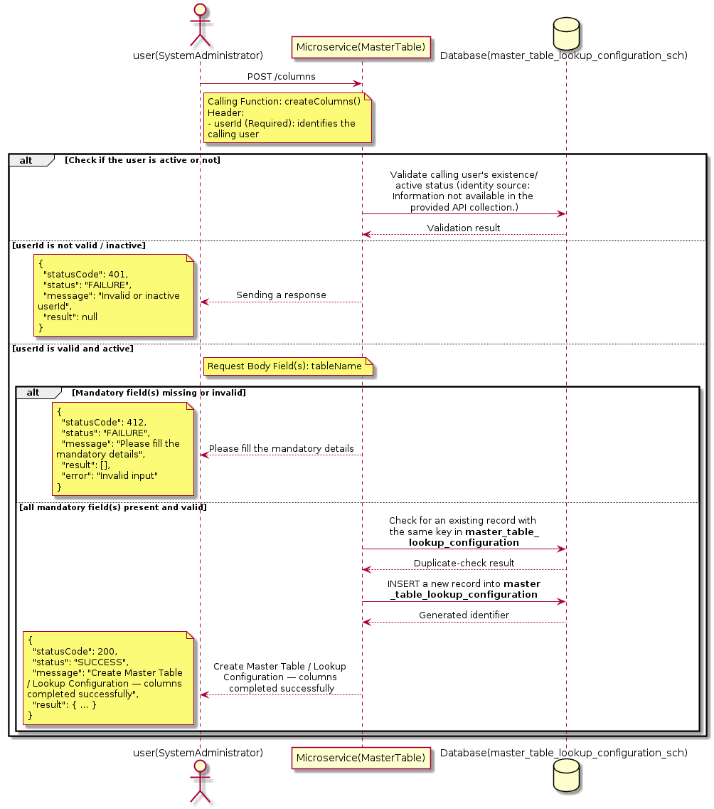

3.10.20.3 API Endpoint
Method | POST
URL | http://localhost:7002/srv2/genie/columns
Headers | Content-Type: application/json userId: 67
Authorization | Not present in the captured request. Information not available in the provided API collection.
Content-Type | Content-Type: application/json
Query Parameters | None
Path Variables | None
Request Body:
{
"tableName": "event_reciepients"
}
Response Body (illustrative — see 3.x.4.5 Success Response for details):
The source Postman collection does not include a captured sample response for this request (the response array is empty). Information not available in the provided API collection. Section 3.10.20.4.5 below presents the response envelope inferred from the standard response wrapper used consistently by this platform's services.

3.10.20.4 Detailed Process Flow

3.10.20.4.1 Request Initiation
The flow begins when System Administrator (or a calling microservice on their behalf) invokes the POST endpoint http://localhost:7002/srv2/genie/columns. The request must include the mandatory `userId` header used by the Master Table Microservice to identify the calling user for auditing purposes. The request carries a JSON payload in the request body which the Controller binds to its Data Transfer Object (DTO) before any processing begins. At the Controller layer, Spring Boot's request-mapping infrastructure routes the call to the appropriate handler method (`createColumns`), and Bean Validation annotations (if configured on the DTO) perform structural validation before the request reaches the Service layer. Information not available in the provided API collection. regarding the exact validation annotations used in the source code.

3.10.20.4.2 User Validation
The Master Table Microservice relies on the `userId` header to identify the calling user. Based on the pattern observed consistently across this API collection, the platform's authentication/authorization is expected to be enforced upstream (e.g., by an API Gateway or a shared security filter) using this identifier; the Postman collection does not include an `Authorization` / `Bearer` token header on this request, so the exact authentication mechanism (JWT validation, session lookup, or gateway-level SSO) is Information not available in the provided API collection. Role-based authorization — i.e., confirming that the user identified by `userId` holds a role/permission entitled to perform this operation — is expected to be enforced by the Service layer (see Section 8 – Controller Analysis and Section 14 – Authentication & Authorization), but the specific role/permission checks are Information not available in the provided API collection.

3.10.20.4.3 Business Logic
The Service layer performs the following: (1) validates that mandatory fields are present and correctly formatted, (2) checks for duplicates (e.g., an existing Master Table / Lookup Configuration with the same name/code), (3) sets system-managed fields (e.g., `isActive = 1`, `createdBy`, timestamps) where applicable, and (4) persists the new record via the Repository. If any validation fails, the Service layer returns a business error rather than proceeding to persistence. The key fields exchanged for this operation, as observed in the sample payload, are: `tableName`.

3.10.20.4.4 Database Interaction
The Repository layer (Spring Data JPA) interacts with the underlying relational database that backs the Master Table / Lookup Configuration master table. The primary operation issued is a **INSERT** against the table associated with Master Table / Lookup Configuration. A new row is inserted into the master table; if the entity has related child records (as seen in nested request payload arrays), corresponding child-table inserts are performed within the same transaction. The exact table name, column names, primary/foreign key definitions, and JPA repository method signatures are not included in the Postman collection; therefore, precise schema details are information not available in the provided api collection.

3.10.20.4.5 Success Response
Status Code: 200 OK. Sample response envelope (illustrative — the source collection did not capture a sample response for this API):
{
"statusCode": 200,
"status": "SUCCESS",
"message": "Create Master Table / Lookup Configuration — columns completed successfully",
"result": {
"id": 101,
"tableName": "event_reciepients"
},
"error": null,
"corelationId": "c6f2a1e4-2b3d-4a9e-9f1a-1234567890ab",
"url": null
}

3.10.20.4.6 Conclusion
This API provides a well-defined, single-purpose capability within the Master Table Microservice for create master table / lookup configuration — columns. The Controller → Service → Repository → Database layering keeps request validation, business rules, and persistence concerns separated, which allows the Master Table / Lookup Configuration master data to be maintained consistently and safely by authorized administrators while remaining available for consumption by every other module that depends on this reference data.

3.10.21 Enable / Disable Master Table / Lookup Configuration

3.10.21.1 Overview
Purpose: To enable or disable (soft-delete) a Master Table / Lookup Configuration master record, allowing administrators to retire a record from active use while preserving it for historical/audit purposes.
Business Requirement: Rather than physically deleting a Master Table / Lookup Configuration record (which could break referential integrity with historical tickets/records that reference it), the business requires a reversible enable/disable mechanism.
Who Uses the API: System Administrator / Application Configuration Team responsible for activating/deactivating configuration values.
Business Flow: Client sends a request carrying the Master Table / Lookup Configuration identifier and the desired active/inactive flag → Controller validates the payload → Service layer fetches the record and flips its status flag → Repository persists the change → the updated status is returned to the Client.

3.10.21.2 Sequence Diagram
The diagram below illustrates the end-to-end interaction for "Enable / Disable Master Table / Lookup Configuration" across the Client, Controller, Service, Repository, and Database layers.
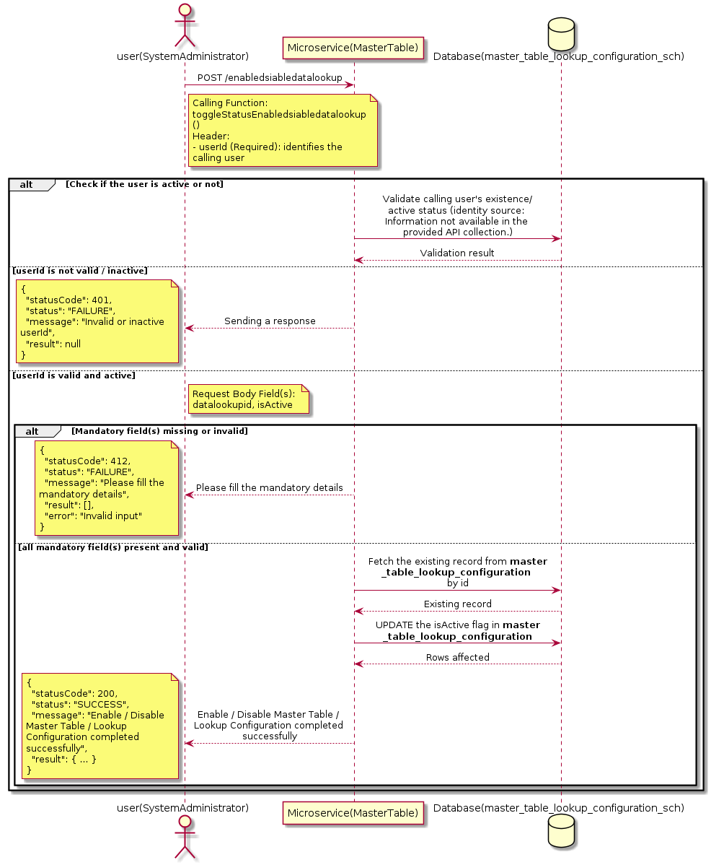

3.10.21.3 API Endpoint
Method | POST
URL | http://localhost:7002/srv2/genie/enabledsiabledatalookup
Headers | Content-Type: application/json userId: 879
Authorization | Not present in the captured request. Information not available in the provided API collection.
Content-Type | Content-Type: application/json
Query Parameters | None
Path Variables | None
Request Body:
{
"datalookupid": 1,
"isActive": "1"
}
Response Body (illustrative — see 3.x.4.5 Success Response for details):
The source Postman collection does not include a captured sample response for this request (the response array is empty). Information not available in the provided API collection. Section 3.10.21.4.5 below presents the response envelope inferred from the standard response wrapper used consistently by this platform's services.

3.10.21.4 Detailed Process Flow

3.10.21.4.1 Request Initiation
The flow begins when System Administrator (or a calling microservice on their behalf) invokes the POST endpoint http://localhost:7002/srv2/genie/enabledsiabledatalookup. The request must include the mandatory `userId` header used by the Master Table Microservice to identify the calling user for auditing purposes. The request carries a JSON payload in the request body which the Controller binds to its Data Transfer Object (DTO) before any processing begins. At the Controller layer, Spring Boot's request-mapping infrastructure routes the call to the appropriate handler method (`toggleStatusEnabledsiabledatalookup`), and Bean Validation annotations (if configured on the DTO) perform structural validation before the request reaches the Service layer. Information not available in the provided API collection. regarding the exact validation annotations used in the source code.

3.10.21.4.2 User Validation
The Master Table Microservice relies on the `userId` header to identify the calling user. Based on the pattern observed consistently across this API collection, the platform's authentication/authorization is expected to be enforced upstream (e.g., by an API Gateway or a shared security filter) using this identifier; the Postman collection does not include an `Authorization` / `Bearer` token header on this request, so the exact authentication mechanism (JWT validation, session lookup, or gateway-level SSO) is Information not available in the provided API collection. Role-based authorization — i.e., confirming that the user identified by `userId` holds a role/permission entitled to perform this operation — is expected to be enforced by the Service layer (see Section 8 – Controller Analysis and Section 14 – Authentication & Authorization), but the specific role/permission checks are Information not available in the provided API collection.

3.10.21.4.3 Business Logic
The Service layer fetches the existing Master Table / Lookup Configuration record by its identifier and flips the `isActive` flag to the value supplied in the request. No other attributes of the record are modified by this operation. The key fields exchanged for this operation, as observed in the sample payload, are: `datalookupid`, `isActive`.

3.10.21.4.4 Database Interaction
The Repository layer (Spring Data JPA) interacts with the underlying relational database that backs the Master Table / Lookup Configuration master table. The primary operation issued is a **UPDATE** against the table associated with Master Table / Lookup Configuration. Only the `is_active` (status) column is updated for the row identified by the primary key; all other columns remain unchanged. The exact table name, column names, primary/foreign key definitions, and JPA repository method signatures are not included in the Postman collection; therefore, precise schema details are information not available in the provided api collection.

3.10.21.4.5 Success Response
Status Code: 200 OK. Sample response envelope (illustrative — the source collection did not capture a sample response for this API):
{
"statusCode": 200,
"status": "SUCCESS",
"message": "Enable / Disable Master Table / Lookup Configuration completed successfully",
"result": {
"id": 1,
"isActive": 1
},
"error": null,
"corelationId": "c6f2a1e4-2b3d-4a9e-9f1a-1234567890ab",
"url": null
}

3.10.21.4.6 Conclusion
This API provides a well-defined, single-purpose capability within the Master Table Microservice for enable / disable master table / lookup configuration. The Controller → Service → Repository → Database layering keeps request validation, business rules, and persistence concerns separated, which allows the Master Table / Lookup Configuration master data to be maintained consistently and safely by authorized administrators while remaining available for consumption by every other module that depends on this reference data.

3.10.22 Retrieve All Master Table / Lookup Configuration — tables

3.10.22.1 Overview
Purpose: To retrieve the complete list of Master Table / Lookup Configuration master records configured in the Master Table Microservice, so that consuming screens and downstream services can populate dropdowns, grids, and configuration views.
Business Requirement: Every screen and workflow that references Master Table / Lookup Configuration data (creation forms, filters, reports) needs an authoritative, always-current list of active Master Table / Lookup Configuration values sourced from a single master table rather than being hard-coded.
Who Uses the API: System Administrator / Application Configuration Team, and any internal microservice/UI module that needs to render Master Table / Lookup Configuration options.
Business Flow: Client sends a GET request → Controller delegates to the Service layer → Service layer calls the Repository → Repository queries the Master Table / Lookup Configuration table → the result set is mapped to response DTOs and returned to the Client.

3.10.22.2 Sequence Diagram
The diagram below illustrates the end-to-end interaction for "Retrieve All Master Table / Lookup Configuration — tables" across the Client, Controller, Service, Repository, and Database layers.
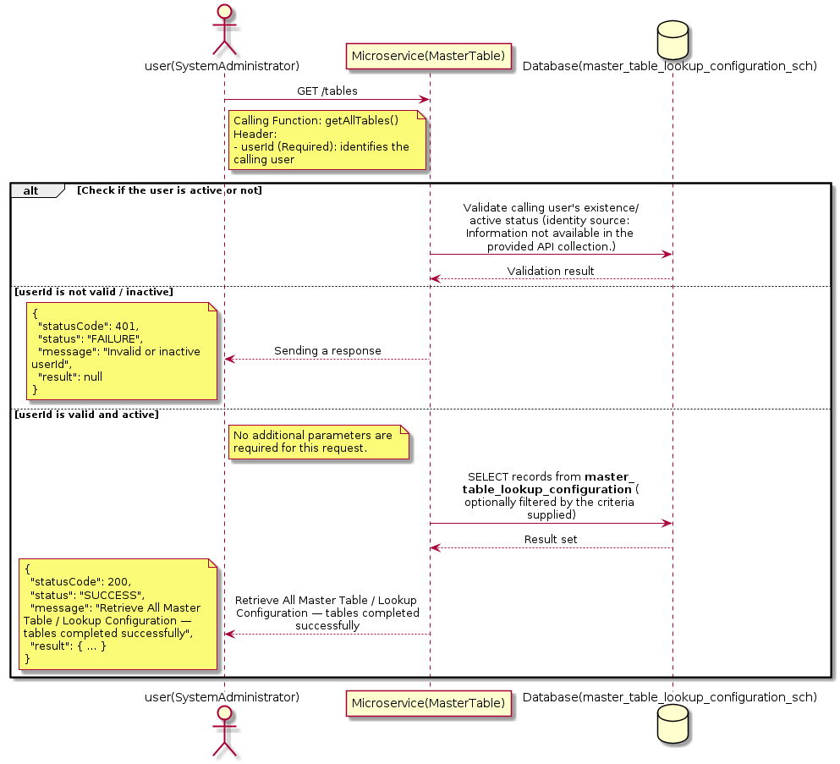

3.10.22.3 API Endpoint
Method | GET
URL | http://localhost:7002/srv2/genie/tables
Headers | userId: 67
Authorization | Not present in the captured request. Information not available in the provided API collection.
Content-Type | application/json (assumed)
Query Parameters | None
Path Variables | None
Request Body:
Not applicable — this operation does not accept a request body.
Response Body (illustrative — see 3.x.4.5 Success Response for details):
The source Postman collection does not include a captured sample response for this request (the response array is empty). Information not available in the provided API collection. Section 3.10.22.4.5 below presents the response envelope inferred from the standard response wrapper used consistently by this platform's services.

3.10.22.4 Detailed Process Flow

3.10.22.4.1 Request Initiation
The flow begins when System Administrator (or a calling microservice on their behalf) invokes the GET endpoint http://localhost:7002/srv2/genie/tables. The request must include the mandatory `userId` header used by the Master Table Microservice to identify the calling user for auditing purposes. At the Controller layer, Spring Boot's request-mapping infrastructure routes the call to the appropriate handler method (`getAllTables`), and Bean Validation annotations (if configured on the DTO) perform structural validation before the request reaches the Service layer. Information not available in the provided API collection. regarding the exact validation annotations used in the source code.

3.10.22.4.2 User Validation
The Master Table Microservice relies on the `userId` header to identify the calling user. Based on the pattern observed consistently across this API collection, the platform's authentication/authorization is expected to be enforced upstream (e.g., by an API Gateway or a shared security filter) using this identifier; the Postman collection does not include an `Authorization` / `Bearer` token header on this request, so the exact authentication mechanism (JWT validation, session lookup, or gateway-level SSO) is Information not available in the provided API collection. Role-based authorization — i.e., confirming that the user identified by `userId` holds a role/permission entitled to perform this operation — is expected to be enforced by the Service layer (see Section 8 – Controller Analysis and Section 14 – Authentication & Authorization), but the specific role/permission checks are Information not available in the provided API collection.

3.10.22.4.3 Business Logic
The Service layer contains no conditional business branching for this operation beyond invoking the Repository to fetch all Master Table / Lookup Configuration records. Depending on the record volume, the Service layer may apply default sorting (e.g., by name or creation order) before returning the list.

3.10.22.4.4 Database Interaction
The Repository layer (Spring Data JPA) interacts with the underlying relational database that backs the Master Table / Lookup Configuration master table. The primary operation issued is a **SELECT** against the table associated with Master Table / Lookup Configuration. No write operations occur; the query returns all rows that satisfy the entity's default scope (typically active records). The exact table name, column names, primary/foreign key definitions, and JPA repository method signatures are not included in the Postman collection; therefore, precise schema details are information not available in the provided api collection.

3.10.22.4.5 Success Response
Status Code: 200 OK. Sample response envelope (illustrative — the source collection did not capture a sample response for this API):
{
"statusCode": 200,
"status": "SUCCESS",
"message": "Retrieve All Master Table / Lookup Configuration — tables completed successfully",
"result": [
{
"id": 1,
"name": "Sample Master Table / Lookup Configuration",
"isActive": 1
}
],
"error": null,
"corelationId": "c6f2a1e4-2b3d-4a9e-9f1a-1234567890ab",
"url": null
}

3.10.22.4.6 Conclusion
This API provides a well-defined, single-purpose capability within the Master Table Microservice for retrieve all master table / lookup configuration — tables. The Controller → Service → Repository → Database layering keeps request validation, business rules, and persistence concerns separated, which allows the Master Table / Lookup Configuration master data to be maintained consistently and safely by authorized administrators while remaining available for consumption by every other module that depends on this reference data.

3.10.23 Retrieve All Master Table / Lookup Configuration — getlookuprule

3.10.23.1 Overview
Purpose: To retrieve the complete list of Master Table / Lookup Configuration master records configured in the Master Table Microservice, so that consuming screens and downstream services can populate dropdowns, grids, and configuration views.
Business Requirement: Every screen and workflow that references Master Table / Lookup Configuration data (creation forms, filters, reports) needs an authoritative, always-current list of active Master Table / Lookup Configuration values sourced from a single master table rather than being hard-coded.
Who Uses the API: System Administrator / Application Configuration Team, and any internal microservice/UI module that needs to render Master Table / Lookup Configuration options.
Business Flow: Client sends a GET request → Controller delegates to the Service layer → Service layer calls the Repository → Repository queries the Master Table / Lookup Configuration table → the result set is mapped to response DTOs and returned to the Client.

3.10.23.2 Sequence Diagram
The diagram below illustrates the end-to-end interaction for "Retrieve All Master Table / Lookup Configuration — getlookuprule" across the Client, Controller, Service, Repository, and Database layers.
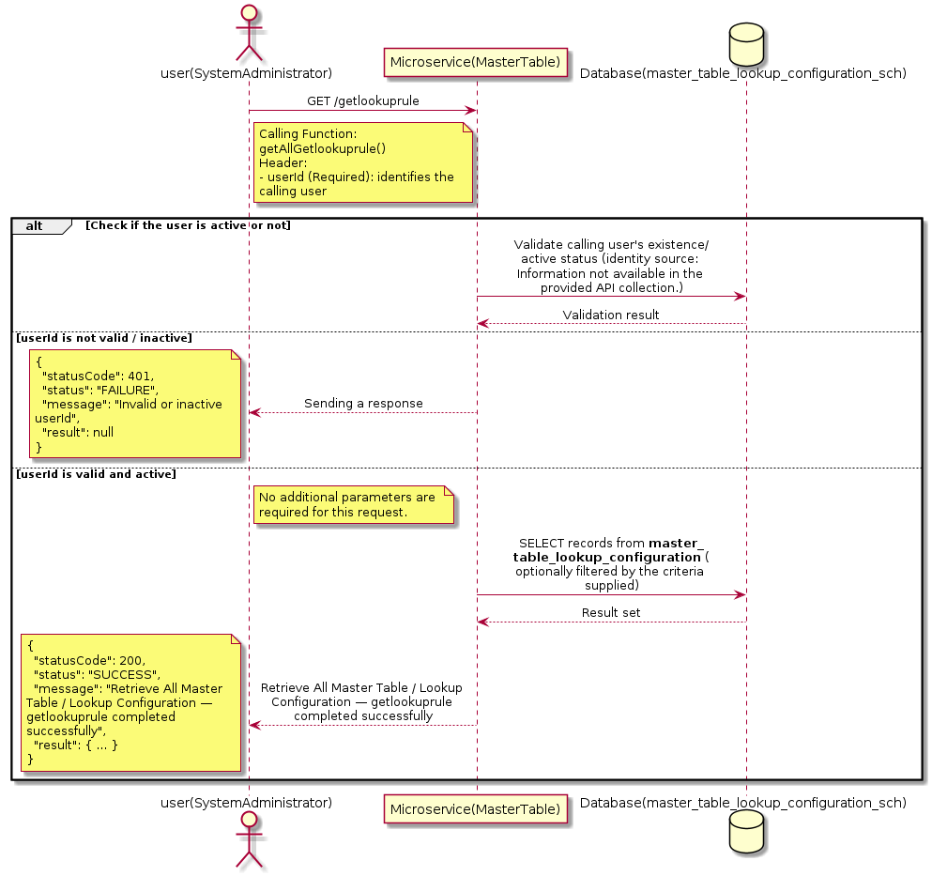

3.10.23.3 API Endpoint
Method | GET
URL | http://localhost:7002/srv2/genie/getlookuprule
Headers | userId: 67
Authorization | Not present in the captured request. Information not available in the provided API collection.
Content-Type | application/json (assumed)
Query Parameters | None
Path Variables | None
Request Body:
Not applicable — this operation does not accept a request body.
Response Body (illustrative — see 3.x.4.5 Success Response for details):
The source Postman collection does not include a captured sample response for this request (the response array is empty). Information not available in the provided API collection. Section 3.10.23.4.5 below presents the response envelope inferred from the standard response wrapper used consistently by this platform's services.

3.10.23.4 Detailed Process Flow

3.10.23.4.1 Request Initiation
The flow begins when System Administrator (or a calling microservice on their behalf) invokes the GET endpoint http://localhost:7002/srv2/genie/getlookuprule. The request must include the mandatory `userId` header used by the Master Table Microservice to identify the calling user for auditing purposes. At the Controller layer, Spring Boot's request-mapping infrastructure routes the call to the appropriate handler method (`getAllGetlookuprule`), and Bean Validation annotations (if configured on the DTO) perform structural validation before the request reaches the Service layer. Information not available in the provided API collection. regarding the exact validation annotations used in the source code.

3.10.23.4.2 User Validation
The Master Table Microservice relies on the `userId` header to identify the calling user. Based on the pattern observed consistently across this API collection, the platform's authentication/authorization is expected to be enforced upstream (e.g., by an API Gateway or a shared security filter) using this identifier; the Postman collection does not include an `Authorization` / `Bearer` token header on this request, so the exact authentication mechanism (JWT validation, session lookup, or gateway-level SSO) is Information not available in the provided API collection. Role-based authorization — i.e., confirming that the user identified by `userId` holds a role/permission entitled to perform this operation — is expected to be enforced by the Service layer (see Section 8 – Controller Analysis and Section 14 – Authentication & Authorization), but the specific role/permission checks are Information not available in the provided API collection.

3.10.23.4.3 Business Logic
The Service layer contains no conditional business branching for this operation beyond invoking the Repository to fetch all Master Table / Lookup Configuration records. Depending on the record volume, the Service layer may apply default sorting (e.g., by name or creation order) before returning the list.

3.10.23.4.4 Database Interaction
The Repository layer (Spring Data JPA) interacts with the underlying relational database that backs the Master Table / Lookup Configuration master table. The primary operation issued is a **SELECT** against the table associated with Master Table / Lookup Configuration. No write operations occur; the query returns all rows that satisfy the entity's default scope (typically active records). The exact table name, column names, primary/foreign key definitions, and JPA repository method signatures are not included in the Postman collection; therefore, precise schema details are information not available in the provided api collection.

3.10.23.4.5 Success Response
Status Code: 200 OK. Sample response envelope (illustrative — the source collection did not capture a sample response for this API):
{
"statusCode": 200,
"status": "SUCCESS",
"message": "Retrieve All Master Table / Lookup Configuration — getlookuprule completed successfully",
"result": [
{
"id": 1,
"name": "Sample Master Table / Lookup Configuration",
"isActive": 1
}
],
"error": null,
"corelationId": "c6f2a1e4-2b3d-4a9e-9f1a-1234567890ab",
"url": null
}

3.10.23.4.6 Conclusion
This API provides a well-defined, single-purpose capability within the Master Table Microservice for retrieve all master table / lookup configuration — getlookuprule. The Controller → Service → Repository → Database layering keeps request validation, business rules, and persistence concerns separated, which allows the Master Table / Lookup Configuration master data to be maintained consistently and safely by authorized administrators while remaining available for consumption by every other module that depends on this reference data.

3.10.24 Retrieve Master Table / Lookup Configuration by ID

3.10.24.1 Overview
Purpose: To retrieve a single Master Table / Lookup Configuration record identified by its unique identifier, typically used to pre-populate an edit screen or to validate a reference before use.
Business Requirement: Edit screens, validation routines, and cross-service lookups need to resolve a single Master Table / Lookup Configuration record by its identifier reliably and quickly.
Who Uses the API: System Administrator / Application Configuration Team, and internal services validating a Master Table / Lookup Configuration reference (e.g., ticket creation, workflow configuration).
Business Flow: Client sends a GET request with the identifier in the URL path → Controller extracts the path variable → Service layer requests the Repository to fetch the record → if found, the record is mapped and returned; if not found, a 404 is returned.

3.10.24.2 Sequence Diagram
The diagram below illustrates the end-to-end interaction for "Retrieve Master Table / Lookup Configuration by ID" across the Client, Controller, Service, Repository, and Database layers.
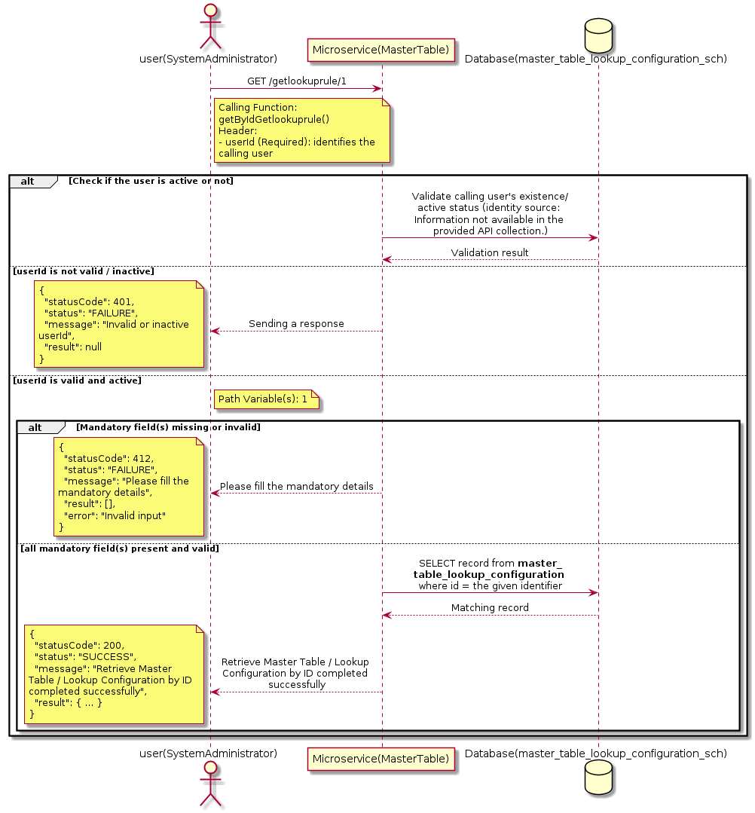

3.10.24.3 API Endpoint
Method | GET
URL | http://localhost:7002/srv2/genie/getlookuprule/1
Headers | userId: 67
Authorization | Not present in the captured request. Information not available in the provided API collection.
Content-Type | application/json (assumed)
Query Parameters | None
Path Variables | 1
Request Body:
Not applicable — this operation does not accept a request body.
Response Body (illustrative — see 3.x.4.5 Success Response for details):
The source Postman collection does not include a captured sample response for this request (the response array is empty). Information not available in the provided API collection. Section 3.10.24.4.5 below presents the response envelope inferred from the standard response wrapper used consistently by this platform's services.

3.10.24.4 Detailed Process Flow

3.10.24.4.1 Request Initiation
The flow begins when System Administrator (or a calling microservice on their behalf) invokes the GET endpoint http://localhost:7002/srv2/genie/getlookuprule/1. The request must include the mandatory `userId` header used by the Master Table Microservice to identify the calling user for auditing purposes. At the Controller layer, Spring Boot's request-mapping infrastructure routes the call to the appropriate handler method (`getByIdGetlookuprule`), and Bean Validation annotations (if configured on the DTO) perform structural validation before the request reaches the Service layer. Information not available in the provided API collection. regarding the exact validation annotations used in the source code.

3.10.24.4.2 User Validation
The Master Table Microservice relies on the `userId` header to identify the calling user. Based on the pattern observed consistently across this API collection, the platform's authentication/authorization is expected to be enforced upstream (e.g., by an API Gateway or a shared security filter) using this identifier; the Postman collection does not include an `Authorization` / `Bearer` token header on this request, so the exact authentication mechanism (JWT validation, session lookup, or gateway-level SSO) is Information not available in the provided API collection. Role-based authorization — i.e., confirming that the user identified by `userId` holds a role/permission entitled to perform this operation — is expected to be enforced by the Service layer (see Section 8 – Controller Analysis and Section 14 – Authentication & Authorization), but the specific role/permission checks are Information not available in the provided API collection.

3.10.24.4.3 Business Logic
The Service layer forwards the identifier to the Repository. If no record is found for the given identifier, the Service layer raises a not-found condition that the Controller/global exception handler converts into an HTTP 404 response.

3.10.24.4.4 Database Interaction
The Repository layer (Spring Data JPA) interacts with the underlying relational database that backs the Master Table / Lookup Configuration master table. The primary operation issued is a **SELECT** against the table associated with Master Table / Lookup Configuration. No write operations occur; a single-row lookup is performed using the primary key. The exact table name, column names, primary/foreign key definitions, and JPA repository method signatures are not included in the Postman collection; therefore, precise schema details are information not available in the provided api collection.

3.10.24.4.5 Success Response
Status Code: 200 OK. Sample response envelope (illustrative — the source collection did not capture a sample response for this API):
{
"statusCode": 200,
"status": "SUCCESS",
"message": "Retrieve Master Table / Lookup Configuration by ID completed successfully",
"result": {
"id": 1,
"name": "Sample Master Table / Lookup Configuration",
"isActive": 1
},
"error": null,
"corelationId": "c6f2a1e4-2b3d-4a9e-9f1a-1234567890ab",
"url": null
}

3.10.24.4.6 Conclusion
This API provides a well-defined, single-purpose capability within the Master Table Microservice for retrieve master table / lookup configuration by id. The Controller → Service → Repository → Database layering keeps request validation, business rules, and persistence concerns separated, which allows the Master Table / Lookup Configuration master data to be maintained consistently and safely by authorized administrators while remaining available for consumption by every other module that depends on this reference data.

3.11 Nominate Approver (Delegation) APIs (Nominate-Approver)
Allows an approver to nominate a delegate/alternate approver for a specific date range so that pending approvals continue to be actioned while the primary approver is unavailable.

3.11.1 Retrieve Nominate Approver (Delegation) (Filtered)

3.11.1.1 Overview
Purpose: To retrieve Nominate Approver (Delegation) master records that match the supplied filter/query criteria, allowing consumers to narrow down large master-data sets to a relevant subset.
Business Requirement: Administrators and downstream services need the ability to narrow Nominate Approver (Delegation) records by specific criteria rather than retrieving and filtering the full data set on the client side.
Who Uses the API: Approver / Employee, and reporting/search screens that filter by Nominate Approver (Delegation).
Business Flow: Client sends a GET request with query parameters → Controller parses and validates the parameters → Service layer builds the filter criteria → Repository executes the filtered query against the Nominate Approver (Delegation) table → the filtered result is returned to the Client.

3.11.1.2 Sequence Diagram
The diagram below illustrates the end-to-end interaction for "Retrieve Nominate Approver (Delegation) (Filtered)" across the Client, Controller, Service, Repository, and Database layers.
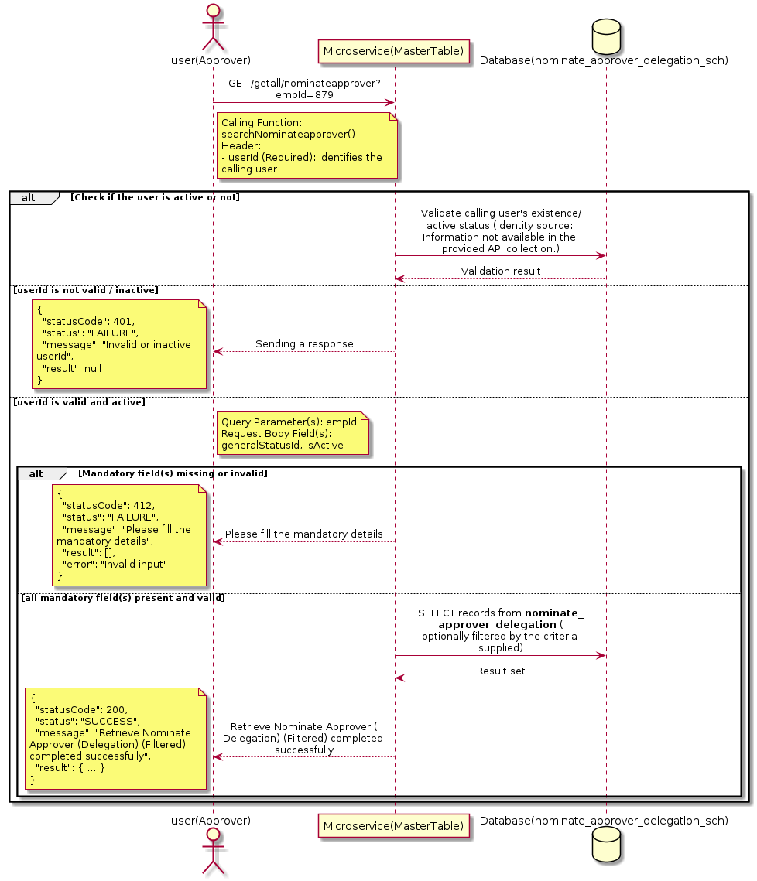

3.11.1.3 API Endpoint
Method | GET
URL | http://localhost:7002/srv2/genie/getall/nominateapprover?empId=879
Headers | userId: 67 Content-Type: application/json
Authorization | Not present in the captured request. Information not available in the provided API collection.
Content-Type | Content-Type: application/json
Query Parameters | empId = 879
Path Variables | None
Request Body:
{
"generalStatusId": 6,
"isActive": 1
}
Response Body (illustrative — see 3.x.4.5 Success Response for details):
The source Postman collection does not include a captured sample response for this request (the response array is empty). Information not available in the provided API collection. Section 3.11.1.4.5 below presents the response envelope inferred from the standard response wrapper used consistently by this platform's services.

3.11.1.4 Detailed Process Flow

3.11.1.4.1 Request Initiation
The flow begins when Approver (or a calling microservice on their behalf) invokes the GET endpoint http://localhost:7002/srv2/genie/getall/nominateapprover?empId=879. The request must include the mandatory `userId` header used by the Master Table Microservice to identify the calling user for auditing purposes. The endpoint also expects one or more query parameters as listed in the API Endpoint section. The request carries a JSON payload in the request body which the Controller binds to its Data Transfer Object (DTO) before any processing begins. At the Controller layer, Spring Boot's request-mapping infrastructure routes the call to the appropriate handler method (`searchNominateapprover`), and Bean Validation annotations (if configured on the DTO) perform structural validation before the request reaches the Service layer. Information not available in the provided API collection. regarding the exact validation annotations used in the source code.

3.11.1.4.2 User Validation
The Master Table Microservice relies on the `userId` header to identify the calling user. Based on the pattern observed consistently across this API collection, the platform's authentication/authorization is expected to be enforced upstream (e.g., by an API Gateway or a shared security filter) using this identifier; the Postman collection does not include an `Authorization` / `Bearer` token header on this request, so the exact authentication mechanism (JWT validation, session lookup, or gateway-level SSO) is Information not available in the provided API collection. Role-based authorization — i.e., confirming that the user identified by `userId` holds a role/permission entitled to perform this operation — is expected to be enforced by the Service layer (see Section 8 – Controller Analysis and Section 14 – Authentication & Authorization), but the specific role/permission checks are Information not available in the provided API collection.

3.11.1.4.3 Business Logic
The Service layer inspects the supplied query parameters, builds the corresponding filter/predicate, and forwards it to the Repository. If a parameter is absent, the corresponding filter is typically skipped rather than treated as an error. The key fields exchanged for this operation, as observed in the sample payload, are: `generalStatusId`, `isActive`.

3.11.1.4.4 Database Interaction
The Repository layer (Spring Data JPA) interacts with the underlying relational database that backs the Nominate Approver (Delegation) master table. The primary operation issued is a **SELECT** against the table associated with Nominate Approver (Delegation). No write operations occur; the query is scoped using the supplied filter parameters, translated into a JPA derived-query or `@Query`/native query. The exact table name, column names, primary/foreign key definitions, and JPA repository method signatures are not included in the Postman collection; therefore, precise schema details are information not available in the provided api collection.

3.11.1.4.5 Success Response
Status Code: 200 OK. Sample response envelope (illustrative — the source collection did not capture a sample response for this API):
{
"statusCode": 200,
"status": "SUCCESS",
"message": "Retrieve Nominate Approver (Delegation) (Filtered) completed successfully",
"result": [
{
"id": 1,
"name": "Sample Nominate Approver (Delegation)",
"isActive": 1
}
],
"error": null,
"corelationId": "c6f2a1e4-2b3d-4a9e-9f1a-1234567890ab",
"url": null
}

3.11.1.4.6 Conclusion
This API provides a well-defined, single-purpose capability within the Master Table Microservice for retrieve nominate approver (delegation) (filtered). The Controller → Service → Repository → Database layering keeps request validation, business rules, and persistence concerns separated, which allows the Nominate Approver (Delegation) master data to be maintained consistently and safely by authorized administrators while remaining available for consumption by every other module that depends on this reference data.

3.11.2 Create Nominate Approver (Delegation)

3.11.2.1 Overview
Purpose: To create a new Nominate Approver (Delegation) master record in the system, allowing administrators to extend the master-data catalogue that other modules (ticketing, workflow, notifications) depend on.
Business Requirement: Business/process owners need a controlled way to add new Nominate Approver (Delegation) values so that the platform's classification, routing, and reporting capabilities can evolve as the organization changes.
Who Uses the API: Approver / Employee responsible for master-data configuration.
Business Flow: Client sends a POST request with the new Nominate Approver (Delegation) payload → Controller validates the payload (mandatory fields, formats) → Service layer applies business rules (e.g., duplicate-name check) → Repository persists the new record → the created record (with generated identifier) is returned to the Client.

3.11.2.2 Sequence Diagram
The diagram below illustrates the end-to-end interaction for "Create Nominate Approver (Delegation)" across the Client, Controller, Service, Repository, and Database layers.
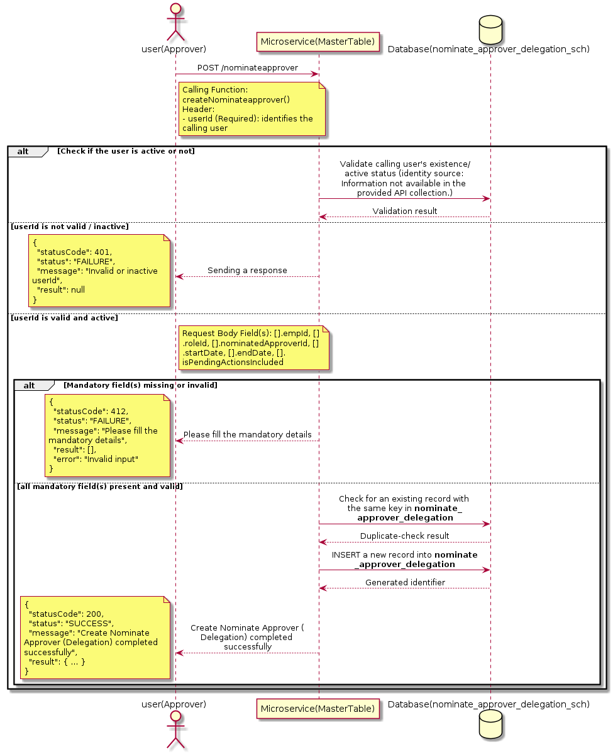

3.11.2.3 API Endpoint
Method | POST
URL | http://localhost:7002/srv2/genie/nominateapprover
Headers | userId: 67 Content-Type: application/json
Authorization | Not present in the captured request. Information not available in the provided API collection.
Content-Type | Content-Type: application/json
Query Parameters | None
Path Variables | None
Request Body:
[
{
"empId": 879,
"roleId": "10",
"nominatedApproverId": 100,
"startDate": "2026-05-25",
"endDate": "2026-06-25",
"isPendingActionsIncluded": "0"
}
]
Response Body (illustrative — see 3.x.4.5 Success Response for details):
The source Postman collection does not include a captured sample response for this request (the response array is empty). Information not available in the provided API collection. Section 3.11.2.4.5 below presents the response envelope inferred from the standard response wrapper used consistently by this platform's services.

3.11.2.4 Detailed Process Flow

3.11.2.4.1 Request Initiation
The flow begins when Approver (or a calling microservice on their behalf) invokes the POST endpoint http://localhost:7002/srv2/genie/nominateapprover. The request must include the mandatory `userId` header used by the Master Table Microservice to identify the calling user for auditing purposes. The request carries a JSON payload in the request body which the Controller binds to its Data Transfer Object (DTO) before any processing begins. At the Controller layer, Spring Boot's request-mapping infrastructure routes the call to the appropriate handler method (`createNominateapprover`), and Bean Validation annotations (if configured on the DTO) perform structural validation before the request reaches the Service layer. Information not available in the provided API collection. regarding the exact validation annotations used in the source code.

3.11.2.4.2 User Validation
The Master Table Microservice relies on the `userId` header to identify the calling user. Based on the pattern observed consistently across this API collection, the platform's authentication/authorization is expected to be enforced upstream (e.g., by an API Gateway or a shared security filter) using this identifier; the Postman collection does not include an `Authorization` / `Bearer` token header on this request, so the exact authentication mechanism (JWT validation, session lookup, or gateway-level SSO) is Information not available in the provided API collection. Role-based authorization — i.e., confirming that the user identified by `userId` holds a role/permission entitled to perform this operation — is expected to be enforced by the Service layer (see Section 8 – Controller Analysis and Section 14 – Authentication & Authorization), but the specific role/permission checks are Information not available in the provided API collection.

3.11.2.4.3 Business Logic
The Service layer performs the following: (1) validates that mandatory fields are present and correctly formatted, (2) checks for duplicates (e.g., an existing Nominate Approver (Delegation) with the same name/code), (3) sets system-managed fields (e.g., `isActive = 1`, `createdBy`, timestamps) where applicable, and (4) persists the new record via the Repository. If any validation fails, the Service layer returns a business error rather than proceeding to persistence. The key fields exchanged for this operation, as observed in the sample payload, are: `[].empId`, `[].roleId`, `[].nominatedApproverId`, `[].startDate`, `[].endDate`, `[].isPendingActionsIncluded`.

3.11.2.4.4 Database Interaction
The Repository layer (Spring Data JPA) interacts with the underlying relational database that backs the Nominate Approver (Delegation) master table. The primary operation issued is a **INSERT** against the table associated with Nominate Approver (Delegation). A new row is inserted into the master table; if the entity has related child records (as seen in nested request payload arrays), corresponding child-table inserts are performed within the same transaction. The exact table name, column names, primary/foreign key definitions, and JPA repository method signatures are not included in the Postman collection; therefore, precise schema details are information not available in the provided api collection.

3.11.2.4.5 Success Response
Status Code: 200 OK. Sample response envelope (illustrative — the source collection did not capture a sample response for this API):
{
"statusCode": 200,
"status": "SUCCESS",
"message": "Create Nominate Approver (Delegation) completed successfully",
"result": {
"id": 101,
"[].empId": 879,
"[].roleId": "10",
"[].nominatedApproverId": 100,
"[].startDate": "2026-05-25",
"[].endDate": "2026-06-25",
"[].isPendingActionsIncluded": "0"
},
"error": null,
"corelationId": "c6f2a1e4-2b3d-4a9e-9f1a-1234567890ab",
"url": null
}

3.11.2.4.6 Conclusion
This API provides a well-defined, single-purpose capability within the Master Table Microservice for create nominate approver (delegation). The Controller → Service → Repository → Database layering keeps request validation, business rules, and persistence concerns separated, which allows the Nominate Approver (Delegation) master data to be maintained consistently and safely by authorized administrators while remaining available for consumption by every other module that depends on this reference data.

3.11.3 Search / List Nominate Approver (Delegation)

3.11.3.1 Overview
Purpose: To search and list Nominate Approver (Delegation) records based on a search payload (e.g., free-text search or structured criteria), supporting list/grid screens that need paginated or filtered master data.
Business Requirement: List/search screens for Nominate Approver (Delegation) configuration need server-side search so that administrators can locate specific records in large master tables without scanning the full data set.
Who Uses the API: Approver / Employee operating the Nominate Approver (Delegation) configuration/list screen.
Business Flow: Client sends a POST request with a search payload → Controller validates the payload → Service layer constructs the search/query logic → Repository executes the search against the Nominate Approver (Delegation) table → matching records are returned to the Client.

3.11.3.2 Sequence Diagram
The diagram below illustrates the end-to-end interaction for "Search / List Nominate Approver (Delegation)" across the Client, Controller, Service, Repository, and Database layers.
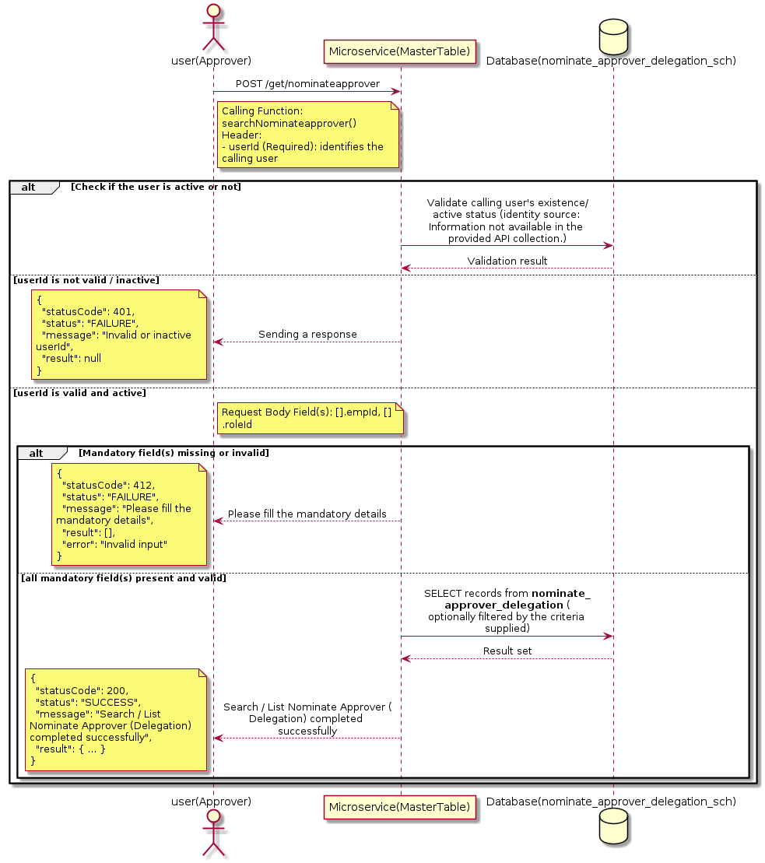

3.11.3.3 API Endpoint
Method | POST
URL | http://localhost:7002/srv2/genie/get/nominateapprover
Headers | userId: 67 Content-Type: application/json
Authorization | Not present in the captured request. Information not available in the provided API collection.
Content-Type | Content-Type: application/json
Query Parameters | None
Path Variables | None
Request Body:
[
{
"empId": 879,
"roleId": "10"
}
]
Response Body (illustrative — see 3.x.4.5 Success Response for details):
The source Postman collection does not include a captured sample response for this request (the response array is empty). Information not available in the provided API collection. Section 3.11.3.4.5 below presents the response envelope inferred from the standard response wrapper used consistently by this platform's services.

3.11.3.4 Detailed Process Flow

3.11.3.4.1 Request Initiation
The flow begins when Approver (or a calling microservice on their behalf) invokes the POST endpoint http://localhost:7002/srv2/genie/get/nominateapprover. The request must include the mandatory `userId` header used by the Master Table Microservice to identify the calling user for auditing purposes. The request carries a JSON payload in the request body which the Controller binds to its Data Transfer Object (DTO) before any processing begins. At the Controller layer, Spring Boot's request-mapping infrastructure routes the call to the appropriate handler method (`searchNominateapprover`), and Bean Validation annotations (if configured on the DTO) perform structural validation before the request reaches the Service layer. Information not available in the provided API collection. regarding the exact validation annotations used in the source code.

3.11.3.4.2 User Validation
The Master Table Microservice relies on the `userId` header to identify the calling user. Based on the pattern observed consistently across this API collection, the platform's authentication/authorization is expected to be enforced upstream (e.g., by an API Gateway or a shared security filter) using this identifier; the Postman collection does not include an `Authorization` / `Bearer` token header on this request, so the exact authentication mechanism (JWT validation, session lookup, or gateway-level SSO) is Information not available in the provided API collection. Role-based authorization — i.e., confirming that the user identified by `userId` holds a role/permission entitled to perform this operation — is expected to be enforced by the Service layer (see Section 8 – Controller Analysis and Section 14 – Authentication & Authorization), but the specific role/permission checks are Information not available in the provided API collection.

3.11.3.4.3 Business Logic
The Service layer evaluates the search payload; if the search text/criteria is empty, the operation typically behaves like a full list (all Nominate Approver (Delegation) records); if populated, it is used to build a case-insensitive `LIKE`/contains predicate against the relevant column(s). The key fields exchanged for this operation, as observed in the sample payload, are: `[].empId`, `[].roleId`.

3.11.3.4.4 Database Interaction
The Repository layer (Spring Data JPA) interacts with the underlying relational database that backs the Nominate Approver (Delegation) master table. The primary operation issued is a **SELECT** against the table associated with Nominate Approver (Delegation). No write operations occur; the search is typically implemented using a JPA derived query method or a native/JPQL query with `LIKE` predicates. The exact table name, column names, primary/foreign key definitions, and JPA repository method signatures are not included in the Postman collection; therefore, precise schema details are information not available in the provided api collection.

3.11.3.4.5 Success Response
Status Code: 200 OK. Sample response envelope (illustrative — the source collection did not capture a sample response for this API):
{
"statusCode": 200,
"status": "SUCCESS",
"message": "Search / List Nominate Approver (Delegation) completed successfully",
"result": [
{
"id": 1,
"name": "Sample Nominate Approver (Delegation)",
"isActive": 1
}
],
"error": null,
"corelationId": "c6f2a1e4-2b3d-4a9e-9f1a-1234567890ab",
"url": null
}

3.11.3.4.6 Conclusion
This API provides a well-defined, single-purpose capability within the Master Table Microservice for search / list nominate approver (delegation). The Controller → Service → Repository → Database layering keeps request validation, business rules, and persistence concerns separated, which allows the Nominate Approver (Delegation) master data to be maintained consistently and safely by authorized administrators while remaining available for consumption by every other module that depends on this reference data.

3.11.4 Enable / Disable Nominate Approver (Delegation)

3.11.4.1 Overview
Purpose: To enable or disable (soft-delete) a Nominate Approver (Delegation) master record, allowing administrators to retire a record from active use while preserving it for historical/audit purposes.
Business Requirement: Rather than physically deleting a Nominate Approver (Delegation) record (which could break referential integrity with historical tickets/records that reference it), the business requires a reversible enable/disable mechanism.
Who Uses the API: Approver / Employee responsible for activating/deactivating configuration values.
Business Flow: Client sends a request carrying the Nominate Approver (Delegation) identifier and the desired active/inactive flag → Controller validates the payload → Service layer fetches the record and flips its status flag → Repository persists the change → the updated status is returned to the Client.

3.11.4.2 Sequence Diagram
The diagram below illustrates the end-to-end interaction for "Enable / Disable Nominate Approver (Delegation)" across the Client, Controller, Service, Repository, and Database layers.
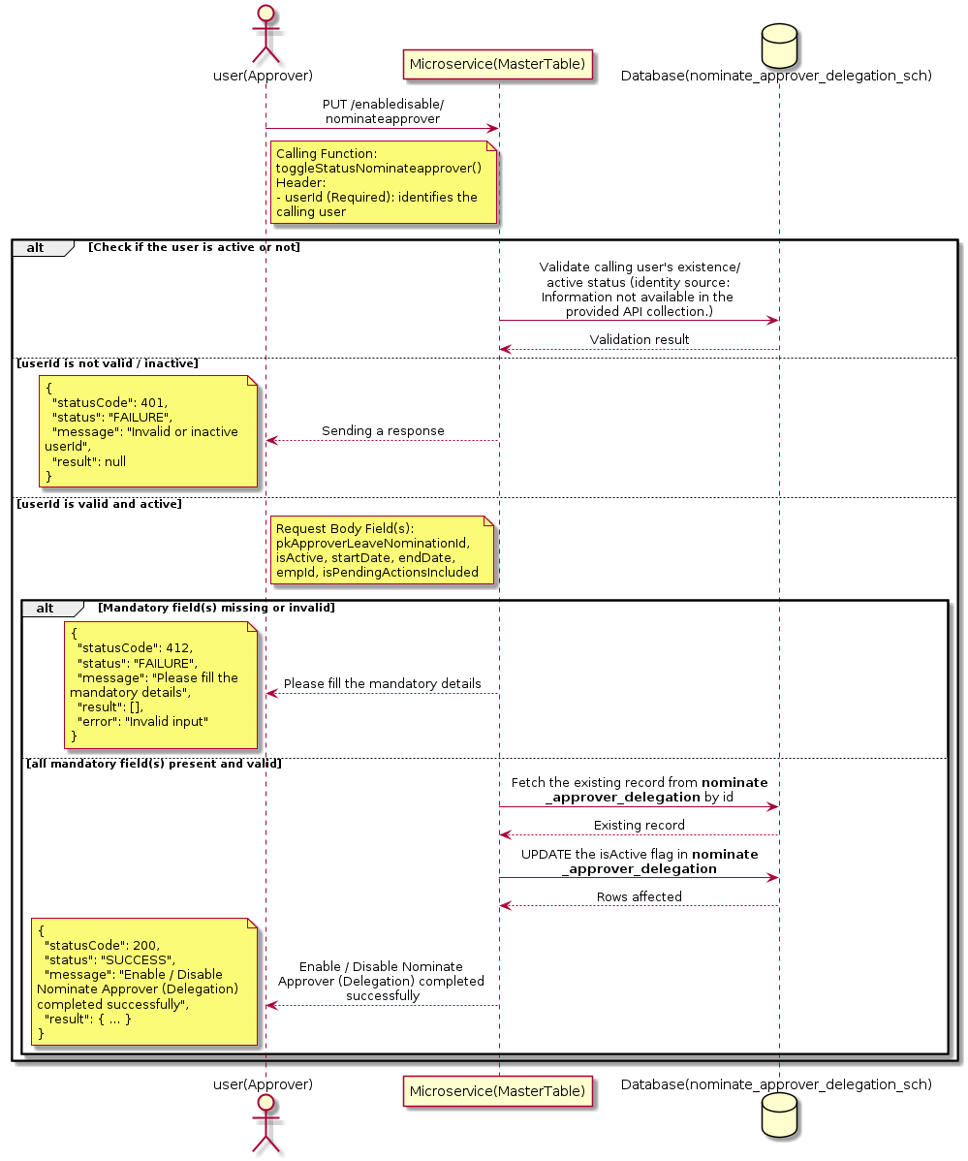

3.11.4.3 API Endpoint
Method | PUT
URL | http://localhost:7002/srv2/genie/enabledisable/nominateapprover
Headers | userId: 67 Content-Type: application/json
Authorization | Not present in the captured request. Information not available in the provided API collection.
Content-Type | Content-Type: application/json
Query Parameters | None
Path Variables | None
Request Body:
{
"pkApproverLeaveNominationId": 1,
"isActive": "0",
"startDate": "2026-05-25",
"endDate": "2026-06-25",
"empId": 879,
"isPendingActionsIncluded": "0"
}
Response Body (illustrative — see 3.x.4.5 Success Response for details):
The source Postman collection does not include a captured sample response for this request (the response array is empty). Information not available in the provided API collection. Section 3.11.4.4.5 below presents the response envelope inferred from the standard response wrapper used consistently by this platform's services.

3.11.4.4 Detailed Process Flow

3.11.4.4.1 Request Initiation
The flow begins when Approver (or a calling microservice on their behalf) invokes the PUT endpoint http://localhost:7002/srv2/genie/enabledisable/nominateapprover. The request must include the mandatory `userId` header used by the Master Table Microservice to identify the calling user for auditing purposes. The request carries a JSON payload in the request body which the Controller binds to its Data Transfer Object (DTO) before any processing begins. At the Controller layer, Spring Boot's request-mapping infrastructure routes the call to the appropriate handler method (`toggleStatusNominateapprover`), and Bean Validation annotations (if configured on the DTO) perform structural validation before the request reaches the Service layer. Information not available in the provided API collection. regarding the exact validation annotations used in the source code.

3.11.4.4.2 User Validation
The Master Table Microservice relies on the `userId` header to identify the calling user. Based on the pattern observed consistently across this API collection, the platform's authentication/authorization is expected to be enforced upstream (e.g., by an API Gateway or a shared security filter) using this identifier; the Postman collection does not include an `Authorization` / `Bearer` token header on this request, so the exact authentication mechanism (JWT validation, session lookup, or gateway-level SSO) is Information not available in the provided API collection. Role-based authorization — i.e., confirming that the user identified by `userId` holds a role/permission entitled to perform this operation — is expected to be enforced by the Service layer (see Section 8 – Controller Analysis and Section 14 – Authentication & Authorization), but the specific role/permission checks are Information not available in the provided API collection.

3.11.4.4.3 Business Logic
The Service layer fetches the existing Nominate Approver (Delegation) record by its identifier and flips the `isActive` flag to the value supplied in the request. No other attributes of the record are modified by this operation. The key fields exchanged for this operation, as observed in the sample payload, are: `pkApproverLeaveNominationId`, `isActive`, `startDate`, `endDate`, `empId`, `isPendingActionsIncluded`.

3.11.4.4.4 Database Interaction
The Repository layer (Spring Data JPA) interacts with the underlying relational database that backs the Nominate Approver (Delegation) master table. The primary operation issued is a **UPDATE** against the table associated with Nominate Approver (Delegation). Only the `is_active` (status) column is updated for the row identified by the primary key; all other columns remain unchanged. The exact table name, column names, primary/foreign key definitions, and JPA repository method signatures are not included in the Postman collection; therefore, precise schema details are information not available in the provided api collection.

3.11.4.4.5 Success Response
Status Code: 200 OK. Sample response envelope (illustrative — the source collection did not capture a sample response for this API):
{
"statusCode": 200,
"status": "SUCCESS",
"message": "Enable / Disable Nominate Approver (Delegation) completed successfully",
"result": {
"id": 1,
"isActive": 1
},
"error": null,
"corelationId": "c6f2a1e4-2b3d-4a9e-9f1a-1234567890ab",
"url": null
}

3.11.4.4.6 Conclusion
This API provides a well-defined, single-purpose capability within the Master Table Microservice for enable / disable nominate approver (delegation). The Controller → Service → Repository → Database layering keeps request validation, business rules, and persistence concerns separated, which allows the Nominate Approver (Delegation) master data to be maintained consistently and safely by authorized administrators while remaining available for consumption by every other module that depends on this reference data.
3.11.5 Update Nominate Approver (Delegation)

3.11.5.1 Overview
Purpose: To update an existing Nominate Approver (Delegation) master record, allowing administrators to correct or evolve master-data attributes without impacting the record's identity/history.
Business Requirement: Master data changes over time (renames, corrections, re-classification); the platform must allow controlled updates while preserving referential integrity for records that already reference this Nominate Approver (Delegation).
Who Uses the API: Approver / Employee responsible for maintaining master-data accuracy.
Business Flow: Client sends a PUT/PATCH request with the updated Nominate Approver (Delegation) payload → Controller validates the payload → Service layer fetches the existing record, applies the changes, and re-validates business rules → Repository persists the updated record → the updated record is returned to the Client.

3.11.5.2 Sequence Diagram
The diagram below illustrates the end-to-end interaction for "Update Nominate Approver (Delegation)" across the Client, Controller, Service, Repository, and Database layers.
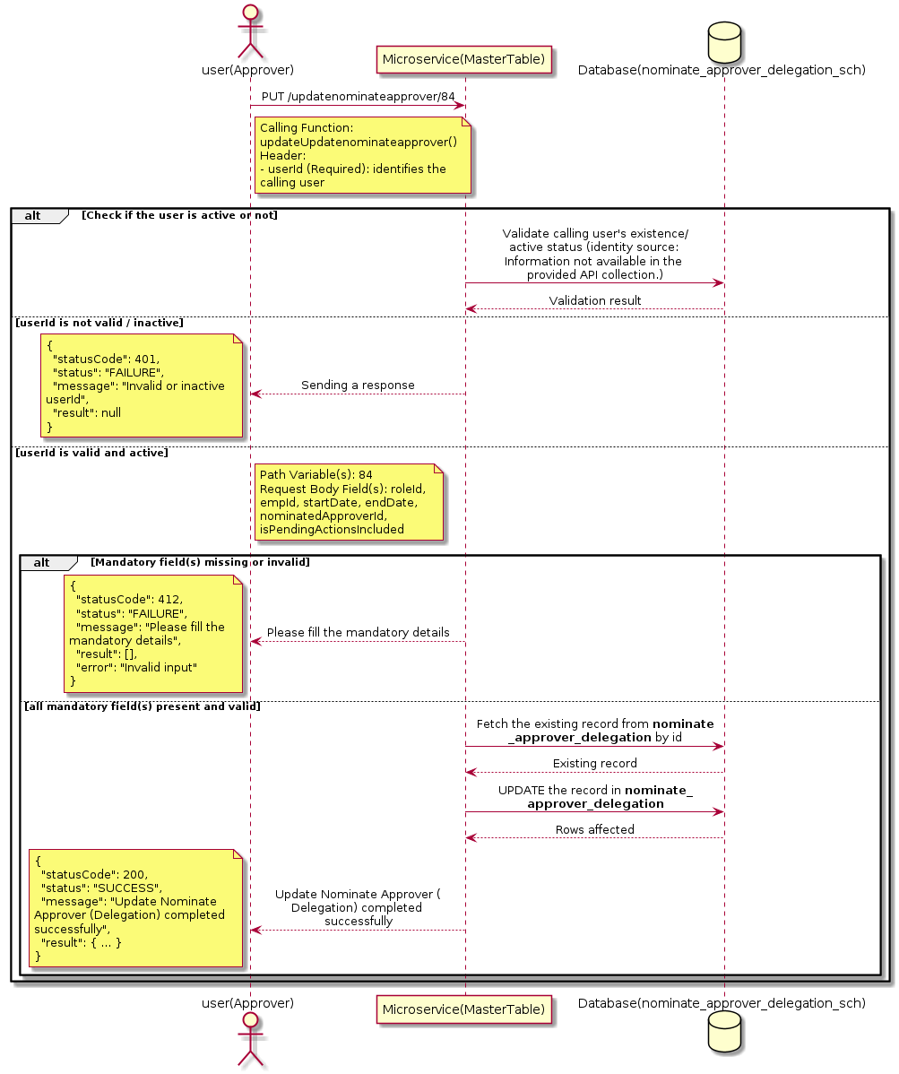

3.11.5.3 API Endpoint
Method | PUT
URL | http://localhost:7002/srv2/genie/updatenominateapprover/84
Headers | userId: 67 Content-Type: application/json
Authorization | Not present in the captured request. Information not available in the provided API collection.
Content-Type | Content-Type: application/json
Query Parameters | None
Path Variables | 84
Request Body:
{
"roleId": "7",
"empId": 3544,
"startDate": "2026-06-01",
"endDate": "2026-07-01",
"nominatedApproverId": 3871,
"isPendingActionsIncluded": "0"
}
Response Body (illustrative — see 3.x.4.5 Success Response for details):
The source Postman collection does not include a captured sample response for this request (the response array is empty). Information not available in the provided API collection. Section 3.11.5.4.5 below presents the response envelope inferred from the standard response wrapper used consistently by this platform's services.

3.11.5.4 Detailed Process Flow

3.11.5.4.1 Request Initiation
The flow begins when Approver (or a calling microservice on their behalf) invokes the PUT endpoint http://localhost:7002/srv2/genie/updatenominateapprover/84. The request must include the mandatory `userId` header used by the Master Table Microservice to identify the calling user for auditing purposes. The request carries a JSON payload in the request body which the Controller binds to its Data Transfer Object (DTO) before any processing begins. At the Controller layer, Spring Boot's request-mapping infrastructure routes the call to the appropriate handler method (`updateUpdatenominateapprover`), and Bean Validation annotations (if configured on the DTO) perform structural validation before the request reaches the Service layer. Information not available in the provided API collection. regarding the exact validation annotations used in the source code.

3.11.5.4.2 User Validation
The Master Table Microservice relies on the `userId` header to identify the calling user. Based on the pattern observed consistently across this API collection, the platform's authentication/authorization is expected to be enforced upstream (e.g., by an API Gateway or a shared security filter) using this identifier; the Postman collection does not include an `Authorization` / `Bearer` token header on this request, so the exact authentication mechanism (JWT validation, session lookup, or gateway-level SSO) is Information not available in the provided API collection. Role-based authorization — i.e., confirming that the user identified by `userId` holds a role/permission entitled to perform this operation — is expected to be enforced by the Service layer (see Section 8 – Controller Analysis and Section 14 – Authentication & Authorization), but the specific role/permission checks are Information not available in the provided API collection.

3.11.5.4.3 Business Logic
The Service layer fetches the existing Nominate Approver (Delegation) record by its identifier, verifies it exists, applies the incoming changes field by field, re-validates business rules (e.g., uniqueness of a renamed field), and persists the updated entity via the Repository. If the record does not exist, the operation is rejected with a not-found error. The key fields exchanged for this operation, as observed in the sample payload, are: `roleId`, `empId`, `startDate`, `endDate`, `nominatedApproverId`, `isPendingActionsIncluded`.

3.11.5.4.4 Database Interaction
The Repository layer (Spring Data JPA) interacts with the underlying relational database that backs the Nominate Approver (Delegation) master table. The primary operation issued is a **UPDATE** against the table associated with Nominate Approver (Delegation). The existing row is located by primary key and updated; if the entity has related child records, the existing child rows are typically replaced/updated within the same transaction. The exact table name, column names, primary/foreign key definitions, and JPA repository method signatures are not included in the Postman collection; therefore, precise schema details are information not available in the provided api collection.

3.11.5.4.5 Success Response
Status Code: 200 OK. Sample response envelope (illustrative — the source collection did not capture a sample response for this API):
{
"statusCode": 200,
"status": "SUCCESS",
"message": "Update Nominate Approver (Delegation) completed successfully",
"result": {
"id": "84",
"isActive": 1
},
"error": null,
"corelationId": "c6f2a1e4-2b3d-4a9e-9f1a-1234567890ab",
"url": null
}

3.11.5.4.6 Conclusion
This API provides a well-defined, single-purpose capability within the Master Table Microservice for update nominate approver (delegation). The Controller → Service → Repository → Database layering keeps request validation, business rules, and persistence concerns separated, which allows the Nominate Approver (Delegation) master data to be maintained consistently and safely by authorized administrators while remaining available for consumption by every other module that depends on this reference data.

3.12 Participant Purpose APIs (Participant Purpose Controlle)
Maintains the master list of participant purposes (e.g., Approving, Informing) used to classify the role a participant plays on a ticket or workflow.

3.12.1 Retrieve All Participant Purpose — participantpurposes

3.12.1.1 Overview
Purpose: To retrieve the complete list of Participant Purpose master records configured in the Master Table Microservice, so that consuming screens and downstream services can populate dropdowns, grids, and configuration views.
Business Requirement: Every screen and workflow that references Participant Purpose data (creation forms, filters, reports) needs an authoritative, always-current list of active Participant Purpose values sourced from a single master table rather than being hard-coded.
Who Uses the API: System Administrator, and any internal microservice/UI module that needs to render Participant Purpose options.
Business Flow: Client sends a GET request → Controller delegates to the Service layer → Service layer calls the Repository → Repository queries the Participant Purpose table → the result set is mapped to response DTOs and returned to the Client.

3.12.1.2 Sequence Diagram
The diagram below illustrates the end-to-end interaction for "Retrieve All Participant Purpose — participantpurposes" across the Client, Controller, Service, Repository, and Database layers.
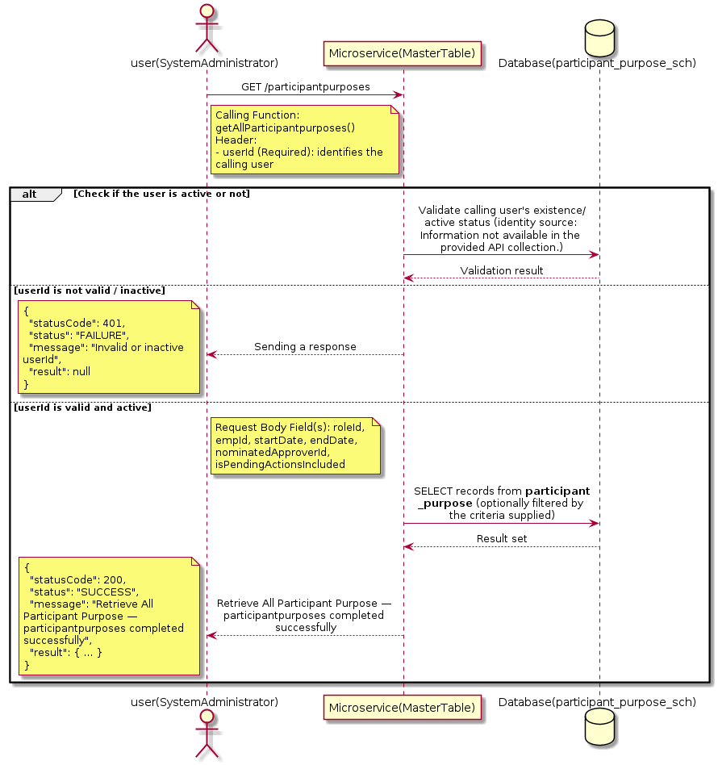

3.12.1.3 API Endpoint
Method | GET
URL | http://localhost:7002/srv2/genie/participantpurposes
Headers | userId: 67 Content-Type: application/json
Authorization | Not present in the captured request. Information not available in the provided API collection.
Content-Type | Content-Type: application/json
Query Parameters | None
Path Variables | None
Request Body:
{
"roleId": "7",
"empId": 3544,
"startDate": "2026-06-01",
"endDate": "2026-07-01",
"nominatedApproverId": 3871,
"isPendingActionsIncluded": "0"
}
Response Body (illustrative — see 3.x.4.5 Success Response for details):
The source Postman collection does not include a captured sample response for this request (the response array is empty). Information not available in the provided API collection. Section 3.12.1.4.5 below presents the response envelope inferred from the standard response wrapper used consistently by this platform's services.

3.12.1.4 Detailed Process Flow

3.12.1.4.1 Request Initiation
The flow begins when System Administrator (or a calling microservice on their behalf) invokes the GET endpoint http://localhost:7002/srv2/genie/participantpurposes. The request must include the mandatory `userId` header used by the Master Table Microservice to identify the calling user for auditing purposes. The request carries a JSON payload in the request body which the Controller binds to its Data Transfer Object (DTO) before any processing begins. At the Controller layer, Spring Boot's request-mapping infrastructure routes the call to the appropriate handler method (`getAllParticipantpurposes`), and Bean Validation annotations (if configured on the DTO) perform structural validation before the request reaches the Service layer. Information not available in the provided API collection. regarding the exact validation annotations used in the source code.

3.12.1.4.2 User Validation
The Master Table Microservice relies on the `userId` header to identify the calling user. Based on the pattern observed consistently across this API collection, the platform's authentication/authorization is expected to be enforced upstream (e.g., by an API Gateway or a shared security filter) using this identifier; the Postman collection does not include an `Authorization` / `Bearer` token header on this request, so the exact authentication mechanism (JWT validation, session lookup, or gateway-level SSO) is Information not available in the provided API collection. Role-based authorization — i.e., confirming that the user identified by `userId` holds a role/permission entitled to perform this operation — is expected to be enforced by the Service layer (see Section 8 – Controller Analysis and Section 14 – Authentication & Authorization), but the specific role/permission checks are Information not available in the provided API collection.

3.12.1.4.3 Business Logic
The Service layer contains no conditional business branching for this operation beyond invoking the Repository to fetch all Participant Purpose records. Depending on the record volume, the Service layer may apply default sorting (e.g., by name or creation order) before returning the list. The key fields exchanged for this operation, as observed in the sample payload, are: `roleId`, `empId`, `startDate`, `endDate`, `nominatedApproverId`, `isPendingActionsIncluded`.

3.12.1.4.4 Database Interaction
The Repository layer (Spring Data JPA) interacts with the underlying relational database that backs the Participant Purpose master table. The primary operation issued is a **SELECT** against the table associated with Participant Purpose. No write operations occur; the query returns all rows that satisfy the entity's default scope (typically active records). The exact table name, column names, primary/foreign key definitions, and JPA repository method signatures are not included in the Postman collection; therefore, precise schema details are information not available in the provided api collection.

3.12.1.4.5 Success Response
Status Code: 200 OK. Sample response envelope (illustrative — the source collection did not capture a sample response for this API):
{
"statusCode": 200,
"status": "SUCCESS",
"message": "Retrieve All Participant Purpose — participantpurposes completed successfully",
"result": [
{
"id": 1,
"name": "Sample Participant Purpose",
"isActive": 1
}
],
"error": null,
"corelationId": "c6f2a1e4-2b3d-4a9e-9f1a-1234567890ab",
"url": null
}

3.12.1.4.6 Conclusion
This API provides a well-defined, single-purpose capability within the Master Table Microservice for retrieve all participant purpose — participantpurposes. The Controller → Service → Repository → Database layering keeps request validation, business rules, and persistence concerns separated, which allows the Participant Purpose master data to be maintained consistently and safely by authorized administrators while remaining available for consumption by every other module that depends on this reference data.

3.12.2 Create Participant Purpose

3.12.2.1 Overview
Purpose: To create a new Participant Purpose master record in the system, allowing administrators to extend the master-data catalogue that other modules (ticketing, workflow, notifications) depend on.
Business Requirement: Business/process owners need a controlled way to add new Participant Purpose values so that the platform's classification, routing, and reporting capabilities can evolve as the organization changes.
Who Uses the API: System Administrator responsible for master-data configuration.
Business Flow: Client sends a POST request with the new Participant Purpose payload → Controller validates the payload (mandatory fields, formats) → Service layer applies business rules (e.g., duplicate-name check) → Repository persists the new record → the created record (with generated identifier) is returned to the Client.

3.12.2.2 Sequence Diagram
The diagram below illustrates the end-to-end interaction for "Create Participant Purpose" across the Client, Controller, Service, Repository, and Database layers.
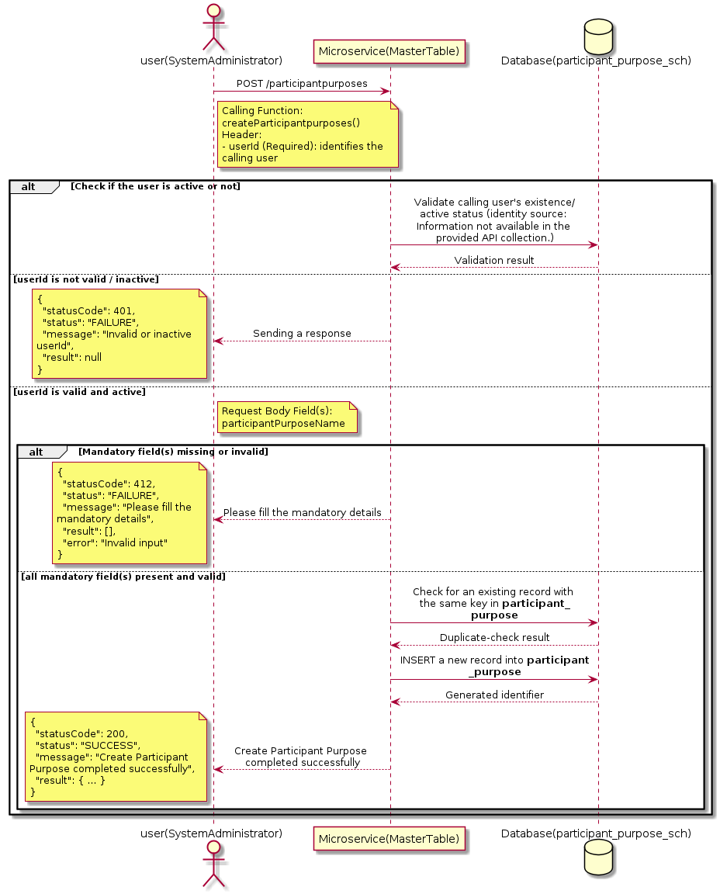

3.12.2.3 API Endpoint
Method | POST
URL | http://localhost:7002/srv2/genie/participantpurposes
Headers | userId: 67 Content-Type: application/json
Authorization | Not present in the captured request. Information not available in the provided API collection.
Content-Type | Content-Type: application/json
Query Parameters | None
Path Variables | None
Request Body:
{
"participantPurposeName": "Approving"
}
Response Body (illustrative — see 3.x.4.5 Success Response for details):
The source Postman collection does not include a captured sample response for this request (the response array is empty). Information not available in the provided API collection. Section 3.12.2.4.5 below presents the response envelope inferred from the standard response wrapper used consistently by this platform's services.

3.12.2.4 Detailed Process Flow

3.12.2.4.1 Request Initiation
The flow begins when System Administrator (or a calling microservice on their behalf) invokes the POST endpoint http://localhost:7002/srv2/genie/participantpurposes. The request must include the mandatory `userId` header used by the Master Table Microservice to identify the calling user for auditing purposes. The request carries a JSON payload in the request body which the Controller binds to its Data Transfer Object (DTO) before any processing begins. At the Controller layer, Spring Boot's request-mapping infrastructure routes the call to the appropriate handler method (`createParticipantpurposes`), and Bean Validation annotations (if configured on the DTO) perform structural validation before the request reaches the Service layer. Information not available in the provided API collection. regarding the exact validation annotations used in the source code.

3.12.2.4.2 User Validation
The Master Table Microservice relies on the `userId` header to identify the calling user. Based on the pattern observed consistently across this API collection, the platform's authentication/authorization is expected to be enforced upstream (e.g., by an API Gateway or a shared security filter) using this identifier; the Postman collection does not include an `Authorization` / `Bearer` token header on this request, so the exact authentication mechanism (JWT validation, session lookup, or gateway-level SSO) is Information not available in the provided API collection. Role-based authorization — i.e., confirming that the user identified by `userId` holds a role/permission entitled to perform this operation — is expected to be enforced by the Service layer (see Section 8 – Controller Analysis and Section 14 – Authentication & Authorization), but the specific role/permission checks are Information not available in the provided API collection.

3.12.2.4.3 Business Logic
The Service layer performs the following: (1) validates that mandatory fields are present and correctly formatted, (2) checks for duplicates (e.g., an existing Participant Purpose with the same name/code), (3) sets system-managed fields (e.g., `isActive = 1`, `createdBy`, timestamps) where applicable, and (4) persists the new record via the Repository. If any validation fails, the Service layer returns a business error rather than proceeding to persistence. The key fields exchanged for this operation, as observed in the sample payload, are: `participantPurposeName`.

3.12.2.4.4 Database Interaction
The Repository layer (Spring Data JPA) interacts with the underlying relational database that backs the Participant Purpose master table. The primary operation issued is a **INSERT** against the table associated with Participant Purpose. A new row is inserted into the master table; if the entity has related child records (as seen in nested request payload arrays), corresponding child-table inserts are performed within the same transaction. The exact table name, column names, primary/foreign key definitions, and JPA repository method signatures are not included in the Postman collection; therefore, precise schema details are information not available in the provided api collection.

3.12.2.4.5 Success Response
Status Code: 200 OK. Sample response envelope (illustrative — the source collection did not capture a sample response for this API):
{
"statusCode": 200,
"status": "SUCCESS",
"message": "Create Participant Purpose completed successfully",
"result": {
"id": 101,
"participantPurposeName": "Approving"
},
"error": null,
"corelationId": "c6f2a1e4-2b3d-4a9e-9f1a-1234567890ab",
"url": null
}

3.12.2.4.6 Conclusion
This API provides a well-defined, single-purpose capability within the Master Table Microservice for create participant purpose. The Controller → Service → Repository → Database layering keeps request validation, business rules, and persistence concerns separated, which allows the Participant Purpose master data to be maintained consistently and safely by authorized administrators while remaining available for consumption by every other module that depends on this reference data.

3.12.3 Update Participant Purpose

3.12.3.1 Overview
Purpose: To update an existing Participant Purpose master record, allowing administrators to correct or evolve master-data attributes without impacting the record's identity/history.
Business Requirement: Master data changes over time (renames, corrections, re-classification); the platform must allow controlled updates while preserving referential integrity for records that already reference this Participant Purpose.
Who Uses the API: System Administrator responsible for maintaining master-data accuracy.
Business Flow: Client sends a PUT/PATCH request with the updated Participant Purpose payload → Controller validates the payload → Service layer fetches the existing record, applies the changes, and re-validates business rules → Repository persists the updated record → the updated record is returned to the Client.

3.12.3.2 Sequence Diagram
The diagram below illustrates the end-to-end interaction for "Update Participant Purpose" across the Client, Controller, Service, Repository, and Database layers.
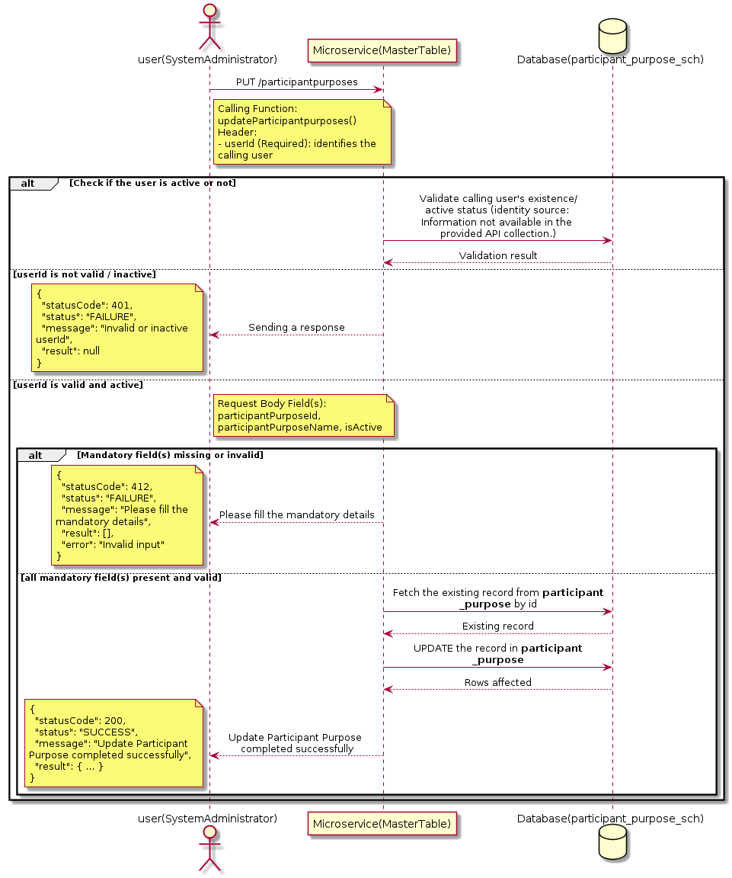

3.12.3.3 API Endpoint
Method | PUT
URL | http://localhost:7002/srv2/genie/participantpurposes
Headers | userId: 67 Content-Type: application/json
Authorization | Not present in the captured request. Information not available in the provided API collection.
Content-Type | Content-Type: application/json
Query Parameters | None
Path Variables | None
Request Body:
{
"participantPurposeId": 1,
"participantPurposeName": "Informing Updated",
"isActive": "1"
}
Response Body (illustrative — see 3.x.4.5 Success Response for details):
The source Postman collection does not include a captured sample response for this request (the response array is empty). Information not available in the provided API collection. Section 3.12.3.4.5 below presents the response envelope inferred from the standard response wrapper used consistently by this platform's services.

3.12.3.4 Detailed Process Flow

3.12.3.4.1 Request Initiation
The flow begins when System Administrator (or a calling microservice on their behalf) invokes the PUT endpoint http://localhost:7002/srv2/genie/participantpurposes. The request must include the mandatory `userId` header used by the Master Table Microservice to identify the calling user for auditing purposes. The request carries a JSON payload in the request body which the Controller binds to its Data Transfer Object (DTO) before any processing begins. At the Controller layer, Spring Boot's request-mapping infrastructure routes the call to the appropriate handler method (`updateParticipantpurposes`), and Bean Validation annotations (if configured on the DTO) perform structural validation before the request reaches the Service layer. Information not available in the provided API collection. regarding the exact validation annotations used in the source code.

3.12.3.4.2 User Validation
The Master Table Microservice relies on the `userId` header to identify the calling user. Based on the pattern observed consistently across this API collection, the platform's authentication/authorization is expected to be enforced upstream (e.g., by an API Gateway or a shared security filter) using this identifier; the Postman collection does not include an `Authorization` / `Bearer` token header on this request, so the exact authentication mechanism (JWT validation, session lookup, or gateway-level SSO) is Information not available in the provided API collection. Role-based authorization — i.e., confirming that the user identified by `userId` holds a role/permission entitled to perform this operation — is expected to be enforced by the Service layer (see Section 8 – Controller Analysis and Section 14 – Authentication & Authorization), but the specific role/permission checks are Information not available in the provided API collection.

3.12.3.4.3 Business Logic
The Service layer fetches the existing Participant Purpose record by its identifier, verifies it exists, applies the incoming changes field by field, re-validates business rules (e.g., uniqueness of a renamed field), and persists the updated entity via the Repository. If the record does not exist, the operation is rejected with a not-found error. The key fields exchanged for this operation, as observed in the sample payload, are: `participantPurposeId`, `participantPurposeName`, `isActive`.

3.12.3.4.4 Database Interaction
The Repository layer (Spring Data JPA) interacts with the underlying relational database that backs the Participant Purpose master table. The primary operation issued is a **UPDATE** against the table associated with Participant Purpose. The existing row is located by primary key and updated; if the entity has related child records, the existing child rows are typically replaced/updated within the same transaction. The exact table name, column names, primary/foreign key definitions, and JPA repository method signatures are not included in the Postman collection; therefore, precise schema details are information not available in the provided api collection.

3.12.3.4.5 Success Response
Status Code: 200 OK. Sample response envelope (illustrative — the source collection did not capture a sample response for this API):
{
"statusCode": 200,
"status": "SUCCESS",
"message": "Update Participant Purpose completed successfully",
"result": {
"id": 1,
"isActive": 1
},
"error": null,
"corelationId": "c6f2a1e4-2b3d-4a9e-9f1a-1234567890ab",
"url": null
}

3.12.3.4.6 Conclusion
This API provides a well-defined, single-purpose capability within the Master Table Microservice for update participant purpose. The Controller → Service → Repository → Database layering keeps request validation, business rules, and persistence concerns separated, which allows the Participant Purpose master data to be maintained consistently and safely by authorized administrators while remaining available for consumption by every other module that depends on this reference data.
3.12.4 Retrieve Participant Purpose by ID

3.12.4.1 Overview
Purpose: To retrieve a single Participant Purpose record identified by its unique identifier, typically used to pre-populate an edit screen or to validate a reference before use.
Business Requirement: Edit screens, validation routines, and cross-service lookups need to resolve a single Participant Purpose record by its identifier reliably and quickly.
Who Uses the API: System Administrator, and internal services validating a Participant Purpose reference (e.g., ticket creation, workflow configuration).
Business Flow: Client sends a GET request with the identifier in the URL path → Controller extracts the path variable → Service layer requests the Repository to fetch the record → if found, the record is mapped and returned; if not found, a 404 is returned.

3.12.4.2 Sequence Diagram
The diagram below illustrates the end-to-end interaction for "Retrieve Participant Purpose by ID" across the Client, Controller, Service, Repository, and Database layers.
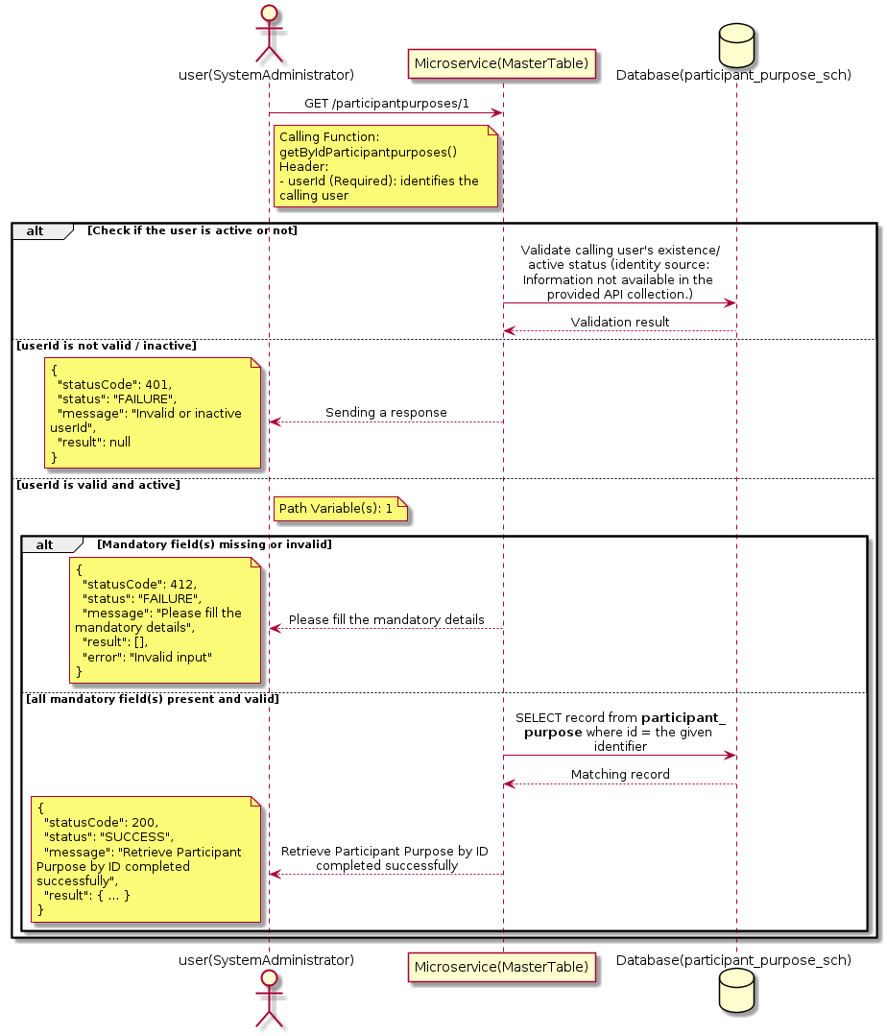

3.12.4.3 API Endpoint
Method | GET
URL | http://localhost:7002/srv2/genie/participantpurposes/1
Headers | userId: 67
Authorization | Not present in the captured request. Information not available in the provided API collection.
Content-Type | application/json (assumed)
Query Parameters | None
Path Variables | 1
Request Body:
Not applicable — this operation does not accept a request body.
Response Body (illustrative — see 3.x.4.5 Success Response for details):
The source Postman collection does not include a captured sample response for this request (the response array is empty). Information not available in the provided API collection. Section 3.12.4.4.5 below presents the response envelope inferred from the standard response wrapper used consistently by this platform's services.

3.12.4.4 Detailed Process Flow

3.12.4.4.1 Request Initiation
The flow begins when System Administrator (or a calling microservice on their behalf) invokes the GET endpoint http://localhost:7002/srv2/genie/participantpurposes/1. The request must include the mandatory `userId` header used by the Master Table Microservice to identify the calling user for auditing purposes. At the Controller layer, Spring Boot's request-mapping infrastructure routes the call to the appropriate handler method (`getByIdParticipantpurposes`), and Bean Validation annotations (if configured on the DTO) perform structural validation before the request reaches the Service layer. Information not available in the provided API collection. regarding the exact validation annotations used in the source code.

3.12.4.4.2 User Validation
The Master Table Microservice relies on the `userId` header to identify the calling user. Based on the pattern observed consistently across this API collection, the platform's authentication/authorization is expected to be enforced upstream (e.g., by an API Gateway or a shared security filter) using this identifier; the Postman collection does not include an `Authorization` / `Bearer` token header on this request, so the exact authentication mechanism (JWT validation, session lookup, or gateway-level SSO) is Information not available in the provided API collection. Role-based authorization — i.e., confirming that the user identified by `userId` holds a role/permission entitled to perform this operation — is expected to be enforced by the Service layer (see Section 8 – Controller Analysis and Section 14 – Authentication & Authorization), but the specific role/permission checks are Information not available in the provided API collection.

3.12.4.4.3 Business Logic
The Service layer forwards the identifier to the Repository. If no record is found for the given identifier, the Service layer raises a not-found condition that the Controller/global exception handler converts into an HTTP 404 response.

3.12.4.4.4 Database Interaction
The Repository layer (Spring Data JPA) interacts with the underlying relational database that backs the Participant Purpose master table. The primary operation issued is a **SELECT** against the table associated with Participant Purpose. No write operations occur; a single-row lookup is performed using the primary key. The exact table name, column names, primary/foreign key definitions, and JPA repository method signatures are not included in the Postman collection; therefore, precise schema details are information not available in the provided api collection.

3.12.4.4.5 Success Response
Status Code: 200 OK. Sample response envelope (illustrative — the source collection did not capture a sample response for this API):
{
"statusCode": 200,
"status": "SUCCESS",
"message": "Retrieve Participant Purpose by ID completed successfully",
"result": {
"id": 1,
"name": "Sample Participant Purpose",
"isActive": 1
},
"error": null,
"corelationId": "c6f2a1e4-2b3d-4a9e-9f1a-1234567890ab",
"url": null
}

3.12.4.4.6 Conclusion
This API provides a well-defined, single-purpose capability within the Master Table Microservice for retrieve participant purpose by id. The Controller → Service → Repository → Database layering keeps request validation, business rules, and persistence concerns separated, which allows the Participant Purpose master data to be maintained consistently and safely by authorized administrators while remaining available for consumption by every other module that depends on this reference data.

3.12.5 Retrieve All Participant Purpose — participantpurposes/evict

3.12.5.1 Overview
Purpose: To retrieve the complete list of Participant Purpose master records configured in the Master Table Microservice, so that consuming screens and downstream services can populate dropdowns, grids, and configuration views.
Business Requirement: Every screen and workflow that references Participant Purpose data (creation forms, filters, reports) needs an authoritative, always-current list of active Participant Purpose values sourced from a single master table rather than being hard-coded.
Who Uses the API: System Administrator, and any internal microservice/UI module that needs to render Participant Purpose options.
Business Flow: Client sends a GET request → Controller delegates to the Service layer → Service layer calls the Repository → Repository queries the Participant Purpose table → the result set is mapped to response DTOs and returned to the Client.

3.12.5.2 Sequence Diagram
The diagram below illustrates the end-to-end interaction for "Retrieve All Participant Purpose — participantpurposes/evict" across the Client, Controller, Service, Repository, and Database layers.
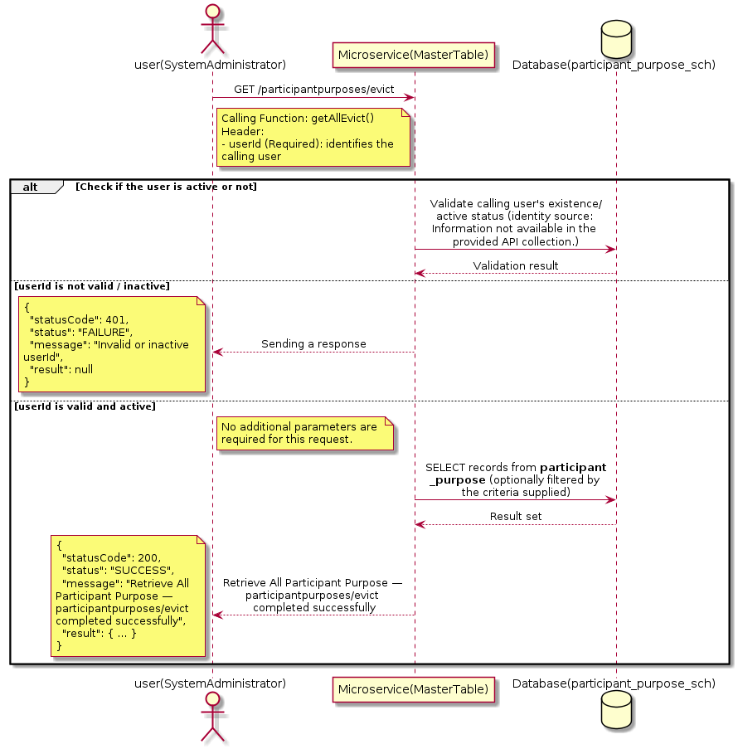

3.12.5.3 API Endpoint
Method | GET
URL | http://localhost:7002/srv2/genie/participantpurposes/evict
Headers | userId: 67
Authorization | Not present in the captured request. Information not available in the provided API collection.
Content-Type | application/json (assumed)
Query Parameters | None
Path Variables | None
Request Body:
Not applicable — this operation does not accept a request body.
Response Body (illustrative — see 3.x.4.5 Success Response for details):
The source Postman collection does not include a captured sample response for this request (the response array is empty). Information not available in the provided API collection. Section 3.12.5.4.5 below presents the response envelope inferred from the standard response wrapper used consistently by this platform's services.

3.12.5.4 Detailed Process Flow

3.12.5.4.1 Request Initiation
The flow begins when System Administrator (or a calling microservice on their behalf) invokes the GET endpoint http://localhost:7002/srv2/genie/participantpurposes/evict. The request must include the mandatory `userId` header used by the Master Table Microservice to identify the calling user for auditing purposes. At the Controller layer, Spring Boot's request-mapping infrastructure routes the call to the appropriate handler method (`getAllEvict`), and Bean Validation annotations (if configured on the DTO) perform structural validation before the request reaches the Service layer. Information not available in the provided API collection. regarding the exact validation annotations used in the source code.

3.12.5.4.2 User Validation
The Master Table Microservice relies on the `userId` header to identify the calling user. Based on the pattern observed consistently across this API collection, the platform's authentication/authorization is expected to be enforced upstream (e.g., by an API Gateway or a shared security filter) using this identifier; the Postman collection does not include an `Authorization` / `Bearer` token header on this request, so the exact authentication mechanism (JWT validation, session lookup, or gateway-level SSO) is Information not available in the provided API collection. Role-based authorization — i.e., confirming that the user identified by `userId` holds a role/permission entitled to perform this operation — is expected to be enforced by the Service layer (see Section 8 – Controller Analysis and Section 14 – Authentication & Authorization), but the specific role/permission checks are Information not available in the provided API collection.

3.12.5.4.3 Business Logic
The Service layer contains no conditional business branching for this operation beyond invoking the Repository to fetch all Participant Purpose records. Depending on the record volume, the Service layer may apply default sorting (e.g., by name or creation order) before returning the list.

3.12.5.4.4 Database Interaction
The Repository layer (Spring Data JPA) interacts with the underlying relational database that backs the Participant Purpose master table. The primary operation issued is a **SELECT** against the table associated with Participant Purpose. No write operations occur; the query returns all rows that satisfy the entity's default scope (typically active records). The exact table name, column names, primary/foreign key definitions, and JPA repository method signatures are not included in the Postman collection; therefore, precise schema details are information not available in the provided api collection.

3.12.5.4.5 Success Response
Status Code: 200 OK. Sample response envelope (illustrative — the source collection did not capture a sample response for this API):
{
"statusCode": 200,
"status": "SUCCESS",
"message": "Retrieve All Participant Purpose — participantpurposes/evict completed successfully",
"result": [
{
"id": 1,
"name": "Sample Participant Purpose",
"isActive": 1
}
],
"error": null,
"corelationId": "c6f2a1e4-2b3d-4a9e-9f1a-1234567890ab",
"url": null
}

3.12.5.4.6 Conclusion
This API provides a well-defined, single-purpose capability within the Master Table Microservice for retrieve all participant purpose — participantpurposes/evict. The Controller → Service → Repository → Database layering keeps request validation, business rules, and persistence concerns separated, which allows the Participant Purpose master data to be maintained consistently and safely by authorized administrators while remaining available for consumption by every other module that depends on this reference data.

3.12.6 Retrieve All Participant Purpose — participantpurposes/all

3.12.6.1 Overview
Purpose: To retrieve the complete list of Participant Purpose master records configured in the Master Table Microservice, so that consuming screens and downstream services can populate dropdowns, grids, and configuration views.
Business Requirement: Every screen and workflow that references Participant Purpose data (creation forms, filters, reports) needs an authoritative, always-current list of active Participant Purpose values sourced from a single master table rather than being hard-coded.
Who Uses the API: System Administrator, and any internal microservice/UI module that needs to render Participant Purpose options.
Business Flow: Client sends a GET request → Controller delegates to the Service layer → Service layer calls the Repository → Repository queries the Participant Purpose table → the result set is mapped to response DTOs and returned to the Client.

3.12.6.2 Sequence Diagram
The diagram below illustrates the end-to-end interaction for "Retrieve All Participant Purpose — participantpurposes/all" across the Client, Controller, Service, Repository, and Database layers.
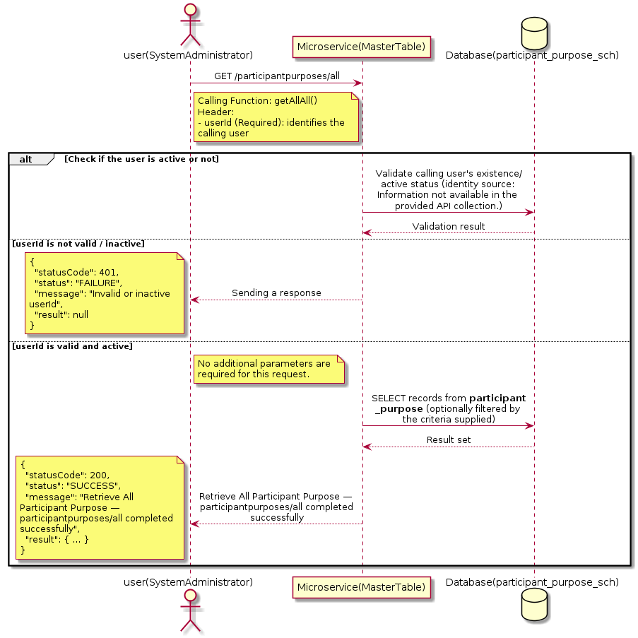

3.12.6.3 API Endpoint
Method | GET
URL | http://localhost:7002/srv2/genie/participantpurposes/all
Headers | userId: 67
Authorization | Not present in the captured request. Information not available in the provided API collection.
Content-Type | application/json (assumed)
Query Parameters | None
Path Variables | None
Request Body:
Not applicable — this operation does not accept a request body.
Response Body (illustrative — see 3.x.4.5 Success Response for details):
The source Postman collection does not include a captured sample response for this request (the response array is empty). Information not available in the provided API collection. Section 3.12.6.4.5 below presents the response envelope inferred from the standard response wrapper used consistently by this platform's services.

3.12.6.4 Detailed Process Flow

3.12.6.4.1 Request Initiation
The flow begins when System Administrator (or a calling microservice on their behalf) invokes the GET endpoint http://localhost:7002/srv2/genie/participantpurposes/all. The request must include the mandatory `userId` header used by the Master Table Microservice to identify the calling user for auditing purposes. At the Controller layer, Spring Boot's request-mapping infrastructure routes the call to the appropriate handler method (`getAllAll`), and Bean Validation annotations (if configured on the DTO) perform structural validation before the request reaches the Service layer. Information not available in the provided API collection. regarding the exact validation annotations used in the source code.

3.12.6.4.2 User Validation
The Master Table Microservice relies on the `userId` header to identify the calling user. Based on the pattern observed consistently across this API collection, the platform's authentication/authorization is expected to be enforced upstream (e.g., by an API Gateway or a shared security filter) using this identifier; the Postman collection does not include an `Authorization` / `Bearer` token header on this request, so the exact authentication mechanism (JWT validation, session lookup, or gateway-level SSO) is Information not available in the provided API collection. Role-based authorization — i.e., confirming that the user identified by `userId` holds a role/permission entitled to perform this operation — is expected to be enforced by the Service layer (see Section 8 – Controller Analysis and Section 14 – Authentication & Authorization), but the specific role/permission checks are Information not available in the provided API collection.

3.12.6.4.3 Business Logic
The Service layer contains no conditional business branching for this operation beyond invoking the Repository to fetch all Participant Purpose records. Depending on the record volume, the Service layer may apply default sorting (e.g., by name or creation order) before returning the list.

3.12.6.4.4 Database Interaction
The Repository layer (Spring Data JPA) interacts with the underlying relational database that backs the Participant Purpose master table. The primary operation issued is a **SELECT** against the table associated with Participant Purpose. No write operations occur; the query returns all rows that satisfy the entity's default scope (typically active records). The exact table name, column names, primary/foreign key definitions, and JPA repository method signatures are not included in the Postman collection; therefore, precise schema details are information not available in the provided api collection.

3.12.6.4.5 Success Response
Status Code: 200 OK. Sample response envelope (illustrative — the source collection did not capture a sample response for this API):
{
"statusCode": 200,
"status": "SUCCESS",
"message": "Retrieve All Participant Purpose — participantpurposes/all completed successfully",
"result": [
{
"id": 1,
"name": "Sample Participant Purpose",
"isActive": 1
}
],
"error": null,
"corelationId": "c6f2a1e4-2b3d-4a9e-9f1a-1234567890ab",
"url": null
}

3.12.6.4.6 Conclusion
This API provides a well-defined, single-purpose capability within the Master Table Microservice for retrieve all participant purpose — participantpurposes/all. The Controller → Service → Repository → Database layering keeps request validation, business rules, and persistence concerns separated, which allows the Participant Purpose master data to be maintained consistently and safely by authorized administrators while remaining available for consumption by every other module that depends on this reference data.

3.13 Permission APIs (Permission)
Maintains the permission master and the mapping of permissions to roles that drives feature-level authorization across the platform.

3.13.1 Retrieve Permission by ID — permissions/{permissionid}

3.13.1.1 Overview
Purpose: To retrieve a single Permission record identified by its unique identifier, typically used to pre-populate an edit screen or to validate a reference before use.
Business Requirement: Edit screens, validation routines, and cross-service lookups need to resolve a single Permission record by its identifier reliably and quickly.
Who Uses the API: System Administrator / Security Administrator, and internal services validating a Permission reference (e.g., ticket creation, workflow configuration).
Business Flow: Client sends a GET request with the identifier in the URL path → Controller extracts the path variable → Service layer requests the Repository to fetch the record → if found, the record is mapped and returned; if not found, a 404 is returned.

3.13.1.2 Sequence Diagram
The diagram below illustrates the end-to-end interaction for "Retrieve Permission by ID — permissions/{permissionid}" across the Client, Controller, Service, Repository, and Database layers.
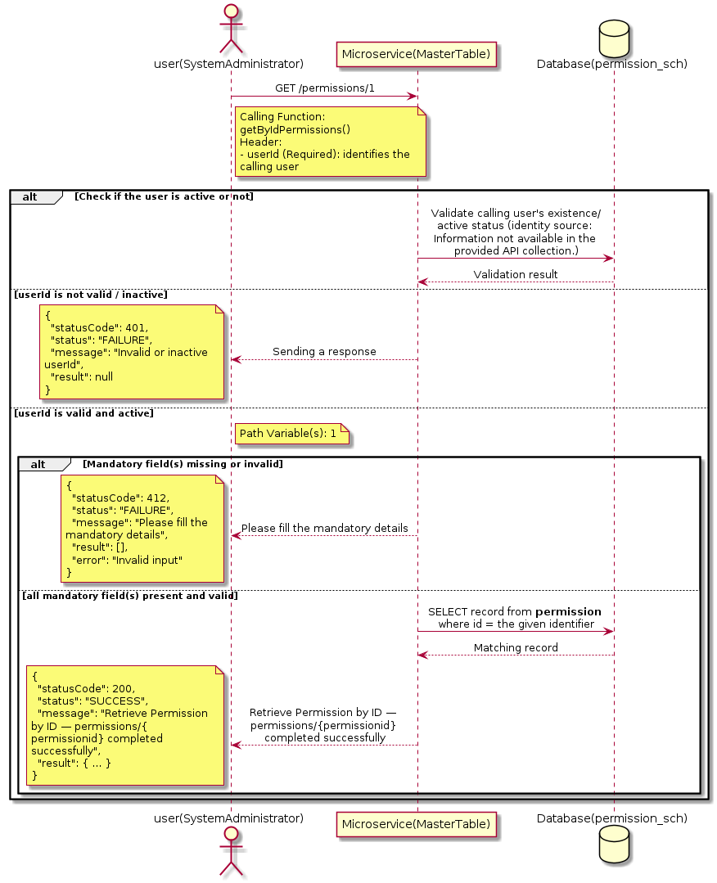

3.13.1.3 API Endpoint
Method | GET
URL | http://localhost:7002/srv2/genie/permissions/1
Headers | userId: 67
Authorization | Not present in the captured request. Information not available in the provided API collection.
Content-Type | application/json (assumed)
Query Parameters | None
Path Variables | 1
Request Body:
Not applicable — this operation does not accept a request body.
Response Body (illustrative — see 3.x.4.5 Success Response for details):
The source Postman collection does not include a captured sample response for this request (the response array is empty). Information not available in the provided API collection. Section 3.13.1.4.5 below presents the response envelope inferred from the standard response wrapper used consistently by this platform's services.

3.13.1.4 Detailed Process Flow

3.13.1.4.1 Request Initiation
The flow begins when System Administrator (or a calling microservice on their behalf) invokes the GET endpoint http://localhost:7002/srv2/genie/permissions/1. The request must include the mandatory `userId` header used by the Master Table Microservice to identify the calling user for auditing purposes. At the Controller layer, Spring Boot's request-mapping infrastructure routes the call to the appropriate handler method (`getByIdPermissions`), and Bean Validation annotations (if configured on the DTO) perform structural validation before the request reaches the Service layer. Information not available in the provided API collection. regarding the exact validation annotations used in the source code.

3.13.1.4.2 User Validation
The Master Table Microservice relies on the `userId` header to identify the calling user. Based on the pattern observed consistently across this API collection, the platform's authentication/authorization is expected to be enforced upstream (e.g., by an API Gateway or a shared security filter) using this identifier; the Postman collection does not include an `Authorization` / `Bearer` token header on this request, so the exact authentication mechanism (JWT validation, session lookup, or gateway-level SSO) is Information not available in the provided API collection. Role-based authorization — i.e., confirming that the user identified by `userId` holds a role/permission entitled to perform this operation — is expected to be enforced by the Service layer (see Section 8 – Controller Analysis and Section 14 – Authentication & Authorization), but the specific role/permission checks are Information not available in the provided API collection.

3.13.1.4.3 Business Logic
The Service layer forwards the identifier to the Repository. If no record is found for the given identifier, the Service layer raises a not-found condition that the Controller/global exception handler converts into an HTTP 404 response.

3.13.1.4.4 Database Interaction
The Repository layer (Spring Data JPA) interacts with the underlying relational database that backs the Permission master table. The primary operation issued is a **SELECT** against the table associated with Permission. No write operations occur; a single-row lookup is performed using the primary key. The exact table name, column names, primary/foreign key definitions, and JPA repository method signatures are not included in the Postman collection; therefore, precise schema details are information not available in the provided api collection.

3.13.1.4.5 Success Response
Status Code: 200 OK. Sample response envelope (illustrative — the source collection did not capture a sample response for this API):
{
"statusCode": 200,
"status": "SUCCESS",
"message": "Retrieve Permission by ID — permissions/{permissionid} completed successfully",
"result": {
"id": 1,
"name": "Sample Permission",
"isActive": 1
},
"error": null,
"corelationId": "c6f2a1e4-2b3d-4a9e-9f1a-1234567890ab",
"url": null
}

3.13.1.4.6 Conclusion
This API provides a well-defined, single-purpose capability within the Master Table Microservice for retrieve permission by id — permissions/{permissionid}. The Controller → Service → Repository → Database layering keeps request validation, business rules, and persistence concerns separated, which allows the Permission master data to be maintained consistently and safely by authorized administrators while remaining available for consumption by every other module that depends on this reference data.

3.13.2 Retrieve Permission by ID — permissions/role/{roleid}

3.13.2.1 Overview
Purpose: To retrieve a single Permission record identified by its unique identifier, typically used to pre-populate an edit screen or to validate a reference before use.
Business Requirement: Edit screens, validation routines, and cross-service lookups need to resolve a single Permission record by its identifier reliably and quickly.
Who Uses the API: System Administrator / Security Administrator, and internal services validating a Permission reference (e.g., ticket creation, workflow configuration).
Business Flow: Client sends a GET request with the identifier in the URL path → Controller extracts the path variable → Service layer requests the Repository to fetch the record → if found, the record is mapped and returned; if not found, a 404 is returned.

3.13.2.2 Sequence Diagram
The diagram below illustrates the end-to-end interaction for "Retrieve Permission by ID — permissions/role/{roleid}" across the Client, Controller, Service, Repository, and Database layers.
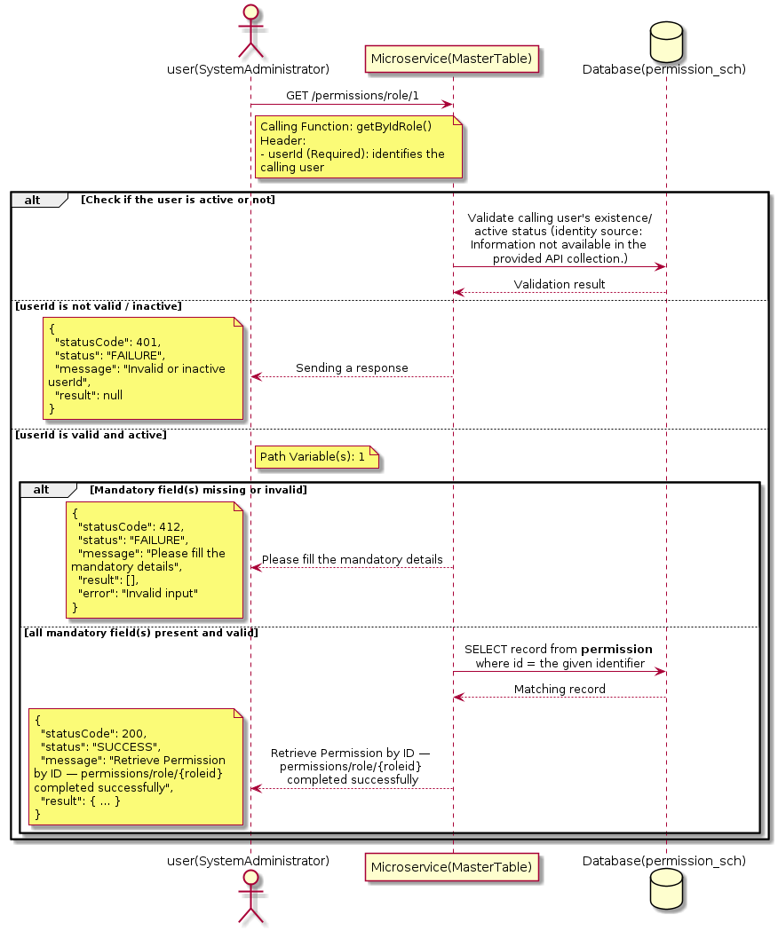

3.13.2.3 API Endpoint
Method | GET
URL | http://localhost:7002/srv2/genie/permissions/role/1
Headers | No custom headers captured in the source collection.
Authorization | Not present in the captured request. Information not available in the provided API collection.
Content-Type | application/json (assumed)
Query Parameters | None
Path Variables | 1
Request Body:
Not applicable — this operation does not accept a request body.
Response Body (illustrative — see 3.x.4.5 Success Response for details):
The source Postman collection does not include a captured sample response for this request (the response array is empty). Information not available in the provided API collection. Section 3.13.2.4.5 below presents the response envelope inferred from the standard response wrapper used consistently by this platform's services.

3.13.2.4 Detailed Process Flow

3.13.2.4.1 Request Initiation
The flow begins when System Administrator (or a calling microservice on their behalf) invokes the GET endpoint http://localhost:7002/srv2/genie/permissions/role/1. The request must include the mandatory `userId` header used by the Master Table Microservice to identify the calling user for auditing purposes. At the Controller layer, Spring Boot's request-mapping infrastructure routes the call to the appropriate handler method (`getByIdRole`), and Bean Validation annotations (if configured on the DTO) perform structural validation before the request reaches the Service layer. Information not available in the provided API collection. regarding the exact validation annotations used in the source code.

3.13.2.4.2 User Validation
The Master Table Microservice relies on the `userId` header to identify the calling user. Based on the pattern observed consistently across this API collection, the platform's authentication/authorization is expected to be enforced upstream (e.g., by an API Gateway or a shared security filter) using this identifier; the Postman collection does not include an `Authorization` / `Bearer` token header on this request, so the exact authentication mechanism (JWT validation, session lookup, or gateway-level SSO) is Information not available in the provided API collection. Role-based authorization — i.e., confirming that the user identified by `userId` holds a role/permission entitled to perform this operation — is expected to be enforced by the Service layer (see Section 8 – Controller Analysis and Section 14 – Authentication & Authorization), but the specific role/permission checks are Information not available in the provided API collection.

3.13.2.4.3 Business Logic
The Service layer forwards the identifier to the Repository. If no record is found for the given identifier, the Service layer raises a not-found condition that the Controller/global exception handler converts into an HTTP 404 response.

3.13.2.4.4 Database Interaction
The Repository layer (Spring Data JPA) interacts with the underlying relational database that backs the Permission master table. The primary operation issued is a **SELECT** against the table associated with Permission. No write operations occur; a single-row lookup is performed using the primary key. The exact table name, column names, primary/foreign key definitions, and JPA repository method signatures are not included in the Postman collection; therefore, precise schema details are information not available in the provided api collection.

3.13.2.4.5 Success Response
Status Code: 200 OK. Sample response envelope (illustrative — the source collection did not capture a sample response for this API):
{
"statusCode": 200,
"status": "SUCCESS",
"message": "Retrieve Permission by ID — permissions/role/{roleid} completed successfully",
"result": {
"id": 1,
"name": "Sample Permission",
"isActive": 1
},
"error": null,
"corelationId": "c6f2a1e4-2b3d-4a9e-9f1a-1234567890ab",
"url": null
}

3.13.2.4.6 Conclusion
This API provides a well-defined, single-purpose capability within the Master Table Microservice for retrieve permission by id — permissions/role/{roleid}. The Controller → Service → Repository → Database layering keeps request validation, business rules, and persistence concerns separated, which allows the Permission master data to be maintained consistently and safely by authorized administrators while remaining available for consumption by every other module that depends on this reference data.

3.13.3 Create Permission

3.13.3.1 Overview
Purpose: To create a new Permission master record in the system, allowing administrators to extend the master-data catalogue that other modules (ticketing, workflow, notifications) depend on.
Business Requirement: Business/process owners need a controlled way to add new Permission values so that the platform's classification, routing, and reporting capabilities can evolve as the organization changes.
Who Uses the API: System Administrator / Security Administrator responsible for master-data configuration.
Business Flow: Client sends a POST request with the new Permission payload → Controller validates the payload (mandatory fields, formats) → Service layer applies business rules (e.g., duplicate-name check) → Repository persists the new record → the created record (with generated identifier) is returned to the Client.

3.13.3.2 Sequence Diagram
The diagram below illustrates the end-to-end interaction for "Create Permission" across the Client, Controller, Service, Repository, and Database layers.
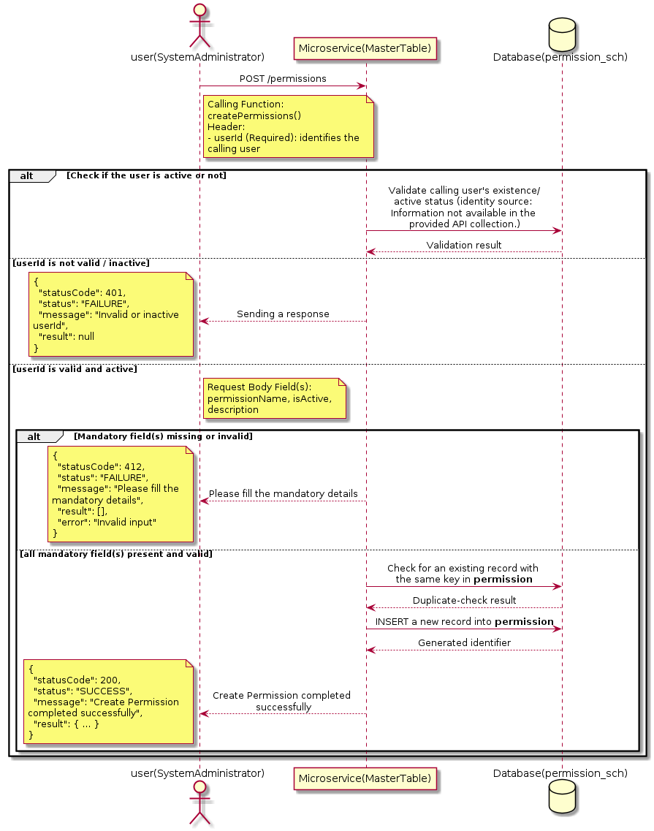

3.13.3.3 API Endpoint
Method | POST
URL | http://localhost:7002/srv2/genie/permissions
Headers | userId: 67 Content-Type: application/json (assumed based on JSON request payload; Information not available in the provided API collection.)
Authorization | Not present in the captured request. Information not available in the provided API collection.
Content-Type | Content-Type: application/json (assumed based on JSON request payload; Information not available in the provided API collection.)
Query Parameters | None
Path Variables | None
Request Body:
{
"permissionName": "Test Permission",
"isActive": "1",
"description": "Test"
}
Response Body (illustrative — see 3.x.4.5 Success Response for details):
The source Postman collection does not include a captured sample response for this request (the response array is empty). Information not available in the provided API collection. Section 3.13.3.4.5 below presents the response envelope inferred from the standard response wrapper used consistently by this platform's services.

3.13.3.4 Detailed Process Flow

3.13.3.4.1 Request Initiation
The flow begins when System Administrator (or a calling microservice on their behalf) invokes the POST endpoint http://localhost:7002/srv2/genie/permissions. The request must include the mandatory `userId` header used by the Master Table Microservice to identify the calling user for auditing purposes. The request carries a JSON payload in the request body which the Controller binds to its Data Transfer Object (DTO) before any processing begins. At the Controller layer, Spring Boot's request-mapping infrastructure routes the call to the appropriate handler method (`createPermissions`), and Bean Validation annotations (if configured on the DTO) perform structural validation before the request reaches the Service layer. Information not available in the provided API collection. regarding the exact validation annotations used in the source code.

3.13.3.4.2 User Validation
The Master Table Microservice relies on the `userId` header to identify the calling user. Based on the pattern observed consistently across this API collection, the platform's authentication/authorization is expected to be enforced upstream (e.g., by an API Gateway or a shared security filter) using this identifier; the Postman collection does not include an `Authorization` / `Bearer` token header on this request, so the exact authentication mechanism (JWT validation, session lookup, or gateway-level SSO) is Information not available in the provided API collection. Role-based authorization — i.e., confirming that the user identified by `userId` holds a role/permission entitled to perform this operation — is expected to be enforced by the Service layer (see Section 8 – Controller Analysis and Section 14 – Authentication & Authorization), but the specific role/permission checks are Information not available in the provided API collection.

3.13.3.4.3 Business Logic
The Service layer performs the following: (1) validates that mandatory fields are present and correctly formatted, (2) checks for duplicates (e.g., an existing Permission with the same name/code), (3) sets system-managed fields (e.g., `isActive = 1`, `createdBy`, timestamps) where applicable, and (4) persists the new record via the Repository. If any validation fails, the Service layer returns a business error rather than proceeding to persistence. The key fields exchanged for this operation, as observed in the sample payload, are: `permissionName`, `isActive`, `description`.

3.13.3.4.4 Database Interaction
The Repository layer (Spring Data JPA) interacts with the underlying relational database that backs the Permission master table. The primary operation issued is a **INSERT** against the table associated with Permission. A new row is inserted into the master table; if the entity has related child records (as seen in nested request payload arrays), corresponding child-table inserts are performed within the same transaction. The exact table name, column names, primary/foreign key definitions, and JPA repository method signatures are not included in the Postman collection; therefore, precise schema details are information not available in the provided api collection.

3.13.3.4.5 Success Response
Status Code: 200 OK. Sample response envelope (illustrative — the source collection did not capture a sample response for this API):
{
"statusCode": 200,
"status": "SUCCESS",
"message": "Create Permission completed successfully",
"result": {
"id": 101,
"permissionName": "Test Permission",
"isActive": "1",
"description": "Test"
},
"error": null,
"corelationId": "c6f2a1e4-2b3d-4a9e-9f1a-1234567890ab",
"url": null
}

3.13.3.4.6 Conclusion
This API provides a well-defined, single-purpose capability within the Master Table Microservice for create permission. The Controller → Service → Repository → Database layering keeps request validation, business rules, and persistence concerns separated, which allows the Permission master data to be maintained consistently and safely by authorized administrators while remaining available for consumption by every other module that depends on this reference data.

3.13.4 Update Permission

3.13.4.1 Overview
Purpose: To update an existing Permission master record, allowing administrators to correct or evolve master-data attributes without impacting the record's identity/history.
Business Requirement: Master data changes over time (renames, corrections, re-classification); the platform must allow controlled updates while preserving referential integrity for records that already reference this Permission.
Who Uses the API: System Administrator / Security Administrator responsible for maintaining master-data accuracy.
Business Flow: Client sends a PUT/PATCH request with the updated Permission payload → Controller validates the payload → Service layer fetches the existing record, applies the changes, and re-validates business rules → Repository persists the updated record → the updated record is returned to the Client.

3.13.4.2 Sequence Diagram
The diagram below illustrates the end-to-end interaction for "Update Permission" across the Client, Controller, Service, Repository, and Database layers.
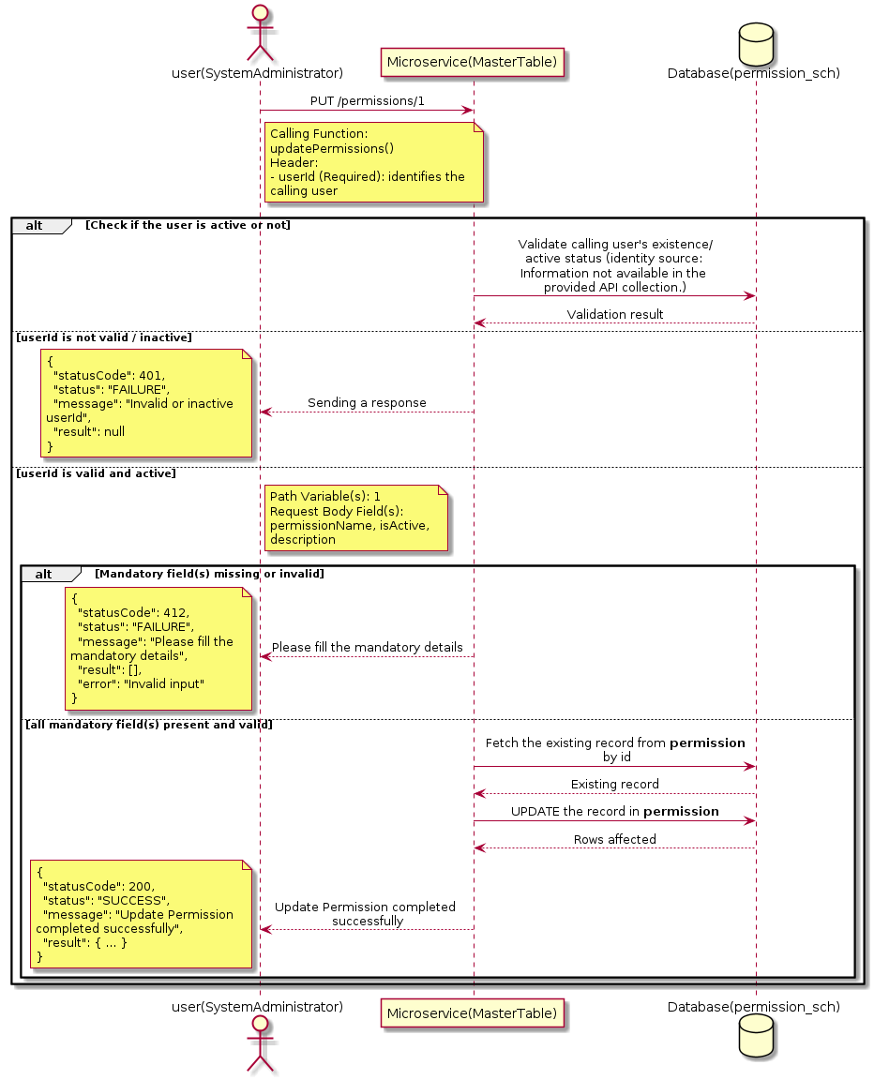

3.13.4.3 API Endpoint
Method | PUT
URL | http://localhost:7002/srv2/genie/permissions/1
Headers | userId: 67 Content-Type: application/json (assumed based on JSON request payload; Information not available in the provided API collection.)
Authorization | Not present in the captured request. Information not available in the provided API collection.
Content-Type | Content-Type: application/json (assumed based on JSON request payload; Information not available in the provided API collection.)
Query Parameters | None
Path Variables | 1
Request Body:
{
"permissionName": "Test Permission",
"isActive": "1",
"description": "Test"
}
Response Body (illustrative — see 3.x.4.5 Success Response for details):
The source Postman collection does not include a captured sample response for this request (the response array is empty). Information not available in the provided API collection. Section 3.13.4.4.5 below presents the response envelope inferred from the standard response wrapper used consistently by this platform's services.

3.13.4.4 Detailed Process Flow

3.13.4.4.1 Request Initiation
The flow begins when System Administrator (or a calling microservice on their behalf) invokes the PUT endpoint http://localhost:7002/srv2/genie/permissions/1. The request must include the mandatory `userId` header used by the Master Table Microservice to identify the calling user for auditing purposes. The request carries a JSON payload in the request body which the Controller binds to its Data Transfer Object (DTO) before any processing begins. At the Controller layer, Spring Boot's request-mapping infrastructure routes the call to the appropriate handler method (`updatePermissions`), and Bean Validation annotations (if configured on the DTO) perform structural validation before the request reaches the Service layer. Information not available in the provided API collection. regarding the exact validation annotations used in the source code.

3.13.4.4.2 User Validation
The Master Table Microservice relies on the `userId` header to identify the calling user. Based on the pattern observed consistently across this API collection, the platform's authentication/authorization is expected to be enforced upstream (e.g., by an API Gateway or a shared security filter) using this identifier; the Postman collection does not include an `Authorization` / `Bearer` token header on this request, so the exact authentication mechanism (JWT validation, session lookup, or gateway-level SSO) is Information not available in the provided API collection. Role-based authorization — i.e., confirming that the user identified by `userId` holds a role/permission entitled to perform this operation — is expected to be enforced by the Service layer (see Section 8 – Controller Analysis and Section 14 – Authentication & Authorization), but the specific role/permission checks are Information not available in the provided API collection.

3.13.4.4.3 Business Logic
The Service layer fetches the existing Permission record by its identifier, verifies it exists, applies the incoming changes field by field, re-validates business rules (e.g., uniqueness of a renamed field), and persists the updated entity via the Repository. If the record does not exist, the operation is rejected with a not-found error. The key fields exchanged for this operation, as observed in the sample payload, are: `permissionName`, `isActive`, `description`.

3.13.4.4.4 Database Interaction
The Repository layer (Spring Data JPA) interacts with the underlying relational database that backs the Permission master table. The primary operation issued is a **UPDATE** against the table associated with Permission. The existing row is located by primary key and updated; if the entity has related child records, the existing child rows are typically replaced/updated within the same transaction. The exact table name, column names, primary/foreign key definitions, and JPA repository method signatures are not included in the Postman collection; therefore, precise schema details are information not available in the provided api collection.

3.13.4.4.5 Success Response
Status Code: 200 OK. Sample response envelope (illustrative — the source collection did not capture a sample response for this API):
{
"statusCode": 200,
"status": "SUCCESS",
"message": "Update Permission completed successfully",
"result": {
"id": "1",
"isActive": 1
},
"error": null,
"corelationId": "c6f2a1e4-2b3d-4a9e-9f1a-1234567890ab",
"url": null
}

3.13.4.4.6 Conclusion
This API provides a well-defined, single-purpose capability within the Master Table Microservice for update permission. The Controller → Service → Repository → Database layering keeps request validation, business rules, and persistence concerns separated, which allows the Permission master data to be maintained consistently and safely by authorized administrators while remaining available for consumption by every other module that depends on this reference data.
3.13.5 Search / List Permission

3.13.5.1 Overview
Purpose: To search and list Permission records based on a search payload (e.g., free-text search or structured criteria), supporting list/grid screens that need paginated or filtered master data.
Business Requirement: List/search screens for Permission configuration need server-side search so that administrators can locate specific records in large master tables without scanning the full data set.
Who Uses the API: System Administrator / Security Administrator operating the Permission configuration/list screen.
Business Flow: Client sends a POST request with a search payload → Controller validates the payload → Service layer constructs the search/query logic → Repository executes the search against the Permission table → matching records are returned to the Client.

3.13.5.2 Sequence Diagram
The diagram below illustrates the end-to-end interaction for "Search / List Permission" across the Client, Controller, Service, Repository, and Database layers.
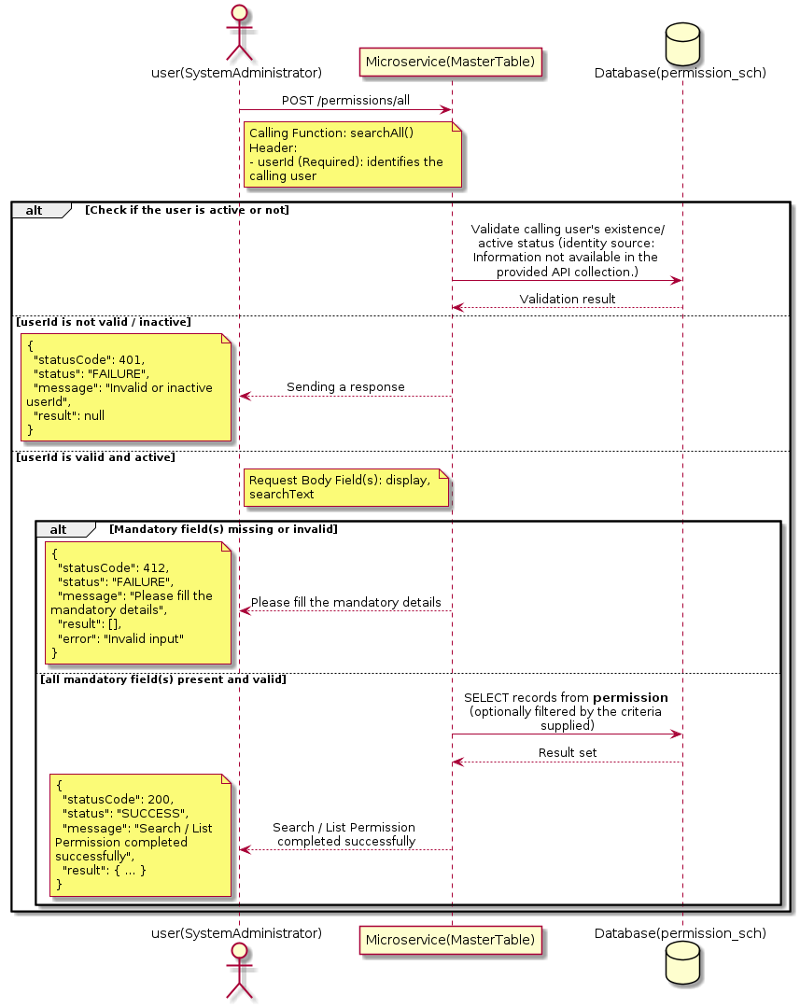

3.13.5.3 API Endpoint
Method | POST
URL | http://localhost:7002/srv2/genie/permissions/all
Headers | userId: 67 Content-Type: application/json (assumed based on JSON request payload; Information not available in the provided API collection.)
Authorization | Not present in the captured request. Information not available in the provided API collection.
Content-Type | Content-Type: application/json (assumed based on JSON request payload; Information not available in the provided API collection.)
Query Parameters | None
Path Variables | None
Request Body:
{
"display": "",
"searchText": ""
}
Response Body (illustrative — see 3.x.4.5 Success Response for details):
The source Postman collection does not include a captured sample response for this request (the response array is empty). Information not available in the provided API collection. Section 3.13.5.4.5 below presents the response envelope inferred from the standard response wrapper used consistently by this platform's services.

3.13.5.4 Detailed Process Flow

3.13.5.4.1 Request Initiation
The flow begins when System Administrator (or a calling microservice on their behalf) invokes the POST endpoint http://localhost:7002/srv2/genie/permissions/all. The request must include the mandatory `userId` header used by the Master Table Microservice to identify the calling user for auditing purposes. The request carries a JSON payload in the request body which the Controller binds to its Data Transfer Object (DTO) before any processing begins. At the Controller layer, Spring Boot's request-mapping infrastructure routes the call to the appropriate handler method (`searchAll`), and Bean Validation annotations (if configured on the DTO) perform structural validation before the request reaches the Service layer. Information not available in the provided API collection. regarding the exact validation annotations used in the source code.

3.13.5.4.2 User Validation
The Master Table Microservice relies on the `userId` header to identify the calling user. Based on the pattern observed consistently across this API collection, the platform's authentication/authorization is expected to be enforced upstream (e.g., by an API Gateway or a shared security filter) using this identifier; the Postman collection does not include an `Authorization` / `Bearer` token header on this request, so the exact authentication mechanism (JWT validation, session lookup, or gateway-level SSO) is Information not available in the provided API collection. Role-based authorization — i.e., confirming that the user identified by `userId` holds a role/permission entitled to perform this operation — is expected to be enforced by the Service layer (see Section 8 – Controller Analysis and Section 14 – Authentication & Authorization), but the specific role/permission checks are Information not available in the provided API collection.

3.13.5.4.3 Business Logic
The Service layer evaluates the search payload; if the search text/criteria is empty, the operation typically behaves like a full list (all Permission records); if populated, it is used to build a case-insensitive `LIKE`/contains predicate against the relevant column(s). The key fields exchanged for this operation, as observed in the sample payload, are: `display`, `searchText`.

3.13.5.4.4 Database Interaction
The Repository layer (Spring Data JPA) interacts with the underlying relational database that backs the Permission master table. The primary operation issued is a **SELECT** against the table associated with Permission. No write operations occur; the search is typically implemented using a JPA derived query method or a native/JPQL query with `LIKE` predicates. The exact table name, column names, primary/foreign key definitions, and JPA repository method signatures are not included in the Postman collection; therefore, precise schema details are information not available in the provided api collection.

3.13.5.4.5 Success Response
Status Code: 200 OK. Sample response envelope (illustrative — the source collection did not capture a sample response for this API):
{
"statusCode": 200,
"status": "SUCCESS",
"message": "Search / List Permission completed successfully",
"result": [
{
"id": 1,
"name": "Sample Permission",
"isActive": 1
}
],
"error": null,
"corelationId": "c6f2a1e4-2b3d-4a9e-9f1a-1234567890ab",
"url": null
}

3.13.5.4.6 Conclusion
This API provides a well-defined, single-purpose capability within the Master Table Microservice for search / list permission. The Controller → Service → Repository → Database layering keeps request validation, business rules, and persistence concerns separated, which allows the Permission master data to be maintained consistently and safely by authorized administrators while remaining available for consumption by every other module that depends on this reference data.
3.13.6 Enable / Disable Permission

3.13.6.1 Overview
Purpose: To enable or disable (soft-delete) a Permission master record, allowing administrators to retire a record from active use while preserving it for historical/audit purposes.
Business Requirement: Rather than physically deleting a Permission record (which could break referential integrity with historical tickets/records that reference it), the business requires a reversible enable/disable mechanism.
Who Uses the API: System Administrator / Security Administrator responsible for activating/deactivating configuration values.
Business Flow: Client sends a request carrying the Permission identifier and the desired active/inactive flag → Controller validates the payload → Service layer fetches the record and flips its status flag → Repository persists the change → the updated status is returned to the Client.

3.13.6.2 Sequence Diagram
The diagram below illustrates the end-to-end interaction for "Enable / Disable Permission" across the Client, Controller, Service, Repository, and Database layers.
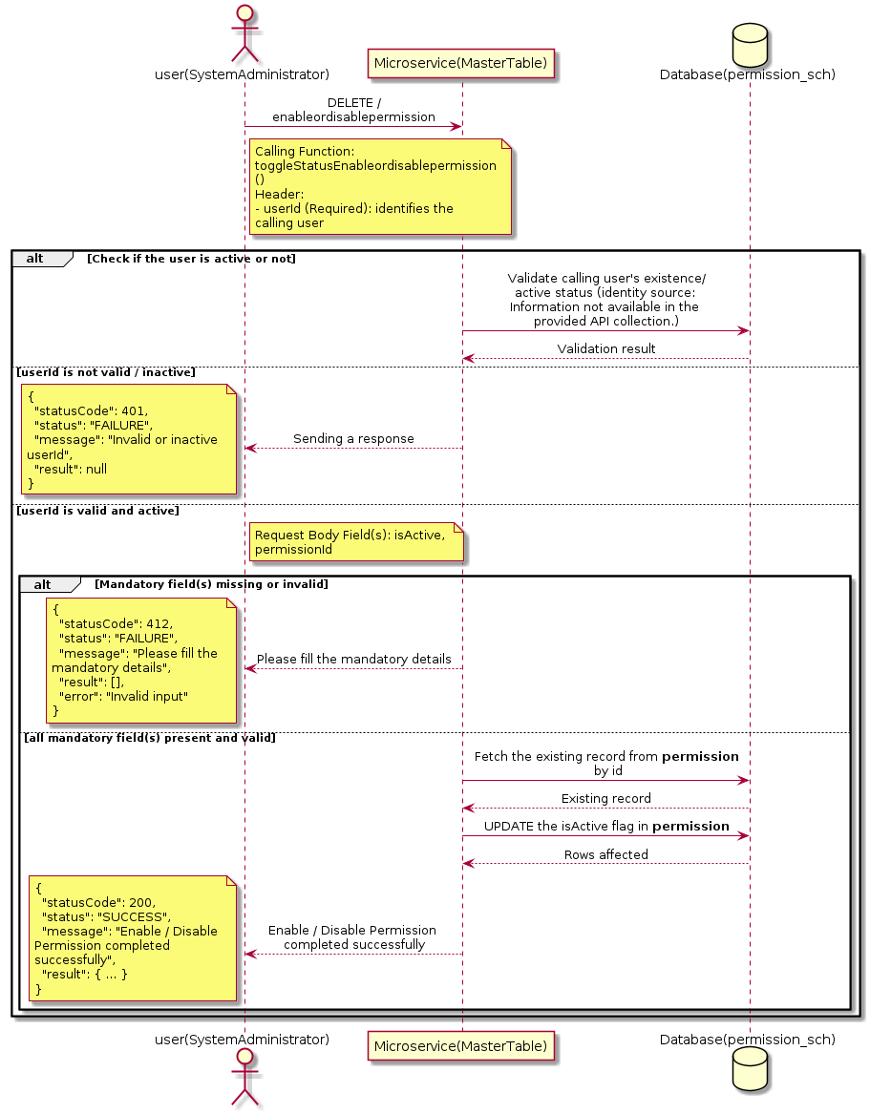

3.13.6.3 API Endpoint
Method | DELETE
URL | http://localhost:7002/srv2/genie/enableordisablepermission
Headers | userId: 67
Authorization | Not present in the captured request. Information not available in the provided API collection.
Content-Type | application/json (assumed)
Query Parameters | None
Path Variables | None
Request Body:
{
"isActive": "1",
"permissionId": 1
}
Response Body (illustrative — see 3.x.4.5 Success Response for details):
The source Postman collection does not include a captured sample response for this request (the response array is empty). Information not available in the provided API collection. Section 3.13.6.4.5 below presents the response envelope inferred from the standard response wrapper used consistently by this platform's services.

3.13.6.4 Detailed Process Flow

3.13.6.4.1 Request Initiation
The flow begins when System Administrator (or a calling microservice on their behalf) invokes the DELETE endpoint http://localhost:7002/srv2/genie/enableordisablepermission. The request must include the mandatory `userId` header used by the Master Table Microservice to identify the calling user for auditing purposes. The request carries a JSON payload in the request body which the Controller binds to its Data Transfer Object (DTO) before any processing begins. At the Controller layer, Spring Boot's request-mapping infrastructure routes the call to the appropriate handler method (`toggleStatusEnableordisablepermission`), and Bean Validation annotations (if configured on the DTO) perform structural validation before the request reaches the Service layer. Information not available in the provided API collection. regarding the exact validation annotations used in the source code.

3.13.6.4.2 User Validation
The Master Table Microservice relies on the `userId` header to identify the calling user. Based on the pattern observed consistently across this API collection, the platform's authentication/authorization is expected to be enforced upstream (e.g., by an API Gateway or a shared security filter) using this identifier; the Postman collection does not include an `Authorization` / `Bearer` token header on this request, so the exact authentication mechanism (JWT validation, session lookup, or gateway-level SSO) is Information not available in the provided API collection. Role-based authorization — i.e., confirming that the user identified by `userId` holds a role/permission entitled to perform this operation — is expected to be enforced by the Service layer (see Section 8 – Controller Analysis and Section 14 – Authentication & Authorization), but the specific role/permission checks are Information not available in the provided API collection.

3.13.6.4.3 Business Logic
The Service layer fetches the existing Permission record by its identifier and flips the `isActive` flag to the value supplied in the request. No other attributes of the record are modified by this operation. The key fields exchanged for this operation, as observed in the sample payload, are: `isActive`, `permissionId`.

3.13.6.4.4 Database Interaction
The Repository layer (Spring Data JPA) interacts with the underlying relational database that backs the Permission master table. The primary operation issued is a **UPDATE** against the table associated with Permission. Only the `is_active` (status) column is updated for the row identified by the primary key; all other columns remain unchanged. The exact table name, column names, primary/foreign key definitions, and JPA repository method signatures are not included in the Postman collection; therefore, precise schema details are information not available in the provided api collection.

3.13.6.4.5 Success Response
Status Code: 200 OK. Sample response envelope (illustrative — the source collection did not capture a sample response for this API):
{
"statusCode": 200,
"status": "SUCCESS",
"message": "Enable / Disable Permission completed successfully",
"result": {
"id": 1,
"isActive": 1
},
"error": null,
"corelationId": "c6f2a1e4-2b3d-4a9e-9f1a-1234567890ab",
"url": null
}

3.13.6.4.6 Conclusion
This API provides a well-defined, single-purpose capability within the Master Table Microservice for enable / disable permission. The Controller → Service → Repository → Database layering keeps request validation, business rules, and persistence concerns separated, which allows the Permission master data to be maintained consistently and safely by authorized administrators while remaining available for consumption by every other module that depends on this reference data.
3.14 Priority Type APIs (Priority APIs)
Maintains the priority-type master used to classify and later derive the priority of tickets/requests.

3.14.1 Retrieve All Priority Type — prioritytypes/all

3.14.1.1 Overview
Purpose: To retrieve the complete list of Priority Type master records configured in the Master Table Microservice, so that consuming screens and downstream services can populate dropdowns, grids, and configuration views.
Business Requirement: Every screen and workflow that references Priority Type data (creation forms, filters, reports) needs an authoritative, always-current list of active Priority Type values sourced from a single master table rather than being hard-coded.
Who Uses the API: System Administrator, and any internal microservice/UI module that needs to render Priority Type options.
Business Flow: Client sends a GET request → Controller delegates to the Service layer → Service layer calls the Repository → Repository queries the Priority Type table → the result set is mapped to response DTOs and returned to the Client.

3.14.1.2 Sequence Diagram
The diagram below illustrates the end-to-end interaction for "Retrieve All Priority Type — prioritytypes/all" across the Client, Controller, Service, Repository, and Database layers.
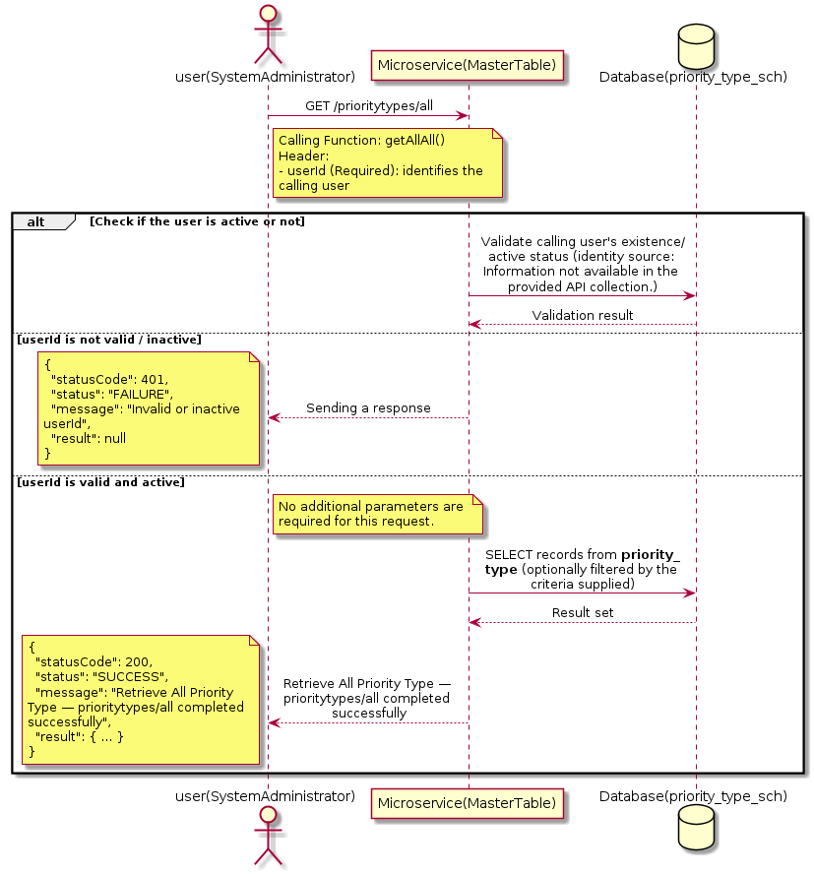

3.14.1.3 API Endpoint
Method | GET
URL | http://localhost:7002/srv2/genie/prioritytypes/all
Headers | userId: 67
Authorization | Not present in the captured request. Information not available in the provided API collection.
Content-Type | application/json (assumed)
Query Parameters | None
Path Variables | None
Request Body:
Not applicable — this operation does not accept a request body.
Response Body (illustrative — see 3.x.4.5 Success Response for details):
The source Postman collection does not include a captured sample response for this request (the response array is empty). Information not available in the provided API collection. Section 3.14.1.4.5 below presents the response envelope inferred from the standard response wrapper used consistently by this platform's services.

3.14.1.4 Detailed Process Flow

3.14.1.4.1 Request Initiation
The flow begins when System Administrator (or a calling microservice on their behalf) invokes the GET endpoint http://localhost:7002/srv2/genie/prioritytypes/all. The request must include the mandatory `userId` header used by the Master Table Microservice to identify the calling user for auditing purposes. At the Controller layer, Spring Boot's request-mapping infrastructure routes the call to the appropriate handler method (`getAllAll`), and Bean Validation annotations (if configured on the DTO) perform structural validation before the request reaches the Service layer. Information not available in the provided API collection. regarding the exact validation annotations used in the source code.

3.14.1.4.2 User Validation
The Master Table Microservice relies on the `userId` header to identify the calling user. Based on the pattern observed consistently across this API collection, the platform's authentication/authorization is expected to be enforced upstream (e.g., by an API Gateway or a shared security filter) using this identifier; the Postman collection does not include an `Authorization` / `Bearer` token header on this request, so the exact authentication mechanism (JWT validation, session lookup, or gateway-level SSO) is Information not available in the provided API collection. Role-based authorization — i.e., confirming that the user identified by `userId` holds a role/permission entitled to perform this operation — is expected to be enforced by the Service layer (see Section 8 – Controller Analysis and Section 14 – Authentication & Authorization), but the specific role/permission checks are Information not available in the provided API collection.

3.14.1.4.3 Business Logic
The Service layer contains no conditional business branching for this operation beyond invoking the Repository to fetch all Priority Type records. Depending on the record volume, the Service layer may apply default sorting (e.g., by name or creation order) before returning the list.

3.14.1.4.4 Database Interaction
The Repository layer (Spring Data JPA) interacts with the underlying relational database that backs the Priority Type master table. The primary operation issued is a **SELECT** against the table associated with Priority Type. No write operations occur; the query returns all rows that satisfy the entity's default scope (typically active records). The exact table name, column names, primary/foreign key definitions, and JPA repository method signatures are not included in the Postman collection; therefore, precise schema details are information not available in the provided api collection.

3.14.1.4.5 Success Response
Status Code: 200 OK. Sample response envelope (illustrative — the source collection did not capture a sample response for this API):
{
"statusCode": 200,
"status": "SUCCESS",
"message": "Retrieve All Priority Type — prioritytypes/all completed successfully",
"result": [
{
"id": 1,
"name": "Sample Priority Type",
"isActive": 1
}
],
"error": null,
"corelationId": "c6f2a1e4-2b3d-4a9e-9f1a-1234567890ab",
"url": null
}

3.14.1.4.6 Conclusion
This API provides a well-defined, single-purpose capability within the Master Table Microservice for retrieve all priority type — prioritytypes/all. The Controller → Service → Repository → Database layering keeps request validation, business rules, and persistence concerns separated, which allows the Priority Type master data to be maintained consistently and safely by authorized administrators while remaining available for consumption by every other module that depends on this reference data.

3.14.2 Retrieve All Priority Type — prioritytypes

3.14.2.1 Overview
Purpose: To retrieve the complete list of Priority Type master records configured in the Master Table Microservice, so that consuming screens and downstream services can populate dropdowns, grids, and configuration views.
Business Requirement: Every screen and workflow that references Priority Type data (creation forms, filters, reports) needs an authoritative, always-current list of active Priority Type values sourced from a single master table rather than being hard-coded.
Who Uses the API: System Administrator, and any internal microservice/UI module that needs to render Priority Type options.
Business Flow: Client sends a GET request → Controller delegates to the Service layer → Service layer calls the Repository → Repository queries the Priority Type table → the result set is mapped to response DTOs and returned to the Client.

3.14.2.2 Sequence Diagram
The diagram below illustrates the end-to-end interaction for "Retrieve All Priority Type — prioritytypes" across the Client, Controller, Service, Repository, and Database layers.
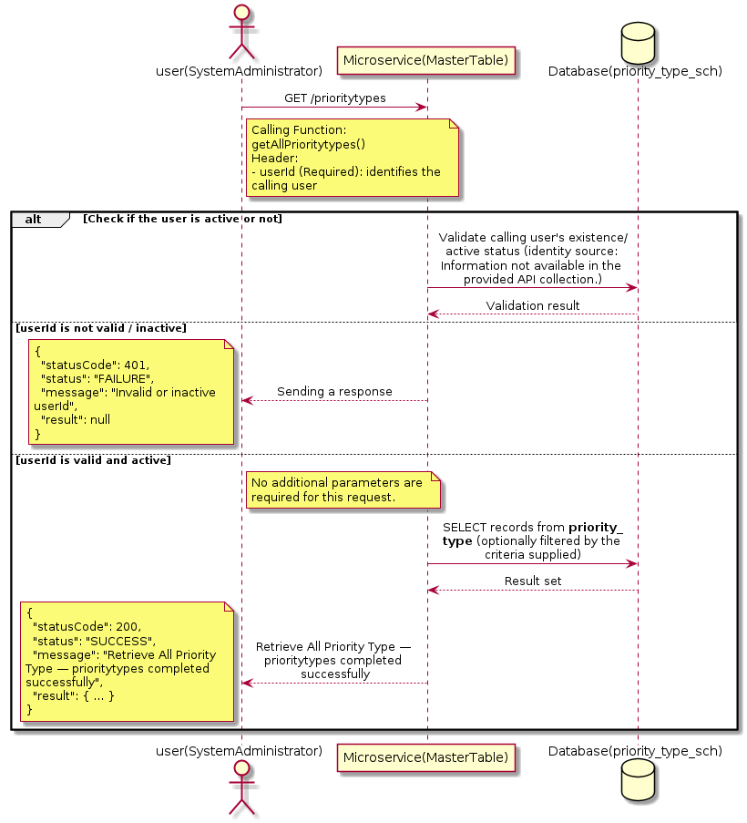

3.14.2.3 API Endpoint
Method | GET
URL | http://localhost:7002/srv2/genie/prioritytypes
Headers | userId: 67
Authorization | Not present in the captured request. Information not available in the provided API collection.
Content-Type | application/json (assumed)
Query Parameters | None
Path Variables | None
Request Body:
Not applicable — this operation does not accept a request body.
Response Body (illustrative — see 3.x.4.5 Success Response for details):
The source Postman collection does not include a captured sample response for this request (the response array is empty). Information not available in the provided API collection. Section 3.14.2.4.5 below presents the response envelope inferred from the standard response wrapper used consistently by this platform's services.

3.14.2.4 Detailed Process Flow

3.14.2.4.1 Request Initiation
The flow begins when System Administrator (or a calling microservice on their behalf) invokes the GET endpoint http://localhost:7002/srv2/genie/prioritytypes. The request must include the mandatory `userId` header used by the Master Table Microservice to identify the calling user for auditing purposes. At the Controller layer, Spring Boot's request-mapping infrastructure routes the call to the appropriate handler method (`getAllPrioritytypes`), and Bean Validation annotations (if configured on the DTO) perform structural validation before the request reaches the Service layer. Information not available in the provided API collection. regarding the exact validation annotations used in the source code.

3.14.2.4.2 User Validation
The Master Table Microservice relies on the `userId` header to identify the calling user. Based on the pattern observed consistently across this API collection, the platform's authentication/authorization is expected to be enforced upstream (e.g., by an API Gateway or a shared security filter) using this identifier; the Postman collection does not include an `Authorization` / `Bearer` token header on this request, so the exact authentication mechanism (JWT validation, session lookup, or gateway-level SSO) is Information not available in the provided API collection. Role-based authorization — i.e., confirming that the user identified by `userId` holds a role/permission entitled to perform this operation — is expected to be enforced by the Service layer (see Section 8 – Controller Analysis and Section 14 – Authentication & Authorization), but the specific role/permission checks are Information not available in the provided API collection.

3.14.2.4.3 Business Logic
The Service layer contains no conditional business branching for this operation beyond invoking the Repository to fetch all Priority Type records. Depending on the record volume, the Service layer may apply default sorting (e.g., by name or creation order) before returning the list.

3.14.2.4.4 Database Interaction
The Repository layer (Spring Data JPA) interacts with the underlying relational database that backs the Priority Type master table. The primary operation issued is a **SELECT** against the table associated with Priority Type. No write operations occur; the query returns all rows that satisfy the entity's default scope (typically active records). The exact table name, column names, primary/foreign key definitions, and JPA repository method signatures are not included in the Postman collection; therefore, precise schema details are information not available in the provided api collection.

3.14.2.4.5 Success Response
Status Code: 200 OK. Sample response envelope (illustrative — the source collection did not capture a sample response for this API):
{
"statusCode": 200,
"status": "SUCCESS",
"message": "Retrieve All Priority Type — prioritytypes completed successfully",
"result": [
{
"id": 1,
"name": "Sample Priority Type",
"isActive": 1
}
],
"error": null,
"corelationId": "c6f2a1e4-2b3d-4a9e-9f1a-1234567890ab",
"url": null
}

3.14.2.4.6 Conclusion
This API provides a well-defined, single-purpose capability within the Master Table Microservice for retrieve all priority type — prioritytypes. The Controller → Service → Repository → Database layering keeps request validation, business rules, and persistence concerns separated, which allows the Priority Type master data to be maintained consistently and safely by authorized administrators while remaining available for consumption by every other module that depends on this reference data.

3.14.3 Create Priority Type

3.14.3.1 Overview
Purpose: To create a new Priority Type master record in the system, allowing administrators to extend the master-data catalogue that other modules (ticketing, workflow, notifications) depend on.
Business Requirement: Business/process owners need a controlled way to add new Priority Type values so that the platform's classification, routing, and reporting capabilities can evolve as the organization changes.
Who Uses the API: System Administrator responsible for master-data configuration.
Business Flow: Client sends a POST request with the new Priority Type payload → Controller validates the payload (mandatory fields, formats) → Service layer applies business rules (e.g., duplicate-name check) → Repository persists the new record → the created record (with generated identifier) is returned to the Client.

3.14.3.2 Sequence Diagram
The diagram below illustrates the end-to-end interaction for "Create Priority Type" across the Client, Controller, Service, Repository, and Database layers.
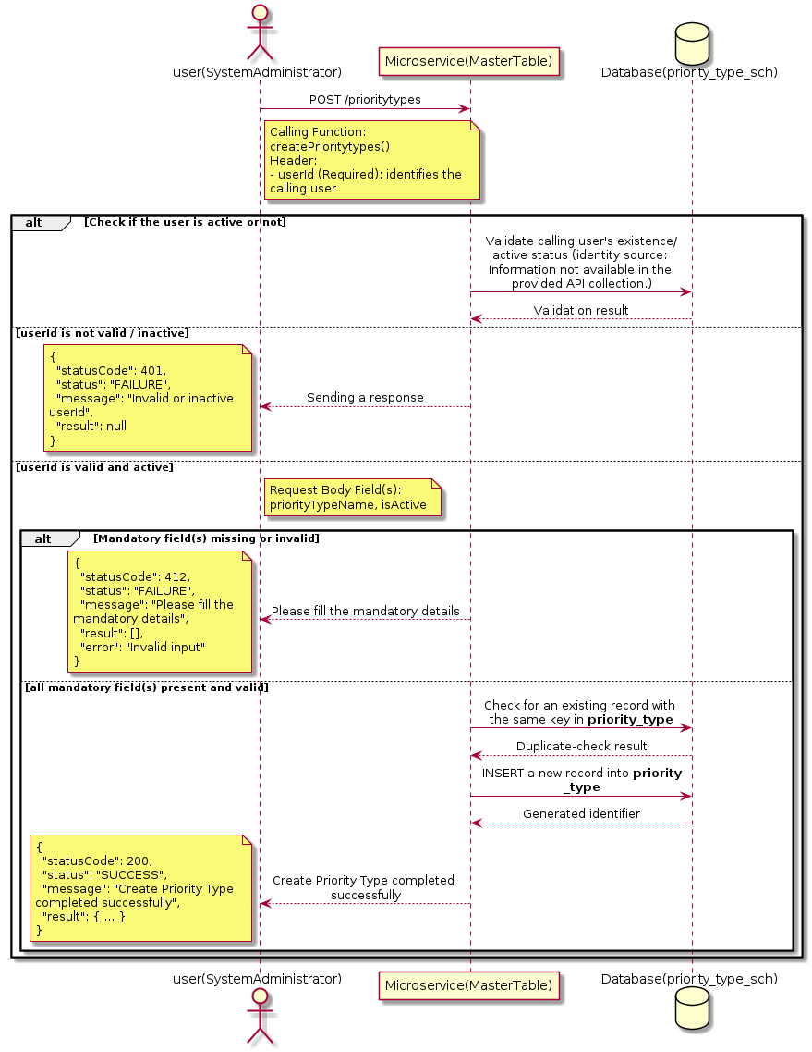

3.14.3.3 API Endpoint
Method | POST
URL | http://localhost:7002/srv2/genie/prioritytypes
Headers | userId: 67 Content-Type: application/json (assumed based on JSON request payload; Information not available in the provided API collection.)
Authorization | Not present in the captured request. Information not available in the provided API collection.
Content-Type | Content-Type: application/json (assumed based on JSON request payload; Information not available in the provided API collection.)
Query Parameters | None
Path Variables | None
Request Body:
{
"priorityTypeName": "TestPriority1",
"isActive": "1"
}
Response Body (illustrative — see 3.x.4.5 Success Response for details):
The source Postman collection does not include a captured sample response for this request (the response array is empty). Information not available in the provided API collection. Section 3.14.3.4.5 below presents the response envelope inferred from the standard response wrapper used consistently by this platform's services.

3.14.3.4 Detailed Process Flow

3.14.3.4.1 Request Initiation
The flow begins when System Administrator (or a calling microservice on their behalf) invokes the POST endpoint http://localhost:7002/srv2/genie/prioritytypes. The request must include the mandatory `userId` header used by the Master Table Microservice to identify the calling user for auditing purposes. The request carries a JSON payload in the request body which the Controller binds to its Data Transfer Object (DTO) before any processing begins. At the Controller layer, Spring Boot's request-mapping infrastructure routes the call to the appropriate handler method (`createPrioritytypes`), and Bean Validation annotations (if configured on the DTO) perform structural validation before the request reaches the Service layer. Information not available in the provided API collection. regarding the exact validation annotations used in the source code.

3.14.3.4.2 User Validation
The Master Table Microservice relies on the `userId` header to identify the calling user. Based on the pattern observed consistently across this API collection, the platform's authentication/authorization is expected to be enforced upstream (e.g., by an API Gateway or a shared security filter) using this identifier; the Postman collection does not include an `Authorization` / `Bearer` token header on this request, so the exact authentication mechanism (JWT validation, session lookup, or gateway-level SSO) is Information not available in the provided API collection. Role-based authorization — i.e., confirming that the user identified by `userId` holds a role/permission entitled to perform this operation — is expected to be enforced by the Service layer (see Section 8 – Controller Analysis and Section 14 – Authentication & Authorization), but the specific role/permission checks are Information not available in the provided API collection.

3.14.3.4.3 Business Logic
The Service layer performs the following: (1) validates that mandatory fields are present and correctly formatted, (2) checks for duplicates (e.g., an existing Priority Type with the same name/code), (3) sets system-managed fields (e.g., `isActive = 1`, `createdBy`, timestamps) where applicable, and (4) persists the new record via the Repository. If any validation fails, the Service layer returns a business error rather than proceeding to persistence. The key fields exchanged for this operation, as observed in the sample payload, are: `priorityTypeName`, `isActive`.

3.14.3.4.4 Database Interaction
The Repository layer (Spring Data JPA) interacts with the underlying relational database that backs the Priority Type master table. The primary operation issued is a **INSERT** against the table associated with Priority Type. A new row is inserted into the master table; if the entity has related child records (as seen in nested request payload arrays), corresponding child-table inserts are performed within the same transaction. The exact table name, column names, primary/foreign key definitions, and JPA repository method signatures are not included in the Postman collection; therefore, precise schema details are information not available in the provided api collection.

3.14.3.4.5 Success Response
Status Code: 200 OK. Sample response envelope (illustrative — the source collection did not capture a sample response for this API):
{
"statusCode": 200,
"status": "SUCCESS",
"message": "Create Priority Type completed successfully",
"result": {
"id": 101,
"priorityTypeName": "TestPriority1",
"isActive": "1"
},
"error": null,
"corelationId": "c6f2a1e4-2b3d-4a9e-9f1a-1234567890ab",
"url": null
}

3.14.3.4.6 Conclusion
This API provides a well-defined, single-purpose capability within the Master Table Microservice for create priority type. The Controller → Service → Repository → Database layering keeps request validation, business rules, and persistence concerns separated, which allows the Priority Type master data to be maintained consistently and safely by authorized administrators while remaining available for consumption by every other module that depends on this reference data.
3.14.4 Retrieve Priority Type by ID

3.14.4.1 Overview
Purpose: To retrieve a single Priority Type record identified by its unique identifier, typically used to pre-populate an edit screen or to validate a reference before use.
Business Requirement: Edit screens, validation routines, and cross-service lookups need to resolve a single Priority Type record by its identifier reliably and quickly.
Who Uses the API: System Administrator, and internal services validating a Priority Type reference (e.g., ticket creation, workflow configuration).
Business Flow: Client sends a GET request with the identifier in the URL path → Controller extracts the path variable → Service layer requests the Repository to fetch the record → if found, the record is mapped and returned; if not found, a 404 is returned.

3.14.4.2 Sequence Diagram
The diagram below illustrates the end-to-end interaction for "Retrieve Priority Type by ID" across the Client, Controller, Service, Repository, and Database layers.
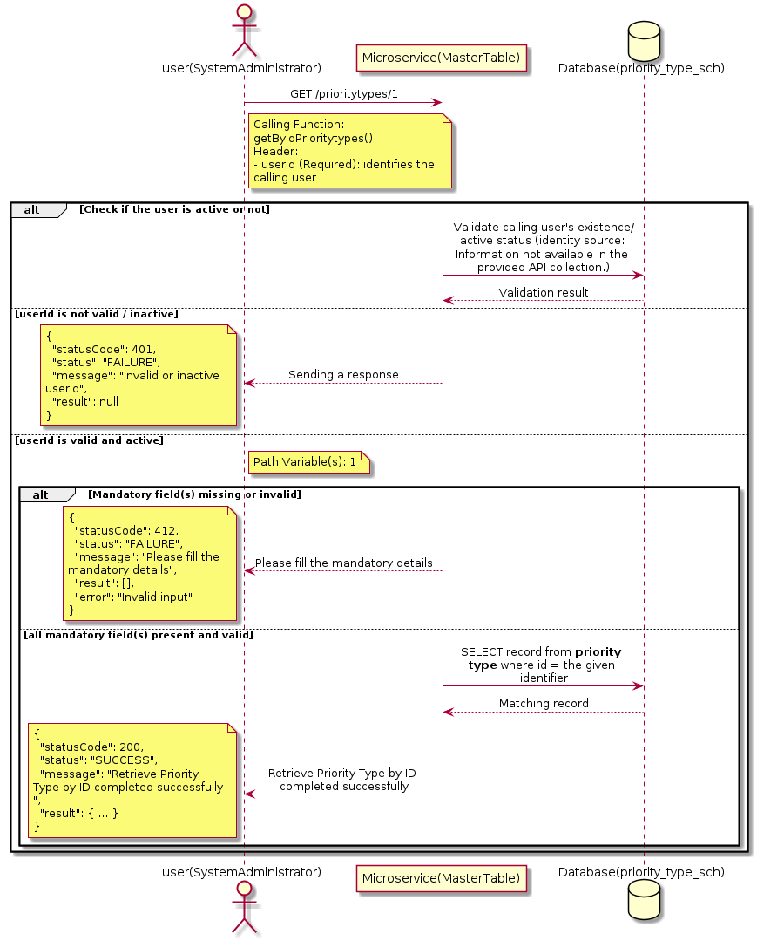

3.14.4.3 API Endpoint
Method | GET
URL | http://localhost:7002/srv2/genie/prioritytypes/1
Headers | userId: 67
Authorization | Not present in the captured request. Information not available in the provided API collection.
Content-Type | application/json (assumed)
Query Parameters | None
Path Variables | 1
Request Body:
Not applicable — this operation does not accept a request body.
Response Body (illustrative — see 3.x.4.5 Success Response for details):
The source Postman collection does not include a captured sample response for this request (the response array is empty). Information not available in the provided API collection. Section 3.14.4.4.5 below presents the response envelope inferred from the standard response wrapper used consistently by this platform's services.

3.14.4.4 Detailed Process Flow

3.14.4.4.1 Request Initiation
The flow begins when System Administrator (or a calling microservice on their behalf) invokes the GET endpoint http://localhost:7002/srv2/genie/prioritytypes/1. The request must include the mandatory `userId` header used by the Master Table Microservice to identify the calling user for auditing purposes. At the Controller layer, Spring Boot's request-mapping infrastructure routes the call to the appropriate handler method (`getByIdPrioritytypes`), and Bean Validation annotations (if configured on the DTO) perform structural validation before the request reaches the Service layer. Information not available in the provided API collection. regarding the exact validation annotations used in the source code.

3.14.4.4.2 User Validation
The Master Table Microservice relies on the `userId` header to identify the calling user. Based on the pattern observed consistently across this API collection, the platform's authentication/authorization is expected to be enforced upstream (e.g., by an API Gateway or a shared security filter) using this identifier; the Postman collection does not include an `Authorization` / `Bearer` token header on this request, so the exact authentication mechanism (JWT validation, session lookup, or gateway-level SSO) is Information not available in the provided API collection. Role-based authorization — i.e., confirming that the user identified by `userId` holds a role/permission entitled to perform this operation — is expected to be enforced by the Service layer (see Section 8 – Controller Analysis and Section 14 – Authentication & Authorization), but the specific role/permission checks are Information not available in the provided API collection.

3.14.4.4.3 Business Logic
The Service layer forwards the identifier to the Repository. If no record is found for the given identifier, the Service layer raises a not-found condition that the Controller/global exception handler converts into an HTTP 404 response.

3.14.4.4.4 Database Interaction
The Repository layer (Spring Data JPA) interacts with the underlying relational database that backs the Priority Type master table. The primary operation issued is a **SELECT** against the table associated with Priority Type. No write operations occur; a single-row lookup is performed using the primary key. The exact table name, column names, primary/foreign key definitions, and JPA repository method signatures are not included in the Postman collection; therefore, precise schema details are information not available in the provided api collection.

3.14.4.4.5 Success Response
Status Code: 200 OK. Sample response envelope (illustrative — the source collection did not capture a sample response for this API):
{
"statusCode": 200,
"status": "SUCCESS",
"message": "Retrieve Priority Type by ID completed successfully",
"result": {
"id": 1,
"name": "Sample Priority Type",
"isActive": 1
},
"error": null,
"corelationId": "c6f2a1e4-2b3d-4a9e-9f1a-1234567890ab",
"url": null
}

3.14.4.4.6 Conclusion
This API provides a well-defined, single-purpose capability within the Master Table Microservice for retrieve priority type by id. The Controller → Service → Repository → Database layering keeps request validation, business rules, and persistence concerns separated, which allows the Priority Type master data to be maintained consistently and safely by authorized administrators while remaining available for consumption by every other module that depends on this reference data.

3.14.5 Update Priority Type

3.14.5.1 Overview
Purpose: To update an existing Priority Type master record, allowing administrators to correct or evolve master-data attributes without impacting the record's identity/history.
Business Requirement: Master data changes over time (renames, corrections, re-classification); the platform must allow controlled updates while preserving referential integrity for records that already reference this Priority Type.
Who Uses the API: System Administrator responsible for maintaining master-data accuracy.
Business Flow: Client sends a PUT/PATCH request with the updated Priority Type payload → Controller validates the payload → Service layer fetches the existing record, applies the changes, and re-validates business rules → Repository persists the updated record → the updated record is returned to the Client.

3.14.5.2 Sequence Diagram
The diagram below illustrates the end-to-end interaction for "Update Priority Type" across the Client, Controller, Service, Repository, and Database layers.
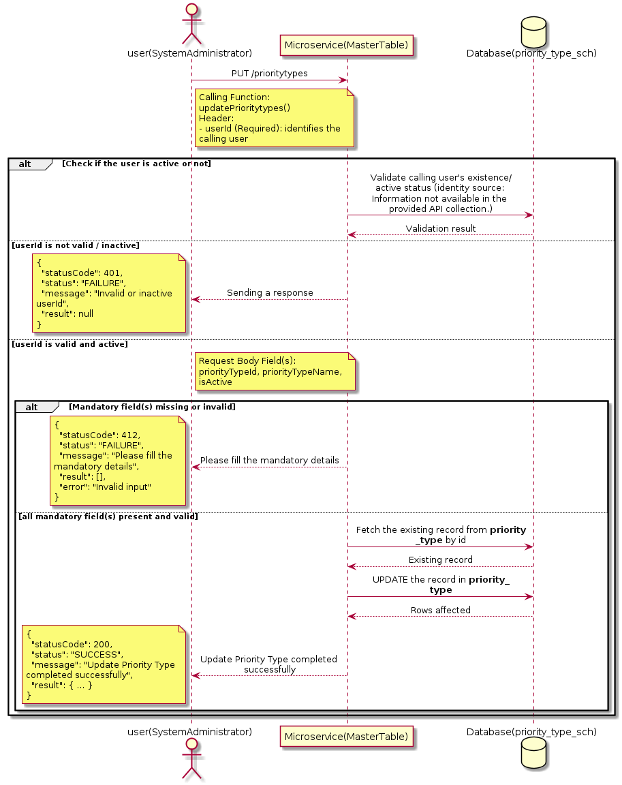

3.14.5.3 API Endpoint
Method | PUT
URL | http://localhost:7002/srv2/genie/prioritytypes
Headers | userId: 67 Content-Type: application/json (assumed based on JSON request payload; Information not available in the provided API collection.)
Authorization | Not present in the captured request. Information not available in the provided API collection.
Content-Type | Content-Type: application/json (assumed based on JSON request payload; Information not available in the provided API collection.)
Query Parameters | None
Path Variables | None
Request Body:
{
"priorityTypeId": 1,
"priorityTypeName": "UpdatedPriority",
"isActive": "1"
}
Response Body (illustrative — see 3.x.4.5 Success Response for details):
The source Postman collection does not include a captured sample response for this request (the response array is empty). Information not available in the provided API collection. Section 3.14.5.4.5 below presents the response envelope inferred from the standard response wrapper used consistently by this platform's services.

3.14.5.4 Detailed Process Flow

3.14.5.4.1 Request Initiation
The flow begins when System Administrator (or a calling microservice on their behalf) invokes the PUT endpoint http://localhost:7002/srv2/genie/prioritytypes. The request must include the mandatory `userId` header used by the Master Table Microservice to identify the calling user for auditing purposes. The request carries a JSON payload in the request body which the Controller binds to its Data Transfer Object (DTO) before any processing begins. At the Controller layer, Spring Boot's request-mapping infrastructure routes the call to the appropriate handler method (`updatePrioritytypes`), and Bean Validation annotations (if configured on the DTO) perform structural validation before the request reaches the Service layer. Information not available in the provided API collection. regarding the exact validation annotations used in the source code.

3.14.5.4.2 User Validation
The Master Table Microservice relies on the `userId` header to identify the calling user. Based on the pattern observed consistently across this API collection, the platform's authentication/authorization is expected to be enforced upstream (e.g., by an API Gateway or a shared security filter) using this identifier; the Postman collection does not include an `Authorization` / `Bearer` token header on this request, so the exact authentication mechanism (JWT validation, session lookup, or gateway-level SSO) is Information not available in the provided API collection. Role-based authorization — i.e., confirming that the user identified by `userId` holds a role/permission entitled to perform this operation — is expected to be enforced by the Service layer (see Section 8 – Controller Analysis and Section 14 – Authentication & Authorization), but the specific role/permission checks are Information not available in the provided API collection.

3.14.5.4.3 Business Logic
The Service layer fetches the existing Priority Type record by its identifier, verifies it exists, applies the incoming changes field by field, re-validates business rules (e.g., uniqueness of a renamed field), and persists the updated entity via the Repository. If the record does not exist, the operation is rejected with a not-found error. The key fields exchanged for this operation, as observed in the sample payload, are: `priorityTypeId`, `priorityTypeName`, `isActive`.

3.14.5.4.4 Database Interaction
The Repository layer (Spring Data JPA) interacts with the underlying relational database that backs the Priority Type master table. The primary operation issued is a **UPDATE** against the table associated with Priority Type. The existing row is located by primary key and updated; if the entity has related child records, the existing child rows are typically replaced/updated within the same transaction. The exact table name, column names, primary/foreign key definitions, and JPA repository method signatures are not included in the Postman collection; therefore, precise schema details are information not available in the provided api collection.

3.14.5.4.5 Success Response
Status Code: 200 OK. Sample response envelope (illustrative — the source collection did not capture a sample response for this API):
{
"statusCode": 200,
"status": "SUCCESS",
"message": "Update Priority Type completed successfully",
"result": {
"id": 1,
"isActive": 1
},
"error": null,
"corelationId": "c6f2a1e4-2b3d-4a9e-9f1a-1234567890ab",
"url": null
}

3.14.5.4.6 Conclusion
This API provides a well-defined, single-purpose capability within the Master Table Microservice for update priority type. The Controller → Service → Repository → Database layering keeps request validation, business rules, and persistence concerns separated, which allows the Priority Type master data to be maintained consistently and safely by authorized administrators while remaining available for consumption by every other module that depends on this reference data.

3.15 Reason APIs (Reason APIs)
Provides the reason categories and sub-categories used to qualify actions such as ticket closure, rejection, or status change.

3.15.1 Retrieve All Reason

3.15.1.1 Overview
Purpose: To retrieve the complete list of Reason master records configured in the Master Table Microservice, so that consuming screens and downstream services can populate dropdowns, grids, and configuration views.
Business Requirement: Every screen and workflow that references Reason data (creation forms, filters, reports) needs an authoritative, always-current list of active Reason values sourced from a single master table rather than being hard-coded.
Who Uses the API: System Administrator, and any internal microservice/UI module that needs to render Reason options.
Business Flow: Client sends a GET request → Controller delegates to the Service layer → Service layer calls the Repository → Repository queries the Reason table → the result set is mapped to response DTOs and returned to the Client.

3.15.1.2 Sequence Diagram
The diagram below illustrates the end-to-end interaction for "Retrieve All Reason" across the Client, Controller, Service, Repository, and Database layers.
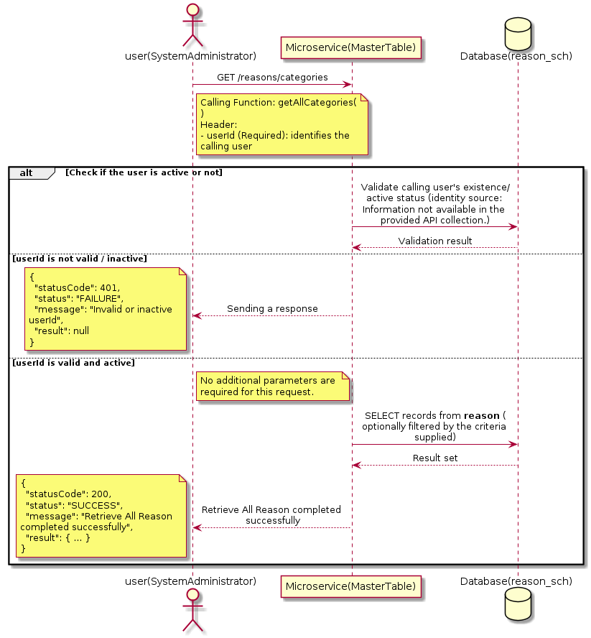

3.15.1.3 API Endpoint
Method | GET
URL | http://localhost:7002/srv2/genie/reasons/categories
Headers | userId: 67
Authorization | Not present in the captured request. Information not available in the provided API collection.
Content-Type | application/json (assumed)
Query Parameters | None
Path Variables | None
Request Body:
Not applicable — this operation does not accept a request body.
Response Body (illustrative — see 3.x.4.5 Success Response for details):
The source Postman collection does not include a captured sample response for this request (the response array is empty). Information not available in the provided API collection. Section 3.15.1.4.5 below presents the response envelope inferred from the standard response wrapper used consistently by this platform's services.

3.15.1.4 Detailed Process Flow

3.15.1.4.1 Request Initiation
The flow begins when System Administrator (or a calling microservice on their behalf) invokes the GET endpoint http://localhost:7002/srv2/genie/reasons/categories. The request must include the mandatory `userId` header used by the Master Table Microservice to identify the calling user for auditing purposes. At the Controller layer, Spring Boot's request-mapping infrastructure routes the call to the appropriate handler method (`getAllCategories`), and Bean Validation annotations (if configured on the DTO) perform structural validation before the request reaches the Service layer. Information not available in the provided API collection. regarding the exact validation annotations used in the source code.

3.15.1.4.2 User Validation
The Master Table Microservice relies on the `userId` header to identify the calling user. Based on the pattern observed consistently across this API collection, the platform's authentication/authorization is expected to be enforced upstream (e.g., by an API Gateway or a shared security filter) using this identifier; the Postman collection does not include an `Authorization` / `Bearer` token header on this request, so the exact authentication mechanism (JWT validation, session lookup, or gateway-level SSO) is Information not available in the provided API collection. Role-based authorization — i.e., confirming that the user identified by `userId` holds a role/permission entitled to perform this operation — is expected to be enforced by the Service layer (see Section 8 – Controller Analysis and Section 14 – Authentication & Authorization), but the specific role/permission checks are Information not available in the provided API collection.

3.15.1.4.3 Business Logic
The Service layer contains no conditional business branching for this operation beyond invoking the Repository to fetch all Reason records. Depending on the record volume, the Service layer may apply default sorting (e.g., by name or creation order) before returning the list.

3.15.1.4.4 Database Interaction
The Repository layer (Spring Data JPA) interacts with the underlying relational database that backs the Reason master table. The primary operation issued is a **SELECT** against the table associated with Reason. No write operations occur; the query returns all rows that satisfy the entity's default scope (typically active records). The exact table name, column names, primary/foreign key definitions, and JPA repository method signatures are not included in the Postman collection; therefore, precise schema details are information not available in the provided api collection.

3.15.1.4.5 Success Response
Status Code: 200 OK. Sample response envelope (illustrative — the source collection did not capture a sample response for this API):
{
"statusCode": 200,
"status": "SUCCESS",
"message": "Retrieve All Reason completed successfully",
"result": [
{
"id": 1,
"name": "Sample Reason",
"isActive": 1
}
],
"error": null,
"corelationId": "c6f2a1e4-2b3d-4a9e-9f1a-1234567890ab",
"url": null
}

3.15.1.4.6 Conclusion
This API provides a well-defined, single-purpose capability within the Master Table Microservice for retrieve all reason. The Controller → Service → Repository → Database layering keeps request validation, business rules, and persistence concerns separated, which allows the Reason master data to be maintained consistently and safely by authorized administrators while remaining available for consumption by every other module that depends on this reference data.

3.15.2 Retrieve Reason (Filtered)

3.15.2.1 Overview
Purpose: To retrieve Reason master records that match the supplied filter/query criteria, allowing consumers to narrow down large master-data sets to a relevant subset.
Business Requirement: Administrators and downstream services need the ability to narrow Reason records by specific criteria rather than retrieving and filtering the full data set on the client side.
Who Uses the API: System Administrator, and reporting/search screens that filter by Reason.
Business Flow: Client sends a GET request with query parameters → Controller parses and validates the parameters → Service layer builds the filter criteria → Repository executes the filtered query against the Reason table → the filtered result is returned to the Client.

3.15.2.2 Sequence Diagram
The diagram below illustrates the end-to-end interaction for "Retrieve Reason (Filtered)" across the Client, Controller, Service, Repository, and Database layers.
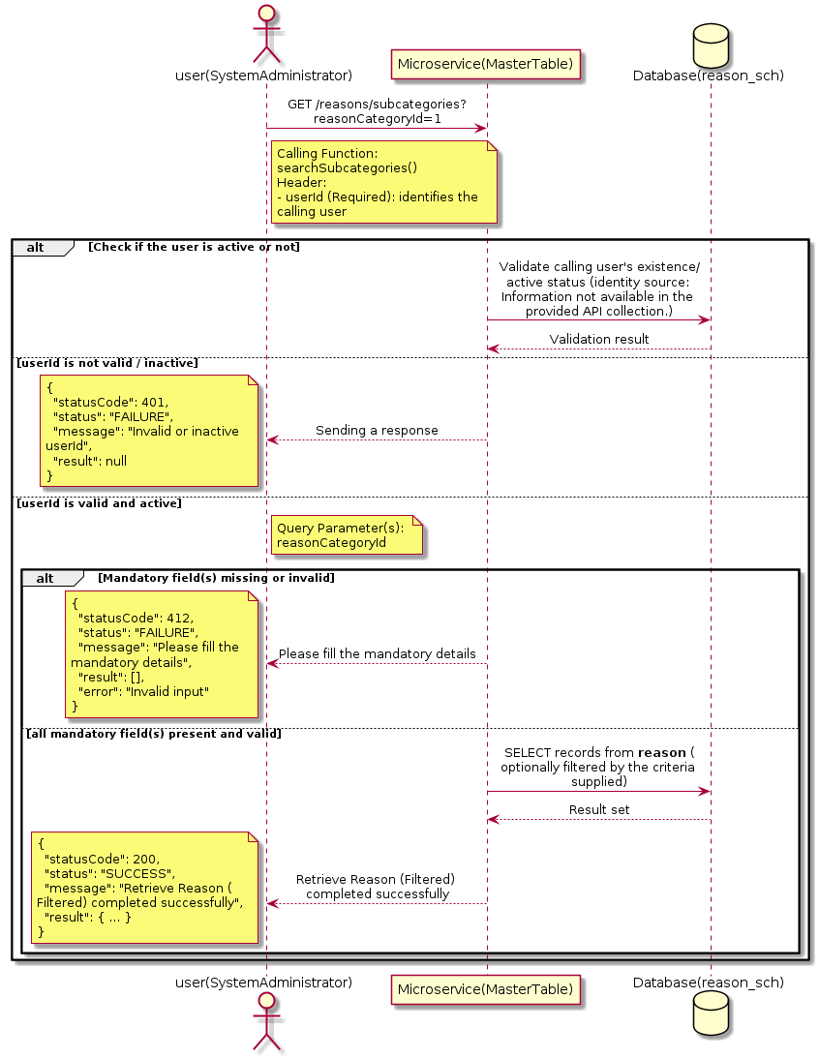

3.15.2.3 API Endpoint
Method | GET
URL | http://localhost:7002/srv2/genie/reasons/subcategories?reasonCategoryId=1
Headers | userId: 67
Authorization | Not present in the captured request. Information not available in the provided API collection.
Content-Type | application/json (assumed)
Query Parameters | reasonCategoryId = 1
Path Variables | None
Request Body:
Not applicable — this operation does not accept a request body.
Response Body (illustrative — see 3.x.4.5 Success Response for details):
The source Postman collection does not include a captured sample response for this request (the response array is empty). Information not available in the provided API collection. Section 3.15.2.4.5 below presents the response envelope inferred from the standard response wrapper used consistently by this platform's services.

3.15.2.4 Detailed Process Flow

3.15.2.4.1 Request Initiation
The flow begins when System Administrator (or a calling microservice on their behalf) invokes the GET endpoint http://localhost:7002/srv2/genie/reasons/subcategories?reasonCategoryId=1. The request must include the mandatory `userId` header used by the Master Table Microservice to identify the calling user for auditing purposes. The endpoint also expects one or more query parameters as listed in the API Endpoint section. At the Controller layer, Spring Boot's request-mapping infrastructure routes the call to the appropriate handler method (`searchSubcategories`), and Bean Validation annotations (if configured on the DTO) perform structural validation before the request reaches the Service layer. Information not available in the provided API collection. regarding the exact validation annotations used in the source code.

3.15.2.4.2 User Validation
The Master Table Microservice relies on the `userId` header to identify the calling user. Based on the pattern observed consistently across this API collection, the platform's authentication/authorization is expected to be enforced upstream (e.g., by an API Gateway or a shared security filter) using this identifier; the Postman collection does not include an `Authorization` / `Bearer` token header on this request, so the exact authentication mechanism (JWT validation, session lookup, or gateway-level SSO) is Information not available in the provided API collection. Role-based authorization — i.e., confirming that the user identified by `userId` holds a role/permission entitled to perform this operation — is expected to be enforced by the Service layer (see Section 8 – Controller Analysis and Section 14 – Authentication & Authorization), but the specific role/permission checks are Information not available in the provided API collection.

3.15.2.4.3 Business Logic
The Service layer inspects the supplied query parameters, builds the corresponding filter/predicate, and forwards it to the Repository. If a parameter is absent, the corresponding filter is typically skipped rather than treated as an error.

3.15.2.4.4 Database Interaction
The Repository layer (Spring Data JPA) interacts with the underlying relational database that backs the Reason master table. The primary operation issued is a **SELECT** against the table associated with Reason. No write operations occur; the query is scoped using the supplied filter parameters, translated into a JPA derived-query or `@Query`/native query. The exact table name, column names, primary/foreign key definitions, and JPA repository method signatures are not included in the Postman collection; therefore, precise schema details are information not available in the provided api collection.

3.15.2.4.5 Success Response
Status Code: 200 OK. Sample response envelope (illustrative — the source collection did not capture a sample response for this API):
{
"statusCode": 200,
"status": "SUCCESS",
"message": "Retrieve Reason (Filtered) completed successfully",
"result": [
{
"id": 1,
"name": "Sample Reason",
"isActive": 1
}
],
"error": null,
"corelationId": "c6f2a1e4-2b3d-4a9e-9f1a-1234567890ab",
"url": null
}

3.15.2.4.6 Conclusion
This API provides a well-defined, single-purpose capability within the Master Table Microservice for retrieve reason (filtered). The Controller → Service → Repository → Database layering keeps request validation, business rules, and persistence concerns separated, which allows the Reason master data to be maintained consistently and safely by authorized administrators while remaining available for consumption by every other module that depends on this reference data.
3.16 Role APIs (Roles)
Maintains organizational and application roles, including role hierarchy and permission mapping, that drive authorization and approval routing across the platform.

3.16.1 Retrieve All Role — roles (1)

3.16.1.1 Overview
Purpose: To retrieve the complete list of Role master records configured in the Master Table Microservice, so that consuming screens and downstream services can populate dropdowns, grids, and configuration views.
Business Requirement: Every screen and workflow that references Role data (creation forms, filters, reports) needs an authoritative, always-current list of active Role values sourced from a single master table rather than being hard-coded.
Who Uses the API: System Administrator / Security Administrator, and any internal microservice/UI module that needs to render Role options.
Business Flow: Client sends a GET request → Controller delegates to the Service layer → Service layer calls the Repository → Repository queries the Role table → the result set is mapped to response DTOs and returned to the Client.

3.16.1.2 Sequence Diagram
The diagram below illustrates the end-to-end interaction for "Retrieve All Role — roles (1)" across the Client, Controller, Service, Repository, and Database layers.
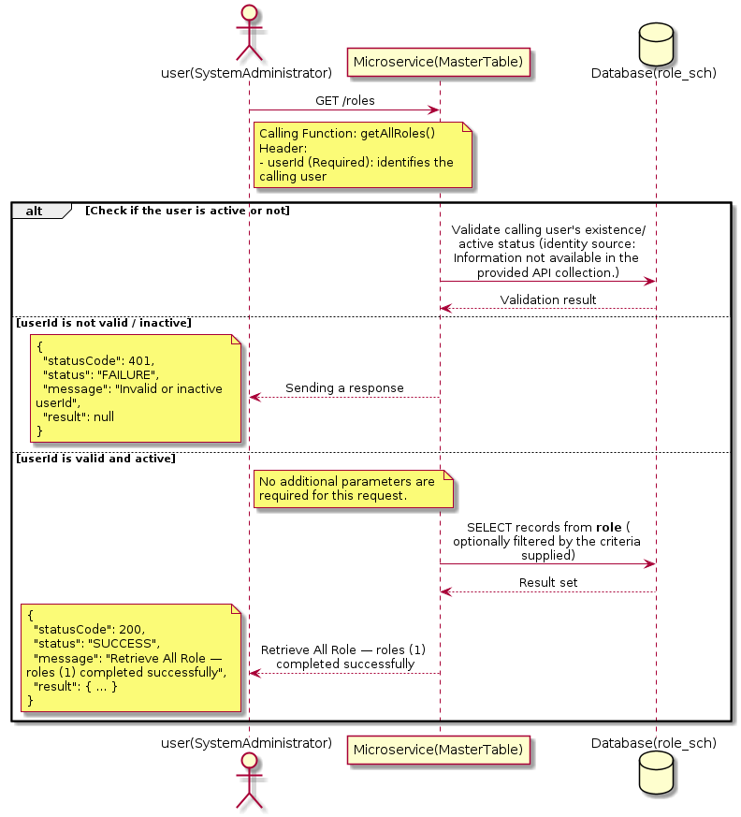

3.16.1.3 API Endpoint
Method | GET
URL | http://localhost:7002/srv2/genie/roles
Headers | userId: 67 Content-Type: application/json
Authorization | Not present in the captured request. Information not available in the provided API collection.
Content-Type | Content-Type: application/json
Query Parameters | None
Path Variables | None
Request Body:
Not applicable — this operation does not accept a request body.
Response Body (illustrative — see 3.x.4.5 Success Response for details):
The source Postman collection does not include a captured sample response for this request (the response array is empty). Information not available in the provided API collection. Section 3.16.1.4.5 below presents the response envelope inferred from the standard response wrapper used consistently by this platform's services.

3.16.1.4 Detailed Process Flow

3.16.1.4.1 Request Initiation
The flow begins when System Administrator (or a calling microservice on their behalf) invokes the GET endpoint http://localhost:7002/srv2/genie/roles. The request must include the mandatory `userId` header used by the Master Table Microservice to identify the calling user for auditing purposes. At the Controller layer, Spring Boot's request-mapping infrastructure routes the call to the appropriate handler method (`getAllRoles`), and Bean Validation annotations (if configured on the DTO) perform structural validation before the request reaches the Service layer. Information not available in the provided API collection. regarding the exact validation annotations used in the source code.

3.16.1.4.2 User Validation
The Master Table Microservice relies on the `userId` header to identify the calling user. Based on the pattern observed consistently across this API collection, the platform's authentication/authorization is expected to be enforced upstream (e.g., by an API Gateway or a shared security filter) using this identifier; the Postman collection does not include an `Authorization` / `Bearer` token header on this request, so the exact authentication mechanism (JWT validation, session lookup, or gateway-level SSO) is Information not available in the provided API collection. Role-based authorization — i.e., confirming that the user identified by `userId` holds a role/permission entitled to perform this operation — is expected to be enforced by the Service layer (see Section 8 – Controller Analysis and Section 14 – Authentication & Authorization), but the specific role/permission checks are Information not available in the provided API collection.

3.16.1.4.3 Business Logic
The Service layer contains no conditional business branching for this operation beyond invoking the Repository to fetch all Role records. Depending on the record volume, the Service layer may apply default sorting (e.g., by name or creation order) before returning the list.

3.16.1.4.4 Database Interaction
The Repository layer (Spring Data JPA) interacts with the underlying relational database that backs the Role master table. The primary operation issued is a **SELECT** against the table associated with Role. No write operations occur; the query returns all rows that satisfy the entity's default scope (typically active records). The exact table name, column names, primary/foreign key definitions, and JPA repository method signatures are not included in the Postman collection; therefore, precise schema details are information not available in the provided api collection.

3.16.1.4.5 Success Response
Status Code: 200 OK. Sample response envelope (illustrative — the source collection did not capture a sample response for this API):
{
"statusCode": 200,
"status": "SUCCESS",
"message": "Retrieve All Role — roles (1) completed successfully",
"result": [
{
"id": 1,
"name": "Sample Role",
"isActive": 1
}
],
"error": null,
"corelationId": "c6f2a1e4-2b3d-4a9e-9f1a-1234567890ab",
"url": null
}

3.16.1.4.6 Conclusion
This API provides a well-defined, single-purpose capability within the Master Table Microservice for retrieve all role — roles (1). The Controller → Service → Repository → Database layering keeps request validation, business rules, and persistence concerns separated, which allows the Role master data to be maintained consistently and safely by authorized administrators while remaining available for consumption by every other module that depends on this reference data.

3.16.2 Retrieve All Role — roles (2)

3.16.2.1 Overview
Purpose: To retrieve the complete list of Role master records configured in the Master Table Microservice, so that consuming screens and downstream services can populate dropdowns, grids, and configuration views.
Business Requirement: Every screen and workflow that references Role data (creation forms, filters, reports) needs an authoritative, always-current list of active Role values sourced from a single master table rather than being hard-coded.
Who Uses the API: System Administrator / Security Administrator, and any internal microservice/UI module that needs to render Role options.
Business Flow: Client sends a GET request → Controller delegates to the Service layer → Service layer calls the Repository → Repository queries the Role table → the result set is mapped to response DTOs and returned to the Client.

3.16.2.2 Sequence Diagram
The diagram below illustrates the end-to-end interaction for "Retrieve All Role — roles (2)" across the Client, Controller, Service, Repository, and Database layers.
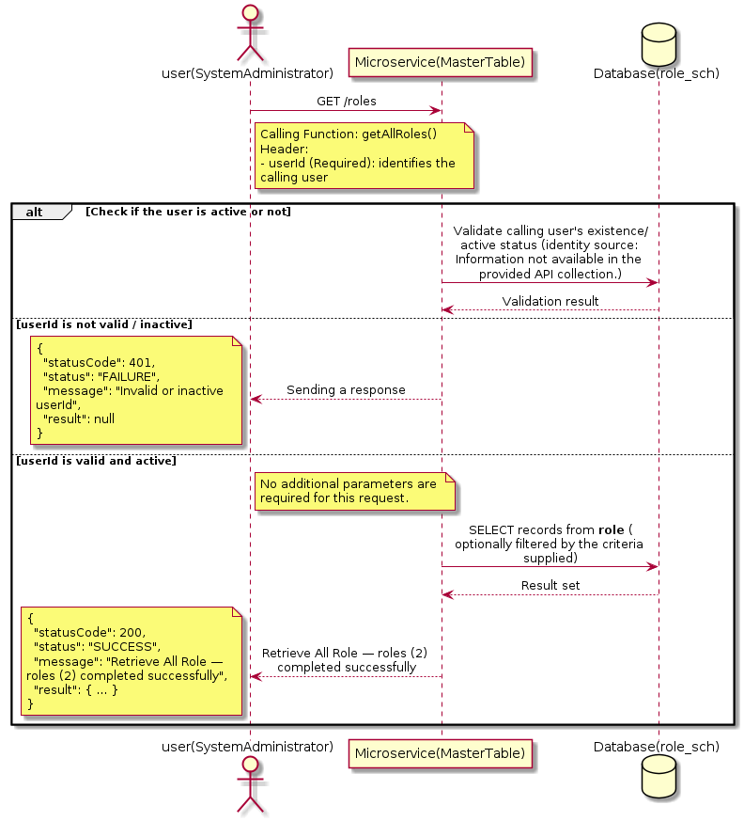

3.16.2.3 API Endpoint
Method | GET
URL | http://localhost:7002/srv2/genie/roles
Headers | userId: 67 Content-Type: application/json
Authorization | Not present in the captured request. Information not available in the provided API collection.
Content-Type | Content-Type: application/json
Query Parameters | None
Path Variables | None
Request Body:
Not applicable — this operation does not accept a request body.
Response Body (illustrative — see 3.x.4.5 Success Response for details):
The source Postman collection does not include a captured sample response for this request (the response array is empty). Information not available in the provided API collection. Section 3.16.2.4.5 below presents the response envelope inferred from the standard response wrapper used consistently by this platform's services.

3.16.2.4 Detailed Process Flow

3.16.2.4.1 Request Initiation
The flow begins when System Administrator (or a calling microservice on their behalf) invokes the GET endpoint http://localhost:7002/srv2/genie/roles. The request must include the mandatory `userId` header used by the Master Table Microservice to identify the calling user for auditing purposes. At the Controller layer, Spring Boot's request-mapping infrastructure routes the call to the appropriate handler method (`getAllRoles`), and Bean Validation annotations (if configured on the DTO) perform structural validation before the request reaches the Service layer. Information not available in the provided API collection. regarding the exact validation annotations used in the source code.

3.16.2.4.2 User Validation
The Master Table Microservice relies on the `userId` header to identify the calling user. Based on the pattern observed consistently across this API collection, the platform's authentication/authorization is expected to be enforced upstream (e.g., by an API Gateway or a shared security filter) using this identifier; the Postman collection does not include an `Authorization` / `Bearer` token header on this request, so the exact authentication mechanism (JWT validation, session lookup, or gateway-level SSO) is Information not available in the provided API collection. Role-based authorization — i.e., confirming that the user identified by `userId` holds a role/permission entitled to perform this operation — is expected to be enforced by the Service layer (see Section 8 – Controller Analysis and Section 14 – Authentication & Authorization), but the specific role/permission checks are Information not available in the provided API collection.

3.16.2.4.3 Business Logic
The Service layer contains no conditional business branching for this operation beyond invoking the Repository to fetch all Role records. Depending on the record volume, the Service layer may apply default sorting (e.g., by name or creation order) before returning the list.

3.16.2.4.4 Database Interaction
The Repository layer (Spring Data JPA) interacts with the underlying relational database that backs the Role master table. The primary operation issued is a **SELECT** against the table associated with Role. No write operations occur; the query returns all rows that satisfy the entity's default scope (typically active records). The exact table name, column names, primary/foreign key definitions, and JPA repository method signatures are not included in the Postman collection; therefore, precise schema details are information not available in the provided api collection.

3.16.2.4.5 Success Response
Status Code: 200 OK. Sample response envelope (illustrative — the source collection did not capture a sample response for this API):
{
"statusCode": 200,
"status": "SUCCESS",
"message": "Retrieve All Role — roles (2) completed successfully",
"result": [
{
"id": 1,
"name": "Sample Role",
"isActive": 1
}
],
"error": null,
"corelationId": "c6f2a1e4-2b3d-4a9e-9f1a-1234567890ab",
"url": null
}

3.16.2.4.6 Conclusion
This API provides a well-defined, single-purpose capability within the Master Table Microservice for retrieve all role — roles (2). The Controller → Service → Repository → Database layering keeps request validation, business rules, and persistence concerns separated, which allows the Role master data to be maintained consistently and safely by authorized administrators while remaining available for consumption by every other module that depends on this reference data.

3.16.3 Create Role — roles

3.16.3.1 Overview
Purpose: To create a new Role master record in the system, allowing administrators to extend the master-data catalogue that other modules (ticketing, workflow, notifications) depend on.
Business Requirement: Business/process owners need a controlled way to add new Role values so that the platform's classification, routing, and reporting capabilities can evolve as the organization changes.
Who Uses the API: System Administrator / Security Administrator responsible for master-data configuration.
Business Flow: Client sends a POST request with the new Role payload → Controller validates the payload (mandatory fields, formats) → Service layer applies business rules (e.g., duplicate-name check) → Repository persists the new record → the created record (with generated identifier) is returned to the Client.

3.16.3.2 Sequence Diagram
The diagram below illustrates the end-to-end interaction for "Create Role — roles" across the Client, Controller, Service, Repository, and Database layers.
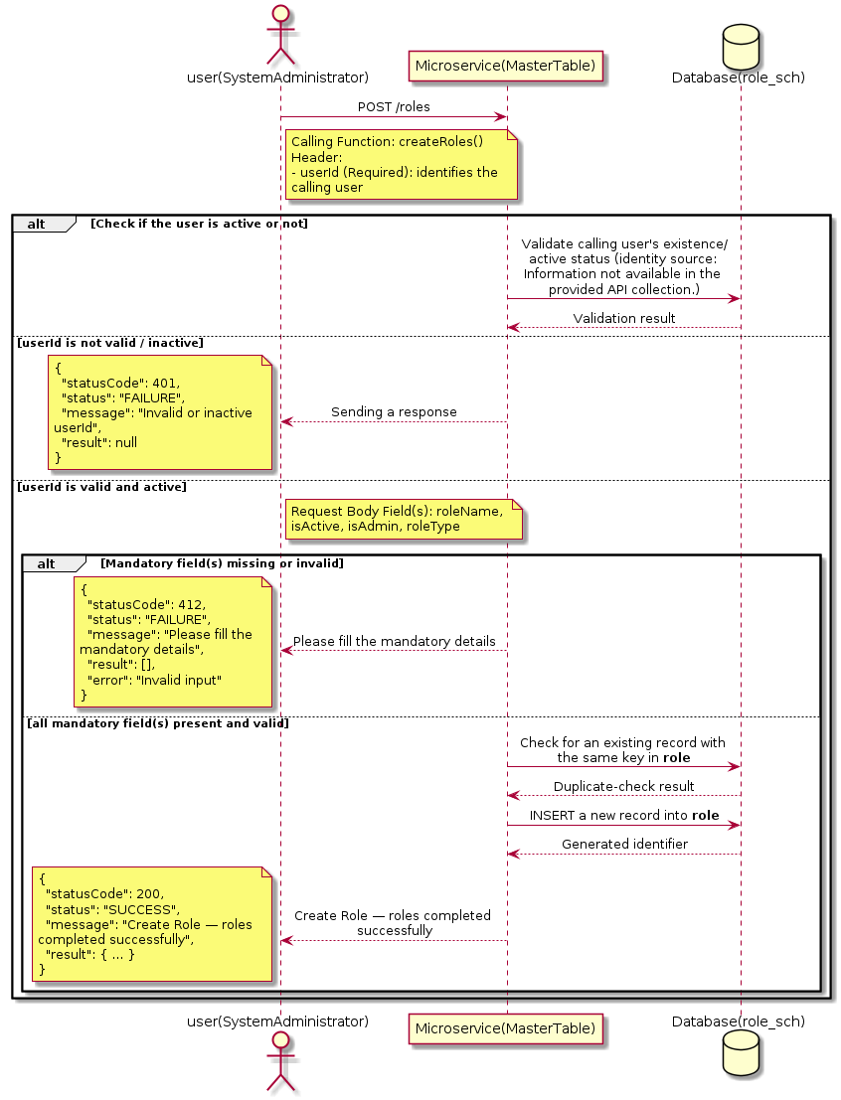

3.16.3.3 API Endpoint
Method | POST
URL | http://localhost:7002/srv2/genie/roles
Headers | userId: 67 Content-Type: application/json (assumed based on JSON request payload; Information not available in the provided API collection.)
Authorization | Not present in the captured request. Information not available in the provided API collection.
Content-Type | Content-Type: application/json (assumed based on JSON request payload; Information not available in the provided API collection.)
Query Parameters | None
Path Variables | None
Request Body:
{
"roleName": "Test Role1",
"isActive": "1",
"isAdmin": "0",
"roleType": "role",
"permissionId": []
}
Response Body (illustrative — see 3.x.4.5 Success Response for details):
The source Postman collection does not include a captured sample response for this request (the response array is empty). Information not available in the provided API collection. Section 3.16.3.4.5 below presents the response envelope inferred from the standard response wrapper used consistently by this platform's services.

3.16.3.4 Detailed Process Flow

3.16.3.4.1 Request Initiation
The flow begins when System Administrator (or a calling microservice on their behalf) invokes the POST endpoint http://localhost:7002/srv2/genie/roles. The request must include the mandatory `userId` header used by the Master Table Microservice to identify the calling user for auditing purposes. The request carries a JSON payload in the request body which the Controller binds to its Data Transfer Object (DTO) before any processing begins. At the Controller layer, Spring Boot's request-mapping infrastructure routes the call to the appropriate handler method (`createRoles`), and Bean Validation annotations (if configured on the DTO) perform structural validation before the request reaches the Service layer. Information not available in the provided API collection. regarding the exact validation annotations used in the source code.

3.16.3.4.2 User Validation
The Master Table Microservice relies on the `userId` header to identify the calling user. Based on the pattern observed consistently across this API collection, the platform's authentication/authorization is expected to be enforced upstream (e.g., by an API Gateway or a shared security filter) using this identifier; the Postman collection does not include an `Authorization` / `Bearer` token header on this request, so the exact authentication mechanism (JWT validation, session lookup, or gateway-level SSO) is Information not available in the provided API collection. Role-based authorization — i.e., confirming that the user identified by `userId` holds a role/permission entitled to perform this operation — is expected to be enforced by the Service layer (see Section 8 – Controller Analysis and Section 14 – Authentication & Authorization), but the specific role/permission checks are Information not available in the provided API collection.

3.16.3.4.3 Business Logic
The Service layer performs the following: (1) validates that mandatory fields are present and correctly formatted, (2) checks for duplicates (e.g., an existing Role with the same name/code), (3) sets system-managed fields (e.g., `isActive = 1`, `createdBy`, timestamps) where applicable, and (4) persists the new record via the Repository. If any validation fails, the Service layer returns a business error rather than proceeding to persistence. The key fields exchanged for this operation, as observed in the sample payload, are: `roleName`, `isActive`, `isAdmin`, `roleType`.

3.16.3.4.4 Database Interaction
The Repository layer (Spring Data JPA) interacts with the underlying relational database that backs the Role master table. The primary operation issued is a **INSERT** against the table associated with Role. A new row is inserted into the master table; if the entity has related child records (as seen in nested request payload arrays), corresponding child-table inserts are performed within the same transaction. The exact table name, column names, primary/foreign key definitions, and JPA repository method signatures are not included in the Postman collection; therefore, precise schema details are information not available in the provided api collection.

3.16.3.4.5 Success Response
Status Code: 200 OK. Sample response envelope (illustrative — the source collection did not capture a sample response for this API):
{
"statusCode": 200,
"status": "SUCCESS",
"message": "Create Role — roles completed successfully",
"result": {
"id": 101,
"roleName": "Test Role1",
"isActive": "1",
"isAdmin": "0",
"roleType": "role"
},
"error": null,
"corelationId": "c6f2a1e4-2b3d-4a9e-9f1a-1234567890ab",
"url": null
}

3.16.3.4.6 Conclusion
This API provides a well-defined, single-purpose capability within the Master Table Microservice for create role — roles. The Controller → Service → Repository → Database layering keeps request validation, business rules, and persistence concerns separated, which allows the Role master data to be maintained consistently and safely by authorized administrators while remaining available for consumption by every other module that depends on this reference data.

3.16.4 Search / List Role

3.16.4.1 Overview
Purpose: To search and list Role records based on a search payload (e.g., free-text search or structured criteria), supporting list/grid screens that need paginated or filtered master data.
Business Requirement: List/search screens for Role configuration need server-side search so that administrators can locate specific records in large master tables without scanning the full data set.
Who Uses the API: System Administrator / Security Administrator operating the Role configuration/list screen.
Business Flow: Client sends a POST request with a search payload → Controller validates the payload → Service layer constructs the search/query logic → Repository executes the search against the Role table → matching records are returned to the Client.

3.16.4.2 Sequence Diagram
The diagram below illustrates the end-to-end interaction for "Search / List Role" across the Client, Controller, Service, Repository, and Database layers.
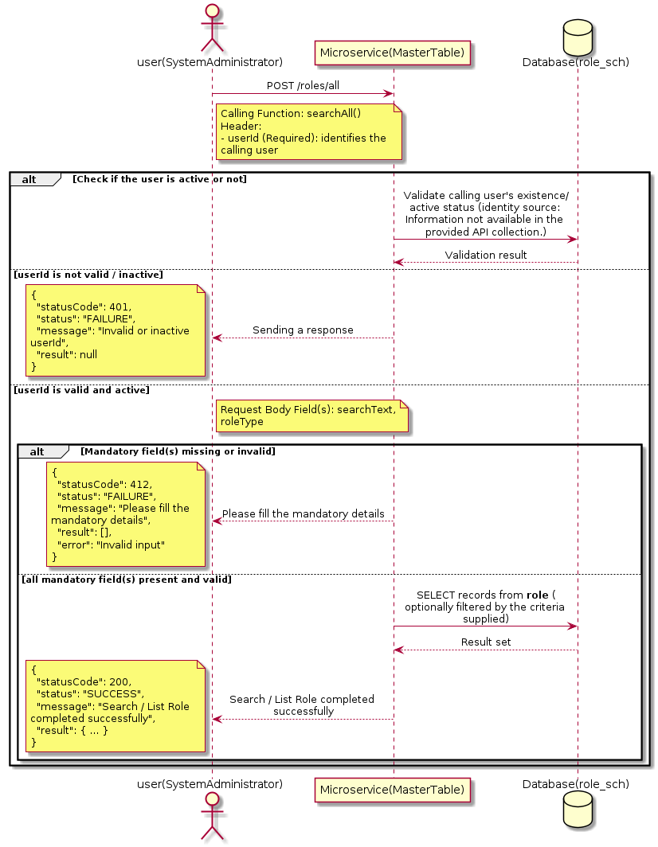

3.16.4.3 API Endpoint
Method | POST
URL | http://localhost:7002/srv2/genie/roles/all
Headers | userId: 67 Content-Type: application/json (assumed based on JSON request payload; Information not available in the provided API collection.)
Authorization | Not present in the captured request. Information not available in the provided API collection.
Content-Type | Content-Type: application/json (assumed based on JSON request payload; Information not available in the provided API collection.)
Query Parameters | None
Path Variables | None
Request Body:
{
"searchText": "",
"roleType": ""
}
Response Body (illustrative — see 3.x.4.5 Success Response for details):
The source Postman collection does not include a captured sample response for this request (the response array is empty). Information not available in the provided API collection. Section 3.16.4.4.5 below presents the response envelope inferred from the standard response wrapper used consistently by this platform's services.

3.16.4.4 Detailed Process Flow

3.16.4.4.1 Request Initiation
The flow begins when System Administrator (or a calling microservice on their behalf) invokes the POST endpoint http://localhost:7002/srv2/genie/roles/all. The request must include the mandatory `userId` header used by the Master Table Microservice to identify the calling user for auditing purposes. The request carries a JSON payload in the request body which the Controller binds to its Data Transfer Object (DTO) before any processing begins. At the Controller layer, Spring Boot's request-mapping infrastructure routes the call to the appropriate handler method (`searchAll`), and Bean Validation annotations (if configured on the DTO) perform structural validation before the request reaches the Service layer. Information not available in the provided API collection. regarding the exact validation annotations used in the source code.

3.16.4.4.2 User Validation
The Master Table Microservice relies on the `userId` header to identify the calling user. Based on the pattern observed consistently across this API collection, the platform's authentication/authorization is expected to be enforced upstream (e.g., by an API Gateway or a shared security filter) using this identifier; the Postman collection does not include an `Authorization` / `Bearer` token header on this request, so the exact authentication mechanism (JWT validation, session lookup, or gateway-level SSO) is Information not available in the provided API collection. Role-based authorization — i.e., confirming that the user identified by `userId` holds a role/permission entitled to perform this operation — is expected to be enforced by the Service layer (see Section 8 – Controller Analysis and Section 14 – Authentication & Authorization), but the specific role/permission checks are Information not available in the provided API collection.

3.16.4.4.3 Business Logic
The Service layer evaluates the search payload; if the search text/criteria is empty, the operation typically behaves like a full list (all Role records); if populated, it is used to build a case-insensitive `LIKE`/contains predicate against the relevant column(s). The key fields exchanged for this operation, as observed in the sample payload, are: `searchText`, `roleType`.

3.16.4.4.4 Database Interaction
The Repository layer (Spring Data JPA) interacts with the underlying relational database that backs the Role master table. The primary operation issued is a **SELECT** against the table associated with Role. No write operations occur; the search is typically implemented using a JPA derived query method or a native/JPQL query with `LIKE` predicates. The exact table name, column names, primary/foreign key definitions, and JPA repository method signatures are not included in the Postman collection; therefore, precise schema details are information not available in the provided api collection.

3.16.4.4.5 Success Response
Status Code: 200 OK. Sample response envelope (illustrative — the source collection did not capture a sample response for this API):
{
"statusCode": 200,
"status": "SUCCESS",
"message": "Search / List Role completed successfully",
"result": [
{
"id": 1,
"name": "Sample Role",
"isActive": 1
}
],
"error": null,
"corelationId": "c6f2a1e4-2b3d-4a9e-9f1a-1234567890ab",
"url": null
}

3.16.4.4.6 Conclusion
This API provides a well-defined, single-purpose capability within the Master Table Microservice for search / list role. The Controller → Service → Repository → Database layering keeps request validation, business rules, and persistence concerns separated, which allows the Role master data to be maintained consistently and safely by authorized administrators while remaining available for consumption by every other module that depends on this reference data.
3.16.5 Create Role — rolebyid

3.16.5.1 Overview
Purpose: To create a new Role master record in the system, allowing administrators to extend the master-data catalogue that other modules (ticketing, workflow, notifications) depend on.
Business Requirement: Business/process owners need a controlled way to add new Role values so that the platform's classification, routing, and reporting capabilities can evolve as the organization changes.
Who Uses the API: System Administrator / Security Administrator responsible for master-data configuration.
Business Flow: Client sends a POST request with the new Role payload → Controller validates the payload (mandatory fields, formats) → Service layer applies business rules (e.g., duplicate-name check) → Repository persists the new record → the created record (with generated identifier) is returned to the Client.

3.16.5.2 Sequence Diagram
The diagram below illustrates the end-to-end interaction for "Create Role — rolebyid" across the Client, Controller, Service, Repository, and Database layers.
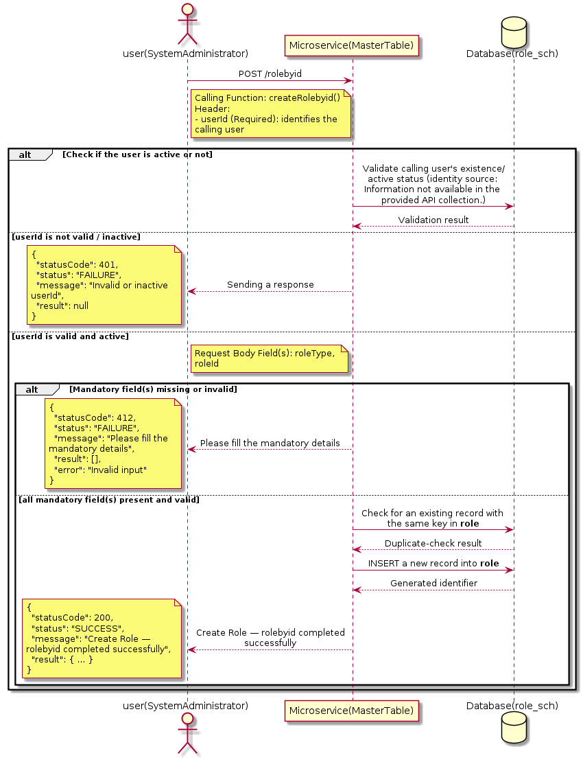

3.16.5.3 API Endpoint
Method | POST
URL | http://localhost:7002/srv2/genie/rolebyid
Headers | userId: 67 Content-Type: application/json (assumed based on JSON request payload; Information not available in the provided API collection.)
Authorization | Not present in the captured request. Information not available in the provided API collection.
Content-Type | Content-Type: application/json (assumed based on JSON request payload; Information not available in the provided API collection.)
Query Parameters | None
Path Variables | None
Request Body:
{
"roleType": "role",
"roleId": 4
}
Response Body (illustrative — see 3.x.4.5 Success Response for details):
The source Postman collection does not include a captured sample response for this request (the response array is empty). Information not available in the provided API collection. Section 3.16.5.4.5 below presents the response envelope inferred from the standard response wrapper used consistently by this platform's services.

3.16.5.4 Detailed Process Flow

3.16.5.4.1 Request Initiation
The flow begins when System Administrator (or a calling microservice on their behalf) invokes the POST endpoint http://localhost:7002/srv2/genie/rolebyid. The request must include the mandatory `userId` header used by the Master Table Microservice to identify the calling user for auditing purposes. The request carries a JSON payload in the request body which the Controller binds to its Data Transfer Object (DTO) before any processing begins. At the Controller layer, Spring Boot's request-mapping infrastructure routes the call to the appropriate handler method (`createRolebyid`), and Bean Validation annotations (if configured on the DTO) perform structural validation before the request reaches the Service layer. Information not available in the provided API collection. regarding the exact validation annotations used in the source code.

3.16.5.4.2 User Validation
The Master Table Microservice relies on the `userId` header to identify the calling user. Based on the pattern observed consistently across this API collection, the platform's authentication/authorization is expected to be enforced upstream (e.g., by an API Gateway or a shared security filter) using this identifier; the Postman collection does not include an `Authorization` / `Bearer` token header on this request, so the exact authentication mechanism (JWT validation, session lookup, or gateway-level SSO) is Information not available in the provided API collection. Role-based authorization — i.e., confirming that the user identified by `userId` holds a role/permission entitled to perform this operation — is expected to be enforced by the Service layer (see Section 8 – Controller Analysis and Section 14 – Authentication & Authorization), but the specific role/permission checks are Information not available in the provided API collection.

3.16.5.4.3 Business Logic
The Service layer performs the following: (1) validates that mandatory fields are present and correctly formatted, (2) checks for duplicates (e.g., an existing Role with the same name/code), (3) sets system-managed fields (e.g., `isActive = 1`, `createdBy`, timestamps) where applicable, and (4) persists the new record via the Repository. If any validation fails, the Service layer returns a business error rather than proceeding to persistence. The key fields exchanged for this operation, as observed in the sample payload, are: `roleType`, `roleId`.

3.16.5.4.4 Database Interaction
The Repository layer (Spring Data JPA) interacts with the underlying relational database that backs the Role master table. The primary operation issued is a **INSERT** against the table associated with Role. A new row is inserted into the master table; if the entity has related child records (as seen in nested request payload arrays), corresponding child-table inserts are performed within the same transaction. The exact table name, column names, primary/foreign key definitions, and JPA repository method signatures are not included in the Postman collection; therefore, precise schema details are information not available in the provided api collection.

3.16.5.4.5 Success Response
Status Code: 200 OK. Sample response envelope (illustrative — the source collection did not capture a sample response for this API):
{
"statusCode": 200,
"status": "SUCCESS",
"message": "Create Role — rolebyid completed successfully",
"result": {
"id": 101,
"roleType": "role",
"roleId": 4
},
"error": null,
"corelationId": "c6f2a1e4-2b3d-4a9e-9f1a-1234567890ab",
"url": null
}

3.16.5.4.6 Conclusion
This API provides a well-defined, single-purpose capability within the Master Table Microservice for create role — rolebyid. The Controller → Service → Repository → Database layering keeps request validation, business rules, and persistence concerns separated, which allows the Role master data to be maintained consistently and safely by authorized administrators while remaining available for consumption by every other module that depends on this reference data.
3.16.6 Update Role

3.16.6.1 Overview
Purpose: To update an existing Role master record, allowing administrators to correct or evolve master-data attributes without impacting the record's identity/history.
Business Requirement: Master data changes over time (renames, corrections, re-classification); the platform must allow controlled updates while preserving referential integrity for records that already reference this Role.
Who Uses the API: System Administrator / Security Administrator responsible for maintaining master-data accuracy.
Business Flow: Client sends a PUT/PATCH request with the updated Role payload → Controller validates the payload → Service layer fetches the existing record, applies the changes, and re-validates business rules → Repository persists the updated record → the updated record is returned to the Client.

3.16.6.2 Sequence Diagram
The diagram below illustrates the end-to-end interaction for "Update Role" across the Client, Controller, Service, Repository, and Database layers.
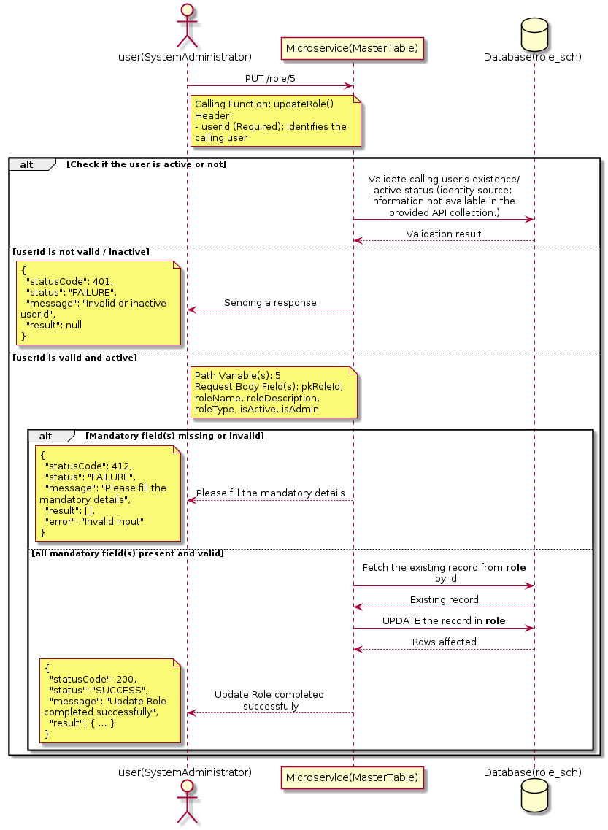

3.16.6.3 API Endpoint
Method | PUT
URL | http://localhost:7002/srv2/genie/role/5
Headers | userId: 67 Content-Type: application/json (assumed based on JSON request payload; Information not available in the provided API collection.)
Authorization | Not present in the captured request. Information not available in the provided API collection.
Content-Type | Content-Type: application/json (assumed based on JSON request payload; Information not available in the provided API collection.)
Query Parameters | None
Path Variables | 5
Request Body:
{
"pkRoleId": 5,
"roleName": "Test Role Updated",
"roleDescription": "Updated test role",
"roleType": "role",
"isActive": "1",
"isAdmin": "0",
"permissionId": []
}
Response Body (illustrative — see 3.x.4.5 Success Response for details):
The source Postman collection does not include a captured sample response for this request (the response array is empty). Information not available in the provided API collection. Section 3.16.6.4.5 below presents the response envelope inferred from the standard response wrapper used consistently by this platform's services.

3.16.6.4 Detailed Process Flow

3.16.6.4.1 Request Initiation
The flow begins when System Administrator (or a calling microservice on their behalf) invokes the PUT endpoint http://localhost:7002/srv2/genie/role/5. The request must include the mandatory `userId` header used by the Master Table Microservice to identify the calling user for auditing purposes. The request carries a JSON payload in the request body which the Controller binds to its Data Transfer Object (DTO) before any processing begins. At the Controller layer, Spring Boot's request-mapping infrastructure routes the call to the appropriate handler method (`updateRole`), and Bean Validation annotations (if configured on the DTO) perform structural validation before the request reaches the Service layer. Information not available in the provided API collection. regarding the exact validation annotations used in the source code.

3.16.6.4.2 User Validation
The Master Table Microservice relies on the `userId` header to identify the calling user. Based on the pattern observed consistently across this API collection, the platform's authentication/authorization is expected to be enforced upstream (e.g., by an API Gateway or a shared security filter) using this identifier; the Postman collection does not include an `Authorization` / `Bearer` token header on this request, so the exact authentication mechanism (JWT validation, session lookup, or gateway-level SSO) is Information not available in the provided API collection. Role-based authorization — i.e., confirming that the user identified by `userId` holds a role/permission entitled to perform this operation — is expected to be enforced by the Service layer (see Section 8 – Controller Analysis and Section 14 – Authentication & Authorization), but the specific role/permission checks are Information not available in the provided API collection.

3.16.6.4.3 Business Logic
The Service layer fetches the existing Role record by its identifier, verifies it exists, applies the incoming changes field by field, re-validates business rules (e.g., uniqueness of a renamed field), and persists the updated entity via the Repository. If the record does not exist, the operation is rejected with a not-found error. The key fields exchanged for this operation, as observed in the sample payload, are: `pkRoleId`, `roleName`, `roleDescription`, `roleType`, `isActive`, `isAdmin`.

3.16.6.4.4 Database Interaction
The Repository layer (Spring Data JPA) interacts with the underlying relational database that backs the Role master table. The primary operation issued is a **UPDATE** against the table associated with Role. The existing row is located by primary key and updated; if the entity has related child records, the existing child rows are typically replaced/updated within the same transaction. The exact table name, column names, primary/foreign key definitions, and JPA repository method signatures are not included in the Postman collection; therefore, precise schema details are information not available in the provided api collection.

3.16.6.4.5 Success Response
Status Code: 200 OK. Sample response envelope (illustrative — the source collection did not capture a sample response for this API):
{
"statusCode": 200,
"status": "SUCCESS",
"message": "Update Role completed successfully",
"result": {
"id": "5",
"isActive": 1
},
"error": null,
"corelationId": "c6f2a1e4-2b3d-4a9e-9f1a-1234567890ab",
"url": null
}

3.16.6.4.6 Conclusion
This API provides a well-defined, single-purpose capability within the Master Table Microservice for update role. The Controller → Service → Repository → Database layering keeps request validation, business rules, and persistence concerns separated, which allows the Role master data to be maintained consistently and safely by authorized administrators while remaining available for consumption by every other module that depends on this reference data.

3.16.7 Retrieve All Role — roles/evit

3.16.7.1 Overview
Purpose: To retrieve the complete list of Role master records configured in the Master Table Microservice, so that consuming screens and downstream services can populate dropdowns, grids, and configuration views.
Business Requirement: Every screen and workflow that references Role data (creation forms, filters, reports) needs an authoritative, always-current list of active Role values sourced from a single master table rather than being hard-coded.
Who Uses the API: System Administrator / Security Administrator, and any internal microservice/UI module that needs to render Role options.
Business Flow: Client sends a GET request → Controller delegates to the Service layer → Service layer calls the Repository → Repository queries the Role table → the result set is mapped to response DTOs and returned to the Client.

3.16.7.2 Sequence Diagram
The diagram below illustrates the end-to-end interaction for "Retrieve All Role — roles/evit" across the Client, Controller, Service, Repository, and Database layers.
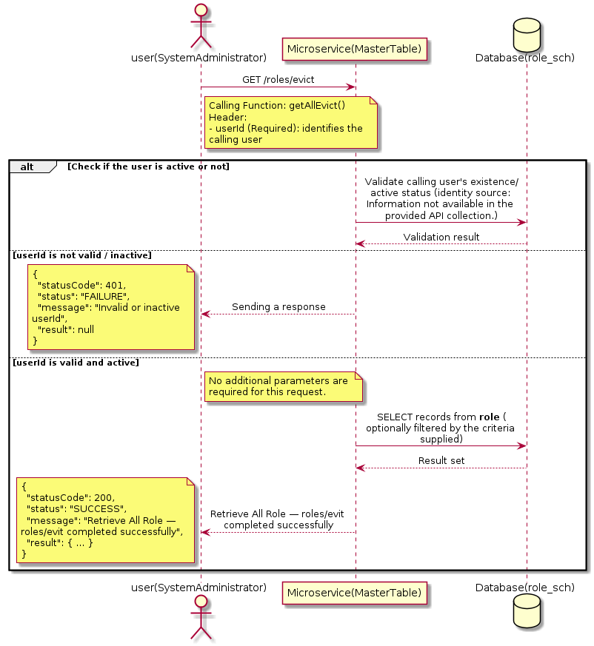

3.16.7.3 API Endpoint
Method | GET
URL | http://localhost:7002/srv2/genie/roles/evict
Headers | userId: 67
Authorization | Not present in the captured request. Information not available in the provided API collection.
Content-Type | application/json (assumed)
Query Parameters | None
Path Variables | None
Request Body:
Not applicable — this operation does not accept a request body.
Response Body (illustrative — see 3.x.4.5 Success Response for details):
The source Postman collection does not include a captured sample response for this request (the response array is empty). Information not available in the provided API collection. Section 3.16.7.4.5 below presents the response envelope inferred from the standard response wrapper used consistently by this platform's services.

3.16.7.4 Detailed Process Flow

3.16.7.4.1 Request Initiation
The flow begins when System Administrator (or a calling microservice on their behalf) invokes the GET endpoint http://localhost:7002/srv2/genie/roles/evict. The request must include the mandatory `userId` header used by the Master Table Microservice to identify the calling user for auditing purposes. At the Controller layer, Spring Boot's request-mapping infrastructure routes the call to the appropriate handler method (`getAllEvict`), and Bean Validation annotations (if configured on the DTO) perform structural validation before the request reaches the Service layer. Information not available in the provided API collection. regarding the exact validation annotations used in the source code.

3.16.7.4.2 User Validation
The Master Table Microservice relies on the `userId` header to identify the calling user. Based on the pattern observed consistently across this API collection, the platform's authentication/authorization is expected to be enforced upstream (e.g., by an API Gateway or a shared security filter) using this identifier; the Postman collection does not include an `Authorization` / `Bearer` token header on this request, so the exact authentication mechanism (JWT validation, session lookup, or gateway-level SSO) is Information not available in the provided API collection. Role-based authorization — i.e., confirming that the user identified by `userId` holds a role/permission entitled to perform this operation — is expected to be enforced by the Service layer (see Section 8 – Controller Analysis and Section 14 – Authentication & Authorization), but the specific role/permission checks are Information not available in the provided API collection.

3.16.7.4.3 Business Logic
The Service layer contains no conditional business branching for this operation beyond invoking the Repository to fetch all Role records. Depending on the record volume, the Service layer may apply default sorting (e.g., by name or creation order) before returning the list.

3.16.7.4.4 Database Interaction
The Repository layer (Spring Data JPA) interacts with the underlying relational database that backs the Role master table. The primary operation issued is a **SELECT** against the table associated with Role. No write operations occur; the query returns all rows that satisfy the entity's default scope (typically active records). The exact table name, column names, primary/foreign key definitions, and JPA repository method signatures are not included in the Postman collection; therefore, precise schema details are information not available in the provided api collection.

3.16.7.4.5 Success Response
Status Code: 200 OK. Sample response envelope (illustrative — the source collection did not capture a sample response for this API):
{
"statusCode": 200,
"status": "SUCCESS",
"message": "Retrieve All Role — roles/evit completed successfully",
"result": [
{
"id": 1,
"name": "Sample Role",
"isActive": 1
}
],
"error": null,
"corelationId": "c6f2a1e4-2b3d-4a9e-9f1a-1234567890ab",
"url": null
}

3.16.7.4.6 Conclusion
This API provides a well-defined, single-purpose capability within the Master Table Microservice for retrieve all role — roles/evit. The Controller → Service → Repository → Database layering keeps request validation, business rules, and persistence concerns separated, which allows the Role master data to be maintained consistently and safely by authorized administrators while remaining available for consumption by every other module that depends on this reference data.

3.16.8 Create Role — report

3.16.8.1 Overview
Purpose: To create a new Role master record in the system, allowing administrators to extend the master-data catalogue that other modules (ticketing, workflow, notifications) depend on.
Business Requirement: Business/process owners need a controlled way to add new Role values so that the platform's classification, routing, and reporting capabilities can evolve as the organization changes.
Who Uses the API: System Administrator / Security Administrator responsible for master-data configuration.
Business Flow: Client sends a POST request with the new Role payload → Controller validates the payload (mandatory fields, formats) → Service layer applies business rules (e.g., duplicate-name check) → Repository persists the new record → the created record (with generated identifier) is returned to the Client.

3.16.8.2 Sequence Diagram
The diagram below illustrates the end-to-end interaction for "Create Role — report" across the Client, Controller, Service, Repository, and Database layers.
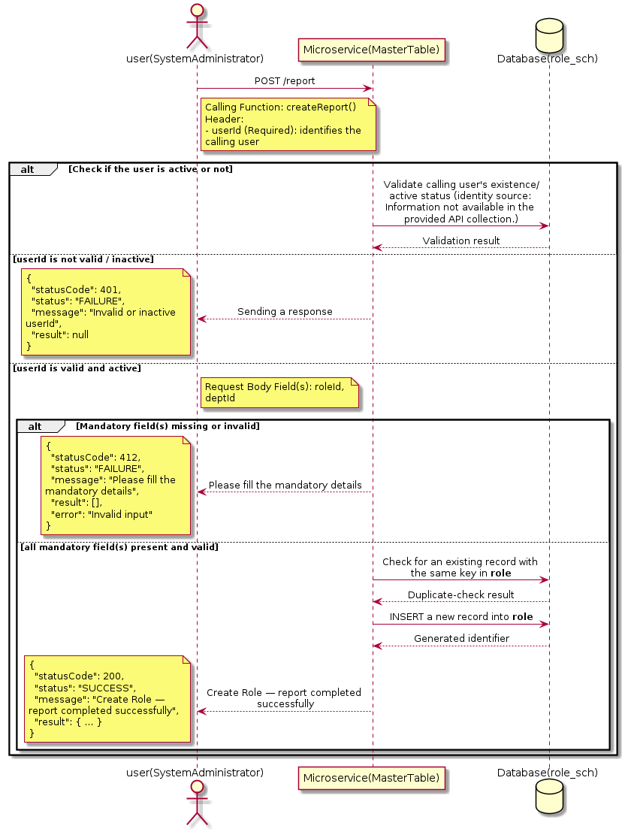

3.16.8.3 API Endpoint
Method | POST
URL | http://localhost:7002/srv2/genie/report
Headers | userId: 67 Content-Type: application/json (assumed based on JSON request payload; Information not available in the provided API collection.)
Authorization | Not present in the captured request. Information not available in the provided API collection.
Content-Type | Content-Type: application/json (assumed based on JSON request payload; Information not available in the provided API collection.)
Query Parameters | None
Path Variables | None
Request Body:
{
"roleId": 3,
"deptId": 1
}
Response Body (illustrative — see 3.x.4.5 Success Response for details):
The source Postman collection does not include a captured sample response for this request (the response array is empty). Information not available in the provided API collection. Section 3.16.8.4.5 below presents the response envelope inferred from the standard response wrapper used consistently by this platform's services.

3.16.8.4 Detailed Process Flow

3.16.8.4.1 Request Initiation
The flow begins when System Administrator (or a calling microservice on their behalf) invokes the POST endpoint http://localhost:7002/srv2/genie/report. The request must include the mandatory `userId` header used by the Master Table Microservice to identify the calling user for auditing purposes. The request carries a JSON payload in the request body which the Controller binds to its Data Transfer Object (DTO) before any processing begins. At the Controller layer, Spring Boot's request-mapping infrastructure routes the call to the appropriate handler method (`createReport`), and Bean Validation annotations (if configured on the DTO) perform structural validation before the request reaches the Service layer. Information not available in the provided API collection. regarding the exact validation annotations used in the source code.

3.16.8.4.2 User Validation
The Master Table Microservice relies on the `userId` header to identify the calling user. Based on the pattern observed consistently across this API collection, the platform's authentication/authorization is expected to be enforced upstream (e.g., by an API Gateway or a shared security filter) using this identifier; the Postman collection does not include an `Authorization` / `Bearer` token header on this request, so the exact authentication mechanism (JWT validation, session lookup, or gateway-level SSO) is Information not available in the provided API collection. Role-based authorization — i.e., confirming that the user identified by `userId` holds a role/permission entitled to perform this operation — is expected to be enforced by the Service layer (see Section 8 – Controller Analysis and Section 14 – Authentication & Authorization), but the specific role/permission checks are Information not available in the provided API collection.

3.16.8.4.3 Business Logic
The Service layer performs the following: (1) validates that mandatory fields are present and correctly formatted, (2) checks for duplicates (e.g., an existing Role with the same name/code), (3) sets system-managed fields (e.g., `isActive = 1`, `createdBy`, timestamps) where applicable, and (4) persists the new record via the Repository. If any validation fails, the Service layer returns a business error rather than proceeding to persistence. The key fields exchanged for this operation, as observed in the sample payload, are: `roleId`, `deptId`.

3.16.8.4.4 Database Interaction
The Repository layer (Spring Data JPA) interacts with the underlying relational database that backs the Role master table. The primary operation issued is a **INSERT** against the table associated with Role. A new row is inserted into the master table; if the entity has related child records (as seen in nested request payload arrays), corresponding child-table inserts are performed within the same transaction. The exact table name, column names, primary/foreign key definitions, and JPA repository method signatures are not included in the Postman collection; therefore, precise schema details are information not available in the provided api collection.

3.16.8.4.5 Success Response
Status Code: 200 OK. Sample response envelope (illustrative — the source collection did not capture a sample response for this API):
{
"statusCode": 200,
"status": "SUCCESS",
"message": "Create Role — report completed successfully",
"result": {
"id": 101,
"roleId": 3,
"deptId": 1
},
"error": null,
"corelationId": "c6f2a1e4-2b3d-4a9e-9f1a-1234567890ab",
"url": null
}

3.16.8.4.6 Conclusion
This API provides a well-defined, single-purpose capability within the Master Table Microservice for create role — report. The Controller → Service → Repository → Database layering keeps request validation, business rules, and persistence concerns separated, which allows the Role master data to be maintained consistently and safely by authorized administrators while remaining available for consumption by every other module that depends on this reference data.

3.16.9 Retrieve All Role — getgenieroles

3.16.9.1 Overview
Purpose: To retrieve the complete list of Role master records configured in the Master Table Microservice, so that consuming screens and downstream services can populate dropdowns, grids, and configuration views.
Business Requirement: Every screen and workflow that references Role data (creation forms, filters, reports) needs an authoritative, always-current list of active Role values sourced from a single master table rather than being hard-coded.
Who Uses the API: System Administrator / Security Administrator, and any internal microservice/UI module that needs to render Role options.
Business Flow: Client sends a GET request → Controller delegates to the Service layer → Service layer calls the Repository → Repository queries the Role table → the result set is mapped to response DTOs and returned to the Client.

3.16.9.2 Sequence Diagram
The diagram below illustrates the end-to-end interaction for "Retrieve All Role — getgenieroles" across the Client, Controller, Service, Repository, and Database layers.
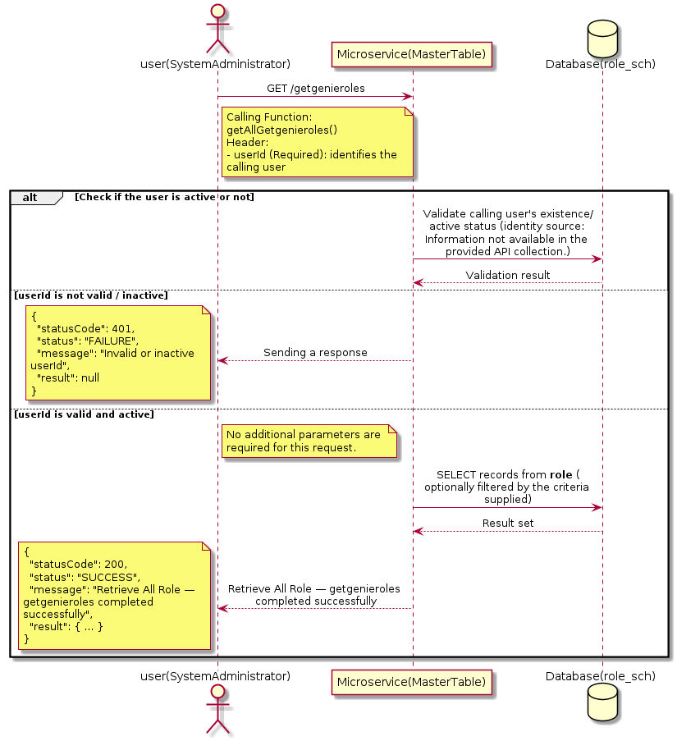

3.16.9.3 API Endpoint
Method | GET
URL | http://localhost:7002/srv2/genie/getgenieroles
Headers | userId: 67
Authorization | Not present in the captured request. Information not available in the provided API collection.
Content-Type | application/json (assumed)
Query Parameters | None
Path Variables | None
Request Body:
Not applicable — this operation does not accept a request body.
Response Body (illustrative — see 3.x.4.5 Success Response for details):
The source Postman collection does not include a captured sample response for this request (the response array is empty). Information not available in the provided API collection. Section 3.16.9.4.5 below presents the response envelope inferred from the standard response wrapper used consistently by this platform's services.

3.16.9.4 Detailed Process Flow

3.16.9.4.1 Request Initiation
The flow begins when System Administrator (or a calling microservice on their behalf) invokes the GET endpoint http://localhost:7002/srv2/genie/getgenieroles. The request must include the mandatory `userId` header used by the Master Table Microservice to identify the calling user for auditing purposes. At the Controller layer, Spring Boot's request-mapping infrastructure routes the call to the appropriate handler method (`getAllGetgenieroles`), and Bean Validation annotations (if configured on the DTO) perform structural validation before the request reaches the Service layer. Information not available in the provided API collection. regarding the exact validation annotations used in the source code.

3.16.9.4.2 User Validation
The Master Table Microservice relies on the `userId` header to identify the calling user. Based on the pattern observed consistently across this API collection, the platform's authentication/authorization is expected to be enforced upstream (e.g., by an API Gateway or a shared security filter) using this identifier; the Postman collection does not include an `Authorization` / `Bearer` token header on this request, so the exact authentication mechanism (JWT validation, session lookup, or gateway-level SSO) is Information not available in the provided API collection. Role-based authorization — i.e., confirming that the user identified by `userId` holds a role/permission entitled to perform this operation — is expected to be enforced by the Service layer (see Section 8 – Controller Analysis and Section 14 – Authentication & Authorization), but the specific role/permission checks are Information not available in the provided API collection.

3.16.9.4.3 Business Logic
The Service layer contains no conditional business branching for this operation beyond invoking the Repository to fetch all Role records. Depending on the record volume, the Service layer may apply default sorting (e.g., by name or creation order) before returning the list.

3.16.9.4.4 Database Interaction
The Repository layer (Spring Data JPA) interacts with the underlying relational database that backs the Role master table. The primary operation issued is a **SELECT** against the table associated with Role. No write operations occur; the query returns all rows that satisfy the entity's default scope (typically active records). The exact table name, column names, primary/foreign key definitions, and JPA repository method signatures are not included in the Postman collection; therefore, precise schema details are information not available in the provided api collection.

3.16.9.4.5 Success Response
Status Code: 200 OK. Sample response envelope (illustrative — the source collection did not capture a sample response for this API):
{
"statusCode": 200,
"status": "SUCCESS",
"message": "Retrieve All Role — getgenieroles completed successfully",
"result": [
{
"id": 1,
"name": "Sample Role",
"isActive": 1
}
],
"error": null,
"corelationId": "c6f2a1e4-2b3d-4a9e-9f1a-1234567890ab",
"url": null
}

3.16.9.4.6 Conclusion
This API provides a well-defined, single-purpose capability within the Master Table Microservice for retrieve all role — getgenieroles. The Controller → Service → Repository → Database layering keeps request validation, business rules, and persistence concerns separated, which allows the Role master data to be maintained consistently and safely by authorized administrators while remaining available for consumption by every other module that depends on this reference data.

3.16.10 Retrieve Role by ID

3.16.10.1 Overview
Purpose: To retrieve a single Role record identified by its unique identifier, typically used to pre-populate an edit screen or to validate a reference before use.
Business Requirement: Edit screens, validation routines, and cross-service lookups need to resolve a single Role record by its identifier reliably and quickly.
Who Uses the API: System Administrator / Security Administrator, and internal services validating a Role reference (e.g., ticket creation, workflow configuration).
Business Flow: Client sends a GET request with the identifier in the URL path → Controller extracts the path variable → Service layer requests the Repository to fetch the record → if found, the record is mapped and returned; if not found, a 404 is returned.

3.16.10.2 Sequence Diagram
The diagram below illustrates the end-to-end interaction for "Retrieve Role by ID" across the Client, Controller, Service, Repository, and Database layers.
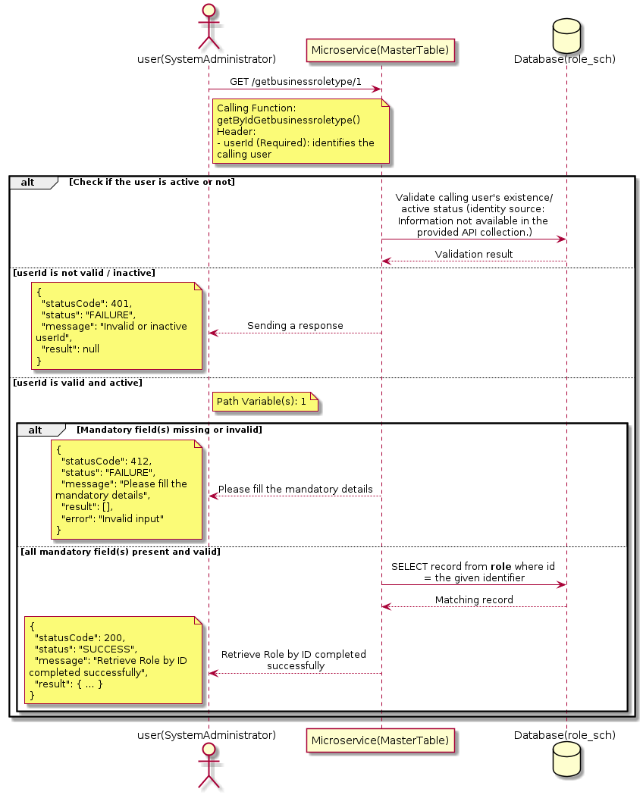

3.16.10.3 API Endpoint
Method | GET
URL | http://localhost:7002/srv2/genie/getbusinessroletype/1
Headers | userId: 67
Authorization | Not present in the captured request. Information not available in the provided API collection.
Content-Type | application/json (assumed)
Query Parameters | None
Path Variables | 1
Request Body:
Not applicable — this operation does not accept a request body.
Response Body (illustrative — see 3.x.4.5 Success Response for details):
The source Postman collection does not include a captured sample response for this request (the response array is empty). Information not available in the provided API collection. Section 3.16.10.4.5 below presents the response envelope inferred from the standard response wrapper used consistently by this platform's services.

3.16.10.4 Detailed Process Flow

3.16.10.4.1 Request Initiation
The flow begins when System Administrator (or a calling microservice on their behalf) invokes the GET endpoint http://localhost:7002/srv2/genie/getbusinessroletype/1. The request must include the mandatory `userId` header used by the Master Table Microservice to identify the calling user for auditing purposes. At the Controller layer, Spring Boot's request-mapping infrastructure routes the call to the appropriate handler method (`getByIdGetbusinessroletype`), and Bean Validation annotations (if configured on the DTO) perform structural validation before the request reaches the Service layer. Information not available in the provided API collection. regarding the exact validation annotations used in the source code.

3.16.10.4.2 User Validation
The Master Table Microservice relies on the `userId` header to identify the calling user. Based on the pattern observed consistently across this API collection, the platform's authentication/authorization is expected to be enforced upstream (e.g., by an API Gateway or a shared security filter) using this identifier; the Postman collection does not include an `Authorization` / `Bearer` token header on this request, so the exact authentication mechanism (JWT validation, session lookup, or gateway-level SSO) is Information not available in the provided API collection. Role-based authorization — i.e., confirming that the user identified by `userId` holds a role/permission entitled to perform this operation — is expected to be enforced by the Service layer (see Section 8 – Controller Analysis and Section 14 – Authentication & Authorization), but the specific role/permission checks are Information not available in the provided API collection.

3.16.10.4.3 Business Logic
The Service layer forwards the identifier to the Repository. If no record is found for the given identifier, the Service layer raises a not-found condition that the Controller/global exception handler converts into an HTTP 404 response.

3.16.10.4.4 Database Interaction
The Repository layer (Spring Data JPA) interacts with the underlying relational database that backs the Role master table. The primary operation issued is a **SELECT** against the table associated with Role. No write operations occur; a single-row lookup is performed using the primary key. The exact table name, column names, primary/foreign key definitions, and JPA repository method signatures are not included in the Postman collection; therefore, precise schema details are information not available in the provided api collection.

3.16.10.4.5 Success Response
Status Code: 200 OK. Sample response envelope (illustrative — the source collection did not capture a sample response for this API):
{
"statusCode": 200,
"status": "SUCCESS",
"message": "Retrieve Role by ID completed successfully",
"result": {
"id": 1,
"name": "Sample Role",
"isActive": 1
},
"error": null,
"corelationId": "c6f2a1e4-2b3d-4a9e-9f1a-1234567890ab",
"url": null
}

3.16.10.4.6 Conclusion
This API provides a well-defined, single-purpose capability within the Master Table Microservice for retrieve role by id. The Controller → Service → Repository → Database layering keeps request validation, business rules, and persistence concerns separated, which allows the Role master data to be maintained consistently and safely by authorized administrators while remaining available for consumption by every other module that depends on this reference data.

3.16.11 Retrieve All Role — getalladminroles

3.16.11.1 Overview
Purpose: To retrieve the complete list of Role master records configured in the Master Table Microservice, so that consuming screens and downstream services can populate dropdowns, grids, and configuration views.
Business Requirement: Every screen and workflow that references Role data (creation forms, filters, reports) needs an authoritative, always-current list of active Role values sourced from a single master table rather than being hard-coded.
Who Uses the API: System Administrator / Security Administrator, and any internal microservice/UI module that needs to render Role options.
Business Flow: Client sends a GET request → Controller delegates to the Service layer → Service layer calls the Repository → Repository queries the Role table → the result set is mapped to response DTOs and returned to the Client.

3.16.11.2 Sequence Diagram
The diagram below illustrates the end-to-end interaction for "Retrieve All Role — getalladminroles" across the Client, Controller, Service, Repository, and Database layers.
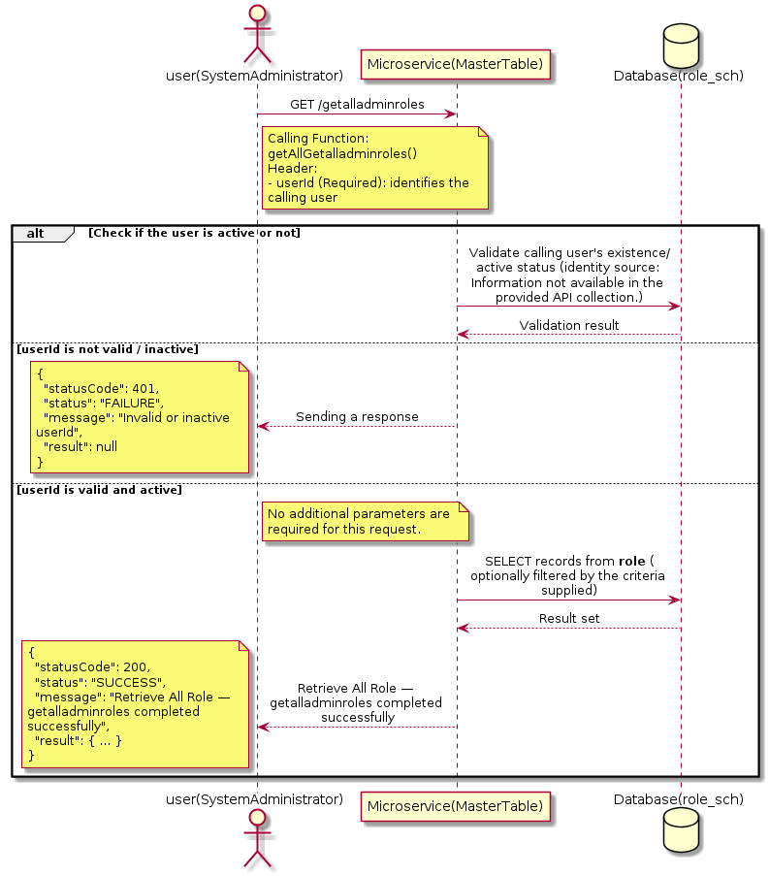

3.16.11.3 API Endpoint
Method | GET
URL | http://localhost:7002/srv2/genie/getalladminroles
Headers | userId: 67
Authorization | Not present in the captured request. Information not available in the provided API collection.
Content-Type | application/json (assumed)
Query Parameters | None
Path Variables | None
Request Body:
Not applicable — this operation does not accept a request body.
Response Body (illustrative — see 3.x.4.5 Success Response for details):
The source Postman collection does not include a captured sample response for this request (the response array is empty). Information not available in the provided API collection. Section 3.16.11.4.5 below presents the response envelope inferred from the standard response wrapper used consistently by this platform's services.

3.16.11.4 Detailed Process Flow

3.16.11.4.1 Request Initiation
The flow begins when System Administrator (or a calling microservice on their behalf) invokes the GET endpoint http://localhost:7002/srv2/genie/getalladminroles. The request must include the mandatory `userId` header used by the Master Table Microservice to identify the calling user for auditing purposes. At the Controller layer, Spring Boot's request-mapping infrastructure routes the call to the appropriate handler method (`getAllGetalladminroles`), and Bean Validation annotations (if configured on the DTO) perform structural validation before the request reaches the Service layer. Information not available in the provided API collection. regarding the exact validation annotations used in the source code.

3.16.11.4.2 User Validation
The Master Table Microservice relies on the `userId` header to identify the calling user. Based on the pattern observed consistently across this API collection, the platform's authentication/authorization is expected to be enforced upstream (e.g., by an API Gateway or a shared security filter) using this identifier; the Postman collection does not include an `Authorization` / `Bearer` token header on this request, so the exact authentication mechanism (JWT validation, session lookup, or gateway-level SSO) is Information not available in the provided API collection. Role-based authorization — i.e., confirming that the user identified by `userId` holds a role/permission entitled to perform this operation — is expected to be enforced by the Service layer (see Section 8 – Controller Analysis and Section 14 – Authentication & Authorization), but the specific role/permission checks are Information not available in the provided API collection.

3.16.11.4.3 Business Logic
The Service layer contains no conditional business branching for this operation beyond invoking the Repository to fetch all Role records. Depending on the record volume, the Service layer may apply default sorting (e.g., by name or creation order) before returning the list.

3.16.11.4.4 Database Interaction
The Repository layer (Spring Data JPA) interacts with the underlying relational database that backs the Role master table. The primary operation issued is a **SELECT** against the table associated with Role. No write operations occur; the query returns all rows that satisfy the entity's default scope (typically active records). The exact table name, column names, primary/foreign key definitions, and JPA repository method signatures are not included in the Postman collection; therefore, precise schema details are information not available in the provided api collection.

3.16.11.4.5 Success Response
Status Code: 200 OK. Sample response envelope (illustrative — the source collection did not capture a sample response for this API):
{
"statusCode": 200,
"status": "SUCCESS",
"message": "Retrieve All Role — getalladminroles completed successfully",
"result": [
{
"id": 1,
"name": "Sample Role",
"isActive": 1
}
],
"error": null,
"corelationId": "c6f2a1e4-2b3d-4a9e-9f1a-1234567890ab",
"url": null
}

3.16.11.4.6 Conclusion
This API provides a well-defined, single-purpose capability within the Master Table Microservice for retrieve all role — getalladminroles. The Controller → Service → Repository → Database layering keeps request validation, business rules, and persistence concerns separated, which allows the Role master data to be maintained consistently and safely by authorized administrators while remaining available for consumption by every other module that depends on this reference data.

3.16.12 Retrieve All Role — businessunit

3.16.12.1 Overview
Purpose: To retrieve the complete list of Role master records configured in the Master Table Microservice, so that consuming screens and downstream services can populate dropdowns, grids, and configuration views.
Business Requirement: Every screen and workflow that references Role data (creation forms, filters, reports) needs an authoritative, always-current list of active Role values sourced from a single master table rather than being hard-coded.
Who Uses the API: System Administrator / Security Administrator, and any internal microservice/UI module that needs to render Role options.
Business Flow: Client sends a GET request → Controller delegates to the Service layer → Service layer calls the Repository → Repository queries the Role table → the result set is mapped to response DTOs and returned to the Client.

3.16.12.2 Sequence Diagram
The diagram below illustrates the end-to-end interaction for "Retrieve All Role — businessunit" across the Client, Controller, Service, Repository, and Database layers.
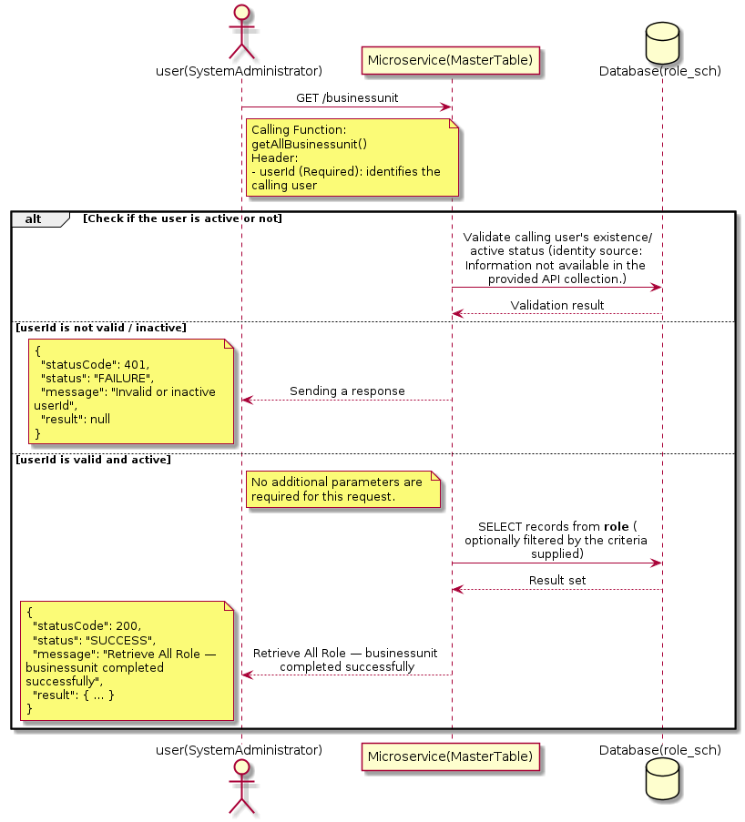

3.16.12.3 API Endpoint
Method | GET
URL | http://localhost:7002/srv2/genie/businessunit
Headers | userId: 67
Authorization | Not present in the captured request. Information not available in the provided API collection.
Content-Type | application/json (assumed)
Query Parameters | None
Path Variables | None
Request Body:
Not applicable — this operation does not accept a request body.
Response Body (illustrative — see 3.x.4.5 Success Response for details):
The source Postman collection does not include a captured sample response for this request (the response array is empty). Information not available in the provided API collection. Section 3.16.12.4.5 below presents the response envelope inferred from the standard response wrapper used consistently by this platform's services.

3.16.12.4 Detailed Process Flow

3.16.12.4.1 Request Initiation
The flow begins when System Administrator (or a calling microservice on their behalf) invokes the GET endpoint http://localhost:7002/srv2/genie/businessunit. The request must include the mandatory `userId` header used by the Master Table Microservice to identify the calling user for auditing purposes. At the Controller layer, Spring Boot's request-mapping infrastructure routes the call to the appropriate handler method (`getAllBusinessunit`), and Bean Validation annotations (if configured on the DTO) perform structural validation before the request reaches the Service layer. Information not available in the provided API collection. regarding the exact validation annotations used in the source code.

3.16.12.4.2 User Validation
The Master Table Microservice relies on the `userId` header to identify the calling user. Based on the pattern observed consistently across this API collection, the platform's authentication/authorization is expected to be enforced upstream (e.g., by an API Gateway or a shared security filter) using this identifier; the Postman collection does not include an `Authorization` / `Bearer` token header on this request, so the exact authentication mechanism (JWT validation, session lookup, or gateway-level SSO) is Information not available in the provided API collection. Role-based authorization — i.e., confirming that the user identified by `userId` holds a role/permission entitled to perform this operation — is expected to be enforced by the Service layer (see Section 8 – Controller Analysis and Section 14 – Authentication & Authorization), but the specific role/permission checks are Information not available in the provided API collection.

3.16.12.4.3 Business Logic
The Service layer contains no conditional business branching for this operation beyond invoking the Repository to fetch all Role records. Depending on the record volume, the Service layer may apply default sorting (e.g., by name or creation order) before returning the list.

3.16.12.4.4 Database Interaction
The Repository layer (Spring Data JPA) interacts with the underlying relational database that backs the Role master table. The primary operation issued is a **SELECT** against the table associated with Role. No write operations occur; the query returns all rows that satisfy the entity's default scope (typically active records). The exact table name, column names, primary/foreign key definitions, and JPA repository method signatures are not included in the Postman collection; therefore, precise schema details are information not available in the provided api collection.

3.16.12.4.5 Success Response
Status Code: 200 OK. Sample response envelope (illustrative — the source collection did not capture a sample response for this API):
{
"statusCode": 200,
"status": "SUCCESS",
"message": "Retrieve All Role — businessunit completed successfully",
"result": [
{
"id": 1,
"name": "Sample Role",
"isActive": 1
}
],
"error": null,
"corelationId": "c6f2a1e4-2b3d-4a9e-9f1a-1234567890ab",
"url": null
}

3.16.12.4.6 Conclusion
This API provides a well-defined, single-purpose capability within the Master Table Microservice for retrieve all role — businessunit. The Controller → Service → Repository → Database layering keeps request validation, business rules, and persistence concerns separated, which allows the Role master data to be maintained consistently and safely by authorized administrators while remaining available for consumption by every other module that depends on this reference data.

3.16.13 Retrieve All Role — businessrole

3.16.13.1 Overview
Purpose: To retrieve the complete list of Role master records configured in the Master Table Microservice, so that consuming screens and downstream services can populate dropdowns, grids, and configuration views.
Business Requirement: Every screen and workflow that references Role data (creation forms, filters, reports) needs an authoritative, always-current list of active Role values sourced from a single master table rather than being hard-coded.
Who Uses the API: System Administrator / Security Administrator, and any internal microservice/UI module that needs to render Role options.
Business Flow: Client sends a GET request → Controller delegates to the Service layer → Service layer calls the Repository → Repository queries the Role table → the result set is mapped to response DTOs and returned to the Client.

3.16.13.2 Sequence Diagram
The diagram below illustrates the end-to-end interaction for "Retrieve All Role — businessrole" across the Client, Controller, Service, Repository, and Database layers.
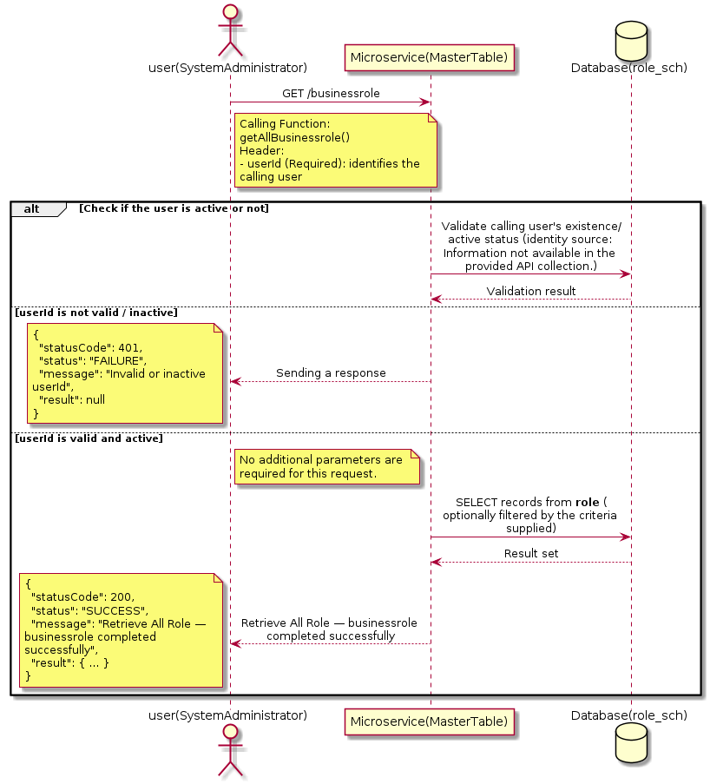

3.16.13.3 API Endpoint
Method | GET
URL | http://localhost:7002/srv2/genie/businessrole
Headers | userId: 67
Authorization | Not present in the captured request. Information not available in the provided API collection.
Content-Type | application/json (assumed)
Query Parameters | None
Path Variables | None
Request Body:
Not applicable — this operation does not accept a request body.
Response Body (illustrative — see 3.x.4.5 Success Response for details):
The source Postman collection does not include a captured sample response for this request (the response array is empty). Information not available in the provided API collection. Section 3.16.13.4.5 below presents the response envelope inferred from the standard response wrapper used consistently by this platform's services.

3.16.13.4 Detailed Process Flow

3.16.13.4.1 Request Initiation
The flow begins when System Administrator (or a calling microservice on their behalf) invokes the GET endpoint http://localhost:7002/srv2/genie/businessrole. The request must include the mandatory `userId` header used by the Master Table Microservice to identify the calling user for auditing purposes. At the Controller layer, Spring Boot's request-mapping infrastructure routes the call to the appropriate handler method (`getAllBusinessrole`), and Bean Validation annotations (if configured on the DTO) perform structural validation before the request reaches the Service layer. Information not available in the provided API collection. regarding the exact validation annotations used in the source code.

3.16.13.4.2 User Validation
The Master Table Microservice relies on the `userId` header to identify the calling user. Based on the pattern observed consistently across this API collection, the platform's authentication/authorization is expected to be enforced upstream (e.g., by an API Gateway or a shared security filter) using this identifier; the Postman collection does not include an `Authorization` / `Bearer` token header on this request, so the exact authentication mechanism (JWT validation, session lookup, or gateway-level SSO) is Information not available in the provided API collection. Role-based authorization — i.e., confirming that the user identified by `userId` holds a role/permission entitled to perform this operation — is expected to be enforced by the Service layer (see Section 8 – Controller Analysis and Section 14 – Authentication & Authorization), but the specific role/permission checks are Information not available in the provided API collection.

3.16.13.4.3 Business Logic
The Service layer contains no conditional business branching for this operation beyond invoking the Repository to fetch all Role records. Depending on the record volume, the Service layer may apply default sorting (e.g., by name or creation order) before returning the list.

3.16.13.4.4 Database Interaction
The Repository layer (Spring Data JPA) interacts with the underlying relational database that backs the Role master table. The primary operation issued is a **SELECT** against the table associated with Role. No write operations occur; the query returns all rows that satisfy the entity's default scope (typically active records). The exact table name, column names, primary/foreign key definitions, and JPA repository method signatures are not included in the Postman collection; therefore, precise schema details are information not available in the provided api collection.

3.16.13.4.5 Success Response
Status Code: 200 OK. Sample response envelope (illustrative — the source collection did not capture a sample response for this API):
{
"statusCode": 200,
"status": "SUCCESS",
"message": "Retrieve All Role — businessrole completed successfully",
"result": [
{
"id": 1,
"name": "Sample Role",
"isActive": 1
}
],
"error": null,
"corelationId": "c6f2a1e4-2b3d-4a9e-9f1a-1234567890ab",
"url": null
}

3.16.13.4.6 Conclusion
This API provides a well-defined, single-purpose capability within the Master Table Microservice for retrieve all role — businessrole. The Controller → Service → Repository → Database layering keeps request validation, business rules, and persistence concerns separated, which allows the Role master data to be maintained consistently and safely by authorized administrators while remaining available for consumption by every other module that depends on this reference data.

3.17 SLA Type & Timezone APIs (SLA Types)
Maintains SLA type definitions, SLA time zones, and the calendar/holiday configuration used to compute SLA due dates and breach status for tickets.

3.17.1 Update SLA Type & Timezone — slatype

3.17.1.1 Overview
Purpose: To update an existing SLA Type & Timezone master record, allowing administrators to correct or evolve master-data attributes without impacting the record's identity/history.
Business Requirement: Master data changes over time (renames, corrections, re-classification); the platform must allow controlled updates while preserving referential integrity for records that already reference this SLA Type & Timezone.
Who Uses the API: System Administrator responsible for maintaining master-data accuracy.
Business Flow: Client sends a PUT/PATCH request with the updated SLA Type & Timezone payload → Controller validates the payload → Service layer fetches the existing record, applies the changes, and re-validates business rules → Repository persists the updated record → the updated record is returned to the Client.

3.17.1.2 Sequence Diagram
The diagram below illustrates the end-to-end interaction for "Update SLA Type & Timezone — slatype" across the Client, Controller, Service, Repository, and Database layers.
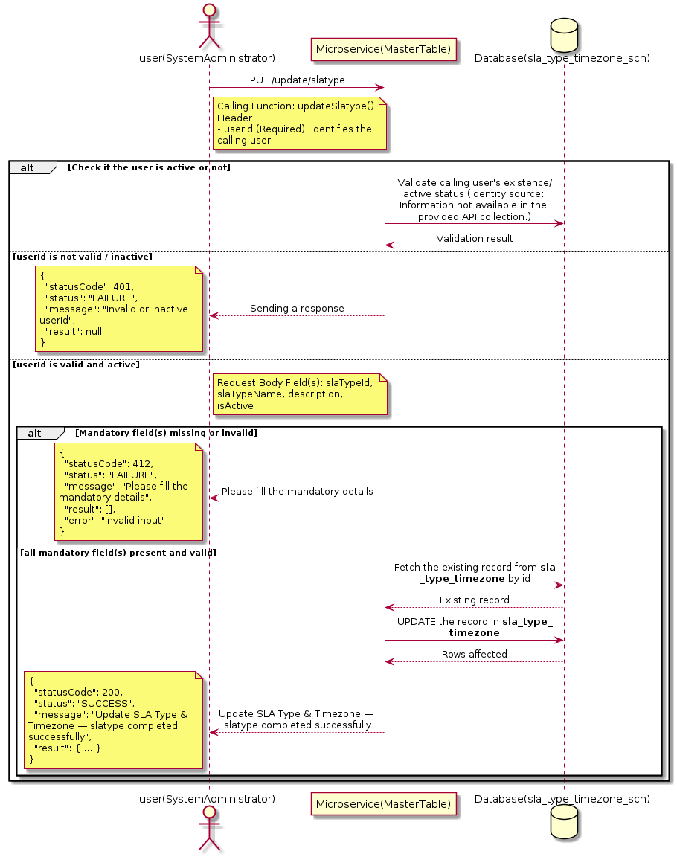

3.17.1.3 API Endpoint
Method | PUT
URL | http://localhost:7002/srv2/genie/update/slatype
Headers | Content-Type: application/json userId: 879
Authorization | Not present in the captured request. Information not available in the provided API collection.
Content-Type | Content-Type: application/json
Query Parameters | None
Path Variables | None
Request Body:
{
"slaTypeId": 3,
"slaTypeName": "Premium SLA Updated",
"description": "Updated premium support SLA",
"isActive": "1"
}
Response Body (illustrative — see 3.x.4.5 Success Response for details):
The source Postman collection does not include a captured sample response for this request (the response array is empty). Information not available in the provided API collection. Section 3.17.1.4.5 below presents the response envelope inferred from the standard response wrapper used consistently by this platform's services.

3.17.1.4 Detailed Process Flow

3.17.1.4.1 Request Initiation
The flow begins when System Administrator (or a calling microservice on their behalf) invokes the PUT endpoint http://localhost:7002/srv2/genie/update/slatype. The request must include the mandatory `userId` header used by the Master Table Microservice to identify the calling user for auditing purposes. The request carries a JSON payload in the request body which the Controller binds to its Data Transfer Object (DTO) before any processing begins. At the Controller layer, Spring Boot's request-mapping infrastructure routes the call to the appropriate handler method (`updateSlatype`), and Bean Validation annotations (if configured on the DTO) perform structural validation before the request reaches the Service layer. Information not available in the provided API collection. regarding the exact validation annotations used in the source code.

3.17.1.4.2 User Validation
The Master Table Microservice relies on the `userId` header to identify the calling user. Based on the pattern observed consistently across this API collection, the platform's authentication/authorization is expected to be enforced upstream (e.g., by an API Gateway or a shared security filter) using this identifier; the Postman collection does not include an `Authorization` / `Bearer` token header on this request, so the exact authentication mechanism (JWT validation, session lookup, or gateway-level SSO) is Information not available in the provided API collection. Role-based authorization — i.e., confirming that the user identified by `userId` holds a role/permission entitled to perform this operation — is expected to be enforced by the Service layer (see Section 8 – Controller Analysis and Section 14 – Authentication & Authorization), but the specific role/permission checks are Information not available in the provided API collection.

3.17.1.4.3 Business Logic
The Service layer fetches the existing SLA Type & Timezone record by its identifier, verifies it exists, applies the incoming changes field by field, re-validates business rules (e.g., uniqueness of a renamed field), and persists the updated entity via the Repository. If the record does not exist, the operation is rejected with a not-found error. The key fields exchanged for this operation, as observed in the sample payload, are: `slaTypeId`, `slaTypeName`, `description`, `isActive`.

3.17.1.4.4 Database Interaction
The Repository layer (Spring Data JPA) interacts with the underlying relational database that backs the SLA Type & Timezone master table. The primary operation issued is a **UPDATE** against the table associated with SLA Type & Timezone. The existing row is located by primary key and updated; if the entity has related child records, the existing child rows are typically replaced/updated within the same transaction. The exact table name, column names, primary/foreign key definitions, and JPA repository method signatures are not included in the Postman collection; therefore, precise schema details are information not available in the provided api collection.

3.17.1.4.5 Success Response
Status Code: 200 OK. Sample response envelope (illustrative — the source collection did not capture a sample response for this API):
{
"statusCode": 200,
"status": "SUCCESS",
"message": "Update SLA Type & Timezone — slatype completed successfully",
"result": {
"id": 1,
"isActive": 1
},
"error": null,
"corelationId": "c6f2a1e4-2b3d-4a9e-9f1a-1234567890ab",
"url": null
}

3.17.1.4.6 Conclusion
This API provides a well-defined, single-purpose capability within the Master Table Microservice for update sla type & timezone — slatype. The Controller → Service → Repository → Database layering keeps request validation, business rules, and persistence concerns separated, which allows the SLA Type & Timezone master data to be maintained consistently and safely by authorized administrators while remaining available for consumption by every other module that depends on this reference data.
3.17.2 Update SLA Type & Timezone — update/slatimezone

3.17.2.1 Overview
Purpose: To update an existing SLA Type & Timezone master record, allowing administrators to correct or evolve master-data attributes without impacting the record's identity/history.
Business Requirement: Master data changes over time (renames, corrections, re-classification); the platform must allow controlled updates while preserving referential integrity for records that already reference this SLA Type & Timezone.
Who Uses the API: System Administrator responsible for maintaining master-data accuracy.
Business Flow: Client sends a PUT/PATCH request with the updated SLA Type & Timezone payload → Controller validates the payload → Service layer fetches the existing record, applies the changes, and re-validates business rules → Repository persists the updated record → the updated record is returned to the Client.

3.17.2.2 Sequence Diagram
The diagram below illustrates the end-to-end interaction for "Update SLA Type & Timezone — update/slatimezone" across the Client, Controller, Service, Repository, and Database layers.
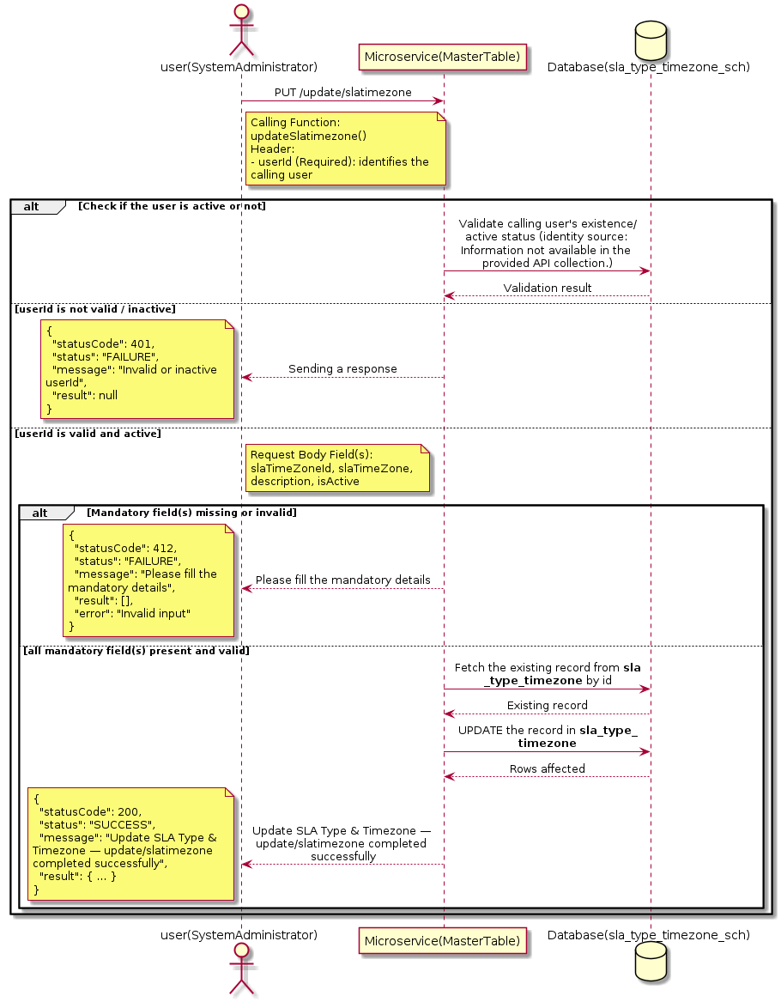

3.17.2.3 API Endpoint
Method | PUT
URL | http://localhost:7002/srv2/genie/update/slatimezone
Headers | Content-Type: application/json userId: 879
Authorization | Not present in the captured request. Information not available in the provided API collection.
Content-Type | Content-Type: application/json
Query Parameters | None
Path Variables | None
Request Body:
{
"slaTimeZoneId": 2,
"slaTimeZone": "IST_Updated",
"description": "Updated Indian Standard Time",
"isActive": "1"
}
Response Body (illustrative — see 3.x.4.5 Success Response for details):
The source Postman collection does not include a captured sample response for this request (the response array is empty). Information not available in the provided API collection. Section 3.17.2.4.5 below presents the response envelope inferred from the standard response wrapper used consistently by this platform's services.

3.17.2.4 Detailed Process Flow

3.17.2.4.1 Request Initiation
The flow begins when System Administrator (or a calling microservice on their behalf) invokes the PUT endpoint http://localhost:7002/srv2/genie/update/slatimezone. The request must include the mandatory `userId` header used by the Master Table Microservice to identify the calling user for auditing purposes. The request carries a JSON payload in the request body which the Controller binds to its Data Transfer Object (DTO) before any processing begins. At the Controller layer, Spring Boot's request-mapping infrastructure routes the call to the appropriate handler method (`updateSlatimezone`), and Bean Validation annotations (if configured on the DTO) perform structural validation before the request reaches the Service layer. Information not available in the provided API collection. regarding the exact validation annotations used in the source code.

3.17.2.4.2 User Validation
The Master Table Microservice relies on the `userId` header to identify the calling user. Based on the pattern observed consistently across this API collection, the platform's authentication/authorization is expected to be enforced upstream (e.g., by an API Gateway or a shared security filter) using this identifier; the Postman collection does not include an `Authorization` / `Bearer` token header on this request, so the exact authentication mechanism (JWT validation, session lookup, or gateway-level SSO) is Information not available in the provided API collection. Role-based authorization — i.e., confirming that the user identified by `userId` holds a role/permission entitled to perform this operation — is expected to be enforced by the Service layer (see Section 8 – Controller Analysis and Section 14 – Authentication & Authorization), but the specific role/permission checks are Information not available in the provided API collection.

3.17.2.4.3 Business Logic
The Service layer fetches the existing SLA Type & Timezone record by its identifier, verifies it exists, applies the incoming changes field by field, re-validates business rules (e.g., uniqueness of a renamed field), and persists the updated entity via the Repository. If the record does not exist, the operation is rejected with a not-found error. The key fields exchanged for this operation, as observed in the sample payload, are: `slaTimeZoneId`, `slaTimeZone`, `description`, `isActive`.

3.17.2.4.4 Database Interaction
The Repository layer (Spring Data JPA) interacts with the underlying relational database that backs the SLA Type & Timezone master table. The primary operation issued is a **UPDATE** against the table associated with SLA Type & Timezone. The existing row is located by primary key and updated; if the entity has related child records, the existing child rows are typically replaced/updated within the same transaction. The exact table name, column names, primary/foreign key definitions, and JPA repository method signatures are not included in the Postman collection; therefore, precise schema details are information not available in the provided api collection.

3.17.2.4.5 Success Response
Status Code: 200 OK. Sample response envelope (illustrative — the source collection did not capture a sample response for this API):
{
"statusCode": 200,
"status": "SUCCESS",
"message": "Update SLA Type & Timezone — update/slatimezone completed successfully",
"result": {
"id": 1,
"isActive": 1
},
"error": null,
"corelationId": "c6f2a1e4-2b3d-4a9e-9f1a-1234567890ab",
"url": null
}

3.17.2.4.6 Conclusion
This API provides a well-defined, single-purpose capability within the Master Table Microservice for update sla type & timezone — update/slatimezone. The Controller → Service → Repository → Database layering keeps request validation, business rules, and persistence concerns separated, which allows the SLA Type & Timezone master data to be maintained consistently and safely by authorized administrators while remaining available for consumption by every other module that depends on this reference data.
3.17.3 Update SLA Type & Timezone — slatarget

3.17.3.1 Overview
Purpose: To update an existing SLA Type & Timezone master record, allowing administrators to correct or evolve master-data attributes without impacting the record's identity/history.
Business Requirement: Master data changes over time (renames, corrections, re-classification); the platform must allow controlled updates while preserving referential integrity for records that already reference this SLA Type & Timezone.
Who Uses the API: System Administrator responsible for maintaining master-data accuracy.
Business Flow: Client sends a PUT/PATCH request with the updated SLA Type & Timezone payload → Controller validates the payload → Service layer fetches the existing record, applies the changes, and re-validates business rules → Repository persists the updated record → the updated record is returned to the Client.

3.17.3.2 Sequence Diagram
The diagram below illustrates the end-to-end interaction for "Update SLA Type & Timezone — slatarget" across the Client, Controller, Service, Repository, and Database layers.
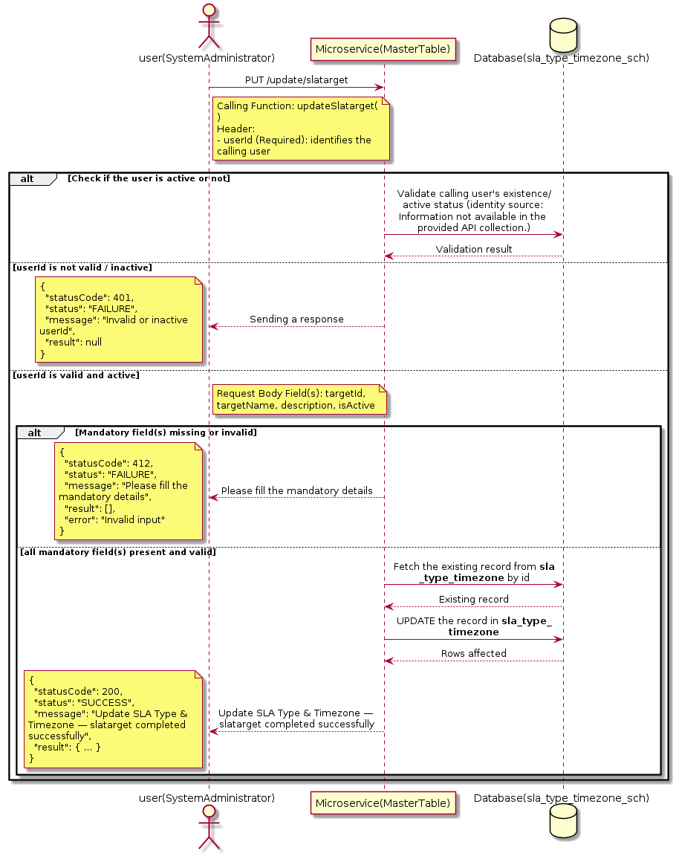

3.17.3.3 API Endpoint
Method | PUT
URL | http://localhost:7002/srv2/genie/update/slatarget
Headers | Content-Type: application/json userId: 879
Authorization | Not present in the captured request. Information not available in the provided API collection.
Content-Type | Content-Type: application/json
Query Parameters | None
Path Variables | None
Request Body:
{
"targetId": 4,
"targetName": "Response Time Updated",
"description": "Updated response time target",
"isActive": "1"
}
Response Body (illustrative — see 3.x.4.5 Success Response for details):
The source Postman collection does not include a captured sample response for this request (the response array is empty). Information not available in the provided API collection. Section 3.17.3.4.5 below presents the response envelope inferred from the standard response wrapper used consistently by this platform's services.

3.17.3.4 Detailed Process Flow

3.17.3.4.1 Request Initiation
The flow begins when System Administrator (or a calling microservice on their behalf) invokes the PUT endpoint http://localhost:7002/srv2/genie/update/slatarget. The request must include the mandatory `userId` header used by the Master Table Microservice to identify the calling user for auditing purposes. The request carries a JSON payload in the request body which the Controller binds to its Data Transfer Object (DTO) before any processing begins. At the Controller layer, Spring Boot's request-mapping infrastructure routes the call to the appropriate handler method (`updateSlatarget`), and Bean Validation annotations (if configured on the DTO) perform structural validation before the request reaches the Service layer. Information not available in the provided API collection. regarding the exact validation annotations used in the source code.

3.17.3.4.2 User Validation
The Master Table Microservice relies on the `userId` header to identify the calling user. Based on the pattern observed consistently across this API collection, the platform's authentication/authorization is expected to be enforced upstream (e.g., by an API Gateway or a shared security filter) using this identifier; the Postman collection does not include an `Authorization` / `Bearer` token header on this request, so the exact authentication mechanism (JWT validation, session lookup, or gateway-level SSO) is Information not available in the provided API collection. Role-based authorization — i.e., confirming that the user identified by `userId` holds a role/permission entitled to perform this operation — is expected to be enforced by the Service layer (see Section 8 – Controller Analysis and Section 14 – Authentication & Authorization), but the specific role/permission checks are Information not available in the provided API collection.

3.17.3.4.3 Business Logic
The Service layer fetches the existing SLA Type & Timezone record by its identifier, verifies it exists, applies the incoming changes field by field, re-validates business rules (e.g., uniqueness of a renamed field), and persists the updated entity via the Repository. If the record does not exist, the operation is rejected with a not-found error. The key fields exchanged for this operation, as observed in the sample payload, are: `targetId`, `targetName`, `description`, `isActive`.

3.17.3.4.4 Database Interaction
The Repository layer (Spring Data JPA) interacts with the underlying relational database that backs the SLA Type & Timezone master table. The primary operation issued is a **UPDATE** against the table associated with SLA Type & Timezone. The existing row is located by primary key and updated; if the entity has related child records, the existing child rows are typically replaced/updated within the same transaction. The exact table name, column names, primary/foreign key definitions, and JPA repository method signatures are not included in the Postman collection; therefore, precise schema details are information not available in the provided api collection.

3.17.3.4.5 Success Response
Status Code: 200 OK. Sample response envelope (illustrative — the source collection did not capture a sample response for this API):
{
"statusCode": 200,
"status": "SUCCESS",
"message": "Update SLA Type & Timezone — slatarget completed successfully",
"result": {
"id": 1,
"isActive": 1
},
"error": null,
"corelationId": "c6f2a1e4-2b3d-4a9e-9f1a-1234567890ab",
"url": null
}

3.17.3.4.6 Conclusion
This API provides a well-defined, single-purpose capability within the Master Table Microservice for update sla type & timezone — slatarget. The Controller → Service → Repository → Database layering keeps request validation, business rules, and persistence concerns separated, which allows the SLA Type & Timezone master data to be maintained consistently and safely by authorized administrators while remaining available for consumption by every other module that depends on this reference data.
3.17.4 Update SLA Type & Timezone — slaschedule

3.17.4.1 Overview
Purpose: To update an existing SLA Type & Timezone master record, allowing administrators to correct or evolve master-data attributes without impacting the record's identity/history.
Business Requirement: Master data changes over time (renames, corrections, re-classification); the platform must allow controlled updates while preserving referential integrity for records that already reference this SLA Type & Timezone.
Who Uses the API: System Administrator responsible for maintaining master-data accuracy.
Business Flow: Client sends a PUT/PATCH request with the updated SLA Type & Timezone payload → Controller validates the payload → Service layer fetches the existing record, applies the changes, and re-validates business rules → Repository persists the updated record → the updated record is returned to the Client.

3.17.4.2 Sequence Diagram
The diagram below illustrates the end-to-end interaction for "Update SLA Type & Timezone — slaschedule" across the Client, Controller, Service, Repository, and Database layers.
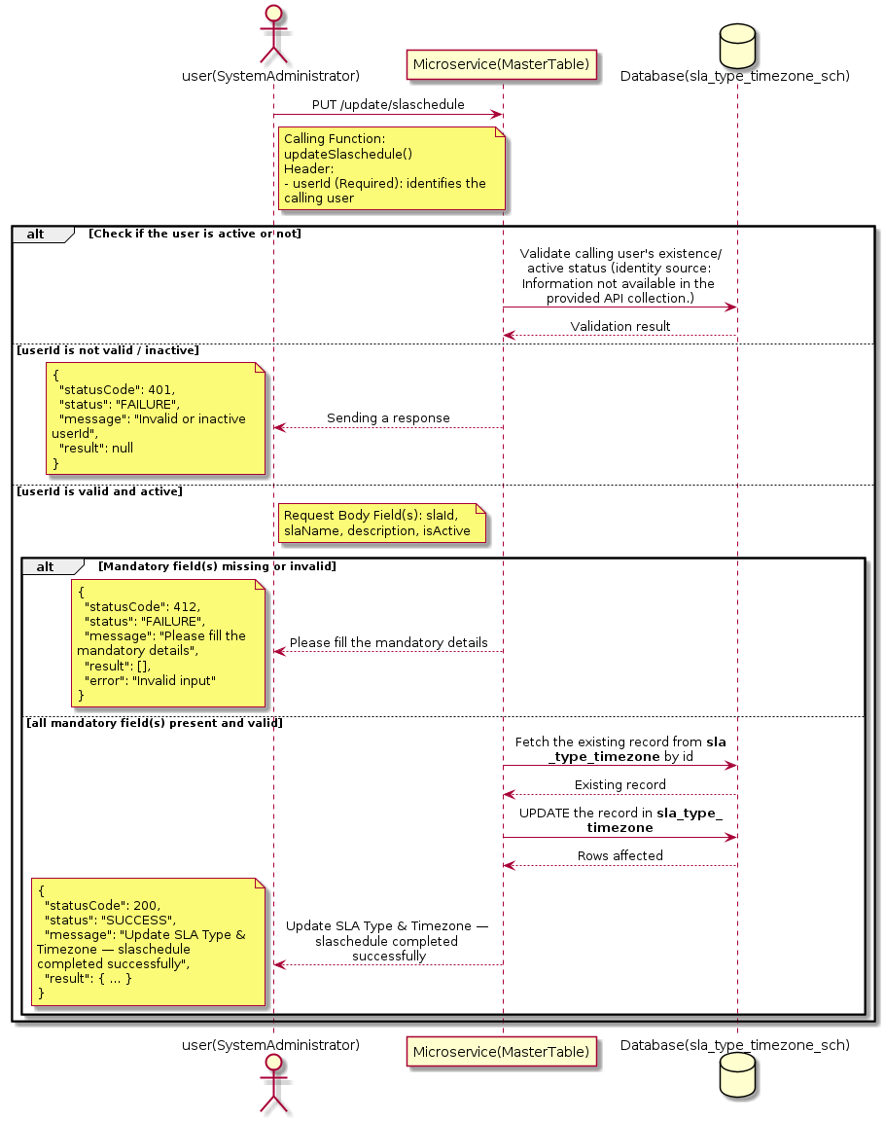

3.17.4.3 API Endpoint
Method | PUT
URL | http://localhost:7002/srv2/genie/update/slaschedule
Headers | Content-Type: application/json userId: 879
Authorization | Not present in the captured request. Information not available in the provided API collection.
Content-Type | Content-Type: application/json
Query Parameters | None
Path Variables | None
Request Body:
{
"slaId": 2,
"slaName": "Business Hours Updated",
"description": "Updated 9 AM to 6 PM",
"isActive": "1"
}
Response Body (illustrative — see 3.x.4.5 Success Response for details):
The source Postman collection does not include a captured sample response for this request (the response array is empty). Information not available in the provided API collection. Section 3.17.4.4.5 below presents the response envelope inferred from the standard response wrapper used consistently by this platform's services.

3.17.4.4 Detailed Process Flow

3.17.4.4.1 Request Initiation
The flow begins when System Administrator (or a calling microservice on their behalf) invokes the PUT endpoint http://localhost:7002/srv2/genie/update/slaschedule. The request must include the mandatory `userId` header used by the Master Table Microservice to identify the calling user for auditing purposes. The request carries a JSON payload in the request body which the Controller binds to its Data Transfer Object (DTO) before any processing begins. At the Controller layer, Spring Boot's request-mapping infrastructure routes the call to the appropriate handler method (`updateSlaschedule`), and Bean Validation annotations (if configured on the DTO) perform structural validation before the request reaches the Service layer. Information not available in the provided API collection. regarding the exact validation annotations used in the source code.

3.17.4.4.2 User Validation
The Master Table Microservice relies on the `userId` header to identify the calling user. Based on the pattern observed consistently across this API collection, the platform's authentication/authorization is expected to be enforced upstream (e.g., by an API Gateway or a shared security filter) using this identifier; the Postman collection does not include an `Authorization` / `Bearer` token header on this request, so the exact authentication mechanism (JWT validation, session lookup, or gateway-level SSO) is Information not available in the provided API collection. Role-based authorization — i.e., confirming that the user identified by `userId` holds a role/permission entitled to perform this operation — is expected to be enforced by the Service layer (see Section 8 – Controller Analysis and Section 14 – Authentication & Authorization), but the specific role/permission checks are Information not available in the provided API collection.

3.17.4.4.3 Business Logic
The Service layer fetches the existing SLA Type & Timezone record by its identifier, verifies it exists, applies the incoming changes field by field, re-validates business rules (e.g., uniqueness of a renamed field), and persists the updated entity via the Repository. If the record does not exist, the operation is rejected with a not-found error. The key fields exchanged for this operation, as observed in the sample payload, are: `slaId`, `slaName`, `description`, `isActive`.

3.17.4.4.4 Database Interaction
The Repository layer (Spring Data JPA) interacts with the underlying relational database that backs the SLA Type & Timezone master table. The primary operation issued is a **UPDATE** against the table associated with SLA Type & Timezone. The existing row is located by primary key and updated; if the entity has related child records, the existing child rows are typically replaced/updated within the same transaction. The exact table name, column names, primary/foreign key definitions, and JPA repository method signatures are not included in the Postman collection; therefore, precise schema details are information not available in the provided api collection.

3.17.4.4.5 Success Response
Status Code: 200 OK. Sample response envelope (illustrative — the source collection did not capture a sample response for this API):
{
"statusCode": 200,
"status": "SUCCESS",
"message": "Update SLA Type & Timezone — slaschedule completed successfully",
"result": {
"id": 1,
"isActive": 1
},
"error": null,
"corelationId": "c6f2a1e4-2b3d-4a9e-9f1a-1234567890ab",
"url": null
}

3.17.4.4.6 Conclusion
This API provides a well-defined, single-purpose capability within the Master Table Microservice for update sla type & timezone — slaschedule. The Controller → Service → Repository → Database layering keeps request validation, business rules, and persistence concerns separated, which allows the SLA Type & Timezone master data to be maintained consistently and safely by authorized administrators while remaining available for consumption by every other module that depends on this reference data.
3.17.5 Enable / Disable SLA Type & Timezone

3.17.5.1 Overview
Purpose: To enable or disable (soft-delete) a SLA Type & Timezone master record, allowing administrators to retire a record from active use while preserving it for historical/audit purposes.
Business Requirement: Rather than physically deleting a SLA Type & Timezone record (which could break referential integrity with historical tickets/records that reference it), the business requires a reversible enable/disable mechanism.
Who Uses the API: System Administrator responsible for activating/deactivating configuration values.
Business Flow: Client sends a request carrying the SLA Type & Timezone identifier and the desired active/inactive flag → Controller validates the payload → Service layer fetches the record and flips its status flag → Repository persists the change → the updated status is returned to the Client.

3.17.5.2 Sequence Diagram
The diagram below illustrates the end-to-end interaction for "Enable / Disable SLA Type & Timezone" across the Client, Controller, Service, Repository, and Database layers.
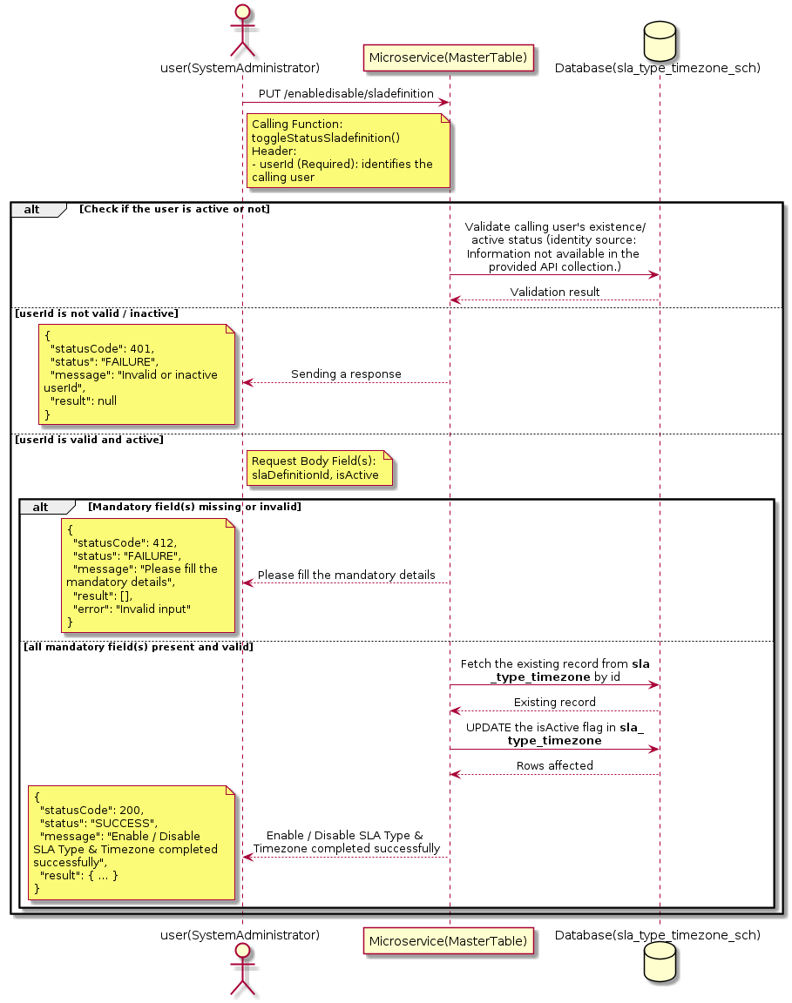

3.17.5.3 API Endpoint
Method | PUT
URL | http://localhost:7002/srv2/genie/enabledisable/sladefinition
Headers | Content-Type: application/json userId: 879
Authorization | Not present in the captured request. Information not available in the provided API collection.
Content-Type | Content-Type: application/json
Query Parameters | None
Path Variables | None
Request Body:
{
"slaDefinitionId": 5,
"isActive": "0"
}
Response Body (illustrative — see 3.x.4.5 Success Response for details):
The source Postman collection does not include a captured sample response for this request (the response array is empty). Information not available in the provided API collection. Section 3.17.5.4.5 below presents the response envelope inferred from the standard response wrapper used consistently by this platform's services.

3.17.5.4 Detailed Process Flow

3.17.5.4.1 Request Initiation
The flow begins when System Administrator (or a calling microservice on their behalf) invokes the PUT endpoint http://localhost:7002/srv2/genie/enabledisable/sladefinition. The request must include the mandatory `userId` header used by the Master Table Microservice to identify the calling user for auditing purposes. The request carries a JSON payload in the request body which the Controller binds to its Data Transfer Object (DTO) before any processing begins. At the Controller layer, Spring Boot's request-mapping infrastructure routes the call to the appropriate handler method (`toggleStatusSladefinition`), and Bean Validation annotations (if configured on the DTO) perform structural validation before the request reaches the Service layer. Information not available in the provided API collection. regarding the exact validation annotations used in the source code.

3.17.5.4.2 User Validation
The Master Table Microservice relies on the `userId` header to identify the calling user. Based on the pattern observed consistently across this API collection, the platform's authentication/authorization is expected to be enforced upstream (e.g., by an API Gateway or a shared security filter) using this identifier; the Postman collection does not include an `Authorization` / `Bearer` token header on this request, so the exact authentication mechanism (JWT validation, session lookup, or gateway-level SSO) is Information not available in the provided API collection. Role-based authorization — i.e., confirming that the user identified by `userId` holds a role/permission entitled to perform this operation — is expected to be enforced by the Service layer (see Section 8 – Controller Analysis and Section 14 – Authentication & Authorization), but the specific role/permission checks are Information not available in the provided API collection.

3.17.5.4.3 Business Logic
The Service layer fetches the existing SLA Type & Timezone record by its identifier and flips the `isActive` flag to the value supplied in the request. No other attributes of the record are modified by this operation. The key fields exchanged for this operation, as observed in the sample payload, are: `slaDefinitionId`, `isActive`.

3.17.5.4.4 Database Interaction
The Repository layer (Spring Data JPA) interacts with the underlying relational database that backs the SLA Type & Timezone master table. The primary operation issued is a **UPDATE** against the table associated with SLA Type & Timezone. Only the `is_active` (status) column is updated for the row identified by the primary key; all other columns remain unchanged. The exact table name, column names, primary/foreign key definitions, and JPA repository method signatures are not included in the Postman collection; therefore, precise schema details are information not available in the provided api collection.

3.17.5.4.5 Success Response
Status Code: 200 OK. Sample response envelope (illustrative — the source collection did not capture a sample response for this API):
{
"statusCode": 200,
"status": "SUCCESS",
"message": "Enable / Disable SLA Type & Timezone completed successfully",
"result": {
"id": 1,
"isActive": 1
},
"error": null,
"corelationId": "c6f2a1e4-2b3d-4a9e-9f1a-1234567890ab",
"url": null
}

3.17.5.4.6 Conclusion
This API provides a well-defined, single-purpose capability within the Master Table Microservice for enable / disable sla type & timezone. The Controller → Service → Repository → Database layering keeps request validation, business rules, and persistence concerns separated, which allows the SLA Type & Timezone master data to be maintained consistently and safely by authorized administrators while remaining available for consumption by every other module that depends on this reference data.

3.17.6 Update SLA Type & Timezone — update/sladefinition

3.17.6.1 Overview
Purpose: To update an existing SLA Type & Timezone master record, allowing administrators to correct or evolve master-data attributes without impacting the record's identity/history.
Business Requirement: Master data changes over time (renames, corrections, re-classification); the platform must allow controlled updates while preserving referential integrity for records that already reference this SLA Type & Timezone.
Who Uses the API: System Administrator responsible for maintaining master-data accuracy.
Business Flow: Client sends a PUT/PATCH request with the updated SLA Type & Timezone payload → Controller validates the payload → Service layer fetches the existing record, applies the changes, and re-validates business rules → Repository persists the updated record → the updated record is returned to the Client.

3.17.6.2 Sequence Diagram
The diagram below illustrates the end-to-end interaction for "Update SLA Type & Timezone — update/sladefinition" across the Client, Controller, Service, Repository, and Database layers.
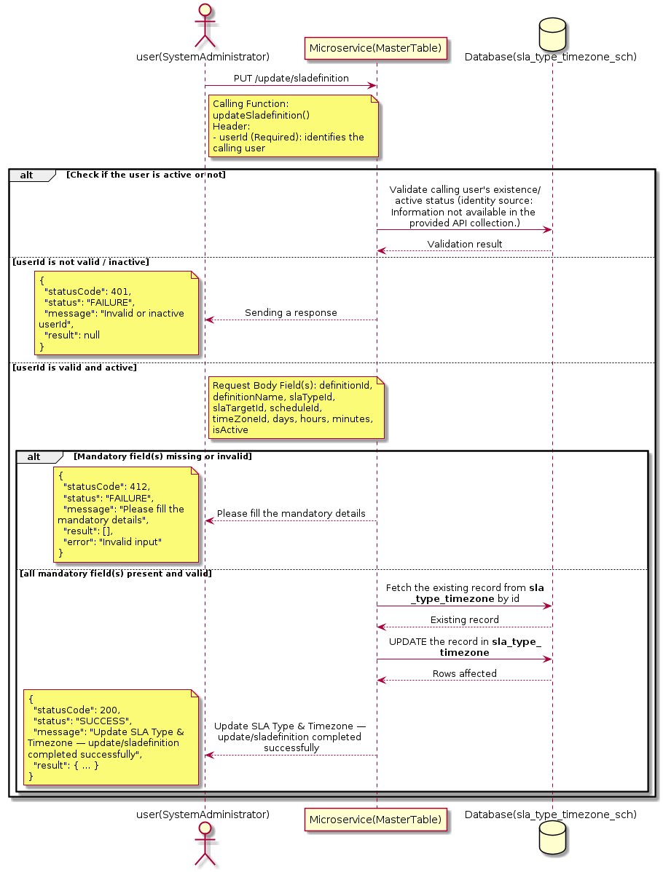

3.17.6.3 API Endpoint
Method | PUT
URL | http://localhost:7002/srv2/genie/update/sladefinition
Headers | Content-Type: application/json userId: 879
Authorization | Not present in the captured request. Information not available in the provided API collection.
Content-Type | Content-Type: application/json
Query Parameters | None
Path Variables | None
Request Body:
{
"definitionId": 4,
"definitionName": "Standard Response SLA Updated",
"slaTypeId": 3,
"slaTargetId": 4,
"scheduleId": 2,
"timeZoneId": 2,
"days": 0,
"hours": 8,
"minutes": 0,
"isActive": "1",
"startCondition": [],
"pauseCondtion": [],
"resumeCondition": [],
"stopCondtion": [],
"breached": [],
"reminders": []
}
Response Body (illustrative — see 3.x.4.5 Success Response for details):
The source Postman collection does not include a captured sample response for this request (the response array is empty). Information not available in the provided API collection. Section 3.17.6.4.5 below presents the response envelope inferred from the standard response wrapper used consistently by this platform's services.

3.17.6.4 Detailed Process Flow

3.17.6.4.1 Request Initiation
The flow begins when System Administrator (or a calling microservice on their behalf) invokes the PUT endpoint http://localhost:7002/srv2/genie/update/sladefinition. The request must include the mandatory `userId` header used by the Master Table Microservice to identify the calling user for auditing purposes. The request carries a JSON payload in the request body which the Controller binds to its Data Transfer Object (DTO) before any processing begins. At the Controller layer, Spring Boot's request-mapping infrastructure routes the call to the appropriate handler method (`updateSladefinition`), and Bean Validation annotations (if configured on the DTO) perform structural validation before the request reaches the Service layer. Information not available in the provided API collection. regarding the exact validation annotations used in the source code.

3.17.6.4.2 User Validation
The Master Table Microservice relies on the `userId` header to identify the calling user. Based on the pattern observed consistently across this API collection, the platform's authentication/authorization is expected to be enforced upstream (e.g., by an API Gateway or a shared security filter) using this identifier; the Postman collection does not include an `Authorization` / `Bearer` token header on this request, so the exact authentication mechanism (JWT validation, session lookup, or gateway-level SSO) is Information not available in the provided API collection. Role-based authorization — i.e., confirming that the user identified by `userId` holds a role/permission entitled to perform this operation — is expected to be enforced by the Service layer (see Section 8 – Controller Analysis and Section 14 – Authentication & Authorization), but the specific role/permission checks are Information not available in the provided API collection.

3.17.6.4.3 Business Logic
The Service layer fetches the existing SLA Type & Timezone record by its identifier, verifies it exists, applies the incoming changes field by field, re-validates business rules (e.g., uniqueness of a renamed field), and persists the updated entity via the Repository. If the record does not exist, the operation is rejected with a not-found error. The key fields exchanged for this operation, as observed in the sample payload, are: `definitionId`, `definitionName`, `slaTypeId`, `slaTargetId`, `scheduleId`, `timeZoneId`, `days`, `hours`, `minutes`, `isActive`.

3.17.6.4.4 Database Interaction
The Repository layer (Spring Data JPA) interacts with the underlying relational database that backs the SLA Type & Timezone master table. The primary operation issued is a **UPDATE** against the table associated with SLA Type & Timezone. The existing row is located by primary key and updated; if the entity has related child records, the existing child rows are typically replaced/updated within the same transaction. The exact table name, column names, primary/foreign key definitions, and JPA repository method signatures are not included in the Postman collection; therefore, precise schema details are information not available in the provided api collection.

3.17.6.4.5 Success Response
Status Code: 200 OK. Sample response envelope (illustrative — the source collection did not capture a sample response for this API):
{
"statusCode": 200,
"status": "SUCCESS",
"message": "Update SLA Type & Timezone — update/sladefinition completed successfully",
"result": {
"id": 1,
"isActive": 1
},
"error": null,
"corelationId": "c6f2a1e4-2b3d-4a9e-9f1a-1234567890ab",
"url": null
}

3.17.6.4.6 Conclusion
This API provides a well-defined, single-purpose capability within the Master Table Microservice for update sla type & timezone — update/sladefinition. The Controller → Service → Repository → Database layering keeps request validation, business rules, and persistence concerns separated, which allows the SLA Type & Timezone master data to be maintained consistently and safely by authorized administrators while remaining available for consumption by every other module that depends on this reference data.

3.17.7 Search / List SLA Type & Timezone — slatype/all

3.17.7.1 Overview
Purpose: To search and list SLA Type & Timezone records based on a search payload (e.g., free-text search or structured criteria), supporting list/grid screens that need paginated or filtered master data.
Business Requirement: List/search screens for SLA Type & Timezone configuration need server-side search so that administrators can locate specific records in large master tables without scanning the full data set.
Who Uses the API: System Administrator operating the SLA Type & Timezone configuration/list screen.
Business Flow: Client sends a POST request with a search payload → Controller validates the payload → Service layer constructs the search/query logic → Repository executes the search against the SLA Type & Timezone table → matching records are returned to the Client.

3.17.7.2 Sequence Diagram
The diagram below illustrates the end-to-end interaction for "Search / List SLA Type & Timezone — slatype/all" across the Client, Controller, Service, Repository, and Database layers.
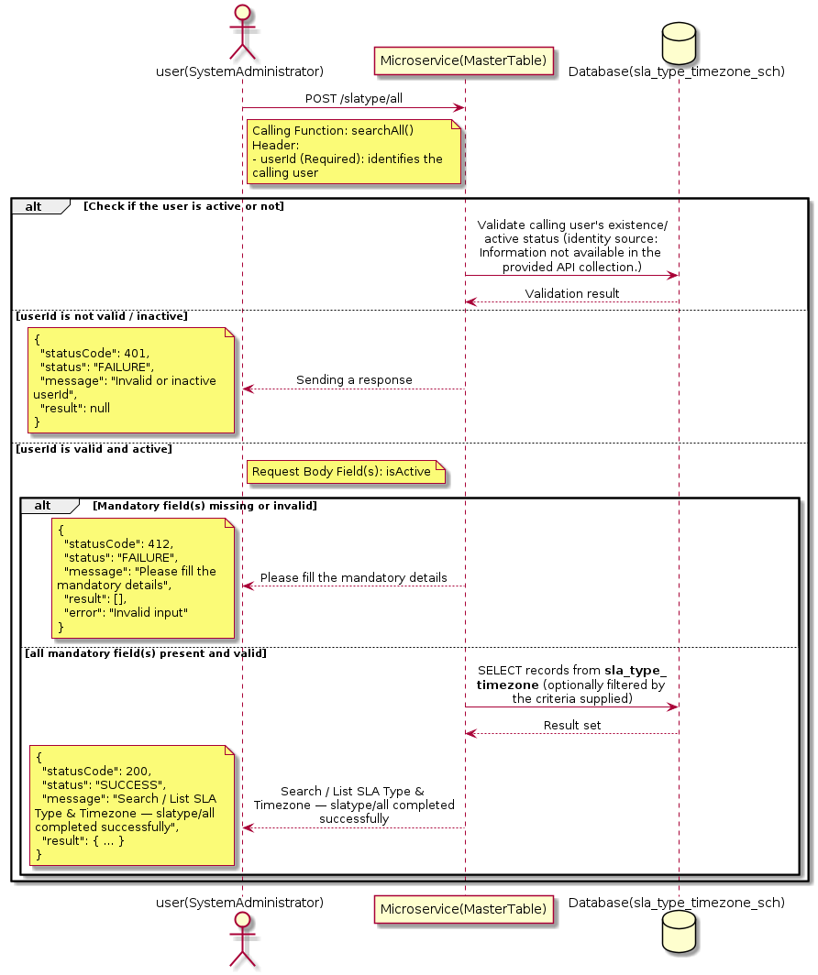

3.17.7.3 API Endpoint
Method | POST
URL | http://localhost:7002/srv2/genie/slatype/all
Headers | Content-Type: application/json userId: 879
Authorization | Not present in the captured request. Information not available in the provided API collection.
Content-Type | Content-Type: application/json
Query Parameters | None
Path Variables | None
Request Body:
{
"isActive": "1"
}
Response Body (illustrative — see 3.x.4.5 Success Response for details):
The source Postman collection does not include a captured sample response for this request (the response array is empty). Information not available in the provided API collection. Section 3.17.7.4.5 below presents the response envelope inferred from the standard response wrapper used consistently by this platform's services.

3.17.7.4 Detailed Process Flow

3.17.7.4.1 Request Initiation
The flow begins when System Administrator (or a calling microservice on their behalf) invokes the POST endpoint http://localhost:7002/srv2/genie/slatype/all. The request must include the mandatory `userId` header used by the Master Table Microservice to identify the calling user for auditing purposes. The request carries a JSON payload in the request body which the Controller binds to its Data Transfer Object (DTO) before any processing begins. At the Controller layer, Spring Boot's request-mapping infrastructure routes the call to the appropriate handler method (`searchAll`), and Bean Validation annotations (if configured on the DTO) perform structural validation before the request reaches the Service layer. Information not available in the provided API collection. regarding the exact validation annotations used in the source code.

3.17.7.4.2 User Validation
The Master Table Microservice relies on the `userId` header to identify the calling user. Based on the pattern observed consistently across this API collection, the platform's authentication/authorization is expected to be enforced upstream (e.g., by an API Gateway or a shared security filter) using this identifier; the Postman collection does not include an `Authorization` / `Bearer` token header on this request, so the exact authentication mechanism (JWT validation, session lookup, or gateway-level SSO) is Information not available in the provided API collection. Role-based authorization — i.e., confirming that the user identified by `userId` holds a role/permission entitled to perform this operation — is expected to be enforced by the Service layer (see Section 8 – Controller Analysis and Section 14 – Authentication & Authorization), but the specific role/permission checks are Information not available in the provided API collection.

3.17.7.4.3 Business Logic
The Service layer evaluates the search payload; if the search text/criteria is empty, the operation typically behaves like a full list (all SLA Type & Timezone records); if populated, it is used to build a case-insensitive `LIKE`/contains predicate against the relevant column(s). The key fields exchanged for this operation, as observed in the sample payload, are: `isActive`.

3.17.7.4.4 Database Interaction
The Repository layer (Spring Data JPA) interacts with the underlying relational database that backs the SLA Type & Timezone master table. The primary operation issued is a **SELECT** against the table associated with SLA Type & Timezone. No write operations occur; the search is typically implemented using a JPA derived query method or a native/JPQL query with `LIKE` predicates. The exact table name, column names, primary/foreign key definitions, and JPA repository method signatures are not included in the Postman collection; therefore, precise schema details are information not available in the provided api collection.

3.17.7.4.5 Success Response
Status Code: 200 OK. Sample response envelope (illustrative — the source collection did not capture a sample response for this API):
{
"statusCode": 200,
"status": "SUCCESS",
"message": "Search / List SLA Type & Timezone — slatype/all completed successfully",
"result": [
{
"id": 1,
"name": "Sample SLA Type & Timezone",
"isActive": 1
}
],
"error": null,
"corelationId": "c6f2a1e4-2b3d-4a9e-9f1a-1234567890ab",
"url": null
}

3.17.7.4.6 Conclusion
This API provides a well-defined, single-purpose capability within the Master Table Microservice for search / list sla type & timezone — slatype/all. The Controller → Service → Repository → Database layering keeps request validation, business rules, and persistence concerns separated, which allows the SLA Type & Timezone master data to be maintained consistently and safely by authorized administrators while remaining available for consumption by every other module that depends on this reference data.
3.17.8 Search / List SLA Type & Timezone — get/slatarget

3.17.8.1 Overview
Purpose: To search and list SLA Type & Timezone records based on a search payload (e.g., free-text search or structured criteria), supporting list/grid screens that need paginated or filtered master data.
Business Requirement: List/search screens for SLA Type & Timezone configuration need server-side search so that administrators can locate specific records in large master tables without scanning the full data set.
Who Uses the API: System Administrator operating the SLA Type & Timezone configuration/list screen.
Business Flow: Client sends a POST request with a search payload → Controller validates the payload → Service layer constructs the search/query logic → Repository executes the search against the SLA Type & Timezone table → matching records are returned to the Client.

3.17.8.2 Sequence Diagram
The diagram below illustrates the end-to-end interaction for "Search / List SLA Type & Timezone — get/slatarget" across the Client, Controller, Service, Repository, and Database layers.
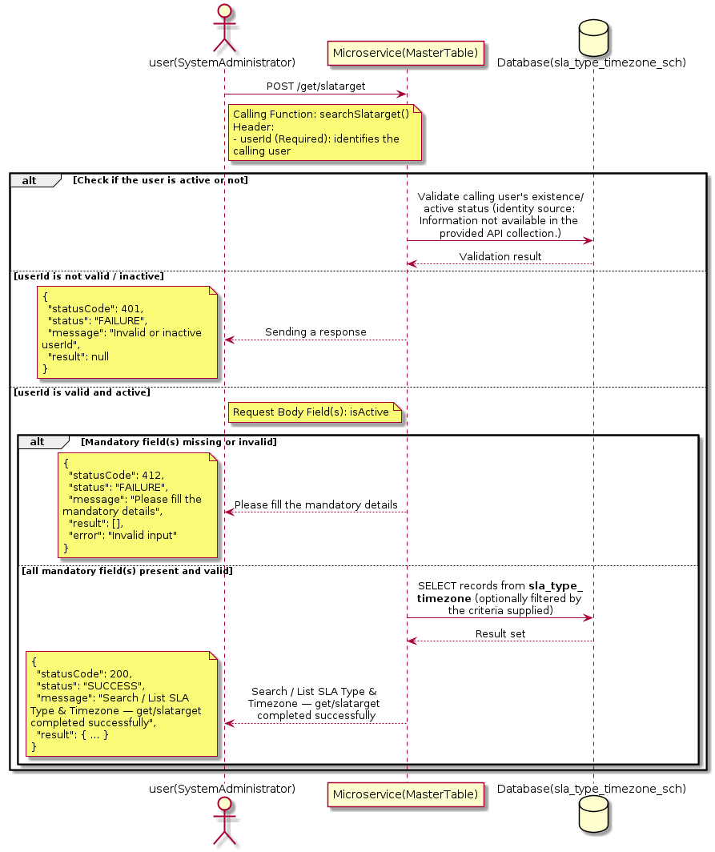

3.17.8.3 API Endpoint
Method | POST
URL | http://localhost:7002/srv2/genie/get/slatarget
Headers | Content-Type: application/json userId: 879
Authorization | Not present in the captured request. Information not available in the provided API collection.
Content-Type | Content-Type: application/json
Query Parameters | None
Path Variables | None
Request Body:
{
"isActive": "1"
}
Response Body (illustrative — see 3.x.4.5 Success Response for details):
The source Postman collection does not include a captured sample response for this request (the response array is empty). Information not available in the provided API collection. Section 3.17.8.4.5 below presents the response envelope inferred from the standard response wrapper used consistently by this platform's services.

3.17.8.4 Detailed Process Flow

3.17.8.4.1 Request Initiation
The flow begins when System Administrator (or a calling microservice on their behalf) invokes the POST endpoint http://localhost:7002/srv2/genie/get/slatarget. The request must include the mandatory `userId` header used by the Master Table Microservice to identify the calling user for auditing purposes. The request carries a JSON payload in the request body which the Controller binds to its Data Transfer Object (DTO) before any processing begins. At the Controller layer, Spring Boot's request-mapping infrastructure routes the call to the appropriate handler method (`searchSlatarget`), and Bean Validation annotations (if configured on the DTO) perform structural validation before the request reaches the Service layer. Information not available in the provided API collection. regarding the exact validation annotations used in the source code.

3.17.8.4.2 User Validation
The Master Table Microservice relies on the `userId` header to identify the calling user. Based on the pattern observed consistently across this API collection, the platform's authentication/authorization is expected to be enforced upstream (e.g., by an API Gateway or a shared security filter) using this identifier; the Postman collection does not include an `Authorization` / `Bearer` token header on this request, so the exact authentication mechanism (JWT validation, session lookup, or gateway-level SSO) is Information not available in the provided API collection. Role-based authorization — i.e., confirming that the user identified by `userId` holds a role/permission entitled to perform this operation — is expected to be enforced by the Service layer (see Section 8 – Controller Analysis and Section 14 – Authentication & Authorization), but the specific role/permission checks are Information not available in the provided API collection.

3.17.8.4.3 Business Logic
The Service layer evaluates the search payload; if the search text/criteria is empty, the operation typically behaves like a full list (all SLA Type & Timezone records); if populated, it is used to build a case-insensitive `LIKE`/contains predicate against the relevant column(s). The key fields exchanged for this operation, as observed in the sample payload, are: `isActive`.

3.17.8.4.4 Database Interaction
The Repository layer (Spring Data JPA) interacts with the underlying relational database that backs the SLA Type & Timezone master table. The primary operation issued is a **SELECT** against the table associated with SLA Type & Timezone. No write operations occur; the search is typically implemented using a JPA derived query method or a native/JPQL query with `LIKE` predicates. The exact table name, column names, primary/foreign key definitions, and JPA repository method signatures are not included in the Postman collection; therefore, precise schema details are information not available in the provided api collection.

3.17.8.4.5 Success Response
Status Code: 200 OK. Sample response envelope (illustrative — the source collection did not capture a sample response for this API):
{
"statusCode": 200,
"status": "SUCCESS",
"message": "Search / List SLA Type & Timezone — get/slatarget completed successfully",
"result": [
{
"id": 1,
"name": "Sample SLA Type & Timezone",
"isActive": 1
}
],
"error": null,
"corelationId": "c6f2a1e4-2b3d-4a9e-9f1a-1234567890ab",
"url": null
}

3.17.8.4.6 Conclusion
This API provides a well-defined, single-purpose capability within the Master Table Microservice for search / list sla type & timezone — get/slatarget. The Controller → Service → Repository → Database layering keeps request validation, business rules, and persistence concerns separated, which allows the SLA Type & Timezone master data to be maintained consistently and safely by authorized administrators while remaining available for consumption by every other module that depends on this reference data.

3.17.9 Search / List SLA Type & Timezone — getsladefinition/all

3.17.9.1 Overview
Purpose: To search and list SLA Type & Timezone records based on a search payload (e.g., free-text search or structured criteria), supporting list/grid screens that need paginated or filtered master data.
Business Requirement: List/search screens for SLA Type & Timezone configuration need server-side search so that administrators can locate specific records in large master tables without scanning the full data set.
Who Uses the API: System Administrator operating the SLA Type & Timezone configuration/list screen.
Business Flow: Client sends a POST request with a search payload → Controller validates the payload → Service layer constructs the search/query logic → Repository executes the search against the SLA Type & Timezone table → matching records are returned to the Client.

3.17.9.2 Sequence Diagram
The diagram below illustrates the end-to-end interaction for "Search / List SLA Type & Timezone — getsladefinition/all" across the Client, Controller, Service, Repository, and Database layers.
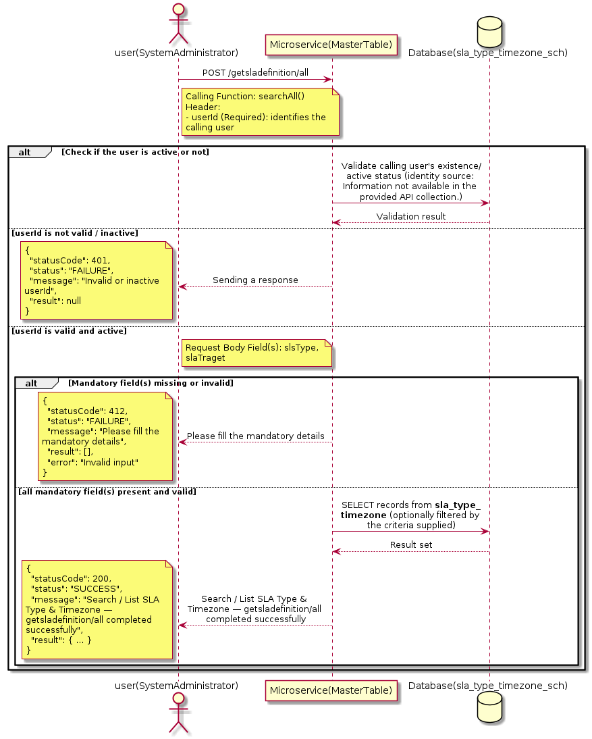

3.17.9.3 API Endpoint
Method | POST
URL | http://localhost:7002/srv2/genie/getsladefinition/all
Headers | Content-Type: application/json userId: 879
Authorization | Not present in the captured request. Information not available in the provided API collection.
Content-Type | Content-Type: application/json
Query Parameters | None
Path Variables | None
Request Body:
{
"slsType": "%",
"slaTraget": "%"
}
Response Body (illustrative — see 3.x.4.5 Success Response for details):
The source Postman collection does not include a captured sample response for this request (the response array is empty). Information not available in the provided API collection. Section 3.17.9.4.5 below presents the response envelope inferred from the standard response wrapper used consistently by this platform's services.

3.17.9.4 Detailed Process Flow

3.17.9.4.1 Request Initiation
The flow begins when System Administrator (or a calling microservice on their behalf) invokes the POST endpoint http://localhost:7002/srv2/genie/getsladefinition/all. The request must include the mandatory `userId` header used by the Master Table Microservice to identify the calling user for auditing purposes. The request carries a JSON payload in the request body which the Controller binds to its Data Transfer Object (DTO) before any processing begins. At the Controller layer, Spring Boot's request-mapping infrastructure routes the call to the appropriate handler method (`searchAll`), and Bean Validation annotations (if configured on the DTO) perform structural validation before the request reaches the Service layer. Information not available in the provided API collection. regarding the exact validation annotations used in the source code.

3.17.9.4.2 User Validation
The Master Table Microservice relies on the `userId` header to identify the calling user. Based on the pattern observed consistently across this API collection, the platform's authentication/authorization is expected to be enforced upstream (e.g., by an API Gateway or a shared security filter) using this identifier; the Postman collection does not include an `Authorization` / `Bearer` token header on this request, so the exact authentication mechanism (JWT validation, session lookup, or gateway-level SSO) is Information not available in the provided API collection. Role-based authorization — i.e., confirming that the user identified by `userId` holds a role/permission entitled to perform this operation — is expected to be enforced by the Service layer (see Section 8 – Controller Analysis and Section 14 – Authentication & Authorization), but the specific role/permission checks are Information not available in the provided API collection.

3.17.9.4.3 Business Logic
The Service layer evaluates the search payload; if the search text/criteria is empty, the operation typically behaves like a full list (all SLA Type & Timezone records); if populated, it is used to build a case-insensitive `LIKE`/contains predicate against the relevant column(s). The key fields exchanged for this operation, as observed in the sample payload, are: `slsType`, `slaTraget`.

3.17.9.4.4 Database Interaction
The Repository layer (Spring Data JPA) interacts with the underlying relational database that backs the SLA Type & Timezone master table. The primary operation issued is a **SELECT** against the table associated with SLA Type & Timezone. No write operations occur; the search is typically implemented using a JPA derived query method or a native/JPQL query with `LIKE` predicates. The exact table name, column names, primary/foreign key definitions, and JPA repository method signatures are not included in the Postman collection; therefore, precise schema details are information not available in the provided api collection.

3.17.9.4.5 Success Response
Status Code: 200 OK. Sample response envelope (illustrative — the source collection did not capture a sample response for this API):
{
"statusCode": 200,
"status": "SUCCESS",
"message": "Search / List SLA Type & Timezone — getsladefinition/all completed successfully",
"result": [
{
"id": 1,
"name": "Sample SLA Type & Timezone",
"isActive": 1
}
],
"error": null,
"corelationId": "c6f2a1e4-2b3d-4a9e-9f1a-1234567890ab",
"url": null
}

3.17.9.4.6 Conclusion
This API provides a well-defined, single-purpose capability within the Master Table Microservice for search / list sla type & timezone — getsladefinition/all. The Controller → Service → Repository → Database layering keeps request validation, business rules, and persistence concerns separated, which allows the SLA Type & Timezone master data to be maintained consistently and safely by authorized administrators while remaining available for consumption by every other module that depends on this reference data.
3.17.10 Search / List SLA Type & Timezone — get/slaschedual

3.17.10.1 Overview
Purpose: To search and list SLA Type & Timezone records based on a search payload (e.g., free-text search or structured criteria), supporting list/grid screens that need paginated or filtered master data.
Business Requirement: List/search screens for SLA Type & Timezone configuration need server-side search so that administrators can locate specific records in large master tables without scanning the full data set.
Who Uses the API: System Administrator operating the SLA Type & Timezone configuration/list screen.
Business Flow: Client sends a POST request with a search payload → Controller validates the payload → Service layer constructs the search/query logic → Repository executes the search against the SLA Type & Timezone table → matching records are returned to the Client.

3.17.10.2 Sequence Diagram
The diagram below illustrates the end-to-end interaction for "Search / List SLA Type & Timezone — get/slaschedual" across the Client, Controller, Service, Repository, and Database layers.
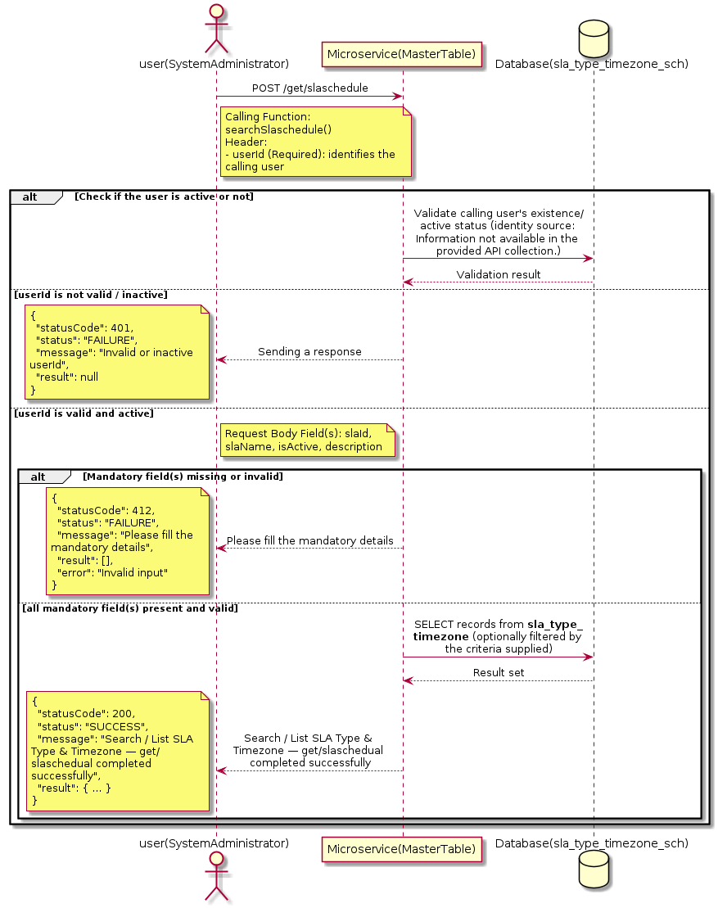

3.17.10.3 API Endpoint
Method | POST
URL | http://localhost:7002/srv2/genie/get/slaschedule
Headers | Content-Type: application/json userId: 879
Authorization | Not present in the captured request. Information not available in the provided API collection.
Content-Type | Content-Type: application/json
Query Parameters | None
Path Variables | None
Request Body:
{
"slaId": 0,
"slaName": "",
"isActive": "1",
"description": ""
}
Response Body (illustrative — see 3.x.4.5 Success Response for details):
The source Postman collection does not include a captured sample response for this request (the response array is empty). Information not available in the provided API collection. Section 3.17.10.4.5 below presents the response envelope inferred from the standard response wrapper used consistently by this platform's services.

3.17.10.4 Detailed Process Flow

3.17.10.4.1 Request Initiation
The flow begins when System Administrator (or a calling microservice on their behalf) invokes the POST endpoint http://localhost:7002/srv2/genie/get/slaschedule. The request must include the mandatory `userId` header used by the Master Table Microservice to identify the calling user for auditing purposes. The request carries a JSON payload in the request body which the Controller binds to its Data Transfer Object (DTO) before any processing begins. At the Controller layer, Spring Boot's request-mapping infrastructure routes the call to the appropriate handler method (`searchSlaschedule`), and Bean Validation annotations (if configured on the DTO) perform structural validation before the request reaches the Service layer. Information not available in the provided API collection. regarding the exact validation annotations used in the source code.

3.17.10.4.2 User Validation
The Master Table Microservice relies on the `userId` header to identify the calling user. Based on the pattern observed consistently across this API collection, the platform's authentication/authorization is expected to be enforced upstream (e.g., by an API Gateway or a shared security filter) using this identifier; the Postman collection does not include an `Authorization` / `Bearer` token header on this request, so the exact authentication mechanism (JWT validation, session lookup, or gateway-level SSO) is Information not available in the provided API collection. Role-based authorization — i.e., confirming that the user identified by `userId` holds a role/permission entitled to perform this operation — is expected to be enforced by the Service layer (see Section 8 – Controller Analysis and Section 14 – Authentication & Authorization), but the specific role/permission checks are Information not available in the provided API collection.

3.17.10.4.3 Business Logic
The Service layer evaluates the search payload; if the search text/criteria is empty, the operation typically behaves like a full list (all SLA Type & Timezone records); if populated, it is used to build a case-insensitive `LIKE`/contains predicate against the relevant column(s). The key fields exchanged for this operation, as observed in the sample payload, are: `slaId`, `slaName`, `isActive`, `description`.

3.17.10.4.4 Database Interaction
The Repository layer (Spring Data JPA) interacts with the underlying relational database that backs the SLA Type & Timezone master table. The primary operation issued is a **SELECT** against the table associated with SLA Type & Timezone. No write operations occur; the search is typically implemented using a JPA derived query method or a native/JPQL query with `LIKE` predicates. The exact table name, column names, primary/foreign key definitions, and JPA repository method signatures are not included in the Postman collection; therefore, precise schema details are information not available in the provided api collection.

3.17.10.4.5 Success Response
Status Code: 200 OK. Sample response envelope (illustrative — the source collection did not capture a sample response for this API):
{
"statusCode": 200,
"status": "SUCCESS",
"message": "Search / List SLA Type & Timezone — get/slaschedual completed successfully",
"result": [
{
"id": 1,
"name": "Sample SLA Type & Timezone",
"isActive": 1
}
],
"error": null,
"corelationId": "c6f2a1e4-2b3d-4a9e-9f1a-1234567890ab",
"url": null
}

3.17.10.4.6 Conclusion
This API provides a well-defined, single-purpose capability within the Master Table Microservice for search / list sla type & timezone — get/slaschedual. The Controller → Service → Repository → Database layering keeps request validation, business rules, and persistence concerns separated, which allows the SLA Type & Timezone master data to be maintained consistently and safely by authorized administrators while remaining available for consumption by every other module that depends on this reference data.

3.17.11 Search / List SLA Type & Timezone — slatarget

3.17.11.1 Overview
Purpose: To search and list SLA Type & Timezone records based on a search payload (e.g., free-text search or structured criteria), supporting list/grid screens that need paginated or filtered master data.
Business Requirement: List/search screens for SLA Type & Timezone configuration need server-side search so that administrators can locate specific records in large master tables without scanning the full data set.
Who Uses the API: System Administrator operating the SLA Type & Timezone configuration/list screen.
Business Flow: Client sends a POST request with a search payload → Controller validates the payload → Service layer constructs the search/query logic → Repository executes the search against the SLA Type & Timezone table → matching records are returned to the Client.

3.17.11.2 Sequence Diagram
The diagram below illustrates the end-to-end interaction for "Search / List SLA Type & Timezone — slatarget" across the Client, Controller, Service, Repository, and Database layers.
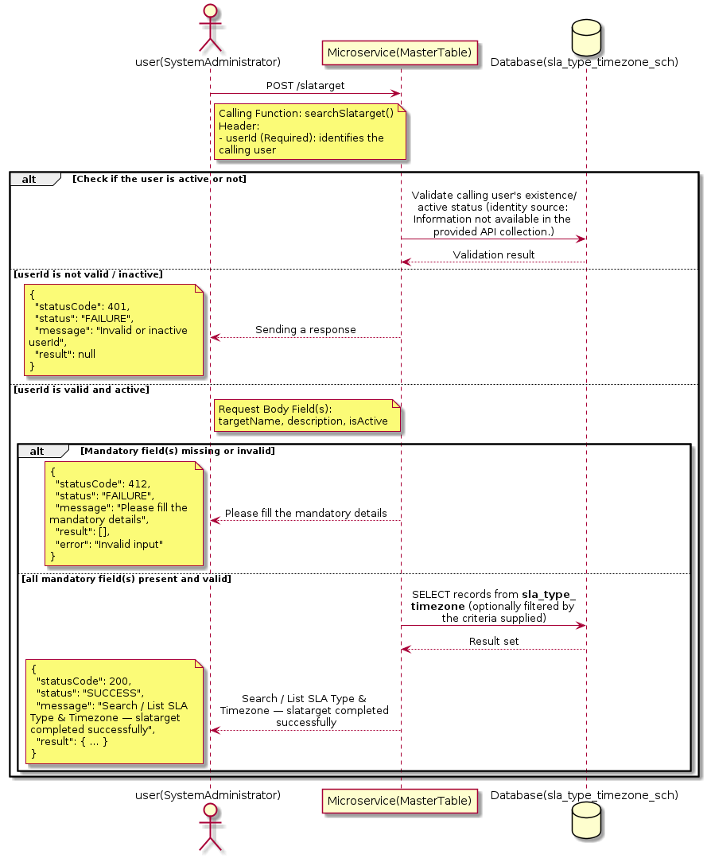

3.17.11.3 API Endpoint
Method | POST
URL | http://localhost:7002/srv2/genie/slatarget
Headers | Content-Type: application/json userId: 879
Authorization | Not present in the captured request. Information not available in the provided API collection.
Content-Type | Content-Type: application/json
Query Parameters | None
Path Variables | None
Request Body:
{
"targetName": "New Target",
"description": "Test new SLA target",
"isActive": "1"
}
Response Body (illustrative — see 3.x.4.5 Success Response for details):
The source Postman collection does not include a captured sample response for this request (the response array is empty). Information not available in the provided API collection. Section 3.17.11.4.5 below presents the response envelope inferred from the standard response wrapper used consistently by this platform's services.

3.17.11.4 Detailed Process Flow

3.17.11.4.1 Request Initiation
The flow begins when System Administrator (or a calling microservice on their behalf) invokes the POST endpoint http://localhost:7002/srv2/genie/slatarget. The request must include the mandatory `userId` header used by the Master Table Microservice to identify the calling user for auditing purposes. The request carries a JSON payload in the request body which the Controller binds to its Data Transfer Object (DTO) before any processing begins. At the Controller layer, Spring Boot's request-mapping infrastructure routes the call to the appropriate handler method (`searchSlatarget`), and Bean Validation annotations (if configured on the DTO) perform structural validation before the request reaches the Service layer. Information not available in the provided API collection. regarding the exact validation annotations used in the source code.

3.17.11.4.2 User Validation
The Master Table Microservice relies on the `userId` header to identify the calling user. Based on the pattern observed consistently across this API collection, the platform's authentication/authorization is expected to be enforced upstream (e.g., by an API Gateway or a shared security filter) using this identifier; the Postman collection does not include an `Authorization` / `Bearer` token header on this request, so the exact authentication mechanism (JWT validation, session lookup, or gateway-level SSO) is Information not available in the provided API collection. Role-based authorization — i.e., confirming that the user identified by `userId` holds a role/permission entitled to perform this operation — is expected to be enforced by the Service layer (see Section 8 – Controller Analysis and Section 14 – Authentication & Authorization), but the specific role/permission checks are Information not available in the provided API collection.

3.17.11.4.3 Business Logic
The Service layer evaluates the search payload; if the search text/criteria is empty, the operation typically behaves like a full list (all SLA Type & Timezone records); if populated, it is used to build a case-insensitive `LIKE`/contains predicate against the relevant column(s). The key fields exchanged for this operation, as observed in the sample payload, are: `targetName`, `description`, `isActive`.

3.17.11.4.4 Database Interaction
The Repository layer (Spring Data JPA) interacts with the underlying relational database that backs the SLA Type & Timezone master table. The primary operation issued is a **SELECT** against the table associated with SLA Type & Timezone. No write operations occur; the search is typically implemented using a JPA derived query method or a native/JPQL query with `LIKE` predicates. The exact table name, column names, primary/foreign key definitions, and JPA repository method signatures are not included in the Postman collection; therefore, precise schema details are information not available in the provided api collection.

3.17.11.4.5 Success Response
Status Code: 200 OK. Sample response envelope (illustrative — the source collection did not capture a sample response for this API):
{
"statusCode": 200,
"status": "SUCCESS",
"message": "Search / List SLA Type & Timezone — slatarget completed successfully",
"result": [
{
"id": 1,
"name": "Sample SLA Type & Timezone",
"isActive": 1
}
],
"error": null,
"corelationId": "c6f2a1e4-2b3d-4a9e-9f1a-1234567890ab",
"url": null
}

3.17.11.4.6 Conclusion
This API provides a well-defined, single-purpose capability within the Master Table Microservice for search / list sla type & timezone — slatarget. The Controller → Service → Repository → Database layering keeps request validation, business rules, and persistence concerns separated, which allows the SLA Type & Timezone master data to be maintained consistently and safely by authorized administrators while remaining available for consumption by every other module that depends on this reference data.
3.17.12 Create SLA Type & Timezone — slatimezone

3.17.12.1 Overview
Purpose: To create a new SLA Type & Timezone master record in the system, allowing administrators to extend the master-data catalogue that other modules (ticketing, workflow, notifications) depend on.
Business Requirement: Business/process owners need a controlled way to add new SLA Type & Timezone values so that the platform's classification, routing, and reporting capabilities can evolve as the organization changes.
Who Uses the API: System Administrator responsible for master-data configuration.
Business Flow: Client sends a POST request with the new SLA Type & Timezone payload → Controller validates the payload (mandatory fields, formats) → Service layer applies business rules (e.g., duplicate-name check) → Repository persists the new record → the created record (with generated identifier) is returned to the Client.

3.17.12.2 Sequence Diagram
The diagram below illustrates the end-to-end interaction for "Create SLA Type & Timezone — slatimezone" across the Client, Controller, Service, Repository, and Database layers.
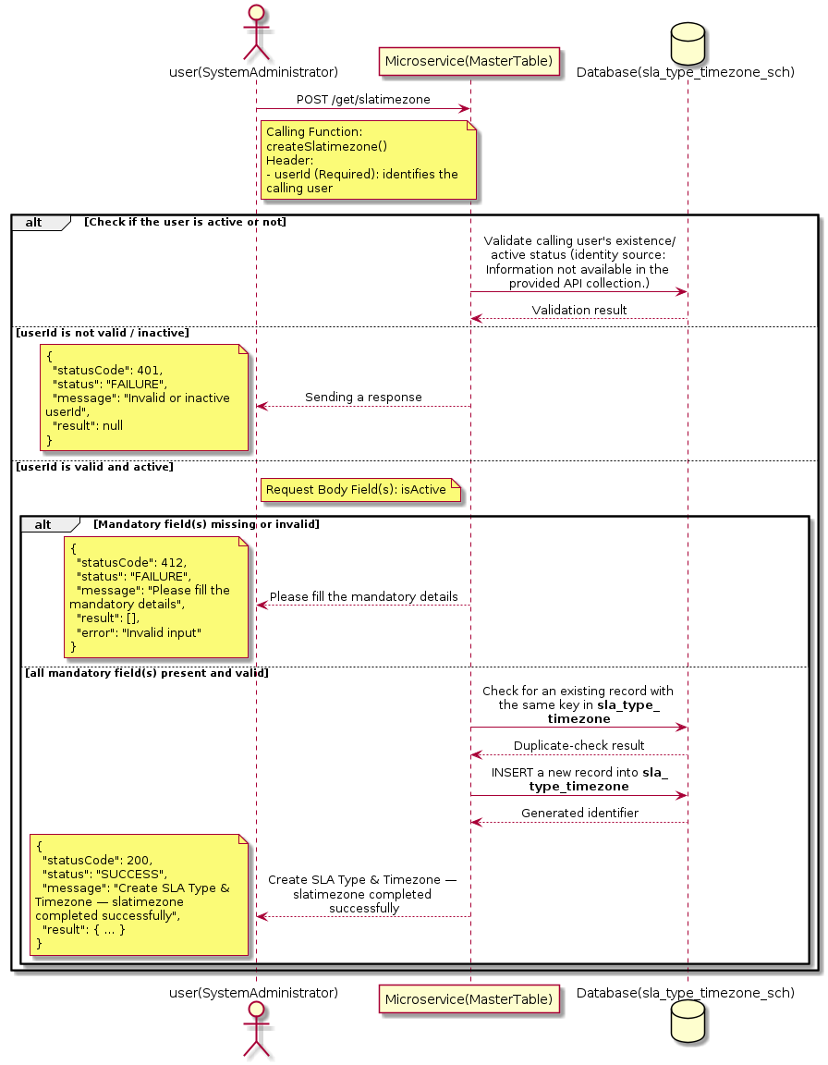

3.17.12.3 API Endpoint
Method | POST
URL | http://localhost:7002/srv2/genie/get/slatimezone
Headers | Content-Type: application/json userId: 879
Authorization | Not present in the captured request. Information not available in the provided API collection.
Content-Type | Content-Type: application/json
Query Parameters | None
Path Variables | None
Request Body:
{
"isActive": "1"
}
Response Body (illustrative — see 3.x.4.5 Success Response for details):
The source Postman collection does not include a captured sample response for this request (the response array is empty). Information not available in the provided API collection. Section 3.17.12.4.5 below presents the response envelope inferred from the standard response wrapper used consistently by this platform's services.

3.17.12.4 Detailed Process Flow

3.17.12.4.1 Request Initiation
The flow begins when System Administrator (or a calling microservice on their behalf) invokes the POST endpoint http://localhost:7002/srv2/genie/get/slatimezone. The request must include the mandatory `userId` header used by the Master Table Microservice to identify the calling user for auditing purposes. The request carries a JSON payload in the request body which the Controller binds to its Data Transfer Object (DTO) before any processing begins. At the Controller layer, Spring Boot's request-mapping infrastructure routes the call to the appropriate handler method (`createSlatimezone`), and Bean Validation annotations (if configured on the DTO) perform structural validation before the request reaches the Service layer. Information not available in the provided API collection. regarding the exact validation annotations used in the source code.

3.17.12.4.2 User Validation
The Master Table Microservice relies on the `userId` header to identify the calling user. Based on the pattern observed consistently across this API collection, the platform's authentication/authorization is expected to be enforced upstream (e.g., by an API Gateway or a shared security filter) using this identifier; the Postman collection does not include an `Authorization` / `Bearer` token header on this request, so the exact authentication mechanism (JWT validation, session lookup, or gateway-level SSO) is Information not available in the provided API collection. Role-based authorization — i.e., confirming that the user identified by `userId` holds a role/permission entitled to perform this operation — is expected to be enforced by the Service layer (see Section 8 – Controller Analysis and Section 14 – Authentication & Authorization), but the specific role/permission checks are Information not available in the provided API collection.

3.17.12.4.3 Business Logic
The Service layer performs the following: (1) validates that mandatory fields are present and correctly formatted, (2) checks for duplicates (e.g., an existing SLA Type & Timezone with the same name/code), (3) sets system-managed fields (e.g., `isActive = 1`, `createdBy`, timestamps) where applicable, and (4) persists the new record via the Repository. If any validation fails, the Service layer returns a business error rather than proceeding to persistence. The key fields exchanged for this operation, as observed in the sample payload, are: `isActive`.

3.17.12.4.4 Database Interaction
The Repository layer (Spring Data JPA) interacts with the underlying relational database that backs the SLA Type & Timezone master table. The primary operation issued is a **INSERT** against the table associated with SLA Type & Timezone. A new row is inserted into the master table; if the entity has related child records (as seen in nested request payload arrays), corresponding child-table inserts are performed within the same transaction. The exact table name, column names, primary/foreign key definitions, and JPA repository method signatures are not included in the Postman collection; therefore, precise schema details are information not available in the provided api collection.

3.17.12.4.5 Success Response
Status Code: 200 OK. Sample response envelope (illustrative — the source collection did not capture a sample response for this API):
{
"statusCode": 200,
"status": "SUCCESS",
"message": "Create SLA Type & Timezone — slatimezone completed successfully",
"result": {
"id": 101,
"isActive": "1"
},
"error": null,
"corelationId": "c6f2a1e4-2b3d-4a9e-9f1a-1234567890ab",
"url": null
}

3.17.12.4.6 Conclusion
This API provides a well-defined, single-purpose capability within the Master Table Microservice for create sla type & timezone — slatimezone. The Controller → Service → Repository → Database layering keeps request validation, business rules, and persistence concerns separated, which allows the SLA Type & Timezone master data to be maintained consistently and safely by authorized administrators while remaining available for consumption by every other module that depends on this reference data.
3.17.13 Create SLA Type & Timezone — create/slatype

3.17.13.1 Overview
Purpose: To create a new SLA Type & Timezone master record in the system, allowing administrators to extend the master-data catalogue that other modules (ticketing, workflow, notifications) depend on.
Business Requirement: Business/process owners need a controlled way to add new SLA Type & Timezone values so that the platform's classification, routing, and reporting capabilities can evolve as the organization changes.
Who Uses the API: System Administrator responsible for master-data configuration.
Business Flow: Client sends a POST request with the new SLA Type & Timezone payload → Controller validates the payload (mandatory fields, formats) → Service layer applies business rules (e.g., duplicate-name check) → Repository persists the new record → the created record (with generated identifier) is returned to the Client.

3.17.13.2 Sequence Diagram
The diagram below illustrates the end-to-end interaction for "Create SLA Type & Timezone — create/slatype" across the Client, Controller, Service, Repository, and Database layers.
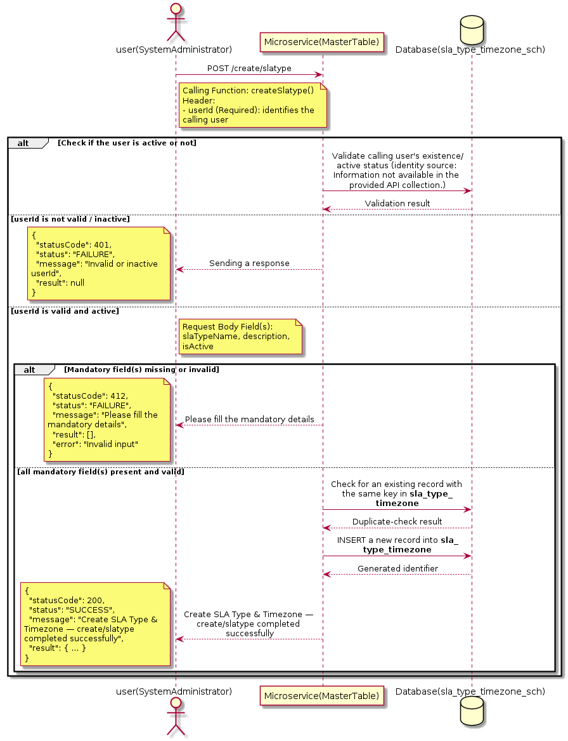

3.17.13.3 API Endpoint
Method | POST
URL | http://localhost:7002/srv2/genie/create/slatype
Headers | Content-Type: application/json userId: 879
Authorization | Not present in the captured request. Information not available in the provided API collection.
Content-Type | Content-Type: application/json
Query Parameters | None
Path Variables | None
Request Body:
{
"slaTypeName": "Gold SLA",
"description": "Gold level SLA support",
"isActive": "1"
}
Response Body (illustrative — see 3.x.4.5 Success Response for details):
The source Postman collection does not include a captured sample response for this request (the response array is empty). Information not available in the provided API collection. Section 3.17.13.4.5 below presents the response envelope inferred from the standard response wrapper used consistently by this platform's services.

3.17.13.4 Detailed Process Flow

3.17.13.4.1 Request Initiation
The flow begins when System Administrator (or a calling microservice on their behalf) invokes the POST endpoint http://localhost:7002/srv2/genie/create/slatype. The request must include the mandatory `userId` header used by the Master Table Microservice to identify the calling user for auditing purposes. The request carries a JSON payload in the request body which the Controller binds to its Data Transfer Object (DTO) before any processing begins. At the Controller layer, Spring Boot's request-mapping infrastructure routes the call to the appropriate handler method (`createSlatype`), and Bean Validation annotations (if configured on the DTO) perform structural validation before the request reaches the Service layer. Information not available in the provided API collection. regarding the exact validation annotations used in the source code.

3.17.13.4.2 User Validation
The Master Table Microservice relies on the `userId` header to identify the calling user. Based on the pattern observed consistently across this API collection, the platform's authentication/authorization is expected to be enforced upstream (e.g., by an API Gateway or a shared security filter) using this identifier; the Postman collection does not include an `Authorization` / `Bearer` token header on this request, so the exact authentication mechanism (JWT validation, session lookup, or gateway-level SSO) is Information not available in the provided API collection. Role-based authorization — i.e., confirming that the user identified by `userId` holds a role/permission entitled to perform this operation — is expected to be enforced by the Service layer (see Section 8 – Controller Analysis and Section 14 – Authentication & Authorization), but the specific role/permission checks are Information not available in the provided API collection.

3.17.13.4.3 Business Logic
The Service layer performs the following: (1) validates that mandatory fields are present and correctly formatted, (2) checks for duplicates (e.g., an existing SLA Type & Timezone with the same name/code), (3) sets system-managed fields (e.g., `isActive = 1`, `createdBy`, timestamps) where applicable, and (4) persists the new record via the Repository. If any validation fails, the Service layer returns a business error rather than proceeding to persistence. The key fields exchanged for this operation, as observed in the sample payload, are: `slaTypeName`, `description`, `isActive`.

3.17.13.4.4 Database Interaction
The Repository layer (Spring Data JPA) interacts with the underlying relational database that backs the SLA Type & Timezone master table. The primary operation issued is a **INSERT** against the table associated with SLA Type & Timezone. A new row is inserted into the master table; if the entity has related child records (as seen in nested request payload arrays), corresponding child-table inserts are performed within the same transaction. The exact table name, column names, primary/foreign key definitions, and JPA repository method signatures are not included in the Postman collection; therefore, precise schema details are information not available in the provided api collection.

3.17.13.4.5 Success Response
Status Code: 200 OK. Sample response envelope (illustrative — the source collection did not capture a sample response for this API):
{
"statusCode": 200,
"status": "SUCCESS",
"message": "Create SLA Type & Timezone — create/slatype completed successfully",
"result": {
"id": 101,
"slaTypeName": "Gold SLA",
"description": "Gold level SLA support",
"isActive": "1"
},
"error": null,
"corelationId": "c6f2a1e4-2b3d-4a9e-9f1a-1234567890ab",
"url": null
}

3.17.13.4.6 Conclusion
This API provides a well-defined, single-purpose capability within the Master Table Microservice for create sla type & timezone — create/slatype. The Controller → Service → Repository → Database layering keeps request validation, business rules, and persistence concerns separated, which allows the SLA Type & Timezone master data to be maintained consistently and safely by authorized administrators while remaining available for consumption by every other module that depends on this reference data.

3.17.14 Create SLA Type & Timezone — create/slatimezone

3.17.14.1 Overview
Purpose: To create a new SLA Type & Timezone master record in the system, allowing administrators to extend the master-data catalogue that other modules (ticketing, workflow, notifications) depend on.
Business Requirement: Business/process owners need a controlled way to add new SLA Type & Timezone values so that the platform's classification, routing, and reporting capabilities can evolve as the organization changes.
Who Uses the API: System Administrator responsible for master-data configuration.
Business Flow: Client sends a POST request with the new SLA Type & Timezone payload → Controller validates the payload (mandatory fields, formats) → Service layer applies business rules (e.g., duplicate-name check) → Repository persists the new record → the created record (with generated identifier) is returned to the Client.

3.17.14.2 Sequence Diagram
The diagram below illustrates the end-to-end interaction for "Create SLA Type & Timezone — create/slatimezone" across the Client, Controller, Service, Repository, and Database layers.
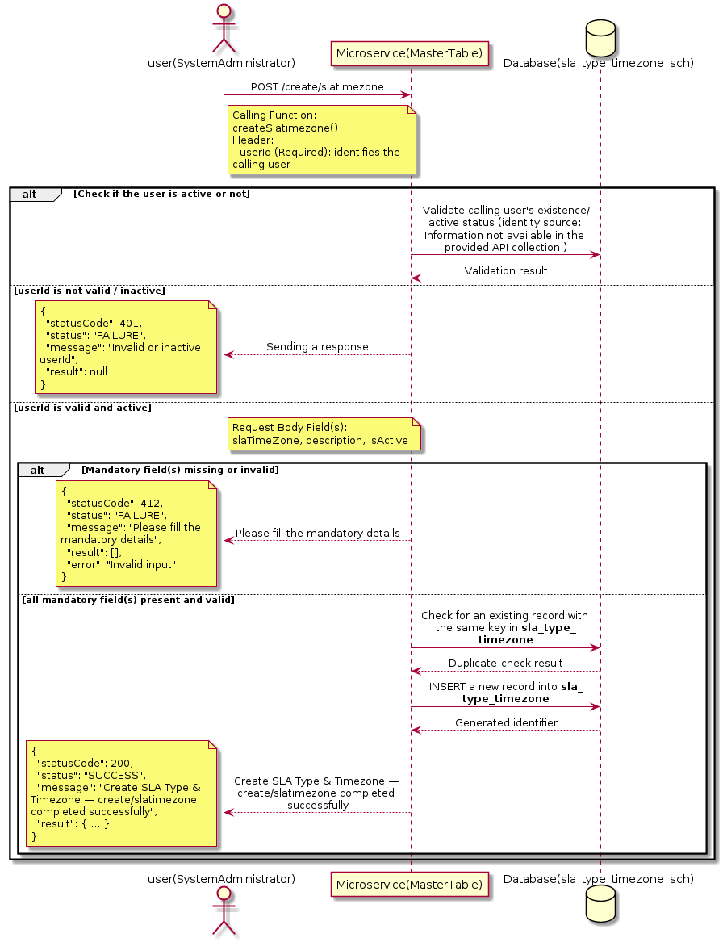

3.17.14.3 API Endpoint
Method | POST
URL | http://localhost:7002/srv2/genie/create/slatimezone
Headers | Content-Type: application/json userId: 879
Authorization | Not present in the captured request. Information not available in the provided API collection.
Content-Type | Content-Type: application/json
Query Parameters | None
Path Variables | None
Request Body:
{
"slaTimeZone": "CST",
"description": "Central Standard Time",
"isActive": "1"
}
Response Body (illustrative — see 3.x.4.5 Success Response for details):
The source Postman collection does not include a captured sample response for this request (the response array is empty). Information not available in the provided API collection. Section 3.17.14.4.5 below presents the response envelope inferred from the standard response wrapper used consistently by this platform's services.

3.17.14.4 Detailed Process Flow

3.17.14.4.1 Request Initiation
The flow begins when System Administrator (or a calling microservice on their behalf) invokes the POST endpoint http://localhost:7002/srv2/genie/create/slatimezone. The request must include the mandatory `userId` header used by the Master Table Microservice to identify the calling user for auditing purposes. The request carries a JSON payload in the request body which the Controller binds to its Data Transfer Object (DTO) before any processing begins. At the Controller layer, Spring Boot's request-mapping infrastructure routes the call to the appropriate handler method (`createSlatimezone`), and Bean Validation annotations (if configured on the DTO) perform structural validation before the request reaches the Service layer. Information not available in the provided API collection. regarding the exact validation annotations used in the source code.

3.17.14.4.2 User Validation
The Master Table Microservice relies on the `userId` header to identify the calling user. Based on the pattern observed consistently across this API collection, the platform's authentication/authorization is expected to be enforced upstream (e.g., by an API Gateway or a shared security filter) using this identifier; the Postman collection does not include an `Authorization` / `Bearer` token header on this request, so the exact authentication mechanism (JWT validation, session lookup, or gateway-level SSO) is Information not available in the provided API collection. Role-based authorization — i.e., confirming that the user identified by `userId` holds a role/permission entitled to perform this operation — is expected to be enforced by the Service layer (see Section 8 – Controller Analysis and Section 14 – Authentication & Authorization), but the specific role/permission checks are Information not available in the provided API collection.

3.17.14.4.3 Business Logic
The Service layer performs the following: (1) validates that mandatory fields are present and correctly formatted, (2) checks for duplicates (e.g., an existing SLA Type & Timezone with the same name/code), (3) sets system-managed fields (e.g., `isActive = 1`, `createdBy`, timestamps) where applicable, and (4) persists the new record via the Repository. If any validation fails, the Service layer returns a business error rather than proceeding to persistence. The key fields exchanged for this operation, as observed in the sample payload, are: `slaTimeZone`, `description`, `isActive`.

3.17.14.4.4 Database Interaction
The Repository layer (Spring Data JPA) interacts with the underlying relational database that backs the SLA Type & Timezone master table. The primary operation issued is a **INSERT** against the table associated with SLA Type & Timezone. A new row is inserted into the master table; if the entity has related child records (as seen in nested request payload arrays), corresponding child-table inserts are performed within the same transaction. The exact table name, column names, primary/foreign key definitions, and JPA repository method signatures are not included in the Postman collection; therefore, precise schema details are information not available in the provided api collection.

3.17.14.4.5 Success Response
Status Code: 200 OK. Sample response envelope (illustrative — the source collection did not capture a sample response for this API):
{
"statusCode": 200,
"status": "SUCCESS",
"message": "Create SLA Type & Timezone — create/slatimezone completed successfully",
"result": {
"id": 101,
"slaTimeZone": "CST",
"description": "Central Standard Time",
"isActive": "1"
},
"error": null,
"corelationId": "c6f2a1e4-2b3d-4a9e-9f1a-1234567890ab",
"url": null
}

3.17.14.4.6 Conclusion
This API provides a well-defined, single-purpose capability within the Master Table Microservice for create sla type & timezone — create/slatimezone. The Controller → Service → Repository → Database layering keeps request validation, business rules, and persistence concerns separated, which allows the SLA Type & Timezone master data to be maintained consistently and safely by authorized administrators while remaining available for consumption by every other module that depends on this reference data.

3.17.15 Create SLA Type & Timezone — create/sladefinition

3.17.15.1 Overview
Purpose: To create a new SLA Type & Timezone master record in the system, allowing administrators to extend the master-data catalogue that other modules (ticketing, workflow, notifications) depend on.
Business Requirement: Business/process owners need a controlled way to add new SLA Type & Timezone values so that the platform's classification, routing, and reporting capabilities can evolve as the organization changes.
Who Uses the API: System Administrator responsible for master-data configuration.
Business Flow: Client sends a POST request with the new SLA Type & Timezone payload → Controller validates the payload (mandatory fields, formats) → Service layer applies business rules (e.g., duplicate-name check) → Repository persists the new record → the created record (with generated identifier) is returned to the Client.

3.17.15.2 Sequence Diagram
The diagram below illustrates the end-to-end interaction for "Create SLA Type & Timezone — create/sladefinition" across the Client, Controller, Service, Repository, and Database layers.
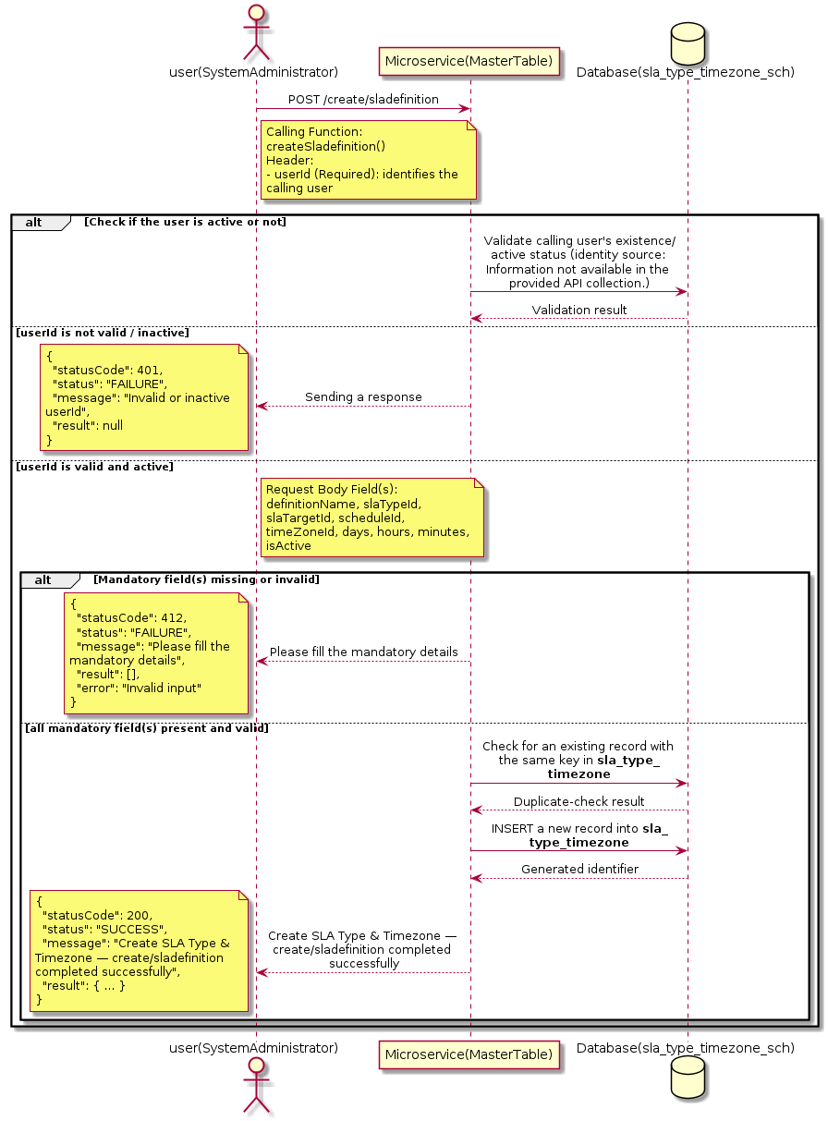

3.17.15.3 API Endpoint
Method | POST
URL | http://localhost:7002/srv2/genie/create/sladefinition
Headers | Content-Type: application/json userId: 879
Authorization | Not present in the captured request. Information not available in the provided API collection.
Content-Type | Content-Type: application/json
Query Parameters | None
Path Variables | None
Request Body:
{
"definitionName": "New Standard SLA",
"slaTypeId": 3,
"slaTargetId": 4,
"scheduleId": 2,
"timeZoneId": 2,
"days": 1,
"hours": 0,
"minutes": 0,
"isActive": "1",
"startCondition": [],
"pauseCondtion": [],
"resumeCondition": [],
"stopCondtion": [],
"breached": [],
"reminders": []
}
Response Body (illustrative — see 3.x.4.5 Success Response for details):
The source Postman collection does not include a captured sample response for this request (the response array is empty). Information not available in the provided API collection. Section 3.17.15.4.5 below presents the response envelope inferred from the standard response wrapper used consistently by this platform's services.

3.17.15.4 Detailed Process Flow

3.17.15.4.1 Request Initiation
The flow begins when System Administrator (or a calling microservice on their behalf) invokes the POST endpoint http://localhost:7002/srv2/genie/create/sladefinition. The request must include the mandatory `userId` header used by the Master Table Microservice to identify the calling user for auditing purposes. The request carries a JSON payload in the request body which the Controller binds to its Data Transfer Object (DTO) before any processing begins. At the Controller layer, Spring Boot's request-mapping infrastructure routes the call to the appropriate handler method (`createSladefinition`), and Bean Validation annotations (if configured on the DTO) perform structural validation before the request reaches the Service layer. Information not available in the provided API collection. regarding the exact validation annotations used in the source code.

3.17.15.4.2 User Validation
The Master Table Microservice relies on the `userId` header to identify the calling user. Based on the pattern observed consistently across this API collection, the platform's authentication/authorization is expected to be enforced upstream (e.g., by an API Gateway or a shared security filter) using this identifier; the Postman collection does not include an `Authorization` / `Bearer` token header on this request, so the exact authentication mechanism (JWT validation, session lookup, or gateway-level SSO) is Information not available in the provided API collection. Role-based authorization — i.e., confirming that the user identified by `userId` holds a role/permission entitled to perform this operation — is expected to be enforced by the Service layer (see Section 8 – Controller Analysis and Section 14 – Authentication & Authorization), but the specific role/permission checks are Information not available in the provided API collection.

3.17.15.4.3 Business Logic
The Service layer performs the following: (1) validates that mandatory fields are present and correctly formatted, (2) checks for duplicates (e.g., an existing SLA Type & Timezone with the same name/code), (3) sets system-managed fields (e.g., `isActive = 1`, `createdBy`, timestamps) where applicable, and (4) persists the new record via the Repository. If any validation fails, the Service layer returns a business error rather than proceeding to persistence. The key fields exchanged for this operation, as observed in the sample payload, are: `definitionName`, `slaTypeId`, `slaTargetId`, `scheduleId`, `timeZoneId`, `days`, `hours`, `minutes`, `isActive`.

3.17.15.4.4 Database Interaction
The Repository layer (Spring Data JPA) interacts with the underlying relational database that backs the SLA Type & Timezone master table. The primary operation issued is a **INSERT** against the table associated with SLA Type & Timezone. A new row is inserted into the master table; if the entity has related child records (as seen in nested request payload arrays), corresponding child-table inserts are performed within the same transaction. The exact table name, column names, primary/foreign key definitions, and JPA repository method signatures are not included in the Postman collection; therefore, precise schema details are information not available in the provided api collection.

3.17.15.4.5 Success Response
Status Code: 200 OK. Sample response envelope (illustrative — the source collection did not capture a sample response for this API):
{
"statusCode": 200,
"status": "SUCCESS",
"message": "Create SLA Type & Timezone — create/sladefinition completed successfully",
"result": {
"id": 101,
"definitionName": "New Standard SLA",
"slaTypeId": 3,
"slaTargetId": 4,
"scheduleId": 2,
"timeZoneId": 2,
"days": 1,
"hours": 0,
"minutes": 0,
"isActive": "1"
},
"error": null,
"corelationId": "c6f2a1e4-2b3d-4a9e-9f1a-1234567890ab",
"url": null
}

3.17.15.4.6 Conclusion
This API provides a well-defined, single-purpose capability within the Master Table Microservice for create sla type & timezone — create/sladefinition. The Controller → Service → Repository → Database layering keeps request validation, business rules, and persistence concerns separated, which allows the SLA Type & Timezone master data to be maintained consistently and safely by authorized administrators while remaining available for consumption by every other module that depends on this reference data.

3.17.16 Create SLA Type & Timezone — slaschedule

3.17.16.1 Overview
Purpose: To create a new SLA Type & Timezone master record in the system, allowing administrators to extend the master-data catalogue that other modules (ticketing, workflow, notifications) depend on.
Business Requirement: Business/process owners need a controlled way to add new SLA Type & Timezone values so that the platform's classification, routing, and reporting capabilities can evolve as the organization changes.
Who Uses the API: System Administrator responsible for master-data configuration.
Business Flow: Client sends a POST request with the new SLA Type & Timezone payload → Controller validates the payload (mandatory fields, formats) → Service layer applies business rules (e.g., duplicate-name check) → Repository persists the new record → the created record (with generated identifier) is returned to the Client.

3.17.16.2 Sequence Diagram
The diagram below illustrates the end-to-end interaction for "Create SLA Type & Timezone — slaschedule" across the Client, Controller, Service, Repository, and Database layers.
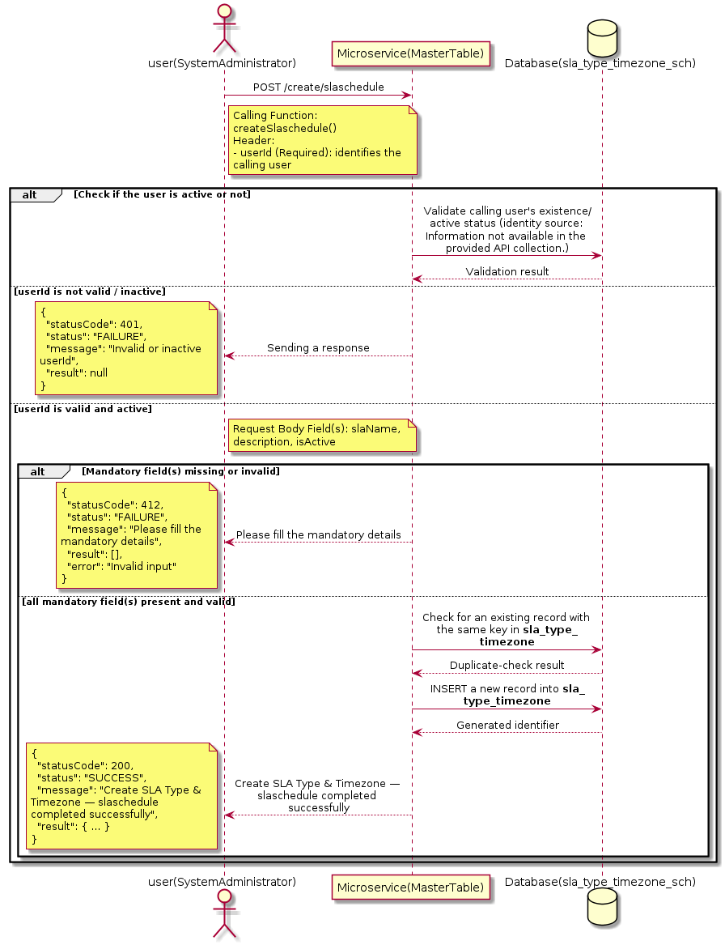

3.17.16.3 API Endpoint
Method | POST
URL | http://localhost:7002/srv2/genie/create/slaschedule
Headers | Content-Type: application/json userId: 879
Authorization | Not present in the captured request. Information not available in the provided API collection.
Content-Type | Content-Type: application/json
Query Parameters | None
Path Variables | None
Request Body:
{
"slaName": "Weekend Support",
"description": "Saturday and Sunday support",
"isActive": "1"
}
Response Body (illustrative — see 3.x.4.5 Success Response for details):
The source Postman collection does not include a captured sample response for this request (the response array is empty). Information not available in the provided API collection. Section 3.17.16.4.5 below presents the response envelope inferred from the standard response wrapper used consistently by this platform's services.

3.17.16.4 Detailed Process Flow

3.17.16.4.1 Request Initiation
The flow begins when System Administrator (or a calling microservice on their behalf) invokes the POST endpoint http://localhost:7002/srv2/genie/create/slaschedule. The request must include the mandatory `userId` header used by the Master Table Microservice to identify the calling user for auditing purposes. The request carries a JSON payload in the request body which the Controller binds to its Data Transfer Object (DTO) before any processing begins. At the Controller layer, Spring Boot's request-mapping infrastructure routes the call to the appropriate handler method (`createSlaschedule`), and Bean Validation annotations (if configured on the DTO) perform structural validation before the request reaches the Service layer. Information not available in the provided API collection. regarding the exact validation annotations used in the source code.

3.17.16.4.2 User Validation
The Master Table Microservice relies on the `userId` header to identify the calling user. Based on the pattern observed consistently across this API collection, the platform's authentication/authorization is expected to be enforced upstream (e.g., by an API Gateway or a shared security filter) using this identifier; the Postman collection does not include an `Authorization` / `Bearer` token header on this request, so the exact authentication mechanism (JWT validation, session lookup, or gateway-level SSO) is Information not available in the provided API collection. Role-based authorization — i.e., confirming that the user identified by `userId` holds a role/permission entitled to perform this operation — is expected to be enforced by the Service layer (see Section 8 – Controller Analysis and Section 14 – Authentication & Authorization), but the specific role/permission checks are Information not available in the provided API collection.

3.17.16.4.3 Business Logic
The Service layer performs the following: (1) validates that mandatory fields are present and correctly formatted, (2) checks for duplicates (e.g., an existing SLA Type & Timezone with the same name/code), (3) sets system-managed fields (e.g., `isActive = 1`, `createdBy`, timestamps) where applicable, and (4) persists the new record via the Repository. If any validation fails, the Service layer returns a business error rather than proceeding to persistence. The key fields exchanged for this operation, as observed in the sample payload, are: `slaName`, `description`, `isActive`.

3.17.16.4.4 Database Interaction
The Repository layer (Spring Data JPA) interacts with the underlying relational database that backs the SLA Type & Timezone master table. The primary operation issued is a **INSERT** against the table associated with SLA Type & Timezone. A new row is inserted into the master table; if the entity has related child records (as seen in nested request payload arrays), corresponding child-table inserts are performed within the same transaction. The exact table name, column names, primary/foreign key definitions, and JPA repository method signatures are not included in the Postman collection; therefore, precise schema details are information not available in the provided api collection.

3.17.16.4.5 Success Response
Status Code: 200 OK. Sample response envelope (illustrative — the source collection did not capture a sample response for this API):
{
"statusCode": 200,
"status": "SUCCESS",
"message": "Create SLA Type & Timezone — slaschedule completed successfully",
"result": {
"id": 101,
"slaName": "Weekend Support",
"description": "Saturday and Sunday support",
"isActive": "1"
},
"error": null,
"corelationId": "c6f2a1e4-2b3d-4a9e-9f1a-1234567890ab",
"url": null
}

3.17.16.4.6 Conclusion
This API provides a well-defined, single-purpose capability within the Master Table Microservice for create sla type & timezone — slaschedule. The Controller → Service → Repository → Database layering keeps request validation, business rules, and persistence concerns separated, which allows the SLA Type & Timezone master data to be maintained consistently and safely by authorized administrators while remaining available for consumption by every other module that depends on this reference data.

3.17.17 Retrieve SLA Type & Timezone by ID

3.17.17.1 Overview
Purpose: To retrieve a single SLA Type & Timezone record identified by its unique identifier, typically used to pre-populate an edit screen or to validate a reference before use.
Business Requirement: Edit screens, validation routines, and cross-service lookups need to resolve a single SLA Type & Timezone record by its identifier reliably and quickly.
Who Uses the API: System Administrator, and internal services validating a SLA Type & Timezone reference (e.g., ticket creation, workflow configuration).
Business Flow: Client sends a GET request with the identifier in the URL path → Controller extracts the path variable → Service layer requests the Repository to fetch the record → if found, the record is mapped and returned; if not found, a 404 is returned.

3.17.17.2 Sequence Diagram
The diagram below illustrates the end-to-end interaction for "Retrieve SLA Type & Timezone by ID" across the Client, Controller, Service, Repository, and Database layers.
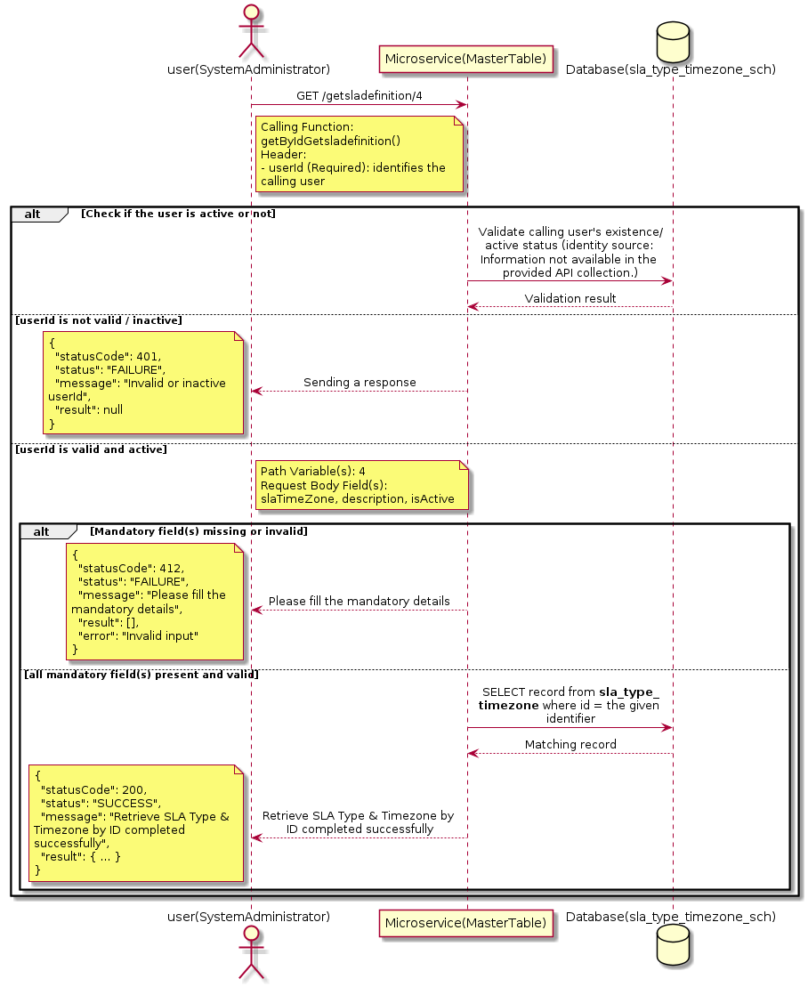

3.17.17.3 API Endpoint
Method | GET
URL | http://localhost:7002/srv2/genie/getsladefinition/4
Headers | Content-Type: application/json userId: 879
Authorization | Not present in the captured request. Information not available in the provided API collection.
Content-Type | Content-Type: application/json
Query Parameters | None
Path Variables | 4
Request Body:
{
"slaTimeZone": "CST",
"description": "Central Standard Time",
"isActive": "1"
}
Response Body (illustrative — see 3.x.4.5 Success Response for details):
The source Postman collection does not include a captured sample response for this request (the response array is empty). Information not available in the provided API collection. Section 3.17.17.4.5 below presents the response envelope inferred from the standard response wrapper used consistently by this platform's services.

3.17.17.4 Detailed Process Flow

3.17.17.4.1 Request Initiation
The flow begins when System Administrator (or a calling microservice on their behalf) invokes the GET endpoint http://localhost:7002/srv2/genie/getsladefinition/4. The request must include the mandatory `userId` header used by the Master Table Microservice to identify the calling user for auditing purposes. The request carries a JSON payload in the request body which the Controller binds to its Data Transfer Object (DTO) before any processing begins. At the Controller layer, Spring Boot's request-mapping infrastructure routes the call to the appropriate handler method (`getByIdGetsladefinition`), and Bean Validation annotations (if configured on the DTO) perform structural validation before the request reaches the Service layer. Information not available in the provided API collection. regarding the exact validation annotations used in the source code.

3.17.17.4.2 User Validation
The Master Table Microservice relies on the `userId` header to identify the calling user. Based on the pattern observed consistently across this API collection, the platform's authentication/authorization is expected to be enforced upstream (e.g., by an API Gateway or a shared security filter) using this identifier; the Postman collection does not include an `Authorization` / `Bearer` token header on this request, so the exact authentication mechanism (JWT validation, session lookup, or gateway-level SSO) is Information not available in the provided API collection. Role-based authorization — i.e., confirming that the user identified by `userId` holds a role/permission entitled to perform this operation — is expected to be enforced by the Service layer (see Section 8 – Controller Analysis and Section 14 – Authentication & Authorization), but the specific role/permission checks are Information not available in the provided API collection.

3.17.17.4.3 Business Logic
The Service layer forwards the identifier to the Repository. If no record is found for the given identifier, the Service layer raises a not-found condition that the Controller/global exception handler converts into an HTTP 404 response. The key fields exchanged for this operation, as observed in the sample payload, are: `slaTimeZone`, `description`, `isActive`.

3.17.17.4.4 Database Interaction
The Repository layer (Spring Data JPA) interacts with the underlying relational database that backs the SLA Type & Timezone master table. The primary operation issued is a **SELECT** against the table associated with SLA Type & Timezone. No write operations occur; a single-row lookup is performed using the primary key. The exact table name, column names, primary/foreign key definitions, and JPA repository method signatures are not included in the Postman collection; therefore, precise schema details are information not available in the provided api collection.

3.17.17.4.5 Success Response
Status Code: 200 OK. Sample response envelope (illustrative — the source collection did not capture a sample response for this API):
{
"statusCode": 200,
"status": "SUCCESS",
"message": "Retrieve SLA Type & Timezone by ID completed successfully",
"result": {
"id": 1,
"name": "Sample SLA Type & Timezone",
"isActive": 1
},
"error": null,
"corelationId": "c6f2a1e4-2b3d-4a9e-9f1a-1234567890ab",
"url": null
}

3.17.17.4.6 Conclusion
This API provides a well-defined, single-purpose capability within the Master Table Microservice for retrieve sla type & timezone by id. The Controller → Service → Repository → Database layering keeps request validation, business rules, and persistence concerns separated, which allows the SLA Type & Timezone master data to be maintained consistently and safely by authorized administrators while remaining available for consumption by every other module that depends on this reference data.

3.17.18 Retrieve All SLA Type & Timezone

3.17.18.1 Overview
Purpose: To retrieve the complete list of SLA Type & Timezone master records configured in the Master Table Microservice, so that consuming screens and downstream services can populate dropdowns, grids, and configuration views.
Business Requirement: Every screen and workflow that references SLA Type & Timezone data (creation forms, filters, reports) needs an authoritative, always-current list of active SLA Type & Timezone values sourced from a single master table rather than being hard-coded.
Who Uses the API: System Administrator, and any internal microservice/UI module that needs to render SLA Type & Timezone options.
Business Flow: Client sends a GET request → Controller delegates to the Service layer → Service layer calls the Repository → Repository queries the SLA Type & Timezone table → the result set is mapped to response DTOs and returned to the Client.

3.17.18.2 Sequence Diagram
The diagram below illustrates the end-to-end interaction for "Retrieve All SLA Type & Timezone" across the Client, Controller, Service, Repository, and Database layers.
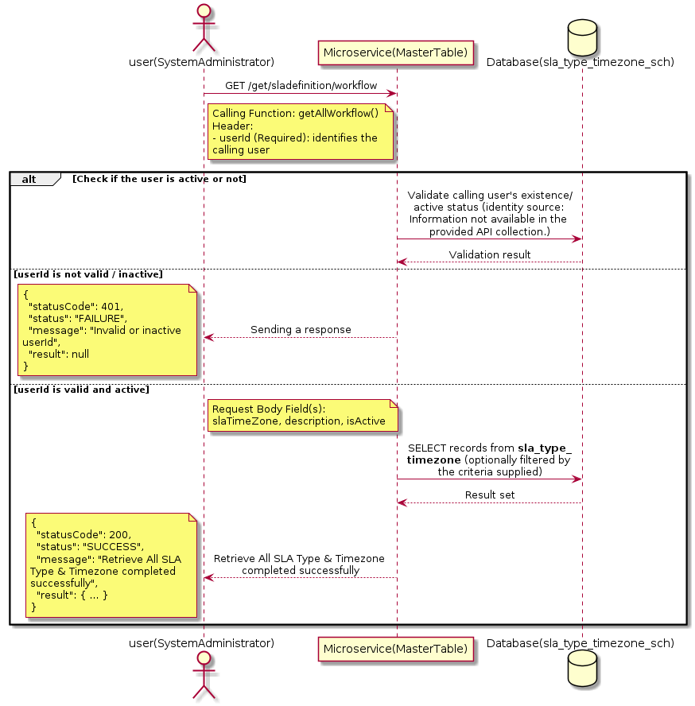

3.17.18.3 API Endpoint
Method | GET
URL | http://localhost:7002/srv2/genie/get/sladefinition/workflow
Headers | Content-Type: application/json userId: 879
Authorization | Not present in the captured request. Information not available in the provided API collection.
Content-Type | Content-Type: application/json
Query Parameters | None
Path Variables | None
Request Body:
{
"slaTimeZone": "CST",
"description": "Central Standard Time",
"isActive": "1"
}
Response Body (illustrative — see 3.x.4.5 Success Response for details):
The source Postman collection does not include a captured sample response for this request (the response array is empty). Information not available in the provided API collection. Section 3.17.18.4.5 below presents the response envelope inferred from the standard response wrapper used consistently by this platform's services.

3.17.18.4 Detailed Process Flow

3.17.18.4.1 Request Initiation
The flow begins when System Administrator (or a calling microservice on their behalf) invokes the GET endpoint http://localhost:7002/srv2/genie/get/sladefinition/workflow. The request must include the mandatory `userId` header used by the Master Table Microservice to identify the calling user for auditing purposes. The request carries a JSON payload in the request body which the Controller binds to its Data Transfer Object (DTO) before any processing begins. At the Controller layer, Spring Boot's request-mapping infrastructure routes the call to the appropriate handler method (`getAllWorkflow`), and Bean Validation annotations (if configured on the DTO) perform structural validation before the request reaches the Service layer. Information not available in the provided API collection. regarding the exact validation annotations used in the source code.

3.17.18.4.2 User Validation
The Master Table Microservice relies on the `userId` header to identify the calling user. Based on the pattern observed consistently across this API collection, the platform's authentication/authorization is expected to be enforced upstream (e.g., by an API Gateway or a shared security filter) using this identifier; the Postman collection does not include an `Authorization` / `Bearer` token header on this request, so the exact authentication mechanism (JWT validation, session lookup, or gateway-level SSO) is Information not available in the provided API collection. Role-based authorization — i.e., confirming that the user identified by `userId` holds a role/permission entitled to perform this operation — is expected to be enforced by the Service layer (see Section 8 – Controller Analysis and Section 14 – Authentication & Authorization), but the specific role/permission checks are Information not available in the provided API collection.

3.17.18.4.3 Business Logic
The Service layer contains no conditional business branching for this operation beyond invoking the Repository to fetch all SLA Type & Timezone records. Depending on the record volume, the Service layer may apply default sorting (e.g., by name or creation order) before returning the list. The key fields exchanged for this operation, as observed in the sample payload, are: `slaTimeZone`, `description`, `isActive`.

3.17.18.4.4 Database Interaction
The Repository layer (Spring Data JPA) interacts with the underlying relational database that backs the SLA Type & Timezone master table. The primary operation issued is a **SELECT** against the table associated with SLA Type & Timezone. No write operations occur; the query returns all rows that satisfy the entity's default scope (typically active records). The exact table name, column names, primary/foreign key definitions, and JPA repository method signatures are not included in the Postman collection; therefore, precise schema details are information not available in the provided api collection.

3.17.18.4.5 Success Response
Status Code: 200 OK. Sample response envelope (illustrative — the source collection did not capture a sample response for this API):
{
"statusCode": 200,
"status": "SUCCESS",
"message": "Retrieve All SLA Type & Timezone completed successfully",
"result": [
{
"id": 1,
"name": "Sample SLA Type & Timezone",
"isActive": 1
}
],
"error": null,
"corelationId": "c6f2a1e4-2b3d-4a9e-9f1a-1234567890ab",
"url": null
}

3.17.18.4.6 Conclusion
This API provides a well-defined, single-purpose capability within the Master Table Microservice for retrieve all sla type & timezone. The Controller → Service → Repository → Database layering keeps request validation, business rules, and persistence concerns separated, which allows the SLA Type & Timezone master data to be maintained consistently and safely by authorized administrators while remaining available for consumption by every other module that depends on this reference data.

3.18 Status Flow APIs (Status Flow APIs)
Maintains the configurable status-transition flow that governs which status changes are legal for a given ticket type/category.

3.18.1 Delete Status Flow

3.18.1.1 Overview
Purpose: To permanently remove a Status Flow master record from the system.
Business Requirement: Obsolete or erroneously created Status Flow records must be removable so the master table does not accumulate invalid configuration.
Who Uses the API: System Administrator with delete/configuration privileges.
Business Flow: Client sends a DELETE request identifying the Status Flow record → Controller validates the request → Service layer verifies the record exists and is not otherwise referenced → Repository removes the record → a confirmation response is returned to the Client.

3.18.1.2 Sequence Diagram
The diagram below illustrates the end-to-end interaction for "Delete Status Flow" across the Client, Controller, Service, Repository, and Database layers.
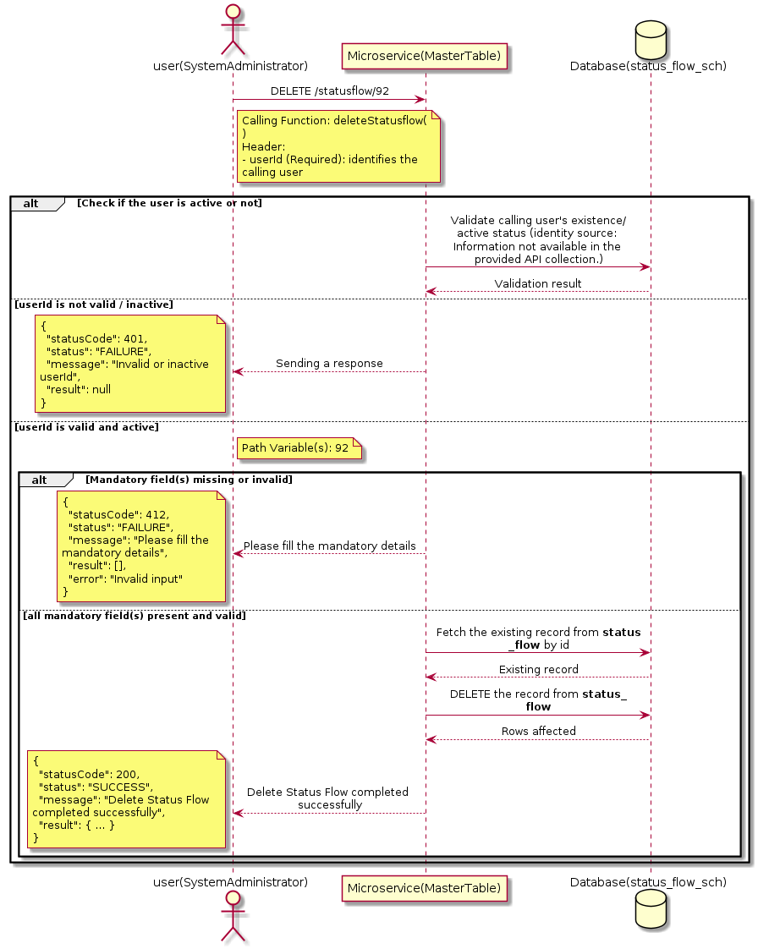

3.18.1.3 API Endpoint
Method | DELETE
URL | http://localhost:7002/srv2/genie/statusflow/92
Headers | userId: 67
Authorization | Not present in the captured request. Information not available in the provided API collection.
Content-Type | application/json (assumed)
Query Parameters | None
Path Variables | 92
Request Body:
Not applicable — this operation does not accept a request body.
Response Body (illustrative — see 3.x.4.5 Success Response for details):
The source Postman collection does not include a captured sample response for this request (the response array is empty). Information not available in the provided API collection. Section 3.18.1.4.5 below presents the response envelope inferred from the standard response wrapper used consistently by this platform's services.

3.18.1.4 Detailed Process Flow

3.18.1.4.1 Request Initiation
The flow begins when System Administrator (or a calling microservice on their behalf) invokes the DELETE endpoint http://localhost:7002/srv2/genie/statusflow/92. The request must include the mandatory `userId` header used by the Master Table Microservice to identify the calling user for auditing purposes. At the Controller layer, Spring Boot's request-mapping infrastructure routes the call to the appropriate handler method (`deleteStatusflow`), and Bean Validation annotations (if configured on the DTO) perform structural validation before the request reaches the Service layer. Information not available in the provided API collection. regarding the exact validation annotations used in the source code.

3.18.1.4.2 User Validation
The Master Table Microservice relies on the `userId` header to identify the calling user. Based on the pattern observed consistently across this API collection, the platform's authentication/authorization is expected to be enforced upstream (e.g., by an API Gateway or a shared security filter) using this identifier; the Postman collection does not include an `Authorization` / `Bearer` token header on this request, so the exact authentication mechanism (JWT validation, session lookup, or gateway-level SSO) is Information not available in the provided API collection. Role-based authorization — i.e., confirming that the user identified by `userId` holds a role/permission entitled to perform this operation — is expected to be enforced by the Service layer (see Section 8 – Controller Analysis and Section 14 – Authentication & Authorization), but the specific role/permission checks are Information not available in the provided API collection.

3.18.1.4.3 Business Logic
The Service layer fetches the existing Status Flow record, checks whether it is referenced by dependent records elsewhere in the platform (referential-integrity check), and only proceeds with deletion if no blocking dependency is found. If dependencies exist, the operation is expected to be rejected. Information not available in the provided API collection. regarding the exact dependency checks implemented.

3.18.1.4.4 Database Interaction
The Repository layer (Spring Data JPA) interacts with the underlying relational database that backs the Status Flow master table. The primary operation issued is a **DELETE** against the table associated with Status Flow. The row is removed from the master table by primary key, subject to the referential-integrity checks described in Section 7.3. The exact table name, column names, primary/foreign key definitions, and JPA repository method signatures are not included in the Postman collection; therefore, precise schema details are information not available in the provided api collection.

3.18.1.4.5 Success Response
Status Code: 200 OK. Sample response envelope (illustrative — the source collection did not capture a sample response for this API):
{
"statusCode": 200,
"status": "SUCCESS",
"message": "Delete Status Flow completed successfully",
"result": null,
"error": null,
"corelationId": "c6f2a1e4-2b3d-4a9e-9f1a-1234567890ab",
"url": null
}

3.18.1.4.6 Conclusion
This API provides a well-defined, single-purpose capability within the Master Table Microservice for delete status flow. The Controller → Service → Repository → Database layering keeps request validation, business rules, and persistence concerns separated, which allows the Status Flow master data to be maintained consistently and safely by authorized administrators while remaining available for consumption by every other module that depends on this reference data.

3.18.2 Update Status Flow

3.18.2.1 Overview
Purpose: To update an existing Status Flow master record, allowing administrators to correct or evolve master-data attributes without impacting the record's identity/history.
Business Requirement: Master data changes over time (renames, corrections, re-classification); the platform must allow controlled updates while preserving referential integrity for records that already reference this Status Flow.
Who Uses the API: System Administrator responsible for maintaining master-data accuracy.
Business Flow: Client sends a PUT/PATCH request with the updated Status Flow payload → Controller validates the payload → Service layer fetches the existing record, applies the changes, and re-validates business rules → Repository persists the updated record → the updated record is returned to the Client.

3.18.2.2 Sequence Diagram
The diagram below illustrates the end-to-end interaction for "Update Status Flow" across the Client, Controller, Service, Repository, and Database layers.
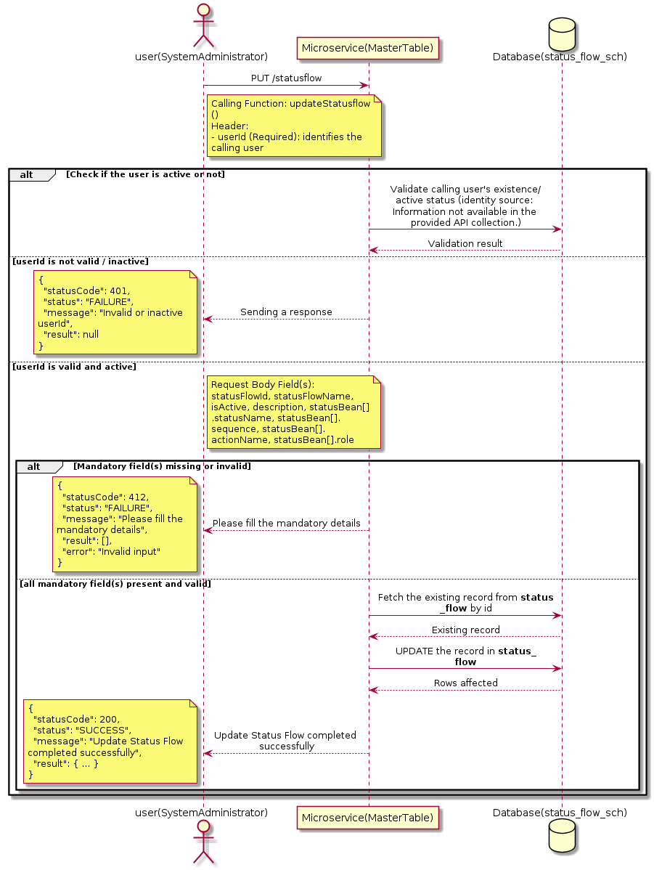

3.18.2.3 API Endpoint
Method | PUT
URL | http://localhost:7002/srv2/genie/statusflow
Headers | userId: 67 Content-Type: application/json (assumed based on JSON request payload; Information not available in the provided API collection.)
Authorization | Not present in the captured request. Information not available in the provided API collection.
Content-Type | Content-Type: application/json (assumed based on JSON request payload; Information not available in the provided API collection.)
Query Parameters | None
Path Variables | None
Request Body:
{
"statusFlowId": 92,
"statusFlowName": "Updated Test Flow",
"isActive": "1",
"description": "Updated description",
"statusBean": [
{
"statusName": "Open",
"sequence": 1,
"actionName": "Create",
"role": 1
},
{
"statusName": "Closed",
"sequence": 2,
"actionName": "Complete",
"role": 1
}
]
}
Response Body (illustrative — see 3.x.4.5 Success Response for details):
The source Postman collection does not include a captured sample response for this request (the response array is empty). Information not available in the provided API collection. Section 3.18.2.4.5 below presents the response envelope inferred from the standard response wrapper used consistently by this platform's services.

3.18.2.4 Detailed Process Flow

3.18.2.4.1 Request Initiation
The flow begins when System Administrator (or a calling microservice on their behalf) invokes the PUT endpoint http://localhost:7002/srv2/genie/statusflow. The request must include the mandatory `userId` header used by the Master Table Microservice to identify the calling user for auditing purposes. The request carries a JSON payload in the request body which the Controller binds to its Data Transfer Object (DTO) before any processing begins. At the Controller layer, Spring Boot's request-mapping infrastructure routes the call to the appropriate handler method (`updateStatusflow`), and Bean Validation annotations (if configured on the DTO) perform structural validation before the request reaches the Service layer. Information not available in the provided API collection. regarding the exact validation annotations used in the source code.

3.18.2.4.2 User Validation
The Master Table Microservice relies on the `userId` header to identify the calling user. Based on the pattern observed consistently across this API collection, the platform's authentication/authorization is expected to be enforced upstream (e.g., by an API Gateway or a shared security filter) using this identifier; the Postman collection does not include an `Authorization` / `Bearer` token header on this request, so the exact authentication mechanism (JWT validation, session lookup, or gateway-level SSO) is Information not available in the provided API collection. Role-based authorization — i.e., confirming that the user identified by `userId` holds a role/permission entitled to perform this operation — is expected to be enforced by the Service layer (see Section 8 – Controller Analysis and Section 14 – Authentication & Authorization), but the specific role/permission checks are Information not available in the provided API collection.

3.18.2.4.3 Business Logic
The Service layer fetches the existing Status Flow record by its identifier, verifies it exists, applies the incoming changes field by field, re-validates business rules (e.g., uniqueness of a renamed field), and persists the updated entity via the Repository. If the record does not exist, the operation is rejected with a not-found error. The key fields exchanged for this operation, as observed in the sample payload, are: `statusFlowId`, `statusFlowName`, `isActive`, `description`, `statusBean[].statusName`, `statusBean[].sequence`, `statusBean[].actionName`, `statusBean[].role`.

3.18.2.4.4 Database Interaction
The Repository layer (Spring Data JPA) interacts with the underlying relational database that backs the Status Flow master table. The primary operation issued is a **UPDATE** against the table associated with Status Flow. The existing row is located by primary key and updated; if the entity has related child records, the existing child rows are typically replaced/updated within the same transaction. The exact table name, column names, primary/foreign key definitions, and JPA repository method signatures are not included in the Postman collection; therefore, precise schema details are information not available in the provided api collection.

3.18.2.4.5 Success Response
Status Code: 200 OK. Sample response envelope (illustrative — the source collection did not capture a sample response for this API):
{
"statusCode": 200,
"status": "SUCCESS",
"message": "Update Status Flow completed successfully",
"result": {
"id": 1,
"isActive": 1
},
"error": null,
"corelationId": "c6f2a1e4-2b3d-4a9e-9f1a-1234567890ab",
"url": null
}

3.18.2.4.6 Conclusion
This API provides a well-defined, single-purpose capability within the Master Table Microservice for update status flow. The Controller → Service → Repository → Database layering keeps request validation, business rules, and persistence concerns separated, which allows the Status Flow master data to be maintained consistently and safely by authorized administrators while remaining available for consumption by every other module that depends on this reference data.

3.18.3 Create Status Flow

3.18.3.1 Overview
Purpose: To create a new Status Flow master record in the system, allowing administrators to extend the master-data catalogue that other modules (ticketing, workflow, notifications) depend on.
Business Requirement: Business/process owners need a controlled way to add new Status Flow values so that the platform's classification, routing, and reporting capabilities can evolve as the organization changes.
Who Uses the API: System Administrator responsible for master-data configuration.
Business Flow: Client sends a POST request with the new Status Flow payload → Controller validates the payload (mandatory fields, formats) → Service layer applies business rules (e.g., duplicate-name check) → Repository persists the new record → the created record (with generated identifier) is returned to the Client.

3.18.3.2 Sequence Diagram
The diagram below illustrates the end-to-end interaction for "Create Status Flow" across the Client, Controller, Service, Repository, and Database layers.
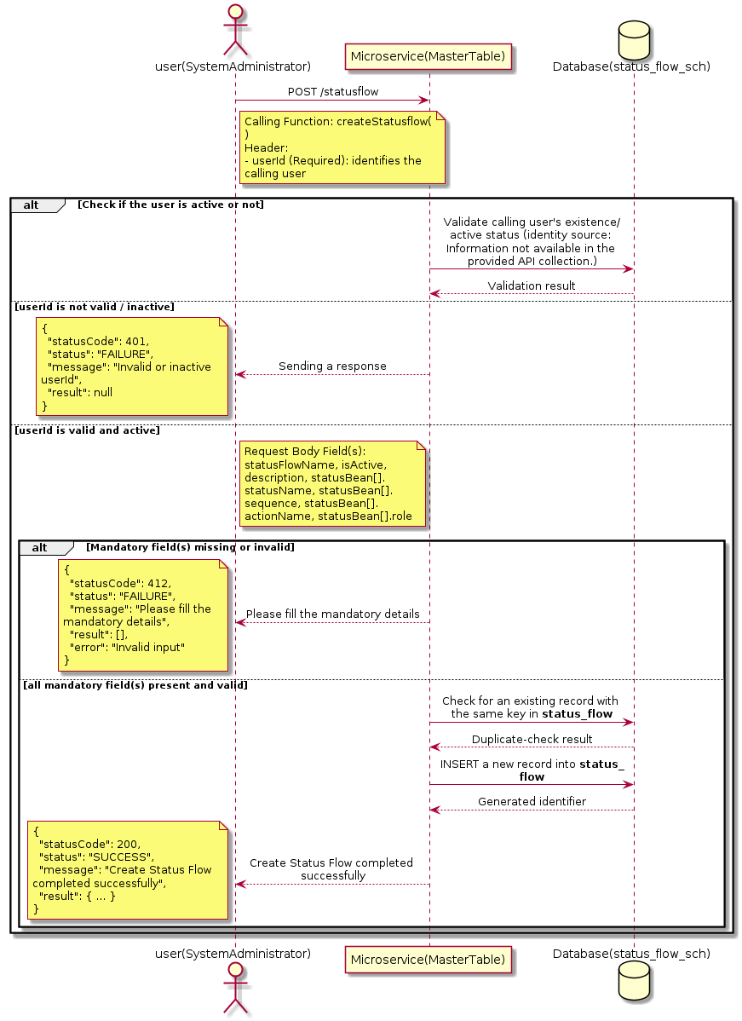

3.18.3.3 API Endpoint
Method | POST
URL | http://localhost:7002/srv2/genie/statusflow
Headers | userId: 67 Content-Type: application/json (assumed based on JSON request payload; Information not available in the provided API collection.)
Authorization | Not present in the captured request. Information not available in the provided API collection.
Content-Type | Content-Type: application/json (assumed based on JSON request payload; Information not available in the provided API collection.)
Query Parameters | None
Path Variables | None
Request Body:
{
"statusFlowName": "Test Flow",
"isActive": "1",
"description": "Test status flow",
"statusBean": [
{
"statusName": "Open",
"sequence": 1,
"actionName": "Create",
"role": 1
},
{
"statusName": "Closed",
"sequence": 2,
"actionName": "Complete",
"role": 1
}
]
}
Response Body (illustrative — see 3.x.4.5 Success Response for details):
The source Postman collection does not include a captured sample response for this request (the response array is empty). Information not available in the provided API collection. Section 3.18.3.4.5 below presents the response envelope inferred from the standard response wrapper used consistently by this platform's services.

3.18.3.4 Detailed Process Flow

3.18.3.4.1 Request Initiation
The flow begins when System Administrator (or a calling microservice on their behalf) invokes the POST endpoint http://localhost:7002/srv2/genie/statusflow. The request must include the mandatory `userId` header used by the Master Table Microservice to identify the calling user for auditing purposes. The request carries a JSON payload in the request body which the Controller binds to its Data Transfer Object (DTO) before any processing begins. At the Controller layer, Spring Boot's request-mapping infrastructure routes the call to the appropriate handler method (`createStatusflow`), and Bean Validation annotations (if configured on the DTO) perform structural validation before the request reaches the Service layer. Information not available in the provided API collection. regarding the exact validation annotations used in the source code.

3.18.3.4.2 User Validation
The Master Table Microservice relies on the `userId` header to identify the calling user. Based on the pattern observed consistently across this API collection, the platform's authentication/authorization is expected to be enforced upstream (e.g., by an API Gateway or a shared security filter) using this identifier; the Postman collection does not include an `Authorization` / `Bearer` token header on this request, so the exact authentication mechanism (JWT validation, session lookup, or gateway-level SSO) is Information not available in the provided API collection. Role-based authorization — i.e., confirming that the user identified by `userId` holds a role/permission entitled to perform this operation — is expected to be enforced by the Service layer (see Section 8 – Controller Analysis and Section 14 – Authentication & Authorization), but the specific role/permission checks are Information not available in the provided API collection.

3.18.3.4.3 Business Logic
The Service layer performs the following: (1) validates that mandatory fields are present and correctly formatted, (2) checks for duplicates (e.g., an existing Status Flow with the same name/code), (3) sets system-managed fields (e.g., `isActive = 1`, `createdBy`, timestamps) where applicable, and (4) persists the new record via the Repository. If any validation fails, the Service layer returns a business error rather than proceeding to persistence. The key fields exchanged for this operation, as observed in the sample payload, are: `statusFlowName`, `isActive`, `description`, `statusBean[].statusName`, `statusBean[].sequence`, `statusBean[].actionName`, `statusBean[].role`.

3.18.3.4.4 Database Interaction
The Repository layer (Spring Data JPA) interacts with the underlying relational database that backs the Status Flow master table. The primary operation issued is a **INSERT** against the table associated with Status Flow. A new row is inserted into the master table; if the entity has related child records (as seen in nested request payload arrays), corresponding child-table inserts are performed within the same transaction. The exact table name, column names, primary/foreign key definitions, and JPA repository method signatures are not included in the Postman collection; therefore, precise schema details are information not available in the provided api collection.

3.18.3.4.5 Success Response
Status Code: 200 OK. Sample response envelope (illustrative — the source collection did not capture a sample response for this API):
{
"statusCode": 200,
"status": "SUCCESS",
"message": "Create Status Flow completed successfully",
"result": {
"id": 101,
"statusFlowName": "Test Flow",
"isActive": "1",
"description": "Test status flow",
"statusBean[].statusName": "Open",
"statusBean[].sequence": 1,
"statusBean[].actionName": "Create",
"statusBean[].role": 1
},
"error": null,
"corelationId": "c6f2a1e4-2b3d-4a9e-9f1a-1234567890ab",
"url": null
}

3.18.3.4.6 Conclusion
This API provides a well-defined, single-purpose capability within the Master Table Microservice for create status flow. The Controller → Service → Repository → Database layering keeps request validation, business rules, and persistence concerns separated, which allows the Status Flow master data to be maintained consistently and safely by authorized administrators while remaining available for consumption by every other module that depends on this reference data.

3.18.4 Search / List Status Flow — statusflow/getallstatusflowdetails

3.18.4.1 Overview
Purpose: To search and list Status Flow records based on a search payload (e.g., free-text search or structured criteria), supporting list/grid screens that need paginated or filtered master data.
Business Requirement: List/search screens for Status Flow configuration need server-side search so that administrators can locate specific records in large master tables without scanning the full data set.
Who Uses the API: System Administrator operating the Status Flow configuration/list screen.
Business Flow: Client sends a POST request with a search payload → Controller validates the payload → Service layer constructs the search/query logic → Repository executes the search against the Status Flow table → matching records are returned to the Client.

3.18.4.2 Sequence Diagram
The diagram below illustrates the end-to-end interaction for "Search / List Status Flow — statusflow/getallstatusflowdetails" across the Client, Controller, Service, Repository, and Database layers.
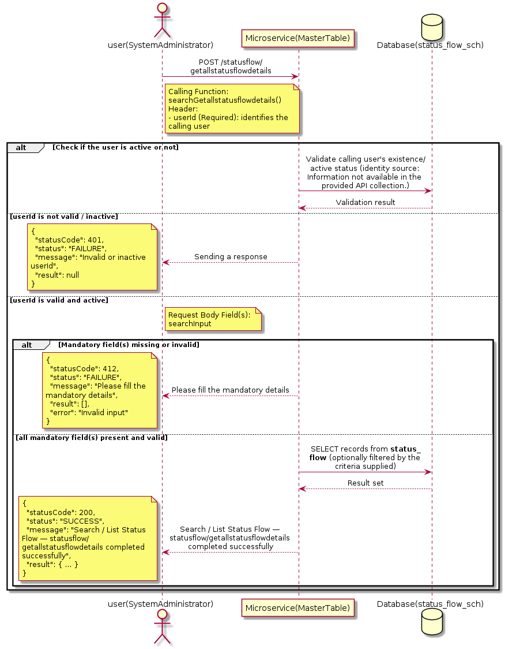

3.18.4.3 API Endpoint
Method | POST
URL | http://localhost:7002/srv2/genie/statusflow/getallstatusflowdetails
Headers | userId: 67 Content-Type: application/json (assumed based on JSON request payload; Information not available in the provided API collection.)
Authorization | Not present in the captured request. Information not available in the provided API collection.
Content-Type | Content-Type: application/json (assumed based on JSON request payload; Information not available in the provided API collection.)
Query Parameters | None
Path Variables | None
Request Body:
{
"searchInput": ""
}
Response Body (illustrative — see 3.x.4.5 Success Response for details):
The source Postman collection does not include a captured sample response for this request (the response array is empty). Information not available in the provided API collection. Section 3.18.4.4.5 below presents the response envelope inferred from the standard response wrapper used consistently by this platform's services.

3.18.4.4 Detailed Process Flow

3.18.4.4.1 Request Initiation
The flow begins when System Administrator (or a calling microservice on their behalf) invokes the POST endpoint http://localhost:7002/srv2/genie/statusflow/getallstatusflowdetails. The request must include the mandatory `userId` header used by the Master Table Microservice to identify the calling user for auditing purposes. The request carries a JSON payload in the request body which the Controller binds to its Data Transfer Object (DTO) before any processing begins. At the Controller layer, Spring Boot's request-mapping infrastructure routes the call to the appropriate handler method (`searchGetallstatusflowdetails`), and Bean Validation annotations (if configured on the DTO) perform structural validation before the request reaches the Service layer. Information not available in the provided API collection. regarding the exact validation annotations used in the source code.

3.18.4.4.2 User Validation
The Master Table Microservice relies on the `userId` header to identify the calling user. Based on the pattern observed consistently across this API collection, the platform's authentication/authorization is expected to be enforced upstream (e.g., by an API Gateway or a shared security filter) using this identifier; the Postman collection does not include an `Authorization` / `Bearer` token header on this request, so the exact authentication mechanism (JWT validation, session lookup, or gateway-level SSO) is Information not available in the provided API collection. Role-based authorization — i.e., confirming that the user identified by `userId` holds a role/permission entitled to perform this operation — is expected to be enforced by the Service layer (see Section 8 – Controller Analysis and Section 14 – Authentication & Authorization), but the specific role/permission checks are Information not available in the provided API collection.

3.18.4.4.3 Business Logic
The Service layer evaluates the search payload; if the search text/criteria is empty, the operation typically behaves like a full list (all Status Flow records); if populated, it is used to build a case-insensitive `LIKE`/contains predicate against the relevant column(s). The key fields exchanged for this operation, as observed in the sample payload, are: `searchInput`.

3.18.4.4.4 Database Interaction
The Repository layer (Spring Data JPA) interacts with the underlying relational database that backs the Status Flow master table. The primary operation issued is a **SELECT** against the table associated with Status Flow. No write operations occur; the search is typically implemented using a JPA derived query method or a native/JPQL query with `LIKE` predicates. The exact table name, column names, primary/foreign key definitions, and JPA repository method signatures are not included in the Postman collection; therefore, precise schema details are information not available in the provided api collection.

3.18.4.4.5 Success Response
Status Code: 200 OK. Sample response envelope (illustrative — the source collection did not capture a sample response for this API):
{
"statusCode": 200,
"status": "SUCCESS",
"message": "Search / List Status Flow — statusflow/getallstatusflowdetails completed successfully",
"result": [
{
"id": 1,
"name": "Sample Status Flow",
"isActive": 1
}
],
"error": null,
"corelationId": "c6f2a1e4-2b3d-4a9e-9f1a-1234567890ab",
"url": null
}

3.18.4.4.6 Conclusion
This API provides a well-defined, single-purpose capability within the Master Table Microservice for search / list status flow — statusflow/getallstatusflowdetails. The Controller → Service → Repository → Database layering keeps request validation, business rules, and persistence concerns separated, which allows the Status Flow master data to be maintained consistently and safely by authorized administrators while remaining available for consumption by every other module that depends on this reference data.

3.18.5 Search / List Status Flow — getstatusflowdetails/{statusflowid}

3.18.5.1 Overview
Purpose: To search and list Status Flow records based on a search payload (e.g., free-text search or structured criteria), supporting list/grid screens that need paginated or filtered master data.
Business Requirement: List/search screens for Status Flow configuration need server-side search so that administrators can locate specific records in large master tables without scanning the full data set.
Who Uses the API: System Administrator operating the Status Flow configuration/list screen.
Business Flow: Client sends a POST request with a search payload → Controller validates the payload → Service layer constructs the search/query logic → Repository executes the search against the Status Flow table → matching records are returned to the Client.

3.18.5.2 Sequence Diagram
The diagram below illustrates the end-to-end interaction for "Search / List Status Flow — getstatusflowdetails/{statusflowid}" across the Client, Controller, Service, Repository, and Database layers.
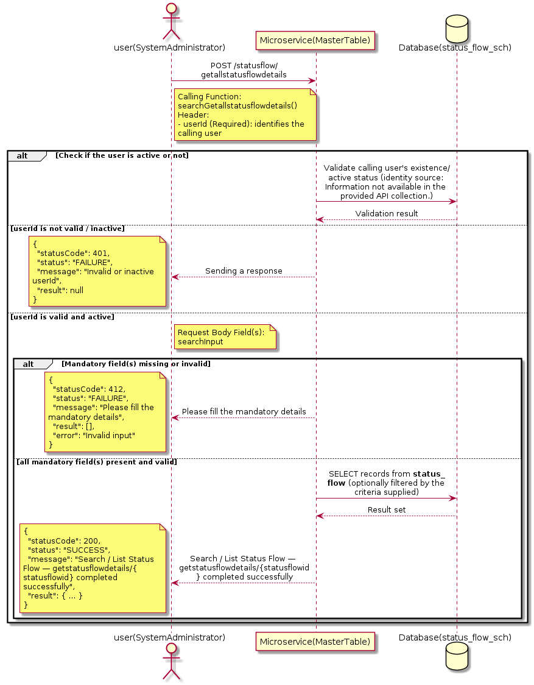

3.18.5.3 API Endpoint
Method | POST
URL | http://localhost:7002/srv2/genie/statusflow/getallstatusflowdetails
Headers | userId: 67 Content-Type: application/json (assumed based on JSON request payload; Information not available in the provided API collection.)
Authorization | Not present in the captured request. Information not available in the provided API collection.
Content-Type | Content-Type: application/json (assumed based on JSON request payload; Information not available in the provided API collection.)
Query Parameters | None
Path Variables | None
Request Body:
{
"searchInput": "1"
}
Response Body (illustrative — see 3.x.4.5 Success Response for details):
The source Postman collection does not include a captured sample response for this request (the response array is empty). Information not available in the provided API collection. Section 3.18.5.4.5 below presents the response envelope inferred from the standard response wrapper used consistently by this platform's services.

3.18.5.4 Detailed Process Flow

3.18.5.4.1 Request Initiation
The flow begins when System Administrator (or a calling microservice on their behalf) invokes the POST endpoint http://localhost:7002/srv2/genie/statusflow/getallstatusflowdetails. The request must include the mandatory `userId` header used by the Master Table Microservice to identify the calling user for auditing purposes. The request carries a JSON payload in the request body which the Controller binds to its Data Transfer Object (DTO) before any processing begins. At the Controller layer, Spring Boot's request-mapping infrastructure routes the call to the appropriate handler method (`searchGetallstatusflowdetails`), and Bean Validation annotations (if configured on the DTO) perform structural validation before the request reaches the Service layer. Information not available in the provided API collection. regarding the exact validation annotations used in the source code.

3.18.5.4.2 User Validation
The Master Table Microservice relies on the `userId` header to identify the calling user. Based on the pattern observed consistently across this API collection, the platform's authentication/authorization is expected to be enforced upstream (e.g., by an API Gateway or a shared security filter) using this identifier; the Postman collection does not include an `Authorization` / `Bearer` token header on this request, so the exact authentication mechanism (JWT validation, session lookup, or gateway-level SSO) is Information not available in the provided API collection. Role-based authorization — i.e., confirming that the user identified by `userId` holds a role/permission entitled to perform this operation — is expected to be enforced by the Service layer (see Section 8 – Controller Analysis and Section 14 – Authentication & Authorization), but the specific role/permission checks are Information not available in the provided API collection.

3.18.5.4.3 Business Logic
The Service layer evaluates the search payload; if the search text/criteria is empty, the operation typically behaves like a full list (all Status Flow records); if populated, it is used to build a case-insensitive `LIKE`/contains predicate against the relevant column(s). The key fields exchanged for this operation, as observed in the sample payload, are: `searchInput`.

3.18.5.4.4 Database Interaction
The Repository layer (Spring Data JPA) interacts with the underlying relational database that backs the Status Flow master table. The primary operation issued is a **SELECT** against the table associated with Status Flow. No write operations occur; the search is typically implemented using a JPA derived query method or a native/JPQL query with `LIKE` predicates. The exact table name, column names, primary/foreign key definitions, and JPA repository method signatures are not included in the Postman collection; therefore, precise schema details are information not available in the provided api collection.

3.18.5.4.5 Success Response
Status Code: 200 OK. Sample response envelope (illustrative — the source collection did not capture a sample response for this API):
{
"statusCode": 200,
"status": "SUCCESS",
"message": "Search / List Status Flow — getstatusflowdetails/{statusflowid} completed successfully",
"result": [
{
"id": 1,
"name": "Sample Status Flow",
"isActive": 1
}
],
"error": null,
"corelationId": "c6f2a1e4-2b3d-4a9e-9f1a-1234567890ab",
"url": null
}

3.18.5.4.6 Conclusion
This API provides a well-defined, single-purpose capability within the Master Table Microservice for search / list status flow — getstatusflowdetails/{statusflowid}. The Controller → Service → Repository → Database layering keeps request validation, business rules, and persistence concerns separated, which allows the Status Flow master data to be maintained consistently and safely by authorized administrators while remaining available for consumption by every other module that depends on this reference data.

3.18.6 Retrieve All Status Flow — statusflow (1)

3.18.6.1 Overview
Purpose: To retrieve the complete list of Status Flow master records configured in the Master Table Microservice, so that consuming screens and downstream services can populate dropdowns, grids, and configuration views.
Business Requirement: Every screen and workflow that references Status Flow data (creation forms, filters, reports) needs an authoritative, always-current list of active Status Flow values sourced from a single master table rather than being hard-coded.
Who Uses the API: System Administrator, and any internal microservice/UI module that needs to render Status Flow options.
Business Flow: Client sends a GET request → Controller delegates to the Service layer → Service layer calls the Repository → Repository queries the Status Flow table → the result set is mapped to response DTOs and returned to the Client.

3.18.6.2 Sequence Diagram
The diagram below illustrates the end-to-end interaction for "Retrieve All Status Flow — statusflow (1)" across the Client, Controller, Service, Repository, and Database layers.
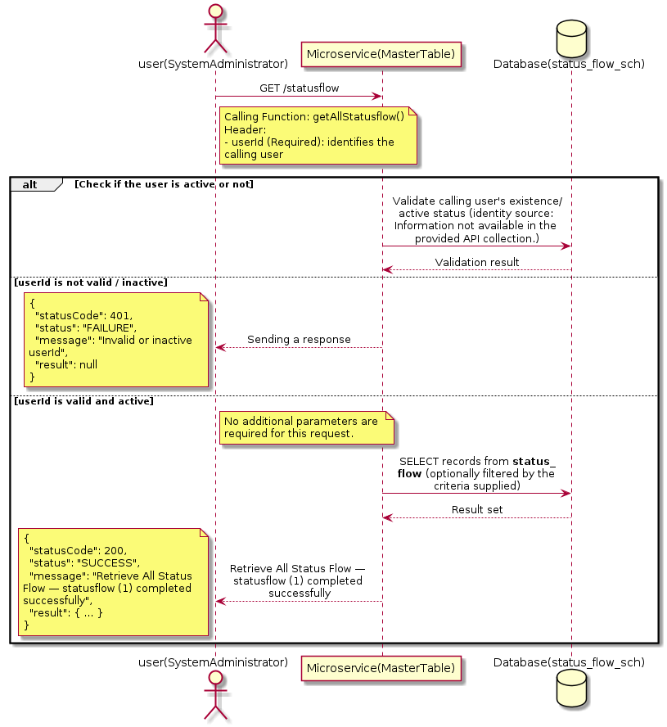

3.18.6.3 API Endpoint
Method | GET
URL | http://localhost:7002/srv2/genie/statusflow
Headers | userId: 67
Authorization | Not present in the captured request. Information not available in the provided API collection.
Content-Type | application/json (assumed)
Query Parameters | None
Path Variables | None
Request Body:
Not applicable — this operation does not accept a request body.
Response Body (illustrative — see 3.x.4.5 Success Response for details):
The source Postman collection does not include a captured sample response for this request (the response array is empty). Information not available in the provided API collection. Section 3.18.6.4.5 below presents the response envelope inferred from the standard response wrapper used consistently by this platform's services.

3.18.6.4 Detailed Process Flow

3.18.6.4.1 Request Initiation
The flow begins when System Administrator (or a calling microservice on their behalf) invokes the GET endpoint http://localhost:7002/srv2/genie/statusflow. The request must include the mandatory `userId` header used by the Master Table Microservice to identify the calling user for auditing purposes. At the Controller layer, Spring Boot's request-mapping infrastructure routes the call to the appropriate handler method (`getAllStatusflow`), and Bean Validation annotations (if configured on the DTO) perform structural validation before the request reaches the Service layer. Information not available in the provided API collection. regarding the exact validation annotations used in the source code.

3.18.6.4.2 User Validation
The Master Table Microservice relies on the `userId` header to identify the calling user. Based on the pattern observed consistently across this API collection, the platform's authentication/authorization is expected to be enforced upstream (e.g., by an API Gateway or a shared security filter) using this identifier; the Postman collection does not include an `Authorization` / `Bearer` token header on this request, so the exact authentication mechanism (JWT validation, session lookup, or gateway-level SSO) is Information not available in the provided API collection. Role-based authorization — i.e., confirming that the user identified by `userId` holds a role/permission entitled to perform this operation — is expected to be enforced by the Service layer (see Section 8 – Controller Analysis and Section 14 – Authentication & Authorization), but the specific role/permission checks are Information not available in the provided API collection.

3.18.6.4.3 Business Logic
The Service layer contains no conditional business branching for this operation beyond invoking the Repository to fetch all Status Flow records. Depending on the record volume, the Service layer may apply default sorting (e.g., by name or creation order) before returning the list.

3.18.6.4.4 Database Interaction
The Repository layer (Spring Data JPA) interacts with the underlying relational database that backs the Status Flow master table. The primary operation issued is a **SELECT** against the table associated with Status Flow. No write operations occur; the query returns all rows that satisfy the entity's default scope (typically active records). The exact table name, column names, primary/foreign key definitions, and JPA repository method signatures are not included in the Postman collection; therefore, precise schema details are information not available in the provided api collection.

3.18.6.4.5 Success Response
Status Code: 200 OK. Sample response envelope (illustrative — the source collection did not capture a sample response for this API):
{
"statusCode": 200,
"status": "SUCCESS",
"message": "Retrieve All Status Flow — statusflow (1) completed successfully",
"result": [
{
"id": 1,
"name": "Sample Status Flow",
"isActive": 1
}
],
"error": null,
"corelationId": "c6f2a1e4-2b3d-4a9e-9f1a-1234567890ab",
"url": null
}

3.18.6.4.6 Conclusion
This API provides a well-defined, single-purpose capability within the Master Table Microservice for retrieve all status flow — statusflow (1). The Controller → Service → Repository → Database layering keeps request validation, business rules, and persistence concerns separated, which allows the Status Flow master data to be maintained consistently and safely by authorized administrators while remaining available for consumption by every other module that depends on this reference data.

3.18.7 Retrieve All Status Flow — statusflow (2)

3.18.7.1 Overview
Purpose: To retrieve the complete list of Status Flow master records configured in the Master Table Microservice, so that consuming screens and downstream services can populate dropdowns, grids, and configuration views.
Business Requirement: Every screen and workflow that references Status Flow data (creation forms, filters, reports) needs an authoritative, always-current list of active Status Flow values sourced from a single master table rather than being hard-coded.
Who Uses the API: System Administrator, and any internal microservice/UI module that needs to render Status Flow options.
Business Flow: Client sends a GET request → Controller delegates to the Service layer → Service layer calls the Repository → Repository queries the Status Flow table → the result set is mapped to response DTOs and returned to the Client.

3.18.7.2 Sequence Diagram
The diagram below illustrates the end-to-end interaction for "Retrieve All Status Flow — statusflow (2)" across the Client, Controller, Service, Repository, and Database layers.
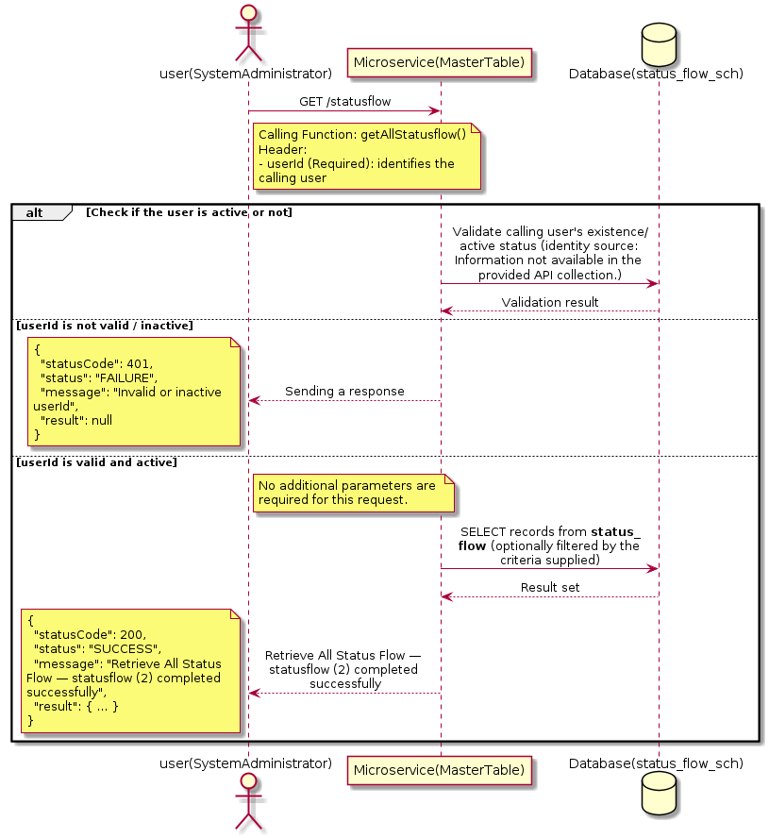

3.18.7.3 API Endpoint
Method | GET
URL | http://localhost:7002/srv2/genie/statusflow
Headers | userId: 67
Authorization | Not present in the captured request. Information not available in the provided API collection.
Content-Type | application/json (assumed)
Query Parameters | None
Path Variables | None
Request Body:
Not applicable — this operation does not accept a request body.
Response Body (illustrative — see 3.x.4.5 Success Response for details):
The source Postman collection does not include a captured sample response for this request (the response array is empty). Information not available in the provided API collection. Section 3.18.7.4.5 below presents the response envelope inferred from the standard response wrapper used consistently by this platform's services.

3.18.7.4 Detailed Process Flow

3.18.7.4.1 Request Initiation
The flow begins when System Administrator (or a calling microservice on their behalf) invokes the GET endpoint http://localhost:7002/srv2/genie/statusflow. The request must include the mandatory `userId` header used by the Master Table Microservice to identify the calling user for auditing purposes. At the Controller layer, Spring Boot's request-mapping infrastructure routes the call to the appropriate handler method (`getAllStatusflow`), and Bean Validation annotations (if configured on the DTO) perform structural validation before the request reaches the Service layer. Information not available in the provided API collection. regarding the exact validation annotations used in the source code.

3.18.7.4.2 User Validation
The Master Table Microservice relies on the `userId` header to identify the calling user. Based on the pattern observed consistently across this API collection, the platform's authentication/authorization is expected to be enforced upstream (e.g., by an API Gateway or a shared security filter) using this identifier; the Postman collection does not include an `Authorization` / `Bearer` token header on this request, so the exact authentication mechanism (JWT validation, session lookup, or gateway-level SSO) is Information not available in the provided API collection. Role-based authorization — i.e., confirming that the user identified by `userId` holds a role/permission entitled to perform this operation — is expected to be enforced by the Service layer (see Section 8 – Controller Analysis and Section 14 – Authentication & Authorization), but the specific role/permission checks are Information not available in the provided API collection.

3.18.7.4.3 Business Logic
The Service layer contains no conditional business branching for this operation beyond invoking the Repository to fetch all Status Flow records. Depending on the record volume, the Service layer may apply default sorting (e.g., by name or creation order) before returning the list.

3.18.7.4.4 Database Interaction
The Repository layer (Spring Data JPA) interacts with the underlying relational database that backs the Status Flow master table. The primary operation issued is a **SELECT** against the table associated with Status Flow. No write operations occur; the query returns all rows that satisfy the entity's default scope (typically active records). The exact table name, column names, primary/foreign key definitions, and JPA repository method signatures are not included in the Postman collection; therefore, precise schema details are information not available in the provided api collection.

3.18.7.4.5 Success Response
Status Code: 200 OK. Sample response envelope (illustrative — the source collection did not capture a sample response for this API):
{
"statusCode": 200,
"status": "SUCCESS",
"message": "Retrieve All Status Flow — statusflow (2) completed successfully",
"result": [
{
"id": 1,
"name": "Sample Status Flow",
"isActive": 1
}
],
"error": null,
"corelationId": "c6f2a1e4-2b3d-4a9e-9f1a-1234567890ab",
"url": null
}

3.18.7.4.6 Conclusion
This API provides a well-defined, single-purpose capability within the Master Table Microservice for retrieve all status flow — statusflow (2). The Controller → Service → Repository → Database layering keeps request validation, business rules, and persistence concerns separated, which allows the Status Flow master data to be maintained consistently and safely by authorized administrators while remaining available for consumption by every other module that depends on this reference data.

3.18.8 Retrieve All Status Flow — statusflow (3)

3.18.8.1 Overview
Purpose: To retrieve the complete list of Status Flow master records configured in the Master Table Microservice, so that consuming screens and downstream services can populate dropdowns, grids, and configuration views.
Business Requirement: Every screen and workflow that references Status Flow data (creation forms, filters, reports) needs an authoritative, always-current list of active Status Flow values sourced from a single master table rather than being hard-coded.
Who Uses the API: System Administrator, and any internal microservice/UI module that needs to render Status Flow options.
Business Flow: Client sends a GET request → Controller delegates to the Service layer → Service layer calls the Repository → Repository queries the Status Flow table → the result set is mapped to response DTOs and returned to the Client.

3.18.8.2 Sequence Diagram
The diagram below illustrates the end-to-end interaction for "Retrieve All Status Flow — statusflow (3)" across the Client, Controller, Service, Repository, and Database layers.
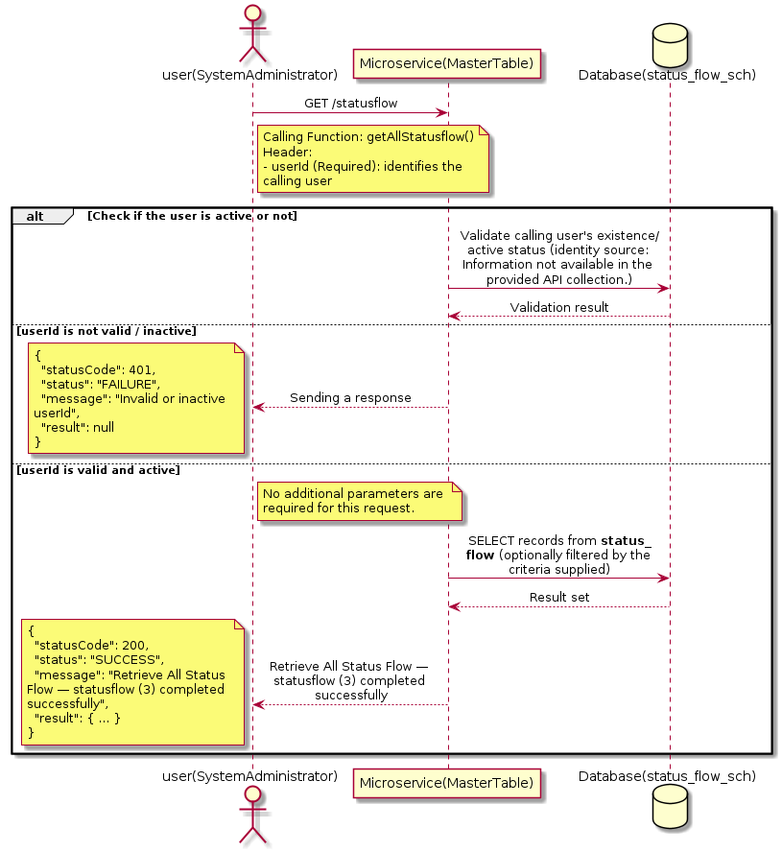

3.18.8.3 API Endpoint
Method | GET
URL | http://localhost:7002/srv2/genie/statusflow
Headers | userId: 67
Authorization | Not present in the captured request. Information not available in the provided API collection.
Content-Type | application/json (assumed)
Query Parameters | None
Path Variables | None
Request Body:
Not applicable — this operation does not accept a request body.
Response Body (illustrative — see 3.x.4.5 Success Response for details):
The source Postman collection does not include a captured sample response for this request (the response array is empty). Information not available in the provided API collection. Section 3.18.8.4.5 below presents the response envelope inferred from the standard response wrapper used consistently by this platform's services.

3.18.8.4 Detailed Process Flow

3.18.8.4.1 Request Initiation
The flow begins when System Administrator (or a calling microservice on their behalf) invokes the GET endpoint http://localhost:7002/srv2/genie/statusflow. The request must include the mandatory `userId` header used by the Master Table Microservice to identify the calling user for auditing purposes. At the Controller layer, Spring Boot's request-mapping infrastructure routes the call to the appropriate handler method (`getAllStatusflow`), and Bean Validation annotations (if configured on the DTO) perform structural validation before the request reaches the Service layer. Information not available in the provided API collection. regarding the exact validation annotations used in the source code.

3.18.8.4.2 User Validation
The Master Table Microservice relies on the `userId` header to identify the calling user. Based on the pattern observed consistently across this API collection, the platform's authentication/authorization is expected to be enforced upstream (e.g., by an API Gateway or a shared security filter) using this identifier; the Postman collection does not include an `Authorization` / `Bearer` token header on this request, so the exact authentication mechanism (JWT validation, session lookup, or gateway-level SSO) is Information not available in the provided API collection. Role-based authorization — i.e., confirming that the user identified by `userId` holds a role/permission entitled to perform this operation — is expected to be enforced by the Service layer (see Section 8 – Controller Analysis and Section 14 – Authentication & Authorization), but the specific role/permission checks are Information not available in the provided API collection.

3.18.8.4.3 Business Logic
The Service layer contains no conditional business branching for this operation beyond invoking the Repository to fetch all Status Flow records. Depending on the record volume, the Service layer may apply default sorting (e.g., by name or creation order) before returning the list.

3.18.8.4.4 Database Interaction
The Repository layer (Spring Data JPA) interacts with the underlying relational database that backs the Status Flow master table. The primary operation issued is a **SELECT** against the table associated with Status Flow. No write operations occur; the query returns all rows that satisfy the entity's default scope (typically active records). The exact table name, column names, primary/foreign key definitions, and JPA repository method signatures are not included in the Postman collection; therefore, precise schema details are information not available in the provided api collection.

3.18.8.4.5 Success Response
Status Code: 200 OK. Sample response envelope (illustrative — the source collection did not capture a sample response for this API):
{
"statusCode": 200,
"status": "SUCCESS",
"message": "Retrieve All Status Flow — statusflow (3) completed successfully",
"result": [
{
"id": 1,
"name": "Sample Status Flow",
"isActive": 1
}
],
"error": null,
"corelationId": "c6f2a1e4-2b3d-4a9e-9f1a-1234567890ab",
"url": null
}

3.18.8.4.6 Conclusion
This API provides a well-defined, single-purpose capability within the Master Table Microservice for retrieve all status flow — statusflow (3). The Controller → Service → Repository → Database layering keeps request validation, business rules, and persistence concerns separated, which allows the Status Flow master data to be maintained consistently and safely by authorized administrators while remaining available for consumption by every other module that depends on this reference data.

3.19 Ticket Category APIs (Ticket category APIs)
Maintains the ticket category master used to classify incoming tickets/requests.

3.19.1 Retrieve Ticket Category by ID — categories/1

3.19.1.1 Overview
Purpose: To retrieve a single Ticket Category record identified by its unique identifier, typically used to pre-populate an edit screen or to validate a reference before use.
Business Requirement: Edit screens, validation routines, and cross-service lookups need to resolve a single Ticket Category record by its identifier reliably and quickly.
Who Uses the API: System Administrator, and internal services validating a Ticket Category reference (e.g., ticket creation, workflow configuration).
Business Flow: Client sends a GET request with the identifier in the URL path → Controller extracts the path variable → Service layer requests the Repository to fetch the record → if found, the record is mapped and returned; if not found, a 404 is returned.

3.19.1.2 Sequence Diagram
The diagram below illustrates the end-to-end interaction for "Retrieve Ticket Category by ID — categories/1" across the Client, Controller, Service, Repository, and Database layers.
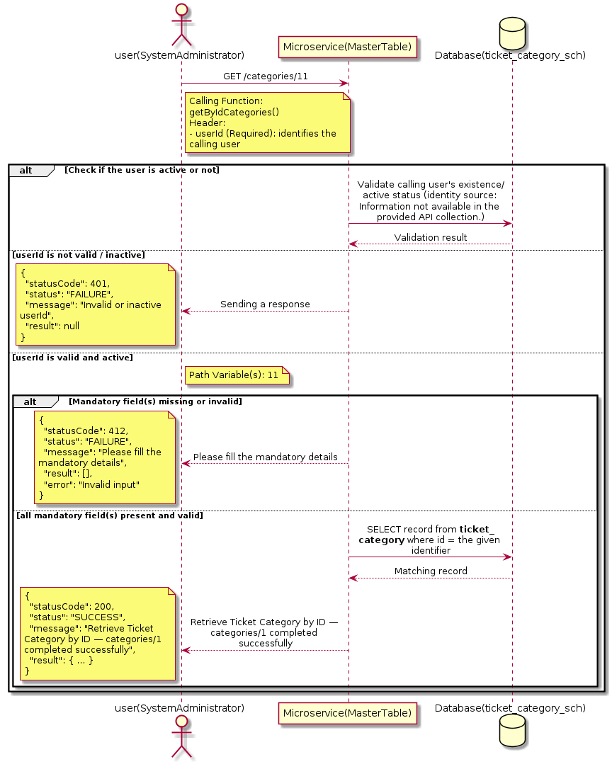

3.19.1.3 API Endpoint
Method | GET
URL | http://172.30.72.35:7002/srv2/genie/categories/11
Headers | userId: 879
Authorization | Not present in the captured request. Information not available in the provided API collection.
Content-Type | application/json (assumed)
Query Parameters | None
Path Variables | 11
Request Body:
Not applicable — this operation does not accept a request body.
Response Body (illustrative — see 3.x.4.5 Success Response for details):
The source Postman collection does not include a captured sample response for this request (the response array is empty). Information not available in the provided API collection. Section 3.19.1.4.5 below presents the response envelope inferred from the standard response wrapper used consistently by this platform's services.

3.19.1.4 Detailed Process Flow

3.19.1.4.1 Request Initiation
The flow begins when System Administrator (or a calling microservice on their behalf) invokes the GET endpoint http://172.30.72.35:7002/srv2/genie/categories/11. The request must include the mandatory `userId` header used by the Master Table Microservice to identify the calling user for auditing purposes. At the Controller layer, Spring Boot's request-mapping infrastructure routes the call to the appropriate handler method (`getByIdCategories`), and Bean Validation annotations (if configured on the DTO) perform structural validation before the request reaches the Service layer. Information not available in the provided API collection. regarding the exact validation annotations used in the source code.

3.19.1.4.2 User Validation
The Master Table Microservice relies on the `userId` header to identify the calling user. Based on the pattern observed consistently across this API collection, the platform's authentication/authorization is expected to be enforced upstream (e.g., by an API Gateway or a shared security filter) using this identifier; the Postman collection does not include an `Authorization` / `Bearer` token header on this request, so the exact authentication mechanism (JWT validation, session lookup, or gateway-level SSO) is Information not available in the provided API collection. Role-based authorization — i.e., confirming that the user identified by `userId` holds a role/permission entitled to perform this operation — is expected to be enforced by the Service layer (see Section 8 – Controller Analysis and Section 14 – Authentication & Authorization), but the specific role/permission checks are Information not available in the provided API collection.

3.19.1.4.3 Business Logic
The Service layer forwards the identifier to the Repository. If no record is found for the given identifier, the Service layer raises a not-found condition that the Controller/global exception handler converts into an HTTP 404 response.

3.19.1.4.4 Database Interaction
The Repository layer (Spring Data JPA) interacts with the underlying relational database that backs the Ticket Category master table. The primary operation issued is a **SELECT** against the table associated with Ticket Category. No write operations occur; a single-row lookup is performed using the primary key. The exact table name, column names, primary/foreign key definitions, and JPA repository method signatures are not included in the Postman collection; therefore, precise schema details are information not available in the provided api collection.

3.19.1.4.5 Success Response
Status Code: 200 OK. Sample response envelope (illustrative — the source collection did not capture a sample response for this API):
{
"statusCode": 200,
"status": "SUCCESS",
"message": "Retrieve Ticket Category by ID — categories/1 completed successfully",
"result": {
"id": 1,
"name": "Sample Ticket Category",
"isActive": 1
},
"error": null,
"corelationId": "c6f2a1e4-2b3d-4a9e-9f1a-1234567890ab",
"url": null
}

3.19.1.4.6 Conclusion
This API provides a well-defined, single-purpose capability within the Master Table Microservice for retrieve ticket category by id — categories/1. The Controller → Service → Repository → Database layering keeps request validation, business rules, and persistence concerns separated, which allows the Ticket Category master data to be maintained consistently and safely by authorized administrators while remaining available for consumption by every other module that depends on this reference data.

3.19.2 Retrieve Ticket Category by ID — categories/dept/id

3.19.2.1 Overview
Purpose: To retrieve a single Ticket Category record identified by its unique identifier, typically used to pre-populate an edit screen or to validate a reference before use.
Business Requirement: Edit screens, validation routines, and cross-service lookups need to resolve a single Ticket Category record by its identifier reliably and quickly.
Who Uses the API: System Administrator, and internal services validating a Ticket Category reference (e.g., ticket creation, workflow configuration).
Business Flow: Client sends a GET request with the identifier in the URL path → Controller extracts the path variable → Service layer requests the Repository to fetch the record → if found, the record is mapped and returned; if not found, a 404 is returned.

3.19.2.2 Sequence Diagram
The diagram below illustrates the end-to-end interaction for "Retrieve Ticket Category by ID — categories/dept/id" across the Client, Controller, Service, Repository, and Database layers.
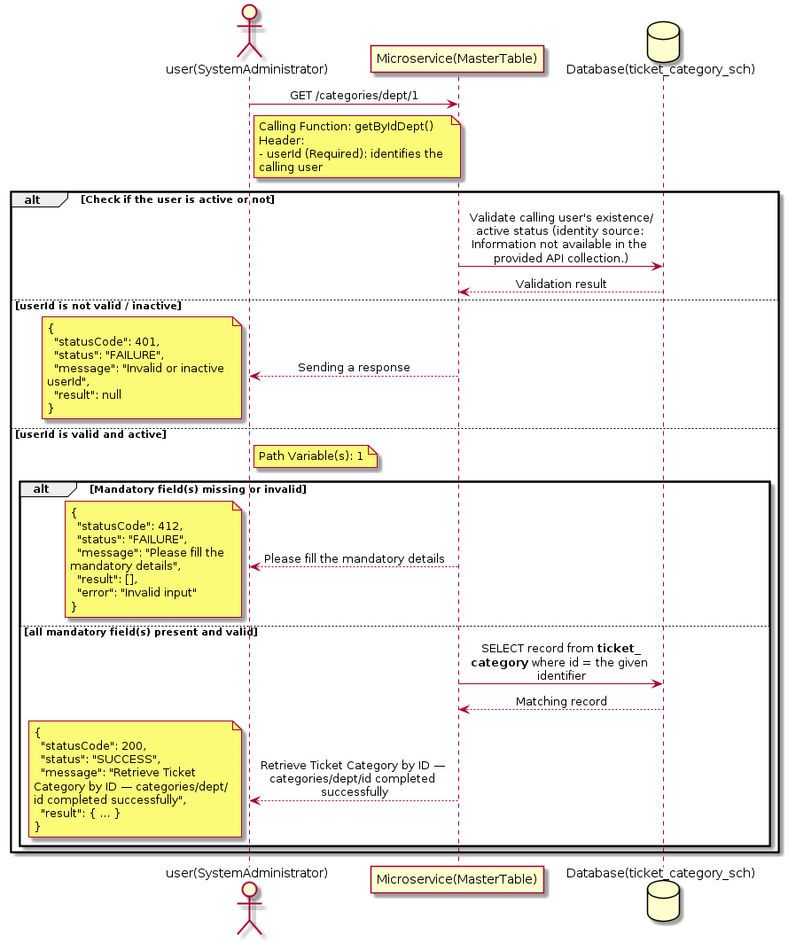

3.19.2.3 API Endpoint
Method | GET
URL | http://localhost:7002/srv2/genie/categories/dept/1
Headers | userId: 879
Authorization | Not present in the captured request. Information not available in the provided API collection.
Content-Type | application/json (assumed)
Query Parameters | None
Path Variables | 1
Request Body:
Not applicable — this operation does not accept a request body.
Response Body (illustrative — see 3.x.4.5 Success Response for details):
The source Postman collection does not include a captured sample response for this request (the response array is empty). Information not available in the provided API collection. Section 3.19.2.4.5 below presents the response envelope inferred from the standard response wrapper used consistently by this platform's services.

3.19.2.4 Detailed Process Flow

3.19.2.4.1 Request Initiation
The flow begins when System Administrator (or a calling microservice on their behalf) invokes the GET endpoint http://localhost:7002/srv2/genie/categories/dept/1. The request must include the mandatory `userId` header used by the Master Table Microservice to identify the calling user for auditing purposes. At the Controller layer, Spring Boot's request-mapping infrastructure routes the call to the appropriate handler method (`getByIdDept`), and Bean Validation annotations (if configured on the DTO) perform structural validation before the request reaches the Service layer. Information not available in the provided API collection. regarding the exact validation annotations used in the source code.

3.19.2.4.2 User Validation
The Master Table Microservice relies on the `userId` header to identify the calling user. Based on the pattern observed consistently across this API collection, the platform's authentication/authorization is expected to be enforced upstream (e.g., by an API Gateway or a shared security filter) using this identifier; the Postman collection does not include an `Authorization` / `Bearer` token header on this request, so the exact authentication mechanism (JWT validation, session lookup, or gateway-level SSO) is Information not available in the provided API collection. Role-based authorization — i.e., confirming that the user identified by `userId` holds a role/permission entitled to perform this operation — is expected to be enforced by the Service layer (see Section 8 – Controller Analysis and Section 14 – Authentication & Authorization), but the specific role/permission checks are Information not available in the provided API collection.

3.19.2.4.3 Business Logic
The Service layer forwards the identifier to the Repository. If no record is found for the given identifier, the Service layer raises a not-found condition that the Controller/global exception handler converts into an HTTP 404 response.

3.19.2.4.4 Database Interaction
The Repository layer (Spring Data JPA) interacts with the underlying relational database that backs the Ticket Category master table. The primary operation issued is a **SELECT** against the table associated with Ticket Category. No write operations occur; a single-row lookup is performed using the primary key. The exact table name, column names, primary/foreign key definitions, and JPA repository method signatures are not included in the Postman collection; therefore, precise schema details are information not available in the provided api collection.

3.19.2.4.5 Success Response
Status Code: 200 OK. Sample response envelope (illustrative — the source collection did not capture a sample response for this API):
{
"statusCode": 200,
"status": "SUCCESS",
"message": "Retrieve Ticket Category by ID — categories/dept/id completed successfully",
"result": {
"id": 1,
"name": "Sample Ticket Category",
"isActive": 1
},
"error": null,
"corelationId": "c6f2a1e4-2b3d-4a9e-9f1a-1234567890ab",
"url": null
}

3.19.2.4.6 Conclusion
This API provides a well-defined, single-purpose capability within the Master Table Microservice for retrieve ticket category by id — categories/dept/id. The Controller → Service → Repository → Database layering keeps request validation, business rules, and persistence concerns separated, which allows the Ticket Category master data to be maintained consistently and safely by authorized administrators while remaining available for consumption by every other module that depends on this reference data.

3.19.3 Update Ticket Category

3.19.3.1 Overview
Purpose: To update an existing Ticket Category master record, allowing administrators to correct or evolve master-data attributes without impacting the record's identity/history.
Business Requirement: Master data changes over time (renames, corrections, re-classification); the platform must allow controlled updates while preserving referential integrity for records that already reference this Ticket Category.
Who Uses the API: System Administrator responsible for maintaining master-data accuracy.
Business Flow: Client sends a PUT/PATCH request with the updated Ticket Category payload → Controller validates the payload → Service layer fetches the existing record, applies the changes, and re-validates business rules → Repository persists the updated record → the updated record is returned to the Client.

3.19.3.2 Sequence Diagram
The diagram below illustrates the end-to-end interaction for "Update Ticket Category" across the Client, Controller, Service, Repository, and Database layers.
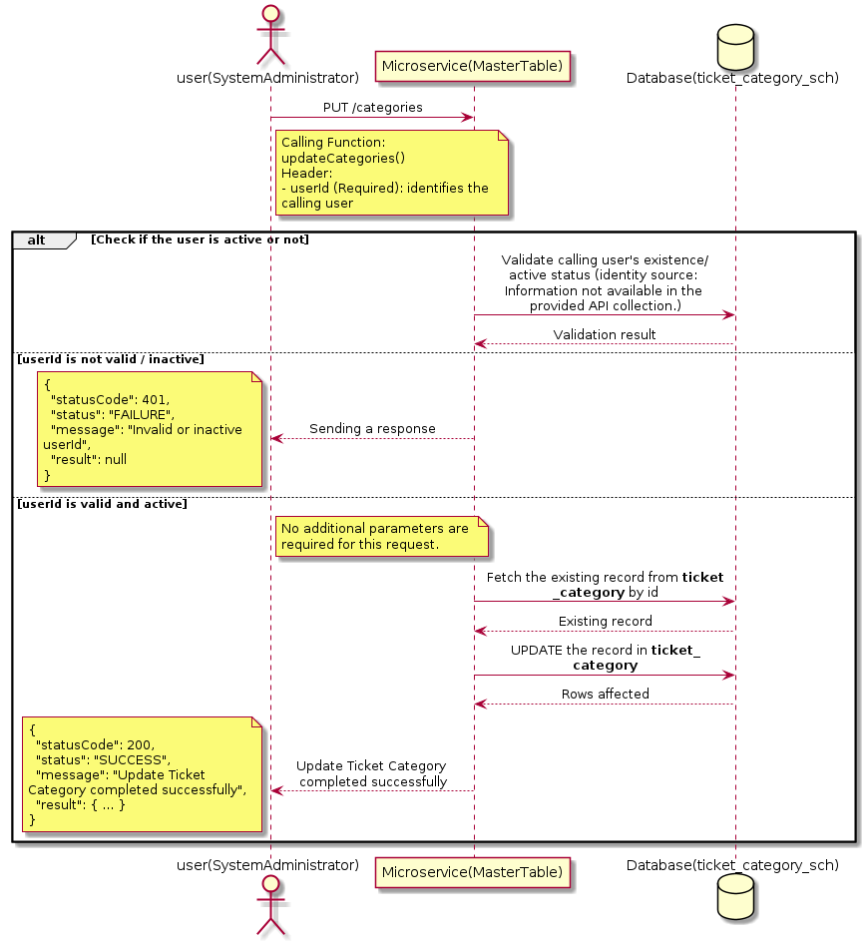

3.19.3.3 API Endpoint
Method | PUT
URL | http://localhost:7002/srv2/genie/categories
Headers | userId: 67 Content-Type: application/json (assumed based on JSON request payload; Information not available in the provided API collection.)
Authorization | Not present in the captured request. Information not available in the provided API collection.
Content-Type | Content-Type: application/json (assumed based on JSON request payload; Information not available in the provided API collection.)
Query Parameters | None
Path Variables | None
Request Body:
No request body is required for this API. Information not available in the provided API collection.
Response Body (illustrative — see 3.x.4.5 Success Response for details):
The source Postman collection does not include a captured sample response for this request (the response array is empty). Information not available in the provided API collection. Section 3.19.3.4.5 below presents the response envelope inferred from the standard response wrapper used consistently by this platform's services.

3.19.3.4 Detailed Process Flow

3.19.3.4.1 Request Initiation
The flow begins when System Administrator (or a calling microservice on their behalf) invokes the PUT endpoint http://localhost:7002/srv2/genie/categories. The request must include the mandatory `userId` header used by the Master Table Microservice to identify the calling user for auditing purposes. At the Controller layer, Spring Boot's request-mapping infrastructure routes the call to the appropriate handler method (`updateCategories`), and Bean Validation annotations (if configured on the DTO) perform structural validation before the request reaches the Service layer. Information not available in the provided API collection. regarding the exact validation annotations used in the source code.

3.19.3.4.2 User Validation
The Master Table Microservice relies on the `userId` header to identify the calling user. Based on the pattern observed consistently across this API collection, the platform's authentication/authorization is expected to be enforced upstream (e.g., by an API Gateway or a shared security filter) using this identifier; the Postman collection does not include an `Authorization` / `Bearer` token header on this request, so the exact authentication mechanism (JWT validation, session lookup, or gateway-level SSO) is Information not available in the provided API collection. Role-based authorization — i.e., confirming that the user identified by `userId` holds a role/permission entitled to perform this operation — is expected to be enforced by the Service layer (see Section 8 – Controller Analysis and Section 14 – Authentication & Authorization), but the specific role/permission checks are Information not available in the provided API collection.

3.19.3.4.3 Business Logic
The Service layer fetches the existing Ticket Category record by its identifier, verifies it exists, applies the incoming changes field by field, re-validates business rules (e.g., uniqueness of a renamed field), and persists the updated entity via the Repository. If the record does not exist, the operation is rejected with a not-found error.

3.19.3.4.4 Database Interaction
The Repository layer (Spring Data JPA) interacts with the underlying relational database that backs the Ticket Category master table. The primary operation issued is a **UPDATE** against the table associated with Ticket Category. The existing row is located by primary key and updated; if the entity has related child records, the existing child rows are typically replaced/updated within the same transaction. The exact table name, column names, primary/foreign key definitions, and JPA repository method signatures are not included in the Postman collection; therefore, precise schema details are information not available in the provided api collection.

3.19.3.4.5 Success Response
Status Code: 200 OK. Sample response envelope (illustrative — the source collection did not capture a sample response for this API):
{
"statusCode": 200,
"status": "SUCCESS",
"message": "Update Ticket Category completed successfully",
"result": {
"id": 1,
"isActive": 1
},
"error": null,
"corelationId": "c6f2a1e4-2b3d-4a9e-9f1a-1234567890ab",
"url": null
}

3.19.3.4.6 Conclusion
This API provides a well-defined, single-purpose capability within the Master Table Microservice for update ticket category. The Controller → Service → Repository → Database layering keeps request validation, business rules, and persistence concerns separated, which allows the Ticket Category master data to be maintained consistently and safely by authorized administrators while remaining available for consumption by every other module that depends on this reference data.

3.19.4 Retrieve Ticket Category by ID — categories/dept/all/id

3.19.4.1 Overview
Purpose: To retrieve a single Ticket Category record identified by its unique identifier, typically used to pre-populate an edit screen or to validate a reference before use.
Business Requirement: Edit screens, validation routines, and cross-service lookups need to resolve a single Ticket Category record by its identifier reliably and quickly.
Who Uses the API: System Administrator, and internal services validating a Ticket Category reference (e.g., ticket creation, workflow configuration).
Business Flow: Client sends a GET request with the identifier in the URL path → Controller extracts the path variable → Service layer requests the Repository to fetch the record → if found, the record is mapped and returned; if not found, a 404 is returned.

3.19.4.2 Sequence Diagram
The diagram below illustrates the end-to-end interaction for "Retrieve Ticket Category by ID — categories/dept/all/id" across the Client, Controller, Service, Repository, and Database layers.
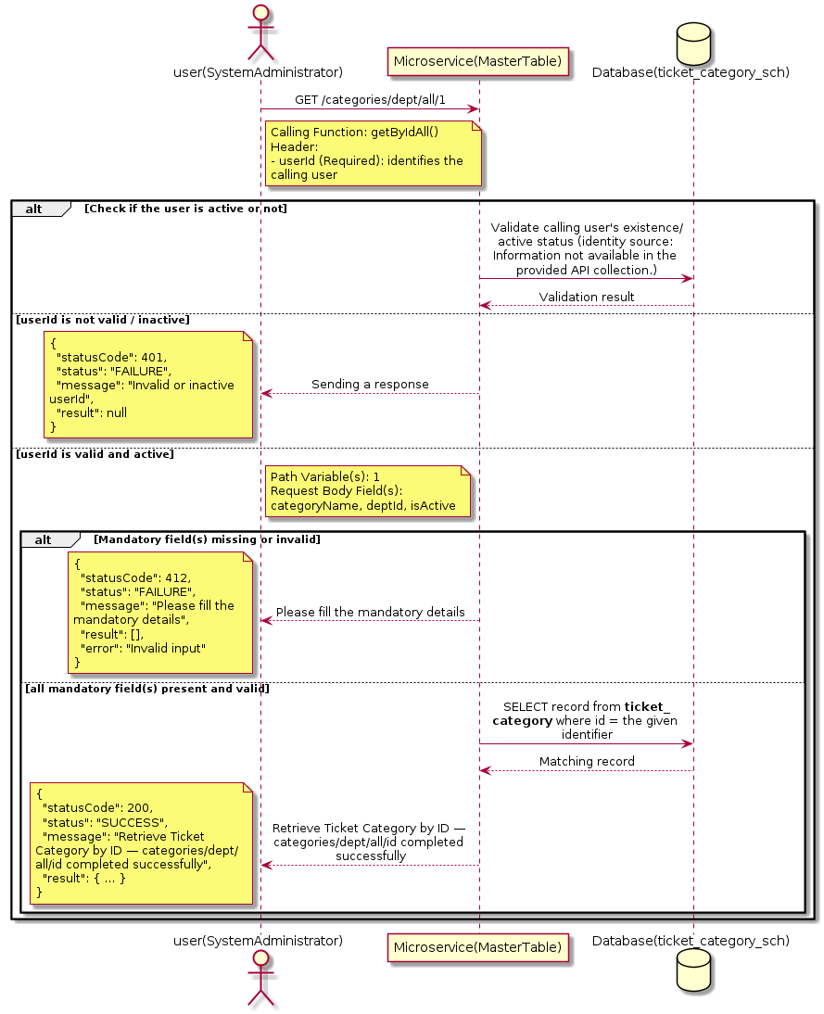

3.19.4.3 API Endpoint
Method | GET
URL | http://localhost:7002/srv2/genie/categories/dept/all/1
Headers | userId: 67
Authorization | Not present in the captured request. Information not available in the provided API collection.
Content-Type | application/json (assumed)
Query Parameters | None
Path Variables | 1
Request Body:
{
"categoryName": "Test Category",
"deptId": 1,
"isActive": "1"
}
Response Body (illustrative — see 3.x.4.5 Success Response for details):
The source Postman collection does not include a captured sample response for this request (the response array is empty). Information not available in the provided API collection. Section 3.19.4.4.5 below presents the response envelope inferred from the standard response wrapper used consistently by this platform's services.

3.19.4.4 Detailed Process Flow

3.19.4.4.1 Request Initiation
The flow begins when System Administrator (or a calling microservice on their behalf) invokes the GET endpoint http://localhost:7002/srv2/genie/categories/dept/all/1. The request must include the mandatory `userId` header used by the Master Table Microservice to identify the calling user for auditing purposes. The request carries a JSON payload in the request body which the Controller binds to its Data Transfer Object (DTO) before any processing begins. At the Controller layer, Spring Boot's request-mapping infrastructure routes the call to the appropriate handler method (`getByIdAll`), and Bean Validation annotations (if configured on the DTO) perform structural validation before the request reaches the Service layer. Information not available in the provided API collection. regarding the exact validation annotations used in the source code.

3.19.4.4.2 User Validation
The Master Table Microservice relies on the `userId` header to identify the calling user. Based on the pattern observed consistently across this API collection, the platform's authentication/authorization is expected to be enforced upstream (e.g., by an API Gateway or a shared security filter) using this identifier; the Postman collection does not include an `Authorization` / `Bearer` token header on this request, so the exact authentication mechanism (JWT validation, session lookup, or gateway-level SSO) is Information not available in the provided API collection. Role-based authorization — i.e., confirming that the user identified by `userId` holds a role/permission entitled to perform this operation — is expected to be enforced by the Service layer (see Section 8 – Controller Analysis and Section 14 – Authentication & Authorization), but the specific role/permission checks are Information not available in the provided API collection.

3.19.4.4.3 Business Logic
The Service layer forwards the identifier to the Repository. If no record is found for the given identifier, the Service layer raises a not-found condition that the Controller/global exception handler converts into an HTTP 404 response. The key fields exchanged for this operation, as observed in the sample payload, are: `categoryName`, `deptId`, `isActive`.

3.19.4.4.4 Database Interaction
The Repository layer (Spring Data JPA) interacts with the underlying relational database that backs the Ticket Category master table. The primary operation issued is a **SELECT** against the table associated with Ticket Category. No write operations occur; a single-row lookup is performed using the primary key. The exact table name, column names, primary/foreign key definitions, and JPA repository method signatures are not included in the Postman collection; therefore, precise schema details are information not available in the provided api collection.

3.19.4.4.5 Success Response
Status Code: 200 OK. Sample response envelope (illustrative — the source collection did not capture a sample response for this API):
{
"statusCode": 200,
"status": "SUCCESS",
"message": "Retrieve Ticket Category by ID — categories/dept/all/id completed successfully",
"result": {
"id": 1,
"name": "Sample Ticket Category",
"isActive": 1
},
"error": null,
"corelationId": "c6f2a1e4-2b3d-4a9e-9f1a-1234567890ab",
"url": null
}

3.19.4.4.6 Conclusion
This API provides a well-defined, single-purpose capability within the Master Table Microservice for retrieve ticket category by id — categories/dept/all/id. The Controller → Service → Repository → Database layering keeps request validation, business rules, and persistence concerns separated, which allows the Ticket Category master data to be maintained consistently and safely by authorized administrators while remaining available for consumption by every other module that depends on this reference data.
3.19.5 Retrieve Ticket Category by ID — getcsrcategory/{deptid}

3.19.5.1 Overview
Purpose: To retrieve a single Ticket Category record identified by its unique identifier, typically used to pre-populate an edit screen or to validate a reference before use.
Business Requirement: Edit screens, validation routines, and cross-service lookups need to resolve a single Ticket Category record by its identifier reliably and quickly.
Who Uses the API: System Administrator, and internal services validating a Ticket Category reference (e.g., ticket creation, workflow configuration).
Business Flow: Client sends a GET request with the identifier in the URL path → Controller extracts the path variable → Service layer requests the Repository to fetch the record → if found, the record is mapped and returned; if not found, a 404 is returned.

3.19.5.2 Sequence Diagram
The diagram below illustrates the end-to-end interaction for "Retrieve Ticket Category by ID — getcsrcategory/{deptid}" across the Client, Controller, Service, Repository, and Database layers.
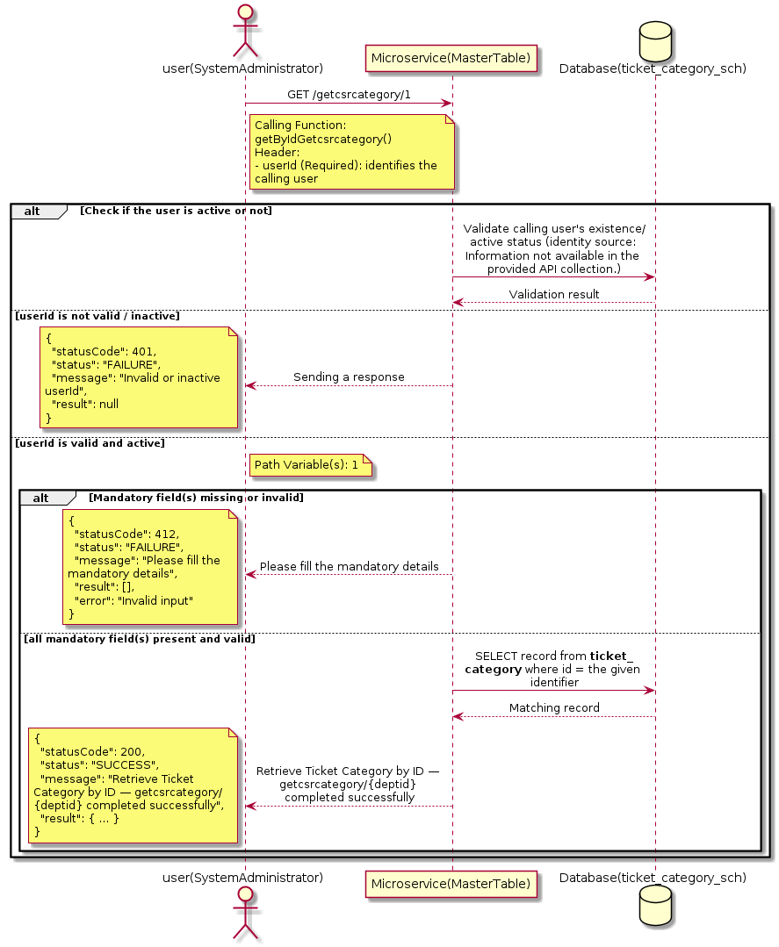

3.19.5.3 API Endpoint
Method | GET
URL | http://localhost:7002/srv2/genie/getcsrcategory/1
Headers | userId: 879
Authorization | Not present in the captured request. Information not available in the provided API collection.
Content-Type | application/json (assumed)
Query Parameters | None
Path Variables | 1
Request Body:
Not applicable — this operation does not accept a request body.
Response Body (illustrative — see 3.x.4.5 Success Response for details):
The source Postman collection does not include a captured sample response for this request (the response array is empty). Information not available in the provided API collection. Section 3.19.5.4.5 below presents the response envelope inferred from the standard response wrapper used consistently by this platform's services.

3.19.5.4 Detailed Process Flow

3.19.5.4.1 Request Initiation
The flow begins when System Administrator (or a calling microservice on their behalf) invokes the GET endpoint http://localhost:7002/srv2/genie/getcsrcategory/1. The request must include the mandatory `userId` header used by the Master Table Microservice to identify the calling user for auditing purposes. At the Controller layer, Spring Boot's request-mapping infrastructure routes the call to the appropriate handler method (`getByIdGetcsrcategory`), and Bean Validation annotations (if configured on the DTO) perform structural validation before the request reaches the Service layer. Information not available in the provided API collection. regarding the exact validation annotations used in the source code.

3.19.5.4.2 User Validation
The Master Table Microservice relies on the `userId` header to identify the calling user. Based on the pattern observed consistently across this API collection, the platform's authentication/authorization is expected to be enforced upstream (e.g., by an API Gateway or a shared security filter) using this identifier; the Postman collection does not include an `Authorization` / `Bearer` token header on this request, so the exact authentication mechanism (JWT validation, session lookup, or gateway-level SSO) is Information not available in the provided API collection. Role-based authorization — i.e., confirming that the user identified by `userId` holds a role/permission entitled to perform this operation — is expected to be enforced by the Service layer (see Section 8 – Controller Analysis and Section 14 – Authentication & Authorization), but the specific role/permission checks are Information not available in the provided API collection.

3.19.5.4.3 Business Logic
The Service layer forwards the identifier to the Repository. If no record is found for the given identifier, the Service layer raises a not-found condition that the Controller/global exception handler converts into an HTTP 404 response.

3.19.5.4.4 Database Interaction
The Repository layer (Spring Data JPA) interacts with the underlying relational database that backs the Ticket Category master table. The primary operation issued is a **SELECT** against the table associated with Ticket Category. No write operations occur; a single-row lookup is performed using the primary key. The exact table name, column names, primary/foreign key definitions, and JPA repository method signatures are not included in the Postman collection; therefore, precise schema details are information not available in the provided api collection.

3.19.5.4.5 Success Response
Status Code: 200 OK. Sample response envelope (illustrative — the source collection did not capture a sample response for this API):
{
"statusCode": 200,
"status": "SUCCESS",
"message": "Retrieve Ticket Category by ID — getcsrcategory/{deptid} completed successfully",
"result": {
"id": 1,
"name": "Sample Ticket Category",
"isActive": 1
},
"error": null,
"corelationId": "c6f2a1e4-2b3d-4a9e-9f1a-1234567890ab",
"url": null
}

3.19.5.4.6 Conclusion
This API provides a well-defined, single-purpose capability within the Master Table Microservice for retrieve ticket category by id — getcsrcategory/{deptid}. The Controller → Service → Repository → Database layering keeps request validation, business rules, and persistence concerns separated, which allows the Ticket Category master data to be maintained consistently and safely by authorized administrators while remaining available for consumption by every other module that depends on this reference data.

3.19.6 Create Ticket Category

3.19.6.1 Overview
Purpose: To create a new Ticket Category master record in the system, allowing administrators to extend the master-data catalogue that other modules (ticketing, workflow, notifications) depend on.
Business Requirement: Business/process owners need a controlled way to add new Ticket Category values so that the platform's classification, routing, and reporting capabilities can evolve as the organization changes.
Who Uses the API: System Administrator responsible for master-data configuration.
Business Flow: Client sends a POST request with the new Ticket Category payload → Controller validates the payload (mandatory fields, formats) → Service layer applies business rules (e.g., duplicate-name check) → Repository persists the new record → the created record (with generated identifier) is returned to the Client.

3.19.6.2 Sequence Diagram
The diagram below illustrates the end-to-end interaction for "Create Ticket Category" across the Client, Controller, Service, Repository, and Database layers.
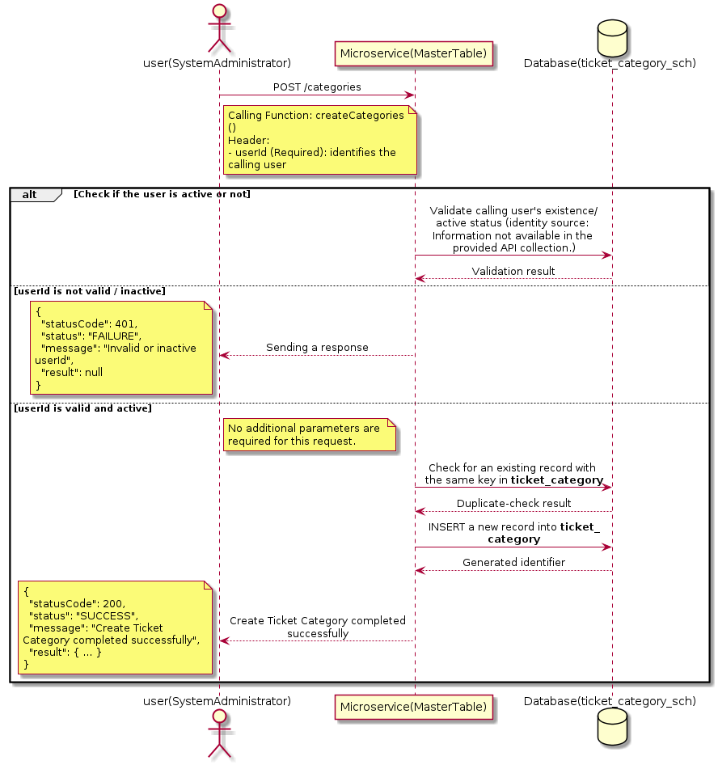

3.19.6.3 API Endpoint
Method | POST
URL | http://localhost:7002/srv2/genie/categories
Headers | userId: 67 Content-Type: application/json (assumed based on JSON request payload; Information not available in the provided API collection.)
Authorization | Not present in the captured request. Information not available in the provided API collection.
Content-Type | Content-Type: application/json (assumed based on JSON request payload; Information not available in the provided API collection.)
Query Parameters | None
Path Variables | None
Request Body:
No request body is required for this API. Information not available in the provided API collection.
Response Body (illustrative — see 3.x.4.5 Success Response for details):
The source Postman collection does not include a captured sample response for this request (the response array is empty). Information not available in the provided API collection. Section 3.19.6.4.5 below presents the response envelope inferred from the standard response wrapper used consistently by this platform's services.

3.19.6.4 Detailed Process Flow

3.19.6.4.1 Request Initiation
The flow begins when System Administrator (or a calling microservice on their behalf) invokes the POST endpoint http://localhost:7002/srv2/genie/categories. The request must include the mandatory `userId` header used by the Master Table Microservice to identify the calling user for auditing purposes. At the Controller layer, Spring Boot's request-mapping infrastructure routes the call to the appropriate handler method (`createCategories`), and Bean Validation annotations (if configured on the DTO) perform structural validation before the request reaches the Service layer. Information not available in the provided API collection. regarding the exact validation annotations used in the source code.

3.19.6.4.2 User Validation
The Master Table Microservice relies on the `userId` header to identify the calling user. Based on the pattern observed consistently across this API collection, the platform's authentication/authorization is expected to be enforced upstream (e.g., by an API Gateway or a shared security filter) using this identifier; the Postman collection does not include an `Authorization` / `Bearer` token header on this request, so the exact authentication mechanism (JWT validation, session lookup, or gateway-level SSO) is Information not available in the provided API collection. Role-based authorization — i.e., confirming that the user identified by `userId` holds a role/permission entitled to perform this operation — is expected to be enforced by the Service layer (see Section 8 – Controller Analysis and Section 14 – Authentication & Authorization), but the specific role/permission checks are Information not available in the provided API collection.

3.19.6.4.3 Business Logic
The Service layer performs the following: (1) validates that mandatory fields are present and correctly formatted, (2) checks for duplicates (e.g., an existing Ticket Category with the same name/code), (3) sets system-managed fields (e.g., `isActive = 1`, `createdBy`, timestamps) where applicable, and (4) persists the new record via the Repository. If any validation fails, the Service layer returns a business error rather than proceeding to persistence.

3.19.6.4.4 Database Interaction
The Repository layer (Spring Data JPA) interacts with the underlying relational database that backs the Ticket Category master table. The primary operation issued is a **INSERT** against the table associated with Ticket Category. A new row is inserted into the master table; if the entity has related child records (as seen in nested request payload arrays), corresponding child-table inserts are performed within the same transaction. The exact table name, column names, primary/foreign key definitions, and JPA repository method signatures are not included in the Postman collection; therefore, precise schema details are information not available in the provided api collection.

3.19.6.4.5 Success Response
Status Code: 200 OK. Sample response envelope (illustrative — the source collection did not capture a sample response for this API):
{
"statusCode": 200,
"status": "SUCCESS",
"message": "Create Ticket Category completed successfully",
"result": {
"id": 101
},
"error": null,
"corelationId": "c6f2a1e4-2b3d-4a9e-9f1a-1234567890ab",
"url": null
}

3.19.6.4.6 Conclusion
This API provides a well-defined, single-purpose capability within the Master Table Microservice for create ticket category. The Controller → Service → Repository → Database layering keeps request validation, business rules, and persistence concerns separated, which allows the Ticket Category master data to be maintained consistently and safely by authorized administrators while remaining available for consumption by every other module that depends on this reference data.

3.20 Ticket Sub Category APIs (Ticket Sub Categories)
Maintains the ticket sub-category master, a child classification under ticket category.

3.20.1 Retrieve Ticket Sub Category by ID — subcategory/subcategoryid

3.20.1.1 Overview
Purpose: To retrieve a single Ticket Sub Category record identified by its unique identifier, typically used to pre-populate an edit screen or to validate a reference before use.
Business Requirement: Edit screens, validation routines, and cross-service lookups need to resolve a single Ticket Sub Category record by its identifier reliably and quickly.
Who Uses the API: System Administrator, and internal services validating a Ticket Sub Category reference (e.g., ticket creation, workflow configuration).
Business Flow: Client sends a GET request with the identifier in the URL path → Controller extracts the path variable → Service layer requests the Repository to fetch the record → if found, the record is mapped and returned; if not found, a 404 is returned.

3.20.1.2 Sequence Diagram
The diagram below illustrates the end-to-end interaction for "Retrieve Ticket Sub Category by ID — subcategory/subcategoryid" across the Client, Controller, Service, Repository, and Database layers.
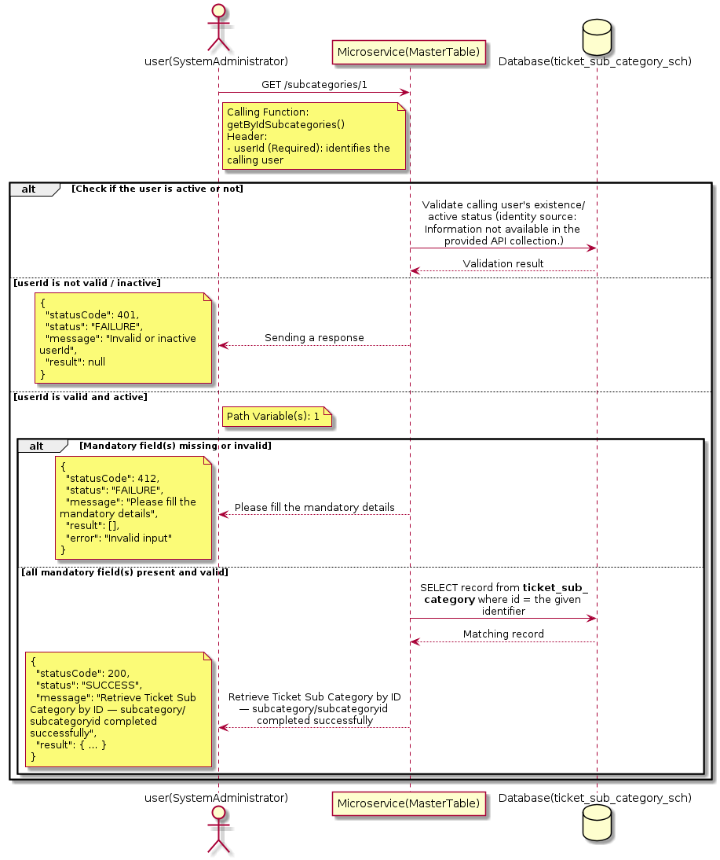

3.20.1.3 API Endpoint
Method | GET
URL | http://localhost:7002/srv2/genie/subcategories/1
Headers | userId: 67
Authorization | Not present in the captured request. Information not available in the provided API collection.
Content-Type | application/json (assumed)
Query Parameters | None
Path Variables | 1
Request Body:
Not applicable — this operation does not accept a request body.
Response Body (illustrative — see 3.x.4.5 Success Response for details):
The source Postman collection does not include a captured sample response for this request (the response array is empty). Information not available in the provided API collection. Section 3.20.1.4.5 below presents the response envelope inferred from the standard response wrapper used consistently by this platform's services.

3.20.1.4 Detailed Process Flow

3.20.1.4.1 Request Initiation
The flow begins when System Administrator (or a calling microservice on their behalf) invokes the GET endpoint http://localhost:7002/srv2/genie/subcategories/1. The request must include the mandatory `userId` header used by the Master Table Microservice to identify the calling user for auditing purposes. At the Controller layer, Spring Boot's request-mapping infrastructure routes the call to the appropriate handler method (`getByIdSubcategories`), and Bean Validation annotations (if configured on the DTO) perform structural validation before the request reaches the Service layer. Information not available in the provided API collection. regarding the exact validation annotations used in the source code.

3.20.1.4.2 User Validation
The Master Table Microservice relies on the `userId` header to identify the calling user. Based on the pattern observed consistently across this API collection, the platform's authentication/authorization is expected to be enforced upstream (e.g., by an API Gateway or a shared security filter) using this identifier; the Postman collection does not include an `Authorization` / `Bearer` token header on this request, so the exact authentication mechanism (JWT validation, session lookup, or gateway-level SSO) is Information not available in the provided API collection. Role-based authorization — i.e., confirming that the user identified by `userId` holds a role/permission entitled to perform this operation — is expected to be enforced by the Service layer (see Section 8 – Controller Analysis and Section 14 – Authentication & Authorization), but the specific role/permission checks are Information not available in the provided API collection.

3.20.1.4.3 Business Logic
The Service layer forwards the identifier to the Repository. If no record is found for the given identifier, the Service layer raises a not-found condition that the Controller/global exception handler converts into an HTTP 404 response.

3.20.1.4.4 Database Interaction
The Repository layer (Spring Data JPA) interacts with the underlying relational database that backs the Ticket Sub Category master table. The primary operation issued is a **SELECT** against the table associated with Ticket Sub Category. No write operations occur; a single-row lookup is performed using the primary key. The exact table name, column names, primary/foreign key definitions, and JPA repository method signatures are not included in the Postman collection; therefore, precise schema details are information not available in the provided api collection.

3.20.1.4.5 Success Response
Status Code: 200 OK. Sample response envelope (illustrative — the source collection did not capture a sample response for this API):
{
"statusCode": 200,
"status": "SUCCESS",
"message": "Retrieve Ticket Sub Category by ID — subcategory/subcategoryid completed successfully",
"result": {
"id": 1,
"name": "Sample Ticket Sub Category",
"isActive": 1
},
"error": null,
"corelationId": "c6f2a1e4-2b3d-4a9e-9f1a-1234567890ab",
"url": null
}

3.20.1.4.6 Conclusion
This API provides a well-defined, single-purpose capability within the Master Table Microservice for retrieve ticket sub category by id — subcategory/subcategoryid. The Controller → Service → Repository → Database layering keeps request validation, business rules, and persistence concerns separated, which allows the Ticket Sub Category master data to be maintained consistently and safely by authorized administrators while remaining available for consumption by every other module that depends on this reference data.

3.20.2 Retrieve Ticket Sub Category by ID — subcategories/bycategory/{categoryid}

3.20.2.1 Overview
Purpose: To retrieve a single Ticket Sub Category record identified by its unique identifier, typically used to pre-populate an edit screen or to validate a reference before use.
Business Requirement: Edit screens, validation routines, and cross-service lookups need to resolve a single Ticket Sub Category record by its identifier reliably and quickly.
Who Uses the API: System Administrator, and internal services validating a Ticket Sub Category reference (e.g., ticket creation, workflow configuration).
Business Flow: Client sends a GET request with the identifier in the URL path → Controller extracts the path variable → Service layer requests the Repository to fetch the record → if found, the record is mapped and returned; if not found, a 404 is returned.

3.20.2.2 Sequence Diagram
The diagram below illustrates the end-to-end interaction for "Retrieve Ticket Sub Category by ID — subcategories/bycategory/{categoryid}" across the Client, Controller, Service, Repository, and Database layers.
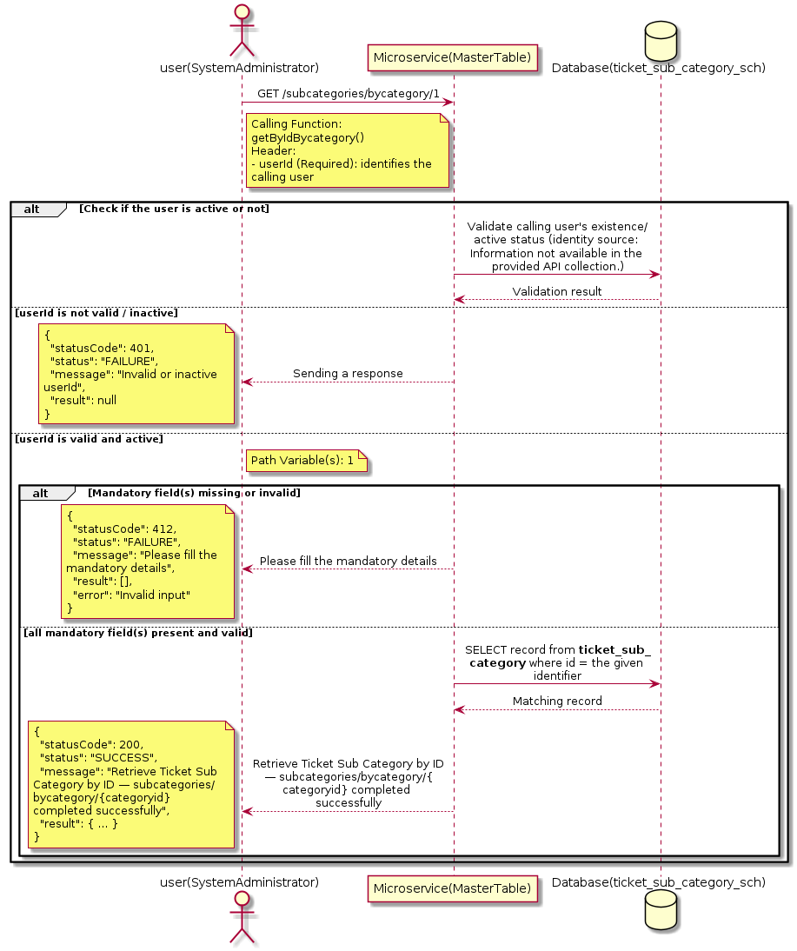

3.20.2.3 API Endpoint
Method | GET
URL | http://localhost:7002/srv2/genie/subcategories/bycategory/1
Headers | userId: 67
Authorization | Not present in the captured request. Information not available in the provided API collection.
Content-Type | application/json (assumed)
Query Parameters | None
Path Variables | 1
Request Body:
Not applicable — this operation does not accept a request body.
Response Body (illustrative — see 3.x.4.5 Success Response for details):
The source Postman collection does not include a captured sample response for this request (the response array is empty). Information not available in the provided API collection. Section 3.20.2.4.5 below presents the response envelope inferred from the standard response wrapper used consistently by this platform's services.

3.20.2.4 Detailed Process Flow

3.20.2.4.1 Request Initiation
The flow begins when System Administrator (or a calling microservice on their behalf) invokes the GET endpoint http://localhost:7002/srv2/genie/subcategories/bycategory/1. The request must include the mandatory `userId` header used by the Master Table Microservice to identify the calling user for auditing purposes. At the Controller layer, Spring Boot's request-mapping infrastructure routes the call to the appropriate handler method (`getByIdBycategory`), and Bean Validation annotations (if configured on the DTO) perform structural validation before the request reaches the Service layer. Information not available in the provided API collection. regarding the exact validation annotations used in the source code.

3.20.2.4.2 User Validation
The Master Table Microservice relies on the `userId` header to identify the calling user. Based on the pattern observed consistently across this API collection, the platform's authentication/authorization is expected to be enforced upstream (e.g., by an API Gateway or a shared security filter) using this identifier; the Postman collection does not include an `Authorization` / `Bearer` token header on this request, so the exact authentication mechanism (JWT validation, session lookup, or gateway-level SSO) is Information not available in the provided API collection. Role-based authorization — i.e., confirming that the user identified by `userId` holds a role/permission entitled to perform this operation — is expected to be enforced by the Service layer (see Section 8 – Controller Analysis and Section 14 – Authentication & Authorization), but the specific role/permission checks are Information not available in the provided API collection.

3.20.2.4.3 Business Logic
The Service layer forwards the identifier to the Repository. If no record is found for the given identifier, the Service layer raises a not-found condition that the Controller/global exception handler converts into an HTTP 404 response.

3.20.2.4.4 Database Interaction
The Repository layer (Spring Data JPA) interacts with the underlying relational database that backs the Ticket Sub Category master table. The primary operation issued is a **SELECT** against the table associated with Ticket Sub Category. No write operations occur; a single-row lookup is performed using the primary key. The exact table name, column names, primary/foreign key definitions, and JPA repository method signatures are not included in the Postman collection; therefore, precise schema details are information not available in the provided api collection.

3.20.2.4.5 Success Response
Status Code: 200 OK. Sample response envelope (illustrative — the source collection did not capture a sample response for this API):
{
"statusCode": 200,
"status": "SUCCESS",
"message": "Retrieve Ticket Sub Category by ID — subcategories/bycategory/{categoryid} completed successfully",
"result": {
"id": 1,
"name": "Sample Ticket Sub Category",
"isActive": 1
},
"error": null,
"corelationId": "c6f2a1e4-2b3d-4a9e-9f1a-1234567890ab",
"url": null
}

3.20.2.4.6 Conclusion
This API provides a well-defined, single-purpose capability within the Master Table Microservice for retrieve ticket sub category by id — subcategories/bycategory/{categoryid}. The Controller → Service → Repository → Database layering keeps request validation, business rules, and persistence concerns separated, which allows the Ticket Sub Category master data to be maintained consistently and safely by authorized administrators while remaining available for consumption by every other module that depends on this reference data.

3.20.3 Retrieve Ticket Sub Category by ID — subcategories/bycategory/all/{categoryid}

3.20.3.1 Overview
Purpose: To retrieve a single Ticket Sub Category record identified by its unique identifier, typically used to pre-populate an edit screen or to validate a reference before use.
Business Requirement: Edit screens, validation routines, and cross-service lookups need to resolve a single Ticket Sub Category record by its identifier reliably and quickly.
Who Uses the API: System Administrator, and internal services validating a Ticket Sub Category reference (e.g., ticket creation, workflow configuration).
Business Flow: Client sends a GET request with the identifier in the URL path → Controller extracts the path variable → Service layer requests the Repository to fetch the record → if found, the record is mapped and returned; if not found, a 404 is returned.

3.20.3.2 Sequence Diagram
The diagram below illustrates the end-to-end interaction for "Retrieve Ticket Sub Category by ID — subcategories/bycategory/all/{categoryid}" across the Client, Controller, Service, Repository, and Database layers.
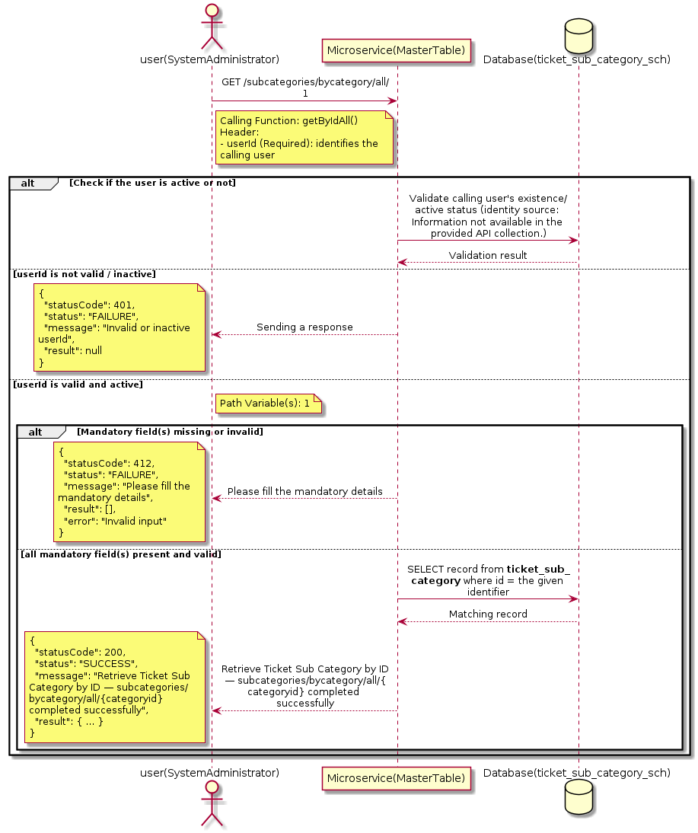

3.20.3.3 API Endpoint
Method | GET
URL | http://localhost:7002/srv2/genie/subcategories/bycategory/all/1
Headers | userId: 67
Authorization | Not present in the captured request. Information not available in the provided API collection.
Content-Type | application/json (assumed)
Query Parameters | None
Path Variables | 1
Request Body:
Not applicable — this operation does not accept a request body.
Response Body (illustrative — see 3.x.4.5 Success Response for details):
The source Postman collection does not include a captured sample response for this request (the response array is empty). Information not available in the provided API collection. Section 3.20.3.4.5 below presents the response envelope inferred from the standard response wrapper used consistently by this platform's services.

3.20.3.4 Detailed Process Flow

3.20.3.4.1 Request Initiation
The flow begins when System Administrator (or a calling microservice on their behalf) invokes the GET endpoint http://localhost:7002/srv2/genie/subcategories/bycategory/all/1. The request must include the mandatory `userId` header used by the Master Table Microservice to identify the calling user for auditing purposes. At the Controller layer, Spring Boot's request-mapping infrastructure routes the call to the appropriate handler method (`getByIdAll`), and Bean Validation annotations (if configured on the DTO) perform structural validation before the request reaches the Service layer. Information not available in the provided API collection. regarding the exact validation annotations used in the source code.

3.20.3.4.2 User Validation
The Master Table Microservice relies on the `userId` header to identify the calling user. Based on the pattern observed consistently across this API collection, the platform's authentication/authorization is expected to be enforced upstream (e.g., by an API Gateway or a shared security filter) using this identifier; the Postman collection does not include an `Authorization` / `Bearer` token header on this request, so the exact authentication mechanism (JWT validation, session lookup, or gateway-level SSO) is Information not available in the provided API collection. Role-based authorization — i.e., confirming that the user identified by `userId` holds a role/permission entitled to perform this operation — is expected to be enforced by the Service layer (see Section 8 – Controller Analysis and Section 14 – Authentication & Authorization), but the specific role/permission checks are Information not available in the provided API collection.

3.20.3.4.3 Business Logic
The Service layer forwards the identifier to the Repository. If no record is found for the given identifier, the Service layer raises a not-found condition that the Controller/global exception handler converts into an HTTP 404 response.

3.20.3.4.4 Database Interaction
The Repository layer (Spring Data JPA) interacts with the underlying relational database that backs the Ticket Sub Category master table. The primary operation issued is a **SELECT** against the table associated with Ticket Sub Category. No write operations occur; a single-row lookup is performed using the primary key. The exact table name, column names, primary/foreign key definitions, and JPA repository method signatures are not included in the Postman collection; therefore, precise schema details are information not available in the provided api collection.

3.20.3.4.5 Success Response
Status Code: 200 OK. Sample response envelope (illustrative — the source collection did not capture a sample response for this API):
{
"statusCode": 200,
"status": "SUCCESS",
"message": "Retrieve Ticket Sub Category by ID — subcategories/bycategory/all/{categoryid} completed successfully",
"result": {
"id": 1,
"name": "Sample Ticket Sub Category",
"isActive": 1
},
"error": null,
"corelationId": "c6f2a1e4-2b3d-4a9e-9f1a-1234567890ab",
"url": null
}

3.20.3.4.6 Conclusion
This API provides a well-defined, single-purpose capability within the Master Table Microservice for retrieve ticket sub category by id — subcategories/bycategory/all/{categoryid}. The Controller → Service → Repository → Database layering keeps request validation, business rules, and persistence concerns separated, which allows the Ticket Sub Category master data to be maintained consistently and safely by authorized administrators while remaining available for consumption by every other module that depends on this reference data.

3.21 Ticket Type APIs (Ticket Type)
Maintains the ticket type master (e.g., Incident, Service Request) used to classify tickets at the highest level.

3.21.1 Retrieve All Ticket Type — tickettypes

3.21.1.1 Overview
Purpose: To retrieve the complete list of Ticket Type master records configured in the Master Table Microservice, so that consuming screens and downstream services can populate dropdowns, grids, and configuration views.
Business Requirement: Every screen and workflow that references Ticket Type data (creation forms, filters, reports) needs an authoritative, always-current list of active Ticket Type values sourced from a single master table rather than being hard-coded.
Who Uses the API: System Administrator, and any internal microservice/UI module that needs to render Ticket Type options.
Business Flow: Client sends a GET request → Controller delegates to the Service layer → Service layer calls the Repository → Repository queries the Ticket Type table → the result set is mapped to response DTOs and returned to the Client.

3.21.1.2 Sequence Diagram
The diagram below illustrates the end-to-end interaction for "Retrieve All Ticket Type — tickettypes" across the Client, Controller, Service, Repository, and Database layers.
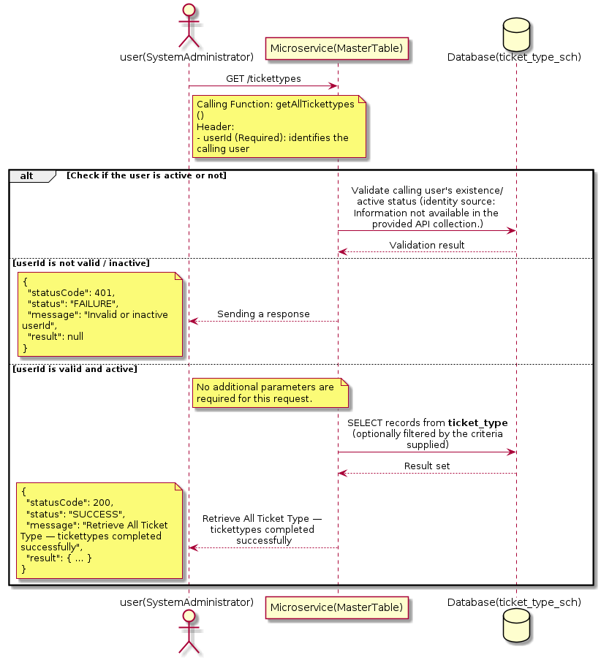

3.21.1.3 API Endpoint
Method | GET
URL | http://localhost:7002/srv2/genie/tickettypes
Headers | userId: 67
Authorization | Not present in the captured request. Information not available in the provided API collection.
Content-Type | application/json (assumed)
Query Parameters | None
Path Variables | None
Request Body:
Not applicable — this operation does not accept a request body.
Response Body (illustrative — see 3.x.4.5 Success Response for details):
The source Postman collection does not include a captured sample response for this request (the response array is empty). Information not available in the provided API collection. Section 3.21.1.4.5 below presents the response envelope inferred from the standard response wrapper used consistently by this platform's services.

3.21.1.4 Detailed Process Flow

3.21.1.4.1 Request Initiation
The flow begins when System Administrator (or a calling microservice on their behalf) invokes the GET endpoint http://localhost:7002/srv2/genie/tickettypes. The request must include the mandatory `userId` header used by the Master Table Microservice to identify the calling user for auditing purposes. At the Controller layer, Spring Boot's request-mapping infrastructure routes the call to the appropriate handler method (`getAllTickettypes`), and Bean Validation annotations (if configured on the DTO) perform structural validation before the request reaches the Service layer. Information not available in the provided API collection. regarding the exact validation annotations used in the source code.

3.21.1.4.2 User Validation
The Master Table Microservice relies on the `userId` header to identify the calling user. Based on the pattern observed consistently across this API collection, the platform's authentication/authorization is expected to be enforced upstream (e.g., by an API Gateway or a shared security filter) using this identifier; the Postman collection does not include an `Authorization` / `Bearer` token header on this request, so the exact authentication mechanism (JWT validation, session lookup, or gateway-level SSO) is Information not available in the provided API collection. Role-based authorization — i.e., confirming that the user identified by `userId` holds a role/permission entitled to perform this operation — is expected to be enforced by the Service layer (see Section 8 – Controller Analysis and Section 14 – Authentication & Authorization), but the specific role/permission checks are Information not available in the provided API collection.

3.21.1.4.3 Business Logic
The Service layer contains no conditional business branching for this operation beyond invoking the Repository to fetch all Ticket Type records. Depending on the record volume, the Service layer may apply default sorting (e.g., by name or creation order) before returning the list.

3.21.1.4.4 Database Interaction
The Repository layer (Spring Data JPA) interacts with the underlying relational database that backs the Ticket Type master table. The primary operation issued is a **SELECT** against the table associated with Ticket Type. No write operations occur; the query returns all rows that satisfy the entity's default scope (typically active records). The exact table name, column names, primary/foreign key definitions, and JPA repository method signatures are not included in the Postman collection; therefore, precise schema details are information not available in the provided api collection.

3.21.1.4.5 Success Response
Status Code: 200 OK. Sample response envelope (illustrative — the source collection did not capture a sample response for this API):
{
"statusCode": 200,
"status": "SUCCESS",
"message": "Retrieve All Ticket Type — tickettypes completed successfully",
"result": [
{
"id": 1,
"name": "Sample Ticket Type",
"isActive": 1
}
],
"error": null,
"corelationId": "c6f2a1e4-2b3d-4a9e-9f1a-1234567890ab",
"url": null
}

3.21.1.4.6 Conclusion
This API provides a well-defined, single-purpose capability within the Master Table Microservice for retrieve all ticket type — tickettypes. The Controller → Service → Repository → Database layering keeps request validation, business rules, and persistence concerns separated, which allows the Ticket Type master data to be maintained consistently and safely by authorized administrators while remaining available for consumption by every other module that depends on this reference data.

3.21.2 Retrieve Ticket Type by ID

3.21.2.1 Overview
Purpose: To retrieve a single Ticket Type record identified by its unique identifier, typically used to pre-populate an edit screen or to validate a reference before use.
Business Requirement: Edit screens, validation routines, and cross-service lookups need to resolve a single Ticket Type record by its identifier reliably and quickly.
Who Uses the API: System Administrator, and internal services validating a Ticket Type reference (e.g., ticket creation, workflow configuration).
Business Flow: Client sends a GET request with the identifier in the URL path → Controller extracts the path variable → Service layer requests the Repository to fetch the record → if found, the record is mapped and returned; if not found, a 404 is returned.

3.21.2.2 Sequence Diagram
The diagram below illustrates the end-to-end interaction for "Retrieve Ticket Type by ID" across the Client, Controller, Service, Repository, and Database layers.
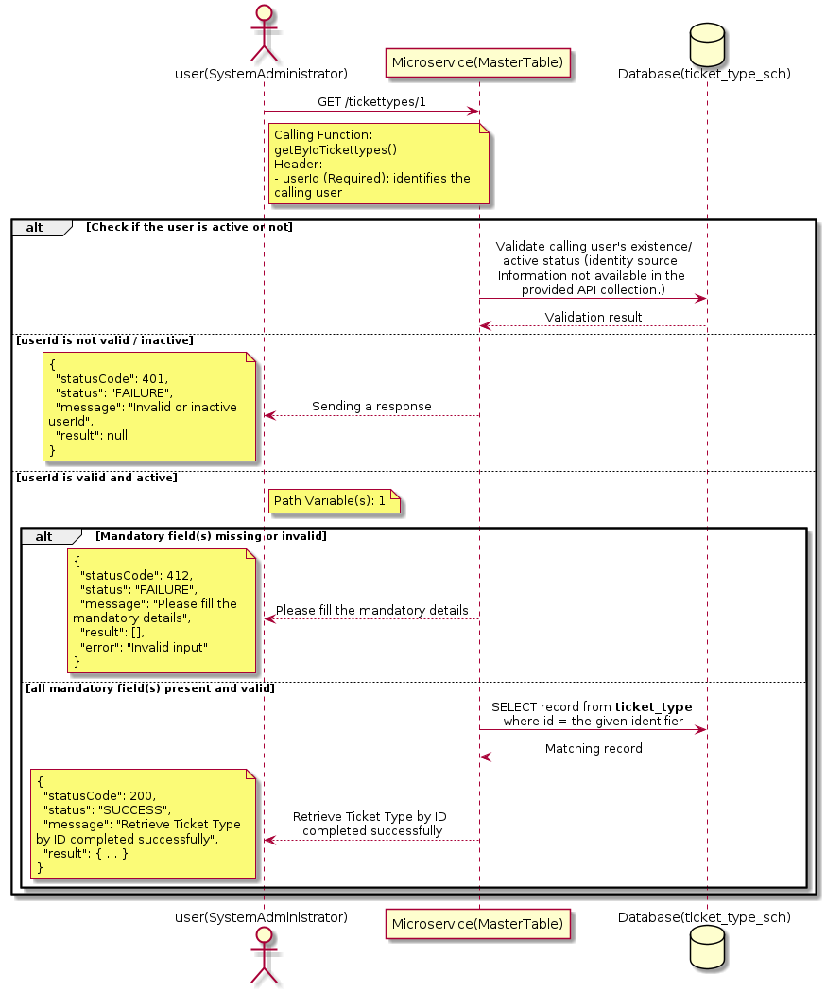

3.21.2.3 API Endpoint
Method | GET
URL | http://localhost:7002/srv2/genie/tickettypes/1
Headers | userId: 67
Authorization | Not present in the captured request. Information not available in the provided API collection.
Content-Type | application/json (assumed)
Query Parameters | None
Path Variables | 1
Request Body:
Not applicable — this operation does not accept a request body.
Response Body (illustrative — see 3.x.4.5 Success Response for details):
The source Postman collection does not include a captured sample response for this request (the response array is empty). Information not available in the provided API collection. Section 3.21.2.4.5 below presents the response envelope inferred from the standard response wrapper used consistently by this platform's services.

3.21.2.4 Detailed Process Flow

3.21.2.4.1 Request Initiation
The flow begins when System Administrator (or a calling microservice on their behalf) invokes the GET endpoint http://localhost:7002/srv2/genie/tickettypes/1. The request must include the mandatory `userId` header used by the Master Table Microservice to identify the calling user for auditing purposes. At the Controller layer, Spring Boot's request-mapping infrastructure routes the call to the appropriate handler method (`getByIdTickettypes`), and Bean Validation annotations (if configured on the DTO) perform structural validation before the request reaches the Service layer. Information not available in the provided API collection. regarding the exact validation annotations used in the source code.

3.21.2.4.2 User Validation
The Master Table Microservice relies on the `userId` header to identify the calling user. Based on the pattern observed consistently across this API collection, the platform's authentication/authorization is expected to be enforced upstream (e.g., by an API Gateway or a shared security filter) using this identifier; the Postman collection does not include an `Authorization` / `Bearer` token header on this request, so the exact authentication mechanism (JWT validation, session lookup, or gateway-level SSO) is Information not available in the provided API collection. Role-based authorization — i.e., confirming that the user identified by `userId` holds a role/permission entitled to perform this operation — is expected to be enforced by the Service layer (see Section 8 – Controller Analysis and Section 14 – Authentication & Authorization), but the specific role/permission checks are Information not available in the provided API collection.

3.21.2.4.3 Business Logic
The Service layer forwards the identifier to the Repository. If no record is found for the given identifier, the Service layer raises a not-found condition that the Controller/global exception handler converts into an HTTP 404 response.

3.21.2.4.4 Database Interaction
The Repository layer (Spring Data JPA) interacts with the underlying relational database that backs the Ticket Type master table. The primary operation issued is a **SELECT** against the table associated with Ticket Type. No write operations occur; a single-row lookup is performed using the primary key. The exact table name, column names, primary/foreign key definitions, and JPA repository method signatures are not included in the Postman collection; therefore, precise schema details are information not available in the provided api collection.

3.21.2.4.5 Success Response
Status Code: 200 OK. Sample response envelope (illustrative — the source collection did not capture a sample response for this API):
{
"statusCode": 200,
"status": "SUCCESS",
"message": "Retrieve Ticket Type by ID completed successfully",
"result": {
"id": 1,
"name": "Sample Ticket Type",
"isActive": 1
},
"error": null,
"corelationId": "c6f2a1e4-2b3d-4a9e-9f1a-1234567890ab",
"url": null
}

3.21.2.4.6 Conclusion
This API provides a well-defined, single-purpose capability within the Master Table Microservice for retrieve ticket type by id. The Controller → Service → Repository → Database layering keeps request validation, business rules, and persistence concerns separated, which allows the Ticket Type master data to be maintained consistently and safely by authorized administrators while remaining available for consumption by every other module that depends on this reference data.

3.21.3 Retrieve All Ticket Type — Tickettypes/all

3.21.3.1 Overview
Purpose: To retrieve the complete list of Ticket Type master records configured in the Master Table Microservice, so that consuming screens and downstream services can populate dropdowns, grids, and configuration views.
Business Requirement: Every screen and workflow that references Ticket Type data (creation forms, filters, reports) needs an authoritative, always-current list of active Ticket Type values sourced from a single master table rather than being hard-coded.
Who Uses the API: System Administrator, and any internal microservice/UI module that needs to render Ticket Type options.
Business Flow: Client sends a GET request → Controller delegates to the Service layer → Service layer calls the Repository → Repository queries the Ticket Type table → the result set is mapped to response DTOs and returned to the Client.

3.21.3.2 Sequence Diagram
The diagram below illustrates the end-to-end interaction for "Retrieve All Ticket Type — Tickettypes/all" across the Client, Controller, Service, Repository, and Database layers.
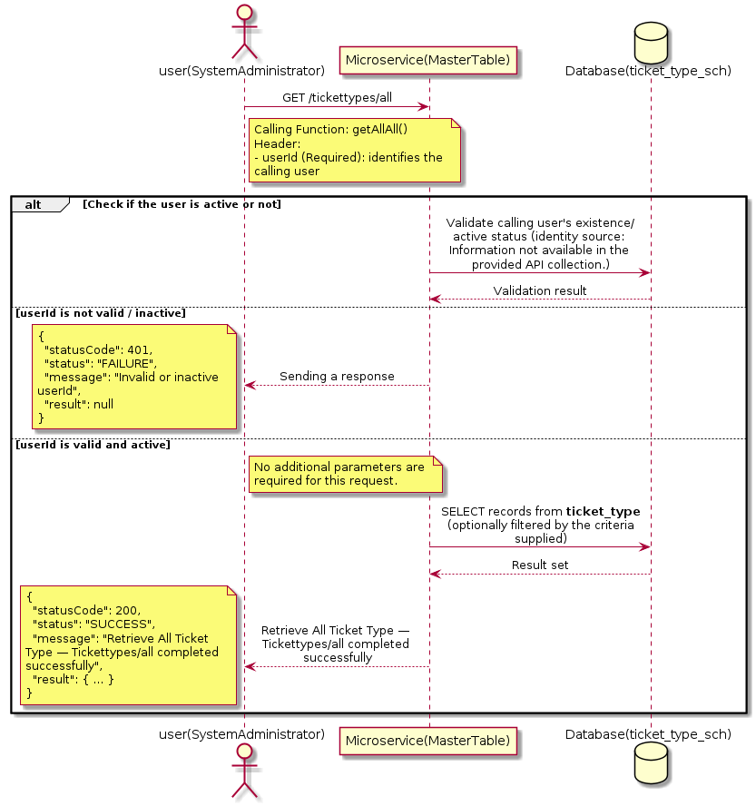

3.21.3.3 API Endpoint
Method | GET
URL | http://localhost:7002/srv2/genie/tickettypes/all
Headers | userId: 67
Authorization | Not present in the captured request. Information not available in the provided API collection.
Content-Type | application/json (assumed)
Query Parameters | None
Path Variables | None
Request Body:
Not applicable — this operation does not accept a request body.
Response Body (illustrative — see 3.x.4.5 Success Response for details):
The source Postman collection does not include a captured sample response for this request (the response array is empty). Information not available in the provided API collection. Section 3.21.3.4.5 below presents the response envelope inferred from the standard response wrapper used consistently by this platform's services.

3.21.3.4 Detailed Process Flow

3.21.3.4.1 Request Initiation
The flow begins when System Administrator (or a calling microservice on their behalf) invokes the GET endpoint http://localhost:7002/srv2/genie/tickettypes/all. The request must include the mandatory `userId` header used by the Master Table Microservice to identify the calling user for auditing purposes. At the Controller layer, Spring Boot's request-mapping infrastructure routes the call to the appropriate handler method (`getAllAll`), and Bean Validation annotations (if configured on the DTO) perform structural validation before the request reaches the Service layer. Information not available in the provided API collection. regarding the exact validation annotations used in the source code.

3.21.3.4.2 User Validation
The Master Table Microservice relies on the `userId` header to identify the calling user. Based on the pattern observed consistently across this API collection, the platform's authentication/authorization is expected to be enforced upstream (e.g., by an API Gateway or a shared security filter) using this identifier; the Postman collection does not include an `Authorization` / `Bearer` token header on this request, so the exact authentication mechanism (JWT validation, session lookup, or gateway-level SSO) is Information not available in the provided API collection. Role-based authorization — i.e., confirming that the user identified by `userId` holds a role/permission entitled to perform this operation — is expected to be enforced by the Service layer (see Section 8 – Controller Analysis and Section 14 – Authentication & Authorization), but the specific role/permission checks are Information not available in the provided API collection.

3.21.3.4.3 Business Logic
The Service layer contains no conditional business branching for this operation beyond invoking the Repository to fetch all Ticket Type records. Depending on the record volume, the Service layer may apply default sorting (e.g., by name or creation order) before returning the list.

3.21.3.4.4 Database Interaction
The Repository layer (Spring Data JPA) interacts with the underlying relational database that backs the Ticket Type master table. The primary operation issued is a **SELECT** against the table associated with Ticket Type. No write operations occur; the query returns all rows that satisfy the entity's default scope (typically active records). The exact table name, column names, primary/foreign key definitions, and JPA repository method signatures are not included in the Postman collection; therefore, precise schema details are information not available in the provided api collection.

3.21.3.4.5 Success Response
Status Code: 200 OK. Sample response envelope (illustrative — the source collection did not capture a sample response for this API):
{
"statusCode": 200,
"status": "SUCCESS",
"message": "Retrieve All Ticket Type — Tickettypes/all completed successfully",
"result": [
{
"id": 1,
"name": "Sample Ticket Type",
"isActive": 1
}
],
"error": null,
"corelationId": "c6f2a1e4-2b3d-4a9e-9f1a-1234567890ab",
"url": null
}

3.21.3.4.6 Conclusion
This API provides a well-defined, single-purpose capability within the Master Table Microservice for retrieve all ticket type — tickettypes/all. The Controller → Service → Repository → Database layering keeps request validation, business rules, and persistence concerns separated, which allows the Ticket Type master data to be maintained consistently and safely by authorized administrators while remaining available for consumption by every other module that depends on this reference data.

3.21.4 Create Ticket Type

3.21.4.1 Overview
Purpose: To create a new Ticket Type master record in the system, allowing administrators to extend the master-data catalogue that other modules (ticketing, workflow, notifications) depend on.
Business Requirement: Business/process owners need a controlled way to add new Ticket Type values so that the platform's classification, routing, and reporting capabilities can evolve as the organization changes.
Who Uses the API: System Administrator responsible for master-data configuration.
Business Flow: Client sends a POST request with the new Ticket Type payload → Controller validates the payload (mandatory fields, formats) → Service layer applies business rules (e.g., duplicate-name check) → Repository persists the new record → the created record (with generated identifier) is returned to the Client.

3.21.4.2 Sequence Diagram
The diagram below illustrates the end-to-end interaction for "Create Ticket Type" across the Client, Controller, Service, Repository, and Database layers.
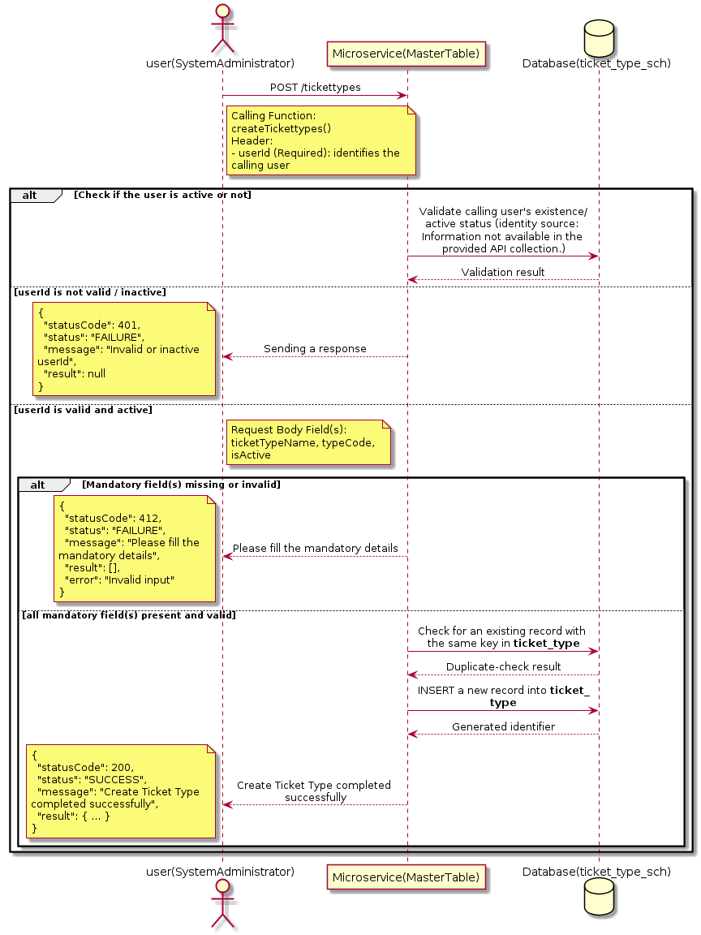

3.21.4.3 API Endpoint
Method | POST
URL | http://localhost:7002/srv2/genie/tickettypes
Headers | userId: 67 Content-Type: application/json (assumed based on JSON request payload; Information not available in the provided API collection.)
Authorization | Not present in the captured request. Information not available in the provided API collection.
Content-Type | Content-Type: application/json (assumed based on JSON request payload; Information not available in the provided API collection.)
Query Parameters | None
Path Variables | None
Request Body:
{
"ticketTypeName": "Test Ticket Type1",
"typeCode": "TST1",
"isActive": "1"
}
Response Body (illustrative — see 3.x.4.5 Success Response for details):
The source Postman collection does not include a captured sample response for this request (the response array is empty). Information not available in the provided API collection. Section 3.21.4.4.5 below presents the response envelope inferred from the standard response wrapper used consistently by this platform's services.

3.21.4.4 Detailed Process Flow

3.21.4.4.1 Request Initiation
The flow begins when System Administrator (or a calling microservice on their behalf) invokes the POST endpoint http://localhost:7002/srv2/genie/tickettypes. The request must include the mandatory `userId` header used by the Master Table Microservice to identify the calling user for auditing purposes. The request carries a JSON payload in the request body which the Controller binds to its Data Transfer Object (DTO) before any processing begins. At the Controller layer, Spring Boot's request-mapping infrastructure routes the call to the appropriate handler method (`createTickettypes`), and Bean Validation annotations (if configured on the DTO) perform structural validation before the request reaches the Service layer. Information not available in the provided API collection. regarding the exact validation annotations used in the source code.

3.21.4.4.2 User Validation
The Master Table Microservice relies on the `userId` header to identify the calling user. Based on the pattern observed consistently across this API collection, the platform's authentication/authorization is expected to be enforced upstream (e.g., by an API Gateway or a shared security filter) using this identifier; the Postman collection does not include an `Authorization` / `Bearer` token header on this request, so the exact authentication mechanism (JWT validation, session lookup, or gateway-level SSO) is Information not available in the provided API collection. Role-based authorization — i.e., confirming that the user identified by `userId` holds a role/permission entitled to perform this operation — is expected to be enforced by the Service layer (see Section 8 – Controller Analysis and Section 14 – Authentication & Authorization), but the specific role/permission checks are Information not available in the provided API collection.

3.21.4.4.3 Business Logic
The Service layer performs the following: (1) validates that mandatory fields are present and correctly formatted, (2) checks for duplicates (e.g., an existing Ticket Type with the same name/code), (3) sets system-managed fields (e.g., `isActive = 1`, `createdBy`, timestamps) where applicable, and (4) persists the new record via the Repository. If any validation fails, the Service layer returns a business error rather than proceeding to persistence. The key fields exchanged for this operation, as observed in the sample payload, are: `ticketTypeName`, `typeCode`, `isActive`.

3.21.4.4.4 Database Interaction
The Repository layer (Spring Data JPA) interacts with the underlying relational database that backs the Ticket Type master table. The primary operation issued is a **INSERT** against the table associated with Ticket Type. A new row is inserted into the master table; if the entity has related child records (as seen in nested request payload arrays), corresponding child-table inserts are performed within the same transaction. The exact table name, column names, primary/foreign key definitions, and JPA repository method signatures are not included in the Postman collection; therefore, precise schema details are information not available in the provided api collection.

3.21.4.4.5 Success Response
Status Code: 200 OK. Sample response envelope (illustrative — the source collection did not capture a sample response for this API):
{
"statusCode": 200,
"status": "SUCCESS",
"message": "Create Ticket Type completed successfully",
"result": {
"id": 101,
"ticketTypeName": "Test Ticket Type1",
"typeCode": "TST1",
"isActive": "1"
},
"error": null,
"corelationId": "c6f2a1e4-2b3d-4a9e-9f1a-1234567890ab",
"url": null
}

3.21.4.4.6 Conclusion
This API provides a well-defined, single-purpose capability within the Master Table Microservice for create ticket type. The Controller → Service → Repository → Database layering keeps request validation, business rules, and persistence concerns separated, which allows the Ticket Type master data to be maintained consistently and safely by authorized administrators while remaining available for consumption by every other module that depends on this reference data.

3.21.5 Update Ticket Type

3.21.5.1 Overview
Purpose: To update an existing Ticket Type master record, allowing administrators to correct or evolve master-data attributes without impacting the record's identity/history.
Business Requirement: Master data changes over time (renames, corrections, re-classification); the platform must allow controlled updates while preserving referential integrity for records that already reference this Ticket Type.
Who Uses the API: System Administrator responsible for maintaining master-data accuracy.
Business Flow: Client sends a PUT/PATCH request with the updated Ticket Type payload → Controller validates the payload → Service layer fetches the existing record, applies the changes, and re-validates business rules → Repository persists the updated record → the updated record is returned to the Client.

3.21.5.2 Sequence Diagram
The diagram below illustrates the end-to-end interaction for "Update Ticket Type" across the Client, Controller, Service, Repository, and Database layers.
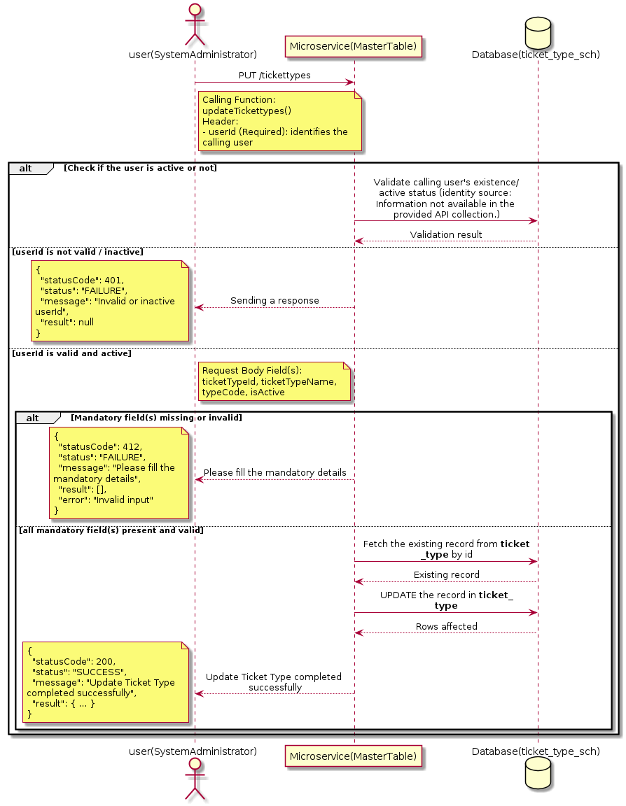

3.21.5.3 API Endpoint
Method | PUT
URL | http://localhost:7002/srv2/genie/tickettypes
Headers | userId: 67 Content-Type: application/json (assumed based on JSON request payload; Information not available in the provided API collection.)
Authorization | Not present in the captured request. Information not available in the provided API collection.
Content-Type | Content-Type: application/json (assumed based on JSON request payload; Information not available in the provided API collection.)
Query Parameters | None
Path Variables | None
Request Body:
{
"ticketTypeId": 1,
"ticketTypeName": "Problem",
"typeCode": "PRB",
"isActive": "1"
}
Response Body (illustrative — see 3.x.4.5 Success Response for details):
The source Postman collection does not include a captured sample response for this request (the response array is empty). Information not available in the provided API collection. Section 3.21.5.4.5 below presents the response envelope inferred from the standard response wrapper used consistently by this platform's services.

3.21.5.4 Detailed Process Flow

3.21.5.4.1 Request Initiation
The flow begins when System Administrator (or a calling microservice on their behalf) invokes the PUT endpoint http://localhost:7002/srv2/genie/tickettypes. The request must include the mandatory `userId` header used by the Master Table Microservice to identify the calling user for auditing purposes. The request carries a JSON payload in the request body which the Controller binds to its Data Transfer Object (DTO) before any processing begins. At the Controller layer, Spring Boot's request-mapping infrastructure routes the call to the appropriate handler method (`updateTickettypes`), and Bean Validation annotations (if configured on the DTO) perform structural validation before the request reaches the Service layer. Information not available in the provided API collection. regarding the exact validation annotations used in the source code.

3.21.5.4.2 User Validation
The Master Table Microservice relies on the `userId` header to identify the calling user. Based on the pattern observed consistently across this API collection, the platform's authentication/authorization is expected to be enforced upstream (e.g., by an API Gateway or a shared security filter) using this identifier; the Postman collection does not include an `Authorization` / `Bearer` token header on this request, so the exact authentication mechanism (JWT validation, session lookup, or gateway-level SSO) is Information not available in the provided API collection. Role-based authorization — i.e., confirming that the user identified by `userId` holds a role/permission entitled to perform this operation — is expected to be enforced by the Service layer (see Section 8 – Controller Analysis and Section 14 – Authentication & Authorization), but the specific role/permission checks are Information not available in the provided API collection.

3.21.5.4.3 Business Logic
The Service layer fetches the existing Ticket Type record by its identifier, verifies it exists, applies the incoming changes field by field, re-validates business rules (e.g., uniqueness of a renamed field), and persists the updated entity via the Repository. If the record does not exist, the operation is rejected with a not-found error. The key fields exchanged for this operation, as observed in the sample payload, are: `ticketTypeId`, `ticketTypeName`, `typeCode`, `isActive`.

3.21.5.4.4 Database Interaction
The Repository layer (Spring Data JPA) interacts with the underlying relational database that backs the Ticket Type master table. The primary operation issued is a **UPDATE** against the table associated with Ticket Type. The existing row is located by primary key and updated; if the entity has related child records, the existing child rows are typically replaced/updated within the same transaction. The exact table name, column names, primary/foreign key definitions, and JPA repository method signatures are not included in the Postman collection; therefore, precise schema details are information not available in the provided api collection.

3.21.5.4.5 Success Response
Status Code: 200 OK. Sample response envelope (illustrative — the source collection did not capture a sample response for this API):
{
"statusCode": 200,
"status": "SUCCESS",
"message": "Update Ticket Type completed successfully",
"result": {
"id": 1,
"isActive": 1
},
"error": null,
"corelationId": "c6f2a1e4-2b3d-4a9e-9f1a-1234567890ab",
"url": null
}

3.21.5.4.6 Conclusion
This API provides a well-defined, single-purpose capability within the Master Table Microservice for update ticket type. The Controller → Service → Repository → Database layering keeps request validation, business rules, and persistence concerns separated, which allows the Ticket Type master data to be maintained consistently and safely by authorized administrators while remaining available for consumption by every other module that depends on this reference data.
3.21.6 Retrieve Ticket Type (Filtered)

3.21.6.1 Overview
Purpose: To retrieve Ticket Type master records that match the supplied filter/query criteria, allowing consumers to narrow down large master-data sets to a relevant subset.
Business Requirement: Administrators and downstream services need the ability to narrow Ticket Type records by specific criteria rather than retrieving and filtering the full data set on the client side.
Who Uses the API: System Administrator, and reporting/search screens that filter by Ticket Type.
Business Flow: Client sends a GET request with query parameters → Controller parses and validates the parameters → Service layer builds the filter criteria → Repository executes the filtered query against the Ticket Type table → the filtered result is returned to the Client.

3.21.6.2 Sequence Diagram
The diagram below illustrates the end-to-end interaction for "Retrieve Ticket Type (Filtered)" across the Client, Controller, Service, Repository, and Database layers.
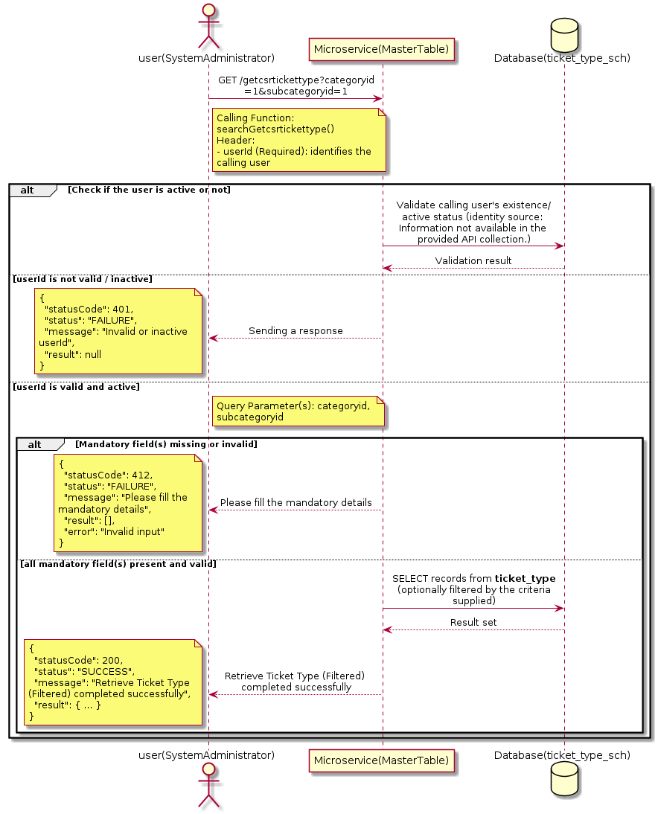

3.21.6.3 API Endpoint
Method | GET
URL | http://localhost:7002/srv2/genie/getcsrtickettype?categoryid=1&subcategoryid=1
Headers | userId: 879
Authorization | Not present in the captured request. Information not available in the provided API collection.
Content-Type | application/json (assumed)
Query Parameters | categoryid = 1 subcategoryid = 1
Path Variables | None
Request Body:
Not applicable — this operation does not accept a request body.
Response Body (illustrative — see 3.x.4.5 Success Response for details):
The source Postman collection does not include a captured sample response for this request (the response array is empty). Information not available in the provided API collection. Section 3.21.6.4.5 below presents the response envelope inferred from the standard response wrapper used consistently by this platform's services.

3.21.6.4 Detailed Process Flow

3.21.6.4.1 Request Initiation
The flow begins when System Administrator (or a calling microservice on their behalf) invokes the GET endpoint http://localhost:7002/srv2/genie/getcsrtickettype?categoryid=1&subcategoryid=1. The request must include the mandatory `userId` header used by the Master Table Microservice to identify the calling user for auditing purposes. The endpoint also expects one or more query parameters as listed in the API Endpoint section. At the Controller layer, Spring Boot's request-mapping infrastructure routes the call to the appropriate handler method (`searchGetcsrtickettype`), and Bean Validation annotations (if configured on the DTO) perform structural validation before the request reaches the Service layer. Information not available in the provided API collection. regarding the exact validation annotations used in the source code.

3.21.6.4.2 User Validation
The Master Table Microservice relies on the `userId` header to identify the calling user. Based on the pattern observed consistently across this API collection, the platform's authentication/authorization is expected to be enforced upstream (e.g., by an API Gateway or a shared security filter) using this identifier; the Postman collection does not include an `Authorization` / `Bearer` token header on this request, so the exact authentication mechanism (JWT validation, session lookup, or gateway-level SSO) is Information not available in the provided API collection. Role-based authorization — i.e., confirming that the user identified by `userId` holds a role/permission entitled to perform this operation — is expected to be enforced by the Service layer (see Section 8 – Controller Analysis and Section 14 – Authentication & Authorization), but the specific role/permission checks are Information not available in the provided API collection.

3.21.6.4.3 Business Logic
The Service layer inspects the supplied query parameters, builds the corresponding filter/predicate, and forwards it to the Repository. If a parameter is absent, the corresponding filter is typically skipped rather than treated as an error.

3.21.6.4.4 Database Interaction
The Repository layer (Spring Data JPA) interacts with the underlying relational database that backs the Ticket Type master table. The primary operation issued is a **SELECT** against the table associated with Ticket Type. No write operations occur; the query is scoped using the supplied filter parameters, translated into a JPA derived-query or `@Query`/native query. The exact table name, column names, primary/foreign key definitions, and JPA repository method signatures are not included in the Postman collection; therefore, precise schema details are information not available in the provided api collection.

3.21.6.4.5 Success Response
Status Code: 200 OK. Sample response envelope (illustrative — the source collection did not capture a sample response for this API):
{
"statusCode": 200,
"status": "SUCCESS",
"message": "Retrieve Ticket Type (Filtered) completed successfully",
"result": [
{
"id": 1,
"name": "Sample Ticket Type",
"isActive": 1
}
],
"error": null,
"corelationId": "c6f2a1e4-2b3d-4a9e-9f1a-1234567890ab",
"url": null
}

3.21.6.4.6 Conclusion
This API provides a well-defined, single-purpose capability within the Master Table Microservice for retrieve ticket type (filtered). The Controller → Service → Repository → Database layering keeps request validation, business rules, and persistence concerns separated, which allows the Ticket Type master data to be maintained consistently and safely by authorized administrators while remaining available for consumption by every other module that depends on this reference data.

